User Interface: Screens Design

1. UI for Guest/User/Borrower:

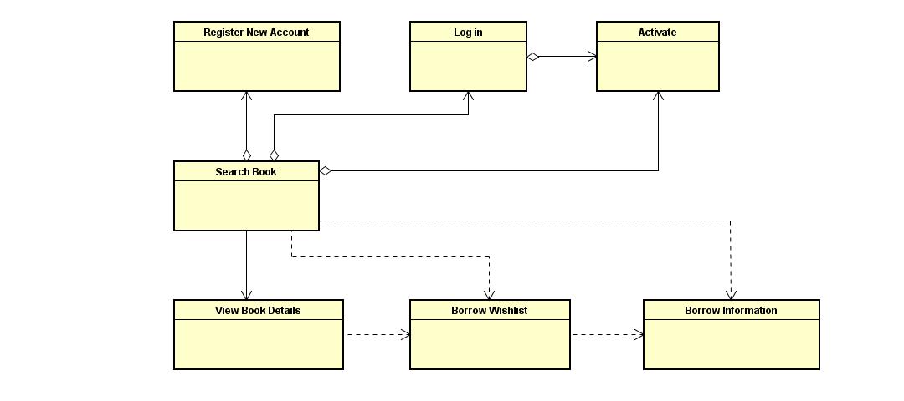

|  |  |  |
| --- | --- | --- |
| **Screen** | **Actor** | **Use case** |
| Search Book | Guest | Search book |
| Register New Account | Guest | Register new account |
| Log in | User | Log in |
| Activate | Guest | Activate account |
| View Book Details | Guest | View detailed book information |
| Borrow wishlist | Borrower | Register to borrow |
| Borrow information | Borrower |  |

2. UI for Librarian: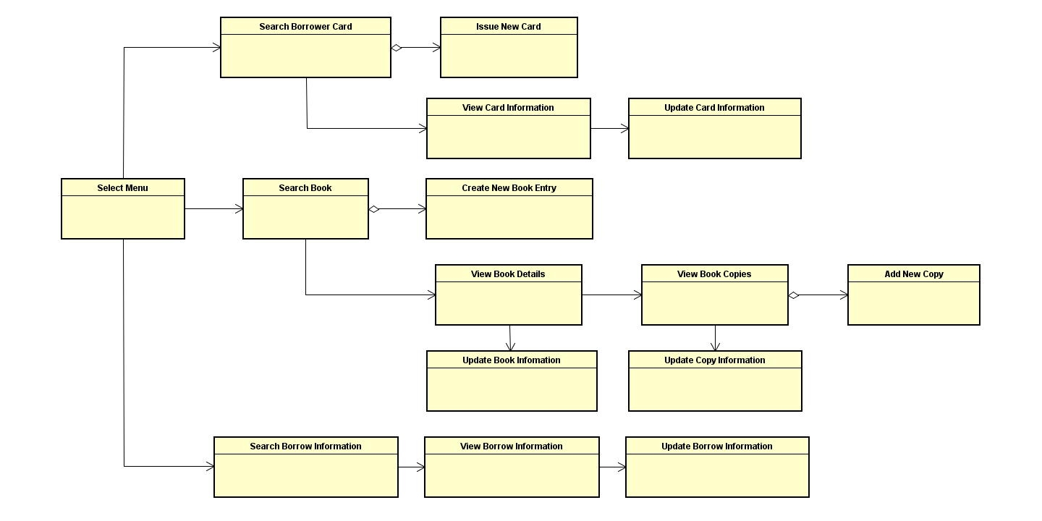

|  |  |
| --- | --- |
| **Screen** | **Use case** |
| Select Menu |  |
| Search Book | CRUD books |
| Create New Book Entry | CRUD books |
| View Book Details | CRUD books |
| View Book Copies | CRUD books |
| Add New Copy | CRUD books |
| Update Book Information | CRUD books |
| Update Copy Information | CRUD books |
| Search Borrow Information | Update borrowing Information |
| View Borrow Information | Update borrowing Information |
| Update Borrow Information | Update borrowing Information |
| Search Borrower Card | CRUD borrower cards |
| Issue New Card | CRUD borrower cards |
| View Card Information | CRUD borrower cards |
| Update Card Information | CRUD borrower cards |

3. UI for Administrator:

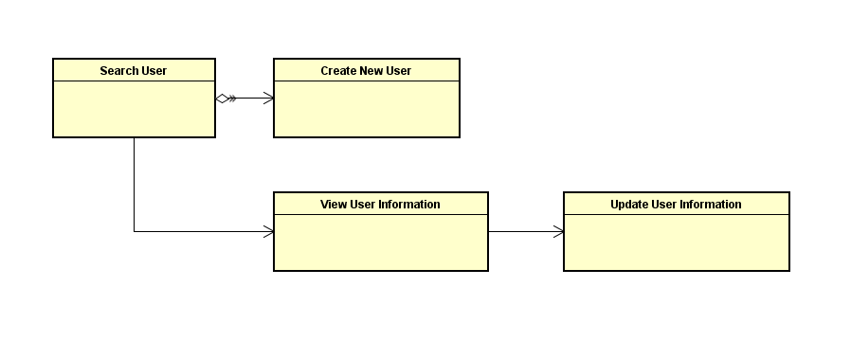

*Use case: Maintain Users and Roles.