UNIVERSITY OF TECHNOLOGY & EDUCATION

PROJECT ARTIFICIAL INTELLIGENCE

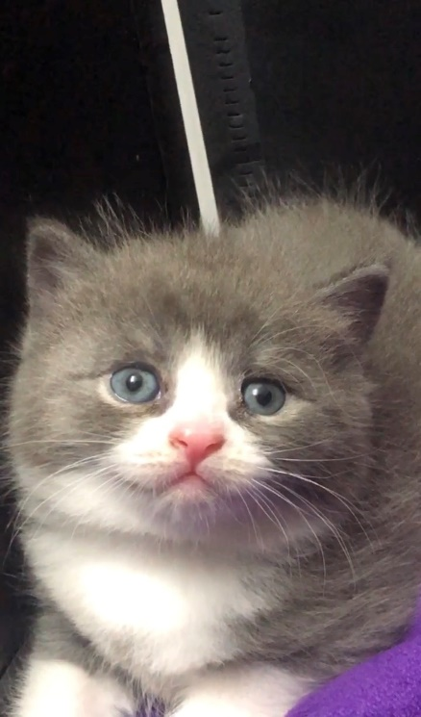 RECOGNIZE THE ANIMAL REAL_TIME

HORSE

CAT

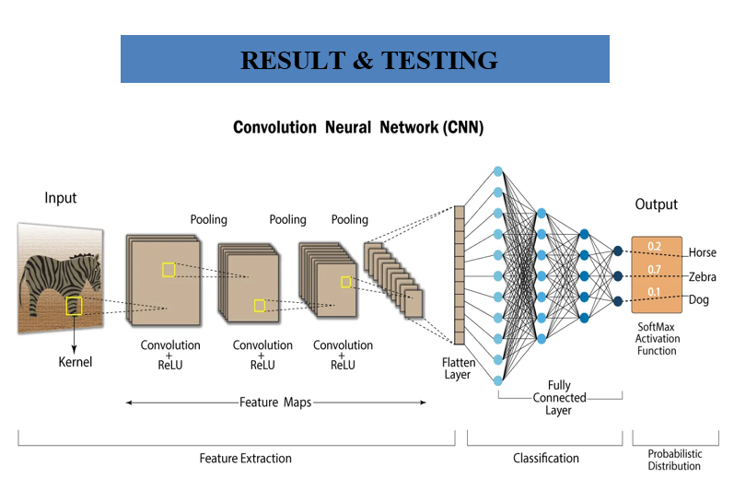

LION

**CONTACT   
 TELEPHONE : 0909787071  
 STUDENT : Đinh Thanh Cường - 19146110  
 INSTRUCTOR: Nguyen Truong Thinh**