PE_PRN222_SU25_TrialTest
SUMMER 2025
Subject: PRN222
Duration: 85 minutes

INSTRUCTIONS
Please read the instructions carefully before doing the questions.
- You are NOT allowed to use any other materials. You are NOT allowed to use any device to share data with others.
- You must use Visual Studio 2019 or above, MSSQL Server 2008 or above for your development tools.
IMPORTANT – before you start doing your solution, MUST do the following steps:
- Create Solution in Visual Studio named PE_PRN222_SU25_TrialTest_StudentName. Inside your Solution, the Project ASP.NET Core Razor Page must be named: LionPetManagement_StudentName.
- To do your program, you must use ASP.NET Core Web App (Razor Pages), apply 3-Layer architecture (Presentation Layer, Business Logic Layer, Data Access Layer), there are at least 2 Projects for the Solution. The database connection string must get from the appsettings.json file.
In the case your code connects direct to the database from ASP.NET Core Web App (Razor Pages) or hard coded the connection string, you will get 0 point.
- Create your MS SQL database named SU25LionDB by running code in script SU25LionDB.sql.
- Set the default user interface for your project as a Login page.
- If there are syntax errors or compilation errors in your PE program, you will not pass the PE requirements, the mark will be 0.
- Your work will be considered invalid (0 point) if your code inserts stuff that is unrelated to the test.

You are required to build an application using ASP.NET Core Razor Pages. The application must connect to the following SQL Server database named SPU5LionDB

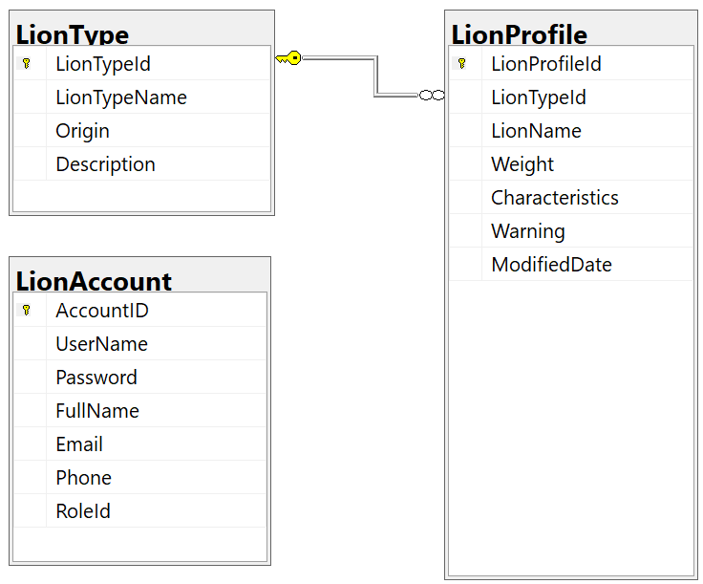
Store account role: Manager = 2; Staff = 3;

Role  Function/URL | Manager | Staff
Create | x
Update | x
Delete | x
View list of items | x | x
View detail of an item | x | x
Search | x | x
Table 1. Permissions to implement functions in the test

Function/URL
Create | http://localhost:XXXX/LionProfile/Create
Update | http://localhost:XXXX/LionProfile/Update
Delete | http://localhost:XXXX/LionProfile/Delete
View list of items | http://localhost:XXXX/LionProfile/Index
View detail of an item | http://localhost:XXXX/LionProfile/Detail
Search | http://localhost:XXXX/LionProfile/Search
Login | http://localhost:XXXX/Login
Table 2. Mapping between functions and URLs
Important Notes:
- The roles and permissions are defined in Table 1.
- Your application must use Razor Page routes as Table 2. If any feature does not follow the required URL structure, the score for that feature will be zero.
- If authentication or authorization is implemented incorrectly, the entire exam will receive 0 points.
- Authentication must be done using email and password.
- Login page must appear first when running the application.
- If the login fails (wrong email or password), display: "Invalid Email or Password!"
- If a user tries to access a feature they don’t have permission for, show: "You have no permission to access this function!"

Question 1 (1.0 point)
Implement the Login page using email and password. Upon successful login, redirect to the LionProfile list page in Question 2.

Question 2 (1.5 points)
Implement the View List function for LionProfile with the following:
- List all of the items in the LionProfile table. Display each record with its associated LionTypeName.
- Paginate the list to show 3 records per page.

Question 3 (2.5 points)
Implement the Create function to add new LionProfile into the database with the following validations:
- All fields are required.
- LionName: Minimum 4 characters, Each word starts with a capital letter. No special characters (#, @, &, (, )).
- Weight must be greater than 30.
- LionTypeId must be selected from a dropdown sourced from the LionType table
- The newly added item should appear at the top of the list.

Question 4 (2.0 points)
Implement the Update function using the same validations as the Create function.

Question 5 (1.5 points)
Implement the Search function with the following:
- Allow filtering by Weight or LionTypeName (OR logic). The UI must include these two input fields.
- Use partial match for LionTypeName.

Question 6 (1.5 points)
Implement the Delete function using SignalR for real-time updates with the following:
- Confirm deletion before proceeding.
- After deletion, all connected clients should receive the updated list automatically.

