Tên: Trần Nguyễn Quốc Cường

Lớp: SE1709

**Bài tập P11.5-7**

**P11.5:**

**Code:**

#include <stdio.h>

void inputArray(int arr[], int *pn) {

for (int i = 0; i < *pn; i++) {

printf("a[%d] = ", i);

scanf("%d", &arr[i]);

}

}

void selectionSort(int arr[], int *pn) {

int minIndex;

int i, j;

for (i = 0; i < *pn - 1; i++) {

minIndex = i;

for (j = i + 1; j < *pn; j++) {

if (arr[minIndex] > arr[j]) minIndex = j;

}

if (minIndex > i) {

int t = arr[minIndex];

arr[minIndex] = arr[i];

arr[i] = t;

}

}

}

int binarySearch(int arr[], int *pn, int a) {

int i = 0, j = *pn - 1, c;

int result = -1;

while (i <= j) {

c = (i + j) / 2;

if (arr[c] == a) result = c;

if (arr[c] > a) j = c - 1;

else i = c + 1;

}

return result;

}

int main() {

int n, a;

int arr[100];

printf("Nhap so phan tu trong mang: ");

scanf("%d", &n);

inputArray(arr, &n);

selectionSort(arr, &n);

printf("Phan tu can tim: ");

scanf("%d", &a);

if (binarySearch(arr, &n, a) == -1) {

printf("Khong tim thay phan tu do");

}

else printf("Phan tu %d ton tai trong mang", a);

return 0;

}

**Kết quả:**

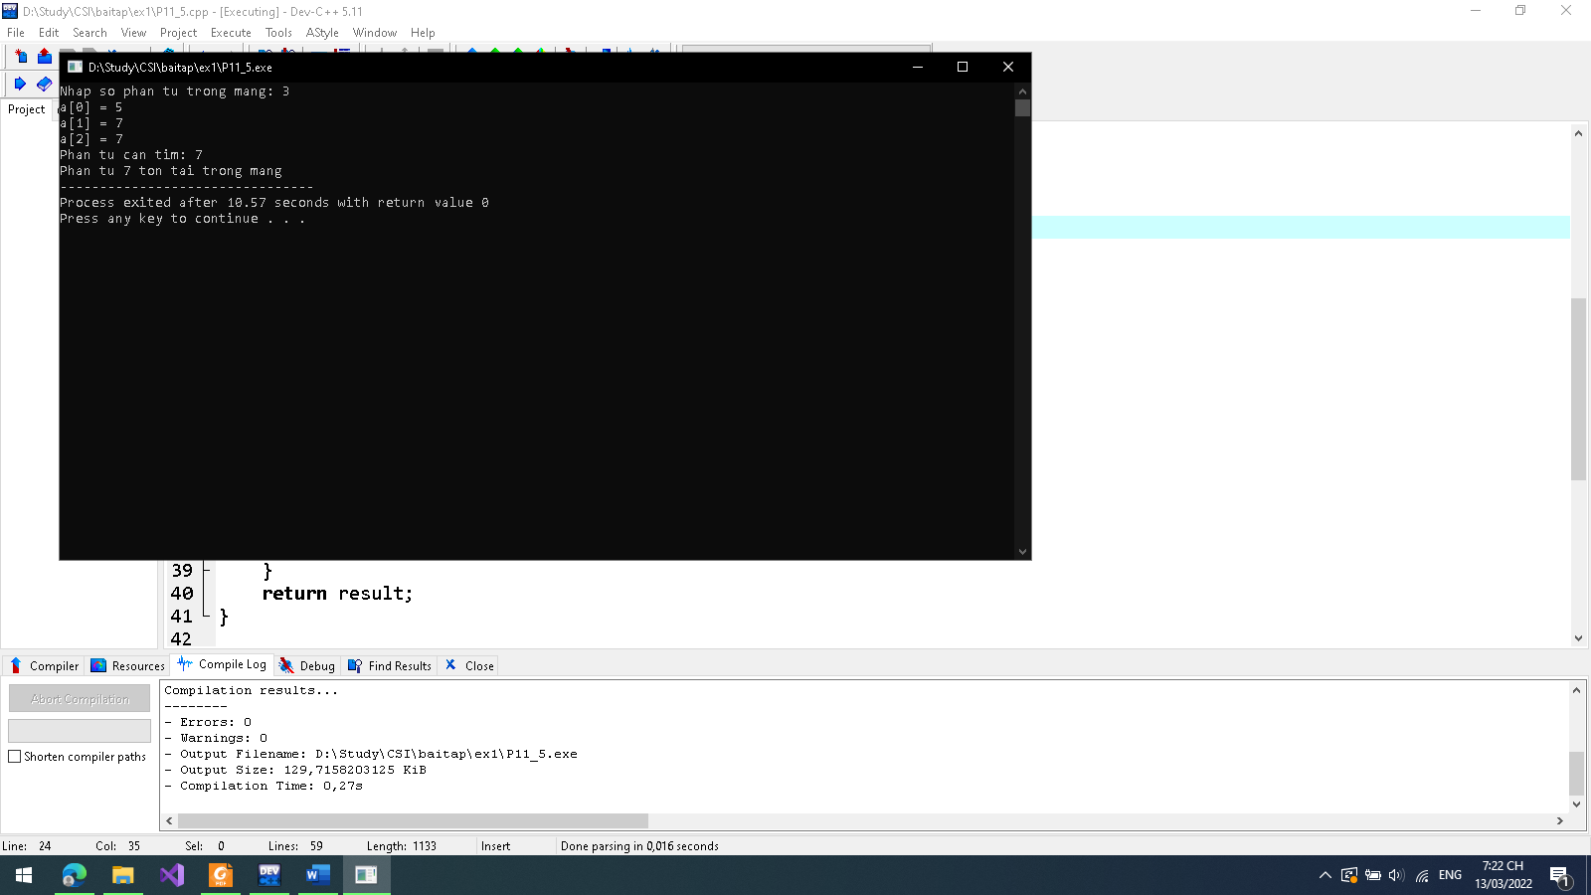

P11-6:

**Code:**

/*

Name: Tran Nguyen Quoc Cuong

Date: 2022/03/02

*/

#include <stdio.h>

#include <stdlib.h>

void inputArray(int arr[], int n) {

for (int i = 0; i < n; i++) {

printf("a[%d] = ", i);

scanf("%d", &arr[i]);

}

}

void selectionSort(int arr[], int n) {

int minIndex;

int i, j;

for (i = 0; i < n - 1; i++) {

minIndex = i;

for (j = i + 1; j < n; j++) {

if (arr[minIndex] > arr[j]) minIndex = j;

}

if (minIndex > i) {

int t = arr[minIndex];

arr[minIndex] = arr[i];

arr[i] = t;

}

}

}

int search(int arr[], int n, int add) {

int p;

for(int i = 0; i < n; i++) {

if(add < arr[i]) {

p = i;

break;

} else {

p = i + 1;

}

return p;

}

}

void addValue(int arr[], int n) {

int add;

printf("Nhap phan tu can nhap vao mang: ");

scanf("%d", &add);

int loc = search(arr, n, add);

for (int i = n + 1; i >= loc; i--) {

arr[i] = arr[i - 1];

}

arr[loc] = add;

++n;

}

void output(int arr[], int n) {

++n;

for (int i = 0; i < n; i++) {

printf("%d ", arr[i]);

}

}

int main() {

int n, a;

int *arr;

arr = (int*)calloc (100, sizeof(int));

printf("Nhap so phan tu trong mang: ");

scanf("%d", &n);

inputArray(arr, n);

selectionSort(arr, n);

addValue(arr, n);

printf("Mang sau khi them phan tu: ");

output(arr, n);

return 0;

}

**Kết quả:**

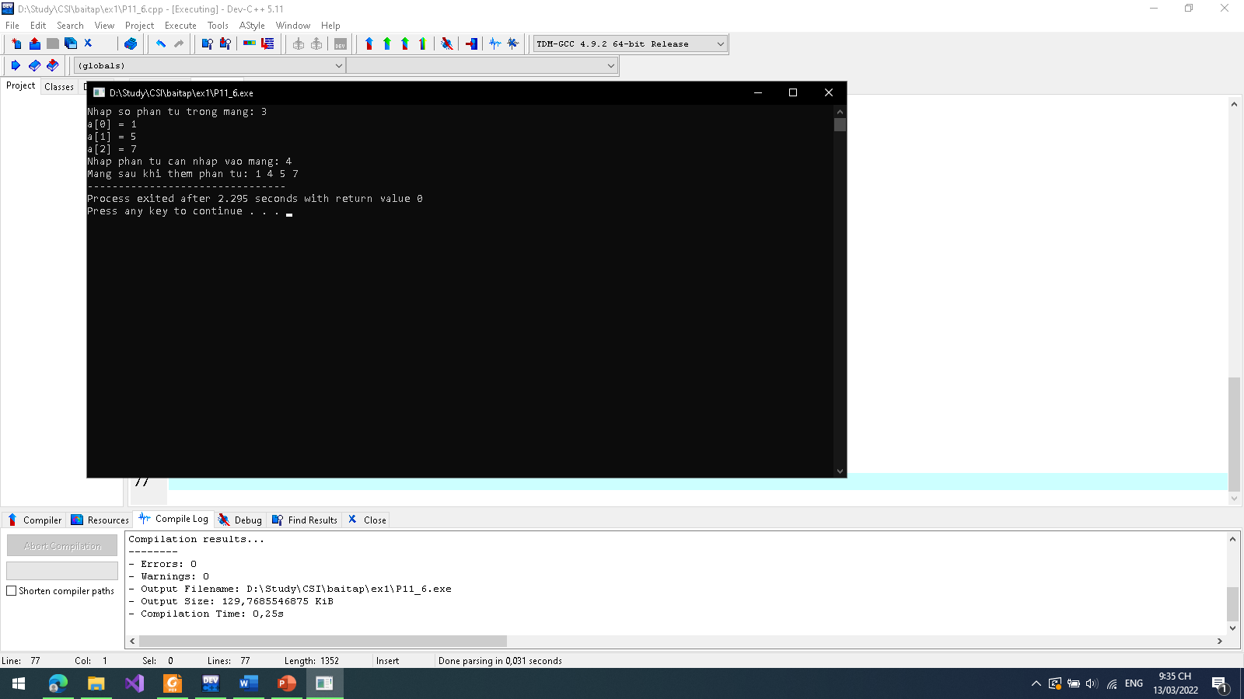

**P11.7:**

**Code:**

/*

Name: Tran Nguyen Quoc Cuong

Date: 2022/03/02

*/

#include <stdio.h>

#include <stdlib.h>

void inputArray(int arr[], int n) {

for (int i = 0; i < n; i++) {

printf("a[%d] = ", i);

scanf("%d", &arr[i]);

}

}

void selectionSort(int arr[], int n) {

int minIndex;

int i, j;

for (i = 0; i < n - 1; i++) {

minIndex = i;

for (j = i + 1; j < n; j++) {

if (arr[minIndex] > arr[j]) minIndex = j;

}

if (minIndex > i) {

int t = arr[minIndex];

arr[minIndex] = arr[i];

arr[i] = t;

}

}

}

int search(int arr[], int n, int del) {

int p = -1;

for (int i = 0; i < n; i++) {

if (del == arr[i]) p = i;

}

return p;

}

void output(int arr[], int n) {

for (int i = 0; i < n - 1; i++) {

printf("%d ", arr[i]);

}

}

void delValue(int arr[], int n) {

int del;

printf("Nhap phan tu can xoa khoi mang: ");

scanf("%d", &del);

int loc = search(arr, n, del);

if (loc == -1) printf("Khong xoa duoc phan tu vi phan tu khong ton tai");

else {

for (int i = loc; i < n - 1; i++) {

arr[i] = arr[i + 1];

}

printf("Mang sau khi xoa phan tu: ");

output(arr, n);

}

}

int main() {

int n, a;

int arr[100];

printf("Nhap so phan tu trong mang: ");

scanf("%d", &n);

inputArray(arr, n);

selectionSort(arr, n);

delValue(arr, n);

return 0;

}

**Kết quả:**

