

E-Banking System

**Software Requirement Specification**

– Danang, May 2023 –

81

Table of Contents

I. Record of Changes: 2

II. Software Requirement Specification 2

Product Overview 2

1. User Requirements 3

1.1. Actors 3

1.2. Use cases 4

1.2.1. Diagram(s) 4

1.2.2. Descriptions 10

2. Functional Requirements 12

2.1. System Functional Overview 12

2.1.1. Screens Flow 12

*2.1.2.* Screen Descriptions 15

*2.1.3.* Screen Authorization 17

*2.1.4.* API Functions 20

2.1.5. Non Screen Functions 20

2.1.6. Entity Relationship Diagram 20

2.2. Use case specification 23

# Record of Changes:

|  |  |  |  |
| --- | --- | --- | --- |
| **Date** | **A,M,D** | **In charge** | **Change description** |
| 24/May | A |  |  |
|  |  |  |  |
|  |  |  |  |
|  |  |  |  |

A - Added M - Modified D - Deleted

# Software Requirement Specification

### Product Overview

An eBanking Transaction System is a software application that enables customers to access and manage their bank accounts, perform various types of transactions, and receive real-time updates on their account balances and transaction history, with the assistance of staff and administrators behind the scene. eBanking is a critical component of modern banking systems, as it provides customers with a convenient and secure way to perform financial transactions.

The eBanking system is responsible for processing and managing a wide range of customer transactions, including transfers, bank savings and pay bills. It typically includes various features, such as online banking portals, which enable customers to perform various financial transactions remotely.

The goal of an eBanking Transaction System is to provide customers with a convenient and reliable platform for managing their bank accounts, performing financial transactions, and receiving real-time account updates. This can result in increased customer satisfaction, loyalty, and revenue for banks and other financial institutions. As a result, the development of an eBanking system is an important strategic initiative for many banks and financial institutions, and is expected to continue to grow in importance in the coming years.

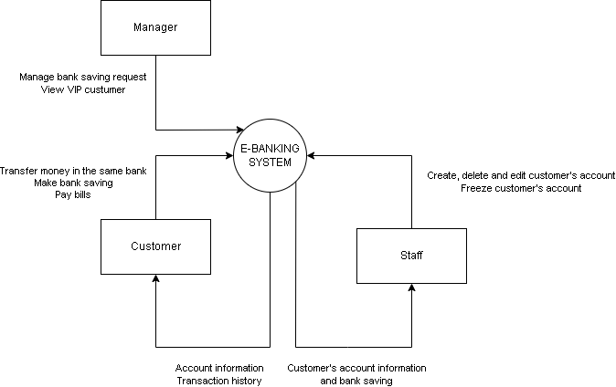

# User Requirements

## Actors

|  |  |  |
| --- | --- | --- |
| **#** | **Actor** | **Description** |
| 1 | Guest | Who use the app without signing in |
| 2 | Customer | Who use the app after signing in |
| 3 | Staff | Who use the app to monitor and help customer do their tasks |
| 4 | Manager | Who monitor the customer’s more delicate information |

# Use cases

### Diagram(s)

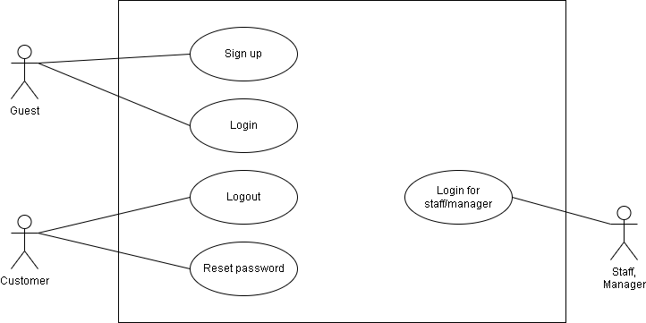

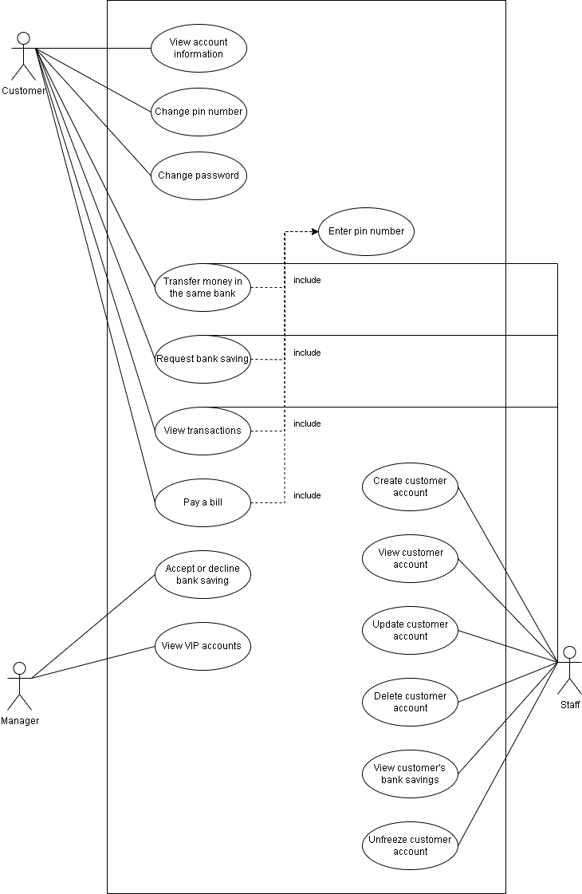

# 1.2.2. Descriptions

|  |  |  |  |
| --- | --- | --- | --- |
| **ID** | **Use Case** | **Actors** | **Use Case Description** |
| UC-01 | Sign up | Guest | Sign up an account to access the system |
| UC-02 | Sign-in | Guest | Sign-in an account to access the system |
| UC-03 | Logout | User | User log out from the app or website |
| UC-04 | Change password | User | Let user change password |
| UC-05 | Forgot password | User | Let user reset their password |
| UC-06 | View profile | User | User can view their profile |
| UC-07 | View other profile | Guest | User can view other profile |
| UC-08 | Update profile name | User | User can update their profile name |
| UC-09 | View class list | Guest | User or guest can view their classes |
| UC-10 | View class | Guest | User or guest can view class |
| UC-11 | Create class | User | User can create a class for their collection |
| UC-12 | Update class | User | User can update their class |
| UC-13 | Delete class | User | User can create their class |
| UC-14 | View member in class | Guest | View a list of member |
| UC-15 | Add user into class | User | Button to add the user into a class |
| UC-16 | Delete user in class | User | Button to delete user in class |
| UC-17 | Update class’s access modifier | User | Class owners can change class’s access modifier. |
| UC-18 | Request to join class | User | Send a join request to the class owner. |
| UC-19 | Manage member’s access permission | User | Allow user to manage user who accesses to their class |
| UC-20 | View join class request | User | Class owners view list join request. |
| UC-21 | Accept joins class request | User | Class owners accept a user to join class. |
| UC-22 | Deny joins class request | User | Class owners deny a user to join the class. |
| UC-23 | View folder list | Guest | View a list of folders. |

|  |  |  |  |
| --- | --- | --- | --- |
| **ID** | **Use Case** | **Actors** | **Use Case Description** |
| UC-24 | Create folder | User | User can create their folder |
| UC-25 | Update folder | User | User can update their folder |
| UC-26 | Delete folder | User | User can delete their folder |
| UC-27 | View study set list | Guest | View a list of study sets. |
| UC-28 | View study set | Guest | View study set properties and flashcards. |
| UC-29 | Create study set | User | User can create their study set |
| UC-30 | Update study set | User | User can update their study set |
| UC-31 | Delete study set | User | User can delete their study set |
| UC-32 | Rate study set | User | User rate study set |
| UC-33 | Import file .txt to create a study set | User | User import file .txt follows a format to create a study set. |
| UC-34 | Save study set | User | User can save their study set |
| UC-35 | Save flashcard | User | User can save their flashcard |
| UC-36 | Search | Guest | User can search based on name |
| UC-37 | Learn study set | Guest | User can learn study set on the system |
| UC-38 | View notifications | User | User can receive notification |
| UC-39 | View questions list | Guest | User or guest can see the list question display on the screen |
| UC-30 | View question | Guest | User or guest can see the detail of the question |
| UC-41 | Create question | User | Users create questions. |
| UC-42 | Update question | User | Users update their questions. |
| UC-43 | Delete question | User | Users delete their questions. |
| UC-44 | Create comment | User | Users create a comment to a question. |
| UC-45 | Update comment | User | Users update their comments to a question. |
| UC-46 | Delete comment | User | Users delete their comment to a question. |
| UC-47 | Up/Downvote comment | User | User up/downvote comment. |

|  |  |  |  |
| --- | --- | --- | --- |
| **ID** | **Use Case** | **Actors** | **Use Case Description** |
| UC-48 | Up/Downvote question | User | User up/downvote question. |
| UC-49 | Add personal folder to class | User | Class’s owner add the personal folder to class |
| UC-50 | Add personal study set to class | User | User add personal study set to class |
| UC-51 | Leave a class | User | User leave a class |
| UC-52 | Update profile avatar | User | User update their profile avatar |
| UC-53 | View user list | Guest | User or guest can see the list of the user profile |

# Functional Requirements

## System Functional Overview

### Screens Flow

See Web Screen Flow Diagram more clearly [here](https://drive.google.com/file/d/1nSANkWRzdKgBROEyPeafm8HMkAiwvdmr/view?usp=sharing).

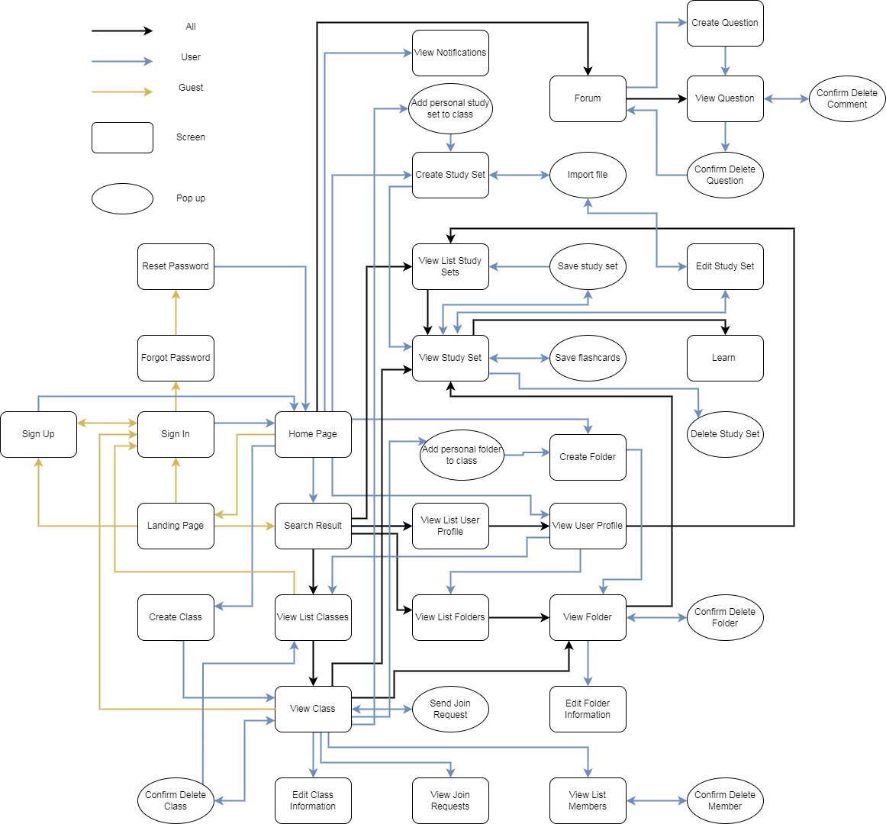

**Web Screen Flow**

See Mobile Screen Flow Diagram more clearly [here](https://drive.google.com/file/d/1A90OGfzMa_IWAfWO7GGyCBwvujsz9MT3/view?usp=sharing).

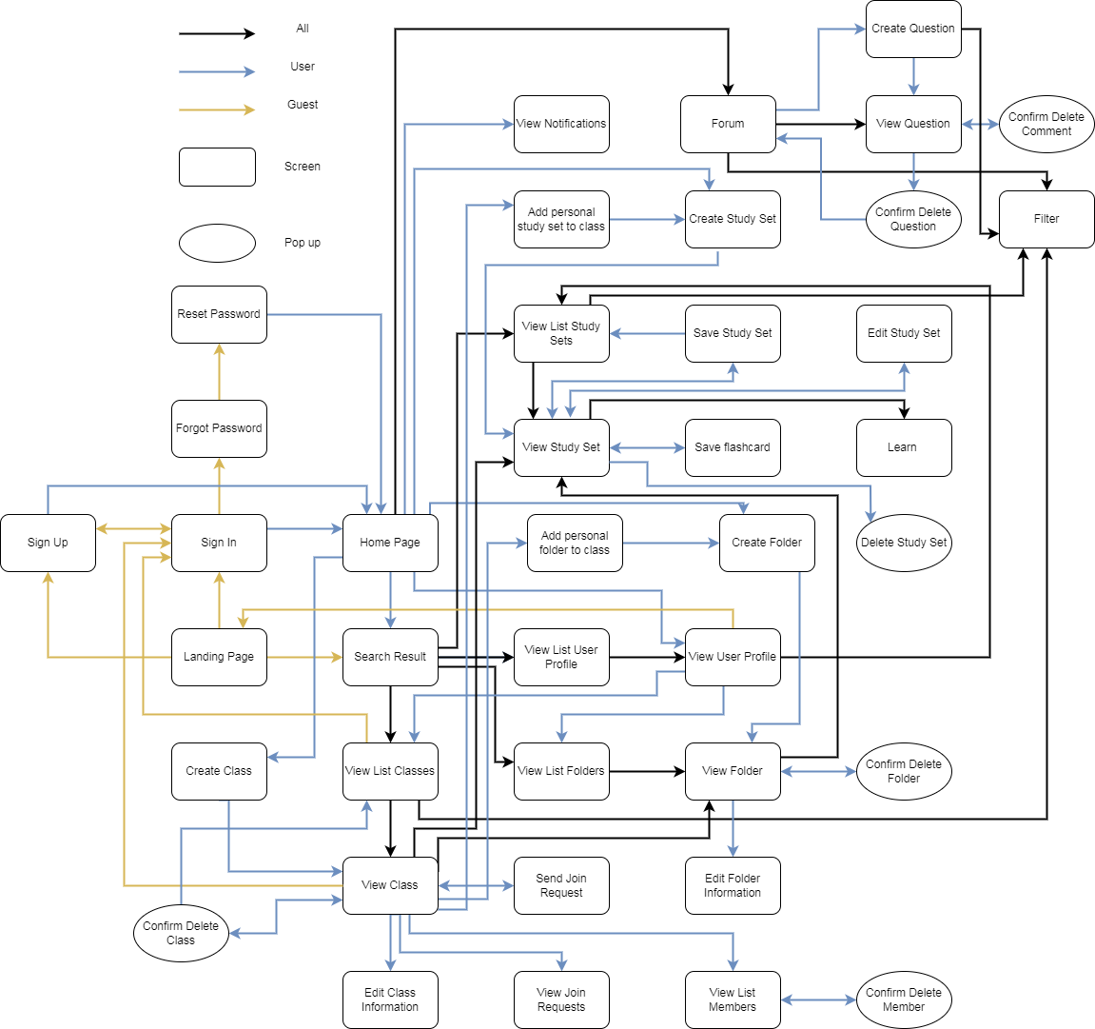

**Mobile Screen Flow**

# Screen Descriptions

|  |  |  |  |
| --- | --- | --- | --- |
| **#** | **Feature** | **Screen** | **Description** |
| 1 | Authentication | Landing page | An overview page for guests. |
| 2 | Authentication | Sign In | Allow guests to login into the system. |
| 3 | Authentication | Sign Up | Allow guests to create an account. |
| 4 | Authentication | Forgot password | Helps users to send a request to reset their password. |
| 5 | Profile | Change password | Helps users to create a new password. |
| 6 | Flashcard | Home Page | An overview page for users, shows some recent study sets. |
| 7 | Flashcard | View class list of search | Show list of classes for the search result. |
| 8 | Profile | View class list of profile | Show list of classes for user profile. |
| 9 | Flashcard | View class | View class information and class content. |
| 10 | Flashcard | Create class | Allow users to create a new class. |
| 11 | Flashcard | add personal study set to class(popup) | Allow users to add personal study set to class |
| 12 | Flashcard | add personal folder to class(popup) | Allow class’s owner add personal folder to class |
| 13 | Flashcard | Edit class information | Allow the class owner to edit their class. |
| 14 | Flashcard | Confirm delete class(pop up) | A popup to confirm delete class. |
| 15 | Flashcard | View join request | Allow the class owner to view all join requests from users. |
| 16 | Flashcard | Send join request(pop up) | A popup to allow users to send a join request to the class owner. |
| 17 | Flashcard | View member list | Show all members in a class. |
| 18 | Flashcard | Confirm delete member (pop up) | A popup to confirm delete member |

|  |  |  |  |
| --- | --- | --- | --- |
| **#** | **Feature** | **Screen** | **Description** |
| 19 | Profile | View folder list of profile | Show list of folders for the search result. |
| 20 | Flashcard | View folder | View folder information and content |
| 21 | Flashcard | Create folder | Allow users to create a new folder |
| 22 | Flashcard | Edit folder information | Allow the owner to edit their folder |
| 23 | Flashcard | Confirm delete the folder(pop up) | A popup to confirm delete folder |
| 24 | Flashcard | View Study set list of search | Show list of study set for search result |
| 25 | Profile | View Study set list of profile | Show a list of study sets for search results. |
| 26 | Flashcard | View study set | View study set information and content |
| 27 | Flashcard | Create study set | Allow user to create a study set |
| 28 | Flashcard | Import file(pop up) | A popup to allow users import file .txt to create flashcards in study sets. |
| 29 | Flashcard | Update study set | Allow owner to update their study set |
| 30 | Flashcard | Confirm to delete study set(pop up) | A popup to confirm delete study set |
| 31 | Flashcard | Save study set(pop up) | A popup to save study set |
| 32 | Flashcard | Save flashcard(pop up) | A popup to save flashcard |
| 33 | Flashcard | Learn study set | A screen allows learning flashcards to make them easier to remember. |
| 34 | Flashcard | View user list of search | Show list of users for the search result. |
| 35 | Profile | View user profile | Show users information and content. |
| 36 | Forum | Forum | An overview forum page, shows some recommended questions. |
| 37 | Forum | View question | View a specific question and question’s comment, allow users to up/down vote question and comments. |

|  |  |  |  |
| --- | --- | --- | --- |
| **#** | **Feature** | **Screen** | **Description** |
| 38 | Forum | Create question | Allow users to create a new question. |
| 39 | Forum | Confirm delete question(pop up) | A popup to confirm delete questions. |
| 40 | Forum | Confirm delete the comment(pop up) | A popup to confirm delete comments. |
| 41 | Notification | View notification | Allow users to view notifications. |

# Screen Authorization

|  |  |  |  |  |  |
| --- | --- | --- | --- | --- | --- |
| **Screen** | **User** | | | | **Guest** |
| **Class Owner** | **Viewer member in class** | **Editor member in class** | **Normal user** |
| Landing page |  |  |  |  | X |
| Sign In |  |  |  |  | X |
| Sign Up |  |  |  |  | X |
| Forgot password | X | X | X | X |  |
| Reset password | X | X | X | X |  |
| Home page | X | X | X | X |  |
| Search Result | X | X | X | X | X |
| View class list | X | X | X | X | X |
| View class | X | X | X | X | X |
| Create class |  |  |  | X |  |
| Edit class information | X |  |  |  |  |
| Confirm delete class (Popup) | X |  |  |  |  |
| View join request | X |  |  |  |  |
| Send join request (popup) |  |  |  | X |  |
| View member list | X | X | X | X | X |
| Confirm delete member (Popup) | X |  |  |  |  |
| View folder list | X | X | X | X | X |
| View folder | X | X | X | X | X |
| Create folder | X | X | X | X |  |
| Create folder in class | X |  |  |  |  |
| Edit folder information | X | X | X | X |  |
| Edit folder in class | X |  |  |  |  |

|  |  |  |  |  |  |
| --- | --- | --- | --- | --- | --- |
| **Screen** | **User** | | | | **Guest** |
| **Class Owner** | **Viewer member in class** | **Editor member in class** | **Normal user** |
| Confirm delete folder (Popup) | X | X | X | X |  |
| Delete folder in class | X |  |  |  |  |
| View study set list | X | X | X | X | X |
| View study set | X | X | X | X | X |
| Create study set | X | X | X | X |  |
| Create study set in class | X |  | X |  |  |
| Import file (Popup) | X | X | X | X |  |
| Update study set | X | X | X | X |  |
| Update study set in class | X |  | X |  |  |
| Confirm delete study set (Popup) | X | X | X | X |  |
| Delete study set in class | X |  | X |  |  |
| Save study set (Popup) | X | X | X | X |  |
| Save flashcard (Popup) | X | X | X | X |  |
| Learn study set | X | X | X | X | X |
| View user profile list | X | X | X | X | X |
| View user profile | X | X | X | X | X |
| Forum | X | X | X | X | X |
| View question | X | X | X | X | X |
| Create question | X | X | X | X |  |
| Edit question | X | X | X | X |  |
| Confirm delete question (popup) | X | X | X | X |  |
| Confirm delete comment (popup) | X | X | X | X |  |

|  |  |  |  |  |  |
| --- | --- | --- | --- | --- | --- |
| **Screen** | **User** | | | | **Guest** |
| **Class Owner** | **Viewer member in class** | **Editor member in class** | **Normal user** |
| View notification | X | X | X | X |  |
| Add personal study set to class | X |  | X |  |  |
| Add personal folder to class | X |  |  |  |  |

# API Functions

|  |  |  |
| --- | --- | --- |
| **API ID** | **Feature** | **Screen** |
| API-001 | Sign up with email, password | Sign up |
| API-002 | Sign up with Google | Sign up |
| API-003 | Sign up with Facebook | Sign up |
| API-004 | Sign in with email, password | Sign in |

### Non Screen Functions

|  |  |  |
| --- | --- | --- |
| **API ID** | **Feature** | **Screen** |
| API-049 | Accept join invitation | View class |

### Entity Relationship Diagram

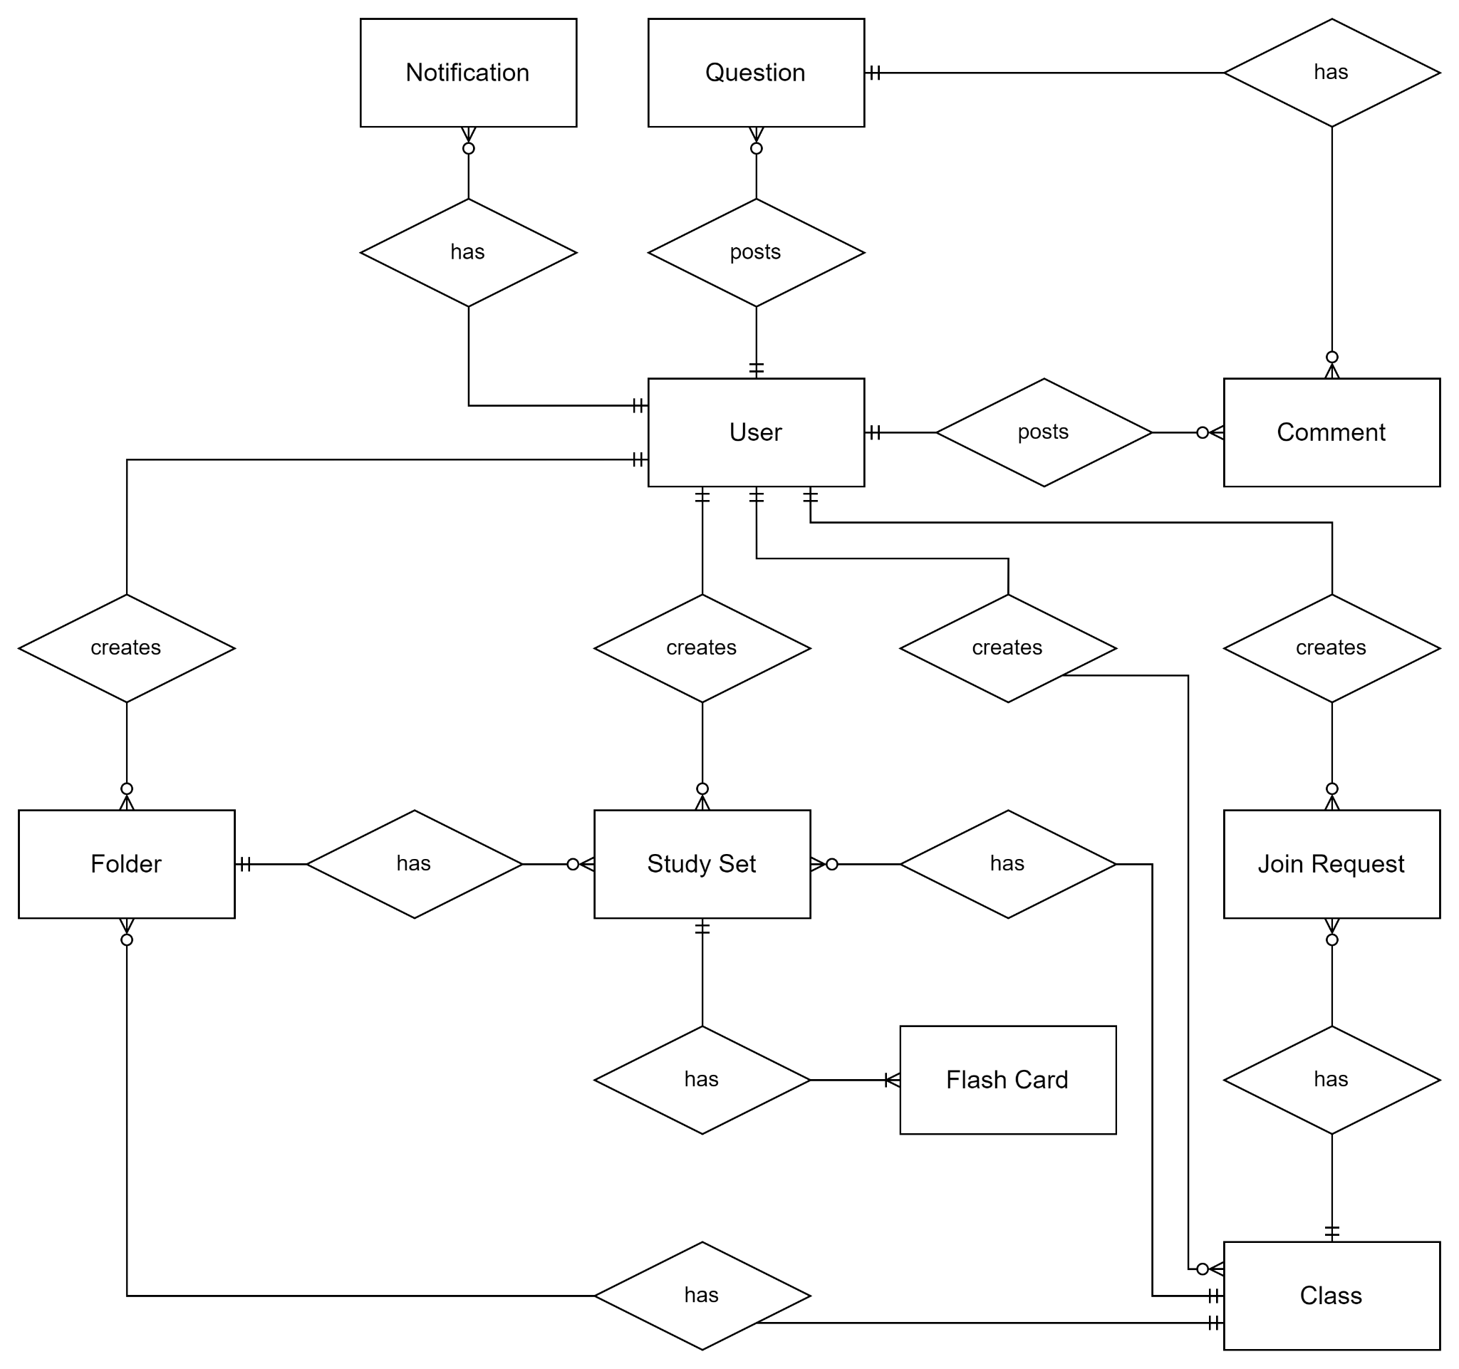

**Entities Description**

|  |  |  |
| --- | --- | --- |
| **#** | **Entity** | **Description** |
| 1 | User | Attributes:   * PK: id * username * name * email |

|  |  |  |
| --- | --- | --- |
| **#** | **Entity** | **Description** |
|  |  | * password * avatar_link |
| 2 | Notification | Attributes:   * PK: id * FK: user_id * created_time * content |
| 3 | Question | Attributes:   * PK: id * FK: user_id * created_time * title * tags * content * upvote * downvote |
| 4 | Comment | Attributes:   * PK: id * FK: user_id, question_id, comment_id * created_time * content * upvote * downvote |
| 5 | Class | Attributes:   * PK: id * FK: user_id * created_time * name * school * description * access_modifier * members |
| 6 | Join Request | Attributes:   * PK: id * FK: user_id, class_id * created_time * message * status |
| 7 | Folder | Attributes:   * PK: id * FK: user_id, class_id * created_time * name * description |

|  |  |  |
| --- | --- | --- |
| **#** | **Entity** | **Description** |
| 8 | Study Set | Attributes:   * PK: id * FK: user_id, class_id, folder_id * created_time * name * subject * textbook * description * access_modifier |
| 9 | Flash Card | Attributes:   * PK: id * FK: studyset_id * created_time * index * term * define |

## Use case specification

See all Use Case Specifications more clearly [*here*](https://docs.google.com/spreadsheets/d/1FglxkO3HoURY0qp2OMSIRF6iwdQcNEPEx7s-X1estY0/edit?usp=sharing).

|  |  |  |  |
| --- | --- | --- | --- |
| Use Case ID: | **UC-01** | Use Case Name: | **Sign Up** |
| Created By: | HungND | Date Created: | 2022/01/03 |
| Primary Actor: | Guest | Secondary Actor: |  |
| Description: | User want to sign up account on the system | | |
| Priority: | Must have | | |
| Trigger: | Guest click sign up button to create a new account on the system | | |
| Preconditions: | PRE-1.1 Guest has a valid email PRE-1.2 Guest has a valid password PRE-1.3 Guest has a valid name | | |
| Post - Conditions: | When normal flow is completed, a new account is created on the system with given information, new user should be redirect to home page | | |
| Basic Flow: | 1. Guests visit Landing Page website from browser or app 2. Waiting for the Landing Page to be loaded 3. Guest click on the Sign Up button to register new account 4. Waiting for the register page to be loaded 5. Guest fill in email, password, confirm password,and name on the displayed   register form or can click the button Sign up with Google or Facebook if they want to  create account with their account google or facebook | | |

|  |  |
| --- | --- |
|  | 1. Guests click on the Signup button 2. New user is redirected to the home page |
| Alternative  Flow: | When sign up with Google user will choose their Google account When sign up with Facebook will use their account to sign in |
| Exception Flow: | **Users enter invalid value in register form**   * System shows error messages on each invalid field and prevents guests from submitting the register form   **Cannot connect to server or some error occurs**   * System shows error messages |
| Business Rules: | BR-03 |

|  |  |  |  |
| --- | --- | --- | --- |
| Use Case ID: | **UC-02** | Use Case Name: | **Sign In** |
| Created By: | HungND | Date Created: | 2022/01/03 |
| Primary Actor: | Guest | Secondary Actor: |  |
| Description: | User want to sign in account on the system | | |
| Priority: | Must have | | |
| Trigger: | A guest clicks on the sign in button | | |
| Preconditions: | PRE-1. The guest has not logged in the system | | |
| Post - Conditions: | POST-1 The user sign in the system  POST-2. The user is provided access to his allowed systems. POST-3 The user accesses the system, make a login request and is directed to the login page. | | |
| Basic Flow: | 1. Access the Anti-Retake website or app 2. Click on the sign in link to sign in to website or app 3. Fill in form with email and password or click sign in with google or Facebook   button   1. Enter or click on the sign in button to sign in website or app | | |
| Alternative Flow: | When sign in with Google user will choose their Google account When sign in with Facebook will use their account to sign in | | |

|  |  |
| --- | --- |
| Exception Flow: | **Form data is invalid**   * System shows error messages below each invalid input field   **Account is not exist or the password is incorrect**   * System shows error messages |
| Business Rules: | BR-03 |

|  |  |  |  |
| --- | --- | --- | --- |
| Use Case ID: | **UC-03** | Use Case Name: | **Logout** |
| Created By: | HungND | Date Created: | 2022/1/4 |
| Primary Actor: | User | Secondary Actor: |  |
| Description: | The user logs out and is now determined as Guest. The guest is provided access to only see,search and learn | | |
| Priority: | Must have | | |
| Trigger: | User click the button logout to logout account out of the system | | |
| Preconditions: | PRE-1. The user has signed in the system | | |
| Post - Conditions: | POST-1. The user logged out the system | | |
| Basic Flow: | **IF user uses app**   1. User click to their profile 2. Click on the button on the navigation bar to open its sub-menu 3. Click on “Logout” button on the sub-menu 4. System redirect the user to the landing page   **IF user uses website**   1. Click on the avatar 2. A pop up will show up and user click logout 3. System redirect the user to the landing page | | |
| Alternative Flow: | N/A | | |
| Exception Flow: | N/A | | |
| Business Rules: | N/A | | |

|  |  |  |  |
| --- | --- | --- | --- |
| Use Case ID: | **UC-04** | Use Case Name: | **Change password** |
| Created By: | HungND | Date Created: | 2022/01/04 |
| Primary Actor: | User | Secondary  Actor: |  |
| Description: | User want to change password for their account | | |
| Priority: | Must have | | |
| Trigger: | A user goes to the profile, clicks the button on the navigation then choose Change password button and fills all the required fields. After that, the user clicks change password button and now the password was changed | | |
| Preconditions: | PRE-1. User is signed into system | | |
| Post - Conditions: | POST-1. The user’s password is changed. | | |
| Basic Flow: | 1. user go to their profile 2. user clicks the button on the navigation. 3. user clicks the Change password button. 4. user fills all the required fields. 5. user clicks Change password button. | | |
| Alternative Flow: | N/A | | |
| Exception Flow: | The user does not provide all required fields.  The user does not input the same password for “New password” and “Enter new password again | | |
| Business Rules: | BR-02,BR-03 | | |

|  |  |  |  |
| --- | --- | --- | --- |
| Use Case ID: | **UC-05** | Use Case Name: | **Forgot password** |
| Created By: | HungND | Date Created: | 2022/01/04 |
| Primary Actor: | User | Secondary Actor: |  |
| Description: | Users can reset their account password | | |
| Priority: | Must have | | |
| Trigger: | User click the send button | | |
| Preconditions: | PRE-4.1 Users has a valid email account which has been registered to the website or app | | |
| Post - Conditions: | POST-4.1. System sends an email which contains the reset password link to the provided email  POST-4.2. System redirects the user to the Home Page after reset password successfully | | |
| Basic Flow: | 1. Fill in the required email field. 2. Focus on the email field and press enter or click on the “Reset Password” button below the field. 3. System should show a notification to inform users to check their email. 4. User accesses the reset password link from the email. 5. User fills in a new password and confirms the password. 6. Press enter button. 7. System shows a success message. | | |
| Alternative Flow: | N/A | | |
| Exception Flow: | **Invalid email or password**   * System shows an error message below the invalid fields   **The email does not exist on the system**   * System shows an error message   **New password and confirm password do not match**   * System shows an error message   **Invalid or expired reset link**   * System shows an error message | | |
| Business Rules: | BR-01,BR-02,BR-03 | | |

|  |  |  |  |
| --- | --- | --- | --- |
| Use Case ID: | **UC-06** | Use Case Name: | **View profile** |
| Created By: | HungN D | Date Created: | 2022/01/04 |
| Primary Actor: | User | Secondary Actor: |  |
| Description: | User can view profile themselves | | |
| Priority: | Must have | | |
| Trigger: | User want view profile themselves | | |
| Preconditions: | PRE-1. User is signed into Anti-Retake site | | |
| Post - Conditions: | POST-1 The user will see their folder, study set, and class | | |
| Basic Flow: | 1. User signed in the system 2. Go to Profile Screen | | |
| Alternative Flow: | N/A | | |
| Exception Flow: | N/A | | |
| Business Rules: | N/A | | |

|  |  |  |  |
| --- | --- | --- | --- |
| Use Case ID: | **UC-07** | Use Case Name: | **View other profile** |
| Created By: | HungND | Date Created: | 2022/01/04 |
| Primary Actor: | User | Secondary Actor: |  |
| Description: | Users can view profiles of other people. User can see other folder, study set, and class | | |
| Priority: | Must have | | |
| Trigger: | User search name and see other profile | | |
| Preconditions: | PRE-1. User must find out the name of other user if they want see other profile | | |
| Post - Conditions: | POST-1 The user will see their folder, study set, and class of other user | | |
| Basic Flow: | 1. Search the name 2. Click on the name and see other profile | | |
| Alternative Flow: | N/A | | |
| Exception Flow: | N/A | | |
| Business Rules: | N/A | | |

|  |  |  |  |
| --- | --- | --- | --- |
| Use Case ID: | **UC-08** | Use Case Name: | **Update profile name** |
| Created By: | QuanDH A | Date Created: | 2022/01/04 |
| Primary Actor: | User | Secondary  Actor: |  |
| Description: | User want to update profile name | | |
| Priority: | Must have | | |
| Trigger: | User press enter or click outside name field | | |
| Preconditions: | PRE-1. User is signed into the Anti-Retake system | | |
| Post - Conditions: | POST-1. Profile name is updated successfully POST-2. Profile data is updated to database | | |
| Basic Flow: | 1. User access to Profile Screen 2. User clicks on edit profile button 3. User edit the profile name 4. User press enter or click outside name field | | |
| Alternative Flow: | N/A | | |
| Exception Flow: | N/A | | |
| Business Rules: | N/A | | |

|  |  |  |  |
| --- | --- | --- | --- |
| Use Case ID: | **UC-09** | Use Case Name: | **View class list** |
| Created By: | HuyNV | Date Created: | 2022/01/03 |
| Primary Actor: | Guest | Secondary Actor: |  |
| Description: | Guest want to view a class list. | | |
| Priority: | Must have | | |
| Trigger: | * Guest clicks on the class tab on user profile screen. * Guest searches for a certain keyword in the search bar and clicks on the class tab. * User click on the class tab in my profile. | | |
| Preconditions: | N/A | | |
| Post - Conditions: | POST-1. System displays a list of class. | | |
| Basic Flow: | 1. Guest access to user profile screen or searching. 2. Guest clicks on the class tab. 3. System shows a list of class | | |
| Alternative Flow: | N/A | | |
| Exception Flow: | N/A | | |

* + 1. **Screen detail**

**Xem ví dụ** [Screen Detail - Google Trang tính](https://docs.google.com/spreadsheets/d/11rIzRUEl-X3Ju6R7kzFSSbj7tTy1OoiKgvvIpc9iHOE/edit#gid=606727300)