

E-Banking System

**Software Requirement Specification**

– Danang, May 2023 –

Contents

I. Record of Changes: 2

II. Software Requirement Specification 2

Product Overview 2

1. User Requirements 3

1.1. Actors 3

1.2. Use cases 4

1.2.1. Diagram(s) 4

1.2.2. Descriptions 6

2. Functional Requirements 6

2.1. System Functional Overview 6

2.1.1. Screens Flow 6

2.1.2. Screen Descriptions 7

2.1.3. Screen Authorization 7

2.1.4. Non Screen Function 8

2.1.5. Entity Relationship Diagram 8

2.2. Use case specification 9

# Record of Changes:

|  |  |  |  |
| --- | --- | --- | --- |
| **Date** | **A,M,D** | **In charge** | **Change description** |
| 23/May | A | CuongTNQ | Product overview |
| 23/May | A | All | Use case, System functional overview |
| 24/May | A | NhatTQ | Entity relationship diagram |
| 24/May | A | DungTA, TuHA | Use case specification |
| 02/June | M | CuongTNQ | Use case |
| 04/June | M | NhatTQ | Entity relationship diagram |
| 06/June | A | All | Use case specification |
| 08/June | M | DungTA | Use case specification |

A - Added M - Modified D - Deleted

# Software Requirement Specification

### Product Overview

An eBanking Transaction System is a software application that enables customers to access and manage their bank accounts, perform various types of transactions, and receive real-time updates on their account balances and transaction history, with the assistance of staff and administrators behind the scene. eBanking is a critical component of modern banking systems, as it provides customers with a convenient and secure way to perform financial transactions.

The eBanking system is responsible for processing and managing a wide range of customer transactions, including transfers, bank savings and pay bills. It typically includes various features, such as online banking portals, which enable customers to perform various financial transactions remotely.

The goal of an eBanking Transaction System is to provide customers with a convenient and reliable platform for managing their bank accounts, performing financial transactions, and receiving real-time account updates. This can result in increased customer satisfaction, loyalty, and revenue for banks and other financial institutions. As a result, the development of an eBanking system is an important strategic initiative for many banks and financial institutions, and is expected to continue to grow in importance in the coming years.

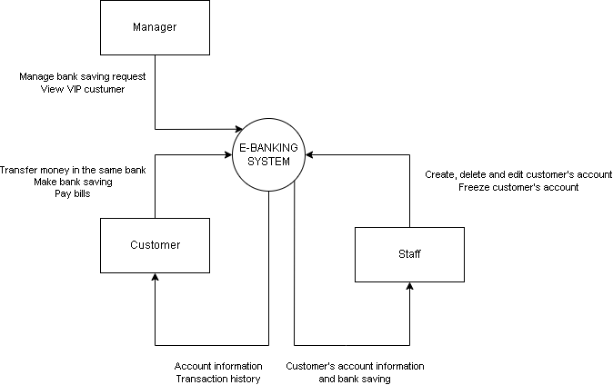

## 1. User Requirements

### 1.1. Actors

|  |  |  |
| --- | --- | --- |
| **#** | **Actor** | **Description** |
| 1 | Guest | Who use the web without signing in |
| 2 | Customer | Who use the web after signing in |
| 3 | Staff | Who use the web to monitor and help customer do their tasks |
| 4 | Manager | Who monitor the customer’s more delicate information |

### 1.2. Use cases

#### 1.2.1. Diagram(s)

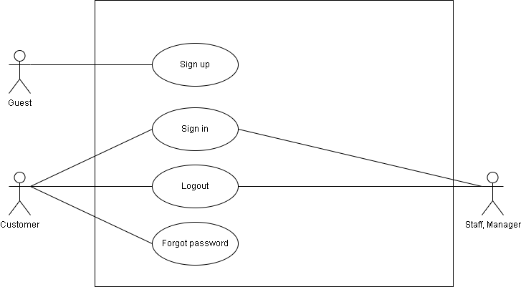

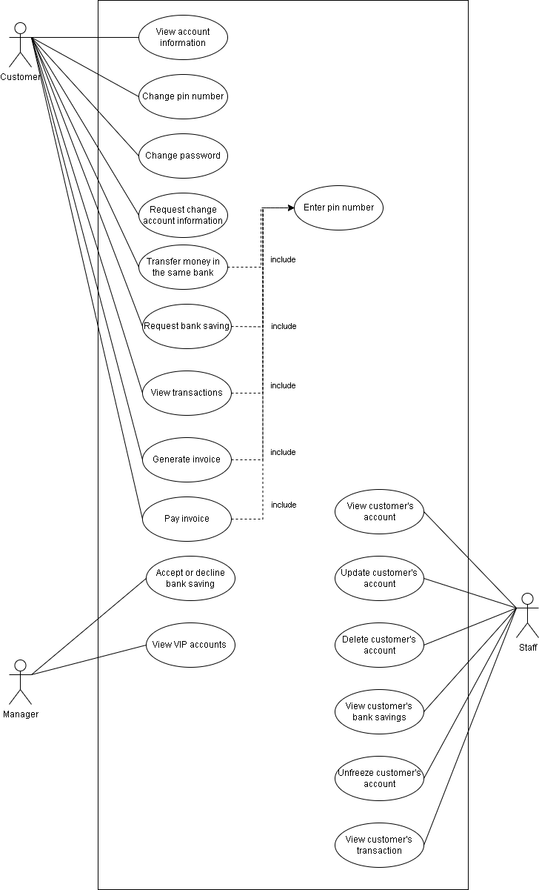

#### 1.2.2. Descriptions

|  |  |  |  |
| --- | --- | --- | --- |
| **ID** | **Use Case** | **Actors** | **Use Case Description** |
| UC-01 | Sign up | Guest | Sign up an account to access the system |
| UC-02 | Sign in | Customer | Sign-in an account to access the system |
| UC-03 | Logout | Customer | Customer log out from the website |
| UC-04 | Change password | Customer | Let customer change password |
| UC-05 | Forgot password | Customer | Let customer reset their password |
| UC-06 | Transfer money | Customer | Let customer transfer money from their account to another account in the same bank |
| UC-07 | Generate invoice | Customer | Let customer create an invoice |
| UC-08 | Pay invoice | Customer | Let customer pay an invoice |

## 2. Functional Requirements

### 2.1. System Functional Overview

#### 2.1.1. Screens Flow

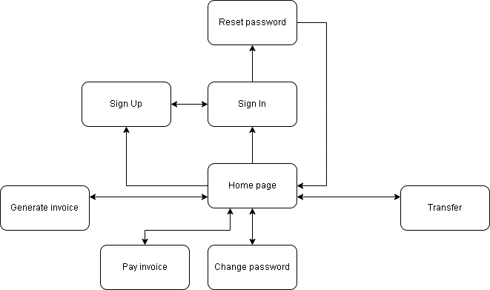

#### 2.1.2. Screen Descriptions

|  |  |  |  |
| --- | --- | --- | --- |
| **#** | **Feature** | **Screen** | **Description** |
| 1 | View services | Home page | An overview page for guests and customers. |
| 2 | Sign In | Sign In | Allow customers to login into the system. |
| 3 | Sign Up | Sign Up | Allow guests to create an account. |
| 4 | Forgot password | Forgot password | Helps customers to send a request to reset their password. |
| 5 | Change password | Change password | Helps customers to create a new password. |
| 6 | Transfer money | Transfer money | Allow customers to transfer money from their account to another account on the same bank |
| 7 | Generate invoice | Generate invoice | Allow customers to create an invoice |
| 8 | Pay invoice | Pay invoice | Allow customers to pay an invoice |

#### 2.1.3. Screen Authorization

| **Screen** | **User** | | | **Guest** |
| --- | --- | --- | --- | --- |
| **Customer** | **Staff** | **Manager** |
| Home page | X |  |  | X |
| Sign In |  |  |  |  |
| Sign Up |  |  |  | X |
| Forgot password | X |  |  |  |
| Change password | X |  |  |  |
| Transfer money | X |  |  |  |
| Generate invoice | X |  |  |  |
| Pay invoice | X |  |  |  |

#### 2.1.4. Non Screen Function

|  |  |  |  |
| --- | --- | --- | --- |
| **ID** | **Feature** | ***System function*** | **Description** |
| 1 | Lock account | Auto lock account | Auto lock when input the wrong password 4 times |

#### 2.1.5. Entity Relationship Diagram

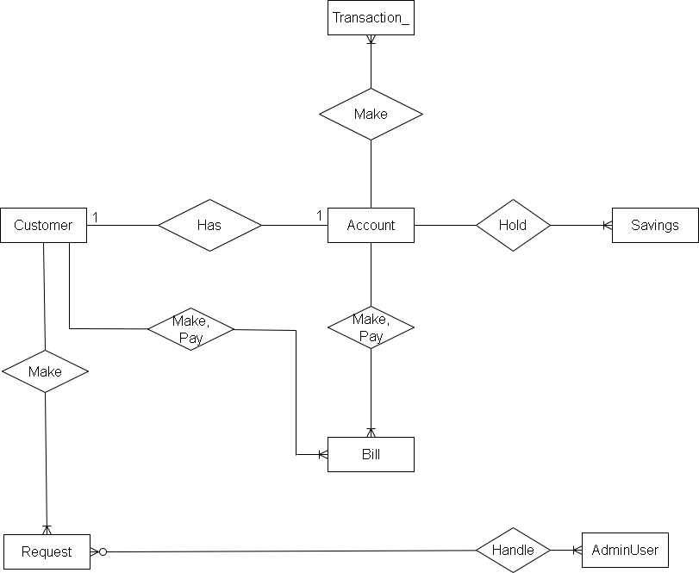

**Entities Description**

|  |  |  |
| --- | --- | --- |
| **#** | **Entity** | **Description** |
| 1 | Customer | Store customer’s information  Include attributes:  - PK: customer_id  - FK: customer_bankAccount  - customer_name  - customer_dob  - customer_address  - customer_phoneNumber  - customer_email  - customer_username  - customer_password  - customer_loginAttempts |
| 2 | Transaction_ | Store transactions’ information  Include attributes:  - PK: transaction_id  - FK: transaction_fromAccount,transaction_toAccount  - transaction_amount  - transaction_date  - transaction_status  - transaction_content |
| 3 | Bill | Store bills’ information  Include attributes:  - PK: bill_id  - FK: bill_createdBy, bill_accountReceive  - bill_accountPaid  - bill_amount  - bill_isPaid  - bill_paidDate |
| 4 | Account | Store customer’s account’s information  Include attributes:  - PK: account_number  - FK: account_savingsId  - account_otp  - account_balance  - account_vipStatus  - account_totalSavings  - account_isLocked |
| 5 | Request | Store requests information  Include attributes:  - PK: request_id  - FK: request_by, request_resolvedBy  - request_type  - request_date  - request_content  - request_status |
| 6 | Savings | Store customer’s bank saving information  Include attributes:  - PK: savings_id  - savings_interest  - savings_maturityDay |
| 7 | AdminUser | Store staff’s information  Include attributes:  - PK: adminUser_id  - adminUser_username  - adminUser_password  - adminUser_userRole |

### 2.2. Use case specification

|  |  |  |  |
| --- | --- | --- | --- |
| Use Case ID: | **UC-01** | Use Case Name: | **Sign Up** |
| Created By: | TuHA | Date Created: | 2023/05/22 |
| Primary Actor: | Guest | Secondary Actor: |  |
| Description: | Guest want to sign up account on the system | | |
| Priority: | Must have | | |
| Trigger: | Guest click sign up button to create a new account on the system | | |
| Preconditions: | PRE-1.1 Guest has a valid email PRE-1.2 Guest has a valid password PRE-1.3 Guest has a valid name  PRE-1.4 Guest must be more than 18 years old | | |
| Post - Conditions: | When normal flow is completed, a new account is created on the system with given information, new customer should be redirect to home page | | |
| Basic Flow: | 1. Guest visit home page website from browser 2. Waiting for the home page to be loaded 3. Guest click on the Sign Up button to register new account 4. Waiting for the register page to be loaded   5. Guest fill in email, password, confirm password,and name on the displayed register form   1. Guests click on the Signup button 2. New customer is redirected to the home page | | |
| Exception Flow: | **Guests enter invalid value in register form**   * System shows error messages on each invalid field and prevents guests from submitting the register form | | |
| Business rules: | None | | |
| Mockup | Không có mô tả.Không có mô tả. | | |

|  |  |  |  |
| --- | --- | --- | --- |
| Use Case ID: | **UC-02** | Use Case Name: | **Sign In** |
| Created By: | NhatTQ | Date Created: | 2022/05/22 |
| Primary Actor: | Guest | Secondary Actor: |  |
| Description: | Customer want to sign in account on the system | | |
| Priority: | Must have | | |
| Trigger: | A customer clicks on the sign in button | | |
| Preconditions: | PRE-1. The guest has not logged in the system | | |
| Post - Conditions: | POST-1 The customer sign in the system  POST-2. The customer is provided access to his allowed systems. POST-3 The customer accesses the system, makes a login request and is directed to the login page. | | |
| Basic Flow: | 1. Access the home page 2. Click on the sign in link to sign in to website 3. Fill in form with username and password 4. Enter or click on the sign in button to sign in website | | |
| Exception Flow: | **Account does not exist or the password is incorrect**   * System shows error messages | | |
| Business rules: | None | | |
| Mockup | Không có mô tả. | | |

|  |  |  |  |
| --- | --- | --- | --- |
| Use Case ID: | **UC-03** | Use Case Name: | **Logout** |
| Created By: | DungTA | Date Created: | 2023/05/22 |
| Primary Actor: | Customer | Secondary Actor: |  |
| Description: | The customer logs out and is now determined as Guest. The guest is provided access to only see the homepage | | |
| Priority: | Must have | | |
| Trigger: | Customer click the button logout to logout account out of the system | | |
| Preconditions: | PRE-1. The customer has signed in the system | | |
| Post - Conditions: | POST-1. The customer logged out the system | | |
| Basic Flow: | 1. Go to the homepage 2. Click logout 3. System redirect the customer to the home page | | |
| Alternative Flow: | N/A | | |
| Exception Flow: | N/A | | |
| Business rules: | None | | |
| Mockup | Không có mô tả. | | |

|  |  |  |  |
| --- | --- | --- | --- |
| Use Case ID: | **UC-04** | Use Case Name: | **Change password** |
| Created By: | DungTA | Date Created: | 2023/05/23 |
| Primary Actor: | Customer | Secondary  Actor: |  |
| Description: | Customer want to change password for their account | | |
| Priority: | Must have | | |
| Trigger: | A customer clicks the Change password button | | |
| Preconditions: | PRE-1. Customer is signed into system | | |
| Post - Conditions: | POST-1. The customer’s password is changed. | | |
| Basic Flow: | 1. Customer go to the homepage 2. Customer clicks the Change password button in Settings and Privacy. 3. Customer fills all the required fields. 4. Customer clicks Confirm button. | | |
| Alternative Flow: | N/A | | |
| Exception Flow: | **Invalid input form**  - The customer does not provide all required fields.  **New password and confirm password do not match**  - System shows an error message | | |
| Business rules: | None | | |
| Mockup | Không có mô tả. | | |

|  |  |  |  |
| --- | --- | --- | --- |
| Use Case ID: | **UC-05** | Use Case Name: | **Forgot password** |
| Created By: | CuongTNQ | Date Created: | 2023/05/24 |
| Primary Actor: | Customer | Secondary Actor: |  |
| Description: | Customer can reset their account password | | |
| Priority: | Must have | | |
| Trigger: | Customer click the Forgot password button in sign in page | | |
| Preconditions: | PRE-1 Customer has a valid email account which has been registered to the website | | |
| Post - Conditions: | POST-1. System sends an email which contains the randomly generated password to the provided email. | | |
| Basic Flow: | 1. Fill in the required email field. 2. Focus on the email field and press enter or click on the “Send me new password” button below the field. 3. System should show a notification to inform customers to check their email. 4. System randomly generate and set a password for customer’s account 5. System sends an email containing the password and advises the customer to change their password. | | |
| Alternative Flow: | N/A | | |
| Exception Flow: | N/A | | |
| Business rules: | None | | |
| Mockup | Không có mô tả. | | |

|  |  |  |  |
| --- | --- | --- | --- |
| Use Case ID: | **UC-06** | Use Case Name: | **Transfer money** |
| Created By: | TuHA | Date Created: | 2023/06/06 |
| Primary Actor: | Customer | Secondary Actor: |  |
| Description: | Let customer transfer money from their account to another account in the same bank | | |
| Priority: | Must have | | |
| Trigger: | Customer click the transfer | | |
| Preconditions: | PRE-1 Customer is signed into system | | |
| Post - Conditions: | POST-1. System sends an email which contains the randomly generated password to the provided email. | | |
| Basic Flow: | 1. Click Generate transfer button in New transaction in homepage 2. Fill in all the required fields 3. Click transfer 4. System update sender and receiver’s account accordingly 5. Log transaction | | |
| Alternative Flow: | N/A | | |
| Exception Flow: | **Invalid input form**  - The customer does not provide all required fields  **Invalid account number**  - The customer does not provide correct account number  **Invalid receiver’s account number**  - The customer does not provide correct receiver’s account number  **Invalid transfer amount**  - The customer does not have enough money or input negative money  **Cannot transfer to self**  - The customer input their own account number in receiver’s account number field | | |
| Business rules: | None | | |
| Mockup | Không có mô tả. | | |

|  |  |  |  |
| --- | --- | --- | --- |
| Use Case ID: | **UC-07** | Use Case Name: | **Generate invoice** |
| Created By: | NhatTQ | Date Created: | 2023/06/06 |
| Primary Actor: | Customer | Secondary Actor: |  |
| Description: | Let customer create an invoice | | |
| Priority: | Must have | | |
| Trigger: | Customer click the Generate invoice button | | |
| Preconditions: | PRE-1 Customer is signed into system | | |
| Post - Conditions: | POST-1. Invoice is created and delivered to the invoice receiver’s account. | | |
| Basic Flow: | 1. Click Generate invoice button in New transaction in homepage 2. Fill in all the required fields 3. Click generate invoice 4. System send invoice to invoice receiver | | |
| Alternative Flow: | N/A | | |
| Exception Flow: | **Invalid input form**  - The customer does not provide all required fields  **Invalid receiver’s account number**  - The customer does not provide correct receiver’s account number  **Invalid transfer amount**  - Input negative money or not a number | | |
| Business rules: | None | | |
| Mockup |  | | |

|  |  |  |  |
| --- | --- | --- | --- |
| Use Case ID: | **UC-08** | Use Case Name: | **Pay invoice** |
| Created By: | CuongTNQ | Date Created: | 2023/06/06 |
| Primary Actor: | Customer | Secondary Actor: |  |
| Description: | Let customer pay an invoice | | |
| Priority: | Must have | | |
| Trigger: | Customer click the send button | | |
| Preconditions: | PRE-1 Customer is signed into system | | |
| Post - Conditions: | POST-1. Invoice is paid and money is delivered from invoice receiver to the invoice sender’s account.  POST-2. Customer is redirected to home page | | |
| Basic Flow: | 1. Click Pay invoice button in New transaction 2. Choose invoice id want to pay or input friend’s invoice id in required field 3. Click Pay invoice 4. System update invoice sender and receiver accordingly 5. System redirect the customer to the home page | | |
| Alternative Flow: | N/A | | |
| Exception Flow: | **Invalid transfer amount**   * The customer does not have enough money | | |
| Business rules: | None | | |
| Mockup |  | | |