Assignment 3 Part 1 of MAE101 Chapter 4 LA
Name of student:
ID:
 | Content | Answers by student |  | Score
 | Chapter 4
1 | What is the dot product of 2 vectors in R^3? Give an example | See Def. 4 in page 198
2 | What is the angle of 2 vectors in R^3?  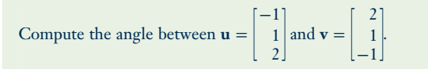 | See Th. 2 page 200
3 | a) What is the projection of a vector u on another vector d? Draw a picture.  b) How to compute the projection? Give an example | See Def. 4.6 page 202  You may use:  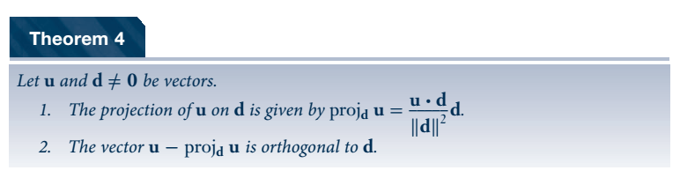
4 | 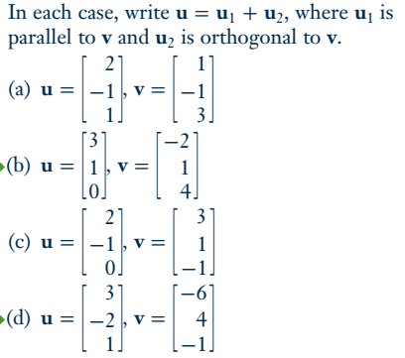 | Solve a t least 2
5 | What is the cross product of 2 vectors in R^3? How to compute the cross product ? Give one example yourself. | See Def 4.8 in page 207
6 | 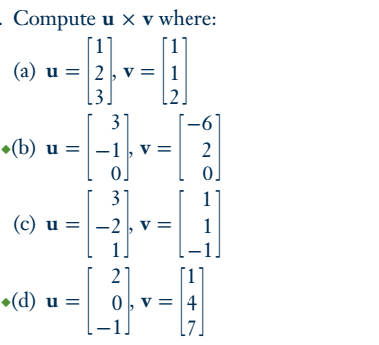 | 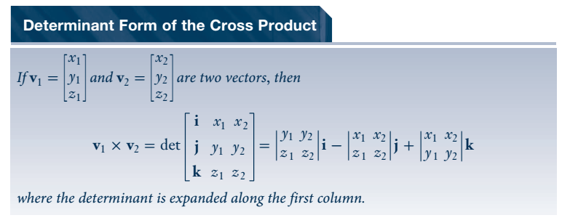  Solve at least 2

