Assignment 3 Part 2 of MAE101 SE 1505
Name of student:
ID:
 | Content | Answers by student | Score
 | Chapter 5
1 | What is a subspace of R^n. Give an example in R^2 of subspace and one example of a subset but not subspace.
2 | What is the spane of vectors and what is a spanning set? Give an example.
3 | 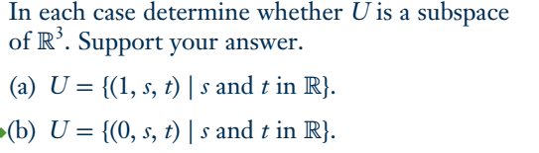  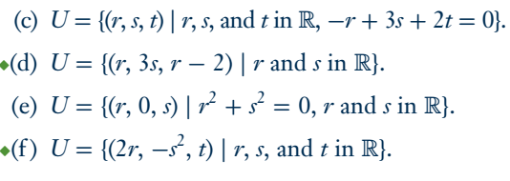 | Note that a vector in R^n can be written as a column or a row.  Solve at least 3
4 | 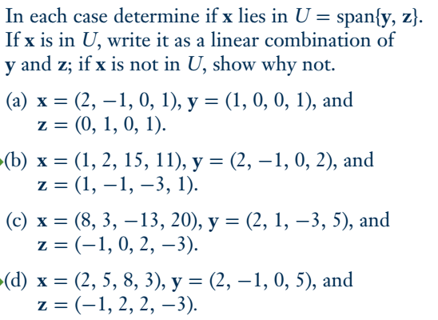
5 | 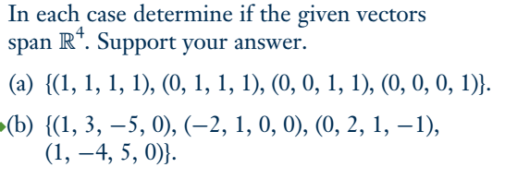
6 | What is linear independent and dependent. Give an example | See Def. 5.3 in page 236.
7 | How to test vectors being independent? Give an example. | 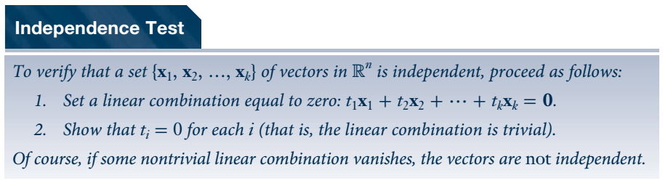
8 | What is a basis of a subspace. Give an exampele | Use Def. 4 in p.241
9 | 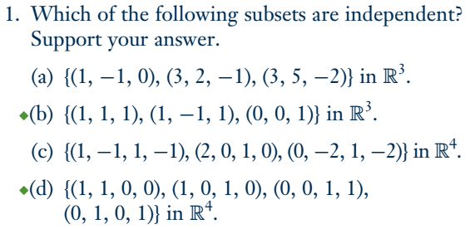 | Solve at least 2
10 | 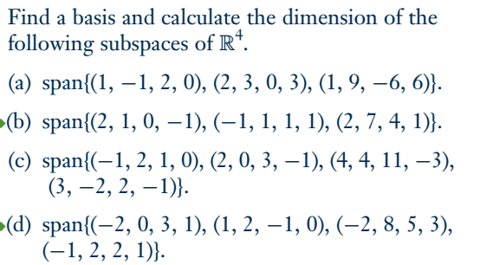
11 | 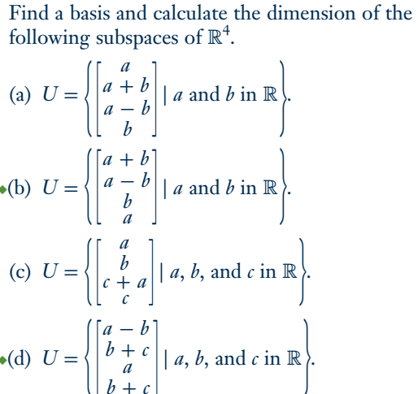  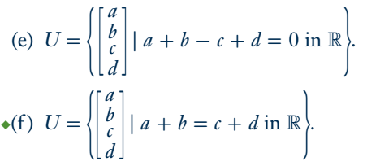
12 | 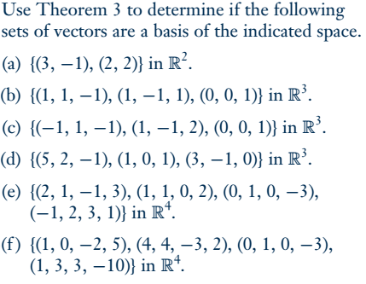 | Solve at least 3

