
HAPPY PROGRAMMING Project Assignment Requirement
– Hanoi, May 2021 –
1 | Page
Table of Contents
1. Introduction........................................................................................................................................3 2. Functional Requirements....................................................................................................................3 a. Overall Description .........................................................................................................................3 b. Public Feature.................................................................................................................................4 c. Common Feature ............................................................................................................................4 d. Mentee Feature..............................................................................................................................4 e. Mentor Feature ..............................................................................................................................4 f. Admin Feature.................................................................................................................................4 3. Other requirements............................................................................................................................4 a. Functional detail .............................................................................................................................4 b. User Input data formats .................................................................................................................5

2 | Page
1. Introduction
This project is aimed at developing an online Happy Programming system which mainly to allow mentors, mentees and other actorsto connect online and support mentee to learn programming. This system support for the below types of user
• Guest: unregistered users
• Registered User: The user that has registered an account
• Mentee: The registered user wishes to hire mentors
• Registered Mentor: The registered user that has registered to be a mentor • Admin: the organization leader/manager, acts as the system administrator
2. Functional Requirements
a. Overall Description
The to-be-developed system includes the 5 features with the functions for each feature are listed in the beneath sections. It needs to provide XXX user screens with the flow as the following diagram. The details for each screen/function are provided in the attached Excel file
(HappyProgramming_Functions.xlsx)
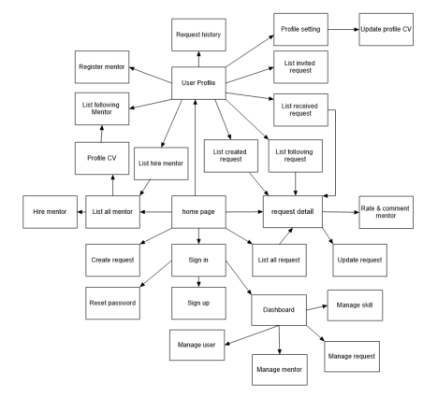3 | Page
b. Public Feature
This feature includes the screens used for the Guests, as listed below
- Home Page: the starting page of the system
- Sign up: allow Guest to register new user into the system, verified by the registered email - View all mentors: list of mentors
- View CV of mentor: show the CV of the mentor
- View rating and comment about a mentor: show rating and comment about a mentor - Search mentor: Allow Guest user to search mentor
- View all skills: Allow Guest user to view all skills of a mentor
c. Common Feature
The common functions/screens used for all types of users, as listed below - Sign in: authenticate the user to give him/her to access authorized features later on - Reset Password: use in case the user forgot his/her password
- Change Password: change user’s login password
- User Profile: view & edit/update user profile
- User Authorization: authorize user into the system functions based on his/her role
d. Mentee Feature
This includes the screens used for system customers, as listed below
- Create request: for Mentee to create his/her request
- Update request: for Mentee to update his/her request
- List all request: for Mentee to view all his/her requests
- Statistic request: for Mentee to view statistic of all his/her requests
e. Mentor Feature
This includes the screens used for marketing members, as listed below
- View list all invited requests belong to the Mentor.
- Create CV of Mentor
- Update CV of Mentor
- Statistic of all request belong to the Mentor.
f. Admin Feature
The Admin feature includes the screens used for the organization manager and system administrator, as listed below
- Statistic all request: view general statistics & trends about the request-related data. - List all request of all Mentee.
- Statistic of all Mentee.
- List all Mentee
- Mentee Detail view the details of a specific Mentee
- Mentor List: list, filter, search, show, hide, view, add new or edit existing Mentor(s) - Mentor Details: view the details of a specific Mentor
3. Other requirements
a. Functional detail
- functional details in the attached Excel file HappyProgramming_Functions.xlsx
4 | Page
b. User Input data formats
The types & format (length, validation, etc) of the input data are suggested by the project team and need to mentioned clearly in the analysing & designing documents.
- Those must be agreed by the supervisor (teacher) before implementing.
- Once agreed, those must be implemented accordingly in the software input validating, data showing and in the system database.
5 | Page

