I. SET UP SERVER
- Install vim. Type following command.
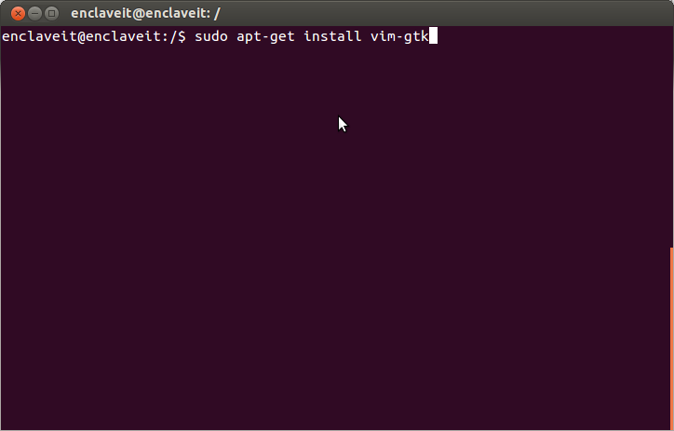
- Install apache. Type following command.
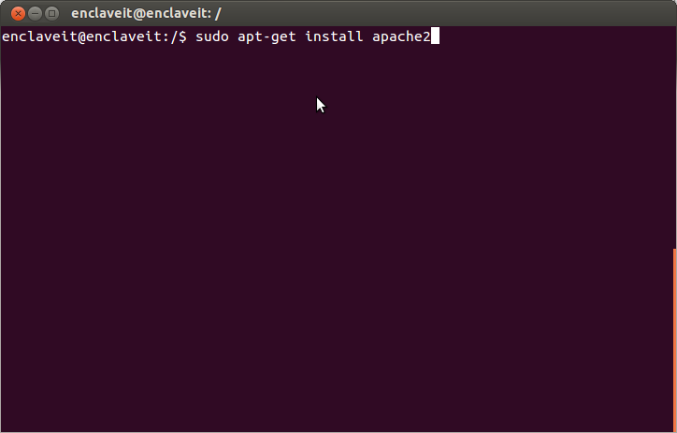
- Install mysql server. Type following command.
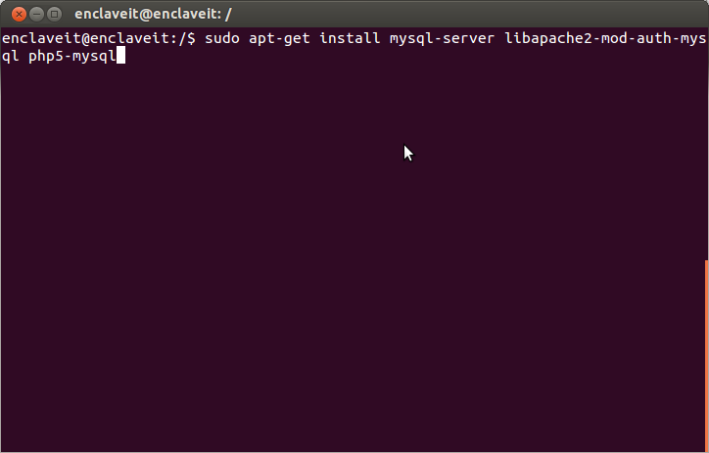
- Install php5. Type following command.
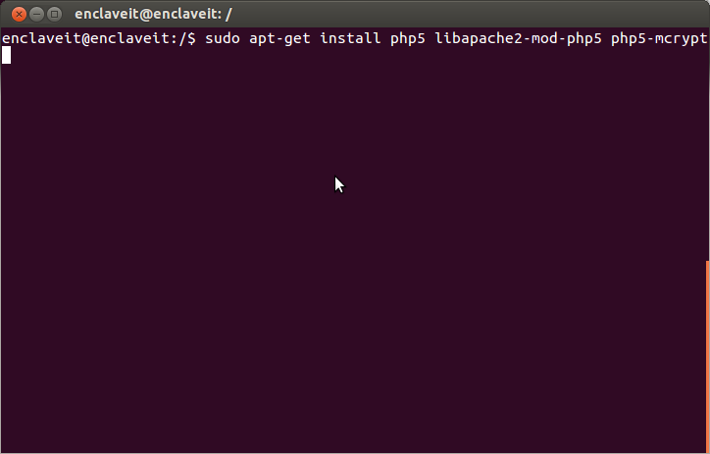
- Install phpmyadmin.
- Type following command.
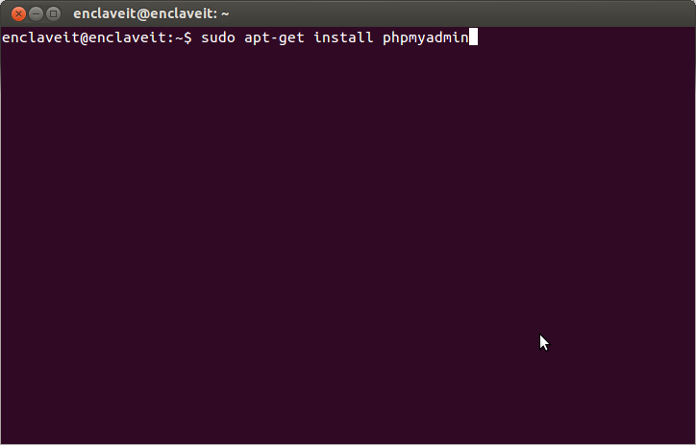
- Basic Configuration.
At the first screen, select by using the space bar, then hit to continue.
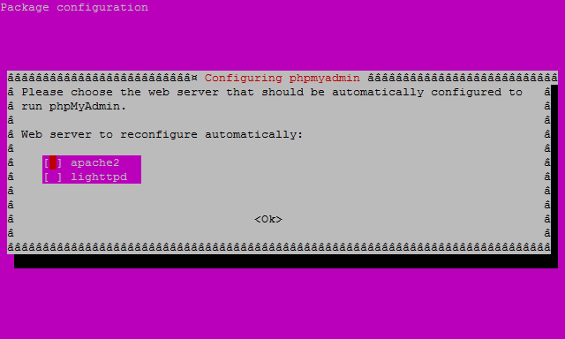
At the second screen, which asks “configure the database for phpmyadmin with dbconfig- common?”, select , then hit to continue.
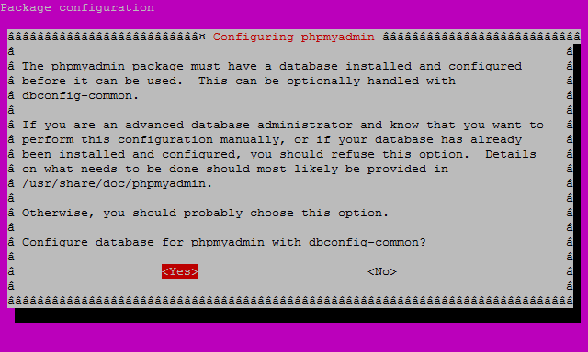
At the third screen enter your MySQL password, then hit to continue.
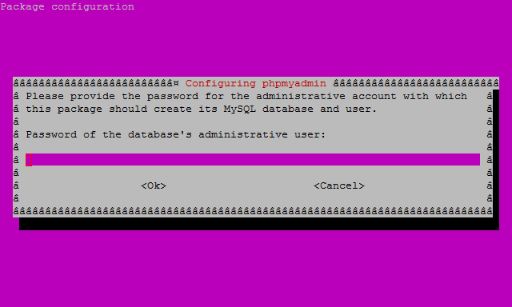
And finally at the fourth screen set the password you’ll use to log into phpmyadmin, hit to continue, and confirm your password.
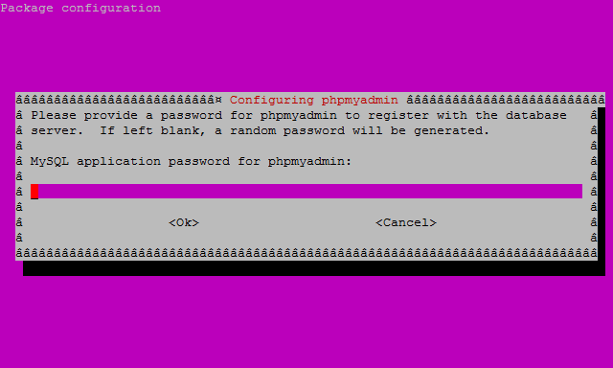
- Finish the Configuration of Apache.
Type following command.
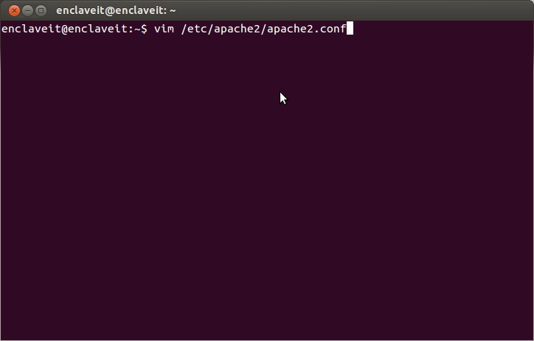
Add the following to the bottom of the file:
“phpmyadmin Configuration
Include /etc/phpmyadmin/apache.conf”
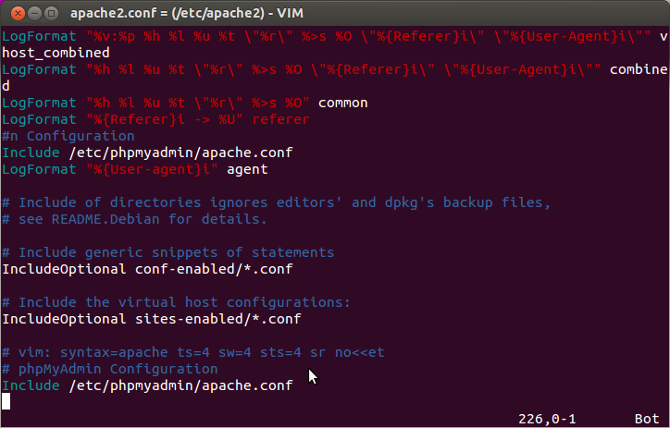
- Restart apache. Type following command.
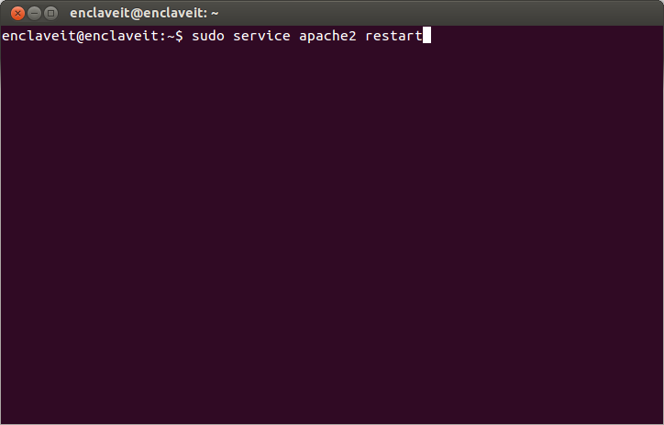
- Change the root directory of an apache server.
- Type following command.
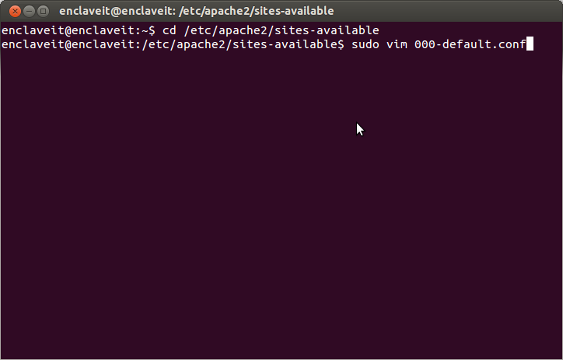
- Change directory in line “DocumentRoot <your directory>” .
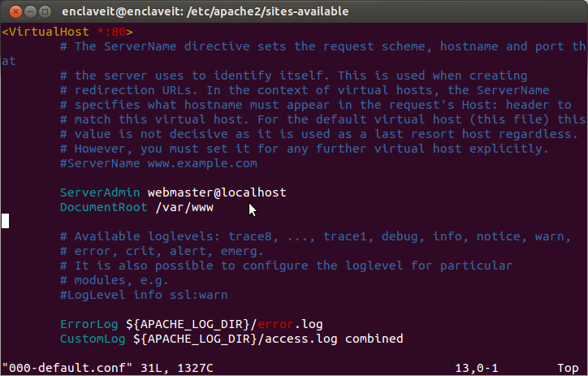
- Type following command.
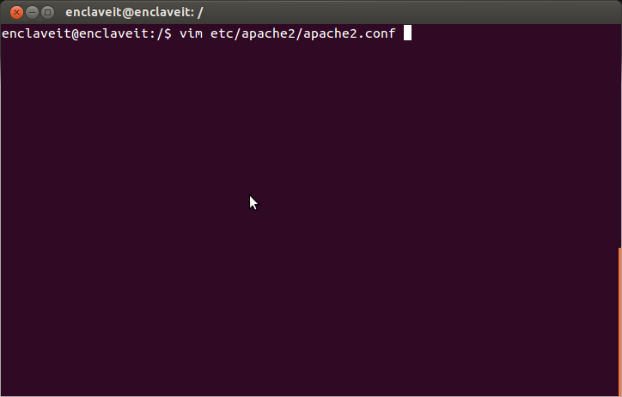
- Change directory in line <Directory your_dir>.
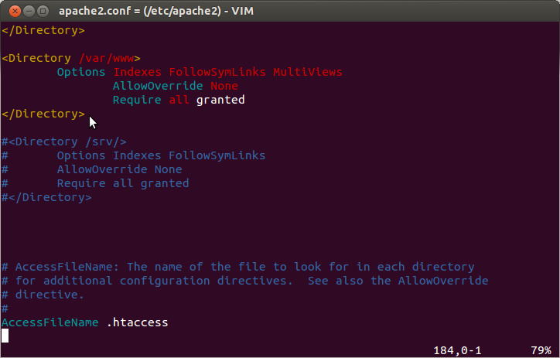
- Restart Apache 2 with the following command.
II. INSTALL CODEIGNITER
- Go to http://www.codeigniter.com/ click the download button.
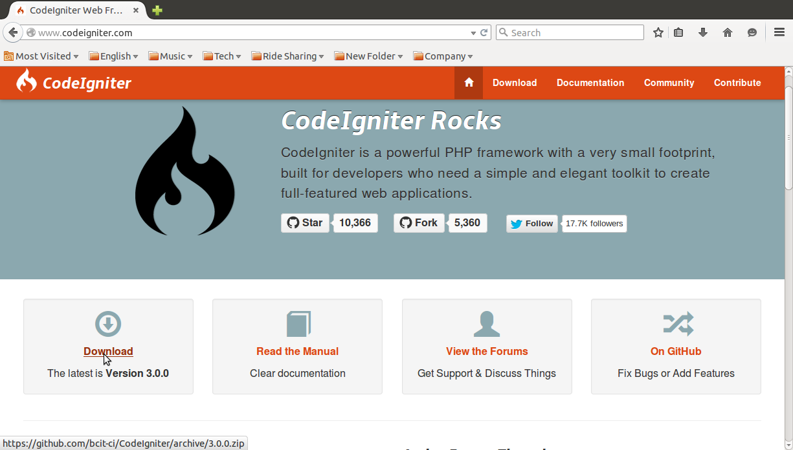
- You need to do is unzip file you just dowloaded.
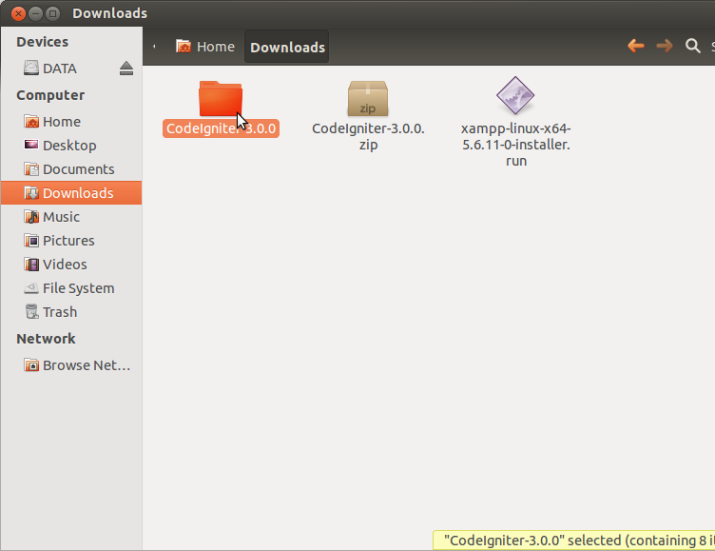
- Rename the "CodeIgniter3.0.0" folder to either the application name or (Example: I did rename it is “eLunch” folder) and upload it to your PHP .
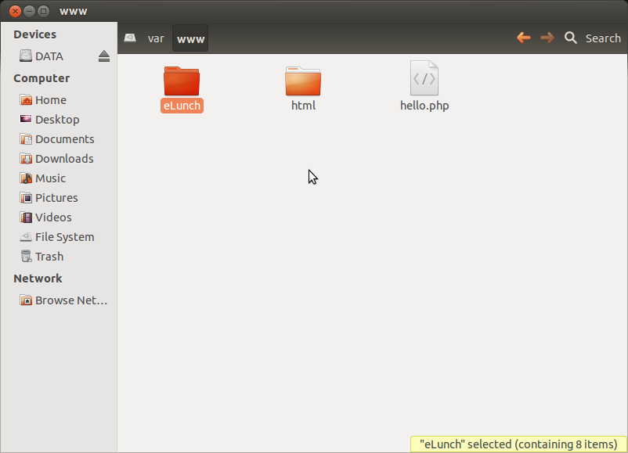
- Go to http://localhost/eLunch/ and should see the following.
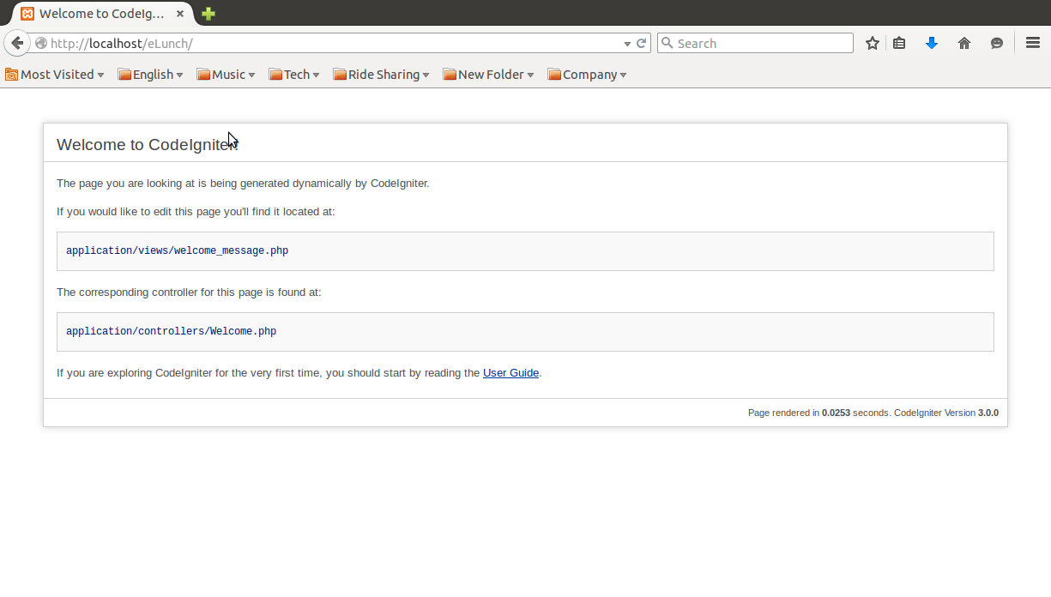
- Configuring Codeigniter. Open up application/config/database.php and set the following array items to there corresponding values.
