Tubelist Software Requirement Specification

Author: dacov team
Email: cuongcua90@gmail.com &
phiencoltech@gmail.com

- Revision History

Date | Version | Description | Author
2013/12/09 | 1.0 | Create | phienkv

- Introduction
  - Purpose
- Tubelist is web application which provides online video service to everyone for creating, sharing video list.
- The users access the website and easily create video list from popular site (youtube, lastfm, etc) and share their video lists.

  - Scope
- User can create video audio list from youtube and other popular websites
- User can listen video audio list of other users
- There are two main page for users :
  - My tubelist: Users can listen their tubelist which created before. They also can create and share new tubelist.
  - Home tubelist: Users can listen tubelist which created by other users. They also can share, comment on this tubelist.

  - Definitions, Acronyms and Abbreviations
- Tubelist: A list of videos form youtube or popular websites.
- SRS: Software Requirements Specification

  - References
- IBM SRS Template

- Overall Description
  - Product Perspective
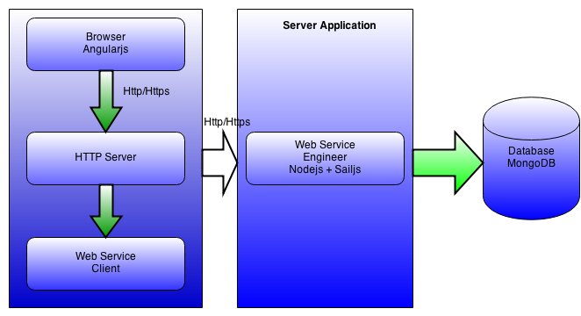

  - Constrains
- In first version just using Youtube for creating tubelists.

  - ER Diagrams
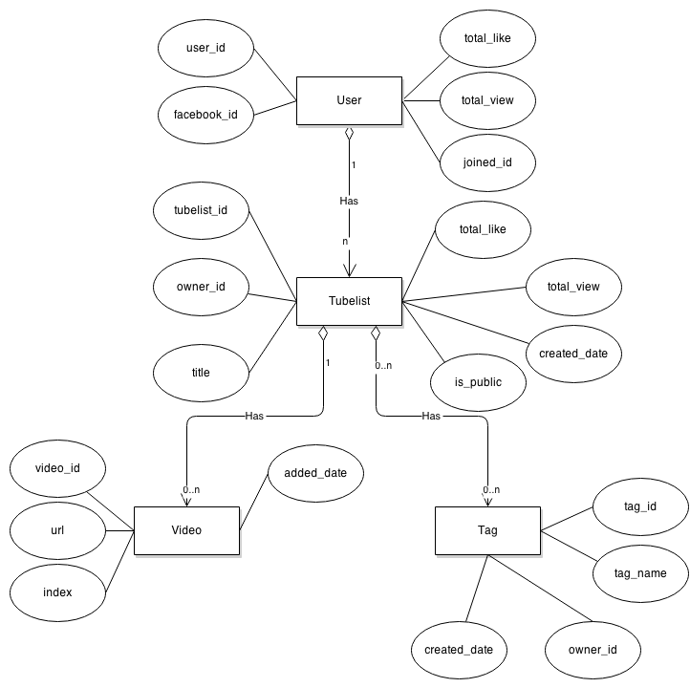

  - Use-Case Model Survey

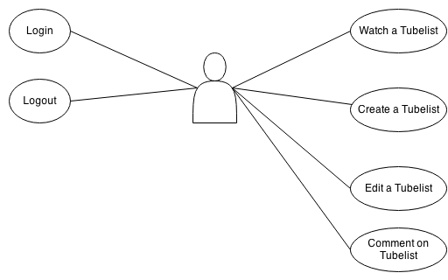

  - Database Design

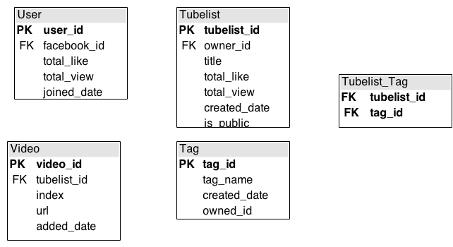
- Specific Requirements
  - R1 – Login
    - Login activity
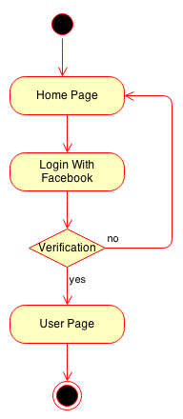

    - Descriptions
- User can login by facebook

    - User Interface

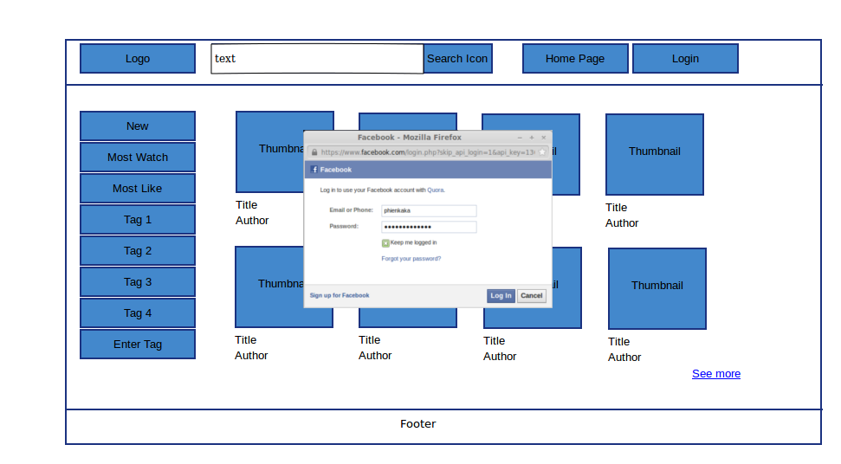
1

    - Data Field
No. | Item | Type | Description
1 | btnLogin | Button | Click to show login facebook dialog

    - User Interaction
- User can click btnLogin (1) to display login facebook dialog and then login with facebook

  - R2 – Logout
    - Logout Activity
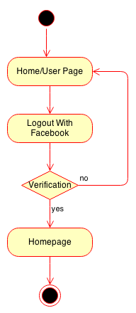
    - Descriptions
- User can logout and back to home page

    - User Interface
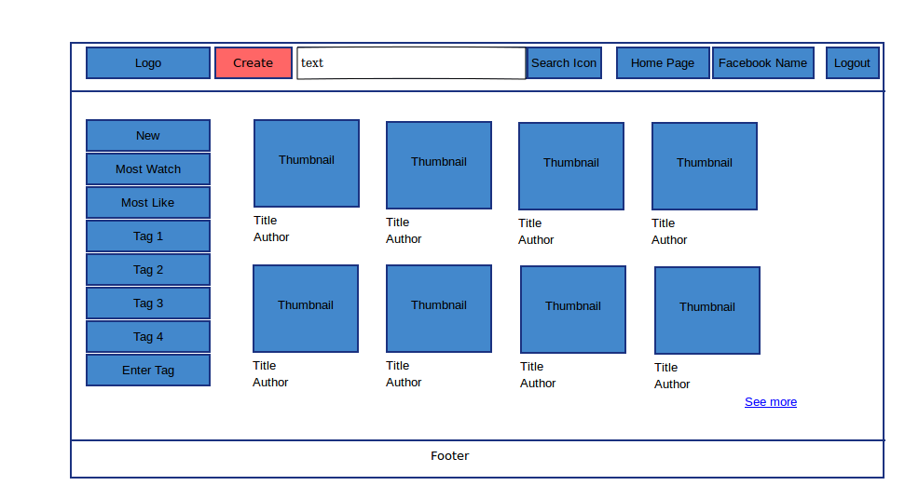
1

    - Data field

No. | Item | Type | Description
1 | btnLogout | Button | Click to logout

    - User Interaction
- User can click on btnLogout (1) to logout and go to Home Page

  - R3 – Create a Tubelist
    - Actitity
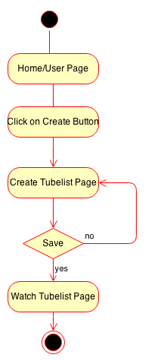

    - Descriptions
- User can create a new Tubelist
- Pre-Condition
  - User must login
- Post-Condition
  - N/G

    - User Interface
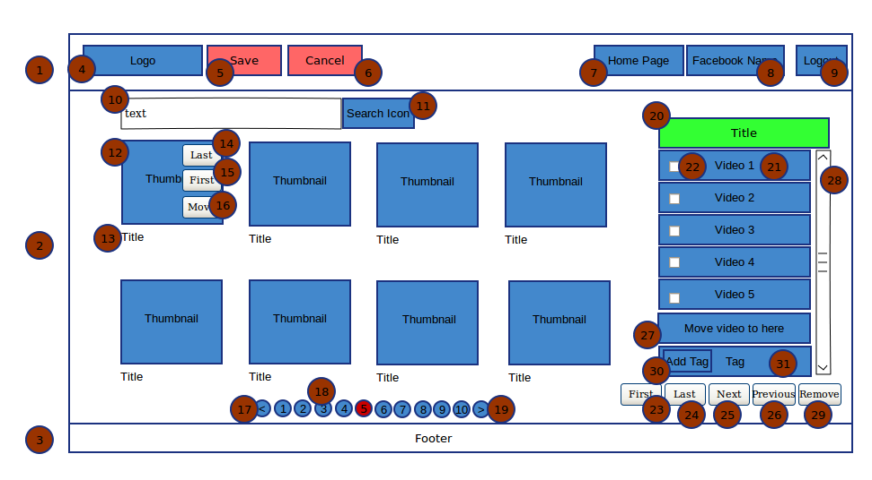

    - Data Field

No. | Item | Type | Description
1 | layoutHeader | Layout | Header Field
2 | layoutBody | Layout | Body Field
3 | layoutFooter | Layout | Footer Layout
4 | ImgLogo | Image | Logo Image
5 | BtnSave | Button | Save Button
6 | BtnCancel | Button | Cancel Button
7 | TabHomepage | Tab | Home Page Tab
8 | TabMyPage | Tab | Show Facebook Name
9 | BtnLogout | Button | Logout Button
10 | TxtboxSearch | Text | Text Box
11 | BtnSearch | Button | Search Button
12 | imgThumbnail | Image | Thumbnail of Video
13 | TxtTitle | Text Field | Title of Video
14 | BntLast | Button | Click to move video to last of list
15 | BtnFirst | Button | Click to move video to first of list
16 | BtnMove | Button | Hold and move to every where in list
17 | BtnPrevious | Button | Click to move previous list video
18 | BtnPage | Button | Click to move choices list video
19 | BtnNext | Button | Click to move next list video
20 | TxtTitleList | Text Field | Title of tubelist
21 | TxtTitleVideo | Text Field | Title of Video
22 | CheckVideo | Check Box | Click to choise a video for specific function
23 | BtnMoveToFirst | Button | Specific function for checked Video/Videos
24 | BtnMoveToLast | Button | Specific function for checked Video/Videos
25 | BtnMoveToNext | Button | Specific function for checked Video/Videos
26 | BtnMoveToPrevious | Button | Specific function for checked Video/Videos
27 | TextMoveDescription | Text Field | Text Description for users
28 | SeekbarTubelist | Seek Bar | Seek Bar of tubelist
29 | BtnRemove | Button | Specific function for checked Video/Videoss
30 | BtnAddTag | Button | Add Tag Button
31 | TxtListTag | Text Field | Text Field of All Tag belong with Tubelist

    - User Interaction
- User can click on imgLogo (4) to go to “Home Page”
- User click on btnSave (5) to save tubelist and go to “My Page”
- User click can click on btnCancel (5) to cancel edit on Tubelist
  - A message box will be showed to confirm user cancel
  - If user agrees to cancel, redirect to “My Page”
  - If user does not agree to cancel, stay on this page
- User click on btnHomePage (7) to redirect to “Home Page”
  - A message box will be showed to confirm user.
  - If user agrees, redirect to “Home Page”
  - If user does not agree, stay on this page
- User click on btnLogout (9) to logout
  - A message box will be showed to confirm logout
  - If user agrees, logout and redirect to “Home Page”
  - If user does not agree, stay on this page
- User can click on txtboxSearch (10) to type and search videos on specific page (Youtube, lastfm, etc)
- User can click on btnSearch (11) to search videos on specific page
  - User also can press “Enter” key on txtboxSearch (10) instead of click on this button
- User can click on btnLast (14) to quick move choose video to last of tubelist
- User can click on btnFirst (15) to quick move choose video to first of tubelist
- User can hold and move btnMove (15) to move choose video to every where in tubelist
  - After user hold this button, a new field will be display at pointer with format like video on tubelist (format like 21)
  - If user unhold this field will be hide
  - User move this field on specific location on tubelist
- User can hold and move txtTitleVideo (21) to specific position or move out of list to remove it.
- User can click on checkboxVideo (22) to choice any video for specific function
- User can click on btnMoveToFirst (23) to move all choose videos to first of tubelist
- User can click on btnMoveToLast (24) to move all choose videos to last of tubelist
- User can click on btnMoveToNext (25) to move all choose videos to next position of tubelist
- User can click on btnMoveToPrevious (26) to move all choose videos to previous position of tubelist
- User can hold and move seekbarTubelist (28) to see list of videos in tubelist
- User can click on btnRemove (29) to remove all choose videos
- User can click on btnAddTag (30) to display popup dialog for adding new Tag

  - R4 – Edit a Tubelist
    - Activity
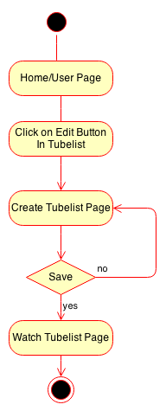

    - Descriptions
- User can edit his/her tubelist
- When user click on edit tubelist, page will be redirect to create tubelist page

    - User Interface
- Like create tubelist

    - Data Field
- Like create tubelist

    - User Interaction
- Like create tubelist

  - R5 – Search a Tubelist
    - Activity
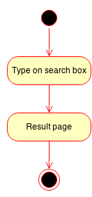
    - Descriptions
- User can search to watch a tubelist

    - User Interface
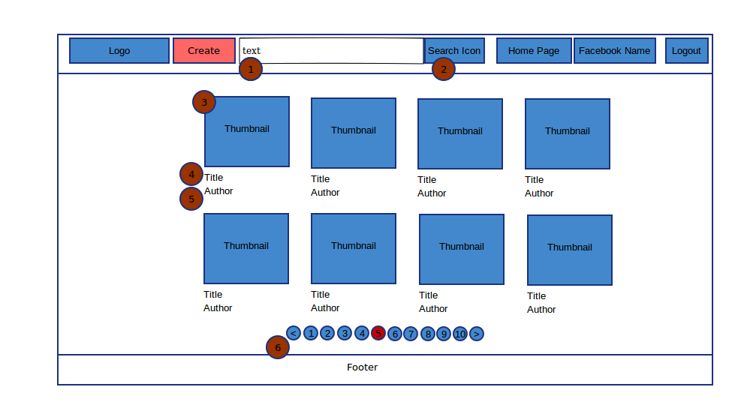

    - Data Field

No. | Item | Type | Description
1 | TxtSearch | Text Field | Type text to search
2 | BtnSearch | Button | Click to search
3 | imgThumbnail | Image | Thumbnail of tubelist
4 | TxtTitle | Text Field | Title of tubelist
5 | TxtAuthor | Text Field | Author of tubelist
6 | Pagination | Pagination | Like Create Tubelist

    - User Interaction
- User can type on txtSearch (1) for searching tubelist. Search will be focus on
  - Title of tubelist
  - Author of tubelist
- User can click on btnSearch (2) to search tubelist.
  - User can press “Enter” key on txtSearch instead of clicking on btnSearch
- User can click on imgThumbnail (3) or txtTile (4) to watch tubelist.
- User can click on txtAuthor (4) for searching tubelist with key that is author name
- User can interact with pagination same like pagination on create tubelist page

  - R6 – Watch Tubelist
    - Activity
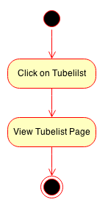

    - Descriptions
- User can view a tubelist by click on it's thumbnail

    - User Interface
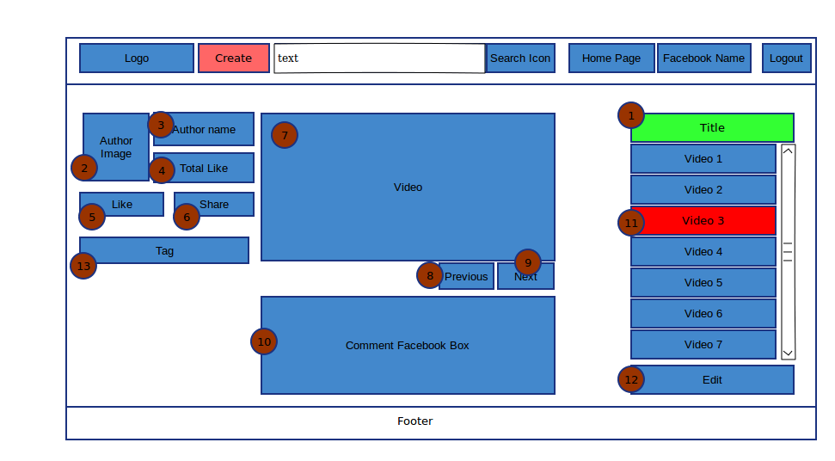

    - Data Field

No. | Item | Type | Description
1 | TxtTitleTubelist | Text Field | Title of tubelist
2 | ImgAuthor | Image | Image of Author form facebook
3 | TxtAuthor | Text Field | Author Name
4 | TxtTotalLike | Text Field | Total Like of Author
5 | BtnLike | Button | Like button from Facebook
6 | BtnShare | Button | Share button from Facebook
7 | VideoWatching | Video | Video
8 | BtnPrevious | Button | Previous Button
9 | BtnNext | Button | Next Button
10 | FieldComment | Field | Comment Facebook Field
11 | FieldCurrentVideo | Field | Current Video Playing
12 | BtnEditTubelist | Button | Edit Tubelist Button
13 | TxtTag | Text Field | List of Tag belong with Tubelist

    - User Interaction
- User can click on imgAuthor (2) to go to facebook page of author
- User can click on txtAuthor (3) to go to search video by name of author as a key
- User can click on btnLike (5) to like this tubelist
- User can click on btnShare (6) to share this tubelist
- User can watching video on videoWatching (7)
- User can click on btnPrevious (8) for watching previous video on this tubelist
- User can click on btnNext (9) for watching next video on this tubelist
- User can comment on fieldComment (10) to comment using facebook comment box
- User can click on any video on tubelist to watching. And this field (11) will be change to different color
- User can click on btnEdit (12) to edit this tubelist. It is enable if only this is his/her tubelist

  - R8 – View Home Page Tubelists
    - Activity
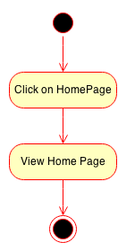

    - Descriptions
- User can click on “Home Page” button on Header to view Home Page Tubelist
- Home Page Tubelist contain every tubelist of all users by specific way

    - User Interface
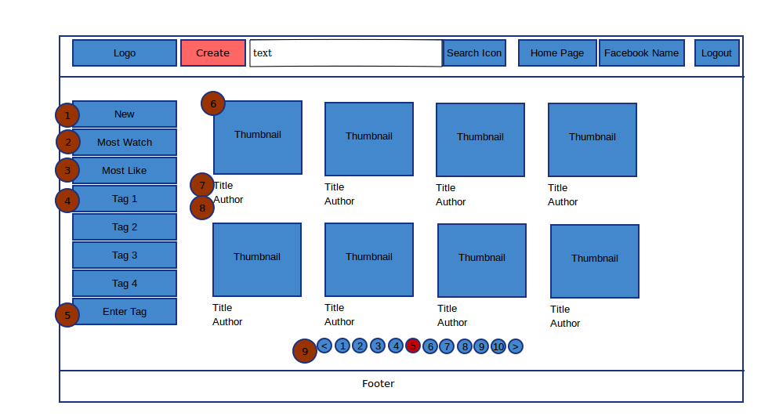

    - Data Field

No. | Item | Type | Description
1 | BtnNew | Button | New Button
2 | BtnMostWatching | Button | Most Watch Button
3 | BtnMostLike | Button | Most Like Button
4 | BtnTag | Button | Tag Button
5 | TxtTag | Text Field | Text Field for Enter Tag
6 | ImgThumbnail | Image | Thumbnail of Tubelist
7 | TxtTitle | Text Field | Title of Tubelist
8 | TxtAuthor | Text Field | Author of Tubelist
9 | Pagination | Pagination | Pagination of list Tubelist

    - User Interaction
- User can click on btnNew (1) for view list of new tubelist
- User can click on btnMostWatching (2) for view list of most watching tubelist
- User can click on btnTag (4) for view list of tubelist by this Tag
- User can type on txtTag (5) for view list of tubelist by enter Tag (this field include suggestion)
- User can click on imgThumbnail (6) and txtTitle (7) for view tubelist
- User can click on txtAuthor by searching tubelist with author name as a key
- User can control Pagination (9) for quick move to view other tubelist (like create tubelist pagination)
  - R9 – View My Page Tubelists
    - Activity
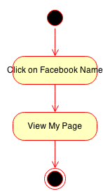

    - Descriptions
- User can view “My Page” with
  - His/Her tubelists
  - Total Like

    - User Interface
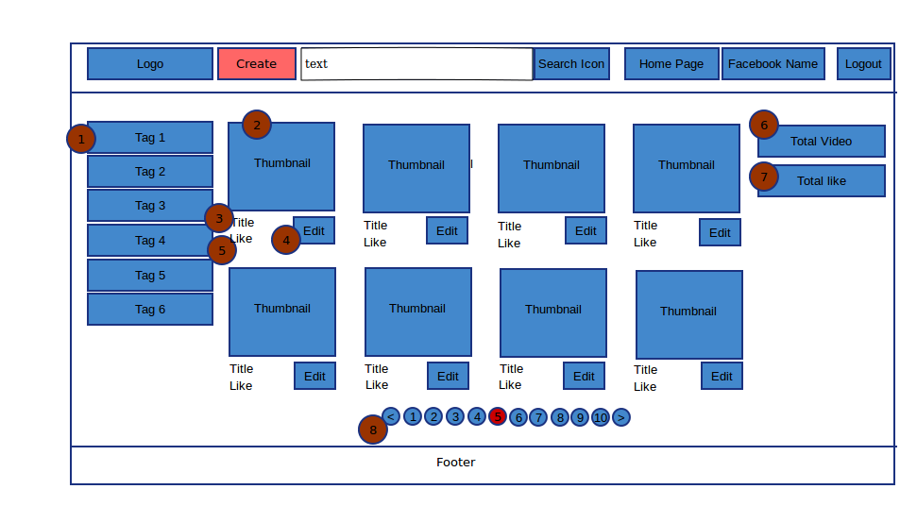

    - Data Field

No. | Item | Type | Description
1 | BtnTag | Button | Tag of Tubelist
2 | ImgThumbnail | Image | Thumbnail of Tubelist
3 | TxtTitle | Text Field | Title of Tubelist
4 | BtnEdit | Button | Quick Edit Button
5 | TxtLike | Text Field | Total Like of Tubelist
6 | TxtTotalTubelist | Text Field | Total Tubelist of User
7 | TxtTotalLike | Text Field | Total Like of User
8 | Pagination | Pagination | Like Pagination in Create Tubelist

    - User Interaction
- User can click on btnTag (1) to view tubelist contain with this Tag
- User can click on imgThumbnail (2) and txtTitle (3) to view tubelist
- User can click on btnEdit (4) to edit tubelist
- Supporting Information

