**FPT ACADEMY INTERNATIONAL**



## FPT – APTECH COMPUTER EDUCATION

TINY TOTS

|  |  |  |  |
| --- | --- | --- | --- |
| **Center Name** | | FPT – Aptech – HCM2  Address: 590 Cach Mang Thang Tam, District 3, Ho Chi Minh City | |
| **Instructor** |  | Ms. Le Mong Thuy |  |
| **Class** |  | T1.2010.E0 |  |
| **Group** |  | 3 |  |
| **Group members** | | **Name** | **Student ID** |
|  |  | Phạm Vũ Thảo Vy | Student1280940 |
|  |  | Lý Quốc Cường | Student1283036 |
| **Duration** | Start date | 28th Dec 2020 |  |
| End date | 22th Jan 2021 |  |

**This is to certify that**

**Mr/Mrs.:**

Phạm Vũ Thảo Vy

Lý Quốc Cường

**has successfully designed & developed**

eProject: Tiny Tots

**Submitted by:**

Lý Quốc Cường

**Date of issue:**

**Authorized Signature:**



**TABLE OF CONTENTS**

FPT – APTECH COMPUTER EDUCATION 1

ACKNOWLEGMENT 3

SYNOSIS 3

PROBLEM DEFINITION 3

CUSTOMER'S REQUIREMENTS SPECIFICATIONS (CRS) 4

Business/Project Objective: 4

Hardware/ Software Requirements: 5

SCOPE OF THE WORK (IN BRIEF) 6

Architecture and design of the system 7

Diagram of the website 8

TASK SHEET REVIEW 1 9

SITE MAP 10

MOCK OF THE WEBSITE 11

1. Homepage 11

2. About Us: 12

3. Product: 13

4. Brands 14

5. Store: 15

6. News: 16

7. Franchies 17

8. Contact Us: 18

TASK SHEET REVIEW 2 19

# ACKNOWLEGMENT

On behalf of all the members of group 3, I would like to thank you all for the hard works, supports to make this eProject complete successfully. Especially, Ms. Le Mong Thuy, our teacher, she helped us a lot from the day that we started to study at FPT Aptech. With this eProject, she has guided us with her enthusiasm and rigorous, because of her guiding, we would be able to finish this project. Besides, I want to thank all the team member of group 3, each of the team member has been working continuously in 4 weeks in order to complete this project. The last but not least, we would like to say thank you to our family for always supporting us, creating the best conditions for us to focus on the project, and putting faith in the dreams we pursue.

# SYNOSIS

We need to create a website that meet all the requirement of our customer, Tiny Tots Company. Tiny Tots is a baby store that not only provide product to take care your baby but also bring useful information.

Over the years, at Tiny Tots have had one major goal; this goal is driven by the fact that we take your baby’s well-being as our central focus.

# PROBLEM DEFINITION

Shopping for a child is often tedious, especially if it means carting your children from one

shop to another. At the end of the shopping spree, nerves are frayed, and the entire

family is left in a bad mood.

Though ecommerce marketplaces and malls have brought about more convenience, there

is nothing like visiting one store and finding everything your child needs right there.

Understanding this gap, “TinyTots” Retail was founded to help parents find everything

they need for their children under one roof.

“TinyTots” Retail operates multi-brand kids’ outlets for all needs and occasions for

children aged 0-12 years. The stores today carry anywhere between 1,000 and 3,000

SKUs, including infant fashion, kids fashion, baby essentials, toys, accessories, baby care,

and hard goods. They opened its first store in the main city and now there are around

100 stores across India.

Now they wish to extend the the business online with the help of a website. You need to

develop a website for TinyTots based on following requirements.

The website is to be developed for the Windows Platform using HTML5, JavaScript

and Geolocation. The site should work well in all leading browsers including Chrome,

IE, Firefox etc.

# CUSTOMER'S REQUIREMENTS SPECIFICATIONS (CRS)

**Client: Tiny Tots**

### Business/Project Objective:

**Tiny Tots** is a baby store in the city. They are not only providing product to take care your baby but also bring useful information.

. They want to build a website to easy reach and support their customers.

We are supposed to create a website for them with the below mentioned requirement specifications.

The website is to be developed for the Windows Platform using HTML5, JavaScript, Bootstrap, jQuery and Geolocation. The site should work well in all leading browsers including Chrome, IE, Firefox etc.

**Input to the system:**

- View product , information about Tiny Tots, all of brands, Tiny Tots stores, News,How can become fanchiese

* + - * Register members on website.

**Output from the system:**

The Home Page will be created making use of Sections with a suitable logo, the header section can be added which will show images of various product images.

The site contain the links to navigate through any category for the

information.

The site will display a menu which will contain the options for brief

introduction about the various products available, location of the shop and any other information if required.

The information will be categorized according to the brand names of the products like if a User wants to see only “funskool” products or any other company products then the customer can click on a Link/button/menu etc and can see only that Brand products.

When a user selects any particular brand, a list of products for that brand will be displayed

A brief summary of features of the products should be displayed on the Web

Page along with the picture but detailed Features should be stored in

Individual Word documents which can be downloaded or viewed by the User

who wishes to see the same.

The user should also be able to compare the various products of different as well as similar brands.

“Contact Us” will have the Address of the Company which should be displayed using GeoLocation API (eg. GoogleMaps) and the email address which when clicked will invoke the local mail client from where they can send an email.

**Process**:

_ Validate data input from users.

**Expected delivery date:** 22-Jan-2021.

**List of deliverables:**

* + - * Document Word.
      * User Guide.
      * Source code.

### Hardware/ Software Requirements:

* **For developer**

**Hardware**

* + A minimum computer system that will help you access all the tools in the courses is a Pentium 166 or better
  + 64 Megabytes of RAM or better

**Software**

* + Notepad/HTML editor
  + Dreamweaver.
  + IE 5.0/ Netscape 6.0
* **For web users**

**Hardware**

* + Intel Pentium 4 processor or higher
  + 512 Megabytes of RAM or higher

**Software**

* + Windows XP OS or higher
  + Web browsers such as IE, Chrome or Firefox are supporting HTML5, CSS3 and Javascript.

# SCOPE OF THE WORK (IN BRIEF)

After a long and detailed discussion, our group has decided to create a website contain the following webpages:

***SCOPE OF THE WORK (IN BRIEF)***

*After a long and detailed discussion, our group has decided to create a website contain the following webpages:*

**1.Homepage:** *Display information about newest-selling products, information about Tiny Tots, brands, news.*

**2.About Us:** *Introduce about company and history of Tiny Tots.*

**3.Products:** *Display all available goods about baby care, fashion, toys, wellness and hygiene.*

**4.Blog:** *All brands which Tiny Tots distribution*

**5.Store:** *Display information about all of stores*

**6.News***: Share usefull information.*

**7.Fanchiese:** *For someone want to be partner with Tiny Tots*

**8.Contact:** *Display the address of the company, allow user to send any information they want to Patrona’s website. Allow user to give Tiny Tots a message.*

**&FAQ:** *Giving user many common Q&A to take care their dog.*

**9.Log in:** *Allow users sign up or sign in to the website.*

# Architecture and design of the system

Webpage request



Requested Page

**RENDERING**

**ENGINE**

**CSS CODE**

**HTML CODE**

**WEB SERVER**

**WEB BROWSER**

**CLIENT**

**SERVER**

# Diagram of the website

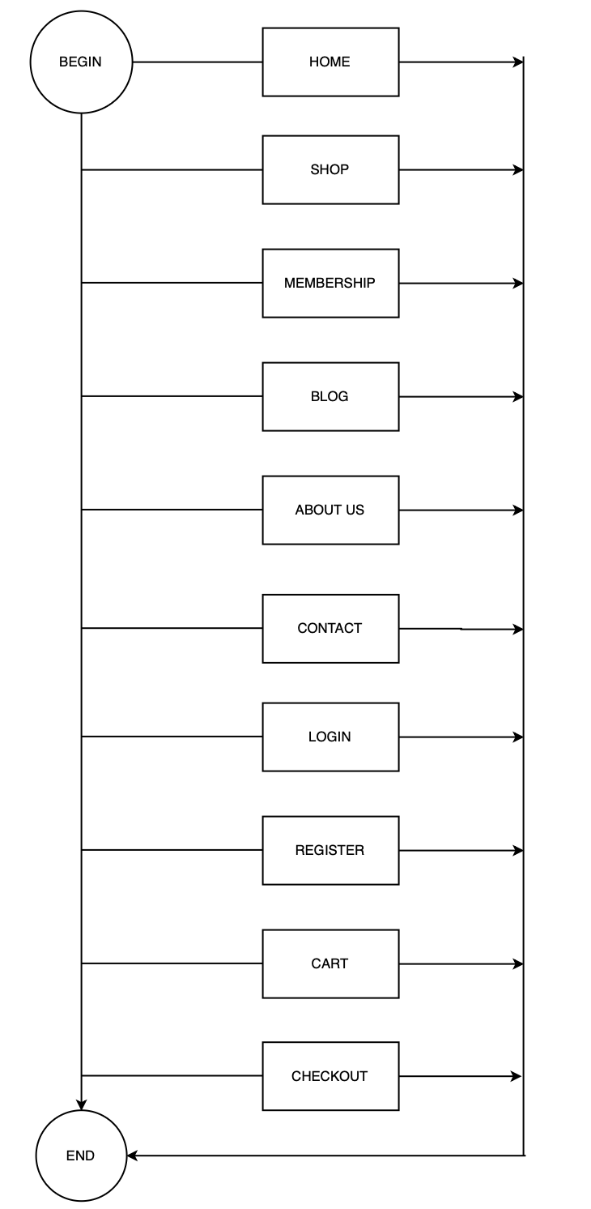



# TASK SHEET REVIEW 1

|  |  |  |  |  |  |  |  |
| --- | --- | --- | --- | --- | --- | --- | --- |
| **Project Ref. No.:**  **eP/Advertisement Portal Management**  **System/01** | | **Project Title:** | **Activity Plan Prepared By:** | **Date of Preparation of Activity Plan:** | | | |
| **Sr.**  **No.** | **Task** | **Actual**  **Start Date** | **Actual Days** | **Team**  **Mate Names** | **Status** |
| 1 | Problem Statement | Tiny Tots | Cuong | 28-Dec-20 | 1 | Cuong | Completed |
| 2 | Analysis of Tiny Tots requirements about the website | 28-Dec-20 | 1 | Vy | Completed |
| 3 | The scope of the work (in brief) | 28-Dec-20 | 1 | Cuong | Completed |
| 4 | Architecture and design of the system | 28-Dec-20 | 1 | Vy | Completed |
| 5 | Diagram of the website | 28-Dec-20 | 1 | Vy | Completed |
| 6 | Task Sheet | 28-Dec-20 | 1 | Cuong | Completed |

|  |  |
| --- | --- |
| **Date: 04/01/2021** | |
| Signature of Instructor:  **Ms. Le Mong Thuy** | Signature of Team Leader:    **Pham Vu Thao Vy** |

# SITE MAP

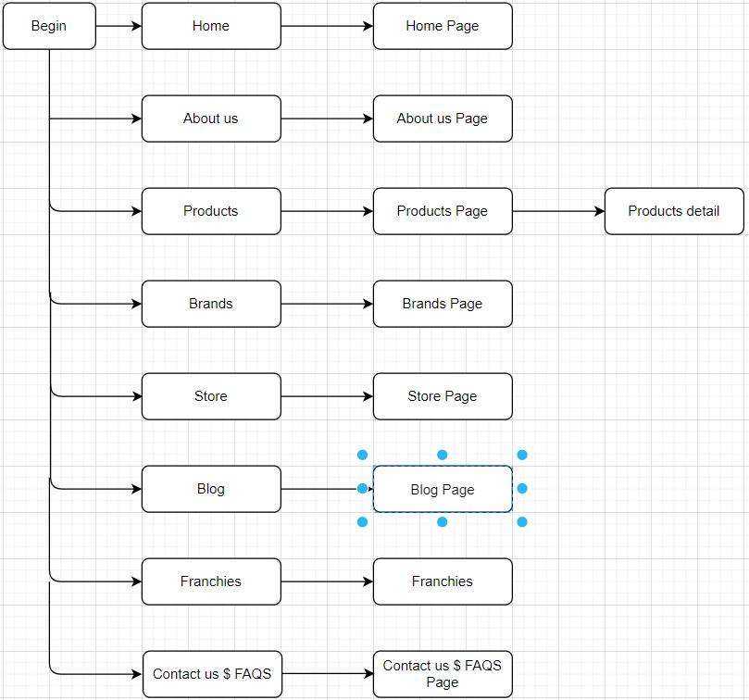

# MOCK OF THE WEBSITE

1. **Homepage**

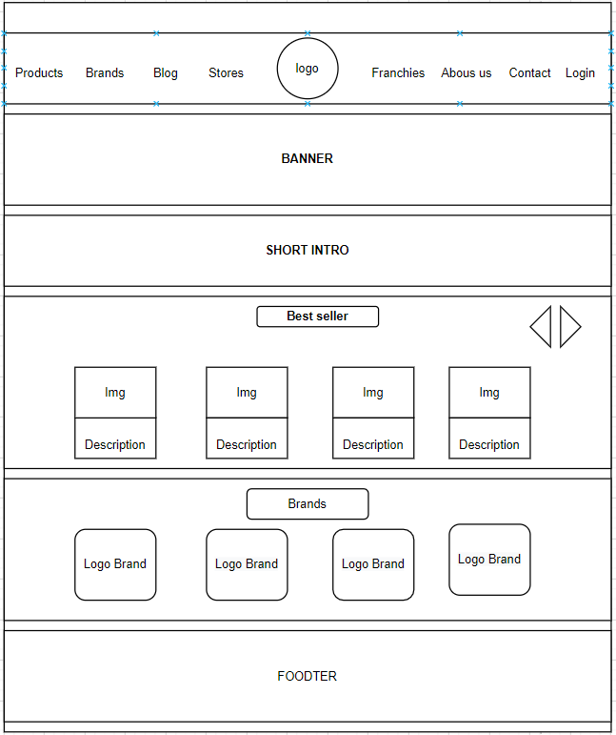

1. **About Us:**

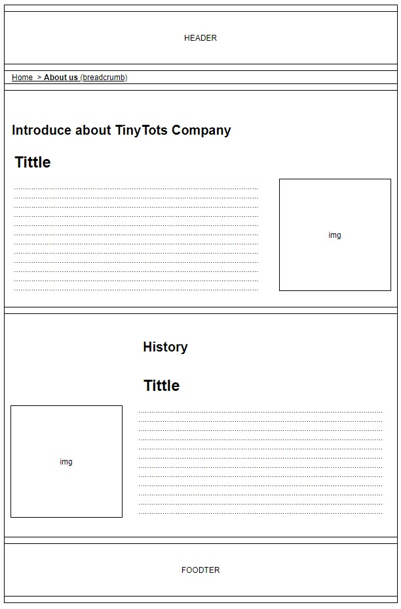

1. **Product:**

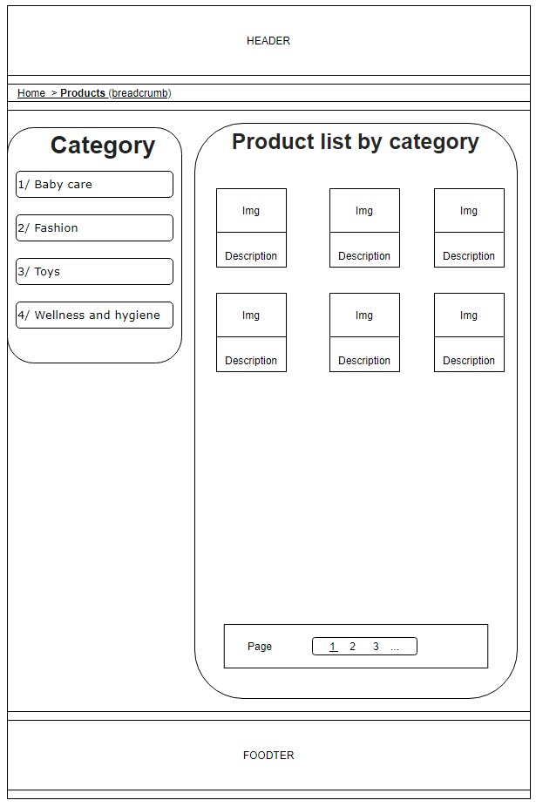

1. **Blog:**

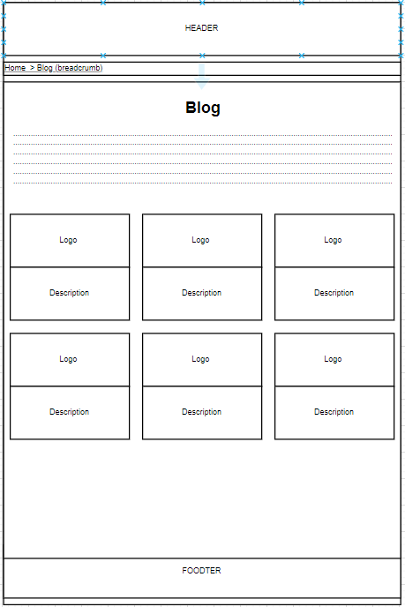

1. **Store:**

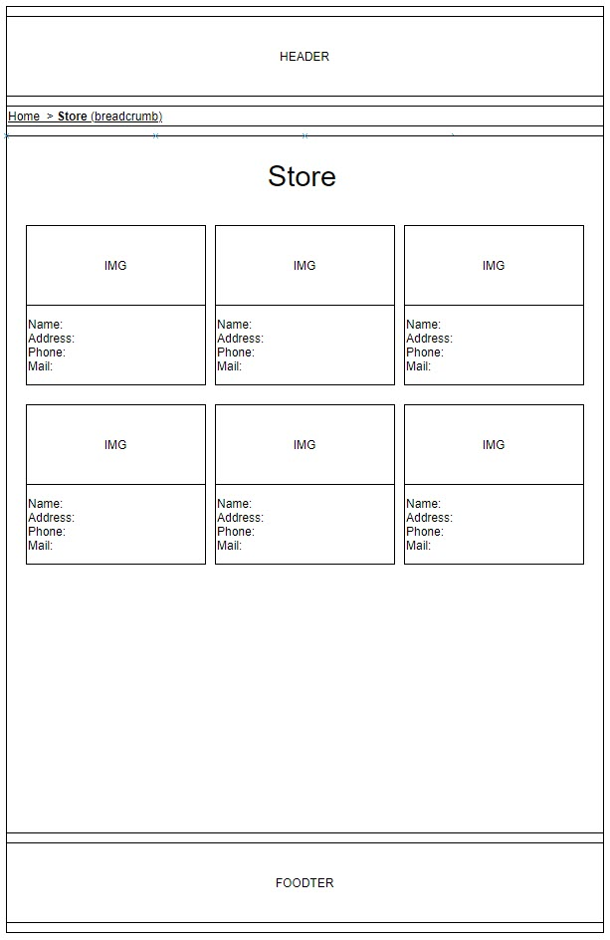

1. **Blogs:**

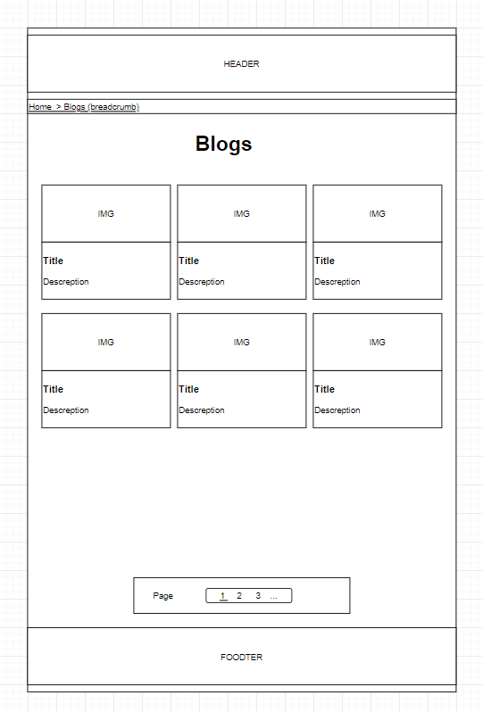

1. **Franchies**

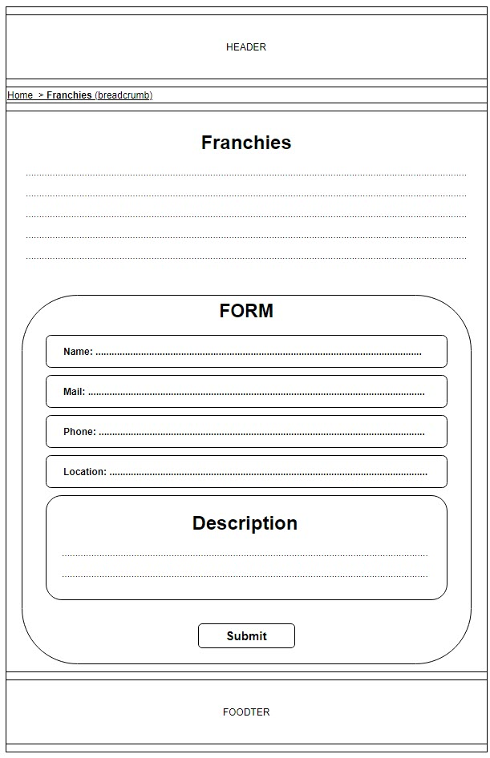

1. **Contact Us:**

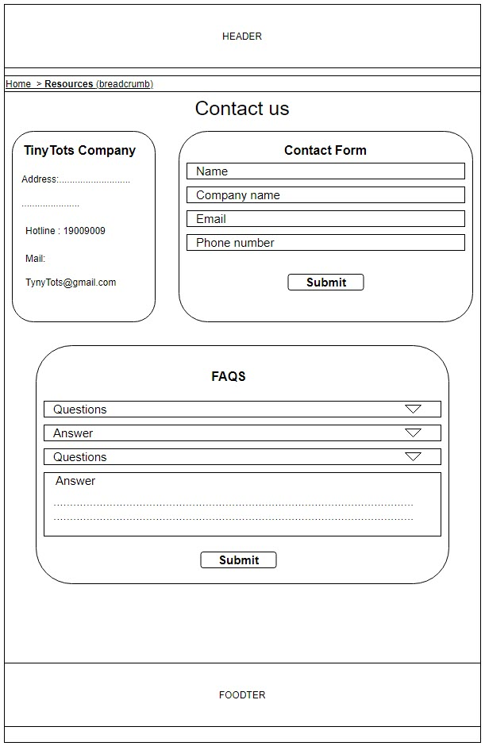

# TASK SHEET REVIEW 2

|  |  |  |  |  |  |  |  |
| --- | --- | --- | --- | --- | --- | --- | --- |
| **Project Ref. No.:**  **eP/Advertisement**  **Portal Management System/01** | | **Project Title:** | **Activity Plan Prepared By:** | **Date of Preparation of Activity Plan:** | | | |
| **Sr.**  **No.** | **Task** | **Actual Start Date** | **Actual Days** | **Team Mate Names** | **Status** |
| 1 | Site map | Tiny Tots | Cuong | 3-Jan-21 | 1 | Vy | Completed |
| 2 | Mock of the website | 3-Jan-21 | 2 | Vy | Completed |
| 3 | Task sheet | 3-Jan-21 | 2 | Cuong | Completed |

|  |  |
| --- | --- |
| **Date:04/01/2021** | |
| Signature of Instructor:  **Ms. Le Mong Thuy** | Signature of Team Leader:  **Pham Vu Thao Vy** |

# WEBSITE DESCRIPTION

1. **Home Page**
2. Description

Home page displays following information:

* Banner about the events
* Short intro
* Best seller products
* Brands

1. 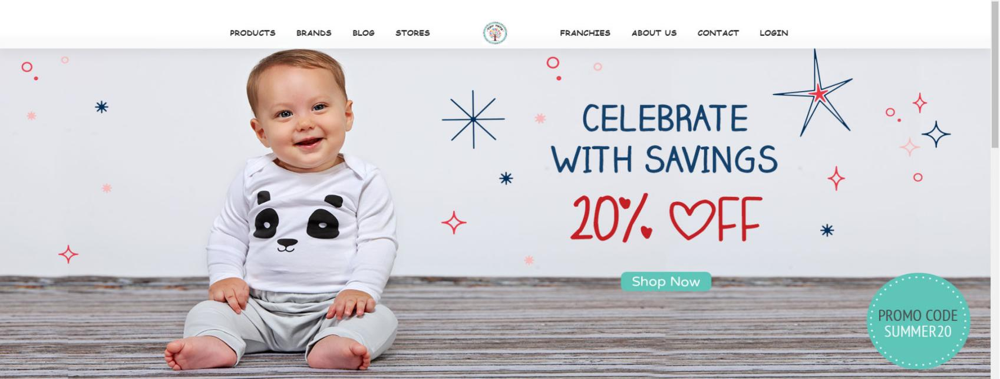Screenshot

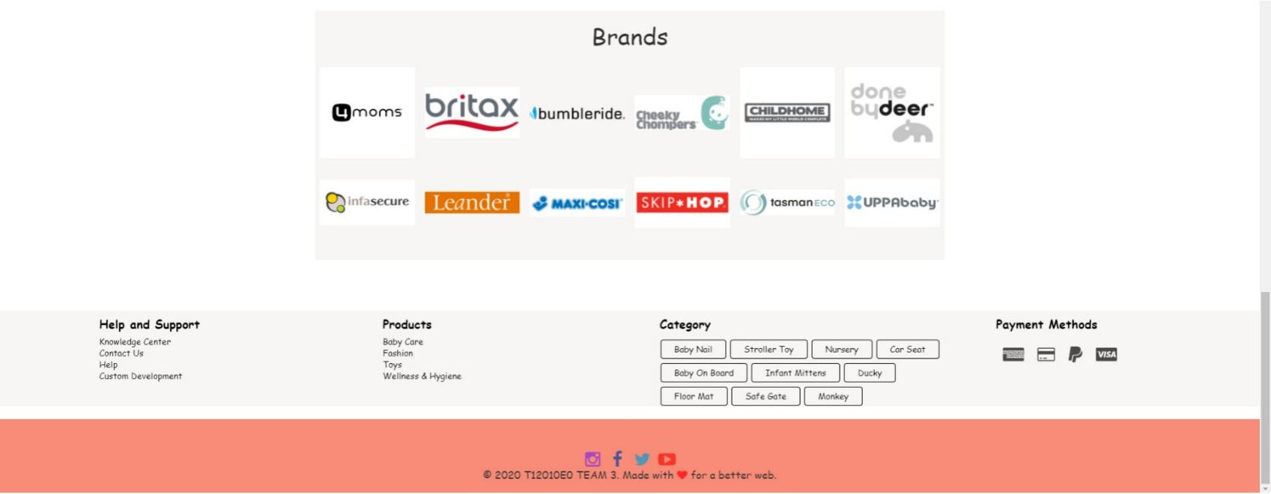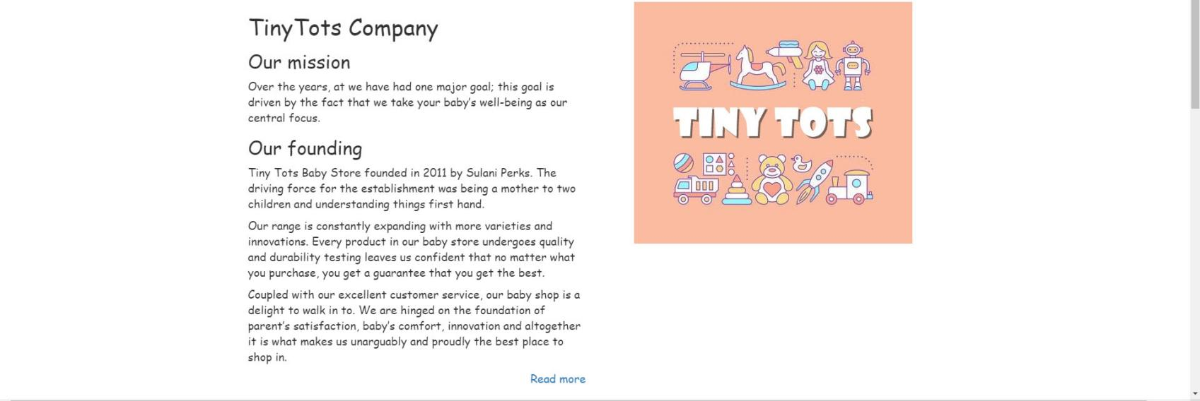

1. **Stores**
2. Description

This shop page displays following information:

* All product that being sold at Tiny Tots
* Products are grouped under each items.

1. Screenshot

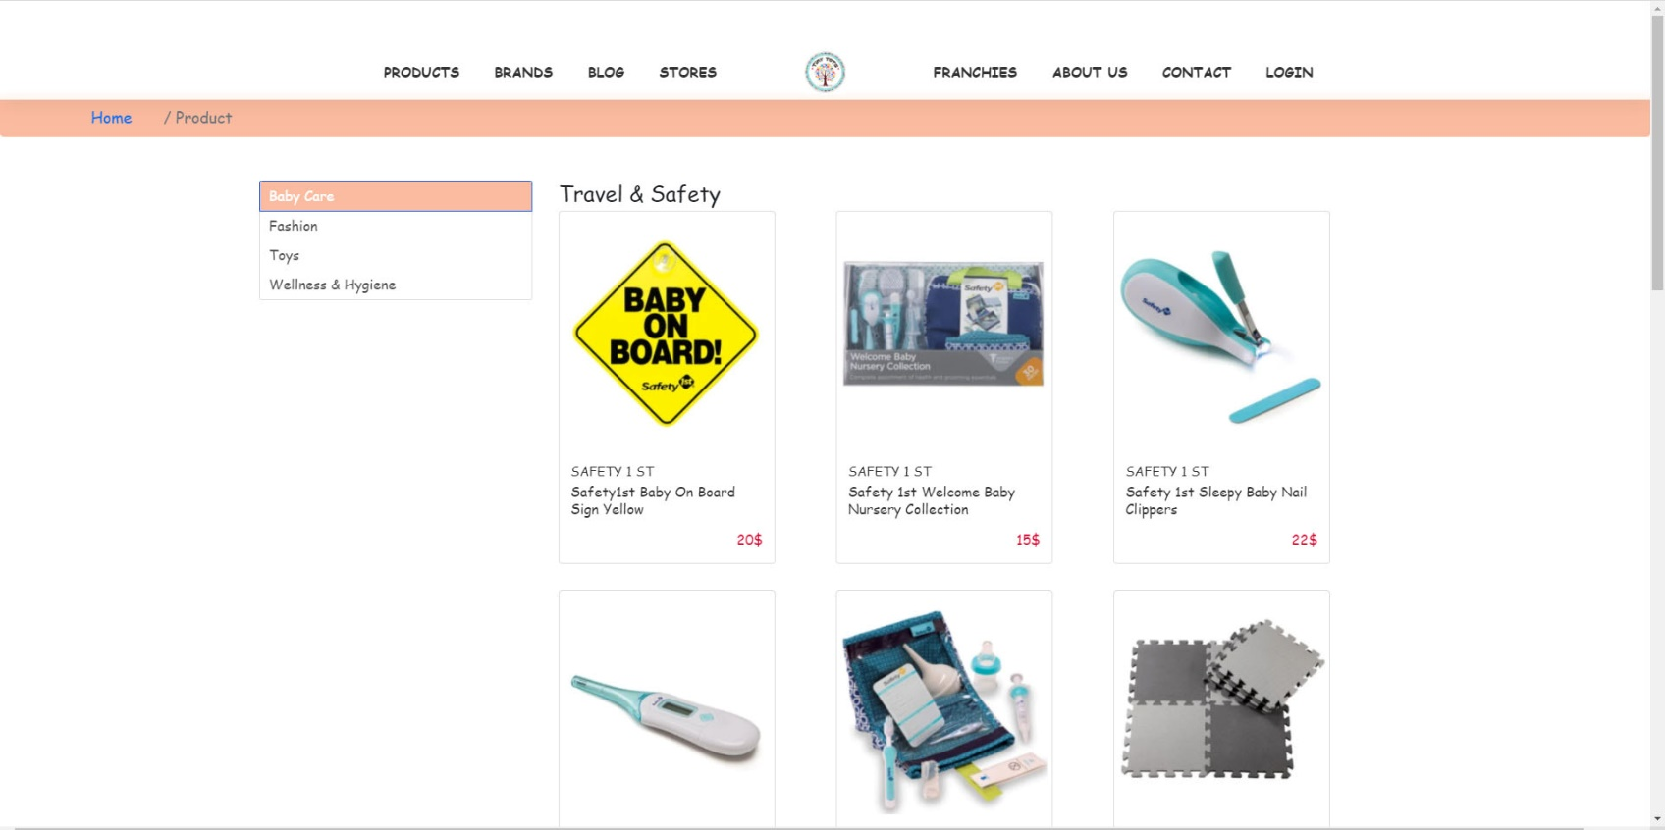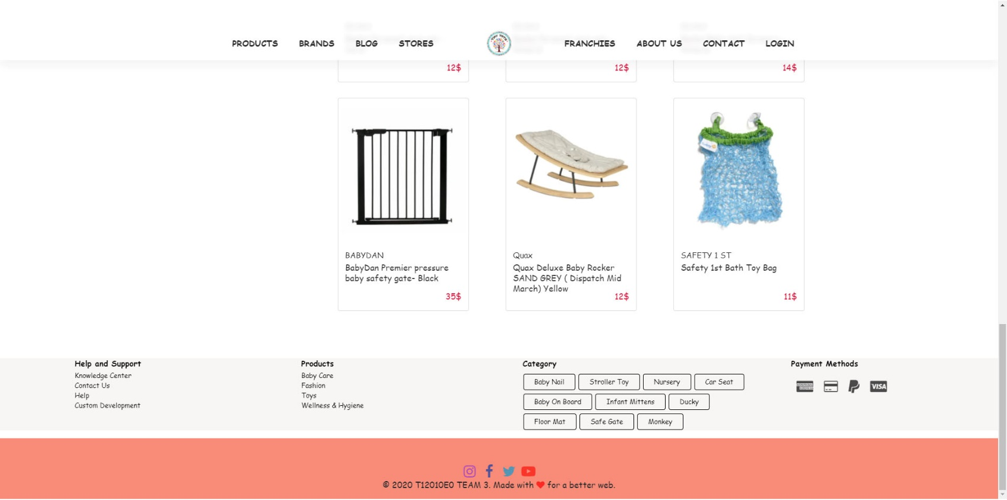

1. **Brands**
2. Description

This shop page displays all brands that being sold at Tiny Tots

1. Screenshot

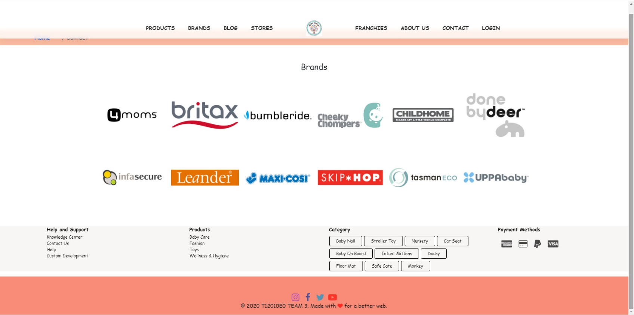

1. **Blogs**
2. Description

This blogs page displays following information:

* Where sharing experience

1. 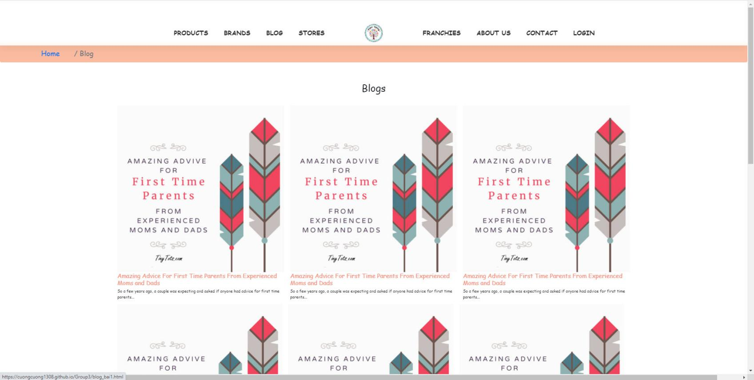Screenshot
2. Detail:

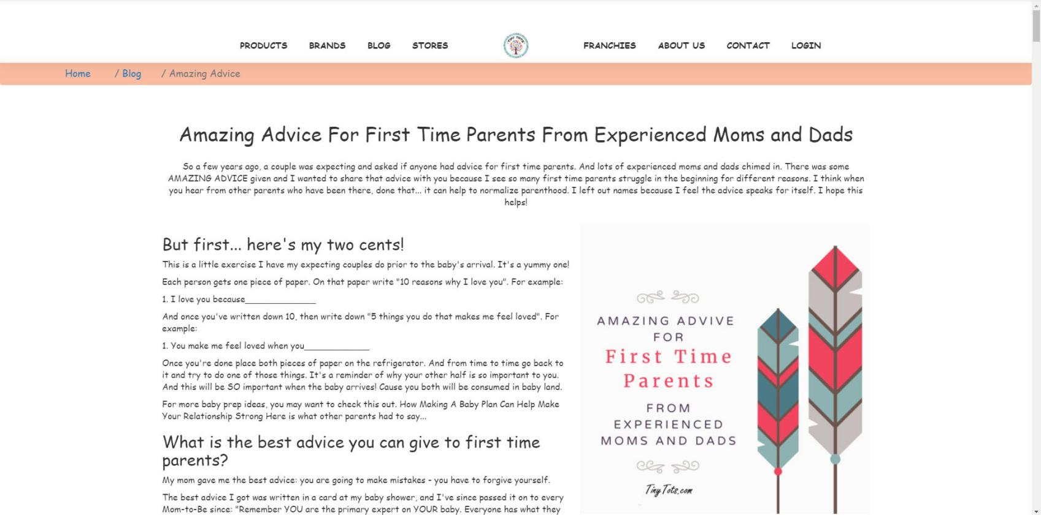

1. **Store**
2. Description

This Store page displays all store of Tiny Tots

1. Screenshot

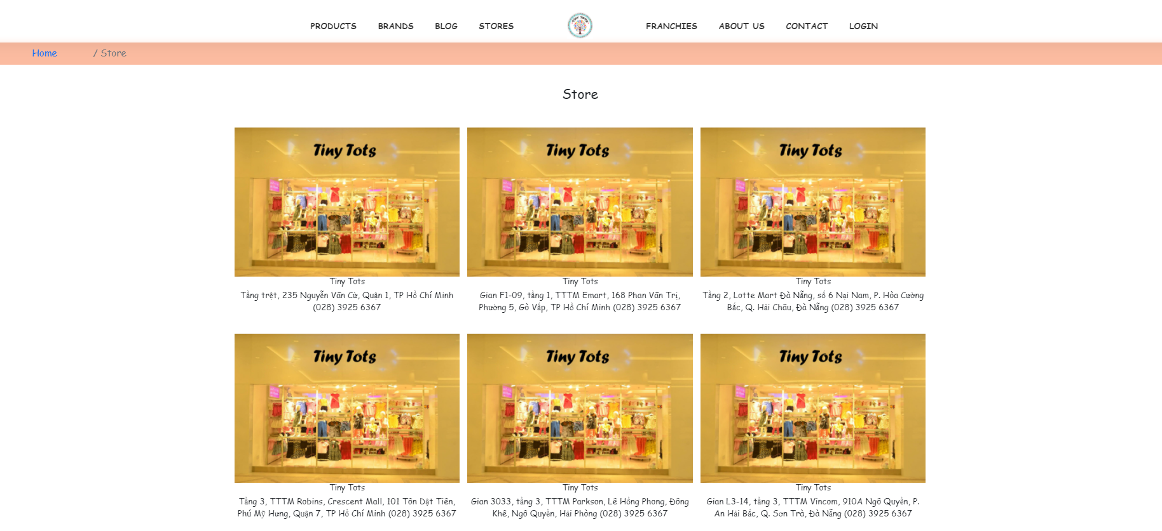

1. **Franchies**
2. Description

This shop page displays information, If someone wish to be partner with us.

1. Screenshot

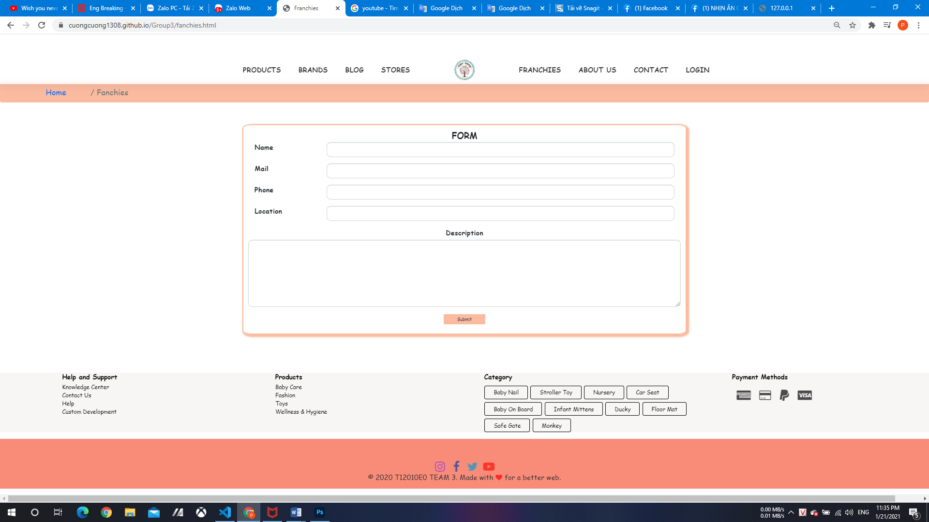

1. **About us**
2. Description

This page displays information about the history of Tiny Tots, our service that we provide

1. Screenshot

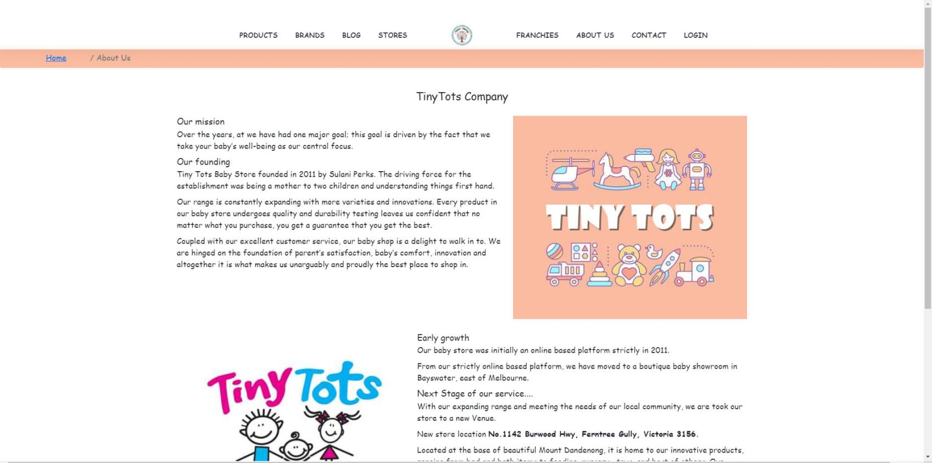

1. **About us**
2. Description

This page displays information about the history of Tiny Tots, our service that we provide

1. Screenshot

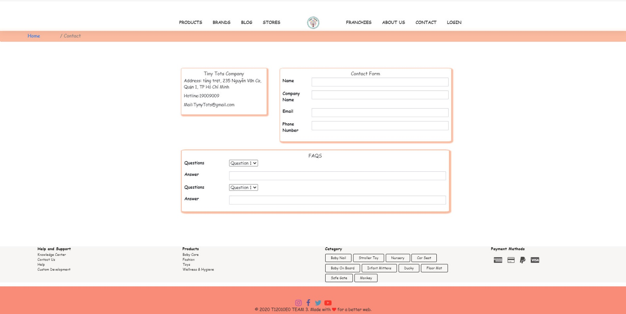

1. **Contact us**
2. Description
3. This page displays contact information: location, telephone number, email and a quick contact form for customer.
4. Screenshot
5. **Login**
6. Description

This webpage displays log in form for customer, it will require email address and password.

1. Screenshot

