MGENv6 Manual
(Multi-Generator Toolset)

Juan Francisco Rodríguez Hervella
Universidad Carlos III de Madrid
jrh@it.uc3m.es
ÍNDICE

INTRODUCTION 3
HOW TO COMPILE THE PACKAGE 4
MGENv6: INTERNAL STRUCTURE. 5
Introduction 5
Sending Flows 6
Computing the elapsed time 9
Graphical Interface 11
Extension headers for IPv6 14
DRECv6: INTERNAL STRUCTURE 15
Introduction 15
Receiving Flows 15
Multicast Groups 18
Graphical Interface 19
MCALCv6: INTERNAL STRUCTURE 21
Introduction 21
Computing Statistics 21
EXAMPLES 22
Example 1: Using the command line. 22
Example 2: Script for Mgen. 22
Example 3: Script for Mgen y Drec. 22
CHANGES BETWEEN *BSD AND LINUX 23
REFERENCES 24
COPYRIGHT 25

INTRODUCTION

MGEN is composed of a set of tools which allow us to take meassures of efficiency about an IP network using flows of UPD packets. The tool “mgen” sends real-time traffic patterns in such a way that network can be filled with different types of load. It’s possible to create scripts that simulate different types of flows (both UDP/IP unicast and multicast).

Packets can be received using the tool “drec” which has the skill of joining/leaving groups dinamically and it also creates a log file with time-stamps. This log can be analized with other tool to get statistics about paket losses, delay, jitter, throughput and so on.

The tool has been ported to IPv6 and it only works with both Linux and FreeBSD, with USAGI and KAME patches if you want to send extension headers.

To sum it up, the MGEN package is shipped with the following tools:
- Mgen: (Multi-GENerator) generates patterns of traffic to destinations unicast and/or multicast using the command line or using a flow configuration script. It’s possible to specify parameters such as size and rate on a per packet basis.
- Drec: (Dynamic-RECeiver) receives and saves the traffic that MGEN tool generates.
- Mcalc: (Multi-CALCulator) Have a look at the log file which DREC creates and compute statistics on a per flow basis..

HOW TO COMPILE THE PACKAGE

There’s a graphic version which is shipped with the library “Lesstif” for both Linux and FreeBSD. Also there’s a non-graphic version. Both of them are dinamically linked with the library “libinet6.a”, which supports IPv6 options which aren’t implemented yet on the “glibc” common library.

The package has been developed for the following distributions:

- FreeBSD-4.3-RELEASE with kernel patched using KAME code.
- Linux-2.4.2 with the kernel patched using USAGI.

The steps to follow to compile the tool are the following:

- The kernel has to be compiled with IPv6 support. Beside, it can be necessary to install advance options of IPv6 wich currently are being developed by KAME/USAGI projects.
- Editing “Makefile” to select the right operating system.
- Executing “make”

The tool must be executed with superuser privileges.

MGENv6: INTERNAL STRUCTURE.

This chapter describes the source code of MGEN tool.

Introduction

The aim of MGEN is generating packets on the right times and managing the creation/extinction of flows dinamically, based on the parameters specified by the configuration script or by the command line.

To do this, after initialized some global variables which are used all over the application, Mgen must analized the command line (or the script) and save the data on the right structures to be able to send the packets. The data structure utilized to save information about flows is defined in <mgenEvent.h> and it’s the following:

typedef struct MgenEvent
{
MgenMode mode; /* ITERATED or SCRIPTED */
MgenCmd cmd;
unsigned long id; /* Flow's ID number */
unsigned long sequence; /* Current sequence number */
double startTime; /* Event start time (msec) */
unsigned long stopTime; /* Event end time (msec) */
MgenPattern pattern; /* PERIODIC or POISSON */
float interval; /* Time between packets (msec) */
int size; /* Packet size (bytes) */
struct sockaddr_in6 addr; /* Flow's current destination address */
struct in6_addr b_addr; /* Base address for "iterated flow */
int n_groups; /* Number of groups for
"iterated" flow */
int count; /* Current count for "iterated" flow */
struct MgenEvent *next; /*Points to next event for_this_ flow*/
struct MgenEvent *parent;/* Points to event for previous flow */
struct MgenEvent *child; /* Points to event for next flow */

/* extension headers for IPv6 */
struct hbh_option options_buf[MAX_OPTIONS]; /*hop-by-hop options*/
struct routing_h routing; /* routing header option. */
struct in6_pktinfo sourceAddr; /* Flow's current
Source address, unspecified address by default. */

} MgenEvent;

This structure is used to make a chain of events of the same flow and also to make a chain of different flows. It contains all the information wich can be utilized when you define the features of a flow.

To send packets, Mgen uses only one socket UDP of type AF_INET6.

Sending Flows

After analize the script and command line, Mgen has a chained list of both events and flows wich is mantained on a global variable named “theList” and which has the following structure:

theList

Flow: 1
Flow: 2
Flow: 3
Flow: 2
Flow: 2
Flow: 3
Flow: 3
Flow: 3
Flow: 1
Flow: 1
Flow: 1

Head

Tail

Every structure has the following pointers:
- Next: it points to the following event on the same flow.
- Child: it points to the begining of the next flow.
- Parent: it points to the begining of the previous flow.

In the picture, to simplify the explanation, it’s only drawn the whole pointers of flow number 2.

The flows are sorted on time. The same occurs with the events inside of each flow. This gives us the chance to not search through the whole list when the next flow has to be planned to enter in action. If the flow which it’s been taking into account has a start time higher than the real time, we can assure that the subsequent flows will have it too. The functions wich are in charge of managing the flows are inside the file <mgenEvent.c>.

To send packets on the right time, Mgen has other two global variables:
- activeFlows: List of flows which are actived in a specific time.
- pendingFlows: List of flows that aren’t running yet because it’s not their turn.

The main loop that sends packets is the following:

while(activeFlows.head || pendingFlows.head)

Inside this loop, the first thing that it’s done is searching the list of pending flows. If there’s no active flows, it’s added to the list the first pending flow. On the other side, if there’s some active flows, the pending flows will only get active status if they are on their turn.. All of this is checked using the following piece of code:

if ((nextEvent->startTime <= thisTime) || !activeFlows.head)
{
/* A pending flow is ready, so fetch it */
pendingFlows.head = nextEvent->child;
if (pendingFlows.head)
pendingFlows.head->parent = NULL;
else
pendingFlows.tail = NULL;
/* Move pending flow to active flow list */
AppendMgenFlow(nextEvent, &activeFlows);
nextEvent = pendingFlows.head;
}

Next, the flows of the active flow list are choosen to be sent.

nextEvent = activeFlows.head;
while(nextEvent)
{

If the event has finished, the events until that time can be deleted from the
list of active flows, but if the same flow has been redefined later, it’s not possible to delete the whole flow of the list of active flows, but the pointers must be refreshed, as it can be observed on the following piece of code:

if (nextEvent->stopTime <= thisTime)
{
/* if the Flow has more events, shitf them properly
and return the next. Note that the resulting flow list are
not sorted, but this is not important*/
nextEvent = DiscardMgenEvent(nextEvent, &activeFlows,
&expiredEvents);
}

In this instant of time, the list of active flows can be messed up, because we are trying to insert a redefinition of a previous flow, which can begin on a time wich hasn’t come yet. This is not a problem, because all the active flows must be launched, no matter the position of the list, but we have to make sure that the flow has actually begun.

On the other hand, if the event is running on the present time (that’s a thing that has to be checked), it’s built the packet and it’s sent, as it’s done on the following piece of code:

else
{
/* Is event ready? It can happen that the event does not start
yet. */
if (nextEvent->startTime <= thisTime)
{

/* Send packet and calculate next packet transmission time.
Note that we modified dinamically the startTime
variable of the Event. */
if (nextEvent->interval)
{
SendTxSocket( txSocket, txBuffer, nextEvent );

switch(nextEvent->pattern)
{
case PERIODIC:
nextEvent->startTime += nextEvent->interval;
break;

case POISSON:
nextEvent->startTime += genexp(nextEvent->interval);
break;
}
}
} /* end if(nextEvent->startTime <= thisTime) */
} /* end else(nextEvent->stopTime) */

/*to progress throught the loop, we pass to the next flow of the
active flow list. */
nextEvent = nextEvent->child;

} /* end while(nextEvent) */

The events change updating their start time (adding the retransmition time they had defined, which can be constant or following a statistical poison-distribution). At the end of the loop the following flow of the active list is choosen.

Computing the elapsed time

In this section it’s explained the time control used by the Mgen tool when it needs to plan the flows. First of all, some variables are initialized:

nextTime = 0.0; /* Start at time ZERO by default */

/* Init timing */
InitMgenTicker(&myTicker);

/* Record start of packet generation */
gettimeofday(&beginTime, &tzone);

The variable used to count the starting time of the next flow/event is initialized (nextTime), and the starting time is saved on the “beginTime” variable. Moreover, the structure which holds the time elapsed since the last capture of time is also initialized.
This structure is defined in <mgenWait.h> as:

typedef struct MgenTicker
{
double count; /* Current bucket content (msec tick count) */
struct timeval lastTime; /* time state (system time) */
} MgenTicker;

Next, only if the referenced time is not equal to zero, the nextTime variable will be upgraded to show the time that must pass before the actual seding of flows begin.

/* If an absolute start time is given */
if (absoluteStartTime)
{
if (beginTime.tv_sec > absoluteStartTime)
{
printf("MGEN: Specified startTime has already passed!\n");
close(txSocket);
exit(-1);
}
nextTime = (beginTime.tv_sec - absoluteStartTime) * 1000.0;
nextTime += (beginTime.tv_usec + 500)/1000;
}

Once we are inside the loop which searches the flows (while there’s any flow, active flows or pending flows), the variable “thisTime” is initialized with the value of “nextTime”, and also the value of “nextTime” is set to infinite, because when the flows are searched, the “nextTime” variable is upgraded with the aim of finding out the nearest future start time (nearest to the real). That means that we have to look for the minimun instant time of begining between all the active flows, as can be observed in the following code:

while(activeFlows.head || pendingFlows.head)
{
thisTime = nextTime;
nextTime = MGEN_TIME_MAX;

/* pass pending flows to active flows, if it is appropiate */

/* loop for active flows */
while(nextEvent)
{
/* dispaching flows… */

/* select the minimun startTime of all the active flows.
Note that the resulting nextTime is always greater than
"thisTime" because all the flows defined by the script (<=>
pendingFlow initially ), are related to the initial
"thisTime", and in pendingFlow list, they are sorted */

if (nextEvent->startTime < nextTime)
nextTime = nextEvent->startTime;
}

Eventually, once all the active flows has been searched, the process gets off to sleep the time needed to reach “nextTime”, I mean, “nextTime-thisTime”. Also, we have to take into account the time we take processing the active flows, which can be high. This is done by the “myTicker” variable, as it’s shown following:

/* Flow control ourselves, avoiding infinite wait.
Note that nextTime is always greater than thisTime, because all
the active flows, or start in the future, or start at the same
time that "thisTime", and after dispatched it, his start time is
incremented... */

if (nextTime != MGEN_TIME_MAX)
MgenWait((nextTime-thisTime), &myTicker);
}

It can happen that the process doesn’t get to sleep inside the function MgenWait(). This can occur if the time elapsed is higher than the time we had to sleep (that means that we are sending packets delayed). This slip will be corrected only and only if the sending rate doesn’t exceed the execution speed of the Mgen process.

Graphical Interface

Mgen shows a graphical interface made up using Lesstif, which is an open version of Motif. Motif is a user graphical interface based on X Windows System. Motif uses the funcitons which Xlib and Xt offer to make its job. It also offers “widgets” of general purpose. Lesstif adds other features which are of general interest for both applications and users, which make it look as a high interface to develop window programs using C.

The graphic interface of Mgen shows the same functionality that the command line version. To interact using the script, the following window it’s utilized:

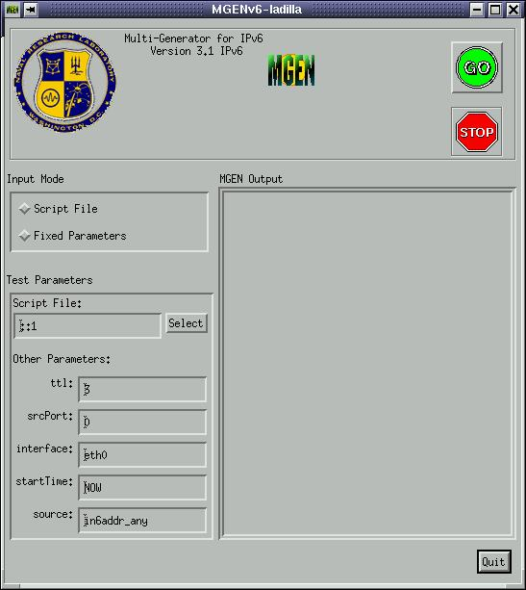

This is the window shown when the command line version is used:

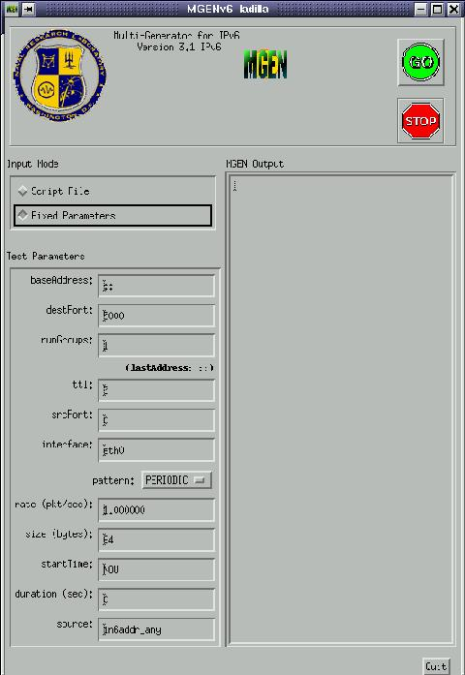

In both windows, the right part shows the output which is produced by the execution of the programe. When the execution is ended, or when the programme is finished using CTRL+C, the following information appears (both in the graphich version and the command line version as well):

- Packets transmitted (Packets Tx’d): number of packets sent through the socket. Mgen uses a counter which is upgraded each time a new packet is sent.
- Frames transmitted (Frames Tx’d): number of packets wich are actually sent through the network interface. This computation is done getting the output of tcpdump/netstat both at the beginning and at the ending of the programme execution, and then making the difference. Usually it will be a number equals to or higher than the number of packets transmitted, unless the NIC is not able to process the packets which are kept on the output queue.
- Transmission period (Transmisión period): seconds which Mgen has been running sending packets.
- Mean of transmition rate of packets: mean rate of the packets, in packets per second.
- Error transmitions and collisions (Tx Errors, Collisions): these are obtanined from tcpdump/netstat, which show both the number of error frames and the number of collisions on the output interface

To sum it up, here it is an example of the information explained:

MGEN: Version 3.1 IPv6
MGEN: Loading event queue ...
MGEN: Seeding random number generator ...
MGEN: Beginning packet generation ...
(Hit <CTRL-C> to stop)^C

MGEN: Packets Tx'd : 2
MGEN: Transmission period: 1.754 seconds.
MGEN: Ave Tx pkt rate : 1.141 pps.
MGEN: Interface Stats : rl0
Frames Tx'd : 2
Tx Errors : 0
Collisions : 0

Extension headers for IPv6

Mgen can send the following extension headers:

- Routing Header (Type 0): based on RFC 2460, it’s the same as the source routing of IPv4.
- Router Alert hop-by-hop option: header which is processed by the routers and can transport information about some messages as “Multicast Listener Discovery” messages, RSVP messages or messages related to active networks. There are some bits reserved for future uses. It’s defined in RFC 2711.
- Jumbo Payload hop-by-hop option: it’s used to send packets with a payload higher than the normal IPv6 packets, and it’s defined in RFC 2675
- Mobility headers:: they are defined in <draft-ietf-mobileip-ipv6-13.txt>:
  - Home Address destination option
  - Binding Update destination option
  - Binding Acknowledge destination option
  - Binding Request destination option

Moreover, it’s possible to choose the source address of the packets for each flow, between all the addresses the machine has configured.

This headers can be inserted inside whatever flow we want to, and they can be switch on/off in every instant of time. Flows can transport different kinds of extension headres at the same time, and of course it’s possible to send various flows with diffent types of extension headers.

At this time, the flow identification is save into the UPD payload, but we expect to be able to use the flow label field to transport this information.

DRECv6: INTERNAL STRUCTURE

In this chapter we will introduce the tool called Drec. Drec is the part of the system in charge of receiving the packets generated by Mgen.

Introduction

To be able to compute statistics, it’s necessary the existence of a tool which can receive every packet sent by Mgen. Drec is used like a tool of logging, which can listen on different multicast addresses as well as normal packets. It saves a time-stamp for every packet which allows the tool to compute delays (if both computer clocks are synchronized using some external source, like for example “ntp”). Drec can also detect IPv6 extension headers if they are passed to the application layer.

Receiving Flows

Drec uses the following scheme of execution to receive the different flows. On the one hand, it must process the events related to multicast groups which must be joined/left dinamically. On the other hand, it must process the packets received and write them in the log file. The way of processing of his own events is very similar to they way Mgen does:

/* Process events in queue while listening for traffic */
nextEvent = eventList.head;
while(nextEvent)
{
/* Process any events whose time has come */
while(nextEvent && (nextEvent->time <= thisTime))
{
gettimeofday(&rxTime, &tzone);

switch(nextEvent->cmd)
{
case JOIN:
/* insert the new group and write to the log file */
case LEAVE:
/* delete the group and write to the log file */
…
}

nextEvent = DiscardDrecEvent(nextEvent, &eventList, &eventTrash);
}

Next, and while there’s some event, the rest of the time (time which has to pass until the next event) is used to listen on the set of sockets through a blocked call to select() with a timeout equals to the time it takes to reach the following Drec event:
if (nextEvent)
{
waitTime = nextEvent->time - thisTime;

/* select() on recv file descriptor(s), with "waitTime" timeout */
while (waitTime > theTicker.count)
{
/* Set "select()" timeout */
…
/* Fill fd_set with file descriptors from our socketList */
…
/* Block on select until packet or timeout */
result = select(max_fd, (fd_set *) &fdset, (fd_set *) NULL,
(fd_set *) NULL, &timeout);

On this point, when the call to select() has returned, we search the list of sockets and if some of them have any packet, it will be processed and saved in the log file:

/* Check socket list, handling any fd's that are ready */
nextSocket = socketList;
while(nextSocket)
{
if (FD_ISSET(nextSocket->fd, &fdset))
{
/* process the received packet */
…
}

/* check the next socket */
nextSocket = nextSocket->child;

}

UpdateMgenTicker(&theTicker);
} /* end while(waitTime > theTicker.count) */

theTicker.count -= waitTime;
thisTime += waitTime;

} /* end if(nextEvent) */

} /* end while(nextEvent) */

The calculation of the time uses the same functions and structures of Mgen, only changing the structure which holds the list of events. This new structure is defined in <drecEvent.h> and is the following:

typedef struct DrecEvent
{
DrecCmd cmd; /* DREC script command */
unsigned long time; /* event execution time (msec) */
struct sockaddr_in6 addr; /* group IP address */
struct DrecEvent *parent;
struct DrecEvent *child;
} DrecEvent;

Besides, in the file <drec.c> we’ve got the structure which holds the list of sockets where we listen to for packets:

typedef struct DrecSocket
{
int fd;
unsigned short port;
#ifdef _LIMIT_GROUPS
int g_count;
struct in6_addr group[IP_MAX_MEMBERSHIPS];
#endif _LIMIT_GROUPS
struct DrecSocket *parent;
struct DrecSocket *child;
} DrecSocket;

If you’re using the command line, to listening to more than one multicast group, it’s used the value of “number of groups” (option “-n”). This range is defined as a range between the initial address specified by “-b” to the address obtained adding the value of option “-n” to the initial address.

Multicast Groups

In Drec, to join/leave multicast groups the following functions are used:
- Join Group()
- LeaveGroup()

To listen to multicast groups we use the system function setsockopt() with the following parameters, depending on the kind of operating system, so we have to use conditional compilation tags, like it’s shown on the following extract:

mreq.ipv6mr_multiaddr = group_addr;
mreq.ipv6mr_interface = if_nametoindex( interfaceName );
#ifdef IPV6_JOIN_GROUP
setsockopt(nextSocket->fd, IPPROTO_IPV6, IPV6_JOIN_GROUP,
(char *)&mreq, sizeof(mreq) )
#else
setsockopt(nextSocket->fd, IPPROTO_IPV6,
IPV6_ADD_MEMBERSHIP,(char *)&mreq, sizeof(mreq) )
#endif

To leave multicast groups, we use in the same way the appropiate constants, which in this specific case also changes if we are using Linux or FreeBSD, as we can see below:

mreq.ipv6mr_multiaddr = group_addr;
mreq.ipv6mr_interface = if_nametoindex( interfaceName );
#ifdef IPV6_LEAVE_GROUP
setsockopt(theSocket->fd, IPPROTO_IPV6, IPV6_LEAVE_GROUP,
(char *)&mreq, sizeof(mreq) )
#else
if(setsockopt(theSocket->fd, IPPROTO_IPV6, IPV6_DROP_MEMBERSHIP,
(char *)&mreq, sizeof(mreq))< 0)
#endif

Graphical Interface

The tool has also a graphical interface, very similar to Mgen, with the same functionality that you can get from the non-graphical version. It can be used both the fixed parameter style or the scripted version, the last one to dinamically listen to different multicast groups at different times. Following both windows are introduced:

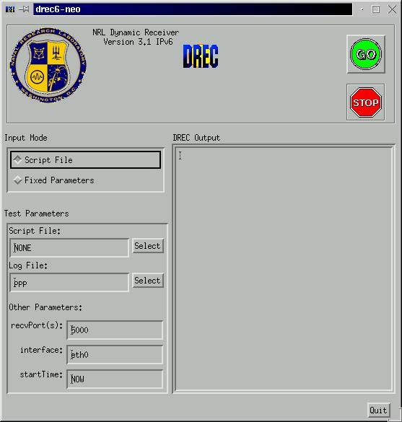

MCALCv6: INTERNAL STRUCTURE

In this chapter we introduce the tool in charge of generating statistics, called Mcalc.

Introduction

Mcalc is the programme in charge of examining the log file created by Drec and showing statistics grouped/joined by flows. The output values are approximate. For example if we send a unique flow of 2000 packets and everything goes well but the last 500 packets, which are lost, Mcalc has no way of knowing if the flow only had 1500 packets or, on the contrary, it had 2000 packets and we’ve got 500 packet losses. In this case, Mcalc will think that the flow only had 1500 packets and will show no packet losses, which is wrong.

Computing Statistics

The functionality of Mcalc is very simple. it takes every line of the log file and saves the appropiate information until the end of the file is reached. Then taking into account the whole number of packets it proceeds to compute mean, minimun and maximun values. It doesn’t take into account entries like JOIN or LEAVE or information about extension headers.

In the examples at the end of this document it can be observed the kind of computations which Mcal can make.

EXAMPLES

Next we show three examples to learn to manage the tool and their fundamental aspects.

Example 1: Using the command line.

We are going to send a constant flow of 1000 packets per second, using the interface “rl1”, towards port number 6000, with source port 5000 and TTL 255, for 50 seconds. To make this, first of all we need to set up “Drec” on the destination machine:

jrh@pulgon:~$ sudo ./drec6 salida.txt

Now, we run Mgen on the source machine:

jrh@mira:~$ sudo ./mgen6 -b pulgon,6000 -r 1000 -s 2000 -d 50 -i rl1 -p 5000 -t 255

After 50 seconds, Mgen shows the following information:

MGEN: Version 3.1 IPv6
MGEN: Loading event queue ...
MGEN: Seeding random number generator ...
MGEN: Beginning packet generation ...
(Hit <CTRL-C> to stop)

Example 2: Script for Mgen.

Example 3: Script for Mgen y Drec.

CHANGES BETWEEN *BSD AND LINUX

REFERENCES

The drafts (unless they’ve already expired) and the RFCs which are shown here can be downloaded from http://www.ietf.org

- RFC 2460, Internet Protocol, Version 6 (IPv6) Specification, S. Deering, R. Hinden.

- RFC 2373, IP Version 6 Addressing Architecture, R. Hinden, S. Deering.

- RFC 2553, Basic Socket Interface Extensions for IPv6, R. Gilligan, S. Thomson,
J. Bound, W. Stevens.

- RFC 2292, Advanced Sockets API for IPv6, R. Stevens, M. Thomas, E. Nordmark.

- RFC 2711, IPv6 Router Alert Option, C. Partridge, A. Jackson.

- RFC 2675, IPv6 Jumbograms, D. Borman, S. Deering, R. Hinden.

- <draft-ietf-mobileip-ipv6-13.txt>, Mobility Support in IPv6, B. Johnson, C. Perkins.

- “IPv6 Flow Labels in Linux-2.2”, Alexey N. Kuznetsov, Institute for Nuclear Research, Moscow, April 11, 1999.

- <draft-ietf-ipngwg-default-addr-select-04.txt>, Default Address Selection for IPv6, Richard Draves, Miscrosoft Research.

- <draft-ietf-kitamura-ipv6-record-route-00.txt>, Record Route for IPv6 (RR6) hopb-by-hop option extension, H. Kitamura, NEC Corporation.

- MOTIF 2.1-Programmer’s Guide, The Open Group, 1997.

- http://manimac.itd.nrl.navy.mil/MGEN: Página del desarrollador de la herramienta para IPv4.

- http://cvs.atm.tut.fi/rude/: Otra herramienta generadora de tráfico IP.

COPYRIGHT

