Electrical Operation Specification

SE Packer Series


Contents
1． General 4
1．1 Power and incoming line requirement of packer series 4
1．2 Electrical composition and main performances of series 4
1．2．1 Electrical composition of series 4
1．2．2 Main performances of series 5
2．Introduction to operation panel/touch screen picture 6
2．1 Operation button 6
2．2 Introduction to touch screen picture 8
2．2．1 Picture sequence chart 8
2．2．2 Run picture（P1） 9
2．2．3 Product change picture（P2） 11
2．2．4 Manual/single-acting picture（P3） 12
2．2．5 Menu picture（P4） 13
2．2．6 Switch picture（P5）（P18） 14
2．2．7 Packaging cam/conveyer belt cam picture（P6） 14
2．2．8 End-seal cam/datum cam picture（P7） 15
2．2．9 Discharge setting picture（P8） 16
2．2．10 Time setting picture（P9） 17
2．2．11 End-seal deviation setting picture（P10） 17
2．2．12 Non-package check picture（P11） 18
2．2．13 Package misalignment detection picture（P12） 20
2．2．14 Data record picture（P13） 22
2．2．15Output/input power signal picture（P14）（P30） 22
2．2．16 Deviation/speed picture（P15） 23
2．2．17 Temperature record picture（P16） 23
2．2．18 Automatic film connection picture（P19）（P29） 24
2．2．19 Product registration picture（P20）（P23） 25
2．2．20 Product deletion picture（P22） 25
2．2．21 End-seal stop angle picture（P24） 26
2．2．22 Cut location adjustment picture（P25） 26
2．2．23 Product name registration picture（P26）（P27）（P28） 27
2．2．24 Adjustment picture（big screen）（P33） 28
2．2．25 Date adjustment picture（big screen）（P34） 28
2．2．26 Parameter setting（cipher）picture（P35）（P36） 29
2．2．27 Mechanical parameter picture（P37）~（P45） 29
2．2．28 Servo parameter picture（P47）~（P52） 30
2．2．29 Mechanical parameter/servo parameter setting list 31
2．2．30 Temperature control picture（big screen）(P67) (P68) 36
2．2．31 Alarm picture 36
3．Commissioning and operating method of packer 38
3．1 Convey PLC and touch screen program 38
3．2 Convey mechanical parameter, servo parameter and alarm name 38
3．3 Adjust servo motor steering 38
3．4 Make a packing product on touch screen (name and specification) 38
3．5 Set end-seal meshing deviation 39
3．6 Adjust home position of servo motor 39
3．7 Adjust cut location 40
3．8 Adjust product location 41
3．9 Adjust end-seal peripheral speed 41
3．10 Adjustment of automatic film connection 41
3．11 Adjustment of automatic diffusing surface 42
3．12 Adjustment of empty-bag prevention 42
3．13 Adjustment of misalignment detection 43
4．Treatment of general abnormal condition 44
5．Explanation for fault alarm code of servo driver 46

1． General

1．1 Power and incoming line requirement of packer series
- Overall power of packer series is usually 5KW (see equipment sign for details).
- Specification of electrical incoming line of packer series is usually AC, 50HZ, 3-phase,380V, three-phase five-line system, that is, three live lines and one working neutral line and one protective neutral line. For the sake of personal safety, metal shell of packer must be reliably connected with protective neutral line.
- According to different user’s special power supply, for example, three-phase 200V and three-phase 415V etc., the packer is equipped with corresponding transformer. Please carefully check if specification of power supply is correct before connecting with that of packer. Improper power supply connection could seriously damage electrical unit. Electrical Principle Diagram released with equipment has indicated specification of power supply of packer.
- Environmental requirement of electrical application of packer series:
Ambient temperature: 0℃～40℃(no freeze)
Ambient humidity: 10～85％RH or below (no dew)
Storage temperature: －20℃～＋70℃。
Storage humidity: 10～90％RH or below (no dew)
Elevation: <1000M

1．2 Electrical composition and main performances of series

1．2．1 Electrical composition of series
packer series, electrically, consist of movement control and heating control, and the two parts are relatively separate.
- Main components of movement control part include:
Transformer: Overall power supply transformer 5KVA (alternative) and servo drive transformer 3KVA.
Human-computer interface: FUJI color touch screen, 5.7 inch or 10.4 inch.
Programmable controller: FUJI MICREX-SX series（SPH）, 16 or 32 input points, 16 or 32 output points.
Driver motor: 3 AC servo motors of FUJI α series, voltage three-phase 200V, power: film feeding 400W or 750W; conveyer belt 400W or 750W; end-seal machine: 750W or 1500W.
Sensor: Photoelectric switch, proximity switch and micro switch.
Relay: IDEC DC24V。
Alarm sound and display: buzzer and indicator.
- Main components of heating control part include:
Temperature controller: Number: 4~8.
Type: OMRON E5CZ-Q2
Or FUJI PXR4NCY1 (with communication function, 10.4 inch touch screen display and temperature regulation）
Heater: End-seal 4×300W, center-seal 2×200W（or 2×500W）, pre-heater 2×200W.
Number, voltage and power of heater vary from different types.
Solid state contactor: Number: 4~8.
Thermal couple: Number: 4~8, K couple, 0~400℃.

1．2．2 Main performances of series
- Pre-stored number of product registration: 10
- Maximum speed of packing material: 50m/min
- Drive mode of packing material: Film feeding roll drive.
- Packing material run-out detection: Micro switch or photoelectric switch
- Temperature control mode: External temperature controller, touch screen display and temperature regulation alternative.
- Automatic feeding device (option): Electromagnetic clutch type
- Automatic film connecting device (option): Non-stop automatic connection of two rolls of packing material
- Automatic discharge device (option): Film connecting discharge, split discharge, startup discharge, empty bag discharge and misalignment discharge etc.
- Empty-bag prevention (option): In the case of no packing material, packing axle and end-seal axle can stop running automatically to save material.
- Misalignment cut prevention (option): In the case of misalignment of packing material, end-seal axle can stop running automatically to avoid damaging end-seal machine and material to be packed.

2．Introduction to operation panel/touch screen picture

2．1 Operation button
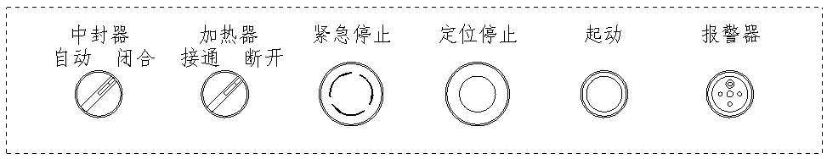
Center-seal machine
Automatic Closing
Heater
On Off
Urgent stop
Positioning stop stop
Startup
Alarm

- Center-seal machine（selector switch）:
（If packer is equipped with 10.4 inch touch screen, this switch would be replaced with that on screen.）
“Automatic”: Status of center-seal machine automatically changes with working condition of packer. Packer running → center-seal closing; packer stop → center-seal open. Under normal operation, please set switch to this location.
“Closing”: Center-seal machine is always closed.
- Heater（selector switch）：
“On”: Switch on power supply of heater.
“Off”: Switch off power supply of heater.
- Urgent stop（red, with mushroom self-lock button）:
Press: Packer will stop urgently and button lock hold. At this moment, end-seal blade may be at any location. In the case of urgent stop, please check state of product and film.
Put up（Turn in arrow direction）: Release urgent stip.
- Positioning stop（yellow, with mushroom button）:
Press: Packer will stop on specific position, with end-seal blade vertically upward (BX type end-seal blade at its highest location). For general stop operation, please press this button.

- Startup (button):
Press: Packer will be started and run. This button is also used for test run and inching run of conveyer belt, film feeder and end-seal machine motor.
- Alarm (buzzer):
Alarm sounds for warning to operator when any fault occurs to packer or before operation.

2．2 Introduction to touch screen picture

2．2．1 Picture sequence chart

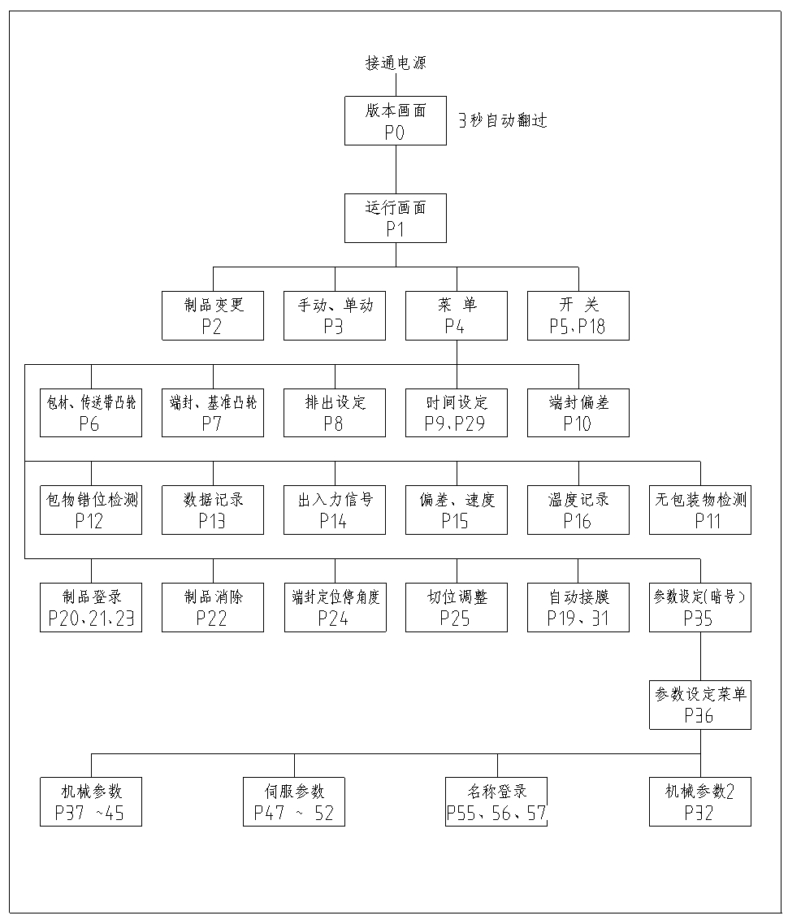
Power on
Version picture
Skip after 3 sec.
Running Picture
P1
Product change
P2
Manual & single-acting
P3
Menu
P4
Switch
P5, P18
Packing material and conveyer belt cam P6

End-seal and datum cam P7

Discharge setting P8

Time setting P9, P29

End-seal deviation P10
Package misalignment check P12

Data record P13

Output/input power signal P14

Deviation, speed P15

Temperature record P16

Non-package check P11

Product registration P20, 21, 23

Product removal
P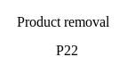22

End-seal stop angle P24

Mechanical parameter
P37~45

Name registration
P55, 56, 57
Mechanical parameter 2 P32
Cut location adjustment P25

Automatic film connection P19, 31

Parameter setting (cipher) P35

Parameter setting menu P36

Servo parameter
P47~52

2．2．2 Run picture（P1）
Running picture of 5.7 inch touch screen:
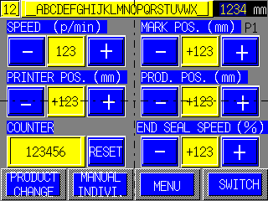

- Packing capacity (/min):
Set packing speed (number per minute), press “Slow” key to reduce the speed and press “Fast” to speed up packing. Heater temperature perhaps needs to be changed with packing speed.
- Mark location (mm):
Adjust film mark location on package (i.e. cut location). Press “Back” key, mark location moves backwards, and press “Front” , forward.
- Printed character location (mm):
Adjust location of printed character on package. Press “Back” key, printed character moves backwards; and press “Front”, forward.
- Product location (mm):
Adjust product feeding time (i.e. product location in packing bag). Press “Back” key, feeding time postpone; and press “Front”, forward.
- Packing number:
Display number of packed product. Press “Zero Clearing” to remove the number.
- End-seal peripheral speed (%):
Adjust speed of end-seal meshing. Press “Slow” key, meshing speed will be reduced; and press “Fast”, speed up. End-seal meshing speed should be adjusted to be equal to film running speed.
- Product change:
Enter product change picture（P10）
- Manual and single-acting:
Enter manual and single-acting picture（P3）
- Menu:
Enter menu picture（P4）
- Switch:
Enter switch picture（P5，P18）

Running Picture of 10.4 inch touch screen:
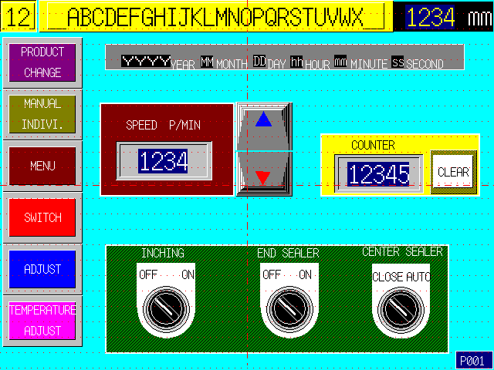
- Packing capacity (/min):
Set packing speed (number per minute), press “▼” key to reduce the speed and press “▲” to speed up packing. Heater temperature perhaps needs to be changed with packing speed.
- Packing number:
Display number of packed product. Press “Zero Clearing” to remove the number.
- Product change:
Enter product change picture（P10）
- Manual and single-acting:
Enter manual and single-acting picture（P3）
- Menu:
Enter menu picture（P4）
- Switch:
Enter switch picture（P5，P18）
- Adjustment:
Enter adjustment picture (P33). Adjust “mark location”, “product location”, “end-seal peripheral speed” and “printed character location” on 10.4 inch touch screen.
- Temperature control:
Enter temperature control: (P67), Adjust and monitor setting and actual temperature of temperature controller on 10.4 inch touch screen.

2．2．3 Product change picture（P2）
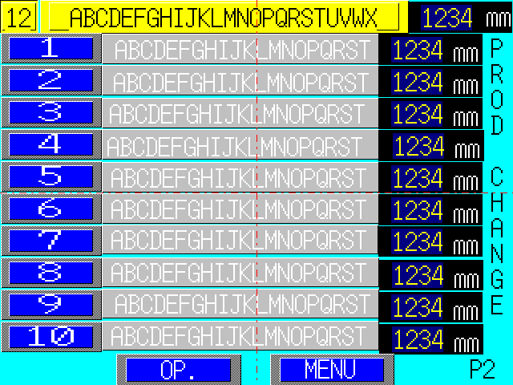
- Operation for product change (P2) can change product parameter run by packer.
- 10 pre-stored product serial numbers and names displayed in P2 are alternative when changing product.
- Press the number key 1~10 on left side of this picture to conclude operation for product change.

2．2．4 Manual/single-acting picture（P3）

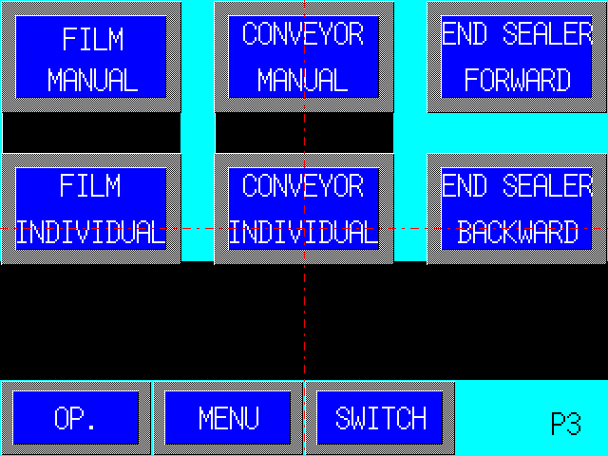
- This picture is used for running check of film feeding, conveyer belt and end-seal axle, for example, motor steering.
- Select [Manual] or [Single-acting] on screen, press “Startup” button to perform related operation. Manual operation will affect synchronous running of three axles of packer, and when they are synchronized again, packer will run back to home position first.
- Manual running:
On screen, select manual keys of film, conveyer belt and end-seal clockwise rotation or counterclockwise rotation.
Press “Startup” button, and selected equipment will be started, and press “Positioning Stop”, the selected equipment will be stopped.
- Single-acting running:
On screen, select single-acting key of film or conveyer belt.
Single operation only can be performed after packer has returned to home position.
Press “Startup” button, alarm buzzer sounds and then the selected equipment will be started. Press “Positioning Stop”, the selected equipment will be stopped.
Single-acting running do not affect synchronous linkage of three axles of packer.

2．2．5 Menu picture（P4）

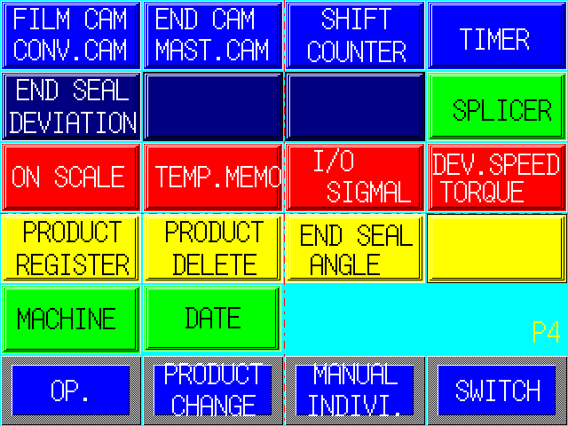
- On menu screen, select different skip key to enter relevant picture. Some pictures only can be displayed after this function has been set in mechanical parameter picture, for example, P11 non-package check picture, P12 misalignment detection picture and P25 cut location adjustment.

2．2．6 Switch picture（P5）（P18）
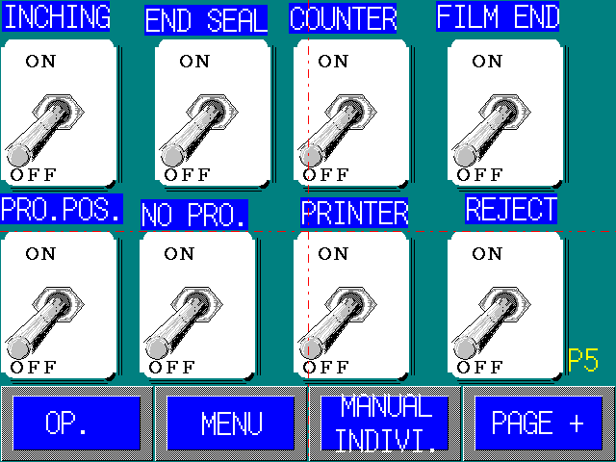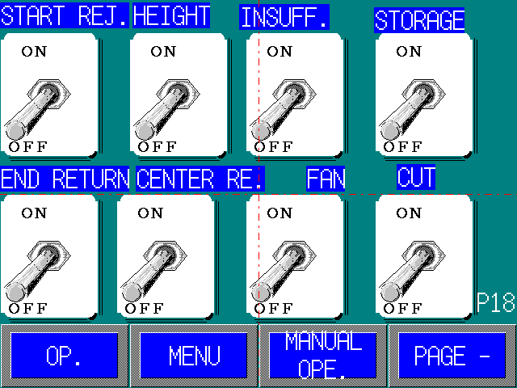
- The switches on the screen are used to open or close related function of packer, two status modes including run and stop can be set for these functional switches.
Take end-seal running switch for an example: When set “End-seal Run” switch in run place, it will run with packer; and set it in stop place, end-seal machine will stop running.

2．2．7 Packaging cam/conveyer belt cam picture（P6）
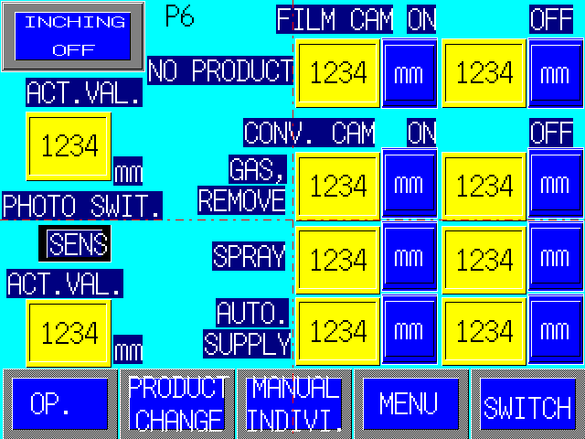

- In this picture, set cam ON/OFF value of related functions of packer.
- Cam value input range:
Film cam: 0 – Bag length value
Conveyor belt cam: 0 – Node distance value of push rod
End-seal cam: 0 - 359º
Datum cam: 0 – Bag length value

2．2．8 End-seal cam/datum cam picture（P7）

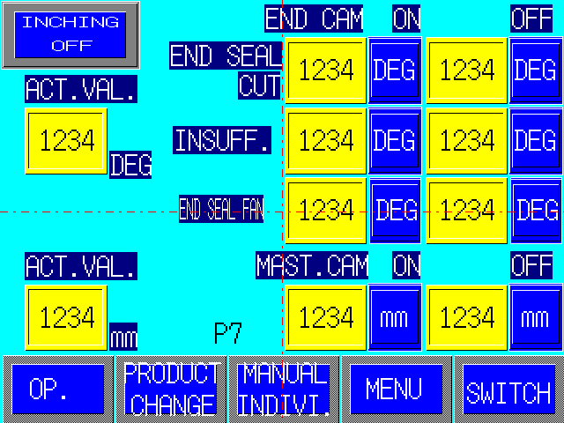

- In this picture, set cam ON/OFF value of related functions of packer.
- Cam value input range:
- Film cam: 0 – Bag length value
- Conveyor cam: 0 – Node distance value of push rod
- End-seal cam: 0 - 359º
- Datum cam: 0 – Bag length value

2．2．9 Discharge setting picture（P8）
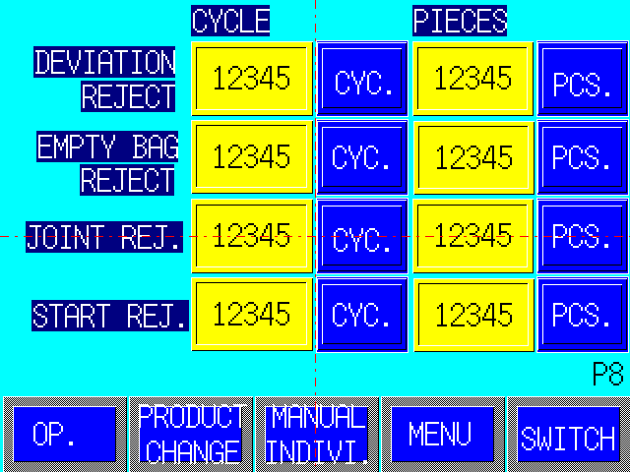

- In this picture, set section number and single number of film connecting discharge, split discharge and startup discharge.
- Take connecting discharge as an example:
- “Section number”: refer to the distance between photo switch marked by detection and discharge air valve (length of several packing bags)
- “Single number”: refer to number setting of single packing bag.

2．2．10 Time setting picture（P9）
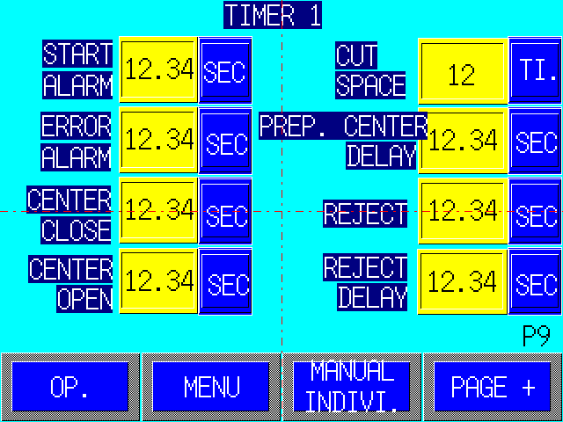

- This picture is related to time setting of all kinds of action of packer.
- Press “Second” key, value keyboard will be displayed, and then input setting value.

2．2．11 End-seal deviation setting picture（P10）
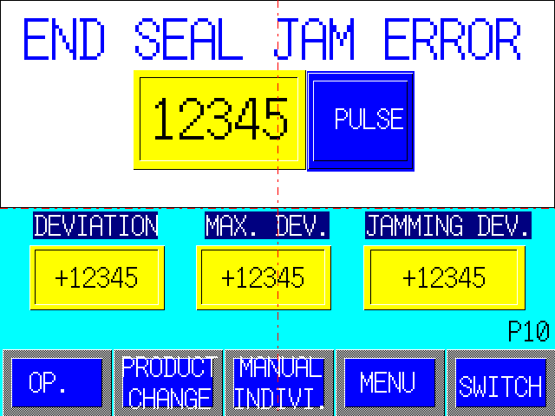
- Press “Pulse” button, value keyboard will be displayed on screen, and then input setting value.
- Setting value of end-seal meshing abnormity should be slightly more than “Maximum Deviation” (see picture display) of packer under normal operation such that packer can smoothly run and automatically stop in the case of end-seal overload for protection.

2．2．12 Non-package check picture（P11）
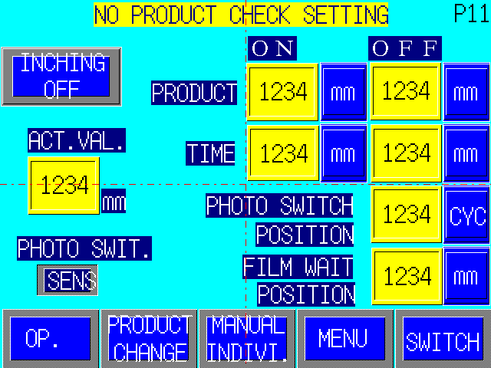
- When empty-bag prevention function is used for packing bag, set related parameters in this picture.
- Conditions for use of empty-bag prevention function:
- Photo switch output mode of empty-bag detection: L.ON (light, photo switch output)
- P45 parameters:（Menu→ P4: parameter setting→ P36: servo parameter→ P45）
- Empty-bag prevention: Yes
- Photo switch mode of non-package detection: No light ON
- P43 parameters:（Menu→ P4: parameter setting→ P36: mechanical parameter→ P43）
- M3 empty-bag prevention action choice: Special
- Empty-bag prevention action choice 2: Automatic
- Set switch of “Empty-bag Detection” in P5 into ON
- Related parameters:
- “Product Location”: Start inching of packer, if product has concealed photo switch (P11, “Detection Signal” light off), set “Current Value” into “OFF Value”, and continue inching packer, if product does not conceal photo switch (“Detection Signal” light up), set “Current value” into “ON value”.
- “Detection Timing”: Take two values between “OFF value” and “ON value” of “Product Location”, the littler is “ON value” of “Detection Timing”, and the bigger is “OFF value”. (Note: The values are current value during product making, that is, if photo switch has not been concealed during product making, there is no product).
- “Installation Location of Photo Switch”: That is, the distance between photo switch and the first fallen push rod and space between push rods.
- “Film wait position”: If product location is wrong when packer is restarted, this value would be adjusted to be correct.
- Setting of this value will lead to fast or slow startup of packer, the bigger value can make packer started slower.
For example:
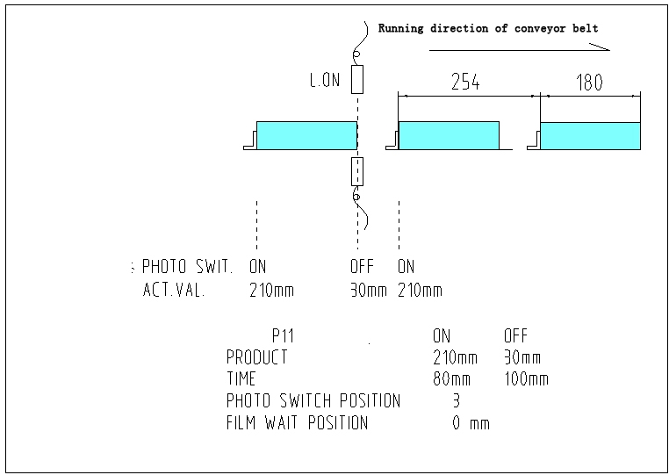

2．2．13 Package misalignment detection picture（P12）
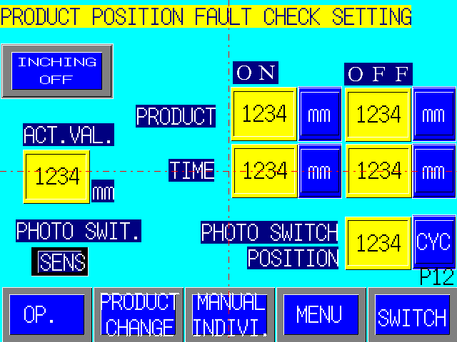

- Set related parameters in this picture in the use of misalignment detection function.
- Conditions for use of misalignment detection function:
- Photo switch output mode of misalignment detection: D.ON (no light, photo switch output)
- P45 parameters: （Menu→ P4: parameter setting→ P36: servo parameter→ P45）
- Product misalignment detection: Yes
- Photo switch mode of product misalignment detection: no light, ON
- Action after product misalignment detection: End-seal blade does not cut
- Empty-bag prevention action choice 2: Automatic
- Set switch of “Packing Material Misalignment Detection” in P5 into ON.
- Related parameters:
- “Product Location”: Start inching of packer, if product has concealed photo switch (P12 “Detection Signal” light up), set “Current value” into “ON value”, and continue inching packer, when product does not conceal photo switch (“Detection Signal” light off), set “Current Value” into “OFF value”.
- “Detection Timing”: Use a value slightly bigger than OFF value of “Product Location” as NO value of “Detection Timing”, and use a value littler than ON value of “Product Location” as OFF value of “Detection Timing”. In other words, when detecting at product interval location, photo switch is concealed, which expresses product misalignment.
- “Installation Location of Photo Switch”: That is, the distance between photo switch and end-seal machine, length of several bags.
For example:
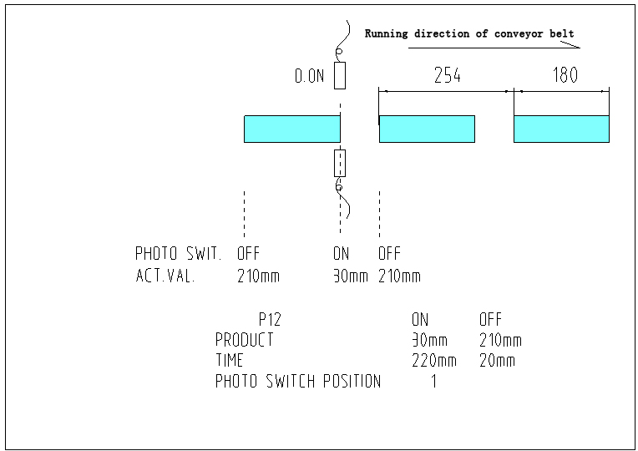
Running direction of conveyor belt

2．2．14 Data record picture（P13）
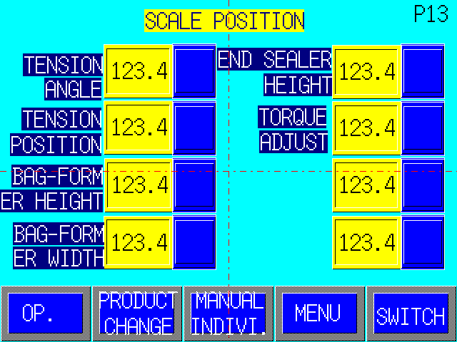

- This picture is related to data record frequently used for packer adjustment, there are 10 sets of such data corresponding to 10 products, which do not affect packer running, only used by operator as reference and record for machine adjustment.

2．2．15Output/input power signal picture（P14）（P30）
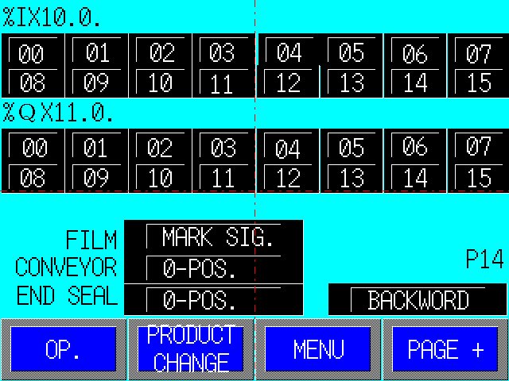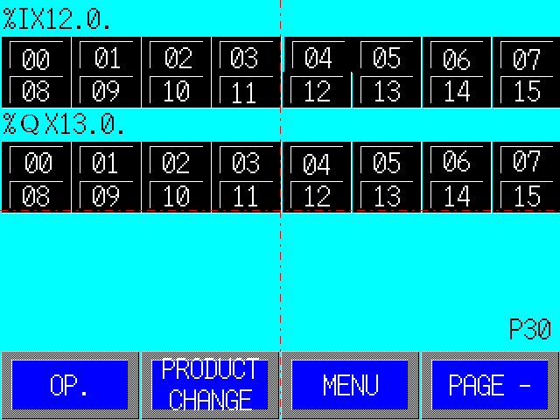

- This picture is related to monitor on running status of PLC I/O point.

2．2．16 Deviation/speed picture（P15）
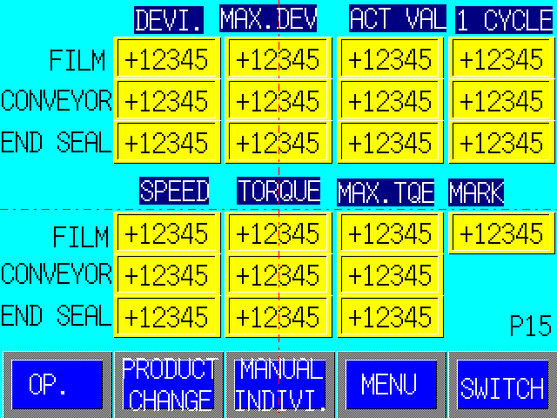

- This picture is related to monitor on running deviation and speed of servo motor.

2．2．17 Temperature record picture（P16）
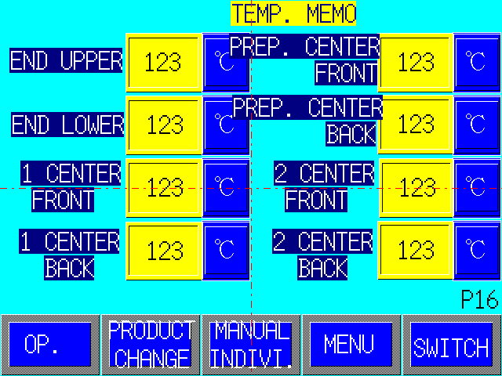

- This picture is related to temperature setting record of temperature controller in packer running, and there are 10 sets of such data corresponding to 10 products, which do not affect running of temperature controller, and only used by operator as reference and record of temperature regulation.

2．2．18 Automatic film connection picture（P19）（P29）
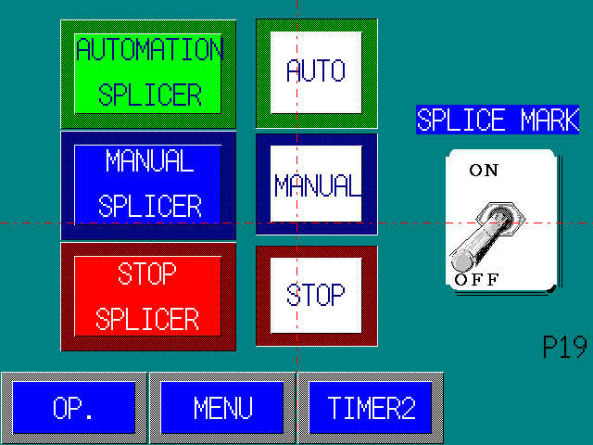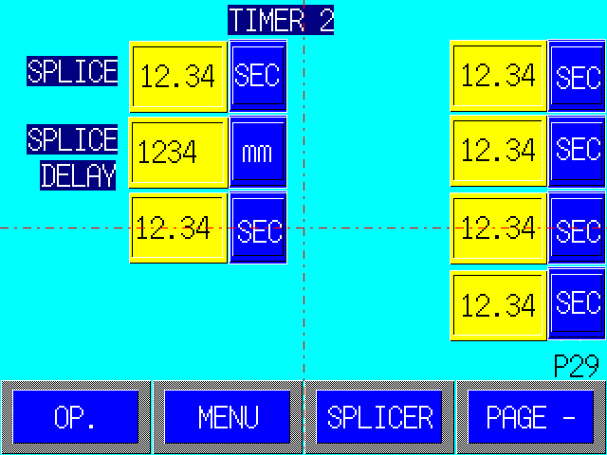

- This picture is related to automatic film connection of packer.
- “Automatic Film connection”: Press this key, and packer will be ready for automatic film connection, and “Auto” light up.
- “Stop Film Connection”: Press this key, and cancel preparing state for automatic film connection.
- “Manual Film Connection”: Press this key to move film connecting device (its movement only can be seen in packer running).
- “Print Mark” switch: If film has print mark, the switch is set “ON”; otherwise, set “OFF”.
- Automatic film connection process: First, packer is prepared for automatic film connection, non-film micro switch check film run out, then, tag photo switch detected mark (this step can be skipped if print mark switch is setting “OFF”), next, set delay time（P29）, film connecting mechanism starts acting, and subsequently operator should make preparations for film connection next time.
- Set action time and delay time of film connection in P29.

2．2．19 Product registration picture（P20）（P23）
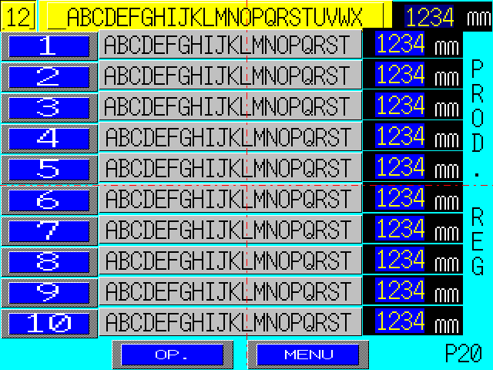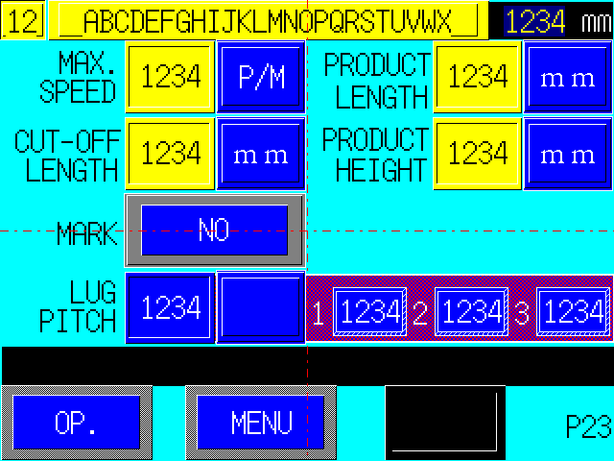

- Operation for product registration can modify product parameter and make new product.
- Product registration process: P4 menu picture → product registration key → P20 registration picture → serial number → P23 product parameter picture
- Make new product, after parameter input, press Registration key, otherwise, the data will be invalid.

2．2．20 Product deletion picture（P22）
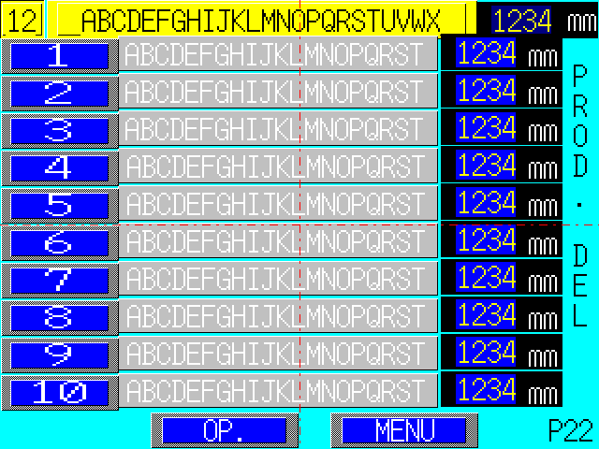

- Delete finished product in this picture, but product in use cannot be deleted.
- Press product serial number to be deleted and operate according to picture indication.
- Product deletion path: P4 menu → product deletion key → P22 product deletion picture → product serial number

2．2．21 End-seal stop angle picture（P24）
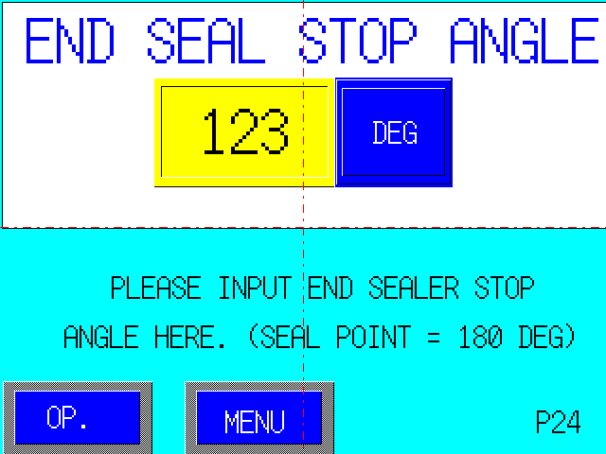

- Set angle of end-seal positioning stop in this picture, which is 0º usually.

2．2．22 Cut location adjustment picture（P25）
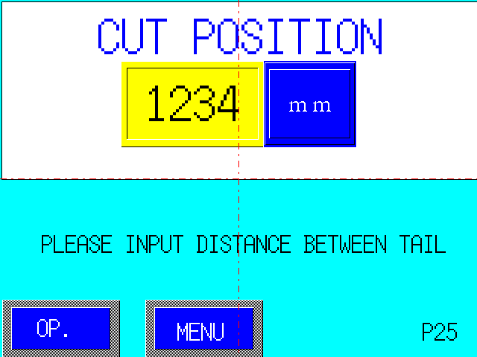
- This picture is related to adjustment of package cut location.
- Press “mm” key in the picture and input adjusted value. After input, touch screen automatically turn to P1 running picture, and the adjusted value will not continue to display in P25.

2．2．23 Product name registration picture（P26）（P27）（P28）

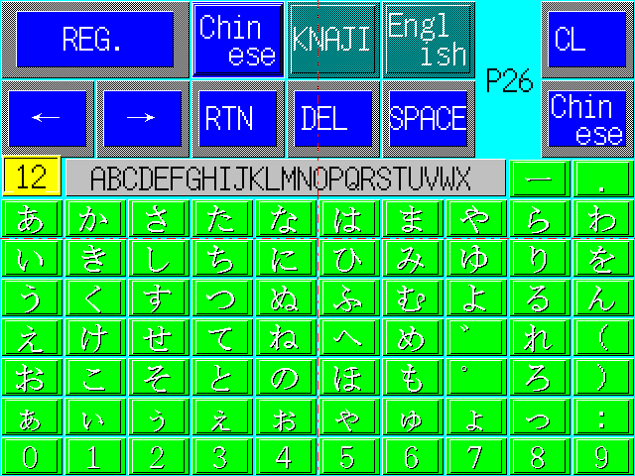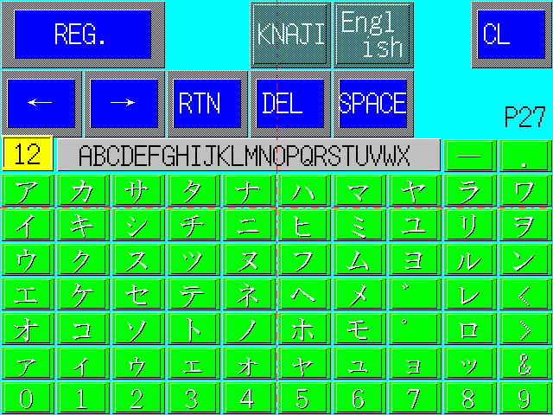

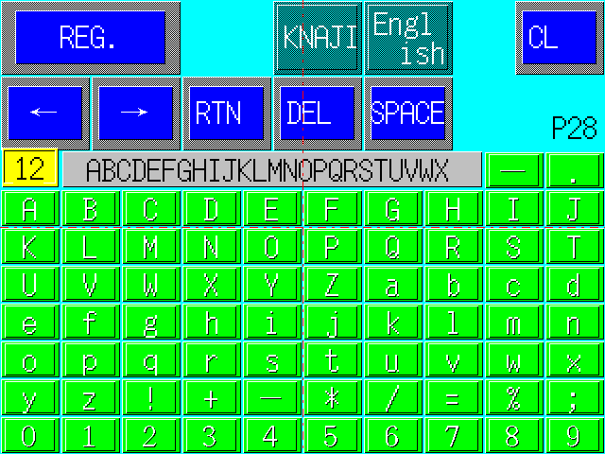

- These pictures are related to registration of new product name.

2．2．24 Adjustment picture（big screen）（P33）
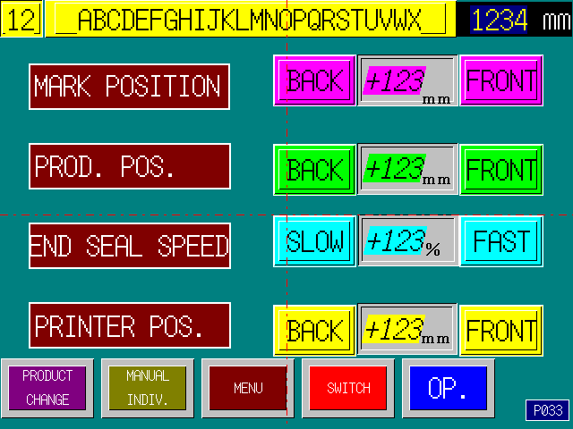
- Adjust mark location, product location, end-seal peripheral speed and printed character location in this picture on 10.4 inch touch screen.

2．2．25 Date adjustment picture（big screen）（P34）
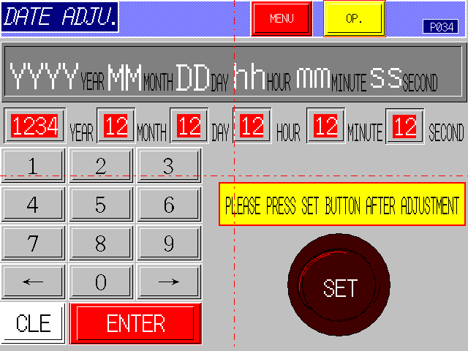

- Adjust date and time in this picture on 10.4 inch touch screen.

2．2．26 Parameter setting（cipher）picture（P35）（P36）
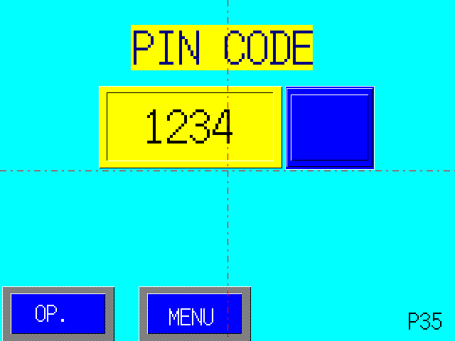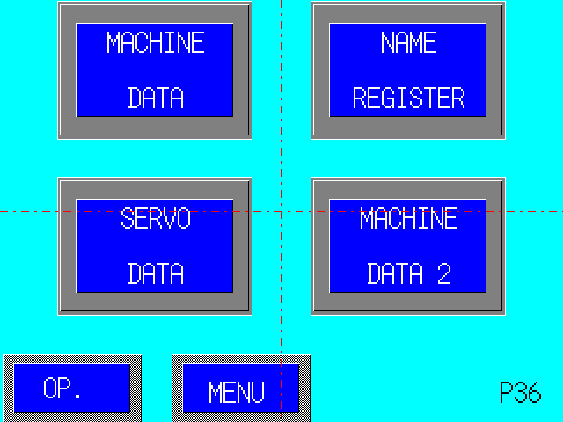

- Press “Parameter Setting” key in P4 menu picture and enter P35 cipher picture.
- If the cipher input is correct, enter P36 parameter menu picture to implement relevant operation.

2．2．27 Mechanical parameter picture（P37）~（P45）
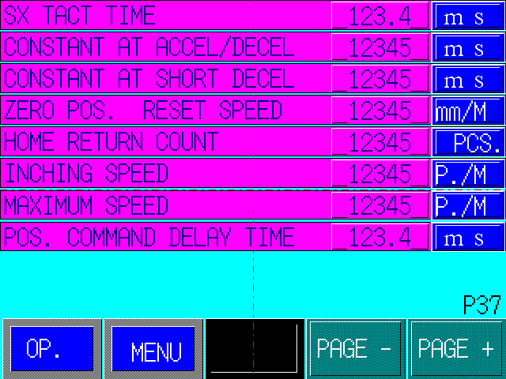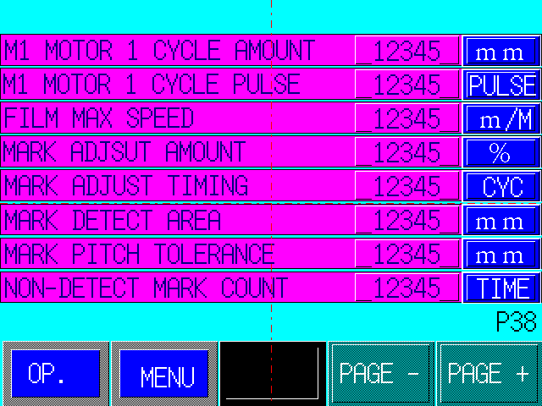

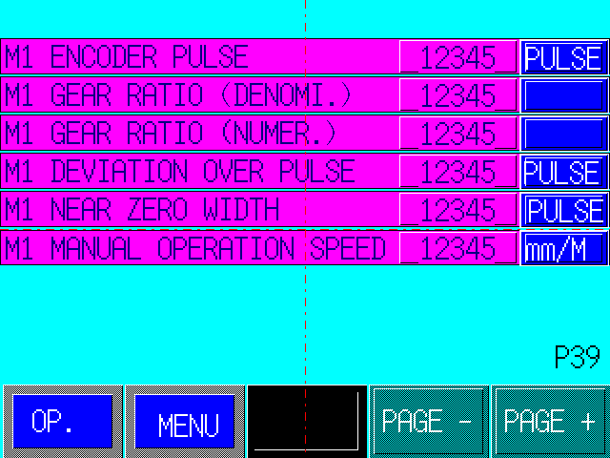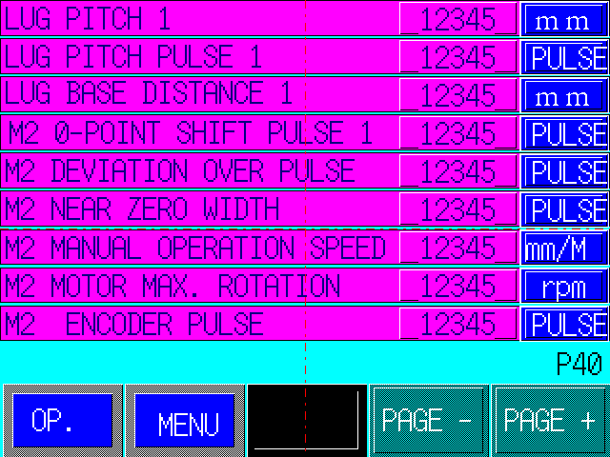

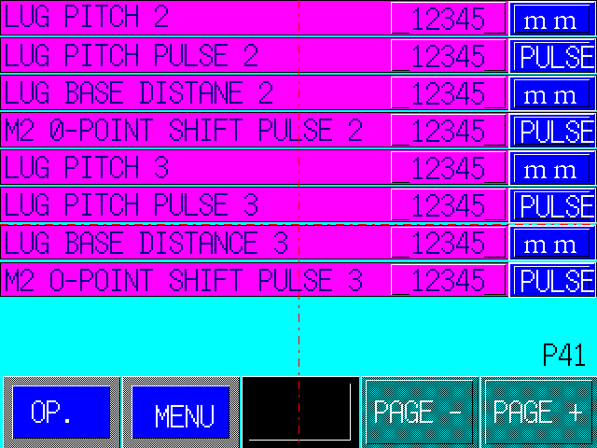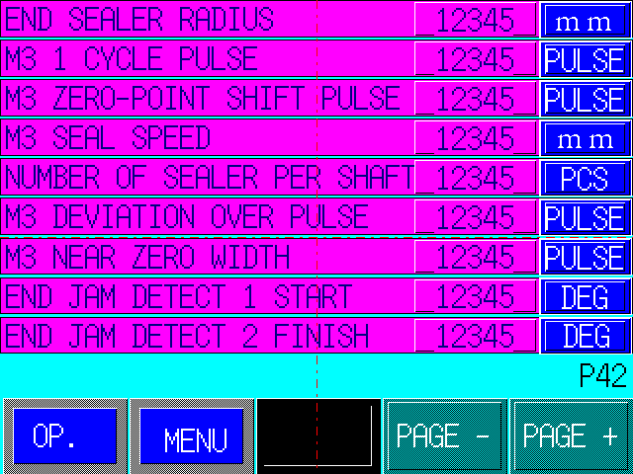
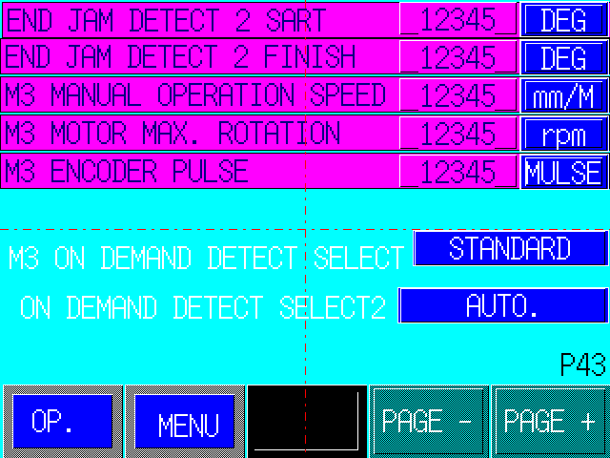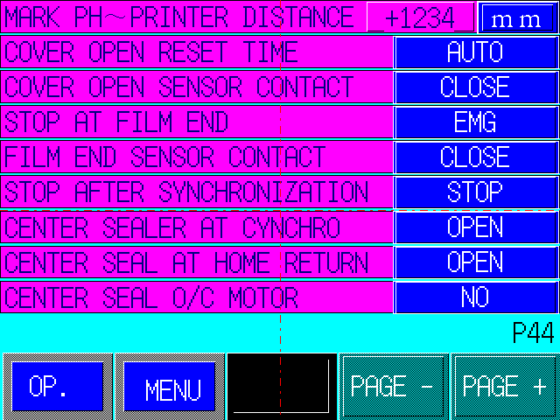

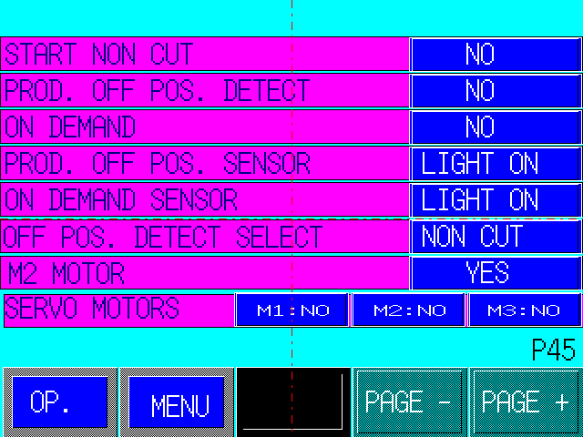

2．2．28 Servo parameter picture（P47）~（P52）
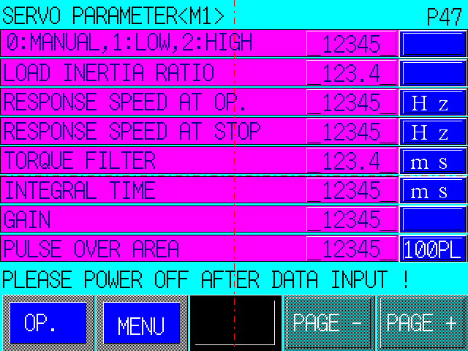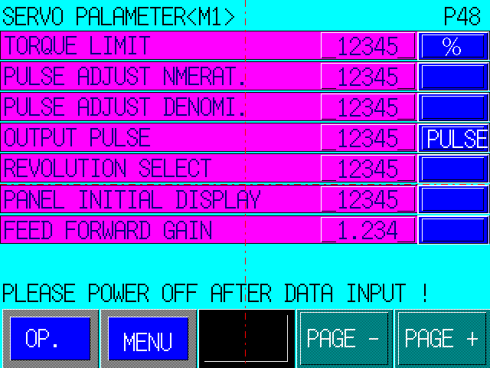

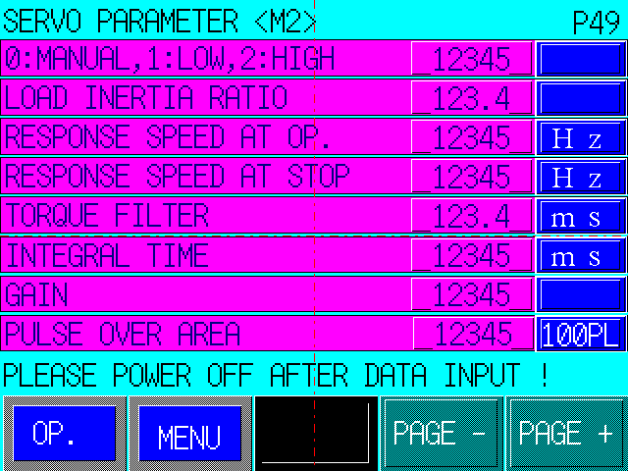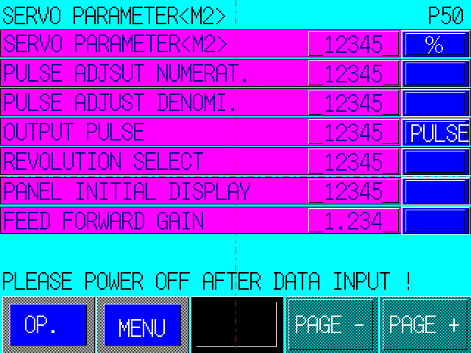

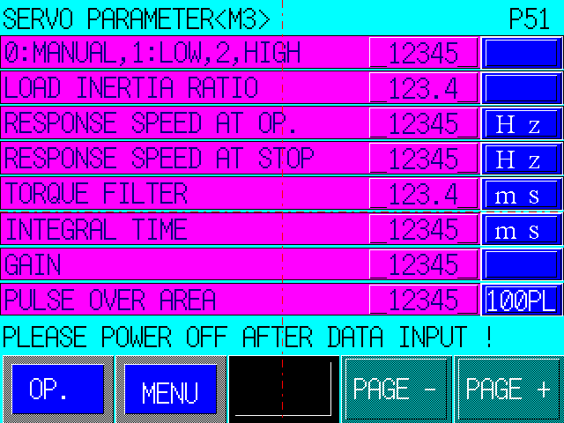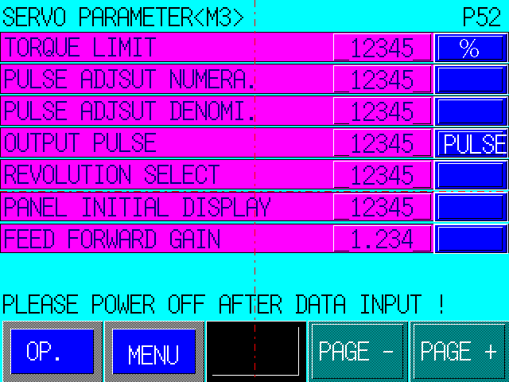

2．2．29 Mechanical parameter/servo parameter setting list

Pict. | Function | Set Value |  | Pict. | Function | Set Value
Packaging cam [P6] | Discharge (packaging cam) | ON  mm | OFF mm | [P24] | Angle of end-seal positioning stop | º
Packaging cam [P6] | (Packaging cam) | ON  mm | OFF mm | [P31] | Film-connecting action | 0.2 sec.
Packaging cam [P6] | Air inflation (conveyor belt cam) | ON  mm | OFF mm | [P31] | Film-connecting delay | 0.0 sec.
Packaging cam [P6] | Spray (conveyor belt cam) | ON  mm | OFF mm | [P31] | Print mark | ON
Packaging cam [P6] |  |  |  | Mechanical parameter Main axle [P37] | SX making period | 2.0 ms
End-seal cam [P6] | (End-seal cam) | ON  mm | OFF mm | Mechanical parameter Main axle [P37] | Acceleration set value | 3000 ms
End-seal cam [P6] | (End-seal cam) | ON  mm | OFF mm | Mechanical parameter Main axle [P37] | Urgent deceleration set value | 500 ms
End-seal cam [P6] | (Datum cam) | ON  mm | OFF mm | Mechanical parameter Main axle [P37] | Return speed to home position | 5000 mm  /min
End-seal cam [P6] | (Datum cam) | ON  mm | OFF mm | Mechanical parameter Main axle [P37] | Return number to set position | 1
End-seal cam [P6] |  |  |  | Mechanical parameter Main axle [P37] | Inching speed | 15  /min
Discharge setting [P8] | Connecting discharge | section |  | Mechanical parameter Main axle [P37] | Maximum packing speed | 250  /min
Discharge setting [P8] | Split discharge | section |  | Mechanical parameter Main axle [P37] | Instruction delay time of servo location | 6.0  ms
Discharge setting [P8] | Startup discharge | section |  | Mechanical parameter Main axle [P37] | Minimum linkage packing speed | 200  /min
Discharge setting [P8] |  |  |  | Mechanical parameter M1 Feed film [P38] | M1 motor rotary capacity (4 circles) | 251  mm
Time [P9] [P29] | Startup alarm | 3.0 sec |  | Mechanical parameter M1 Feed film [P38] | M1 motor rotary pulse (4 circles) | 10240  pulse
Time [P9] [P29] | Abnormal alarm | 3.0 sec |  | Mechanical parameter M1 Feed film [P38] | Maximum packing speed | 50m  /min
Time [P9] [P29] | Center-seal closing before | 0.05 sec |  | Mechanical parameter M1 Feed film [P38] | Mark rectification | 50%
Time [P9] [P29] | Center-seal open after | 0.05 sec |  | Mechanical parameter M1 Feed film [P38] | Mark rectification range | 3 circles
Time [P9] [P29] |  |  |  | Mechanical parameter M1 Feed film [P38] | Mark detection range | 15 mm
Time [P9] [P29] | Center-seal preheat closing delay | 0.0 sec |  | Mechanical parameter M1 Feed film [P38] | Permissible value of mark misalignment | 10 mm
Time [P9] [P29] | Discharge action | 0.5 sec |  | Mechanical parameter M1 Feed film [P38] | Permissible time of mark non-detected | 5 times
Time [P9] [P29] | Discharge delay | 0.0 sec |  | Mechanical parameter M1 Feed film [P39] | Pulse number of M1 pulse generator (1 circle) | 1024  pulse
Time [P9] [P29] |  |  |  | Mechanical parameter M1 Feed film [P39] | M1 gear ratio (numerator) | 1
[P10] | Permissible value of end-seal meshing abnormity | 100 pulse |  | Mechanical parameter M1 Feed film [P39] | M1 gear ratio (nominator) | 10
[P10] |  |  |  | Mechanical parameter M1 Feed film [P39] | M1 deviation overload pulse value | 2000  pulse
Empty-bag detection [P11] | Product Location | ON  mm | OFF  mm | Mechanical parameter M1 Feed film [P39] | M1 deviation pulse amplitude | 100 pulse
Empty-bag detection [P11] | Detection Timing | ON  mm | OFF  mm | Mechanical parameter M1 Feed film [P39] | M1 manual run speed | 3000 mm  /min
Empty-bag detection [P11] | Installation location of photo switch | 2 sections |  | Mechanical parameter M2 Conveyor belt [P40] | Space 1 between push rods (push rod 10P) | 127 mm
Empty-bag detection [P11] | Film wait position | Mm |  | Mechanical parameter M2 Conveyor belt [P40] | Pulse number of space 1 between push rods (push rod 10P) | 7680 pulse
Empty-bag detection [P11] |  |  |  | Mechanical parameter M2 Conveyor belt [P40] | Datum distance 1 of push rod | 912 mm
Misalignment detection [P12] | Product location | ON  mm | OFF  mm | Mechanical parameter M2 Conveyor belt [P40] | Pulse 1 of M2 home position displacement | 1 pulse
Misalignment detection [P12] | Detection timing | ON  mm | OFF  mm | Mechanical parameter M2 Conveyor belt [P40] | Pulse 1 of M2 deviation overload | 2000 pulse
Misalignment detection [P12] | Installation location of photo switch | 1 section |  | Mechanical parameter M2 Conveyor belt [P40] | M2 deviation pulse amplitude | 100 pulse
Misalignment detection [P12] |  |  |  | Mechanical parameter M2 Conveyor belt [P40] | M2 manual running speed | 3000 mm  /min
Product registration [P23] | Maximum packing capacity | /min |  | Mechanical parameter M2 Conveyor belt [P40] | Maximum rotary capacity of M2 motor | 5000 rpm
Product registration [P23] | Bag length | mm |  | Mechanical parameter M2 Conveyor belt [P40] | Pulse number of M2 pulse generator | 1024 pulse
Product registration [P23] | Product length | mm |  | Mechanical parameter [P41] | Space 2 between push rods
Product registration [P23] | Product height | mm |  | Mechanical parameter [P41] | Pulse number of space 2 between push rods
Product registration [P23] | Print mark | Yes |  | Mechanical parameter [P41] | Datum distance 2 of push rod | 912 mm
Product registration [P23] | Conveyor belt | No |  | Mechanical parameter [P41] | Pulse 2 of M2 home position displacement | 1 pulse
Mechanical parameter [P41] | Space 3 between push rods |  |  | M1 Feed film parameter [P47] | Time setting of torque filter | 0.3 ms
Mechanical parameter [P41] | Pulse number of Space 3 between push rods |  |  | M1 Feed film parameter [P47] | Integral time of speed regulator | 20 ms
Mechanical parameter [P41] | Datum distance 3 of push rod | 912 mm |  | M1 Feed film parameter [P47] | Increasing amplitude of location regulator | 50
Mechanical parameter [P41] | Pulse 3 of M2 home position displacement | 1 pulse |  | M1 Feed film parameter [P47] | Deviation overload range | 10000 100PL
Mechanical parameter M3 End-seal [P42] | End-seal radius (rotation.5 BX-15) | 45mm (BX) |  | M1 Feed film Servo parameter [P48] | Maximum torque limit value | 300%
Mechanical parameter M3 End-seal [P42] | Pulse number of 1 end-seal cycle | 8192 pulse |  | M1 Feed film Servo parameter [P48] | Instruction pulse rectification (numerator) | 64
Mechanical parameter M3 End-seal [P42] | Pulse number of M3 home position displacement | 1024 pulse |  | M1 Feed film Servo parameter [P48] | Instruction pulse rectification (nominator) | 1
Mechanical parameter M3 End-seal [P42] | M3 constant-velocity feeding capacity | 35 mm |  | M1 Feed film Servo parameter [P48] | Output power pulse | 1024 pulse
Mechanical parameter M3 End-seal [P42] | Number of end-seal blade holder | 2 pairs | Double blades: 2 pairs | M1 Feed film Servo parameter [P48] | Rotary direction switch | 1
Mechanical parameter M3 End-seal [P42] | M3 deviation overload pulse value | 2000 pulse |  | M1 Feed film Servo parameter [P48] | Initial expression of control panel | 9
Mechanical parameter M3 End-seal [P42] | M3 amplitude | 100 pulse |  | M1 Feed film Servo parameter [P48] | Feeding forward feedback | 1.0000
Mechanical parameter M3 End-seal [P42] | Starting angle of meshing detection 1 | 90º |  | M2 conveyor belt Servo parameter [P49] | Standard, 1: Low rigidity 2: high rigidity | 1
Mechanical parameter M3 End-seal [P42] | End angle of meshing detection 1 | 200º |  | M2 conveyor belt Servo parameter [P49] | Load inertial ratio | 15
Mechanical parameter M3 end-seal [P43] | Starting angle of meshing detection 2 | 90º |  | M2 conveyor belt Servo parameter [P49] | Speed response to action | 100 Hz
Mechanical parameter M3 end-seal [P43] | End angle of meshing detection 2 | 200º |  | M2 conveyor belt Servo parameter [P49] | Speed response to stop | 50 Hz
Mechanical parameter M3 end-seal [P43] | M3 manual run speed | 3000  mm  /min |  | M2 conveyor belt Servo parameter [P49] | Time setting of torque filter | 1.0 ms
Mechanical parameter M3 end-seal [P43] | Maximum rotary capacity of M3 motor | 5000  Rpm |  | M2 conveyor belt Servo parameter [P49] | Integral time of speed regulator | 20 ms
Mechanical parameter M3 end-seal [P43] | Pulse number of M3 pulse generator | 2048 pulse | Double blades: 2048 | M2 conveyor belt Servo parameter [P49] | Increasing amplitude of location regulator | 15
Mechanical parameter M3 end-seal [P43] |  |  |  | M2 conveyor belt Servo parameter [P49] | Deviation overload range | 10000 100PL
Mechanical parameter M3 end-seal [P43] | M3 empty-bag prevention action choice | Special |  |  | Maximum torque limit value | 300%
Mechanical parameter [P44] | Distance between mark photo switch and print character | mm |  | M2 conveyor belt Servo parameter [P50] | Instruction pulse rectification (numerator) | 64
Mechanical parameter [P44] | Restore mode after safety cover open | Auto restore |  | M2 conveyor belt Servo parameter [P50] | Instruction pulse rectification (nominator) | 1
Mechanical parameter [P44] | Safety cover detecting switch contact | B contact |  | M2 conveyor belt Servo parameter [P50] | Output power pulse | 1024 pulse
Mechanical parameter [P44] | Stop action at packaging end | Set stop |  | M2 conveyor belt Servo parameter [P50] | Rotary direction switch | 0
Mechanical parameter [P44] | Detecting switch contact at packaging end | 0 contact |  | M2 conveyor belt Servo parameter [P50] | Initial expression of control panel | 9
Mechanical parameter [P44] | Action after initial location adjustment | Stop |  | M2 conveyor belt Servo parameter [P50] | Feed forward feedback | 1.0000
Mechanical parameter [P44] | Center-seal action after initial location adjustment | Open |  | M3 end-seal Servo parameter [P51] | 1: low rigidity | 1
Mechanical parameter [P44] | Center-seal action in set stop | Open |  | M3 end-seal Servo parameter [P51] | Load inertial ratio | 15
Mechanical parameter [P44] | Center-seal motor type open/closing | No |  | M3 end-seal Servo parameter [P51] | Speed response to action | 120 Hz
Mechanical parameter [P45] | Startup discharge function | No |  | M3 end-seal Servo parameter [P51] | Speed response to stop | 100 Hz
Mechanical parameter [P45] | Product misalignment detection function | Yes |  | M3 end-seal Servo parameter [P51] | Time setting of torque filter | 0.3 ms
Mechanical parameter [P45] | Empty-bag prevention function | No |  | M3 end-seal Servo parameter [P51] | Integral time of speed regulator | 20 ms
Mechanical parameter [P45] | Photo switch mode of product misalignment detection | No light ON |  | M3 end-seal Servo parameter [P51] | Increasing amplitude of location regulator | 48
Mechanical parameter [P45] | Photo switch mode of empty-bag detection | No light ON |  | M3 end-seal Servo parameter [P51] | Deviation overload range | 10000 100PL
Mechanical parameter [P45] | Action after product misalignment detection | No cut |  | M3 end-seal Servo parameter [P52] | Maximum torque limit value | 300%
Mechanical parameter [P45] | M2 motor choice | Yes |  | M3 end-seal Servo parameter [P52] | Instruction pulse rectification (numerator) | 32 | Double blades: 32
Mechanical parameter [P45] | Effective axle choice | M1, M2, M3 |  | M3 end-seal Servo parameter [P52] | Instruction pulse rectification (nominator) | 1
M1 Feed film Parameter | Standard 1: low rigidity 2: high rigidity | 1 |  | M3 end-seal Servo parameter [P52] | Output power pulse | 2048 | Double blades: 2048
M1 Feed film Parameter | Load inertial ratio | 15 |  | M3 end-seal Servo parameter [P52] | Rotary direction switch | 0
M1 Feed film Parameter | Speed response to action | 100Hz |  | M3 end-seal Servo parameter [P52] | Initial expression of control panel | 9
M1 Feed film Parameter | Speed response to stop | 120Hz |  | M3 end-seal Servo parameter [P52] | Feeding forward feedback | 1.0000

2．2．30 Temperature control picture（big screen）(P67) (P68)

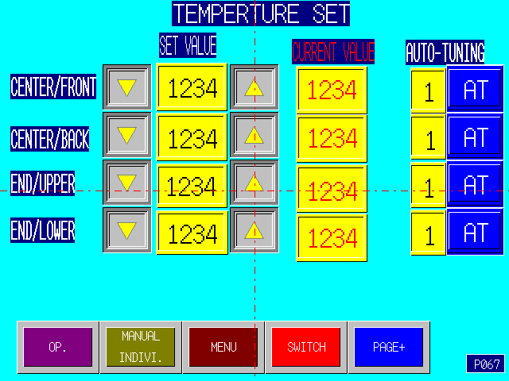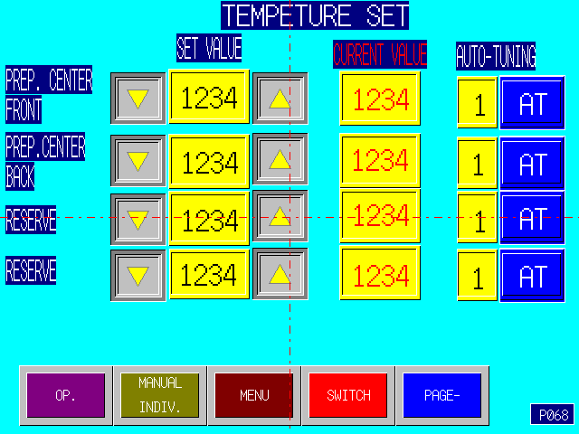

- Monitor temperature of heater in this picture on 10.4 inch touch screen. Automatic setting function: Press “AT” key, input “1” to start automatic setting of temperature controller, after through several heating cycle, the controller will automatically set PID parameter; and number display automatically returns to “0”.

2．2．31 Alarm picture
- In the case of packer fault, the following picture will display on touch screen, and operate according to corresponding instructions.
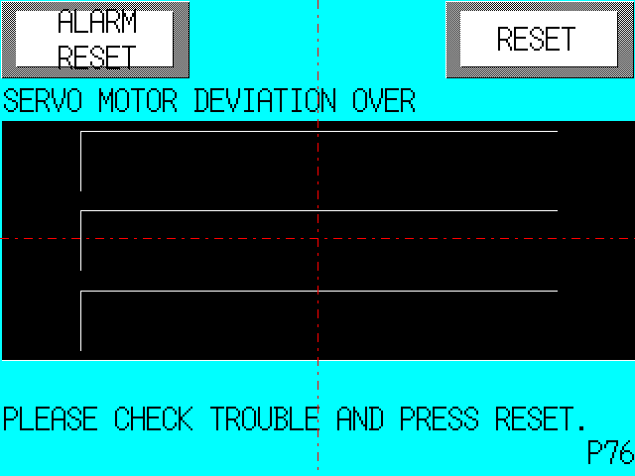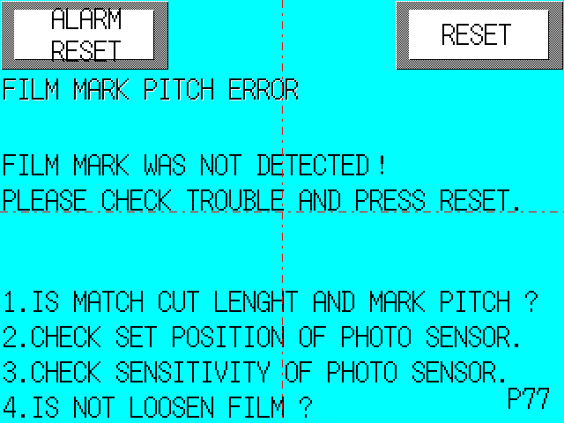
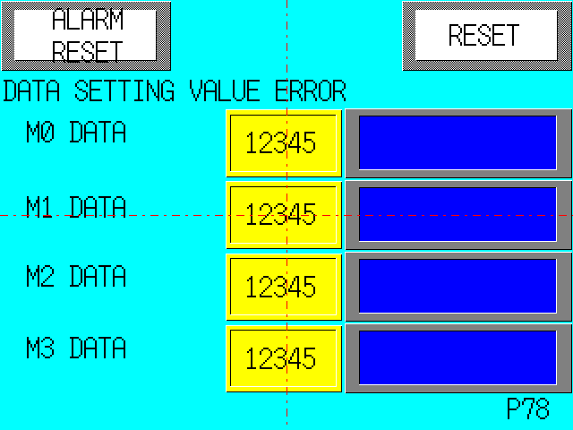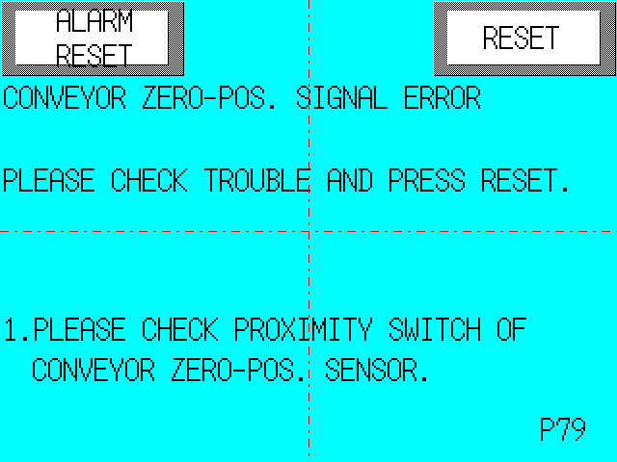
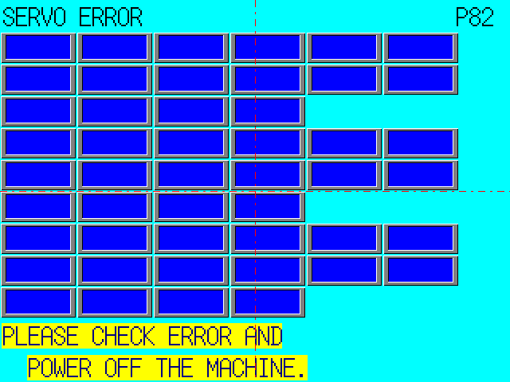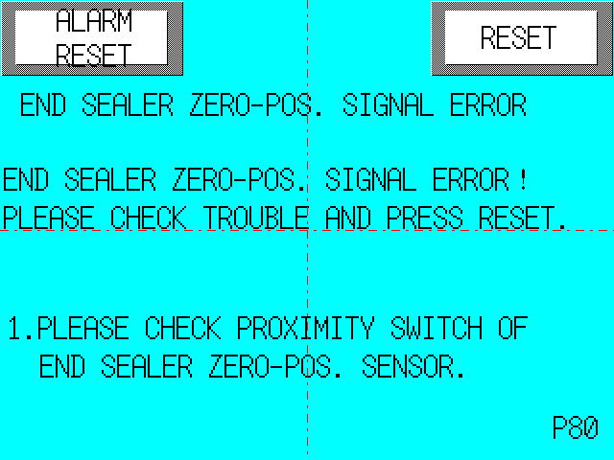

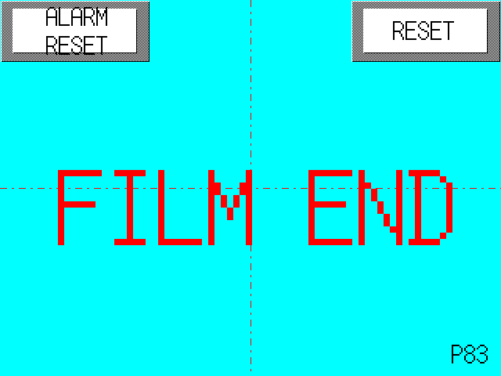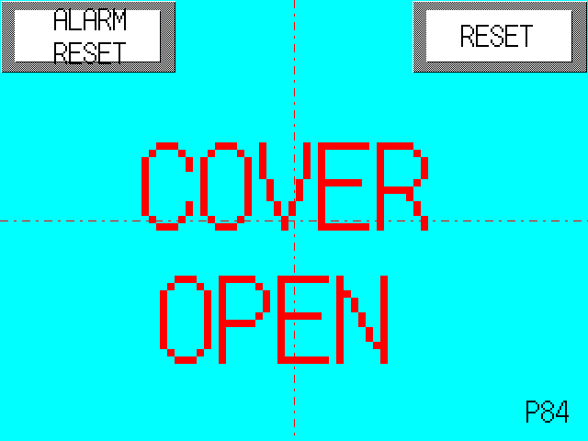

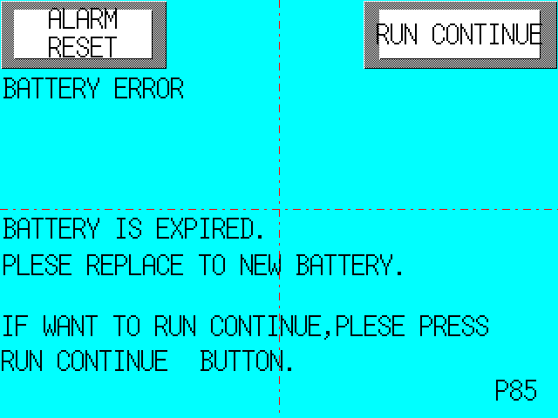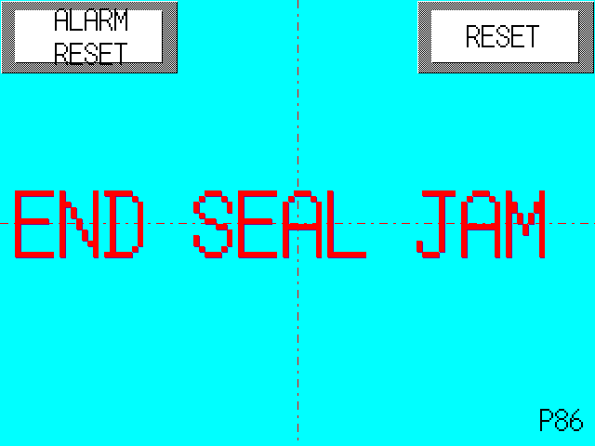

3．Commissioning and operating method of packer
After electrical assembly of packer is completed, carefully check and confirm connecting line and power supply, then, power on packer, and carry out commissioning for it with the following steps. (User of packer will not need to carry out step 1, 2, 3 and 6 because these adjustments have been fulfilled before the equipment leaves factory.）

3．1 Convey PLC and touch screen program

3．2 Convey mechanical parameter, servo parameter and alarm name
- Operate on touch screen according to the parameter list, such data varied for different packer type as end-seal radius, blade number, maximum packing speed and space between push rods etc.

3．3 Adjust servo motor steering
- In P3 picture, separately run end-seal axle, push rod axle and film-feeding axle motor, and observe motor running direction.
- In P48, P50 and P52, adjust servo parameter (change parameter of “Return Direction” into “0” or “1”) to make motor run in correct direction.
Note: After servo parameter is changed, cut off power supply of packer and then power on, only after that, the adjustment will take effect, and sometimes, it is necessary to repeatedly perform the above to change running direction of motor.

3．4 Make a packing product on touch screen (name and specification)
- In P4 menu picture, press “Product Registration” key;
- Enter P20 picture, press a serial number with no name (for example, “1”), press Make key（made into data of new product）;
- Enter P26 name registration picture, input a product name （for example, “ABC”）, and press “Registration” key;
- Enter P23 picture, input “Maximum Packing Capacity”, “Bag Length”, “Product Length” and “Product Height”; select mark “Yes” or “No” and space between push rods.
- Press “Log On” key after conclusion of data input.

3．5 Set end-seal meshing deviation
- In P4 menu picture, press “End-seal Deviation” key;
- Enter P10 picture, set end-seal meshing abnormity value, which should be slightly above “Maximum Deviation” (see picture display) of packer under normal running such that packer can automatically stop running in the case of end-seal overload for protection, usually, 100 (pulse).

3．6 Adjust home position of servo motor
- Check if home position signal of servo motor is normal in P14 I/O picture.
- Home position of M1 film feeding motor: Photo switch detects print mark of package, and it’s no need to adjust home position.
- Home position of M2 conveyor belt: Proximity switch detects cam, home position: Adjust cam for detection by proximity switch when the first push rod (on the side of bag maker) of conveyor belt falls down.
- Home position of M3 end-seal motor: Of the two cams mounted on end-seal motor axle, one is home position cam（the small plate）, its function is to provide home position signal; the other is positive rotary stop cam (big semicircular disc), and its function is to protect package from pressing when end-seal returns to home position (slow speed will burn down package).
- Adjusting method: Turn end-seal to open vertically (open horizontally in the case of double blades), adjust home position cam and positive rotary stop cam to enter the central location of photo switch, see the picture. Note: The adjustment only can be in effect after power off and on again. Correct location of cam is subject to that end-seal returns home position without pressing package and opens vertically (open horizontally in the case of double blades).
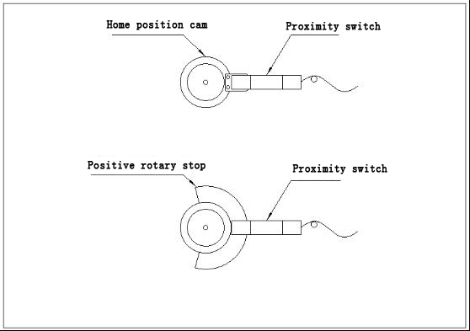

3．7 Adjust cut location
- After the above adjustment is completed, packer can be used for product.
Press startup button →packer returns to home position →press startup button once more → packer run →adjust speed in P1 running picture →press set stop button →packer stop running
- The methods for adjustment of cut location include:
  - Adjust cut location in P25, and press “Cut Location” key in P4 menu picture (note: if product data is non-print mark, there would be no “Cut Location” display in menu picture), enter P25 to input adjusting value, and automatically back to P1 running picture (note: input value has been actually adjusted, although it is not preserved in P25 picture);
  - Adjust in P1 running picture, press mark location “Front” and “Back” to change cut location.

3．8 Adjust product location

- In P1 picture, press “Front” and “Back” of “Product Location” to change location of product.

3．9 Adjust end-seal peripheral speed
- Improper end-seal peripheral speed will cause film heap or pulling in end-seal meshing. The adjusting method for peripheral speed is:
  - In P1 picture, press “Slow” or “Fast” of end-seal peripheral speed;
  - If it still cannot meet the requirement, adjust end-seal radius value in mechanical parameter P42 picture. Generally, increasing ↑ the radius will reduce ↓ peripheral speed. In adjustment, its value should not be changed greatly each time, and 2~3mm is recommended, the changing law of peripheral speed will be different when end-seal radius value exceeds a certain range.

3．10 Adjustment of automatic film connection
- In P4 menu picture, press “Automatic Film Connection” key and enter P19.
- Functions of all keys:
“Print Mark Switch of Film Connection”: If packing material has a mark, set the switch “ON”, otherwise, “OFF”.
“Automatic Film Connection”: Press it to make packer enter preparing state for automatic film connection.
“Manual Film Connection”: Press it to actuate film connecting clutch once and check if the mechanism is in good condition.
“Stop Film Connection”: Press it to cancel preparing state for automatic film connection.
“Time 2”: Press it to enter P29 and set action time and delay value of film connection.
- Action process of film connection:
  - Package with mark: Package run out →Non-film switch act →Photo switch detects mark →Delay set value → Clutch acts → Cancel preparatory state for automatic film connection.
  - Package without mark: Package run out →Non-film switch act →Delay set value →Clutch act →Cancel preparatory state for automatic film connection.

3．11 Adjustment of automatic diffusing surface
- Conditions for use of automatic diffusing surface: Photo switch mode of diffusing surface detection: D.ON;
Photo switch mode of upper and lower limit detection: L.ON
- Adjust time of diffusing surface in P6: “Conveyor Cam Diffusing Surface ON Value”, the littler the value is, the earlier the surface is conveyed; the greater the difference between OFF value and ON value is, the fewer the times clutch of diffusing surface pauses.
- Choose to use or not use upper and lower limit of diffusing surface in P18.
- Photo switch of upper limit of diffusing surface is mounted upstream on conveyor belt in the back of diffuser, and lower limit mounted downstream. The function is: Start to store surface when production begins, and packer only can be actuated after stored surface firstly blocks photo switch of lower limit until blocks that of upper limit. If material feeding is not adequate, stored surface would not conceal photo switch of upper limit up to not conceal that of lower limit, until this moment the packer will stop running. Packer can start up and stop automatically. Set “Upper and Lower Limit Switch” into “ON” in P18, this function will be in effect; set “OFF”, this function will be invalid.

3．12 Adjustment of empty-bag prevention
- In use of empty-bag prevention function, if photo switch detects out no product on conveyor belt, end-seal axle and film feeding axle of packer would automatically stop, but conveyor belt not stop until there is a product detected on it, and then the two axles will start running automatically.
- Conditions for use of empty-bag prevention function:
  - Photo switch of detection: L.ON
  - Mechanical parameter in P45 picture: Set “Empty-bag Prevention” “Yes”, and “Photo Switch Mode of Non-package Detection” “no light, ON”
  - Mechanical parameter in P43 picture: Set “M3 empty-bag prevention action choice” “Special”
  - P5 switch picture: Set “Empty-bag Detection” switch “ON”
- Setting in P11 picture:
  - “Product Location”: Start inching of packer, if product has concealed photo switch (P11, “Detection Signal” light off), set “Current value” into “OFF value”, and continue inching packer, if product does not conceal photo switch (“Detection Signal” light up), set “Current value” into “ON value”.
  - “Detection Timing”: Take two values between “OFF value” and “ON value” of “Product Location”, the littler is “ON value” of “Detection Timing”, and the bigger is “OFF value”. (Note: The values are current value during product making, that is, if photo switch has not been concealed during product making, there is no product).
  - “Installation Location of Photo Switch”: The distance between photo switch and the first fallen push rod and space between push rods.
  - “Film wait position”: If product location is wrong when packer is restarted, this value would be adjusted to be correct.

3．13 Adjustment of misalignment detection
- Conditions for use of misalignment detection function:
  - Photo switch mode of detection: D.ON
  - Mechanical parameter in P45 picture: Set “Product Misalignment Detection ” “Yes”, and “Photo Switch Mode of Product Misalignment Detection” “no light, ON”
  - P5 switch picture: Set “Package Misalignment Detection” switch “ON”
- Setting in P12 picture:
  - “Product Location”: Start inching of packer, if product has concealed photo switch (P12, “Detection Signal” light up), set “Current value” into “ON value”, and continue inching packer, if product does not conceal photo switch (“Detection Signal” light off), set “Current value” into “OFF value”.
  - “Detection Timing”: Use a value slightly bigger than OFF value of “Product Location” as OFF value, and use a value littler than ON value of “Product Location” as ON value of “Detection Timing”. (Note: The selected value is current value with no product block, that is, photo switch should not be concealed, and otherwise, it expresses product misalignment.)
  - “Installation Location of Photo Switch”: The distance between photo switch and the end-seal and space between push rods.

4．Treatment of general abnormal condition
- Phenomenon: Adjusted product location is changed again after power on.
Cause: Usually, because gear number of home position cam of conveyor belt are not equal to chain node number of push rod.
- Phenomenon: Great change of cut location.
Cause: Please check if, in P23 picture, “Mark” is set “Yes”.
- Phenomenon: Abnormal function of empty-bag prevention, stopping a bag after passing a bag.
Cause: Conditions for use of empty-bag prevention are not satisfied, for example, incorrect photo switch mode.
- Phenomenon: Bag pulling occurs when end-seal meshing, adjustment of peripheral speed and radius do not work.
Cause: End-seal home position is wrong.
- Phenomenon: Abnormal function of empty-bag prevention, that is, end-seal acts twice when passing one product.
Solution: Change installation location of photo switch, or change detection timing value.
- Phenomenon: When empty-bag prevention works, end-seal stop location is undesirable, not set stop location.
Solution: In P43 picture, “M3 Empty-bag Prevention Action Choice” is set “Special”.
- Phenomenon: Although photo switch can detect out product misalignment, end-seal blade stop so slowly up to cut product (section number of installation location of photo switch is the minimum and its location cannot get away from end-seal blade further).
Solution: In P45 picture, “Action after Product Misalignment Detected” is set “Unusual Stop”, i.e., packer will stop running immediately after misalignment and be started when completion of manual treatment.

5．Explanation for fault alarm code of servo driver
No. | Fault Alarm Code | Explanation
1 | AL SE | System fault
2 | AL OC | Over current
3 | AL OS | Over speed
4 | AL Lu | Low voltage
5 | AL Hu | High voltage
6 | AL Et | Encoder trouble
7 | AL Ct | Circuit trouble
8 | AL dE | Memory error
9 | AL Fb | Fuse brown
10 | AL CE | Electrical unit and error
11 | AL rH2 | Regenerated resistor overheat
12 | AL EC | Encoder communication error
13 | AL CtE | CONT signal error
14 | AL OL | Over Load
15 | AL rH | Regenerated resistor overheat
16 | AL OF | Deviation error
17 | AL RH | Amp overheat
18 | AL EH | Encoder overheat
19 | AL RL | ABS data loss
20 | AL RF | Multiple rotary date error
21 | AL tE | Bus communication error
22 | AL --- | Detection error

