**HƯỚNG DẪN SỬ DỤNG VAGRANT BOX**

**Mô hình deploy Nginx using Ansible.**

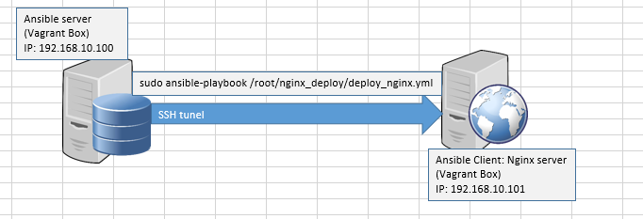

1. **Clone thư mục thư mục chứa Vagrant box về local**

git clone <https://github.com/cuonghm2809/deploy_nginx.git>

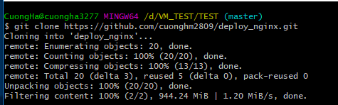

1. Tạo 2 folder folder để chứa Vagrant Box cho Ansible server, và Ansible client.

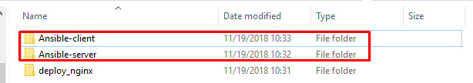

1. Copy Ansible.box to Ansible-server, Nginx.box to Ansible-client

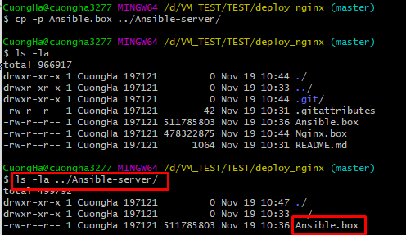

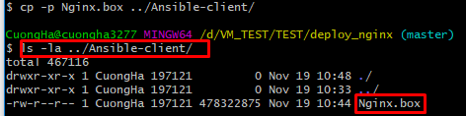

1. Add Vagrant box to Vagrant

* Vào folder Ansible-server, and add vagrant box for Ansible server
* Execute command: vagrant box add --name Ansibe-SV Ansible.box

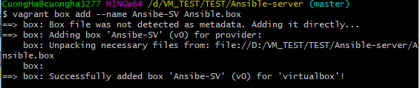

* Vào folder Ansible-client, and add vagrant box for Ansible client.
* Execute command: vagrant box add --name Ansibe-CL Nginx.box

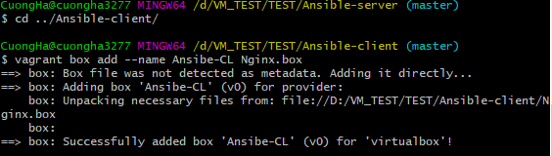

1. Check Box existence

* Execute command: vagrant box list

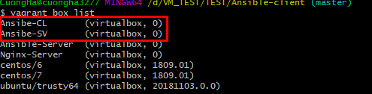

1. Init vagrant box for Ansible-client

Execute command: vagrant init Ansible-CL

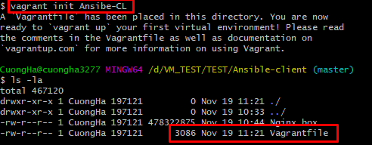

1. Edit Vagrantfile to configure IP static

Command: vim Vagrantfile

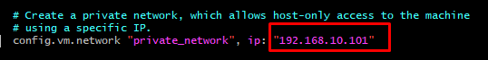

1. Khởi động máy ảo

Command: vagrant up

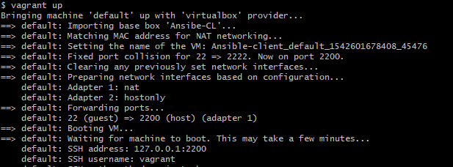

Check VM

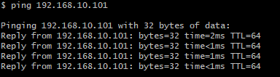

1. Tương tự với Ansible-server

Command: vagrant init Ansible-SV

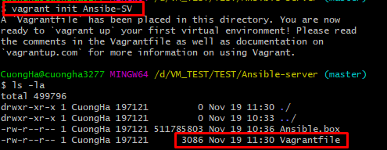

1. Edit file Vagrantfile with IP: 192.168.10.101

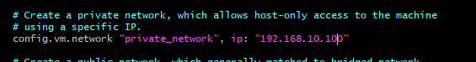

1. KHởi động Ansible server

Command: vagrant up

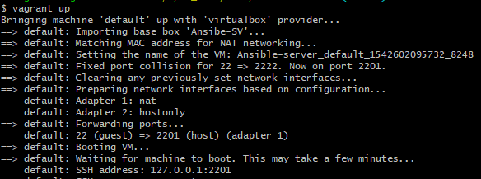

1. Check VM

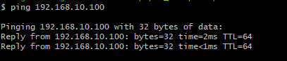

1. SSH to Ansible server

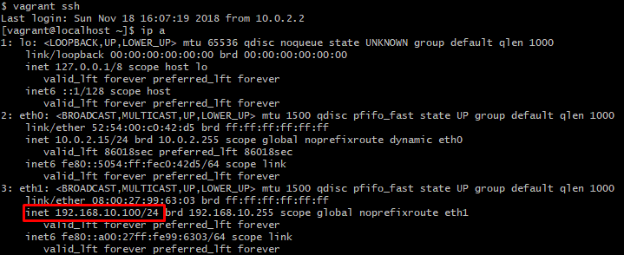

1. Check Ansible client from Ansible server

Cat /etc/ansible/hosts



Command: sudo ansible -m ping all

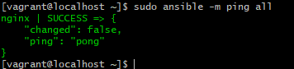

Note: Bởi vì ssh vào vagrant server dung user default: vagrant => Cần phải sudo để execute command.

1. Test SSH key

Command: sudo ssh root@192.168.10.101



1. Deploy Nginx and configure virtual host using Ansible.

* Check folder chứa file deploy:

Command: tree

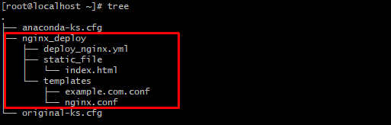

* Deploy Nginx to Ansible client.

Command: sudo ansible-playbook /root/nginx_deploy/deploy_nginx.yml

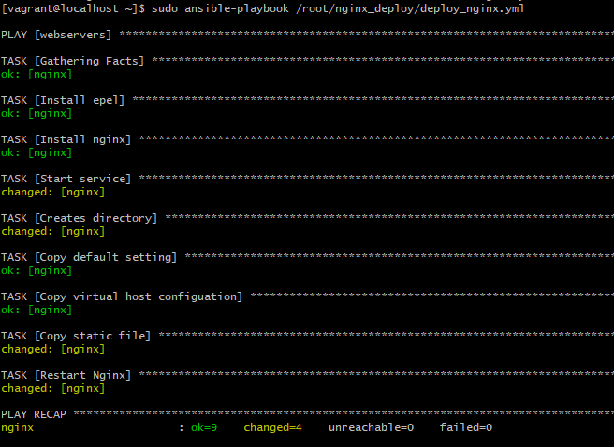

1. Check webpage

Access: http://192.168.10.101/

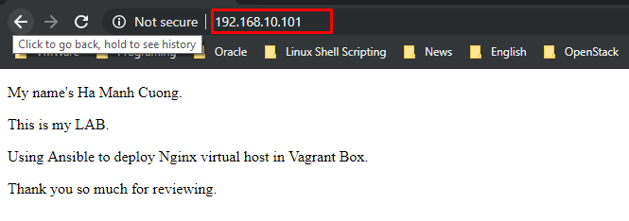

1. Check nginx configuration trên máy ansible client

* Check nginx.conf
* Command: cat /etc/nginx/nginx.conf

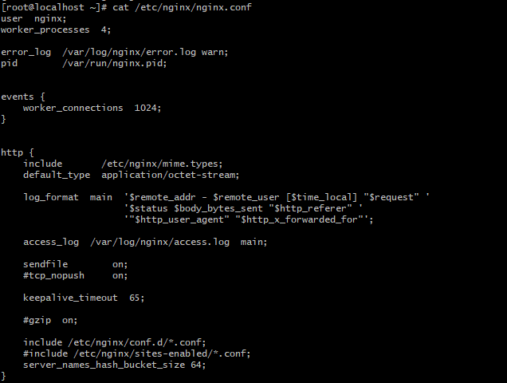

* Check virtual host configuration: example.com.conf
* Command: cat /etc/nginx/conf.d/example.com.conf

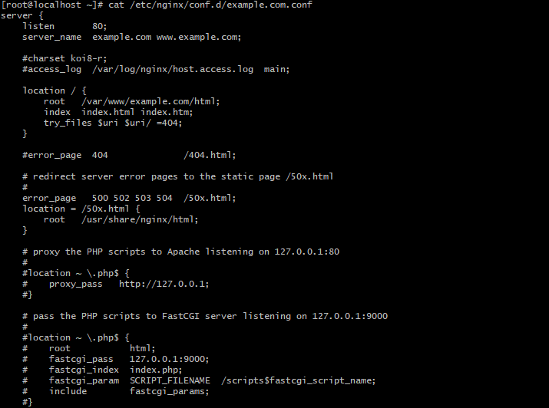

* Check file index.html
* Command: cat /var/www/example.com/html/index.html

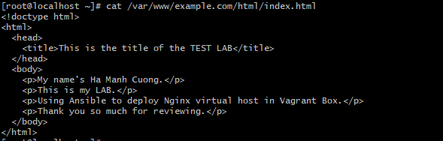

* Ansible đã deploy và tạo ra thư mục /var/www/example.com/html
* Phân quyền thư mục cũng như gán quyền cho file index.html

Command: ls -ls /var/www/example.com/



Mode: 0755

Command: ls -ls /var/www/example.com/html/



Mode: 0644

SSH key: cat .ssh/authorized_keys

