

**SOFTWARE REQUIREMENT SPECIFICATION**

**<<SALES MANAGEMENT APP>>**

– Hanoi, March 2024 –

Table of Contents

I. Product Overview 6

1. Product Vision 6

2. Product Context 6

3. Major Features 7

4. User Requirements 8

4.1 Actors List 8

4.2 Use Cases 9

5. Business Rules 19

II. Use Case Specifications 21

1. Common 21

2. Account Management 24

3. Curriculum Management 27

4. Subject Management 29

5. Syllabus Management 30

6. LO Management 33

7. Material Management 36

8. Schedule Management 38

9. Assessment Management 40

10. Activity Log Management 42

11. Curriculum Authorization 43

12. Syllabus Design 45

13. Decision Management 50

14. Elective Management 52

15. Combo Management 55

16. PO Management 56

III. Functional Requirements 60

1. System Functional Overview 60

1.1 Screens Flow 60

1.2 Screen Descriptions 60

1.3 Screen Authorization 61

1.4 Non-Screen Functions **68**

1.5 Entity Relationship Diagram 69

2. Common 70

2.1 Overview 70

2.2 Login 71

122

# I. Product Overview

## 1. Product Vision

" Sales App is an application used to manage orders that users place. Administrators can control and change information in user accounts.."

## 2. Product Context

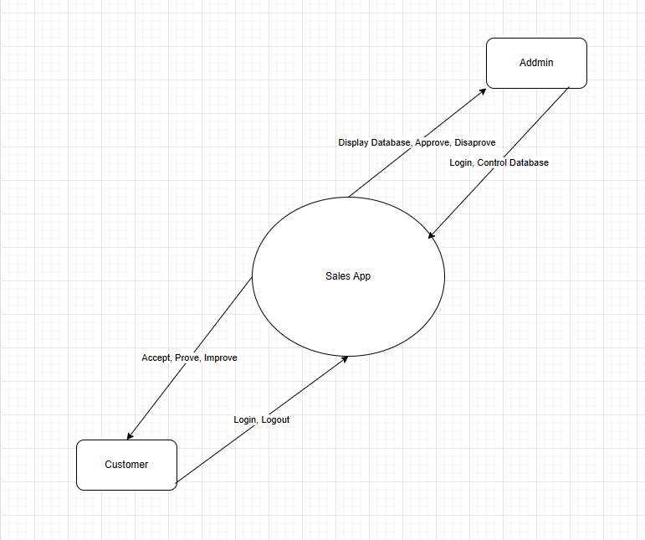

## 3. Major Features

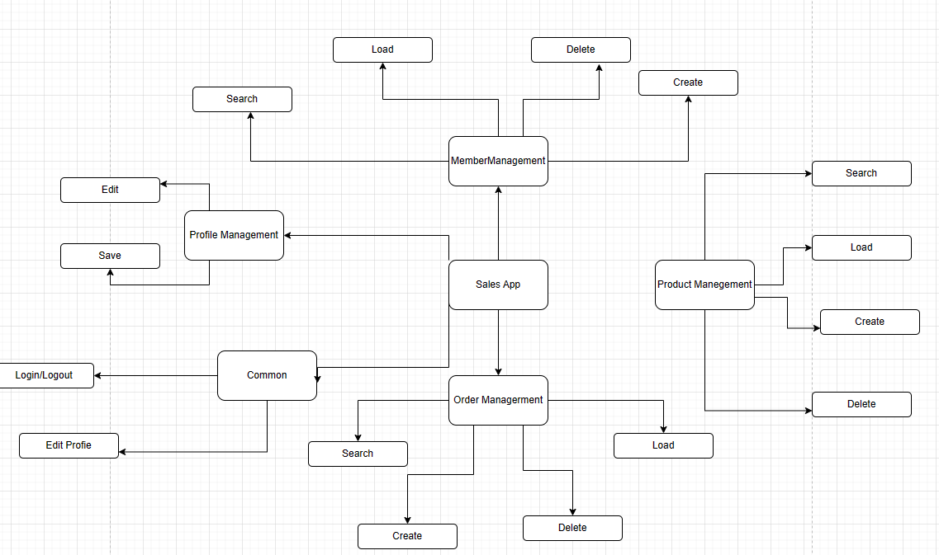

## 

## 

## 

## 4. User Requirements

### 4.1 Actors List

|  |  |  |
| --- | --- | --- |
| **#** | **Actor** | **Description** |
| 1 | Administrator | Manage system/users |
| 2 | Customer | Can Use System and do their works in their role |

### 4.2 Use Cases

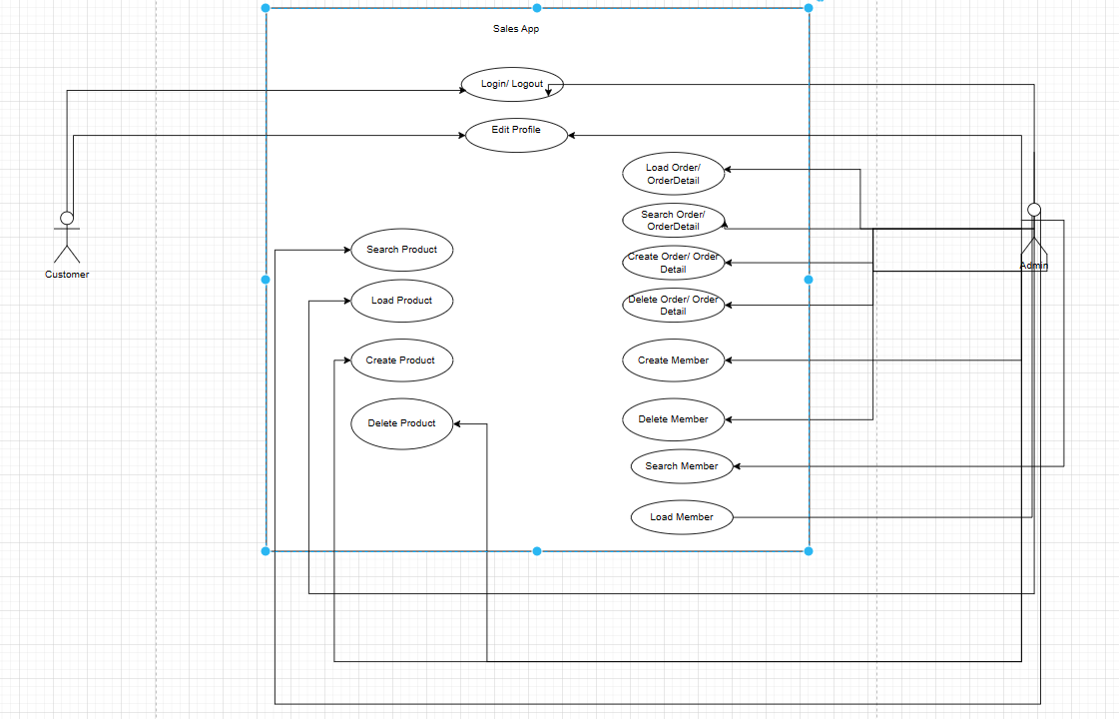

In which

|  |  |  |  |
| --- | --- | --- | --- |
| **ID** | **Feature** | **Use Case** | **Description** |
| 01 | Common | Sign in | Log in to the system |
| 02 | Common | Sign out | Log out of the system |
| 03 | Common | Edit user profile | Edit user information |
| 04 | Common | Change password | Change user password |
| 05 | Common | Reset password | Reset user password |
| 06 | Account Management | View user list | View the list of users in the system |
| 07 | Account Management | Add user | Add new user |
| 08 | Account Management | Edit user | Edit, delete, update user information |
| 09 | Account Management | Create Account user | Manage user accounts, and create new account |
| 10 | Account Management | View Order | View Order in system |
| 11 | Account Management | Search Order | Search Order in system |
| 12 | Account Management | Add new Order | Add new Order |
| 13 | Account Management | Edit curriculum | Edit, delete, update information about curriculum |
| 14 | Account Management | Load Order Detail | Load Order Detail |
| 15 | Account Management | Add Order Detail | Add new Order detail |
| 16 | Account Management | Delete Order Detail | Delete Order Detail |
| 17 | Account Management | Load Product | Load Product |
| 18 | Account Management | Create Product | Create Product |
| 19 | Account Management | Delete Product | Delete Product |
| 20 | Account Management | Search Product | Search Product |
| 21 | Account Management | Edit Profile | Edit, Profile |

# 

# 

# II. Use Case Specifications

## 1. Common

|  |  |  |  |
| --- | --- | --- | --- |
| ID and Name: | * **UC-01 Sign in** * **UC-02 Sign out** * **UC-03 Edit user profile** * **UC-04 Change password** | | |
| Created By: | Hoàng Việt Cường | Date Created: | 19/3/2023 |
| Primary Actor: | System admin, Head of CRDD, Staff of CRDD, Staff of AD, Syllabus Designer, Syllabus Reviewer, Teacher, Student | Secondary Actors: | FAP |
| Description: | UC-01 Sign in: This use case describes the process of authenticating a user's credentials to gain access to the system.  UC-02 Sign out: This use case describes the process of ending a user's session and logging out of the system.  UC-03 Edit user profile: This use case describes the process of updating a user's profile information, such as name, contact information, and other relevant details.  UC-04 Change password: This use case describes the process of changing a user's current password to a new password.  UC-05 Reset password: This use case describes the process of resetting a user's password in the event they have forgotten their current password or have been locked out of their account. | | |
| Trigger: | UC-01 Sign in: User wants to access the LMM system and needs to authenticate their identity to gain access.  UC-02 Sign out: User wants to end their current session and logout from the LMM system.  UC-03 Edit user profile: User wants to update their personal information or profile in the LMM system.  UC-04 Change password: User wants to change their current password for security reasons or if they forget their password.  UC-05 Reset password: User forgets their password and requests a password reset through the LMM system. | | |
| Preconditions: | 1. Sign In:  User has a valid username and password.  The system is operational and available.  2. Logout  The user must be signed in to the system.  3.Edit user profile:  The user must be signed in to the system.  The user must have the necessary permissions to edit their profile.  4. Reset Password:  User is logged in to the system and has forgotten their password.  User has access to their registered email account.  5. Change password  The user must be signed in to the system.  The user must have the necessary permissions to change their password.  The user must know their current password to change it. | | |
| Postconditions: | Sign in:  The user is authenticated and granted access to their account.  The user is redirected to the appropriate page after a successful sign-in.  Sign Out:  The user is logged out of their account.  The user is redirected to the appropriate page after a successful sign-out.  Edit User Profile:  The user's profile is updated with the new information.  The system stores the updated profile information.  Reset Password:  The user receives an email or text message with a link or code to reset their password.  The user is able to reset their password using the link or code provided.  The user is redirected to the appropriate page after a successful password reset.  Change password:  The user's password is updated and stored securely.  The user is redirected to the appropriate page after a successful password change. | | |
| Normal Flow: | 1. Sign in  - User clicks the "Sign In" button.  - System displays the login screen.  - User enters their username and password.  - System verifies the credentials.  - If the credentials are valid, the system logs the user in and redirects them to the home page.  - If the credentials are invalid, the system displays an error message and prompts the user to try again.  2. Sign out  - User clicks the "Sign Out" button.  - System logs the user out of the system.  - System redirects the user to the login screen.  3. Edit User Profile  - User clicks the "Edit Profile" button.  - System displays the edit profile screen.  - User modifies their profile information.  - System saves the changes to the user's profile.  4. Reset Password:  - User clicks the "Reset Password" button.  - System sends an email to the user's registered email address with a link to reset their password.  - User clicks the link in the email to access the password reset screen.  - User enters a new password and confirms the new password.  - System save the new password and logs the user in.  5. Change password:  - User selects the "Change Password" option on their account settings page.  - System presents a form to the user to enter their current password and new password twice to confirm.  - User enters their current password and their desired new password.  - User confirms their new password by entering it again in the confirmation field.  - System validates the current password and the new password for complexity, length, and similarity.  - If the validation is successful, the system updates the user's password and sends a confirmation message to the user.  - User is redirected to the account settings page or the login page. | | |
| Alternative Flows: | 1. Sign in  a. If the user enters an invalid username, the system displays an error message and prompts the user to try again.  b. If the user enters an invalid password, the system displays an error message and prompts the user to try again.  2. Sign out: None  3. Edit user profile: None  4. Reset password  a. If the system cannot send the email to the user, the system displays an error message and prompts the user to try again or contact the administrator.  5. Change password:  5a. If the validation fails, the system presents an error message indicating the reason for the failure.  5b. User corrects the errors and submits the form again. | | |
| Exceptions: | 1. Sign in  If the user account is locked, the system displays an error message and prompts the user to contact the administrator.  Business rules: The system should enforce password strength requirements and expiration policies.  2. Sign out: None  3. Edit user profile: None  4. Reset password:  If the user does not have a registered email address, the system displays an error message and prompts the user to contact the administrator.  5. Change password:  User selects the "Change Password" option on their account settings page.  System presents a form to the user to enter their current password and new password twice to confirm.  User enters their current password and their desired new password.  User confirms their new password by entering it again in the confirmation field.  System attempts to update the user's password, but encounters an error due to a system malfunction or unexpected issue.  System presents an error message to the user indicating the issue and advises them to try again later or contact customer support for assistance.  User is redirected to the account settings page. | | |
| Priority: | High | | |
| Frequency of Use: |  | | |
| Business Rules: | * Users can only edit their own profile information. * Only syllabus designers and reviewers can reset/change passwords. | | |
| Other Information: | 1. Sign in  The system should have a password recovery mechanism in case the user forgets their password.  2. Sign out: None  3. Edit user profile: None  4. Reset password:  The system should have a mechanism to prevent brute force attacks on the password reset process.  5. Change password: None | | |
| Assumptions: |  | | |