*Name: Nguyễn Văn Cường – Student ID: 20215006*

**Report - Lesson 1: Kotlin basics**

1. **Learn about operators and types**
2. *Step 1: Explore numeric operators*

1. *Step 2: Practice using types*

1. *Step 3: Learn the value of variable types*

1. *Step 4: Learn about strings and characters*

1. **Compare conditions and booleans**

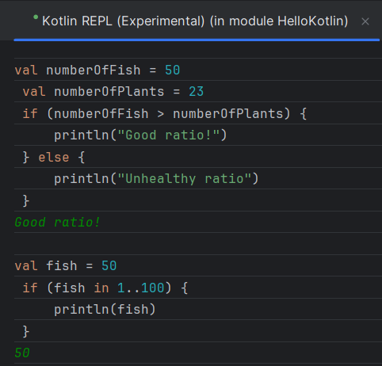

1. **Learn about nullability**
2. *Step 1: Learn about nullability*

1. *Step 2: Learn about the ? and ?: operators*

1. **Explore arrays, lists, and loops**
2. *Step 1: Make lists*

1. *Step 2: Create arrays*

1. *Step 3: Create loops*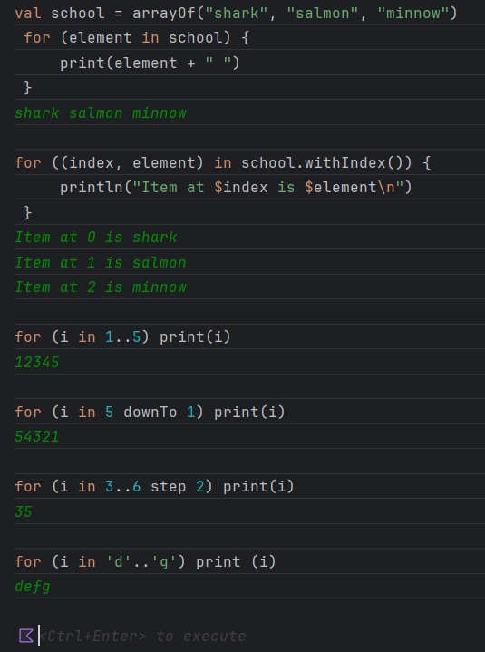A screenshot of a computer code

   Description automatically generated