

**COMPUTER E-COMMERCE SYSTEM** **PROJECT**

Software Requirements Specification

Version 4  
<28/06/2023>

**Giang Hiếu Minh**

**Lead software engineering**

– Hanoi, Summer 2023 –

# Revision History

| **Date** | **Description** | **Author** | **Comments** |
| --- | --- | --- | --- |
| 15/05/2023 | Version 1 | Giang Hiếu Minh,  Đặng Quốc Việt,  Hoàng Tuấn Đạt,  Đinh Bảo Ninh |  |
| 25/05/2023 | Version 2 | Giang Hiếu Minh,  Đặng Quốc Việt,  Hoàng Tuấn Đạt,  Đinh Bảo Ninh |  |
| 17/06/2023 | Version 3 | Giang Hiếu Minh,  Đặng Quốc Việt,  Hoàng Tuấn Đạt,  Đinh Bảo Ninh |  |
| 28/06/2023 | Version 4 | Giang Hiếu Minh,  Đặng Quốc Việt,  Hoàng Tuấn Đạt,  Đinh Bảo Ninh |  |

# Document Approval

The following Software Requirements Specification has been accepted and approved by the following:

| **Signature** | **Printed Name** | **Title** | **Date** |
| --- | --- | --- | --- |
|  | Nguyễn Thành Ý | Instructor, SWP391 |  |
|  | Giang Hiếu Minh | Leader |  |

# Table of content

Revision History 2

Document Approval 2

**Table of content 2**

**1. Introduction 1**

1.1 Overview 1

1.2 Purpose 1

1.3 Scope 2

1.4 Definitions, Acronyms, and Abbreviations 3

**2. General Description 3**

2.1 Product Perspective 3

2.2 Product Functions 3

2.3 User Characteristics 4

2.4 General Constraints 5

3. Specific Requirements 5

3.1 External Interface Requirements 5

3.1.1 User Interfaces 5

3.1.2 Hardware Interfaces 6

3.1.3 Software Interfaces 6

3.1.4 Communications Interfaces 6

3.2 Functional Requirements 6

3.2.1 System Functional Overview 6

3.2.1.1 Screens Flow 6

3.2.1.2 Screen Descriptions 8

3.2.1.3 Screen Authorization 10

3.2.1.4 Non-Screen Functions 12

3.2.1.5 Entity Relationship Diagram 12

3.2.1.6 Entities Description 12

3.3 Use Cases 13

3.3.1 Use Case Overview 13

3.3.2 Use Case Admin 15

3.3.2.1 Use case: Admin with Account Management Role 16

3.3.2.2 Use case: Admin with Customer Management Role 16

3.3.2.3 Use case: Admin with Order Management Role 16

3.3.2.4 Use case: Admin with Category Management Role 17

3.3.2.5 Use case: Admin with Serie Management Role 17

3.3.2.6 Use case: Admin with Product Management Role 18

3.3.2.7 Use case: Admin with News Group Management Role 18

3.3.2.8 Use case: Admin with News Management Role 19

3.3.2.9 Use case: Admin with Error Management Role 19

3.3.2.10 Use case: Admin with Warranty Management Role 20

3.3.3 Use Case Client 21

3.3.4 Use case specification 21

3.3.4.1 Admin Use Cases 21

3.3.4.1.1 Account 21

UC-01: Log In 22

UC-02: Log Out 22

UC-03: View Accounts List 23

UC-04: Create Account 24

UC-05: View Account Detail 25

UC-06: Modify Accounts 26

UC-07: Remove Account 26

UC-08: Search Account by Filter 27

3.3.4.1.2 Customer 28

UC-09: View Customer List 28

UC-10: Create Customer Account 29

UC-11: View Customer Detail 30

UC-12: Modify Customer 32

UC-13: Remove Customer 33

UC-14: Search Customer by Filter 34

3.3.4.1.3 Category 35

UC-15: View Category List 35

UC-16: Search Category by Filter 36

UC-17: Create Category 37

UC-18: View Category Detail 38

UC-19: Modify Category 38

UC-20: Remove Category 39

3.3.4.1.4 Series 40

UC-21: View Serie List 40

UC-22: Search Serie by Filter 41

UC-23: Create Serie 42

UC-24: View Serie Detail 43

UC-25: Modify Serie 45

UC-26: Remove Serie 46

3.3.4.1.5 Product 47

UC-27: View Product List By Series 47

UC-28: View Product List 48

UC-29: Search Products by Filter 49

UC-30: Create Product 50

UC-31: View Products Detail 51

UC-32: Modify Product 53

UC-33: Remove Product 54

3.3.4.1.6 News 55

UC-34: View News list 55

UC-35: Create News 55

UC-36: View News Detail 56

UC-37: Modify News 57

UC-38: Remove News 59

UC-39: Search News 60

3.3.4.1.7 News Groups 61

UC-40: View News group Detail 61

UC-41: Modify News Group 61

UC-42: Remove News Group 63

UC-43: Create NewsGroup 64

UC-44: Search NewsGroup 65

UC-45: Views NewsGroup 66

3.3.4.1.8 Error 67

UC-46: View Error list 67

UC-47: Create Errors 68

UC-48: View Error Detail 69

UC-49: Modify Error 70

UC-50: Remove Errors 71

UC-51: Search Error 72

3.3.4.1.9 Warranties 73

UC-52: View Warranties list 73

UC-53: Create Warranties 74

UC-54: View Warranties Detail 75

UC-55: Modify Warranties 76

UC-56: Remove Warranties 78

UC-57: Search Warranties 79

3.3.4.1.10 Order 80

UC-58: Search Order by Filter 80

UC-59: Create Order 81

UC-60: View Order detail 81

UC-61: Modify Order 82

UC-62: Remove Order 83

3.3.4.2 Client Use Cases 84

3.3.4.2.1 Account 84

UC-1: Register Account 84

UC-2: Login 85

UC-3: Logout 86

UC-4: Update Profile 86

UC-05: View Account Detail 87

3.3.4.2.2 Order/Cart 88

UC-6: Add To Cart 88

UC-7: Delete from Cart 89

UC-8: Checkout by VnPay 90

UC-9: Checkout by Direct Check 90

3.3.4.2.3 News 91

UC-10: Views News Detail 91

UC-11: Views News Group Detail 92

UC-12: View Author's Articles 93

UC-13: Search News 94

3.3.4.2.4 Category 95

UC-14: View Category List 95

3.3.4.2.5 Series 95

UC-15: View Serie List 95

UC-16: Search Serie 96

UC-17: View Serie Detail 97

3.4 Non-Functional Requirements 99

3.4.1 Performance 99

3.4.2 Security 99

3.4.3 Compatibility 99

3.4.4 Maintainability 99

3.5 Design Constraints 99

A. Appendices 99

A.1 Business Rule 99

A.2 References 100

# 1. Introduction

## 1.1 Overview

CECS is an online computer store website which supports a number of functions for both the consumer and store's management.

The website must be available to anyone who is provided authority to experience project’s resources from GitLab project archives . As stated by the customer, there are no hardware or software requirements beyond these including, but not limited to, memory or specific software packages that need to be utilized nor software packages that need not be utilized.

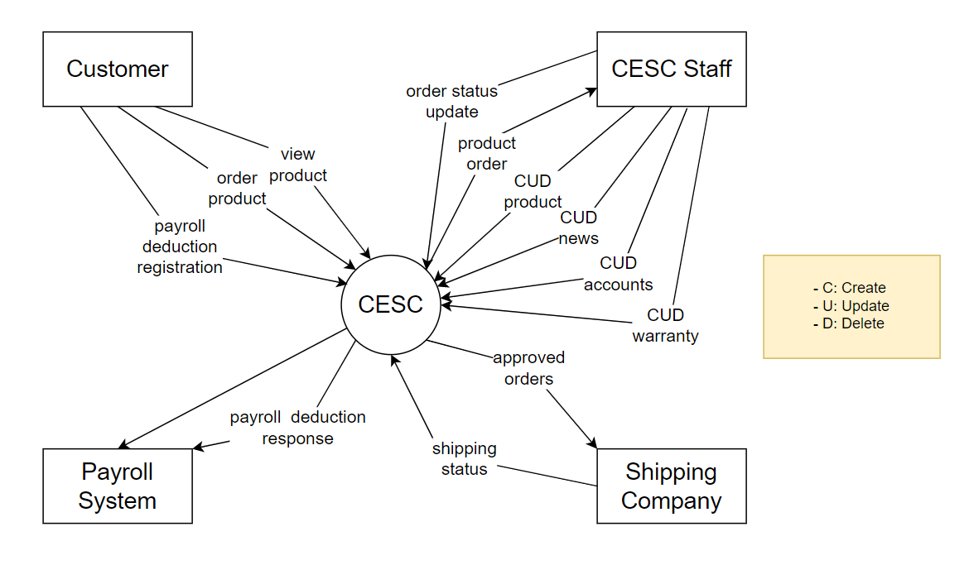

## 1.2 Purpose

The Computer E-Commerce System (CECS) consists of Administrator Web page and Client Web page. Administrator Web page support Administrator and Employees as CMS webpage with full functionality in CRUD to Products, Account,...

Client Web pages will have various software components, such as the main page, product listing, shopping cart, payment process, and user profile management. The user interfaces should be created to be easy to use, intuitive, and in line with contemporary web design norms. Additionally, they should be responsive to different devices and ensure a consistent experience throughout the website.

This Software Requirements Specification illustrates, in clear terms, the system’s primary uses and required functionality as specified by our customer. The intended audience of this document is our primary Computer E-Commerce System customer: Mr. Nguyen Thanh Y - the SWP391 instructor and the 2023 SUMMER semester of class SE1706 Group 5 members, as well as the other students attending SE1706 that will require access to such documentation.

## 1.3 Scope

The software system being produced is called Computer E-Commerce System or CECS. It is being produced for a customer interested in selling Computer via the Internet. This system is designed to “provide automation support” for the process of placing Computers for sale on the Internet and facilitating the actual sale. This system is largely cross-platform and is available to anyone using the Computer Science Department’s provides computer resources in the MSU Engineering Building. The system will be run on a localhost server with class’s attendances to interact with it.

The Computer E-Commerce System will allow any user to create an account to become a Buyer. The system will allow Buyer to browse, search, select, and add Computers to a shopping cart. Then, provided they have Computers in their shopping cart, check out Computers in shopping cart and decrement the stock that the inventory the system maintains

The Employee, through the process of account creation, will have the option to become a admin member – functional manager of the site. The system allows the main administrator to provide roles to an individual manager account, to assign staff with specific right to edit, and create assigned filed. The CECS also allows a manager to manage the inventory with full create, retrieve, update and delete (CRUD) functionality with regards to computers in the system. It will also allow, on an inventory wide basis, customers and managers to interact with a promotion system that handles percentage-off promotions that can be applied to member’s orders. This interaction includes the creation (by managers) and the application to orders (by customers) of the promotions. The CECS has full email capabilities; the automated email functionality will be used to send verified code to members of the system as well as provide the managers with notifications.

The CECS will have numerous constraints on what it can do. The manager will be a hard-coded user and only a single manager will exist. There will be order completion and the system will provide the customer with a receipt and it will log the transaction details. The system will not allow multiple promotions to be added to a single shopping cart nor will it allow a customer to add more than one of each item to their cart. The system also will allow users to retrieve passwords or edit their user details.

## 1.4 Definitions, Acronyms, and Abbreviations

| CECS | Laptop E-Commerce System |
| --- | --- |
| CMS | Content Management System |
| SRS | Software Requirements Specifications |
| BR | Business Rule |
| UI | User Interface |
| N/A | Not applicable, not available |
| Use Case(s) | Diagram describe system requirements |

# 2. General Description

## 2.1 Product Perspective

Our project includes a management system and a website for the purpose of buying and selling personal computers.

* The management system will help us manage all products, users, invoices closely, accurately and quickly. This will help our sales website become more convenient than hunger. With customers. It is extremely difficult to manage all customers manually, so the management system was born as an indispensable part to capture the needs and information that customers need. desired by the customer through the purchase of the product.
* About the website to sell products, each product will be posted by the management system with the selling price parameters and the buyer wants to know, in addition, with a friendly interface that is easy to use, it will help customers have a good experience in the process of buying and selling products.

Policies as well as useful information will also be included on the website to help customers understand the process as well as better understand the online buying and selling system. For example, allowed payment methods, privacy policy, warranty.

## 2.2 Product Functions

* In Client Site:
* Store and process customer information
* Store and process product information
* Manage purchases through the website
* Perform search and data retrieval operations

* In Admin Site:
* Staff Account Management
* Customer Account Management
* Category Management
* Series Management
* Product Management
* News Group Management
* News Management
* Order Management

## 2.3 User Characteristics

This section of the SRS will describe the general end-user characteristics of the project to sell computers online that will affect specific requirements.

**User classes:**

1. **Customers:**

* Frequency of use: Use often or occasionally.
* Functions used: Use many functions of the product, including machine view, add to cart, purchase and manage personal accounts.
* Security and privileges: Standard user rights with access to basic features and personal account management.
* Experience: Diversity in users.
* Related Features: Offers a user-friendly interface, seamless browsing and purchasing experience, secure payment options, and personal account management.

1. **System administrator:**

* Frequency of use: Use occasionally.
* Functions used: User account management, access control and system settings. For example, add, edit and delete products, search for products, post posts, manage employees (decentralized)
* Security and privileges: Permission to manage user accounts and system configuration.
* Experience: Professional experience and clear knowledge of system administration.
* Related characteristics: Features of user management, access control based on different roles in the system

We should always prioritize requests based on the importance of each user class. Regular customers are the most important user classes for this product, as they are the primary users and an important factor in driving sales and user engagement. Meanwhile, system administrators play an important role in system management, but their requirements may not be as important as that of ordinary customers.

## 2.4 General Constraints

This section of the SRS provides a general description of other factors that will be intended to constrain the developer in the design of the system. These constraints may include:

1. **Company policy or regulation:**
   * The system must comply with the security and privacy policies
   * Regulations related to the protection of customer information and electronic transactions should be complied with.
2. **Hardware limitations:**
   * Customers will use the website on different browser platforms (chrome, coc coc, bing) in addition to ios or android operating systems will also be supported.
3. **Interface and language:**
   * Interface must be easy to see, easy to use
   * The main language used will be English.
4. **Tools and databases used:**
   * NetBean, Java Script, Html, Sql server management 19 will be the main tools used

* In addition, data will be created according to the needs and criteria of a sales website.

1. **Security factor:**
   * The system must have strong security measures to protect customers' personal information and transactions.

By considering the above constraints, the development team can design the system in accordance with the necessary requirements and comply with the regulations and other requirements to ensure the stable and safe operation of the system.

# 3. Specific Requirements

## 3.1 External Interface Requirements

### 3.1.1 User Interfaces

To ensure consistency and usability across the user interfaces, the following GUI standard should be followed:

#### **3.1.1.1 Client**

* UI-01: Color scheme: The color black (*#1C1C1C*), white(*#ffffff*), gray(*#848687*) are the theme colors for this Computer E-commerce system for Client
* UI-02: Typography: The website use font-family: “Poppins”, “sans-serif“ for the body text and heading
* UI-03: Error messages: The website should display clear and informative error messages when the user encounters an error or validation issue.

#### **3.1.1.2 Admin**

* UI-04: Color scheme: The color Black - (*#000000*) and Dark blue - (*#191c24*) are the theme colors for this Computer E-commerce system for Admin.
* UI-05: Typography: The website use font-family: “Poppins”, “sans-serif“ for the body text and heading
* UI-06: Error messages: The website should display clear and informative error messages when the user encounters an error or validation issue.

### 3.1.2 Hardware Interfaces

* *No hardware interfaces have been identified.*

### 3.1.3 Software Interfaces

The online computer store system does not integrate with other commercial software. However, it may require software interfaces for the following components:

* Payment gateway VNPAY : The system should integrate with VNPAY service to process online payments securely. The software interface should provide a secure connection for transmitting payment information between the website and the VNPAY.
* Shipping carrier: The system should integrate with a shipping carrier service to calculate shipping rates, generate shipping labels, and track shipments. The software interface should provide a secure connection for transmitting shipping information between the website and the shipping carrier.
* Confirmation email with Google: the system integrate with Google to get a confirmation email in order for the website to verify it and give them access to have an account in the Computer’s online system

### 3.1.4 Communications Interfaces

* The web browser will automatically log out if the user does not use the system within 10 seconds

## 3.2 Functional Requirements

### 3.2.1 System Functional Overview

This will describe the functionality of a computer store software system. It includes information on the screen flow, screen descriptions, system user roles, screen authorization, non-screen functions, and the use of an Entity-Relationship Diagram (ERD) to *model* the system's database. The system supports different user roles, such as Administrator, Salesperson, and Cashier, and uses screen-level authorization to restrict access to certain screens and functions. The system provides both screen-based and non-screen functions to support the operations of the computer store.

#### **3.2.1.1 Screens Flow**

**Administrator Screen Flow**

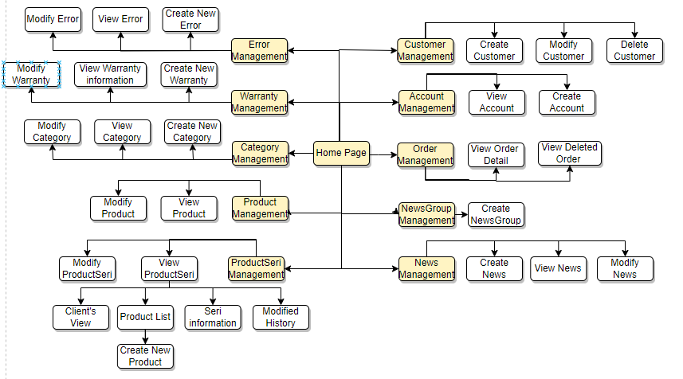

**Client’s Screen Flow**

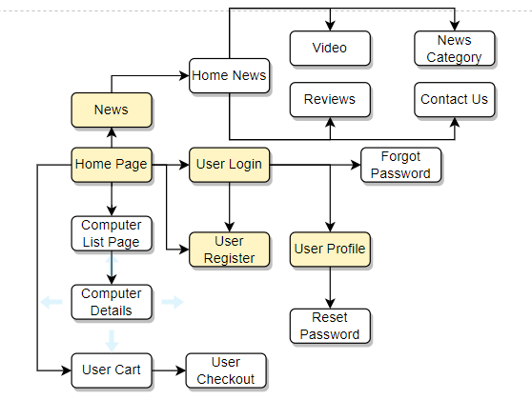

#### **3.2.1.2 Screen Descriptions**

**Admin application**

|  | **Feature** | **Screen** | **Description** |
| --- | --- | --- | --- |
| 1 | **Customer**  **Management** | Add Customer | Add new Customer to the Customer list |
| Update Customer | Change the information of a Customer |
| Delete Customer | Remove the Customer from the Customer list |
| Search News Group | Search the Customer from the Customer list |
| 2 | **Account**  **Management** | Create Account | Add new Account to the Account list |
| Update Account | Change the information of an Account |
| Delete Account | Remove the Account from Account list |
| Search Account | Search the Account from the Account list |
| 3 | **Order Management** | Create Order | Add new Order to the Order list |
| Update Order | Change the information of a Order |
| Delete Order | Remove the Order from the Order list |
| Search Order | Search the Order from the Order list |
| 4 | **News Group**  **Management** | Create News Group | Add new News Group to the News Group list |
| Update News Group | Change the information of a News Group |
| Delete News Group | Remove the News Group from the list |
| Search News Group | Remove the News Group from the list |
| 5 | **News**  **Management** | Create News | Add new News to the News list |
| Update News | Change the information of a News |
| Delete News | Remove the News from the News list |
| Search Order | Search the News from the News list |
| 6 | **Category**  **Management** | Create Category | Add new Category to the Category list |
| Update Category | Change the information of a Category |
| Delete Category | Remove the Category from the Category list |
| Search Category | Search the Category from the Category list |
| 5 | **Product Series**  **Management** | Create Series | Add new order to the Series list |
| Update Series | Change the information of a Series |
| Delete Series | Remove the Series from the Series list |
| Search Series | Search the Series from the Series list |
| 5 | **Product** | Create Product | Add new Product to the Product list |
| Update Product | Change the information of a Product |
| Delete Product | Remove the Product from the Product list |
| Search Product | Search the Product from the Product list |
|  |  |  |  |
|  |  |  |  |

**Client application**

|  | **Feature** | **Screen** | **Description** |
| --- | --- | --- | --- |
| 1 | **Access to page** | Login | Enter username and password to login to system |
| Register | Enter personal information to have an account signing in system |
| View and Edit Profile | Users have right to modify some of their personal information |
| Change password | Users can change their password as long as they have access to their registered email |
| 2 | **Search Series** | Navigation Bar | Search Products by name |
| Shop page | Search Product by Filter |
| 3 | **Add to cart** | Home page | Enter “Add to Cart” in Product Card to add product to personal cart |
| Shop page | Enter “Add to Cart” in Product Card to add product to personal cart |
| Cart page | Users can decrease/increase product quantity and user can delete product from cart. |
| 4 | **CheckOut** | Checkout page | User fill information: name, phone, address, email, ... to process checkout. |
| 5 | **OrderHistory** | Order History page | Users can see all their order |
| Order detail page | user can see list of product in their single Order |
| 5 | **View news** | Home | Users enter Home button to back into indexnews.jsp |
| News | Show all the news group ,and when user enter any group,web will show all the news of newsgroup |
| Search | Users can type any key word here to search news |
| About Us | Show all the information of company |

#### **3.2.1.3 Screen Authorization**

| **Screen** | **Admin** | **Employee** | **Customer** | **Guest** |
| --- | --- | --- | --- | --- |
| Account Management | X | X |  |  |
| Create Account | X | X |  |  |
| Edit Account | X | X |  |  |
| Remove Account | X | X |  |  |
| Customer Management | X | X | X |  |
| Create Customer | X | X | X |  |
| Edit Customer | X | X | X |  |
| Remove Customer | X | X | X |  |
| Order Management | X | X | X | X |
| Create order | X | X | X | X |
| Edit order | X | X | X | X |
| Remove order | X | X | X | X |
| News Group Management | X | X |  |  |
| Create News Group | X | X |  |  |
| Edit News Group | X | X |  |  |
| Remove News Group | X | X |  |  |
| News Management | X | X |  |  |
| Create News | X | X |  |  |
| Edit News | X | X |  |  |
| Remove News | X | X |  |  |
| Category Management | X | X |  |  |
| Create Category | X | X |  |  |
| Edit Category | X | X |  |  |
| Remove Category | X | X |  |  |
| Product Serie Management | X | X |  |  |
| Create Product Serie | X | X |  |  |
| Edit Product Serie | X | X |  |  |
| Remove Product Serie | X | X |  |  |
| Product Management | X | X |  |  |
| Create Product | X | X |  |  |
| Edit Product | X | X |  |  |
| Remove Product | X | X |  |  |
| … |  |  |  |  |

#### **3.2.1.4 Non-Screen Functions**

| **#** | **Feature** | **System Function** | **Description** |
| --- | --- | --- | --- |
| 1 | Search without loading page | Search | Using Ajax to search |

#### **3.2.1.5 Entity Relationship Diagram**

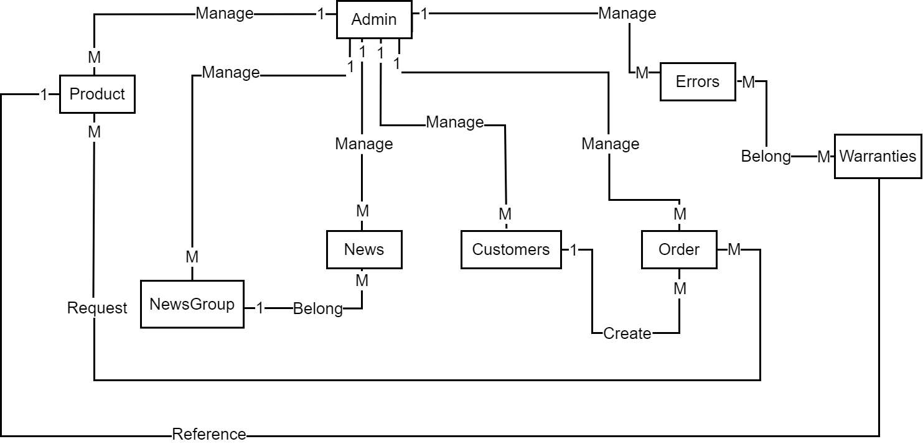

#### **3.2.1.6 Entities Description**

| **#** | **Entity** | **Description** |
| --- | --- | --- |
| 1 | Admin | Containing username, password and other information of admins of admin page |
| 2 | Customer | Containing username, password and other information of users of client page |
| 3 | Product | Containing information about a product |
| 4 | News | Containing news of a website, such as product evaluation, discount, … |
| 5 | Order | Containing information of user and products bought and other related information as orderdate, … |
| 6 | Warranty | Containing information about problems of products bought, then the summary of quality of product |

## 3.3 Use Cases

### 3.3.1 Use Case Overview

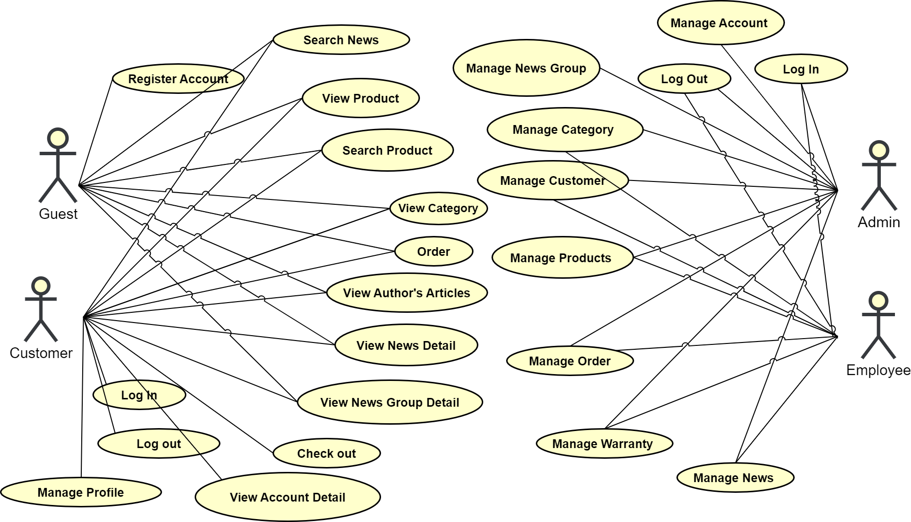

### 3.3.2 Use Case Admin

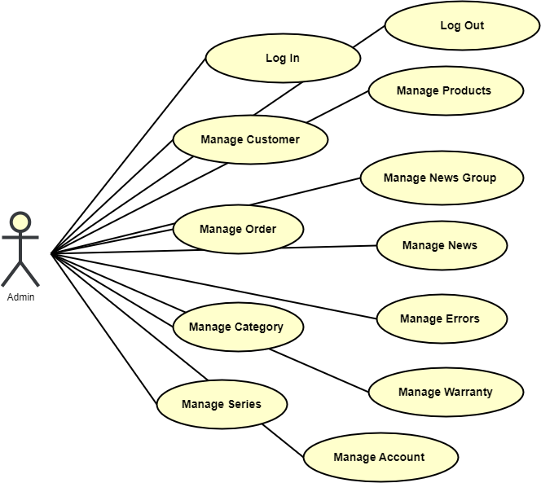

##### 3.3.2.1 Use case: Admin with Account Management Role

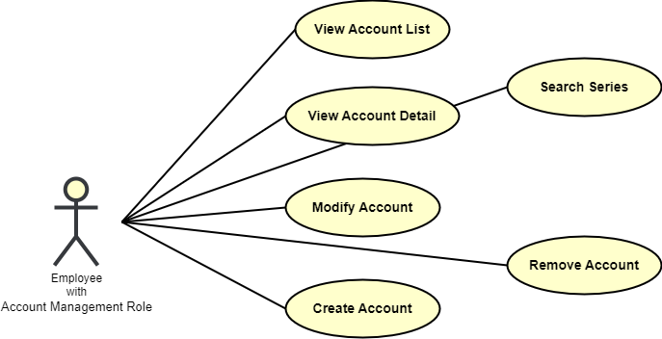

##### 3.3.2.2 Use case: Admin with Customer Management Role

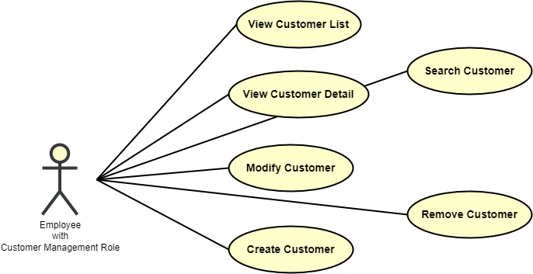

##### 3.3.2.3 Use case: Admin with Order Management Role

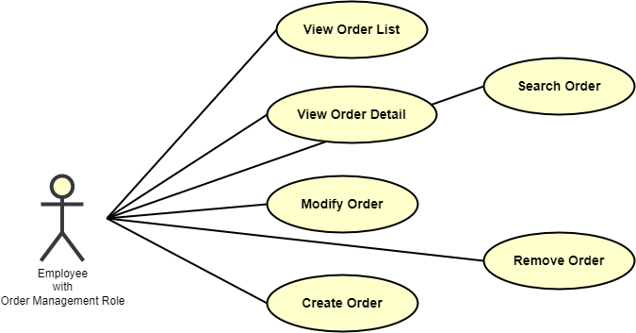

##### 3.3.2.4 Use case: Admin with Category Management Role

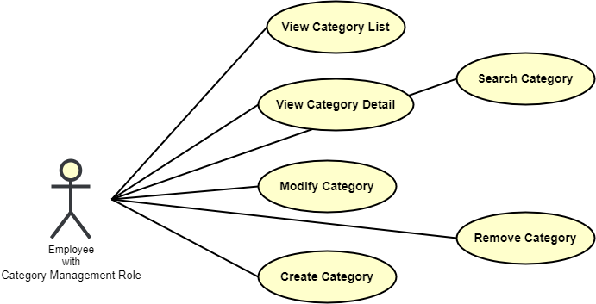

##### 3.3.2.5 Use case: Admin with Serie Management Role

##### 

##### 

##### 3.3.2.6 Use case: Admin with Product Management Role

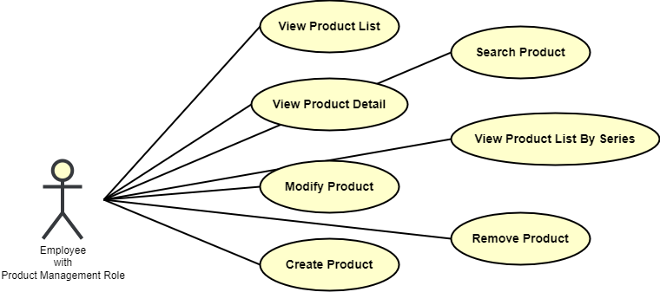

##### 3.3.2.7 Use case: Admin with News Group Management Role

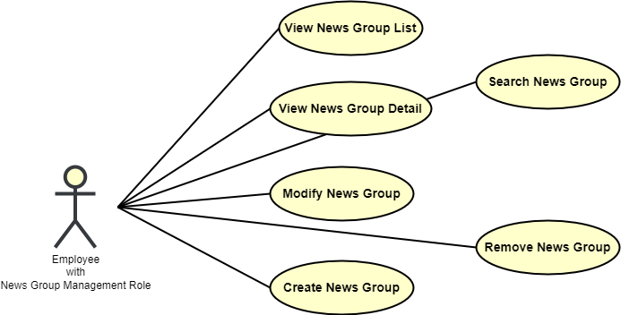

##### 3.3.2.8 Use case: Admin with News Management Role

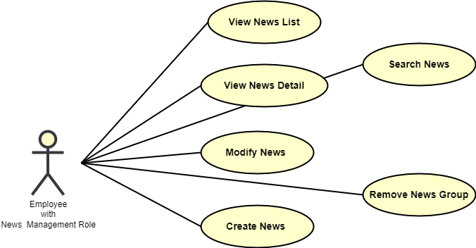

##### 3.3.2.9 Use case: Admin with Error Management Role

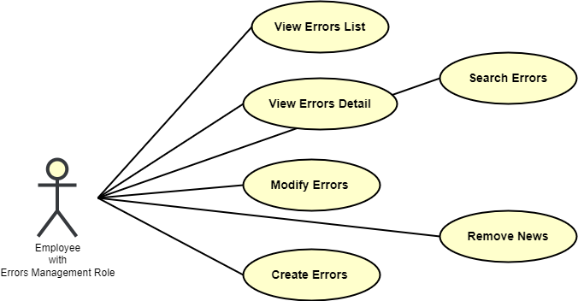

### 

##### 3.3.2.10 Use case: Admin with Warranty Management Role

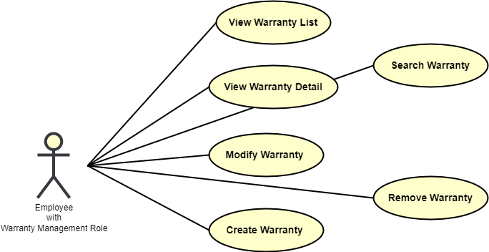

### 

### 3.3.3 Use Case Client

##### 

### 3.3.4 Use case specification

#### **3.3.4.1 Admin Use Cases**

##### 3.3.4.1.1 Account

| **ID and Name:** | UC-01: Log In | | |
| --- | --- | --- | --- |
| Created By: | MinhGH | Date Created: | 20/05/2023 |
| Primary Actor: | Guest | Secondary Actors: | N/A |
| Priority: | High | Frequency of Use: | Usually |
| Trigger: | The actor wants to log in to the ComputerStore Admin Site | | |
| Description: | This feature allows actor to login in the system | | |
| Preconditions: | Actor already has an available account provided by the Manager before | | |
| Post-conditions: | Success: Redirect to home page  Fail: The system shows error message corresponding to error code | | |
| Normal Flow: | 1. In sign in page, Actor inputs username and password. 2. Actor clicks “Log in”.   => System redirects to the home page. | | |
| Alternative Flow: | 1. In sign in page, Actor clicks on the “Remember” checkbox.   => System saves the username and password that the user used to sign in. | | |
| Exceptions: | 1. The username or password is not correct   => System redirects to the login page and informs that “username or password is incorrect” | | |
| Business Rules: | BR-06, BR-11 | | |
| Assumptions: | 1. Actor’s internet connection is available 2. Actor has already been provided an account before | | |

###### 

| **ID and Name:** | UC-02: Log Out | | |
| --- | --- | --- | --- |
| Created By: | MinhGH | Date Created: | 20/05/2023 |
| Primary Actor: | Guest | Secondary Actors: | N/A |
| Priority: | High | Frequency of Use: | Usually |
| Trigger: | The actor wants to log out of the ComputerStore Admin Site | | |
| Description: | This feature allows actor to login out the system | | |
| Preconditions: | Actor logged in the page before | | |
| Post-conditions: | Success: Redirect to login page  Fail: The system shows error message corresponding to error code | | |
| Normal Flow: | 1. In web, Actor clicks on his/her avatar   => A dropdown list will be shown   1. Actor clicks “Log out”   => System redirects to the login page | | |
| Alternative Flow: | 1. In web, Actor clicks on his/her avatar   => A dropdown list will be shown   1. The actor clicks anywhere outside the “Log out” button   => The dropdown list disappear | | |
| Exceptions: | N/A | | |
| Business Rules: | N/A | | |
| Assumptions: | 1. Actor’s internet connection is available 2. Actor has logged in before | | |

###### 

| **ID and Name:** | UC-03: View Accounts List | | |
| --- | --- | --- | --- |
| Created By: | MinhGH | Date Created: | 20/05/2023 |
| Primary Actor: | Admin | Secondary Actors: | N/A |
| Priority: | Normal | Frequency of Use: | Often |
| Trigger: | The actor wants to view the list of account. | | |
| Description: | This feature allows actors to view accounts | | |
| Preconditions: | Have role to Account Management Page | | |
| Post-conditions: | Success: The system shows lists of accounts.  Fail: Go to “400” page | | |
| Normal Flow: | 1. In home page, actor clicks on “Account Management” button.   => System shows the list of account. | | |
| Alternative Flow: | N/A | | |
| Exceptions: | 1. Result is empty.   => System shows message “No data”. | | |
| Business Rules: | 1. Accounts must have records in the storage and still be available. 2. All information in the list must be clear and up-to-date. | | |
| Assumptions: | Actor’s internet connection is available | | |

###### 

| **ID and Name:** | UC-04: Create Account | | |
| --- | --- | --- | --- |
| Created By: | MinhGH | Date Created: | 20/05/2023 |
| Primary Actor: | Admin | Secondary Actors: | N/A |
| Priority: | High | Frequency of Use: | Often |
| Trigger: | The actor wants to create a new Account. | | |
| Description: | This feature allows actor to create a new account. | | |
| Preconditions: | 1. The actor has logged in by an Admin account with the corresponding Role. 2. Current screen is “Account List” screen | | |
| Post-conditions: | Success:  System created account  Fail: System shows message error | | |
| Normal Flow: | 1. The actor clicks on “Create Account” button on “Account List” screen   => System redirect to Create Account page showing all field for the admin to fill, such as:  - Firstname: text  - Lastname: text  - Username: text  - Password: text  - Birthdate: date   1. Admin fills information, then clicks on the “Create” button.   => System valid item’s information inputted by admin and creates account. | | |
| Alternative Flow: | 1. User clicks on the “Cancel” button.   => System redirects to the “Account List” page. | | |
| Exceptions: | 1. Existing invalid input   => System informs a specified error message in a popup dialog. | | |
| Business Rules: | Username cannot be null | | |
| Assumptions: | Actor’s internet connection is available | | |

| **ID and Name:** | UC-05: View Account Detail | | |
| --- | --- | --- | --- |
| Created By: | MinhGH | Date Created: | 20/05/2023 |
| Primary Actor: | Admin | Secondary Actors: | N/A |
| Priority: | Normal | Frequency of Use: | Often |
| Trigger: | The actor wants to view account in detail after choosing that account by clicking the eye icon. | | |
| Description: | This feature allows the actor to view account in detail. | | |
| Preconditions: | N/A | | |
| Post-conditions: | Success: The System shows the details of account such as firstname, lastname, username, password, … | | |
| Normal Flow: | 1. After the actor clicks on the eye icon on the line of the account his/her wants to view in detail.   => Redirect to the account detail information page. The website shows account detail information such as: FirstName, LastName, UserName, Password, …   1. And below page shows “Update” button which redirects to the Update Account Page and a “Cancel” button to get back to the “Account List” page. | | |
| Alternative Flow: | N/A | | |
| Exceptions: | N/A | | |
| Business Rules: | All accounts in the list must be available and up-to-date. | | |
| Assumptions: | Actor’s internet connection is available | | |

##### 

| **ID and Name:** | UC-06: Modify Accounts | | |
| --- | --- | --- | --- |
| Created By: | MinhGH | Date Created: | 20/05/2023 |
| Primary Actor: | Admin | Secondary Actors: | N/A |
| Priority: | Normal | Frequency of Use: | Often |
| Trigger: | The actor wants to modify detailed information of accounts. | | |
| Description: | This feature allows Admin to update accounts. | | |
| Preconditions: | 1. User has logged in as Admin with corresponding role successfully. 2. Current screen is the “Account List” screen. | | |
| Post-conditions: | Success: System shows a dialog with a successful message when the account has been modified successfully in the database.  Fail: System shows a notification with specified error message. | | |
| Normal Flow: | 1. Click on Account detail’s card in page “Manage Account”.   => System shows a form with these fields:   * Name: text * Email: text * Phone: text * Gender: text * Birthday: text * Avatar: image  1. Admin fills information, then clicks on the “Update” button.   => System modifies the fields and redirects to the home screen interface. | | |
| Alternative Flow: | 1. User clicks on the “Cancel” button.   => System closes the pop up. | | |
| Exceptions: | 1. Existing invalid input.   => System informs a specified error message in a popup dialog. | | |
| Business Rules: | Account just only can be updated by the Admin that created it. | | |
| Assumptions: | Actor’s internet connection is available | | |

##### 

| **ID and Name:** | UC-07: Remove Account | | |
| --- | --- | --- | --- |
| Created By: | MinhGH | Date Created: | 15/5/2023 |
| Primary Actor: | Admin | Secondary Actors: | N/A |
| Priority: | Normal | Frequency of Use: | Often |
| Trigger: | The actor wants to remove users’ accounts . | | |
| Description: | This feature allows actor to remove account | | |
| Preconditions: | Actor login into an App with an account has an admin role. | | |
| Post-conditions: | Success: System displays a message “Remove sale task success!”. | | |
| Normal Flow: | 1. In Account Management, click on the “Trash can” symbol in a specific category of favor in page “Account Management”.   => System shows Category detail information such as:  - Name  - Number of Series  => System shows options:  - Delete  - Cancel   1. Actor clicks “Remove” button.   => System returns to “Account Management”. | | |
| Alternative Flow 1: | 1. In the Account Management, check box on “Trash can” symbol in a specific category of favor in page “Account Management”.   => System shows a confirm alert box with two options: Delete and Cancel.   1. Actor clicks “Delete”   => System delete the chosen account and returns to “Account Management”  page. | | |
| Alternative Flow 2: | 1. User clicks on the “Cancel” button.   => System redirects to Account Management page. | | |
| Exceptions: | N/A | | |
| Business Rules: | Account can only can be updated by the Admin with Role to remove Account. | | |
| Assumptions: | Actor’s internet connection is available | | |

| **ID and Name:** | UC-08: Search Account by Filter | | |
| --- | --- | --- | --- |
| Created By: | MinhGH | Date Created: | 20/5/2023 |
| Primary Actor: | Admin | Secondary Actors: | N/A |
| Priority: | Normal | Frequency of Use: | Often |
| Trigger: | The actor wants to search for Account by Filter. | | |
| Description: | This feature allows actor to search for Account by Filter that details contain the keyword. | | |
| Preconditions: | The actor must login to their account as “admin” role  Current screen is the “Account Management” screen. | | |
| Post-conditions: | Success: The system shows a list of Account in Account Management page that details contain the keyword  Fail: The system shows “No data” | | |
| Normal Flow: | 1. In the Account Management page, the actor types the keyword into the search textbox and select filters such as name, username, … 2. Actor click Enter button.   => System shows the list of Account that details contain the keyword and by filter. | | |
| Alternative Flow: | N/A | | |
| Exceptions: | | No | Cause | System Response | | --- | --- | --- | | 1 | Result is empty. | System shows “No data”. | | | |
| Business Rules: | * All Account must have a record in the storage and must not set to be isDelete. | | |
| Assumptions: | Actor’s internet connection is available | | |

##### 3.3.4.1.2 Customer

| **ID and Name:** | UC-09: View Customer List | | |
| --- | --- | --- | --- |
| Created By: | MinhGH | Date Created: | 20/05/2023 |
| Primary Actor: | Admin | Secondary Actors: | N/A |
| Priority: | Normal | Frequency of Use: | Often |
| Trigger: | The actor wants to view the list of Customer. | | |
| Description: | This feature allows actors to view Customer | | |
| Preconditions: | Have role to Customer Management Page | | |
| Post-conditions: | Success: The system shows lists of Customer .  Fail: | | |
| Normal Flow: | | Step | Actor Action | System Response | | --- | --- | --- | | 1 | In home page, actor clicks on “ Customer Management” button. | System shows the list of account. | | | |
| Alternative Flow: | N/A | | |
| Exceptions: | | No | Cause | System Response | | --- | --- | --- | | 1 | Result is empty. | System shows message “No data” . | | | |
| Business Rules: | * Customer must have records in the storage and be publish and still be available. * All information in the list must be clear and up-to-date. | | |
| Assumptions: | Actor’s internet connection is available | | |

| **ID and Name:** | UC-10: Create Customer Account | | |
| --- | --- | --- | --- |
| Created By: | MinhGH | Date Created: | 20/05/2023 |
| Primary Actor: | Admin | Secondary Actors: | N/A |
| Priority: | High | Frequency of Use: | Often |
| Trigger: | The actor wants to create a new Customer . | | |
| Description: | This feature allows actor to create a new Customer . | | |
| Preconditions: | * The actor has logged in by an Admin account with the corresponding Role. * Current screen is “ Customer List” screen | | |
| Post-conditions: | Success:  System created account  Fail: System shows message error | | |
| Normal Flow: | | Step | Actor Action | System Response | | --- | --- | --- | | 1 | The actor clicks on “Create Customer ” button on “ Customer List” screen | System redirect to Create Account page showing all field for the admin to fill, such as:  - Firstname: text  - Lastname: text  - Email: text  - Address: text  - Phone: number | | 2 | Admin fills information, then clicks on the “Create” button. (Alternative A1) | System valid item’s information inputted by admin and creates Customer . | | | |
| Alternative Flow: | | Step | Actor Action | System Response | | --- | --- | --- | | 1 | User clicks on the “Cancel” button. | System redirect to Customer List page. | | | |
| Exceptions: | | No | Cause | System Response | | --- | --- | --- | | 1 | Existing invalid input | System informs a specified error message in a popup dialog. | | | |
| Business Rules: | Inputs cannot be null | | |
| Assumptions: | Actor’s internet connection is available | | |

##### 

| **ID and Name:** | UC-11: View Customer Detail | | |
| --- | --- | --- | --- |
| Created By: | MinhGH | Date Created: | 20/05/2023 |
| Primary Actor: | Admin | Secondary Actors: | N/A |
| Priority: | Normal | Frequency of Use: | Often |
| Trigger: | The actor wants to view account in detail after choosing that account by clicking the eye icon. | | |
| Description: | This feature allows the actor to view account in detail. | | |
| Preconditions: | N/A | | |
| Post-conditions: | Success: The System shows the details of Customer such as firstname, lastname, username, password, … | | |
| Normal Flow: | | Step | Actor Action | System Response | | --- | --- | --- | | 1 | After the actor clicks on the eye icon on the line of the account his/her wants to view in detail | Redirect to the account detail information page. The website shows account detail information such as:   * ID * Name * Email * Address * Phone * …   And below page shows “Update” button which redirects to the Update Account Page and a “Cancel” button to get back to the “Customer List” page. | | | |
| Alternative Flow: | N/A | | |
| Exceptions: | N/A | | |
| Business Rules: | All Customer in the list must be available and up-to-date. | | |
| Assumptions: | Actor’s internet connection is available | | |

##### 

| **ID and Name:** | UC-12: Modify Customer | | |
| --- | --- | --- | --- |
| Created By: | MinhGH | Date Created: | 20/05/2023 |
| Primary Actor: | Admin | Secondary Actors: | N/A |
| Priority: | Normal | Frequency of Use: | Often |
| Trigger: | The actor wants to modify detailed information of accounts. | | |
| Description: | This feature allows Admin to update accounts. | | |
| Preconditions: | * User has logged in as Admin with corresponding role successfully. * Current screen is the “Customer List” screen. | | |
| Post-conditions: | Success: System shows a dialog with a successful message when the Customer has been modified successfully in the database.  Fail: System shows a notification with specified error message. | | |
| Normal Flow: | | Step | Actor Action | System Response | | --- | --- | --- | | 1 | Click on Account detail’s card in page “Manage Customer”.  **[Alternative 1]** | System shows a form with these fields:   * Name: text * Email: text * Phone: text * Address: text | | 2 | Admin fills information, then clicks on the “Update” button. (Alternative A1) | System modifies the fields and redirects to the home screen interface. | | | |
| Alternative Flow: | | Step | Actor Action | System Response | | --- | --- | --- | | 1 | User clicks on the “Cancel” button.  **[Alternative 1]** | System closes the pop up. | | | |
| Exceptions: | | No | Cause | System Response | | --- | --- | --- | | 1 | Existing invalid input. | System informs a specified error message in a popup dialog. | | | |
| Business Rules: | Customer just only can be updated by the Admin that created it. | | |
| Assumptions: | Actor’s internet connection is available | | |

##### 

| **ID and Name:** | UC-13: Remove Customer | | |
| --- | --- | --- | --- |
| Created By: | MinhGH | Date Created: | 15/5/2023 |
| Primary Actor: | Admin | Secondary Actors: | N/A |
| Priority: | Normal | Frequency of Use: | Often |
| Trigger: | The actor wants to remove Customer. | | |
| Description: | This feature allows actor to remove Customer | | |
| Preconditions: | Actor login into an App with an account has an admin role. | | |
| Post-conditions: | Success: System displays a message “Remove sale task success!”. | | |
| Normal Flow: | 1:   | Step | Actor Action | System Response | | --- | --- | --- | | 1 | In the Customer Management, click on “Trash can” symbol in specific category of favor in page “Customer Management”. | shows Category detail information such as:   * Name * Number of Series   System shows options :   * Delete * Cancel | | 2 | Actor clicks “Remove” | System return to “Customer Management”. |   2:   | Step | Actor Action | System Response | | --- | --- | --- | | 1 | In the Account Management, check box on  “Trash can” symbol in specific category of favor in page “Customer Management”. | shows a confirm alert box  System shows options :   * Delete   Cancel | | 2 | Actor clicks “Remove” | System return to “Customer Management”. | | | |
| Alternative Flow: | | Step | Actor Action | System Response | | --- | --- | --- | | 1 | User clicks on the “Cancel” button. | System redirect to Customer Management page. | | | |
| Exceptions: | N/A | | |
| Business Rules: | Customer can only can be updated by the Admin with Role to remove Customer. | | |
| Assumptions: | Actor’s internet connection is available | | |

##### 

| **ID and Name:** | UC-14: Search Customer by Filter | | |
| --- | --- | --- | --- |
| Created By: | MinhGH | Date Created: | 20/5/2023 |
| Primary Actor: | Admin | Secondary Actors: | N/A |
| Priority: | Normal | Frequency of Use: | Often |
| Trigger: | The actor wants to search for Customer by Filter. | | |
| Description: | This feature allows actor to search for Customer by Filter that details contain the keyword. | | |
| Preconditions: | The actor must login to their account as “admin” role  Current screen is the “Customer Management” screen. | | |
| Post-conditions: | Success: The system shows a list of Customer in Customer Management page that details contain the keyword  Fail: The system shows “No data” | | |
| Normal Flow: | | Step | Actor Action | System Response | | --- | --- | --- | | 1 | In the Customer Management page, the actor types the keyword into the search textbox and select Filter:  -        name  -    username  -    … |  | | 2 | Actor click Enter button. | System show the list of Customer that details contain the keyword and by Filter. | | | |
| Alternative Flow: | N/A | | |
| Exceptions: | | No | Cause | System Response | | --- | --- | --- | | 1 | Result is empty. | System shows “No data”. | | | |
| Business Rules: | * All Customer must have a record in the storage and must not set to be isDelete. | | |
| Assumptions: | Actor’s internet connection is available | | |

##### 3.3.4.1.3 Category

| **ID and Name:** | UC-15: View Category List | | |
| --- | --- | --- | --- |
| Created By: | VietDQ | Date Created: | 15/5/2023 |
| Primary Actor: | Admin | Secondary Actors: | N/A |
| Priority: | High | Frequency of Use: | Often |
| Trigger: | The actor wants to view Categoryin the system | | |
| Description: | This feature allows actor to view list of Categoryin the system | | |
| Preconditions: | The actor must login to their account as “admin” role  Current screen is the “Dash board” screen. | | |
| Post-conditions: | Success: System returned list of Category.  Fail: System shows message error. | | |
| Normal Flow: | In the home page, click on the “CategoryManagement” button on the navigation bar.  System redirect to “CategoryManagement” screen, each row item displays basic information like:  -        Name: text  -        Number of Series: number  -     List of actions | | |
| Alternative Flow: | In browser search box, actors enter a links of “/Category Management”  =>System redirect to “CategoryManagement” screen, each row item displays basic information like:  -        Name: text  -        Number of Series: number  -     List of actions | | |
| Exceptions: | N/A | | |
| Business Rules: |  | | |
| Assumptions: | Actor’s internet connection is available | | |

##### 

| **ID and Name:** | UC-16: Search Category by Filter | | |
| --- | --- | --- | --- |
| Created By: | VietDQ | Date Created: | 20/5/2023 |
| Primary Actor: | Admin | Secondary Actors: | N/A |
| Priority: | Normal | Frequency of Use: | Often |
| Trigger: | The actor wants to search for Category by Filter. | | |
| Description: | This feature allows actor to search for Category by Filter that details contain the keyword. | | |
| Preconditions: | The actor must login to their account as “admin” role  Current screen is the “Category Management” screen. | | |
| Post-conditions: | Success: The system shows a list of Category in Category Management page that details contain the keyword  Fail: The system shows “No data” | | |
| Normal Flow: | In the Category Management page, the actor types the keyword into the search textbox and select Filter.  Actor click Enter button.  =>System show the list of Category that details contain the keyword and by Filter. | | |
| Alternative Flow: | N/A | | |
| Exceptions: | Result is empty.  =>System shows “No data”. | | |
| Business Rules: | All Category must have a record in the storage and must not set to be isDelete. | | |
| Assumptions: | Actor’s internet connection is available | | |

| **ID and Name:** | UC-17: Create Category | | |
| --- | --- | --- | --- |
| Created By: | VietDQ | Date Created: | 16/5/2022 |
| Primary Actor: | Admin | Secondary Actors: | N/A |
| Priority: | High | Frequency of Use: | Often |
| Trigger: | The actor wants to create a new Category. | | |
| Description: | This feature allows actor to create a new Category. | | |
| Preconditions: | * The actor has logged in by an Admin account. * Current screen is “Category Management” screen | | |
| Post-conditions: | Success:  System created Category  Fail: System shows message error | | |
| Normal Flow: | 1. The actor clickson “Create Category” button on “Category Management” screen  =>System shows pop up showing all field for the admin to fill, includes:  -        Category Name: text  2. Admin fills information, then clicks on the “Add” button. (Alternative A1)  =>System valid item’s information inputted by admin and creates ac Category. | | |
| Alternative Flow: | User clicks on the “Cancel” button.  =>System redirect to Category Management page. | | |
| Exceptions: | N/A | | |
| Business Rules: | Category Name cannot be null | | |
| Assumptions: | Actor’s internet connection is available | | |

| **ID and Name:** | UC-18: View Category Detail | | |
| --- | --- | --- | --- |
| Created By: | VietDQ | Date Created: | 15/5/2023 |
| Primary Actor: | Admin | Secondary Actors: | N/A |
| Priority: | High | Frequency of Use: | Often |
| Trigger: | The actor wants to view detailed information about Category. | | |
| Description: | This feature allows actor to view details such as Name, Number of Series in the same Category, … | | |
| Preconditions: | The actor must login to their account as “admin” role  Current screen is the “Category Management” screen. | | |
| Post-conditions: | Success: Show detail information of Category  Fail: Show not found page if the Category does not exist or the Category is not set to Deleted. | | |
| Normal Flow: | Click on “Eye” symbol in specific category of favor in page “Category Management”.  =>Redirect to Category detail information page showing Category detail information such as:   * Name * Number of Series | | |
| Alternative Flow: | In browser search box, actors enter a links of Category detail  =>System redirects to View Category detail information page. The website shows Category detail information such as:   * Name * Number of Series | | |
| Exceptions: | Result is empty | | |
| Business Rules: | Category display for actor must allow edit. | | |
| Assumptions: | Actor’s internet connection is available | | |

| **ID and Name:** | UC-19: Modify Category | | |
| --- | --- | --- | --- |
| Created By: | VietDQ | Date Created: | 15/5/2023 |
| Primary Actor: | Admin | Secondary Actors: | N/A |
| Priority: | Normal | Frequency of Use: | Often |
| Trigger: | The actor wants to modify detailed information of Category. | | |
| Description: | This feature allows Admin to update Category. | | |
| Preconditions: | User has logged in as Admin successfully.  Current screen is the “Category List” screen. | | |
| Post-conditions: | Success: System redirect to View Category Detail when the account has been modified successfully in the database.  Fail: System shows a dialog with specified error message. | | |
| Normal Flow: | 1. Click on “Pen” symbol in specific category of favor in page “Category Management”.  =>System shows a form with these fields:   * Category Name: text (with auto fill pre-information)   2. Admin change information, then clicks on the “Confirm Update” button.  =>System redirects to View Category detail information page. The website shows Category detail information such as:   * Name * Number of Series | | |
| Alternative Flow: | User clicks on the “Cancel” button.  =>System redirect to Category Management page. | | |
| Exceptions: | Existing invalid input.  =>System informs a specified error message in a popup dialog. | | |
| Business Rules: | Category can only can be updated by the Admin with Role to adjust Category. | | |
| Assumptions: | Actor’s internet connection is available | | |

##### 

| **ID and Name:** | UC-20: Remove Category | | |
| --- | --- | --- | --- |
| Created By: | VietDQ | Date Created: | 15/5/2023 |
| Primary Actor: | Admin | Secondary Actors: | N/A |
| Priority: | Normal | Frequency of Use: | Often |
| Trigger: | The actor wants to remove Category . | | |
| Description: | This feature allows actor to remove Category and all Series and Product belongs to that Category. | | |
| Preconditions: | Actor login into an App with an account has an admin role. | | |
| Post-conditions: | Success: System displays a message “Remove sale task success!”. | | |
| Normal Flow: | 1. In the Sale tasks list page, actor clicks the button in the Action column at the row that the actor wants to delete.  =>System shows options :   * Delete   2. Actor clicks “Remove”  =>System shows a message is “Remove sale task success!” and remove this food. | | |
| Alternative Flow: | 1. In sale tasks list page, actor inputs keyword to search textbox  =>System shows a list of sale tasks containing the keyword  2. In sale tasks list, actor clicks the button in the Action column at the row that the actor wants to delete.  =>System shows options :   * Delete   3. Actor clicks “Remove”  =>System shows a message is “Remove sale task success!” and remove this food. | | |
| Exceptions: | N/A | | |
| Business Rules: | If Actor has already submitted for a sale task , he cannot submit that sale task again | | |
| Assumptions: | Actor’s internet connection is available | | |

##### 3.3.4.1.4 Series

| **ID and Name:** | UC-21: View Serie List | | |
| --- | --- | --- | --- |
| Created By: | VietDQ | Date Created: | 15/5/2023 |
| Primary Actor: | Admin | Secondary Actors: | N/A |
| Priority: | High | Frequency of Use: | Often |
| Trigger: | The actor wants to view Serie in the system | | |
| Description: | This feature allows actor to view list of Serie in the system | | |
| Preconditions: | The actor must login to their account as “admin” role  Current screen is the “Dash board” screen. | | |
| Post-conditions: | Success: System returned list of Serie.  Fail: System shows message error. | | |
| Normal Flow: | In the home page, click on the “Serie Management” button on the navigation bar.  =>System redirect to “Serie Management” screen, each row item displays basic information like:  -        Image: image  -        Name: text  -     Price: number  -     Category name: text  -     Stock: number  -     Warranty Time: number  -     Size: number  -     Color: text  -     Last Modified: date | | |
| Alternative Flow: | In browser search box, actors enter a links of “/Serie Management”  =>System redirect to “Serie Management” screen, each row item displays basic information like:  -        Name: text  -     Price: number  -     Category name: text  -     Stock: number  -     Warranty Time: number  -     Size: number  -     Color: text  -     Last Modified: date | | |
| Exceptions: | N/A | | |
| Business Rules: |  | | |
| Assumptions: | Actor’s internet connection is available | | |

| **ID and Name:** | UC-22: Search Serie by Filter | | |
| --- | --- | --- | --- |
| Created By: | VietDQ | Date Created: | 20/5/2023 |
| Primary Actor: | Admin | Secondary Actors: | N/A |
| Priority: | Normal | Frequency of Use: | Often |
| Trigger: | The actor wants to search for Serie by Filter. | | |
| Description: | This feature allows actor to search for Serie by Filter that details contain the keyword. | | |
| Preconditions: | The actor must login to their account as “admin” role  Current screen is the “Serie Management” screen. | | |
| Post-conditions: | Success: The system shows a list of Serie in Serie Management page that details contain the keyword  Fail: The system shows “No data” | | |
| Normal Flow: | 1. In the Serie Management page, the actor types the keyword into the search textbox and select Filter:  -        Name  -     Price  -     Manufacturer  -     Size  -     Color  -     Quantity  2. Actor click Enter button.  =>System show the list of Serie that details contain the keyword and by Filter. | | |
| Alternative Flow: |  | | |
| Exceptions: | Result is empty.  =>System shows “No data”. | | |
| Business Rules: | All Product must have a record in the storage and must not show isDelete status Serie. | | |
| Assumptions: | Actor’s internet connection is available | | |

##### 

| **ID and Name:** | UC-23: Create Serie | | |
| --- | --- | --- | --- |
| Created By: | VietDQ | Date Created: | 16/5/2022 |
| Primary Actor: | Admin | Secondary Actors: | N/A |
| Priority: | High | Frequency of Use: | Often |
| Trigger: | The actor wants to create a new Serie. | | |
| Description: | This feature allows actor to create a new Serie. | | |
| Preconditions: | The actor has logged in by an Admin account.  Current screen is “Series Management” screen | | |
| Post-conditions: | Success:  System created Serie  Fail: System shows message error | | |
| Normal Flow: | 1. The actor clickson “Create Serie” button on “Serie Management” screen  =>System shows pop up showing all field for the admin to fill, includes:  -        Serie Name: text  -        Price: text  -        Description: text  -        Image: link  -        Category: options  -        Manufacturer: text  -        Warranty Time: number  -        Size: number  -        Color: text  2. Admin fills information, then clicks on the “Add” button. (Alternative A1)  =>System valid item’s information inputted by admin and creates ac Serie. | | |
| Alternative Flow: | User clicks on the “Cancel” button.  =>System redirect to View Detail Serie page. | | |
| Exceptions: | N/A | | |
| Business Rules: | Input cannot be null | | |
| Assumptions: | Actor’s internet connection is available | | |

##### 

| **ID and Name:** | UC-24: View Serie Detail | | |
| --- | --- | --- | --- |
| Created By: | VietDQ | Date Created: | 15/5/2023 |
| Primary Actor: | Admin | Secondary Actors: | N/A |
| Priority: | High | Frequency of Use: | Often |
| Trigger: | The actor wants to view detailed information about Serie. | | |
| Description: | This feature allows actor to view details such as Name, Price, Description, Image, Manufacturer, Stock, Warranty Time, Size, Color, Category Name Series, Created Date, Created By, Modified Date, Modified By in the same Category | | |
| Preconditions: | The actor must login to their account as “admin” role  Current screen is the “Serie Management” screen. | | |
| Post-conditions: | Success: Show detail information of Serie  Fail: Show not found page if the Serie does not exist or the Serie is not set to Deleted. | | |
| Normal Flow: | Click on “Eye” symbol in specific Serie of favor in page “Serie Management”.  =>Redirect to Serie detail information page showing Serie detail information such as:   * Name * Price * Description * Image * Category * Stock * Size * Color * Created Date * Created By * Modified By * Modified Date   System shows options :   * Update   Systems show Products List belongs to that series | | |
| Alternative Flow: | In browser search box, actors enter a links of Serie detail  System redirects to View Serie detail information page. The website shows Serie detail information such as:   * Name * Price * Description * Image * Category * Stock * Size * Color * Created Date * Created By * Modified By * Modified Date   System shows options :   * Update   Systems show Products List belongs to that series | | |
| Exceptions: | Result is empty | | |
| Business Rules: | Serie display for actor must allow edit. | | |
| Assumptions: | Actor’s internet connection is available | | |

##### 

| **ID and Name:** | UC-25: Modify Serie | | |
| --- | --- | --- | --- |
| Created By: | VietDQ | Date Created: | 15/5/2023 |
| Primary Actor: | Admin | Secondary Actors: | N/A |
| Priority: | Normal | Frequency of Use: | Often |
| Trigger: | The actor wants to modify detailed information of Serie. | | |
| Description: | This feature allows Admin to update Serie. | | |
| Preconditions: | * User has logged in as Admin successfully.  1. Current screen is the “Serie List” screen. 2. Current screen is the “View Serie Detail” screen. | | |
| Post-conditions: | Success: System redirect to View Serie Detail when the account has been modified successfully in the database.  Fail: System shows a dialog with specified error message. | | |
| Normal Flow: | 1.In the Serie Management, click on “Pen” symbol in specific category of favor.  =>System shows a form with these fields:   * Name * Price * Description * Image * Category * Stock * Size * Color   Admin change information, then clicks on the “Confirm Update” button.  2.In the View Serie Detail, click on “Update” button  System shows a form with these fields:   * Name * Price * Description * Image * Category * Stock * Size * Color   Admin change information, then clicks on the “Confirm Update” button.  System redirects to View Serie detail information page. | | |
| Alternative Flow: | User clicks on the “Cancel” button.  =>System redirect to View Detail Serie page. | | |
| Exceptions: | Existing invalid input.  System informs a specified error message in a popup dialog. | | |
| Business Rules: | Serie can only can be updated by the Admin with Role to adjust Serie.  Save update information Modified By, Modified Date | | |
| Assumptions: | Actor’s internet connection is available | | |

##### 

| **ID and Name:** | UC-26: Remove Serie | | |
| --- | --- | --- | --- |
| Created By: | VietDQ | Date Created: | 15/5/2023 |
| Primary Actor: | Admin | Secondary Actors: | N/A |
| Priority: | Normal | Frequency of Use: | Often |
| Trigger: | The actor wants to remove Serie. | | |
| Description: | This feature allows actor to remove Serie and Products belongs to that Serie. | | |
| Preconditions: | Actor login into an App with an account has an admin role. | | |
| Post-conditions: | Success: System displays a message “Remove sale task success!”. | | |
| Normal Flow: | 1.In the Serie Management, click on “Trash can” symbol in specific category of favor in page “Serie Management”.  =>System shows Serie detail information such as:   * Name * Price * Description * Image * Category * Stock * Size   Color System shows options :   * Delete * Cancel   2.Actor clicks “Remove”  =>System return to “Serie Management”. | | |
| Alternative Flow: | User clicks on the “Cancel” button.  System redirect to Serie Management page. | | |
| Exceptions: | N/A | | |
| Business Rules: | Serie can only can be updated to IsDelete by the Admin with Role to remove Serie.  Save update information Modified By, Modified Date | | |
| Assumptions: | Actor’s internet connection is available | | |

##### 3.3.4.1.5 Product

| **ID and Name:** | UC-27: View Product List By Series | | |
| --- | --- | --- | --- |
| Created By: | VietDQ | Date Created: | 15/5/2023 |
| Primary Actor: | Admin | Secondary Actors: | N/A |
| Priority: | High | Frequency of Use: | Often |
| Trigger: | The actor wants to view Products in the system | | |
| Description: | This feature allows actor to view list of Products in the system | | |
| Preconditions: | The actor must login to their account as “admin” role  Current screen is the “Serie Management” screen. | | |
| Post-conditions: | Success: System returned list of Products.  Fail: System shows message error. | | |
| Normal Flow: | In“Serie Management”, click on series of that Products button on the navigation bar.  =>System redirect to “View Management” with Product List below , each row item displays basic information like:  -        ID: text  -        Name: text  -     Sold: true/false  -     Batch Serial: text  -     Warranty Status: number  -     Action: Options | | |
| Alternative Flow: | In browser search box, actors enter a links of “/ViewSerie=?”  =>System redirect to “View Management” with Product List below , each row item displays basic information like:  -        ID: text  -        Name: text  -     Sold: true/false  -     Batch Serial: text  -     Warranty Status: number  -     Action: Options | | |
| Exceptions: | N/A | | |
| Business Rules: |  | | |
| Assumptions: | Actor’s internet connection is available | | |

| **ID and Name:** | UC-28: View Product List | | |
| --- | --- | --- | --- |
| Created By: | VietDQ | Date Created: | 15/5/2023 |
| Primary Actor: | Admin | Secondary Actors: | N/A |
| Priority: | High | Frequency of Use: | Often |
| Trigger: | The actor wants to view Products in the system | | |
| Description: | This feature allows actor to view list of Products in the system | | |
| Preconditions: | The actor must login to their account as “admin” role  Current screen is the “Serie Management” screen. | | |
| Post-conditions: | Success: System returned list of Products.  Fail: System shows message error. | | |
| Normal Flow: | In the home page, click on the “ProductManagement” button on the navigation bar.  =>System redirect to “ProductManagement” screen, each row item displays basic information like:  ID: text  -        Name: text  -     Sold: true/false  -     Batch Serial: text  -     Warranty Status: number  -     Action: Options | | |
| Alternative Flow: | In browser search box, actors enter a links of “/ProductManagement”  =>System redirect to “ProductManagement” screen, each row item displays basic information like:  ID: text  -        Name: text  -     Sold: true/false  -     Batch Serial: text  -     Warranty Status: number  -     Action: Options | | |
| Exceptions: | N/A | | |
| Business Rules: |  | | |
| Assumptions: | Actor’s internet connection is available | | |

##### 

| **ID and Name:** | UC-29: Search Products by Filter | | |
| --- | --- | --- | --- |
| Created By: | VietDQ | Date Created: | 20/5/2023 |
| Primary Actor: | Admin | Secondary Actors: | N/A |
| Priority: | Normal | Frequency of Use: | Often |
| Trigger: | The actor wants to search for Products by Filter. | | |
| Description: | This feature allows actor to search for Products by Filter that details contain the keyword. | | |
| Preconditions: | The actor must login to their account as “admin” role  Current screen is the “Products Management” screen. | | |
| Post-conditions: | Success: The system shows a list of Products in Products Management page that details contain the keyword  Fail: The system shows “No data” | | |
| Normal Flow: | 1.In the Products Management page, the actor types the keyword into the search textbox and select Filter:  -        ID  -     Batch  -     Sold  -     Available  -     Expired Warranty  -     Activated Warranty  2.Actor click Enter button.  =>System show the list of Products that details contain the keyword and by Filter. | | |
| Alternative Flow: | N/A | | |
| Exceptions: | Result is empty.  System shows “No data”. | | |
| Business Rules: | * All Product must have a record in the storage and must not show isDelete status Serie. | | |
| Assumptions: | Actor’s internet connection is available | | |

##### 

| **ID and Name:** | UC-30: Create Product | | |
| --- | --- | --- | --- |
| Created By: | VietDQ | Date Created: | 16/5/2022 |
| Primary Actor: | Admin | Secondary Actors: | N/A |
| Priority: | High | Frequency of Use: | Often |
| Trigger: | The actor wants to create add Products of specific Serie. | | |
| Description: | This feature allows actor to add Products of specific Serie. | | |
| Preconditions: | * The actor has logged in by an Admin account. * Current screen is “View Detail Series” screen | | |
| Post-conditions: | Success:  System add Products of specific Serie.  Fail: System shows message error | | |
| Normal Flow: | 1.The actor clickson “Add Products” button on “View Detail Series” screen  =>System shows pop up showing all field for the admin to fill, includes:  -        Stock: number  -        Batch Serial: text  2. Admin fills information, then clicks on the “Add” button. (Alternative A1)  =>System valid item’s information inputted by admin and add new batch of Products. | | |
| Alternative Flow: | User clicks on the “Cancel” button.  System redirect to View Detail Products page. | | |
| Exceptions: | N/A | | |
| Business Rules: | Input cannot be null | | |
| Assumptions: | Actor’s internet connection is available | | |

##### 

| **ID and Name:** | UC-31: View Products Detail | | |
| --- | --- | --- | --- |
| Created By: | VietDQ | Date Created: | 15/5/2023 |
| Primary Actor: | Admin | Secondary Actors: | N/A |
| Priority: | High | Frequency of Use: | Often |
| Trigger: | The actor wants to view detailed information about Serie. | | |
| Description: | This feature allows actor to view details such as ID, Serie Name, Status, Description, Batch Serial, Created Date, Created By, Modified Date, Modified By in the same Category | | |
| Preconditions: | The actor must login to their account as “admin” role  Current screen is the “View Detail Series” screen or “Product Management”. | | |
| Post-conditions: | Success: Show detail information of Product  Fail: Show not found page if the Product does not exist or the Product is not set to Deleted. | | |
| Normal Flow: | Click on “Eye” symbol in specific Product of favor in page “View Detail Series”.  Redirect to Product detail information page showing Product detail information such as:   * ID * Serie Name * Status * Batch Serial * Created Date * Created By * Modified By * Modified Date   =>System shows options :   * Update | | |
| Alternative Flow: | In browser search box, actors enter a links of Serie detail  Redirect to Product detail information page showing Product detail information such as:   * ID * Serie Name * Status * Batch Serial * Created Date * Created By * Modified By * Modified Date   =>System shows options :   * Update | | |
| Exceptions: | Result is empty | | |
| Business Rules: | * Serie display for actor must allow edit. | | |
| Assumptions: | Actor’s internet connection is available | | |

##### 

| **ID and Name:** | UC-32: Modify Product | | |
| --- | --- | --- | --- |
| Created By: | VietDQ | Date Created: | 15/5/2023 |
| Primary Actor: | Admin | Secondary Actors: | N/A |
| Priority: | Normal | Frequency of Use: | Often |
| Trigger: | The actor wants to modify detailed information of Serie. | | |
| Description: | This feature allows Admin to update Serie. | | |
| Preconditions: | * User has logged in as Admin successfully. * Current screen is the “View Detail Series” screen or “Product Management”. | | |
| Post-conditions: | Success: System redirect to View Products Detail when the account has been modified successfully in the database.  Fail: System shows a dialog with specified error message. | | |
| Normal Flow: | 1.  .In the Serie Management, click on “Pen” symbol in specific product of favor in page “View Detail Series”.  =>System shows a form with these fields:   * Status * Batch   Admin change information, then clicks on the “Confirm Update” button.  =>System redirects to View Product detail information page.  2.  In the View Product Detail, click on “Update” button  =>System shows a form with these fields:   * Status * Batch   Admin change information, then clicks on the “Confirm Update” button.  =>System redirects to View Product detail information page. | | |
| Alternative Flow: | User clicks on the “Cancel” button.  =>System redirect to View Detail Product page. | | |
| Exceptions: | Existing invalid input.  =>System informs a specified error message in a popup dialog. | | |
| Business Rules: | Serie can only can be updated by the Admin with Role to adjust Serie.  Save update information Modified By, Modified Date | | |
| Assumptions: | Actor’s internet connection is available | | |

##### 

| **ID and Name:** | UC-33: Remove Product | | |
| --- | --- | --- | --- |
| Created By: | VietDQ | Date Created: | 15/5/2023 |
| Primary Actor: | Admin | Secondary Actors: | N/A |
| Priority: | Normal | Frequency of Use: | Often |
| Trigger: | The actor wants to remove Product. | | |
| Description: | This feature allows actor to remove Product. | | |
| Preconditions: | Actor login into an App with an account has an admin role. | | |
| Normal Flow: | 1.In the View Product List, click on “Trash can” symbol in specific Product of favor.  shows Product detail information such as:   * Id * Serie Name * Status   Color System shows options :   * Delete * Cancel   2.Actor clicks “Remove”  System return to “View Product List”. | | |
| Alternative Flow: | User clicks on the “Cancel” button.  =>System redirect to Serie Management page. | | |
| Exceptions: | N/A | | |
| Business Rules: | Product can only can be updated to IsDelete by the Admin with Role to remove Product.  Save update information Modified By, Modified Date | | |
| Assumptions: | Actor’s internet connection is available | | |

##### 3.3.4.1.6 News

| **ID and Name:** | UC-34: View News list | | |
| --- | --- | --- | --- |
| Created By: | NinhDB | Date created: | 20/5/2023 |
| Primary Actor: | Admin | Secondary Actors: | N/A |
| Priority: | High | Frequency of Use: | Often |
| Trigger: | The actor wants to view the News in the system | | |
| Description: | This feature allows actor to view list of News in the system | | |
| Preconditions: | The actor must login to their account as “admin” role  Current screen is the “Dash board” screen. | | |
| Post-condition: | Success: System shows a list of created  news  Fail: The system show no data. | | |
| Normal Flow: | In the home page, click on the “News Management” button on the navigtion bar.  System redirect to “News Management” screen, each row item displays basic information like:  -        News Title: text  -        Heading :Text  -     Image | | |
| Alternative Flow: | N/A | | |
| Exceptions: | There is no news  =>System informs “No News” | | |
| Business Rules: | - All information in the list must be clear and up-to-date | | |
| Assumptions: | Actor’s internet connection is available | | |

##### 

| **ID and Name:** | UC-35: Create News | | |
| --- | --- | --- | --- |
| Created By: | NinhDB | Date created: | 20/5/2023 |
| Primary Actor: | Admin | Secondary Actors: | N/A |
| Priority: | High | Frequency of Use: | Often |
| Trigger: | The actor wants to create a new News. | | |
| Description: | This feature allows actor to create a news. | | |
| Preconditions: | - The actor has logged in by an Admin account.  - Current screen is “News Management” screen | | |
| Post-condition: | Success: System shows a list of created  news  Fail: The system show no data. | | |
| Normal Flow: | 1 The actor clickson “Create News” button on “News Management” screen System shows pop up showing all field for the admin to fill, includes:  - News Group  - Heading  - Image  - Content  2 Admin fills information, then clicks on the “Add” button. (Alternative A1) System valid item’s information inputted by admin and creates ac News. | | |
| Alternative Flow: | User clicks on the “Cancel” button. System redirect to News Management page. | | |
| Exceptions: | N/A | | |
| Business Rules: | - All information in the list must be clear and up-to-date | | |
| Assumptions: | Actor’s internet connection is available | | |

##### 

| **ID and Name:** | UC-36: View News Detail | | |
| --- | --- | --- | --- |
| Created By: | NinhDB | Date Created: | 20/5/2023 |
| Primary Actor: | Admin | Secondary Actors: | N/A |
| Priority: | High | Frequency of Use: | Often |
| Trigger: | The actor wants to view detailed information about News. | | |
| Description: | This feature allows actor to view details such as News Group, Heading,Image,Content | | |
| Preconditions: | The actor must login to their account as “admin” role  Current screen is the “News Management” screen. | | |
| Post-conditions: | Success: Show detail information of News  Fail: Show not found page if the News does not exist or the News is not set to Deleted. | | |
| Normal Flow: | 1 Click on “Eye” symbol in specific category of favor in page “News Management”.  [Alternative 1] Redirect to News detail information page showing News detail information such as:  - News Group  - Heading  - Content | | |
| Alternative Flow: | N/A | | |
| Exceptions: | Result is empty | | |
| Business Rules: | * News display for actor must allow edit. | | |
| Assumptions: | Actor’s internet connection is available | | |

##### 

| **ID and Name:** | UC-37: Modify News | | |
| --- | --- | --- | --- |
| Created By: | NinhDB | Date Created: | 20/5/2023 |
| Primary Actor: | Admin | Secondary Actors: | N/A |
| Priority: | Normal | Frequency of Use: | Often |
| Trigger: | The actor wants to modify detailed information of News. | | |
| Description: | This feature allows Admin to update News. | | |
| Preconditions: | * User has logged in as Admin successfully. * Current screen is the “News List” screen. | | |
| Post-conditions: | Success: System redirect to View News Detail when the account has been modified successfully in the database.  Fail: System shows a dialog with specified error message. | | |
| Normal Flow: | 1 Click on “Pen” symbol in specific category of favor in page “News Management”.  [Alternative 1] System shows a form with these fields:  - News Group: text (with auto fill pre-information)  - Heading: text (with auto fill pre-information)  - Image: text (with auto fill pre-information)  - Content: text (with auto fill pre-information)      2 Admin change information, then clicks on the “Confirm Update” button. System redirects to View News detail information page. The website shows News detail information such as:  - News Group  - Heading  - Image  - Content | | |
| Alternative Flow: | User clicks on the “Cancel” button.  [Alternative 1] System redirect to News Management page. | | |
| Exceptions: | Existing invalid input. System informs a specified error message in a popup dialog. | | |
| Business Rules: | Category can only can be updated by the Admin with Role to adjust News. | | |
| Assumptions: | Actor’s internet connection is available | | |

##### 

| **ID and Name:** | UC-38: Remove News | | |
| --- | --- | --- | --- |
| Created By: | NinhDB | Date Created: | 20/5/2023 |
| Primary Actor: | Admin | Secondary Actors: | N/A |
| Priority: | Normal | Frequency of Use: | Often |
| Trigger: | The actor wants to remove news. | | |
| Description: | This feature allows actor to remove News . | | |
| Preconditions: | Actor login into an App with an account has an admin role. | | |
| Post-conditions: | Success: System displays a message “Remove sale task success!”. | | |
| Normal Flow: | In the Sale tasks list page, actor clicks the button in the Action column at the row that the actor wants to delete.  System shows options :  - Delete | | |
| Alternative Flow: | 1.In sale tasks list page, actor inputs keyword to search textbox System shows a list of sale tasks containing the keyword  2.In sale tasks list, actor clicks the button in the Action column at the row that the actor wants to delete.  System shows options :  - Delete  3 Actor clicks “Remove”  System shows a message is “Remove sale task success!” and remove this news. | | |
| Exceptions: | N/A | | |
| Business Rules: | If Actor has already submitted for a delete task , he cannot submit that sale task again | | |
| Assumptions: | Actor’s internet connection is available | | |

##### 

##### 

| **ID and Name:** | UC-39: Search News | | |
| --- | --- | --- | --- |
| Created By: | NinhDB | Date Created: | 20/5/2023 |
| Primary Actor: | Admin | Other  Actors: | Staff |
| Trigger: | The actor wants to search for News by Filter. | | |
| Description: | This feature allows actor to search for News by Filter that details contain the keyword. | | |
| Preconditions: | The actor must login to their account as “admin” role  Current screen is the “News Management” screen. | | |
| Postconditions: | Success: The system shows a list of Products in News Management page that details contain the keyword  Fail: The system shows “No data” | | |
| Normal Flow: | 1 In the News Management page, the actor types the keyword into the search textbox and select Filter:  - Title  - Heading  2 Actor click Enter button. System show the list of News that details contain the keyword and by Filter. | | |
| Alternative Flows: | N/A | | |
| Exceptions: | 1 Result is empty. System shows “No data”. | | |
| Priority: | Normal | | |
| Frequency of Use: | Usually | | |
| Business Rules: | - All News must have a record in the storage and must not show isDelete status Serie. | | |
| Other Information: | N/A | | |
| Assumptions: | Actor’s internet connection is available | | |

##### 3.3.4.1.7 News Groups

| **ID and Name:** | UC-40: View News group Detail | | |
| --- | --- | --- | --- |
| Created By: | NinhDB | Date Created: | 20/5/2023 |
| Primary Actor: | Admin | Secondary Actors: | N/A |
| Priority: | High | Frequency of Use: | Often |
| Trigger: | The actor wants to view detailed information about News Group. | | |
| Description: | This feature allows actor to view details such as News Group Name | | |
| Preconditions: | The actor must login to their account as “admin” role  Current screen is the “News Group Management” screen. | | |
| Post-conditions: | Success: Show detail information of News  Fail: Show not found page if the News Group does not exist or the News Group is not set to Deleted. | | |
| Normal Flow: | Click on “Eye” symbol in specific news Group of favor in page “News Group Management”.Redirect to News Group detail information page showing News Group detail information such as:   * News Group Name | | |
| Alternative Flow: | N/A | | |
| Exceptions: | Result is empty | | |
| Business Rules: | * News Group display for actor must allow edit. | | |
| Assumptions: | Actor’s internet connection is available | | |

| **ID and Name:** | UC-41: Modify News Group | | |
| --- | --- | --- | --- |
| Created By: | NinhDB | Date Created: | 20/5/2023 |
| Primary Actor: | Admin | Secondary Actors: | N/A |
| Priority: | Normal | Frequency of Use: | Often |
| Trigger: | The actor wants to modify detailed information of News Group. | | |
| Description: | This feature allows Admin to update News Group. | | |
| Preconditions: | * User has logged in as Admin successfully. * Current screen is the “News Group List” screen. | | |
| Post-conditions: | Success: System redirect to View News Group Detail when the account has been modified successfully in the database.  Fail: System shows a dialog with specified error message. | | |
| Normal Flow: | 1.Click on the “Pen” symbol in the specific category of favor in the page “News Group Management”.  => System shows a form with these fields:  - News Group Name: text (with auto fill pre-information)      2.Admin change information, then clicks on the “Confirm Update” button.  System redirects to View News Group detail information page. The website shows News Group detail information such as:  - News Group Name | | |
| Alternative Flow: | User clicks on the “Cancel” button.  System redirect to News Group Management page. | | |
| Exceptions: | Existing invalid input.System informs a specified error message in a popup dialog. | | |
| Business Rules: | News Group can only can be updated by the Admin with Role to adjust News Group. | | |
| Assumptions: | Actor’s internet connection is available | | |

| **ID and Name:** | UC-42: Remove News Group | | |
| --- | --- | --- | --- |
| Created By: | NinhDB | Date Created: | 20/5/2023 |
| Primary Actor: | Admin | Secondary Actors: | N/A |
| Priority: | Normal | Frequency of Use: | Often |
| Trigger: | The actor wants to remove News Group. | | |
| Description: | This feature allows actor to remove News Group | | |
| Preconditions: | Actor login into an App with an account has an admin role. | | |
| Post-conditions: | Success: System displays a message “Remove sale task success!”. | | |
| Normal Flow: | In the Sale tasks list page, actor clicks the button in the Action column at the row that the actor wants to delete.  System shows options :  - Delete | | |
| Alternative Flow: | 1.In sale tasks list page, actor inputs keyword to search textbox System shows a list of sale tasks containing the keyword  2.In sale tasks list, actor clicks the button in the Action column at the row that the actor wants to delete. System shows options :  - Delete  3.Actor clicks “Remove”System shows a message is “Remove sale task success!” and remove this News Group. | | |
| Exceptions: | N/A | | |
| Business Rules: | If Actor has already submitted for a delete task , he cannot submit that sale task again | | |
| Assumptions: | Actor’s internet connection is available | | |

##### 

| **ID and Name:** | UC-43: Create NewsGroup | | |
| --- | --- | --- | --- |
| Created By: | NinhDB | Date Created: | 20/5/2023 |
| Primary Actor: | Admin | Secondary Actors: | N/A |
| Priority: | Normal | Frequency of Use: | Often |
| Trigger: | The actor wants to create a new News Group.. | | |
| Description: | This feature allows actor to create a news group. | | |
| Preconditions: | - The actor has logged in by an Admin account.  - Current screen is “News Group Management” screen | | |
| Post-conditions: | Success: System shows a list of created News Group  Fail: The system show no data | | |
| Normal Flow: | 1.The actor clickson “Create News Group” button on “News Management” screen System shows pop up showing all field for the admin to fill, includes:  - News Group Name    2.Admin fills information, then clicks on the “Add” button. System valid item’s information inputted by admin and creates ac News Group. | | |
| Alternative Flow: | User clicks on the “Cancel” button.  System redirect to News Group Management page. | | |
| Exceptions: | N/A | | |
| Business Rules: | - All information in the list must be clear and up-to-date | | |
| Assumptions: | Actor’s internet connection is available | | |

##### 

| **ID and Name:** | UC-44: Search NewsGroup | | |
| --- | --- | --- | --- |
| Created By: | NinhDB | Date Created: | 20/5/2023 |
| Primary Actor: | Admin | Secondary Actors: | N/A |
| Priority: | Normal | Frequency of Use: | Often |
| Trigger: | The actor wants to search for NewsGroup by Filter. | | |
| Description: | This feature allows actor to search for NewsGroup by Filter that details contain the keyword. | | |
| Preconditions: | The actor must login to their account as “admin” role  Current screen is the “NewsGroup Management” screen. | | |
| Post-conditions: | Success: The system shows a list of Products in NewsGroup Management page that details contain the keyword  Fail: The system shows “No data” | | |
| Normal Flow: | 1 In the NewsGroup Management page, the actor types the keyword into the search textbox and select Filter:  - Name  2 Actor click Enter button. System show the list of NewsGroup that details contain the keyword and by Filter. | | |
| Alternative Flow: | N/A | | |
| Exceptions: | N/A | | |
| Business Rules: | - All NewsGroup must have a record in the storage and must not show isDelete status Serie. | | |
| Assumptions: | Actor’s internet connection is available | | |

##### 

| **ID and Name:** | UC-45: Views NewsGroup | | |
| --- | --- | --- | --- |
| Created By: | NinhDB | Date Created: | 20/5/2023 |
| Primary Actor: | Admin | Secondary Actors: | N/A |
| Priority: | Normal | Frequency of Use: | Often |
| Trigger: | The actor wants to view detailed information about News Group. | | |
| Description: | This feature allows actor to view details such as News Group Name | | |
| Preconditions: | The actor must login to their account as “admin” role  Current screen is the “News Group Management” screen. | | |
| Post-conditions: | Success: Show detail information of News  Fail: Show not found page if the News Group does not exist or the News Group is not set to Deleted.  Fail: The system shows “No data” | | |
| Normal Flow: | Click on “Eye” symbol in specific news Group of favor in page “News Group Management”.  Redirect to News Group detail information page showing News Group detail information such as:  - News Group Name | | |
| Alternative Flow: | N/A | | |
| Exceptions: | Result is empty | | |
| Business Rules: | - News Group display for actor must allow edit. | | |
| Assumptions: | Actor’s internet connection is available | | |

##### 3.3.4.1.8 Error

| **ID and Name:** | UC-46: View Error list | | |
| --- | --- | --- | --- |
| Created By: | NinhDB | Date created: | 20/5/2023 |
| Primary Actor: | Admin | Secondary Actors: | N/A |
| Priority: | High | Frequency of Use: | Often |
| Trigger: | The actor wants to view the Errors in the system | | |
| Description: | This feature allows actor to view list of Errors in the system | | |
| Preconditions: | The actor must login to their account as “admin” role  Current screen is the “Dash board” screen. | | |
| Post-condition: | Success: System shows a list of created Errors  Fail: The system show no data. | | |
| Normal Flow: | In the home page, click on the “Errors Management” button on the navigation bar.  System redirect to “Errors Management” screen, each row item displays basic information like:   * Error Message | | |
| Alternative Flow: | N/A | | |
| Exceptions: | There is no Errors.System informs “No Data” | | |
| Business Rules: | - All information in the list must be clear and up-to-date | | |
| Assumptions: | Actor’s internet connection is available | | |

| **ID and Name:** | UC-47: Create Errors | | |
| --- | --- | --- | --- |
| Created By: | NinhDB | Date created: | 20/5/2023 |
| Primary Actor: | Admin | Secondary Actors: | N/A |
| Priority: | High | Frequency of Use: | Often |
| Trigger: | The actor wants to create a new Errors. | | |
| Description: | This feature allows actor to create a Errors. | | |
| Preconditions: | - The actor has logged in by an Admin account.  - Current screen is “Errors Management” screen | | |
| Post-condition: | Success: System shows a list of created Errors  Fail: The system show no data. | | |
| Normal Flow: | 1 The actor clickson “Create Errors” button on “Errors Management” screen System shows pop up showing all field for the admin to fill, includes:  - Error message    2 Admin fills information, then clicks on the “Add” button. System valid item’s information inputted by admin and creates ac Errors. | | |
| Alternative Flow: | User clicks on the “Cancel” button.  System redirect to Errors Management page. | | |
| Exceptions: | N/A | | |
| Business Rules: | - All information in the list must be clear and up-to-date | | |
| Assumptions: | Actor’s internet connection is available | | |

| **ID and Name:** | UC-48: View Error Detail | | |
| --- | --- | --- | --- |
| Created By: | NinhDB | Date Created: | 20/5/2023 |
| Primary Actor: | Admin | Secondary Actors: | N/A |
| Priority: | High | Frequency of Use: | Often |
| Trigger: | The actor wants to view detailed information about Errors. | | |
| Description: | This feature allows actor to view details such as Errors Name | | |
| Preconditions: | The actor must login to their account as “admin” role  Current screen is the “Errors Management” screen. | | |
| Post-conditions: | Success: Show detail information of Errors  Fail: Show not found page if the Errors does not exist or the Errors is not set to Deleted. | | |
| Normal Flow: | 1 Click on “Eye” symbol in specific category of favor in page “Errors Management”.  [Alternative 1] Redirect to Errors detail information page showing Errors detail information such as:Errors Message | | |
| Alternative Flow: | N/A | | |
| Exceptions: | Result is empty | | |
| Business Rules: | * Errors display for actor must allow edit. | | |
| Assumptions: | Actor’s internet connection is available | | |

| **ID and Name:** | UC-49: Modify Error | | |
| --- | --- | --- | --- |
| Created By: | NinhDB | Date Created: | 20/5/2023 |
| Primary Actor: | Admin | Secondary Actors: | N/A |
| Priority: | Normal | Frequency of Use: | Often |
| Trigger: | The actor wants to modify detailed information of Errors. | | |
| Description: | This feature allows Admin to update Errors. | | |
| Preconditions: | * User has logged in as Admin successfully. * Current screen is the “Errors List” screen. | | |
| Post-conditions: | Success: System redirect to View Errors Detail when the account has been modified successfully in the database.  Fail: System shows a dialog with specified error message. | | |
| Normal Flow: | 1 Click on “Pen” symbol in specific category of favor in page “Errors Management”.  System shows a form with these fields:  - Error Message: text (with auto fill pre-information)      2 Admin change information, then clicks on the “Confirm Update” button. System redirects to View Errors detail information page. The website shows Errors detail information such as:  - Error Message | | |
| Alternative Flow: | User clicks on the “Cancel” button.  System redirect Errors Management page. | | |
| Exceptions: | Existing invalid input. System informs a specified error message in a popup dialog. | | |
| Business Rules: | Errors can only can be updated by the Admin with Role to adjust Errors. | | |
| Assumptions: | Actor’s internet connection is available | | |
| **ID and Name:** | UC-50: Remove Errors | | |
| Created By: | NinhDB | Date Created: | 20/5/2023 |
| Primary Actor: | Admin | Secondary Actors: | N/A |
| Priority: | Normal | Frequency of Use: | Often |
| Trigger: | The actor wants to remove Errors. | | |
| Description: | This feature allows actor to remove Errors | | |
| Preconditions: | Actor login into an App with an account has an admin role. | | |
| Post-conditions: | Success: System displays a message “Remove sale task success!”. | | |
| Normal Flow: | In the Sale tasks list page, actor clicks the button in the Action column at the row that the actor wants to delete. System shows options :  - Delete | | |
| Alternative Flow: | 1.In sale tasks list page, actor inputs keyword to search textbox System shows a list of sale tasks containing the keyword  2.In sale tasks list, actor clicks the button in the Action column at the row that the actor wants to delete. System shows options :  - Delete  3.Actor clicks “Remove”System shows a message is “Remove sale task success!” and remove this Errors | | |
| Exceptions: | N/A | | |
| Business Rules: | If Actor has already submitted for a delete task , he cannot submit that sale task again | | |
| Assumptions: | Actor’s internet connection is available | | |

| **ID and Name:** | UC-51: Search Error | | |
| --- | --- | --- | --- |
| Created By: | NinhDB | Date Created: | 20/5/2023 |
| Primary Actor: | Admin | Secondary Actors: | N/A |
| Priority: | High | Frequency of Use: | Often |
| Trigger: | The actor wants to search for Error by Filter | | |
| Description: | This feature allows actor to search for Error by Filter that details contain the keyword. | | |
| Preconditions: | The actor must login to their account as “admin” role  Current screen is the “Error Management” screen. | | |
| Post-conditions: | Success: The system shows a list of Products in Error Management page that details contain the keyword  Fail: The system shows “No data” | | |
| Normal Flow: | 1 In the Error Management page, the actor types the keyword into the search textbox and select Filter:  - Id  - Title  - Detail  2 Actor click Enter button.System show the list of Error that details contain the keyword and by Filter. | | |
| Alternative Flow: | N/A | | |
| Exceptions: | Result is empty.System shows “No data”. | | |
| Business Rules: | * All Error must have a record in the storage and must not show isDelete status Serie. | | |
| Assumptions: | Actor’s internet connection is available | | |

##### 3.3.4.1.9 Warranties

| **ID and Name:** | UC-52: View Warranties list | | |
| --- | --- | --- | --- |
| Created By: | NinhDB | Date created: | 20/5/2023 |
| Primary Actor: | Admin | Secondary Actors: | N/A |
| Priority: | High | Frequency of Use: | Often |
| Trigger: | The actor wants to view the Warranties in the system | | |
| Description: | This feature allows actor to view list of Warranties in the system | | |
| Preconditions: | The actor must login to their account as “admin” role  Current screen is the “Dash board” screen. | | |
| Post-condition: | Success: System shows a list of created Warranties  Fail: The system show no data. | | |
| Normal Flow: | In the home page, click on the “Warranties Management” button on the navigation bar.  System redirect to “Warranties Management” screen, each row item displays basic information like:   * Product Name * Error Message * Warranties Date | | |
| Alternative Flow: | N/A | | |
| Exceptions: | There is no WarrantiesSystem informs “No Data” | | |
| Business Rules: | - All information in the list must be clear and up-to-date | | |
| Assumptions: | Actor’s internet connection is available | | |

| **ID and Name:** | UC-53: Create Warranties | | |
| --- | --- | --- | --- |
| Created By: | NinhDB | Date created: | 20/5/2023 |
| Primary Actor: | Admin | Secondary Actors: | N/A |
| Priority: | High | Frequency of Use: | Often |
| Trigger: | The actor wants to create a new Warranties. | | |
| Description: | This feature allows actor to create a Warranties. | | |
| Preconditions: | - The actor has logged in by an Admin account.  - Current screen is “Warranties Management” screen | | |
| Post-condition: | Success: System shows a list of created  Warranties  Fail: The system show no data. | | |
| Normal Flow: | 1 The actor clickson “Create Warranties” button on “Warranties Management” screen System shows pop up showing all field for the admin to fill, includes:  - Product Name  - Error message  - Warranties Date    2 Admin fills information, then clicks on the “Add” button. System valid item’s information inputted by admin and creates ac Warranties.. | | |
| Alternative Flow: | User clicks on the “Cancel” button.  System redirect to Warranties Management page. | | |
| Exceptions: | N/A | | |
| Business Rules: | - All information in the list must be clear and up-to-date | | |
| Assumptions: | Actor’s internet connection is available | | |

| **ID and Name:** | UC-54: View Warranties Detail | | |
| --- | --- | --- | --- |
| Created By: | NinhDB | Date Created: | 20/5/2023 |
| Primary Actor: | Admin | Secondary Actors: | N/A |
| Priority: | High | Frequency of Use: | Often |
| Trigger: | The actor wants to view detailed information about Warranties. | | |
| Description: | This feature allows actor to view details such as Product Name,Error Message, Warranties Date | | |
| Preconditions: | The actor must login to their account as “admin” role  Current screen is the “Warranties Management” screen. | | |
| Post-conditions: | Success: Show detail information of Warranties  Fail: Show not found page if the Errors does not exist or the Warranties is not set to Deleted. | | |
| Normal Flow: | 1 Click on “Eye” symbol in specific category of favor in page “Warranties Management”.  Redirect to Warranties detail information page showing Warranties detail information such as:  - Errors Message  - Product Name  - Warranties Date | | |
| Alternative Flow: | N/A | | |
| Exceptions: | Result is empty | | |
| Business Rules: | * Errors display for actor must allow edit. | | |
| Assumptions: | Actor’s internet connection is available | | |

| **ID and Name:** | UC-55: Modify Warranties | | |
| --- | --- | --- | --- |
| Created By: | NinhDB | Date Created: | 20/5/2023 |
| Primary Actor: | Admin | Secondary Actors: | N/A |
| Priority: | Normal | Frequency of Use: | Often |
| Trigger: | The actor wants to modify detailed information of Warranties. | | |
| Description: | This feature allows Admin to update Warranties. | | |
| Preconditions: | * User has logged in as Admin successfully. * Current screen is the “Warranties List” screen. | | |
| Post-conditions: | Success: System redirect to View Warranties Detail when the account has been modified successfully in the database.  Fail: System shows a dialog with specified error message. | | |
| Normal Flow: | 1 Click on “Pen” symbol in specific Warranties of favor in page “Warranties Management”.  System shows a form with these fields:  - Product Name: text (with auto fill pre-information)  - Error Message: text (with auto fill pre-information)  - Warranties Date: Date (with auto fill pre-information)  2 Admin change information, then clicks on the “Confirm Update” button. System redirects to View Warranties detail information page. The website shows Warranties detail information such as:  - Product Name  - Error Message  - Warranties Date | | |
| Alternative Flow: | User clicks on the “Cancel” button.  System redirect to Warranties Management page | | |
| Exceptions: | Existing invalid input. System informs a specified error message in a popup dialog. | | |
| Business Rules: | Warranties can only can be updated by the Admin with Role to adjust Warranties. | | |
| Assumptions: | Actor’s internet connection is available | | |

| **ID and Name:** | UC-56: Remove Warranties | | |
| --- | --- | --- | --- |
| Created By: | NinhDB | Date Created: | 20/5/2023 |
| Primary Actor: | Admin | Secondary Actors: | N/A |
| Priority: | Normal | Frequency of Use: | Often |
| Trigger: | The actor wants to remove Warranties. | | |
| Description: | This feature allows actor to remove Warranties | | |
| Preconditions: | Actor login into an App with an account has an admin role. | | |
| Post-conditions: | Success: System displays a message “Remove sale task success!”. | | |
| Normal Flow: | 1.In the Sale tasks list page, actor clicks the button in the Action column at the row that the actor wants to delete. System shows options :  - Delete | | |
| Alternative Flow: | 1 In sale tasks list page, actor inputs keyword to search textbox System shows a list of sale tasks containing the keyword  1 In sale tasks list, actor clicks the button in the Action column at the row that the actor wants to delete. System shows options :  - Delete  2 Actor clicks “Remove” System shows a message is “Remove sale task success!” and remove this Warranties | | |
| Exceptions: | N/A | | |
| Business Rules: | If Actor has already submitted for a delete task , he cannot submit that sale task again | | |
| Assumptions: | Actor’s internet connection is available | | |

| **ID and Name:** | UC-57: Search Warranties | | |
| --- | --- | --- | --- |
| Created By: | NinhDB | Date created: | 20/5/2023 |
| Primary Actor: | Admin | Secondary Actors: | N/A |
| Priority: | High | Frequency of Use: | Often |
| Trigger: | The actor wants to search for Warranties by Filter | | |
| Description: | This feature allows actor to search for Warranties by Filter that details contain the keyword.. | | |
| Preconditions: | -The actor must login to their account as “admin” role  Current screen is the “Warranties Management” screen. | | |
| Post-condition: | Success: The system shows a list of Products in Warranties Management page that details contain the keyword  Fail: The system shows “No data” | | |
| Normal Flow: | 1 In the Warranties Management page, the actor types the keyword into the search textbox and select Filter:  - Id product  - Error  - Status  2 Actor click Enter button.System show the list of Warranties that details contain the keyword and by Filter. | | |
| Alternative Flow: | N/A | | |
| Exceptions: | Result is empty.System shows “No data”. | | |
| Business Rules: | - All information in the list must be clear and up-to-date | | |
| Assumptions: | Actor’s internet connection is available | | |

##### 3.3.4.1.10 Order

| **ID and Name:** | UC-58: Search Order by Filter | | |
| --- | --- | --- | --- |
| Created By: | DatHT | Date created: | 20/5/2023 |
| Primary Actor: | Admin | Secondary Actors: | Distributor |
| Priority: | Normal | Frequency of Use: | Often |
| Trigger: | The actor wants to search for Order by filter | | |
| Description: | This feature allows the actor to search for Order by Filter that details contain the keyword | | |
| Preconditions: | The actor must login to their account as “Admin” and “Distributor” role  Current screen is the “Order Management” screen | | |
| Post-condition: | Success: System shows a list of order in Order Management page that details contain the keyword  Fail: The system show no data. | | |
| Normal Flow: | * Actor action: In the Order Management page, the actor types keyword into the search box and select filter * Actor action: Actor click Enter button →System show a list of Order that match the keyword and filter | | |
| Alternative Flow: | N/A | | |
| Exceptions: | * Cause: Result is empty → System informs “No Data | | |
| Business Rules: | All order must have a record in the storage and must not set to be isDelete | | |
| Assumptions: | Actor’s internet connection is available | | |

| **ID and Name:** | UC-59: Create Order | | |
| --- | --- | --- | --- |
| Created By: | DatHT | Date created: | 20/5/2023 |
| Primary Actor: | Admin | Secondary Actors: | Distributor |
| Priority: | Low | Frequency of Use: | no often |
| Trigger: | The actor wants to create a new Order | | |
| Description: | This feature allows the actor to create a new Order | | |
| Preconditions: | The actor must login to their account as “Admin” and “Distributor” role  Current screen is the “Order Management” screen | | |
| Post-condition: | Success: System created an Order  Fail: The system show message error | | |
| Normal Flow: | * Actor action: Actor clicks on the “Create Order” button on the “Order Management” screen → System pop up showing all field for the admin to fill, includes: * Customer id * Order Date * Total price, status * Payment Method * Cash receive, cash back * Address * Actor action: Admin fill information then clicks on the “Add” button →System valid item’s information input by admin and create an Order | | |
| Alternative Flow: | * Actor action: Actor click on the “Cancel” button. → System redirects to Order Management page | | |
| Exceptions: | N/A | | |
| Business Rules: | N/A | | |
| Assumptions: | Actor’s internet connection is available | | |

| **ID and Name:** | UC-60: View Order detail | | |
| --- | --- | --- | --- |
| Created By: | DatHT | Date created: | 20/5/2023 |
| Primary Actor: | Admin | Secondary Actors: | Distributor |
| Priority: | High | Frequency of Use: | Often |
| Trigger: | The actor wants to view detail information in an Order | | |
| Description: | This feature allows actor to view detail such as Product Name, price of product, quantity | | |
| Preconditions: | The actor must login to their account as “Admin” and “Distributor” role  Current screen is the “Order Management” screen | | |
| Post-condition: | Success: Show detail information in an Order  Fail: show no detail | | |
| Normal Flow: | * Actor action: Actor clicks on the “Eye” symbol in specific order of favor in “Order Management” screen → System redirect to Order detail information page showing Order detail information such as: * Product name * Price * quantity | | |
| Alternative Flow: | * Actor action: In browser search box, actor enter a link of Order detail → System redirect to Order detail information page showing Order detail information such as: * Product name * Price * quantity | | |
| Exceptions: | * Cause: Result is empty | | |
| Business Rules: | N/A | | |
| Assumptions: | Actor’s internet connection is available | | |

| **ID and Name:** | UC-61: Modify Order | | |
| --- | --- | --- | --- |
| Created By: | DatHT | Date created: | 20/5/2023 |
| Primary Actor: | Admin | Secondary Actors: | N/A |
| Priority: | High | Frequency of Use: | Often |
| Trigger: | The actor wants to modify detail information in an order | | |
| Description: | This feature allows actor to update Order | | |
| Preconditions: | The actor must login to their account as “Admin” role  Current screen is the “Order Management” screen | | |
| Post-condition: | Success: System redirect to Order Managemetn screen when the order has been modified successfully in the database  Fail: System show a dialog with specified error message | | |
| Normal Flow: | * Actor action: Actor clicks on the “Pen” symbol in specific order of favor in “Order Management” screen → System show a form with these fields: * Order Date * Payment Method * Cash Receive * Cash back * Address, Status * Actor action: Actor change information, then click on the “Edit” button → System redirect to Order Management screen | | |
| Alternative Flow: | Actor click on the “Cancel” button  System redirect to Order Management screen | | |
| Exceptions: | Existing invalid input  System inform a specified error message in a popup dialog | | |
| Business Rules: | Order can only be update by the Admin with role to adjust order | | |
| Assumptions: | Actor’s internet connection is available | | |

| **ID and Name:** | UC-62: Remove Order | | |
| --- | --- | --- | --- |
| Created By: | DatHT | Date created: | 20/5/2023 |
| Primary Actor: | Admin | Secondary Actors: | N/A |
| Priority: | Normal | Frequency of Use: | No Often |
| Trigger: | The actor wants to remove an Order | | |
| Description: | This feature allows the actor to remove an Order and all order item belong to that specific Order | | |
| Preconditions: | The actor must login to their account as “Admin” role  Current screen is the “Order Management” screen | | |
| Post-condition: | Success: System remove an Order  Fail: The system redirect to Order Management screen and not delete Order | | |
| Normal Flow: | Actor clicks on the “Bin” symbol in specific order of favor in “Order Management” screen  System pop up showing a confirm screen to confirm delete from the actor | | |
| Alternative Flow: | Actor click on the “Cancel” button.  System redirects to Order Management page | | |
| Exceptions: | N/A | | |
| Business Rules: | N/A | | |
| Assumptions: | Actor’s internet connection is available | | |

#### **3.3.4.2 Client Use Cases**

##### 3.3.4.2.1 Account

| **ID and Name:** | UC-63: Register Account | | |
| --- | --- | --- | --- |
| Created By: | MinhGH | Date Created: | 20/06/2023 |
| Primary Actor: | Client | Secondary Actors: | Admin |
| Priority: | High | Frequency of Use: | Often |
| Trigger: | The actor wants to an account to login to the client site | | |
| Description: | This feature allows the actor to create an account. | | |
| Preconditions: | * Actor must have an email. | | |
| Post-conditions: | * Success: Actor has his/her information saved in the system’s database and he/she can review what he/she did. | | |
| Normal Flow: | 1. Actor enters enough information. 2. System validates entered information. 3. If everything is correct, system redirects to login page. If not, system redirects to the register page. | | |
| Alternative Flow: | N/A | | |
| Exceptions: | N/A | | |
| Business Rules: | N/A | | |
| Assumptions: | Actor’s internet connection is available | | |

| **ID and Name:** | UC-64: Login | | |
| --- | --- | --- | --- |
| Created By: | MinhGH | Date Created: | 20/06/2023 |
| Primary Actor: | Client | Secondary Actors: |  |
| Priority: | High | Frequency of Use: | Often |
| Trigger: | * The actor wants to login to client site | | |
| Description: | * This use case describes how a user log into the CECS System. | | |
| Preconditions: | * Actor must have an email. | | |
| Post-conditions: | * Success: If the use case was successful, the actor is now logged into the system. If not, the system state is unchanged. | | |
| Normal Flow: | 1. The system requests that the actor enter his/her email and password. 2. Actor enters his/her email and password. 3. The system validates the entered email and password and logs the actor into the system. | | |
| Alternative Flow: | * If in the Normal Flow the actor enters an invalid email and/or password, the system displays an error message. The actor can choose to either return to the beginning of the Normal Flow or cancel the login, at which point the use case ends. | | |
| Exceptions: | N/A | | |
| Business Rules: | N/A | | |
| Assumptions: | Actor’s internet connection is available | | |

| **ID and Name:** | UC-65: Logout | | |
| --- | --- | --- | --- |
| Created By: | MinhGH | Date Created: | 20/06/2023 |
| Primary Actor: | Client | Secondary Actors: |  |
| Priority: | High | Frequency of Use: | Often |
| Trigger: | * The actor wants to logout of the system | | |
| Description: | * This use case describes how an actor log into the CECS System. | | |
| Preconditions: | * Actor logged in to the system. | | |
| Post-conditions: | * Actor will be logged out of the system | | |
| Normal Flow: | 1. Actor clicks on “Logout”. 2. The system will move the user session and the actor is logged out. | | |
| Alternative Flow: | * Actor waits to the session timeout that he/she will be automatically logged out. | | |
| Exceptions: | N/A | | |
| Business Rules: | N/A | | |
| Assumptions: | Actor’s internet connection is available | | |

| **ID and Name:** | UC-66: Update Profile | | |
| --- | --- | --- | --- |
| Created By: | MinhGH | Date Created: | 20/06/2023 |
| Primary Actor: | Client | Secondary Actors: | Admin |
| Priority: | High | Frequency of Use: | Often |
| Trigger: | * The actor wants to modify his/her personal information | | |
| Description: | * This use case describes how an actor change his/her personal information in CECS System. | | |
| Preconditions: | * Actor has existed account. | | |
| Post-conditions: | * Actor’s profile change. | | |
| Normal Flow: | 1. Actor clicks “” to access to user profile screen. 2. Actor changes any allowed information in the screen and click “Save” button. 3. System validates the entered information and set it to database if no exception thrown. | | |
| Alternative Flow: | * Actor returns to home page. | | |
| Exceptions: | N/A | | |
| Business Rules: | N/A | | |
| Assumptions: | Actor’s internet connection is available | | |

| **ID and Name:** | UC-67: View Account Detail | | |
| --- | --- | --- | --- |
| Created By: | MinhGH | Date Created: | 20/05/2023 |
| Primary Actor: | Admin | Secondary Actors: | N/A |
| Priority: | Normal | Frequency of Use: | Often |
| Trigger: | The actor wants to view account in detail after choosing that account by clicking the eye icon. | | |
| Description: | This feature allows the actor to view account in detail. | | |
| Preconditions: | N/A | | |
| Post-conditions: | Success: The System shows the details of account such as firstname, lastname, username, password, … | | |
| Normal Flow: | | Step | Actor Action | System Response | | --- | --- | --- | | 1 | After the actor clicks on the eye icon on the line of the account his/her wants to view in detail | Redirect to the account detail information page. The website shows account detail information such as:   * FirstName * LastName * UserName * Password * …   And below page shows “Update” button which redirects to the Update Account Page and a “Cancel” button to get back to the “Account List” page. | | | |
| Alternative Flow: | N/A | | |
| Exceptions: | N/A | | |
| Business Rules: | All accounts in the list must be available and up-to-date. | | |
| Assumptions: | Actor’s internet connection is available | | |

##### 3.3.4.2.2 Order/Cart

| **ID and Name:** | UC-68: Add To Cart | | |
| --- | --- | --- | --- |
| Created By: | DatHT | Date Created: | 20/06/2023 |
| Primary Actor: | Customer | Secondary Actors: | N/A |
| Priority: | High | Frequency of Use: | Often |
| Trigger: | The actor wants to add a new product item to their cart. | | |
| Description: | This feature allows actor to add a new product to their cart. | | |
| Preconditions: | * The actor can log in or not log in page in order to add to cart * Current screen is “Home” screen | | |
| Post-conditions: | Success: System add a new product to customer cart  Fail: System shows message error | | |
| Normal Flow: | * The actor clicks on a shopping cart icon on top of the page and it directs customer to their Shopping Cart page * The actor clicks on “Shopping Cart” in the dropdown menu of Page in the navbar and it directs customer to their Shopping Cart page | | |
| Alternative Flow: |  | | |
| Exceptions: | N/A | | |
| Business Rules: | N/A | | |
| Assumptions: | The actor’s internet connection is available | | |

| **ID and Name:** | UC-69: Delete from Cart | | |
| --- | --- | --- | --- |
| Created By: | DatHT | Date Created: | 20/06/2023 |
| Primary Actor: | Customer | Secondary Actors: | N/A |
| Priority: | High | Frequency of Use: | Often |
| Trigger: | The actor wants to delete an item in their cart. | | |
| Description: | This feature allows actor to delete an item in their cart. | | |
| Preconditions: | * In Customer Shopping cart must have at least 1 item * Current screen is “ Shopping Cart ” screen | | |
| Post-conditions: | Success: That product is no longer in the shopping cart  Fail: That product is still in the shopping cart | | |
| Normal Flow: | * The actor clicks on delete button and it reload the page | | |
| Alternative Flow: | N/A | | |
| Exceptions: | N/A | | |
| Business Rules: | N/A | | |
| Assumptions: | The actor’s internet connection is available | | |

| **ID and Name:** | UC-70: Checkout by VnPay | | |
| --- | --- | --- | --- |
| Created By: | DatHT | Date Created: | 20/06/2023 |
| Primary Actor: | Customer | Secondary Actors: | N/A |
| Priority: | High | Frequency of Use: | Often |
| Trigger: | The actor wants to pay for their order by VnPay | | |
| Description: | This feature allows actors to pay for their orders via VnPay. | | |
| Preconditions: | * If Customer hasn’t logged in then they must fill in the following fields: firstName, lastName, email, phone, address * Current screen is “Checkout” screen | | |
| Post-conditions: | Success: The System redirects the Customer to the VnPay payment page.  Fail: The System shows message error | | |
| Normal Flow: | * The actor clicks on Checkout button on CheckOut Page | | |
| Alternative Flow: | N/A | | |
| Exceptions: | N/A | | |
| Business Rules: | N/A | | |
| Assumptions: | The actor’s internet connection is available | | |

| **ID and Name:** | UC-71: Checkout by Direct Check | | |
| --- | --- | --- | --- |
| Created By: | DatHT | Date Created: | 20/06/2023 |
| Primary Actor: | Customer | Secondary Actors: | N/A |
| Priority: | High | Frequency of Use: | Often |
| Trigger: | The actor wants to pay for their order by direct check | | |
| Description: | This feature allows actors to pay for their orders via cash | | |
| Preconditions: | * If Customer hasn’t logged in then they must fill in the following fields: firstName, lastName, email, phone, address * Current screen is “Checkout” screen | | |
| Post-conditions: | Success: The System redirects the Customer to the Home page.  Fail: The System shows a message error | | |
| Normal Flow: | * The actor clicks on Checkout button on Checkout Page | | |
| Alternative Flow: | N/A | | |
| Exceptions: | N/A | | |
| Business Rules: | N/A | | |
| Assumptions: | The actor’s internet connection is available | | |

##### 

##### 3.3.4.2.3 News

| **ID and Name:** | UC-72: Views News Detail | | |
| --- | --- | --- | --- |
| Created By: | NinhDB | Date Created: | 20/06/2023 |
| Primary Actor: | Customer | Secondary Actors: | N/A |
| Priority: | High | Frequency of Use: | Often |
| Trigger: | The actor wants to view the detailed information of a news article. | | |
| Description: | This feature allows actors to view the detailed content of a news article. | | |
| Preconditions: | * The actor is on the home screen or the news listing screen. | | |
| Post-conditions: | The system displays the detailed information of the selected news article.  Fail: The system shows an error message. | | |
| Normal Flow: | * The actor navigates to the news listing screen. * The actor scans the list of news articles. * The actor selects a specific news article of interest. * The system retrieves and displays the detailed information of the selected news article, including the title, author, date, and content. * The actor reads the content and consumes the information. | | |
| Alternative Flow: | N/A | | |
| Exceptions: | If the selected news article is no longer available or has been removed:  The system displays an error message indicating that the news article is not found. | | |
| Business Rules: | The news articles are retrieved from a reliable news source or content management system. | | |
| Assumptions: | The actor’s internet connection is available | | |

| **ID and Name:** | UC-73: Views News Group Detail | | |
| --- | --- | --- | --- |
| Created By: | NinhDB | Date Created: | 20/06/2023 |
| Primary Actor: | Customer | Secondary Actors: | N/A |
| Priority: | High | Frequency of Use: | Often |
| Trigger: | The actor wants to view the news articles belonging to a specific news group. | | |
| Description: | This feature allows actors to view the news articles within a particular news group. | | |
| Preconditions: | * The actor is on the home screen or the news listing screen | | |
| Post-conditions: | The system displays the news articles belonging to the selected news group.  Fail: The system shows an error message. | | |
| Normal Flow: | * The actor navigates to the news listing screen. * The actor selects a specific news group from the available options. * The system retrieves and displays the news articles belonging to the selected news group. * The actor can scroll or browse through the list of news articles within the news group. * The actor can click on a specific news article to view its detailed information (refer to UC-02: View News Detail). | | |
| Alternative Flow: | N/A | | |
| Exceptions: | If the selected news group does not exist or is not available:  The system displays an error message indicating that the news group is not found. | | |
| Business Rules: | The news groups are categorized and organized based on specific topics or themes.  Each news article belongs to one or more news groups. | | |
| Assumptions: | The news articles and news groups are regularly updated and accessible through the system. | | |

| **ID and Name:** | UC-74: View Author's Articles | | |
| --- | --- | --- | --- |
| Created By: | NinhDB | Date Created: | 20/06/2023 |
| Primary Actor: | Customer | Secondary Actors: | N/A |
| Priority: | High | Frequency of Use: | Often |
| Trigger: | The actor wants to view all the news articles written by a specific author. | | |
| Description: | This feature allows actors to view all the news articles written by a particular author. | | |
| Preconditions: | * The actor is on the home screen or the author listing screen. | | |
| Post-conditions: | The system displays the news articles written by the selected author.  Fail: The system shows an error message. | | |
| Normal Flow: | * The actor navigates to the author listing screen. * The actor scans the list of available authors. * The actor selects a specific author of interest. * The system retrieves and displays the news articles written by the selected author. * The actor can scroll through the list of news articles and view their titles, publication dates, and other relevant information. | | |
| Alternative Flow: | N/A | | |
| Exceptions: | If the selected author has not written any news articles:  The system displays an informational message indicating that there are no articles available for the selected author. | | |
| Business Rules: | The authors are identified based on their unique identifiers or names.  The news articles are associated with their respective authors in the system. | | |
| Assumptions: | The actor is interested in exploring the articles written by specific authors.  The system has accurate and up-to-date information about the authors and their associated articles. | | |

| **ID and Name:** | UC-75: Search News | | |
| --- | --- | --- | --- |
| Created By: | NinhDB | Date Created: | 20/06/2023 |
| Primary Actor: | Customer | Secondary Actors: | N/A |
| Priority: | High | Frequency of Use: | Often |
| Trigger: | The actor wants to search for specific news articles using keywords. | | |
| Description: | This feature allows actors to search for news articles based on their titles and headings, utilizing AJAX search for a seamless user experience. | | |
| Preconditions: | * The actor is on the home screen or the search bar is visible on the current screen. | | |
| Post-conditions: | The system displays the search results matching the entered keywords.  Fail: The system shows a message indicating no matching results. | | |
| Normal Flow: | * The actor enters keywords or phrases into the search bar. * As the actor types, the system performs an AJAX search, dynamically displaying suggestions or matching results in real-time. * The actor selects a suggested keyword or completes typing and presses the search button. * The system retrieves and displays the search results, including news articles that have titles or headings containing the entered keywords. * The actor can scroll through the search results and view the titles, authors, and publication dates of the matching news articles. | | |
| Alternative Flow: | N/A | | |
| Exceptions: | If no matching news articles are found:  The system displays a message indicating that no results were found for the entered keywords. | | |
| Business Rules: | The search functionality is implemented using AJAX to provide a seamless and interactive search experience for the actor.  The search encompasses both the titles and headings of the news articles. | | |
| Assumptions: | The search algorithm effectively matches the entered keywords with relevant news articles.  The system handles search queries efficiently, even for large volumes of news articles. | | |

##### 3.3.4.2.4 Category

| **ID and Name:** | UC-76: View Category List | | |
| --- | --- | --- | --- |
| Created By: | VietDQ | Date Created: | 15/5/2023 |
| Primary Actor: | Customer | Secondary Actors: | N/A |
| Priority: | High | Frequency of Use: | Often |
| Trigger: | The actor wants to view Categoryin the home page | | |
| Description: | This feature allows actor to view list of Categoryin the home page | | |
| Preconditions: | The actor is on the home screen or Category drop down list visible on the current screen. | | |
| Post-conditions: | Success: System returned list of Category.  Fail: System shows no category. | | |
| Normal Flow: | On navigation bar, click on the “Category” drop down button on the navigation bar.  System show a drop down list of Category and Series belongs to that Category | | |
| Alternative Flow: | In Home page, there is a list of Category with picture | | |
| Exceptions: | N/A | | |
| Business Rules: | Show available Category and Series | | |
| Assumptions: | Actor’s internet connection is available | | |

##### 

##### 3.3.4.2.5 Series

| **ID and Name:** | UC-77: View Serie List | | |
| --- | --- | --- | --- |
| Created By: | VietDQ | Date Created: | 15/5/2023 |
| Primary Actor: | Admin | Secondary Actors: | N/A |
| Priority: | High | Frequency of Use: | Often |
| Trigger: | The actor wants to view list of Series in the system | | |
| Description: | This feature allows actor to view list of Products in the system | | |
| Preconditions: | The actor is on the home screen or “Home” button visible on the current screen. | | |
| Post-conditions: | Success: System returned list of Series.  Fail: System shows no Series. | | |
| Normal Flow: | On navigation bar, click “Shop” button then system redirect to “Shop” screen, web page displays information like:  List of Series  Filter List  Page navigation | | |
| Alternative Flow: |  | | |
| Exceptions: | N/A | | |
| Business Rules: |  | | |
| Assumptions: | Actor’s internet connection is available | | |

##### 

| **ID and Name:** | UC-78: Search Serie | | |
| --- | --- | --- | --- |
| Created By: | VietDQ | Date Created: | 20/5/2023 |
| Primary Actor: | Customer | Secondary Actors: | N/A |
| Priority: | Normal | Frequency of Use: | Often |
| Trigger: | The actor wants to search for Series by Filter. | | |
| Description: | This feature allows actor to search for Products by Filter that details contain the keyword. | | |
| Preconditions: | The actor must login to their account as “admin” role  Current screen is the “Products Management” screen. | | |
| Post-conditions: | Success: The system shows a list of Products in Products Management page that details contain the keyword  Fail: The system shows “No data” | | |
| Normal Flow: | 1. In Shop page, Actor types keywords in to the search text box and select Filter:   * Price range * Category * Color * Size   2. As Actor is typing  =>System show list of Series with that Details | | |
| Alternative Flow: | 1. In Navigation bar, Actor types name of Serie in to the search box  2. As Actor is typing  =>System show list of 4 Series with that Details and a button “See more” to redirect to shop page with list of Series by that keywords | | |
| Exceptions: | Result is empty.  =>System shows “No data”. | | |
| Business Rules: | * All Product must have a record in the storage and must not show isDelete status Serie. | | |
| Assumptions: | Actor’s internet connection is available | | |

##### 

| **ID and Name:** | UC-79: View Serie Detail | | |
| --- | --- | --- | --- |
| Created By: | VietDQ | Date Created: | 15/5/2023 |
| Primary Actor: | Customer | Secondary Actors: | N/A |
| Priority: | High | Frequency of Use: | Often |
| Trigger: | The actor wants to view detailed information about Serie. | | |
| Description: | This feature allows actor to view details such as Name, Price, Description, Image, Manufacturer, Warranty Time, Size, Color, Category Name of Series | | |
| Preconditions: | The actor must access to Client page | | |
| Post-conditions: | Success: Show detail information of Serie  Fail: Show not found page if the Serie does not exist or the Serie is not set to Deleted. | | |
| Normal Flow: | 1.In Home page, Click on the specific Serie of favor.  =>Redirect to Serie detail information page showing Serie detail information such as:   * Name * Price * Description * Image * Category * Stock * Size * Color * Warranty Time   System shows options :   * Add to cart * -/+ to decrease/increase number of Products to purchase | | |
| Alternative Flow: | 1.In browser search box, actors enter a links of Serie detail in specific format (Example: )  =>System redirects to View Serie detail information page. The website shows Serie detail information such as:   * Name * Price * Description * Image * Category * Stock * Size * Color * Warranty   System shows options :   * Add to cart * -/+ to decrease/increase number of Products to purchase | | |
| Exceptions: | Result is empty | | |
| Business Rules: | Serie display for actor must allow edit. | | |
| Assumptions: | Actor’s internet connection is available | | |

##### 

## 3.4 Non-Functional Requirements

### 3.4.1 Performance

Responsive: The website should load quickly and respond promptly to user actions.

Google Integration: The website allows users to log in and register with google verified account.

### 3.4.2 Security

Data protection: User data, including personal and financial information, should be securely stored and transmitted using encryption and secure protocols.

Authentication and authorization: Proper mechanisms should be in place to verify user identities and control access to sensitive data and functionality.

### 3.4.3 Compatibility

Browser compatibility: The website should be compatible with popular web browsers, ensuring consistent functionality and appearance across different platforms.

Device compatibility: The website should be responsive and optimized for various devices, including desktops, Computers, tablets, and mobile phones.

### 3.4.4 Maintainability

Modularity: The website should be designed in a modular manner, making it easier to maintain, update, and add new features.

Documentation: Comprehensive documentation should be provided to aid in future maintenance and troubleshooting efforts.

## 3.5 Design Constraints

*Specify design constrains imposed by other standards, company policies, hardware limitation, etc. that will impact this software project.*

The programming language is Java and the server is Tomcat 10.

The programming language to manage relational databases is MSSQL with Microsoft SQL Server Management Studio 18.

The system shall use the current corporate standard Oracle database engine.

All HTML code shall conform to the HTML 5.0 standard.

# A. Appendices

## A.1 Business Rule

* BR-01 Firstname and Lastname must not be empty and contain no special characters.
* BR-02 Users can only access information that belongs to them, except administrators.
* BR-03 Staff only signs in with the account provided by the administrator.
* BR-04 Each user can have many roles.
* BR-05 Each email is only registered for an account.
* BR-06 Email must be in the correct format: “abc123@gmail.com”.
* BR-07 Username must be unique.
* BR-08 Username does not contain spaces and special characters.
* BR-09 The length of the username must be between 4-20 characters.
* BR-10 Password must be encrypted before saving to the database.
* BR-11 Password length must be between 4-20 characters and contain no spaces.
* BR-12 When changing the password, the user must enter the old password.
* BR-13 Phone can only contain 10 digits and start with 0.
* BR-14 Date of birth must be before current time.
* BR-15 All managed lists must be displayed with pagination.
* BR-16 Fields marked with an asterisk (*) cannot be left blank.
* BR-17 When resetting the password, the user must enter the email so that the system can send a verification code.
* BR-18 When registering an account, the user must enter the password twice.

## A.2 References

* IEEE Recommended Practice for Software Requirements Specifications," in IEEE Std 830-1998, vol., no., pp.1-40, 20 Oct. 1998
* IEEE Guide for Developing System Requirements Specifications," in IEEE Std 1233-1996, vol., no., pp.1-30, 22 Dec. 1996.