# Source structure

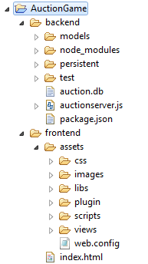

Both Frontend and Backend use socket.io as the main technology in communication between server and clients

# Backend

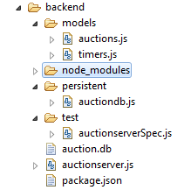

Persistent layer:

Persistent\auctiondb.js, using sqlite3

When Server is started, database (name is auction.db) will be created automatically under folder backend

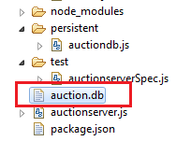

Models

Models\auction.js

Models\timers.js

Test

auctionserverSpec.js

(Test using Mocha+chai to test some APIs)

Server API: auctionserver.js which mainly using Express to create REST API service which

Server will listening on port 9081

Start backend under nodejs by using command:

***node auctionserver.js***

To test service running, open ***http://127.0.0.1:9081/*** in Chrome

# Frontend

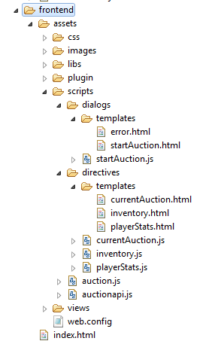

In **auction.js**, there is a place to configure host url:

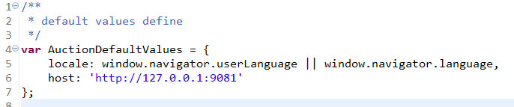

How to run front end

* Deploy frontend in your IIS
* Open frontend in Chrome by this syntax

http://localhost/***{aplication_name}***/#/

***{application_name}***: will be the name of frontend that you defined in IIS

Screenshots:

Login page:

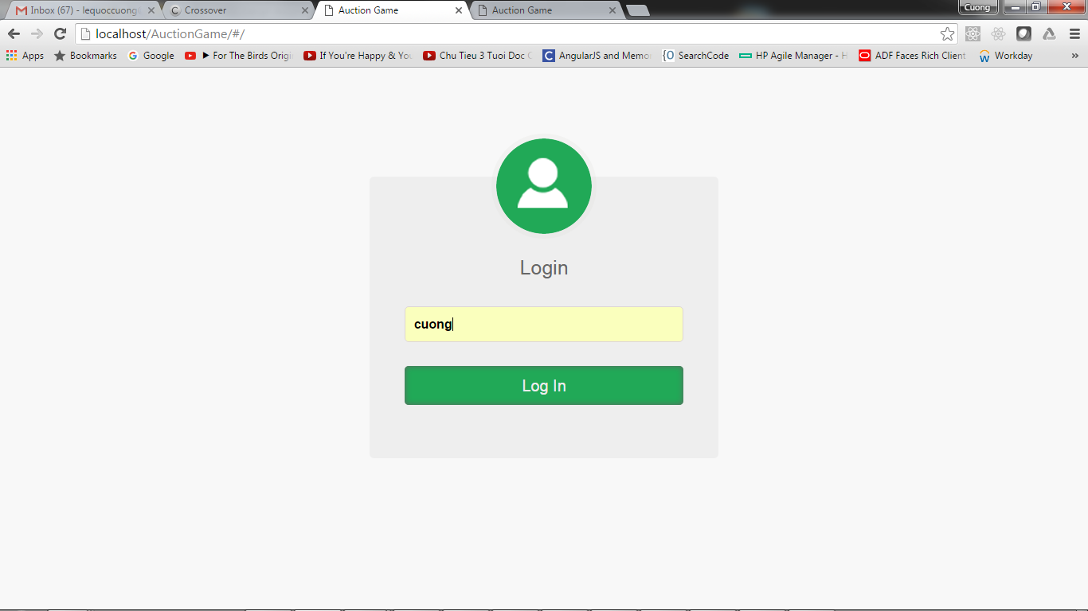

When user logged in, service will check this user is already in database or not, if not this user will be inserted and return

Dashboard page:

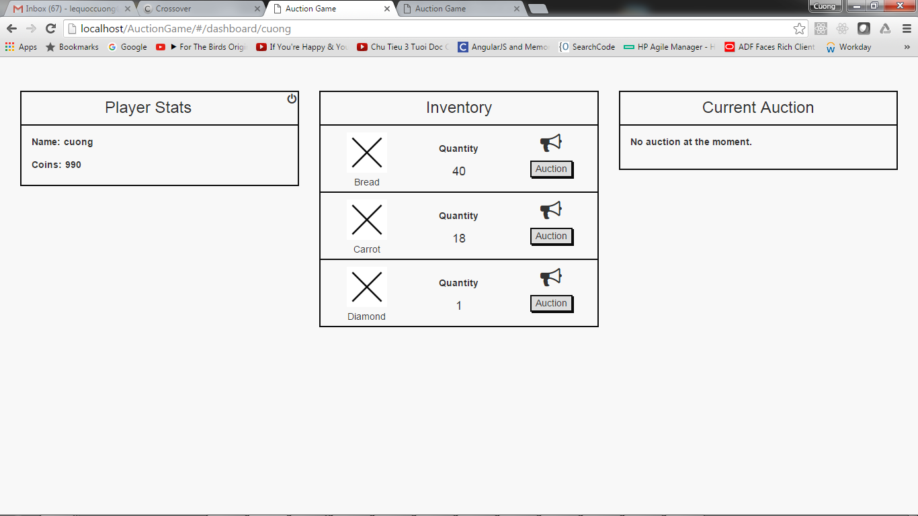

Start Auction

