**C# Coding Conventions**

1. **Naming Convention**

There are several naming conventions to consider when writing C# code.

In the following examples, any of the guidance pertaining to elements marked public is also applicable when working with protected and protected internal elements, all of which are intended to be visible to external callers.

* **Pascal case**

Use pascal casing ("PascalCasing") when naming a class, record, or struct.

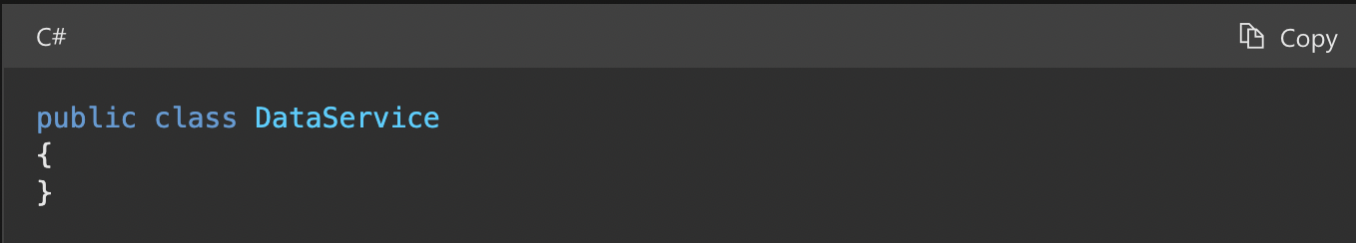

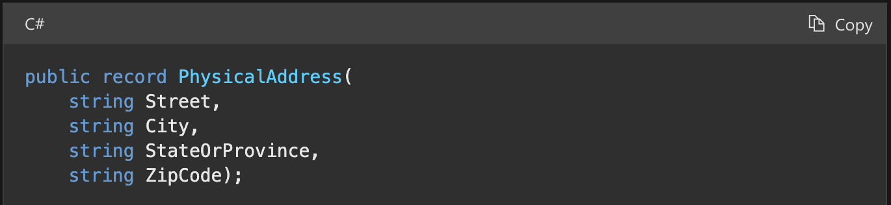

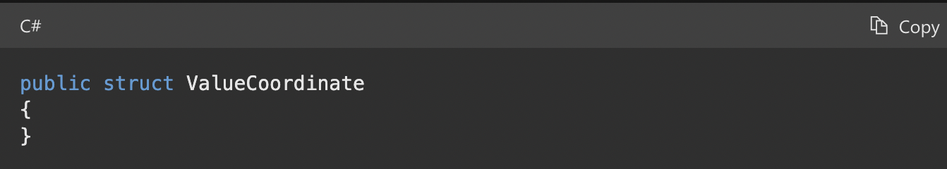

When naming an interface, use pascal casing in addition to prefixing the name with an I. This clearly indicates to consumers that it's an interface.

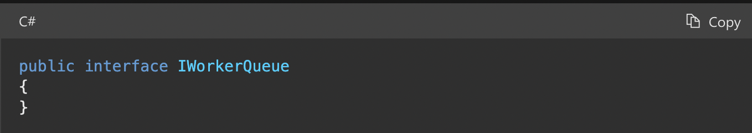

When naming public members of types, such as fields, properties, events, methods, and local functions, use pascal casing.

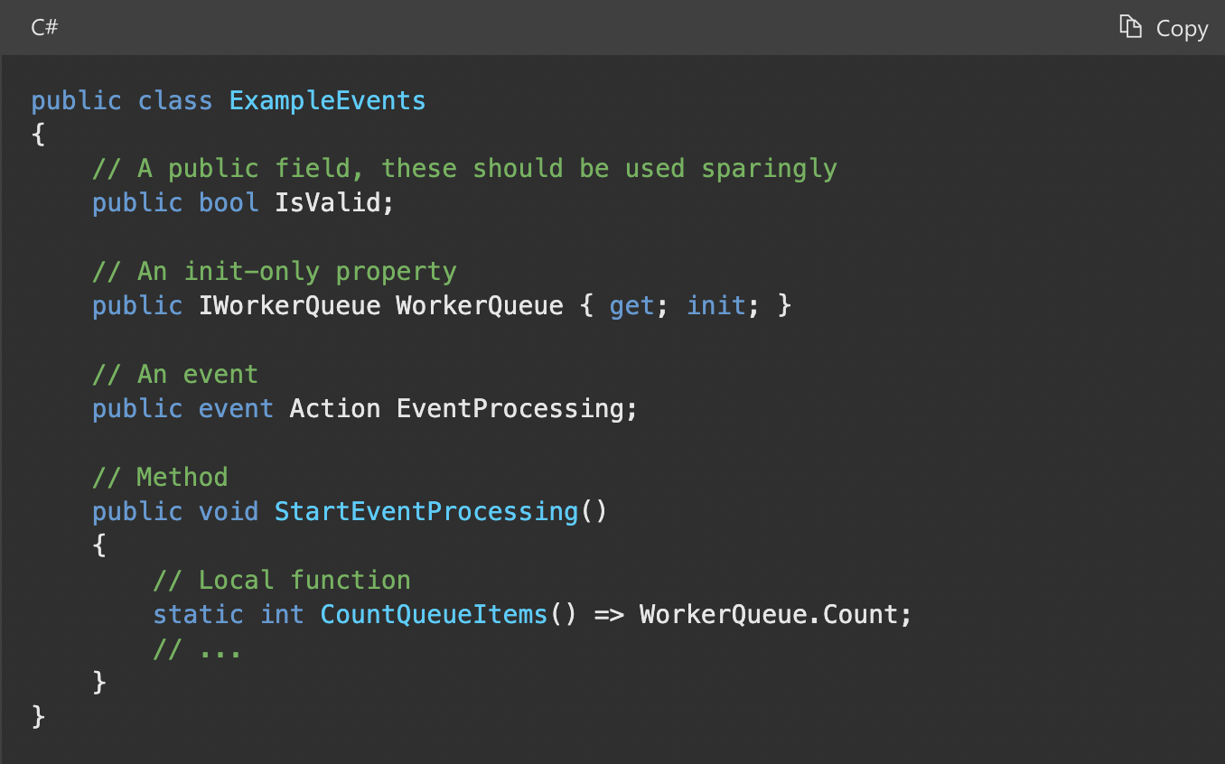

* **Camel case**

Use camel casing ("camelCasing") when naming private or internal fields, and prefix them with _.

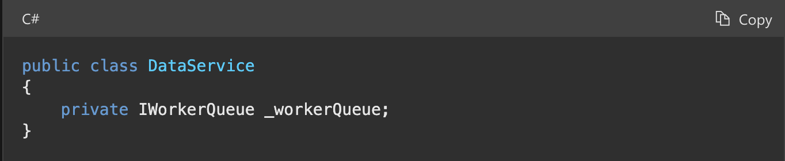

When writing method parameters, use camel casing.

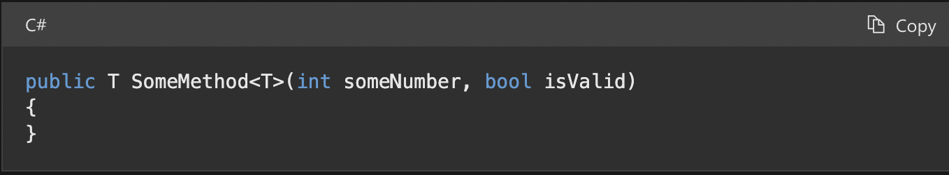

1. **Commenting and Summary conventions**

* Place the comment on a separate line, not at the end of a line of code.
* Begin comment text with an uppercase letter.
* End comment text with a period.
* Insert one space between the comment delimiter (//) and the comment text, as shown in the following example.

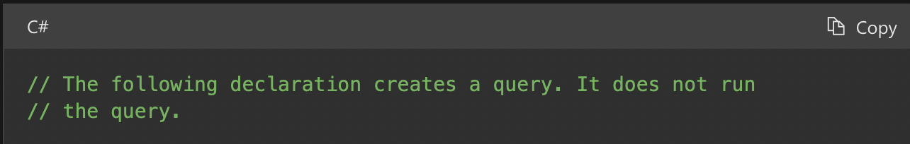

All methods must be summarized. You just need to type /// statement on the method that needs summary then add description in summary.

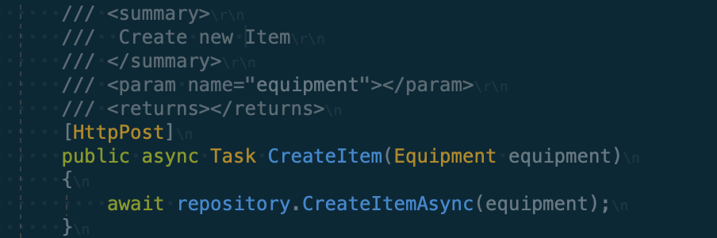

**Link Refer**

<https://docs.microsoft.com/en-us/dotnet/csharp/fundamentals/coding-style/coding-conventions>

<https://docs.microsoft.com/en-us/dotnet/csharp/language-reference/language-specification/documentation-comments>