VALIDATION RULES DOCUMENT
Requirement R4, Function 4: Assess FAS and apply subsidies (FAS Applications)
For Dev. Based on FS F4 FAS Applications v1.1 dated 18/10/2026 and compared with the Figma prototype.
Item | Content
Project | Agileproject, MOE finance system, EAFAMS
Document version | Draft 0.5 (Comprehensive Coverage - FAS Applications & Schemes), 25/10/2026
Author | QA
Main source | [Agile] FS.docx of requirement R4 (FS F4 FAS Applications v1.1)  Figma prototype Edusave, canvas F4 FAS applications, 12 screens (A1 to A4, B1, B2, C1 to C4, D1, D2)
Other sources | Database Design Function Specification, Func4 v0.3  Product Backlog PB-17 to PB-21  Function tree
Companion files | R4_FAS_Seed_Data.sql  R4_FAS_Seed_Data_DB.xlsx  R4_FAS_Seed_Data_QA_Read.xlsx
Status | Updated with complete Scheme Management (F4.13-F4.16) and AI/ML Deny Rules (F4.19)

1. Scope
Screen | Content | Figma screen
A | FAS applications list, School Admin view | C1 and C4
B | FAS applications list, MOE HQ view | A1 and A4
C | SBFAS review drawer | C2 and D1
D | MOEFAS review drawer | A2 and B1
E | Approve SBFAS dialog | C3
F | Approve MOEFAS dialog | A3
G | Reject application dialog | B2 and D2
H | FAS schemes list, MOE HQ and School Admin view | F4 Schemes (Canvas F4)
I | New scheme wizard (General, Eligibility, Subsidy, Review) | F4 New Scheme (Canvas F4)
J | Review and publish scheme (Overlap Prevention rules) | F4 Publish dialog
K | Add fee to a published scheme dialog | F4 Add fee dialog
L | AI/ML Need Score calculation and Deny Rules engine | FS F4 section 7.2

2. Conventions
Item | Rule
Red number in a figure | Same as the field code in the heading below it, for example box A4 is section A4
Source in FS | Section, business rule (BR) or scenario (T) behind the rule
Messages | Exact wording of FS section 8 and 9
QA proposal | Not in the FS. BA must confirm before Dev builds it
Figure | Value read from a figure of the FS or from the Figma prototype
Figma state | A Figma screen that shows a case the FS has no figure for. Rules of the state are listed under the figure
Figma screen id | Letter and number of the Figma frame (A1 to D2), listed in Appendix C
All text input | Treated as data, never as code  Queries are parameterized  Output is encoded for HTML  Never parsed as JSON, XML, template or command  Control characters removed  Stored as Unicode
Language | English only
Role School Admin | Sees and decides SBFAS of the own school
Role MOE HQ | Sees all applications  Decides MOEFAS  Views SBFAS only
Statuses | Pending, Approved, Rejected

3. Screen A. FAS applications list, School Admin view
Menu Financial assistance, FAS applications. Opens on the Pending tab. A School Admin sees SBFAS applications of the own school only. Source: FS 3.1, 3.3 to 3.5.
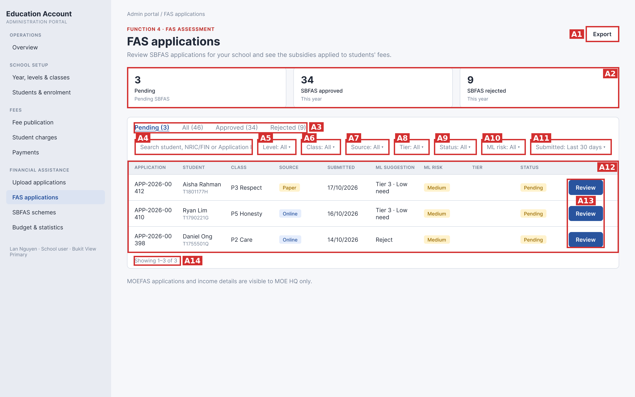
Figure A, Figma screen C1

3.1. Field summary
Code | Field | Type
A1 | Export button | Button
A2 | Summary cards | Display only
A3 | Status tabs | Selection
A4 | Search box | Text input
A5 | Level filter | Selection
A6 | Class filter | Selection
A7 | Source filter | Selection
A8 | Tier filter | Selection
A9 | Status filter | Selection
A10 | ML risk filter | Selection
A11 | Submitted filter | Selection
A12 | Applications table | Display only
A13 | Review or View button | Button
A14 | Footer and paging | Display only

3.2. Field rules

A1. Export button
Item | Rule
Function | Download the current list as CSV
Shown when | Always
Disabled when | File is being prepared
On click | Export all rows matching tab, filters and search (all pages, QA proposal)  Columns: Application, Student, NRIC/FIN, School/Class, Scheme, Source, Submitted, System check, ML, ML risk, Tier, Status  Dates as DD/MM/YYYY  School Admin file: own school SBFAS only  No matching row: header row only  File name: fas-applications_YYYYMMDD.csv (QA proposal)
On double click | One file
On error | Something went wrong. Please try again.
Source in FS | FS 3.1 item 1, 3.4, T29, BR13

Code | Field | Shows | Rule | Source in FS
A2 | Summary cards | Pending (SBFAS waiting for the school)  SBFAS approved (this year)  SBFAS rejected (this year) | Own school only  Not affected by filters or search  Refresh after every decision | FS 3.1 item 2, section 9

A3. Status tabs
Item | Rule
Options | Pending  All  Approved  Rejected  Each tab shows its count in brackets when above 0, for example Pending (3)
Default | Pending
Required | One tab is always active
Depends on | None
On change | Show rows with that status  Back to page 1  Filters and search stay (QA proposal)  After a decision the row leaves Pending and counts refresh
Message | No applications found. when the tab is empty
Source in FS | FS 3.1 item 3, section 9, T24, T27

A4. Search box
Rule | Valid | Invalid | Message
Required | Empty or filled | None | None
Length | 0 to 100 characters | 101 or more characters | Text cut to 100.  Helper text: Search is limited to 100 characters.
Leading and trailing spaces | Removed before search | None | None
Spaces only | Treated as empty, no filter | None | None
Tab or line break | Replaced by one space | None | None
Control characters (U+0000 to U+001F, U+007F) | Removed | None | None
Null byte | Removed, never reaches the database | None | None
Allowed characters | Any printable character  Letters, digits, space, apostrophe, hyphen, slash, period | None | None
Special characters ' " % _ \ ; -- * ? ( ) [ ] | Plain text | None | % and _ are not wildcards  No regular expression
SQL string, for example ' OR 1=1 -- | Plain text, parameterized query | None | No result  No applications found.
Script, for example <script>alert(1)</script>, <img onerror>, javascript: | Plain text, never executed or rendered | None | No result  No applications found.
JSON, XML, template, for example {"a":1}, ${jndi:ldap://x}, $(whoami), ../../etc/passwd | Plain text, never parsed or evaluated | None | No result  No applications found.
Percent code, for example %27 | Plain text, not decoded | None | None
Emoji, letters of any script | Accepted as text | None | No applications found. when nothing matches
Matching | Contains  Ignore case  Student name, NRIC/FIN or Application ID | None | No applications found. when nothing matches
Trigger | Enter key  Or 300 ms after the last key (QA proposal) | None | None
Combined with | Tab and filters by AND, back to page 1 | None | None
Scope | School Admin searches own school SBFAS applications only | None | None
Valid examples | aisha  AISHA  t1801177h  1801177  APP-2026-00412  00412  Lee Zhi  d'souza  zzzz (no match) | None | None
Source in FS | FS 3.1 item 4, FS 3.3, FS 3.5, T26, T27

A5. Level filter
Item | Rule
Options | All  Levels of the own school, ascending
Default | All
Required | No
Depends on | None
On change | Table reloads on page 1  Class options limited to the level
Message | No applications found. when empty
Source in FS | FS 3.3 row Level

A6. Class filter
Item | Rule
Options | All  Classes of the chosen level  All classes of the school when Level is All
Default | All
Required | No
Depends on | Level
On change | Table reloads on page 1  When Level changes and the class is not in the new level, Class returns to All (QA proposal)
Message | No applications found. when empty
Source in FS | FS 3.3 row Class

A7. Source filter
Item | Rule
Options | All  Online  Paper
Default | All
Required | No
Depends on | None
On change | Table reloads on page 1
Message | No applications found. when empty
Source in FS | FS 3.3 row Source

A8. Tier filter
Item | Rule
Options | All  Tier 1  Tier 2  Tier 3
Default | All
Required | No
Depends on | Tiers of the Active SBFAS scheme
On change | Table reloads on page 1  Decided application matches the tier granted  Pending application matches the tier ML suggests  ML Reject has no tier and shows only under All
Message | No applications found. when empty
Source in FS | FS 3.3 row Tier

A9. Status filter
Item | Rule
Options | All  Pending  Approved  Rejected
Default | All
Required | No
Depends on | Status tab
On change | Table reloads on page 1
Message | No applications found. when empty
Source in FS | FS 3.3 row Status, section 2.2

A10. ML risk filter
Item | Rule
Options | All  Low  Medium  High
Default | All
Required | No
Depends on | None
On change | Table reloads on page 1
Message | No applications found. when empty
Source in FS | FS 3.3 row ML risk

A11. Submitted filter
Item | Rule
Options | Last 7 days  Last 30 days  Any time
Default | Last 30 days
Required | One value is always selected
Depends on | None
On change | Table reloads on page 1  Days counted in Singapore time (UTC+8), today included (QA proposal)
Message | No applications found. when empty
Source in FS | FS 3.3 row Submitted

Code | Field | Shows | Rule | Source in FS
A12 | Applications table | Columns: Application, Student (name and NRIC/FIN), Class, Source, Submitted, ML suggestion, ML risk, Tier, Status | Sort: Submitted, newest first  10 rows per page  Application ID: APP-YYYY-NNNNN, unique, one line  Date: DD/MM/YYYY  Tier: filled only when Approved  ML suggestion: Tier X · High, Medium or Low need, or Reject  Another school's link: You do not have access to this application. | FS 3.4, 3.5, BR13, BR14, BR16, T2, T3, T4, T28, T31

A13. Review or View button
Item | Rule
Function | Open the review drawer of the row
Shown when | Review: Pending SBFAS application of the own school  View: every other row
On click | Drawer opens on the right over the list  Review: drawer has Reject and Approve  View: drawer is read only
On error | Decided by someone else after the list loaded: drawer opens read only  This application was already decided by {user} on {DD/MM/YYYY}.  Another school's application: You do not have access to this application.
Source in FS | FS 3.1 item 7, 3.5, section 4, section 8

Code | Field | Shows | Rule | Source in FS
A14 | Footer and paging | Showing X to Y of Z and page controls | 10 rows per page  Page controls only when more than 10 results  New tab, filter or search goes to page 1  No result: footer hidden, No applications found. | FS 3.1 item 8, 3.5, T27, T28

3.3. Figma state C4: list after the School Admin approves application 00412
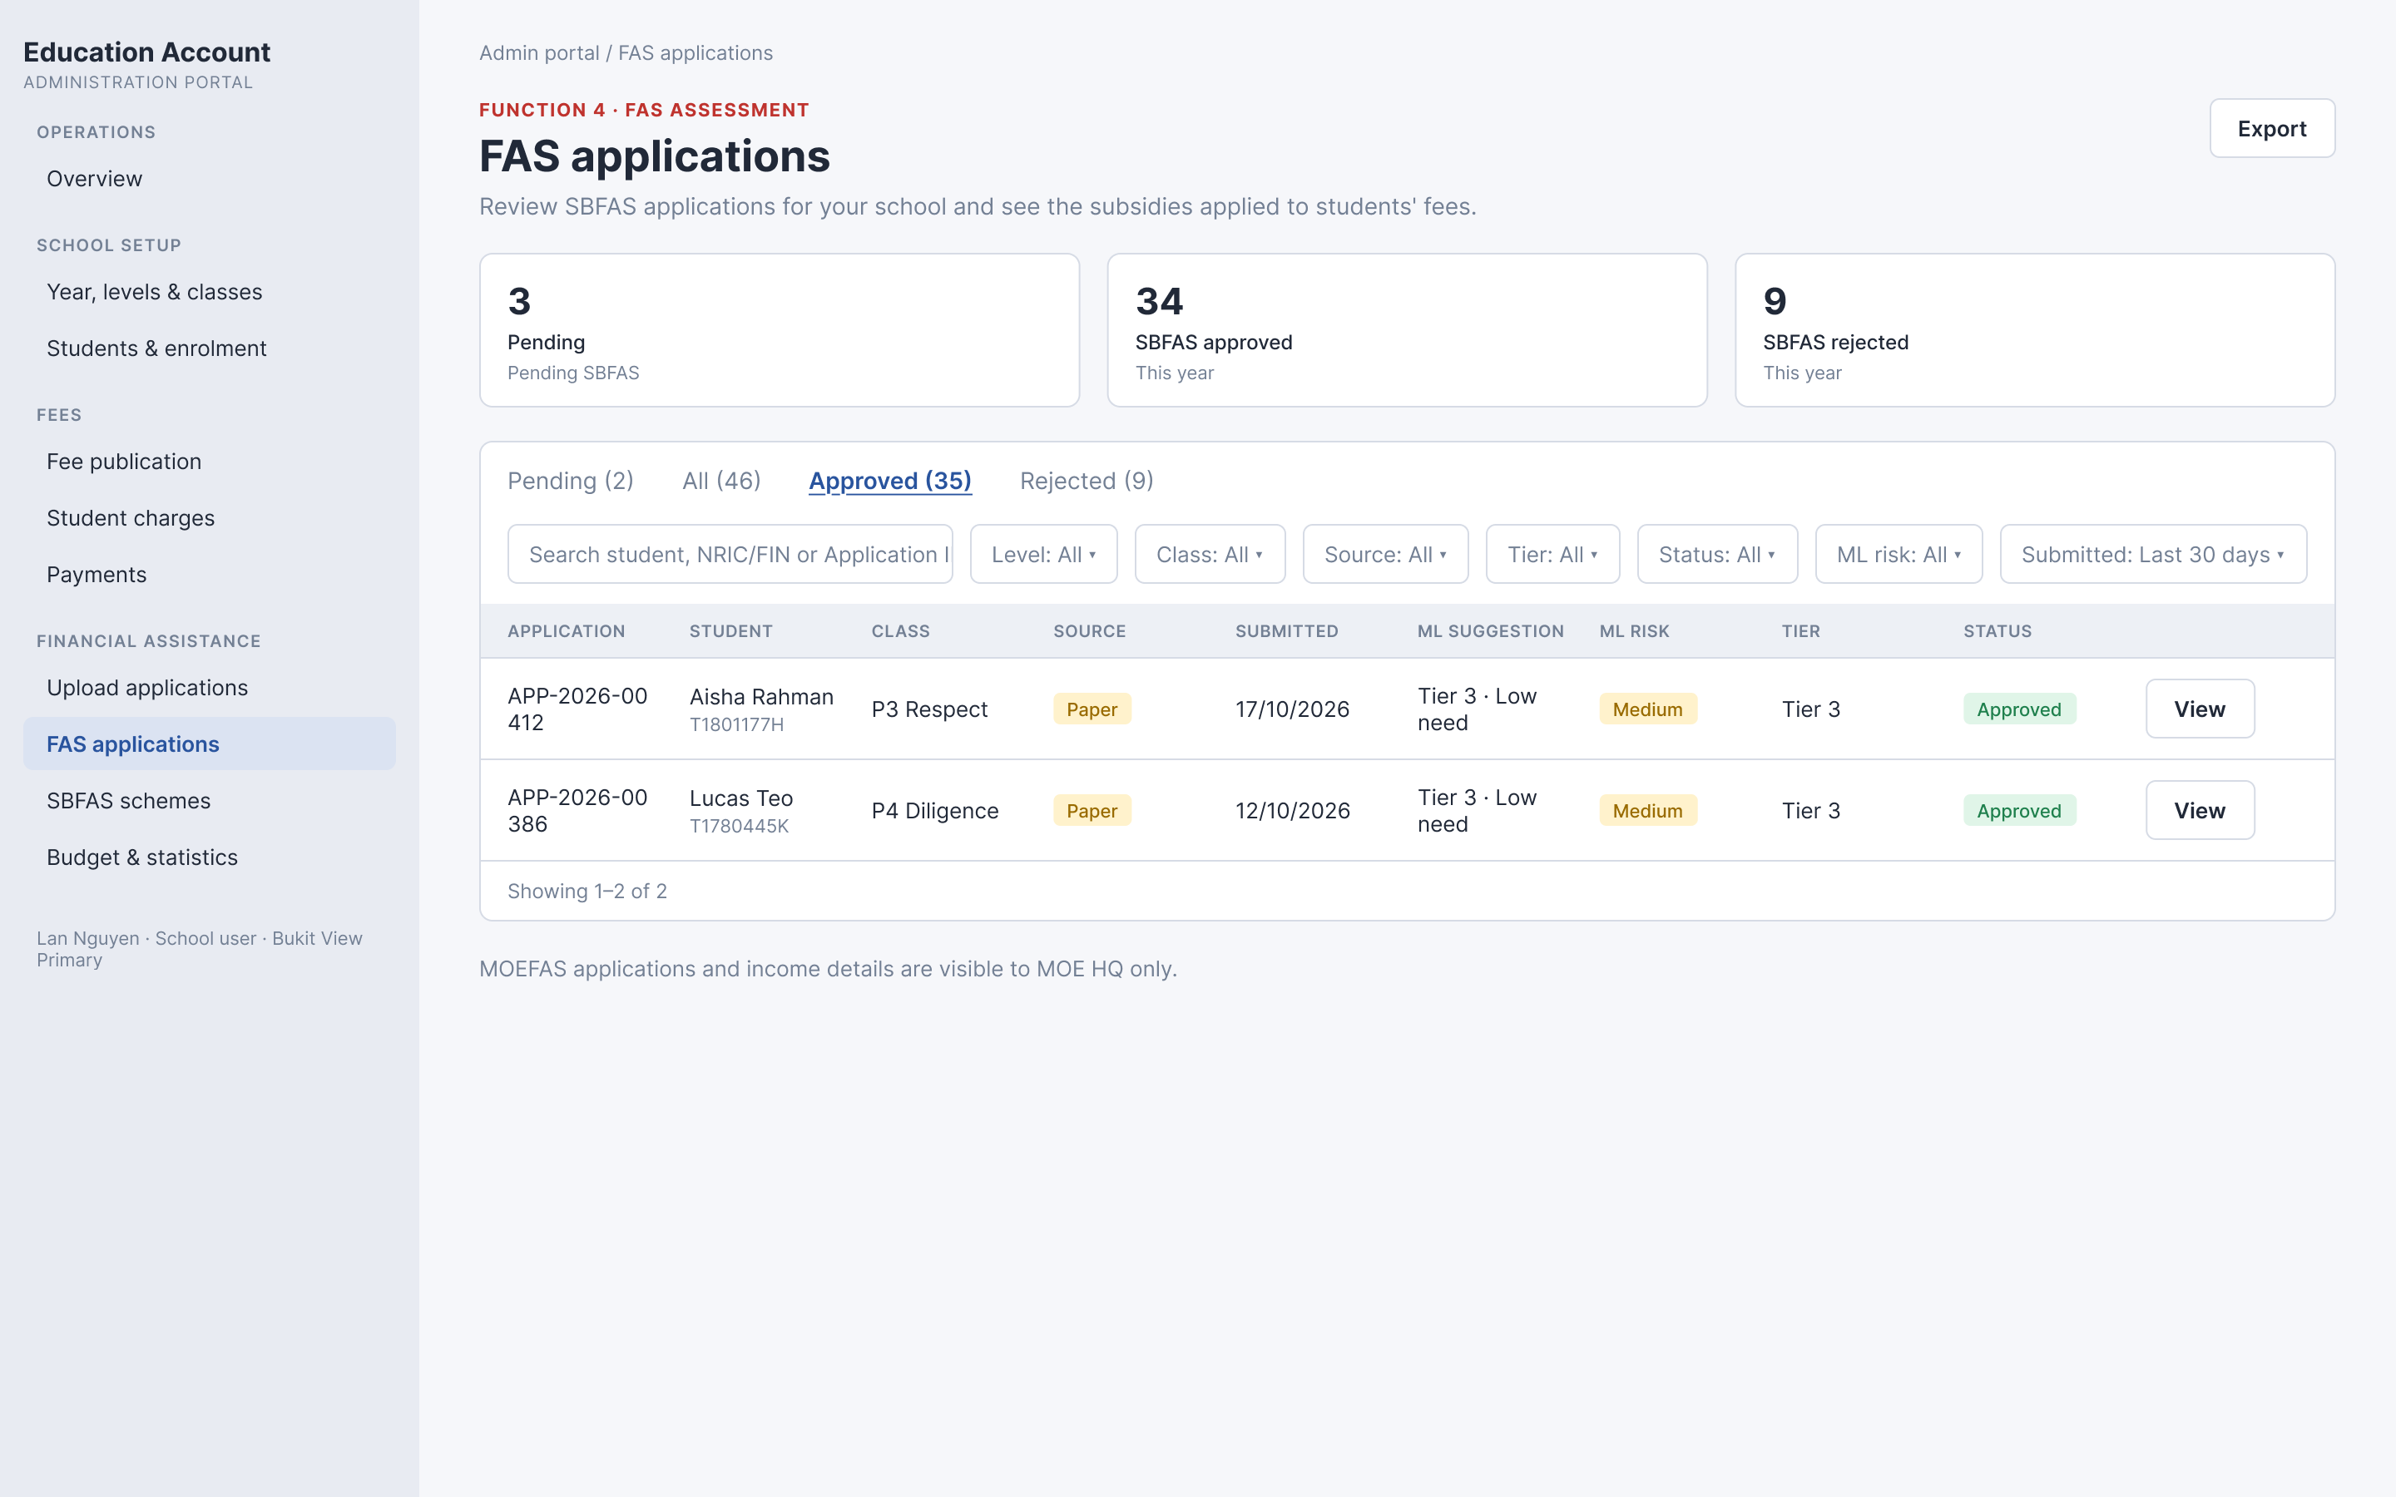
Figure A, Figma screen C4
Item | Rule
Pending card | Goes from 3 to 2 after the decision  Figma C4 still shows 3 (conflict, see open point O22)
SBFAS approved card | Goes from 34 to 35 after the decision  Figma C4 still shows 34 (conflict, see open point O22)
SBFAS rejected card | Stays 9
Tab counts | Pending (2)  All (46), unchanged  Approved (35)  Rejected (9)
Row of application 00412 | Leaves the Pending tab  Shows in the Approved tab  Tier shows Tier 3  Status shows Approved  Button shows View
Rows shown in the Approved tab | Figma shows 2 rows and the footer Showing 1–2 of 2 while the tab says Approved (35)  The Submitted filter is Last 30 days  Tab counts therefore do not follow the filters (open point O1 and O23)
Class column | Shows the class name, for example P3 Respect, P4 Diligence
Source in Figma | Screen C4, sticky note of screen C1

3.4. Open points of screen A
Field | Open point
A1 Export button | FS does not give the export scope or file name. All pages and the file name are QA proposals.
A2 Summary cards | FS does not define this year (calendar or school year).
A3 Status tabs  A9 Status filter | FS does not say if tab counts follow filters and search, or what Pending tab plus Status Approved shows. Figure: All (46) with the 30 day filter.
A4 Search box | FS gives no maximum length, whitespace rule, trigger or special character rule. All are QA proposals.
A6 Class filter | Class reset on Level change is a QA proposal.
A8 Tier filter | Tier 4 and Ineligible exist in the engine (FS 5.3) but not in the Tier filter or the Tier dropdown (FS 1.3, 6.1).
A11 Submitted filter | Today included and Singapore time are QA proposals.
A12 Applications table | Figure: Application ID wraps into two lines (APP-2026-00 and 412). Show on one line.
A2 Summary cards  A3 Status tabs | Figma C4 does not update the cards after a decision (Pending 3 and SBFAS approved 34) but updates the tab counts (Pending 2, Approved 35). FS 9 says cards and tab counts update.
A4 Search box | Figma shows the placeholder cut off: Search student, NRIC/FIN or Application I. Show the full text or shorten it.

4. Screen B. FAS applications list, MOE HQ view
Same page as the School Admin list. MOE HQ sees all schools, MOEFAS and SBFAS. Source: FS 3.2 to 3.5.
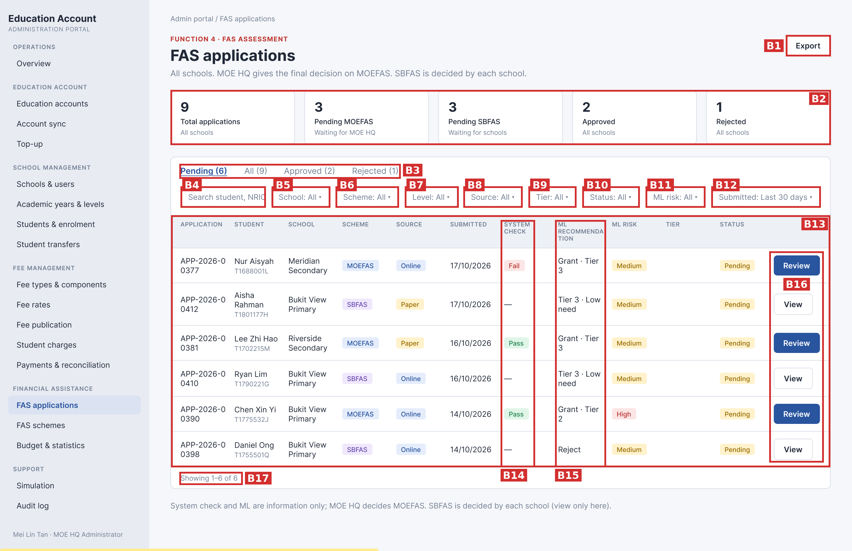
Figure B, Figma screen A1

4.1. Field summary
Code | Field | Type
B1 | Export button | Button
B2 | Summary cards | Display only
B3 | Status tabs | Selection
B4 | Search box | Text input
B5 | School filter | Selection
B6 | Scheme filter | Selection
B7 | Level filter | Selection
B8 | Source filter | Selection
B9 | Tier filter | Selection
B10 | Status filter | Selection
B11 | ML risk filter | Selection
B12 | Submitted filter | Selection
B13 | Applications table | Display only
B14 | System check column | Display only
B15 | ML recommendation column | Display only
B16 | Review or View button | Button
B17 | Footer and paging | Display only

4.2. Field rules

B1. Export button
Item | Rule
Function | Download the current list as CSV
Shown when | Always
Disabled when | File is being prepared
On click | Export all rows matching tab, filters and search (all pages, QA proposal)  Columns: Application, Student, NRIC/FIN, School/Class, Scheme, Source, Submitted, System check, ML, ML risk, Tier, Status  Dates as DD/MM/YYYY  MOE HQ file: all schools, MOEFAS and SBFAS, System check empty for SBFAS  No matching row: header row only  File name: fas-applications_YYYYMMDD.csv (QA proposal)
On double click | One file
On error | Something went wrong. Please try again.
Source in FS | FS 3.2 item 1, 3.4, T29

Code | Field | Shows | Rule | Source in FS
B2 | Summary cards | Total applications  Pending MOEFAS (waiting for MOE HQ)  Pending SBFAS (waiting for schools)  Approved  Rejected | All schools  Not affected by filters or search  Refresh after every decision | FS 3.2 item 2, section 9

B3. Status tabs
Item | Rule
Options | Pending  All  Approved  Rejected  Count in brackets when above 0
Default | Pending
Required | One tab is always active
Depends on | None
On change | Show rows with that status  Back to page 1  Pending contains MOEFAS and SBFAS waiting for a decision
Message | No applications found. when the tab is empty
Source in FS | FS 3.2 item 3

B4. Search box
Rule | Valid | Invalid | Message
Required | Empty or filled | None | None
Length | 0 to 100 characters | 101 or more characters | Text cut to 100.  Helper text: Search is limited to 100 characters.
Leading and trailing spaces | Removed before search | None | None
Spaces only | Treated as empty, no filter | None | None
Tab or line break | Replaced by one space | None | None
Control characters (U+0000 to U+001F, U+007F) | Removed | None | None
Null byte | Removed, never reaches the database | None | None
Allowed characters | Any printable character  Letters, digits, space, apostrophe, hyphen, slash, period | None | None
Special characters ' " % _ \ ; -- * ? ( ) [ ] | Plain text | None | % and _ are not wildcards  No regular expression
SQL string, for example ' OR 1=1 -- | Plain text, parameterized query | None | No result  No applications found.
Script, for example <script>alert(1)</script>, <img onerror>, javascript: | Plain text, never executed or rendered | None | No result  No applications found.
JSON, XML, template, for example {"a":1}, ${jndi:ldap://x}, $(whoami), ../../etc/passwd | Plain text, never parsed or evaluated | None | No result  No applications found.
Percent code, for example %27 | Plain text, not decoded | None | None
Emoji, letters of any script | Accepted as text | None | No applications found. when nothing matches
Matching | Contains  Ignore case  Student name, NRIC/FIN or Application ID | None | No applications found. when nothing matches
Trigger | Enter key  Or 300 ms after the last key (QA proposal) | None | None
Combined with | Tab and filters by AND, back to page 1 | None | None
Scope | MOE HQ searches all schools. School name is not searched | None | None
Valid examples | aisha  AISHA  t1801177h  1801177  APP-2026-00412  00412  Lee Zhi  d'souza  zzzz (no match) | None | None
Source in FS | FS 3.1 item 4, FS 3.3, FS 3.5, T26, T27

B5. School filter
Item | Rule
Options | All  All schools, alphabetical (QA proposal)
Default | All
Required | No
Depends on | None
On change | Table reloads on page 1
Message | No applications found. when empty
Source in FS | FS 3.3 row School

B6. Scheme filter
Item | Rule
Options | All  MOEFAS  SBFAS
Default | All
Required | No
Depends on | None
On change | Table reloads on page 1
Message | No applications found. when empty
Source in FS | FS 3.3 row Scheme

B7. Level filter
Item | Rule
Options | All  Levels of all schools
Default | All
Required | No
Depends on | None
On change | Table reloads on page 1
Message | No applications found. when empty
Source in FS | FS 3.3 row Level

B8. Source filter
Item | Rule
Options | All  Online  Paper
Default | All
Required | No
Depends on | None
On change | Table reloads on page 1
Message | No applications found. when empty
Source in FS | FS 3.3 row Source

B9. Tier filter
Item | Rule
Options | All  Tier 1  Tier 2  Tier 3
Default | All
Required | No
Depends on | Tiers of MOEFAS and SBFAS
On change | Table reloads on page 1  Decided application matches the tier granted  Pending application matches the tier ML suggests
Message | No applications found. when empty
Source in FS | FS 3.3 row Tier

B10. Status filter
Item | Rule
Options | All  Pending  Approved  Rejected
Default | All
Required | No
Depends on | Status tab
On change | Table reloads on page 1
Message | No applications found. when empty
Source in FS | FS 3.3 row Status

B11. ML risk filter
Item | Rule
Options | All  Low  Medium  High
Default | All
Required | No
Depends on | None
On change | Table reloads on page 1
Message | No applications found. when empty
Source in FS | FS 3.3 row ML risk

B12. Submitted filter
Item | Rule
Options | Last 7 days  Last 30 days  Any time
Default | Last 30 days
Required | One value is always selected
Depends on | None
On change | Table reloads on page 1  Singapore time, today included (QA proposal)
Message | No applications found. when empty
Source in FS | FS 3.3 row Submitted

Code | Field | Shows | Rule | Source in FS
B13 | Applications table | Columns: Application, Student, School, Scheme, Source, Submitted, System check, ML recommendation, ML risk, Tier, Status | No Class column  Sort: Submitted, newest first  10 rows per page  Application ID: APP-YYYY-NNNNN, unique, one line  Date: DD/MM/YYYY  Tier: filled only when Approved | FS 3.4, 3.5, BR13, BR14, BR16
B14 | System check column | Pass or Fail for MOEFAS, a dash for SBFAS | Information only, never approves or rejects  Pass and Fail applications both stay Pending for MOE HQ | FS 3.4, BR1, BR6, T7
B15 | ML recommendation column | MOEFAS: Grant · Tier X, Borderline, Do not grant  SBFAS: Tier X · High, Medium or Low need, or Reject | Rule: engine calculation, see Appendix A  Reference only | FS 3.4, 5.4, BR19

B16. Review or View button
Item | Rule
Function | Open the review drawer of the row
Shown when | Review: Pending MOEFAS application  View: all SBFAS rows and decided MOEFAS rows
On click | MOEFAS: opens the MOEFAS review drawer  SBFAS: opens the SBFAS review drawer read only  MOE HQ never decides SBFAS
On error | Decided by someone else after the list loaded: drawer opens read only  This application was already decided by {user} on {DD/MM/YYYY}.
Source in FS | FS 3.2 item 7, BR2, T1, T19

Code | Field | Shows | Rule | Source in FS
B17 | Footer and paging | Showing X to Y of Z and page controls | 10 rows per page  Page controls only when more than 10 results  New tab, filter or search goes to page 1  No result: footer hidden, No applications found. | FS 3.2 item 8

4.3. Figma state A4: list after MOE HQ approves application 00377
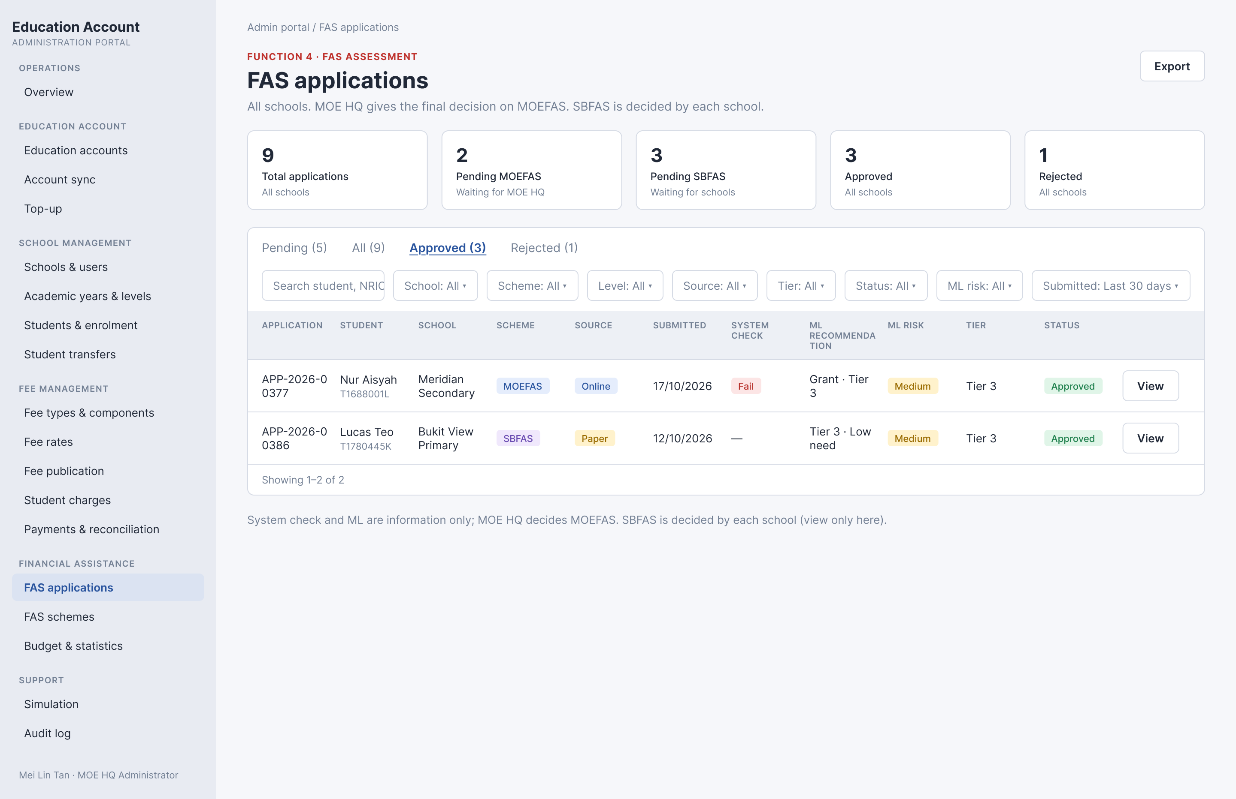
Figure B, Figma screen A4
Item | Rule
Total applications card | Stays 9
Pending MOEFAS card | Goes from 3 to 2
Pending SBFAS card | Stays 3
Approved card | Goes from 2 to 3
Rejected card | Stays 1
Tab counts | Pending (5)  All (9)  Approved (3)  Rejected (1)
Row of application 00377 | Leaves the Pending tab  Shows in the Approved tab  System check keeps Fail  ML recommendation keeps Grant · Tier 3 and ML risk keeps Medium  Tier shows Tier 3  Status shows Approved  Button shows View
Rows shown in the Approved tab | Figma shows 2 rows (00377 and 00386) and the footer Showing 1–2 of 2 while the tab says Approved (3)  Tab counts do not follow the filters (open point O1 and O23)
Source in Figma | Screen A4

4.4. Open points of screen B
Field | Open point
B2 Summary cards | Figure data conflicts with the School Admin figure (Approved 2 for all schools against 34 for one school).
B4 Search box | FS gives no maximum length, whitespace rule, trigger or special character rule. All are QA proposals.
B13 Applications table | Figure: Application ID wraps (APP-2026-0 and 0377).
B14 System check column | FS 3.4: Pass when all criteria pass. FS 4.2: Pass when nationality passes and at least one of GHI or PCI passes. The two differ when only one of GHI or PCI passes.
B15 ML recommendation column | Borderline never occurs with the current formula: within 5 percent over the limit the Need Score is at least 50.50, so the result is always Grant. Figure: header wraps into RECOMMENDA and TION.
B3 Status tabs  B17 Footer and paging | Figma A4 shows Approved (3) with 2 rows and Showing 1–2 of 2 under the 30 day filter. Tab counts and the footer do not use the same scope (open point O1).
B4 Search box | Figma shows the placeholder cut off: Search student, NRIC. Show the full text or shorten it.

5. Screen C. SBFAS review drawer
Opens from Review or View of an SBFAS application. Slides in from the right. Closes with X or a click outside. All fields read only. Source: FS section 4.
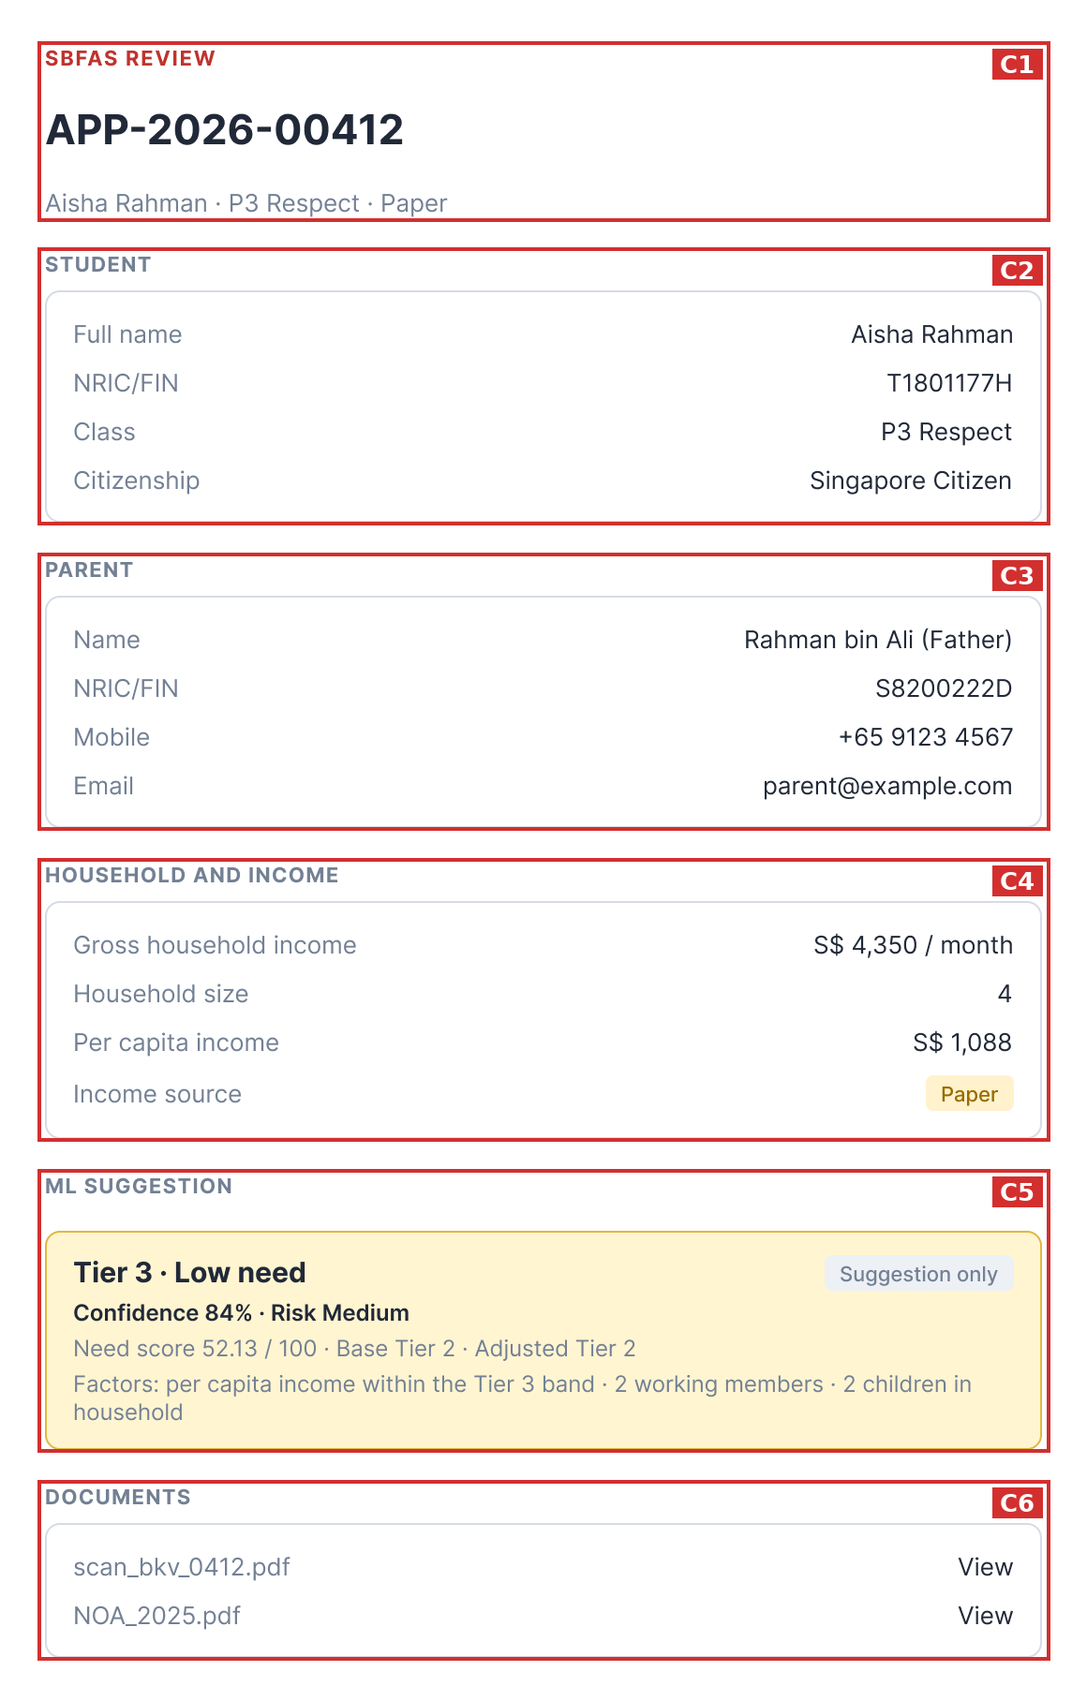
Figure C, Figma screen C2

5.1. Field summary
Code | Field | Type
C1 | Header | Display only
C2 | Student | Display only
C3 | Parent | Display only
C4 | Household and income | Display only
C5 | ML suggestion | Display only
C6 | Documents | Display only

5.2. Field rules
Code | Field | Shows | Rule | Source in FS
C1 | Header | SBFAS REVIEW, Application ID, student name, class, source | School Admin sees class, MOE HQ sees school  X closes the drawer  Another school: You do not have access to this application. | FS 4.1 item 1, T3
C2 | Student | Full name, NRIC/FIN, Class, Citizenship (MOE HQ also sees School) | Citizenship: Singapore Citizen or PR  Non citizen student is always SBFAS  NRIC/FIN: letter, 7 digits, letter (QA proposal) | FS 4.1 item 4, BR18, T32
C3 | Parent | Name and relationship, NRIC/FIN, Mobile, Email | Not editable  Phone and email format: FS 08 | FS 4.1 item 5
C4 | Household and income | Gross household income (S$ per month), Household size, Per capita income (S$), Income source (API or Paper) | Not editable  Per capita income = gross household income / household size  Household size above 0  Amounts in S$ with thousands separators | FS 1.3, 4.1 item 6, BR11, BR16, 5.1
C5 | ML suggestion | Suggestion only, Confidence, Risk, Need Score, Base Tier, Adjusted Tier, Fast-track, deny rule, Factors, Score breakdown | Rule: engine calculation, see Appendix A  Never approves  Warning when the school has no Active SBFAS scheme | FS 4.1 item 7, section 5, BR19, T33 to T35
C6 | Documents | File name and View link | View opens the file  Only users with access to the application can open it | FS 4.1 item 8

5.3. Items in the FS that are not in the cropped figure
Item | Source | Content in the FS
History | FS 4.1 item 9, 4.4 | Date and time, action, oldest first  Actions: Uploaded, Submitted, SBFAS application (not a Singapore Citizen), Eligibility check, Approved, Rejected, Email sent to parent, Moved to SBFAS, Paper application edited
Decision section | FS 4.3 | Shown when Approved or Rejected  Reject and Approve hidden  Shows Result, Tier, Effective from or Reason, Comment, decider, date and time
Reject and Approve buttons | FS 4.1 item 10 | School Admin of the school, Pending only  Reject opens the Reject dialog  Approve opens the Approve SBFAS dialog

5.4. Figma state D1: drawer of a student who is not a Singapore Citizen or PR (application 00398)
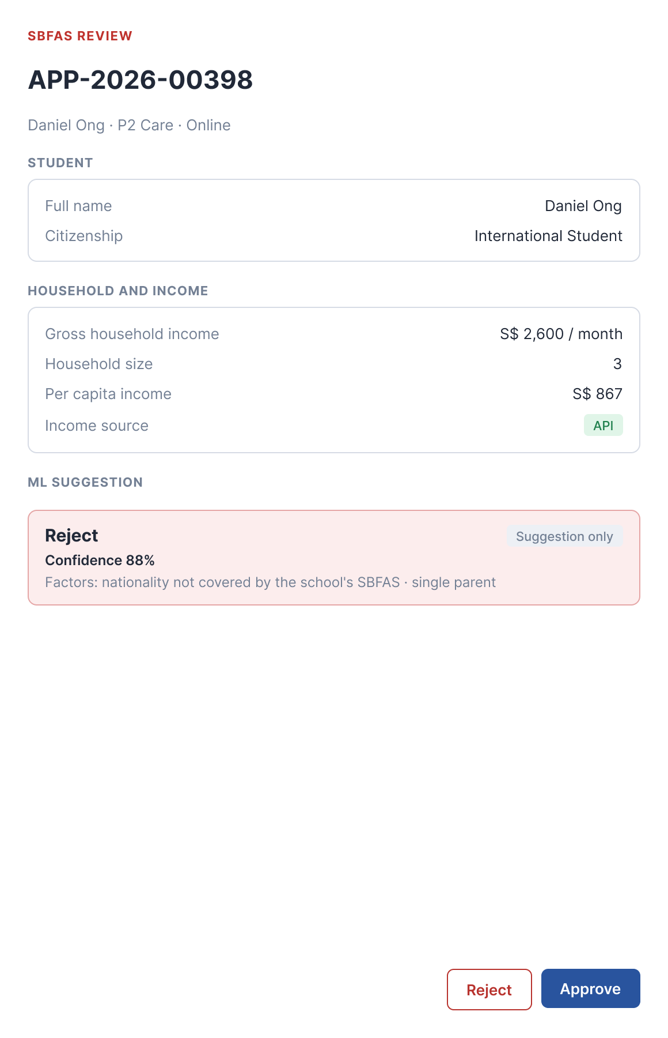
Figure C, Figma screen D1
Item | Rule
Header | SBFAS REVIEW, APP-2026-00398, Daniel Ong · P2 Care · Online
Student section | Figma shows two rows: Full name, Citizenship  FS 4.1 item 4 lists four rows: Full name, NRIC/FIN, Class, Citizenship  Open point O24
Citizenship value | Figma shows International Student  The FS does not list the Citizenship values (open point O24)
Parent section | Not shown in Figma  FS 4.1 item 5 shows it for SBFAS (open point O24)
Household and income | Gross household income S$ 2,600 / month  Household size 3  Per capita income S$ 867  Income source API
ML suggestion | Reject, red box, tag Suggestion only  Confidence 88%  Factors: nationality not covered by the school's SBFAS · single parent  No Risk, Need score, Base Tier or Adjusted Tier line, although the list shows ML risk Medium (open point O24)
Documents section | Not shown in Figma  Online application, so no scanned file  FS 4.1 item 8 does not say what shows when there is no file (open point O24)
Buttons | Reject and Approve, both enabled  The reviewer may approve although the suggestion is Reject (BR19)
Source in Figma | Screen D1, sticky note of screen C1

5.5. Open points of screen C
Field | Open point
C4 Household and income | Figure shows PCI S$ 1,088, stored value is 1,087.50. Dev data design rounds to two decimals, the display rule is not stated.
C5 ML suggestion | Figure has no Score breakdown and no warning. Confidence starts at 92 and only subtracts, so the maximum is 92, and subtracting everything gives 46, below the stated minimum 55.
C6 Documents | Dev data design lists PDF, JPG, PNG, 10 MB, 5 files. Not in FS F4.
C2 Student  C3 Parent  C5 ML suggestion  C6 Documents | Figma D1 (student who is not a Citizen or PR) shows fewer rows and sections than the FS and Figma C2, see the Figma state in section 5.3. Open point O24.

6. Screen D. MOEFAS review drawer
Opens from Review of a Pending MOEFAS application. MOE HQ only. All fields read only. Source: FS section 4.
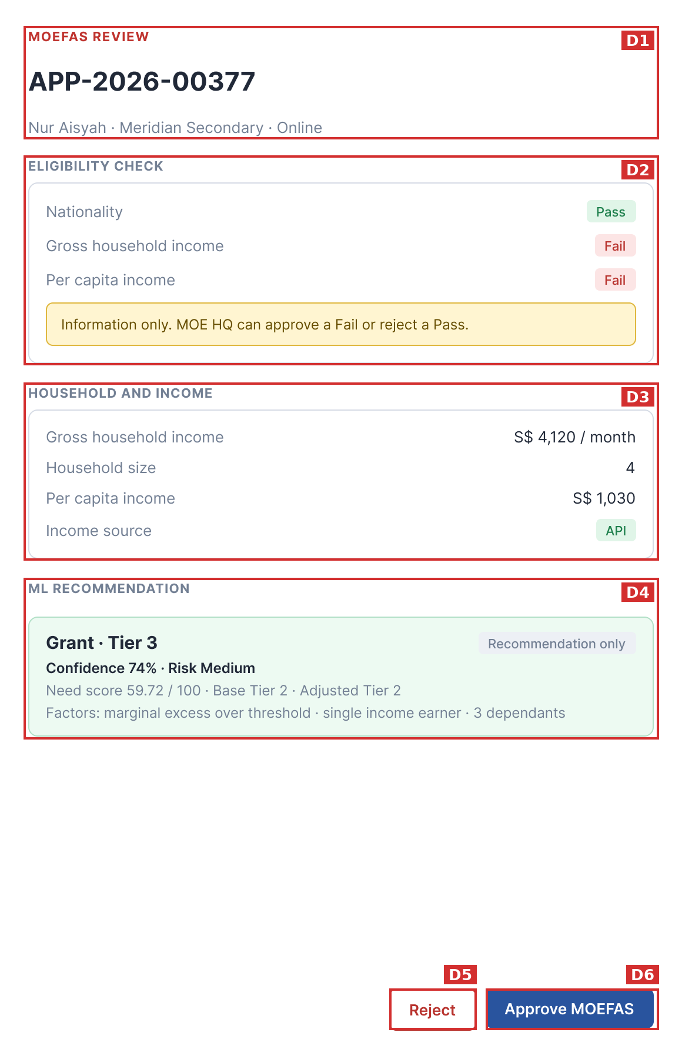
Figure D, Figma screen A2

6.1. Field summary
Code | Field | Type
D1 | Header | Display only
D2 | Eligibility check | Display only
D3 | Household and income | Display only
D4 | ML recommendation | Display only
D5 | Reject button | Button
D6 | Approve MOEFAS button | Button

6.2. Field rules
Code | Field | Shows | Rule | Source in FS
D1 | Header | MOEFAS REVIEW, Application ID, student name, school, source | X closes the drawer | FS 4.1 item 1
D2 | Eligibility check | Each criterion: value, limit, percent above limit, Pass or Fail | Only for MOEFAS  Limits from the Active scheme: Singapore Citizen, GHI up to S$ 4,000, PCI up to S$ 1,000  GHI and PCI are separate rows  Pass: nationality passes and GHI or PCI passes  Value equal to the limit passes (QA proposal)  Information only: MOE HQ can approve a Fail and reject a Pass | FS 4.1 item 3, 4.2, BR5, BR6, T6
D3 | Household and income | Gross household income (S$ per month), Household size, Per capita income (S$), Income source (API or Paper) | Not editable  Per capita income = gross household income / household size  Household size above 0  Amounts in S$ with thousands separators  Visible to MOE HQ only | FS 4.1 item 6, BR11, BR13
D4 | ML recommendation | Recommendation only, Confidence, Risk, Need Score, Base Tier, Adjusted Tier, Factors | Result: Grant · Tier X, Borderline or Do not grant  Rule: engine calculation, see Appendix A  Never approves | FS 4.1 item 7, 5.4, BR19, T5, T33

D5. Reject button
Item | Rule
Function | Open the Reject dialog
Shown when | MOE HQ, Pending MOEFAS
Hidden when | Application decided  SBFAS application
On click | Dialog opens  Drawer stays open behind it
Source in FS | FS 4.1 item 10, 4.3, T5, T22

D6. Approve MOEFAS button
Item | Rule
Function | Open the Approve MOEFAS dialog
Shown when | MOE HQ, Pending MOEFAS
Hidden when | Application decided
Disabled when | Never disabled, also enabled when System check is Fail
On click | Dialog opens  Drawer stays open behind it
Source in FS | FS 4.1 item 10, BR6, T5, T6

6.3. Figma state B1: drawer of a MOEFAS application that passes the system check (application 00390)
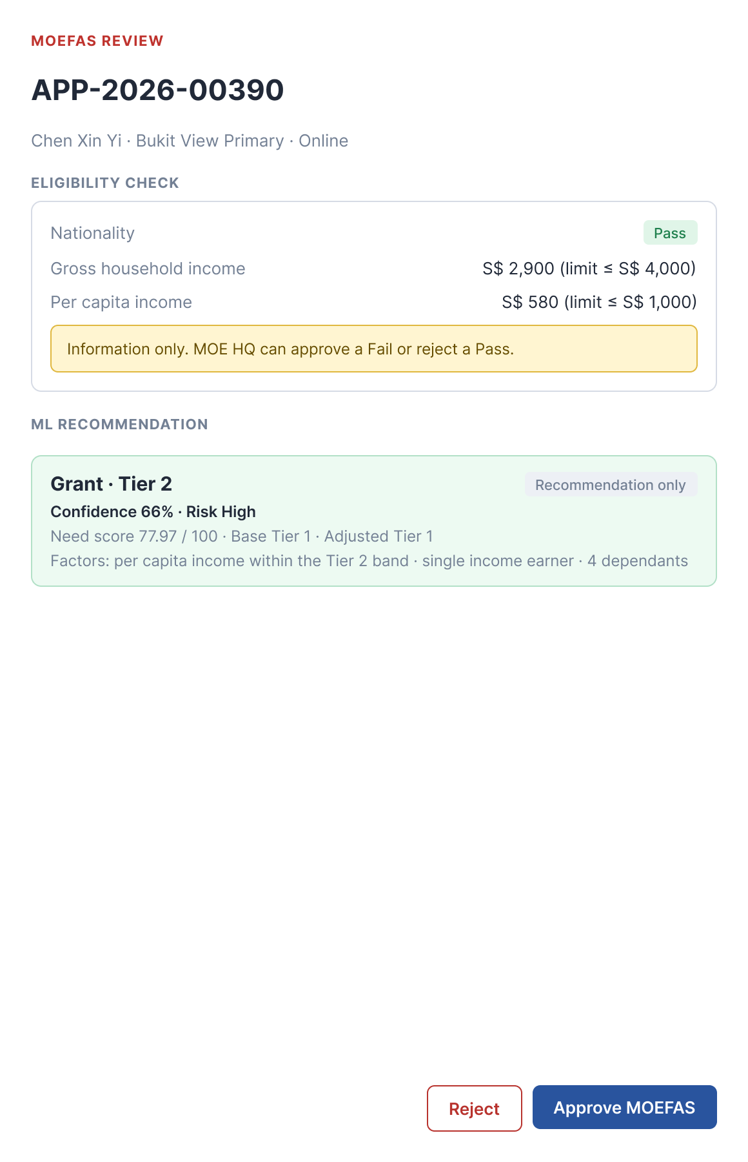
Figure D, Figma screen B1
Item | Rule
Header | MOEFAS REVIEW, APP-2026-00390, Chen Xin Yi · Bukit View Primary · Online
Eligibility check rows | Nationality: Pass  Gross household income: S$ 2,900 (limit ≤ S$ 4,000)  Per capita income: S$ 580 (limit ≤ S$ 1,000)  Figma B1 shows value and limit and no badge on the income rows  Figma A2 (Fail case) shows the badge and no value or limit  FS 4.1 item 3: value, limit, percent above when above, and Pass or Fail  Open point O25
Information note | Information only. MOE HQ can approve a Fail or reject a Pass. Shown in both Figma states
ML recommendation | Grant · Tier 2, tag Recommendation only  Confidence 66% · Risk High  Need score 77.97 / 100 · Base Tier 1 · Adjusted Tier 1  Factors: per capita income within the Tier 2 band · single income earner · 4 dependants  The recommended tier (Tier 2, scheme band match, FS 5.4) differs from the Adjusted Tier (Tier 1, Need Score)
Buttons | Reject and Approve MOEFAS  Reject opens the Reject dialog of Figma screen B2 (Figure G)
Source in Figma | Screen B1

6.4. Open points of screen D
Field | Open point
D2 Eligibility check | Figure shows only Pass or Fail, not value, limit or percent above. FS 3.4: Pass when all criteria pass. FS 4.2: Pass when nationality passes and at least one of GHI or PCI passes. The two differ when only one of GHI or PCI passes.
D4 ML recommendation | Borderline never occurs with the current formula: within 5 percent over the limit the Need Score is at least 50.50, so the result is always Grant.
D2 Eligibility check | Figma B1 shows value and limit and no Pass or Fail badge on the income rows. Figma A2 shows only the badge. Open point O25.
D4 ML recommendation | Figma B1 shows Grant · Tier 2 with Adjusted Tier 1. Recommended tier and Adjusted Tier are two different values, both are shown.

7. Screen E. Approve SBFAS dialog
Opens from Approve in the SBFAS drawer. School Admin of the school. Title carries the scheme name. Source: FS 6.1, sections 8 and 9.
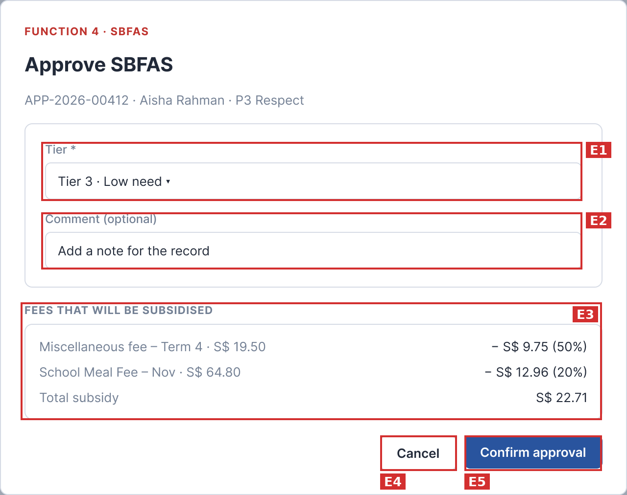
Figure E, Figma screen C3

7.1. Field summary
Code | Field | Type
E1 | Tier | Selection
E2 | Comment (optional) | Text input
E3 | Fees that will be subsidised | Display only
E4 | Cancel button | Button
E5 | Confirm approval button | Button

7.2. Field rules

E1. Tier
Item | Rule
Options | Tier 1 · High need  Tier 2 · Medium need  Tier 3 · Low need
Default | Tier ML suggests, with hint ML suggests Tier X  No selection when ML gives Reject, no tier or Tier 4 (QA proposal)
Required | Yes
Depends on | Active scheme
On change | Fee list recalculates  Total subsidy recalculates
Message | Not chosen: Select a tier to approve. (QA proposal)  Confirm approval disabled  Scheme not Active: No active SBFAS scheme.
Source in FS | FS 6.1 item 1, BR8, section 8

E2. Comment (optional)
Rule | Valid | Invalid | Message
Required | Empty or filled | None | None
Length | 0 to 500 characters | 501 or more characters | Counter turns red, for example 501/500  Error: Comment must be 500 characters or fewer.  Confirm approval disabled
Counter | Shows n/500  Line break counts 1  Emoji counts 1 | None | None
Paste over 500 | Text is kept, not cut | None | Counter shows for example 600/500 in red
Leading and trailing spaces and blank lines | Removed on save | None | None
Spaces only | Saved as empty | None | None
Allowed characters | Any printable Unicode character  Line break and tab | None | None
Control characters other than line break and tab | Removed | None | None
Null byte | Removed before save | None | None
Special characters ' " % \ ; | Saved exactly as typed | None | None
SQL string, for example ' OR 1=1 -- | Saved as text, parameterized query | None | No data changed
Script and HTML, for example <script>, <img onerror>, <b>text</b> | Saved as typed | None | Shown as plain text  Encoded in drawer, History, CSV and parent email
JSON, XML, template, for example {{7*7}}, ${7*7} | Saved as plain text, never parsed | None | API payload escapes quotes and backslash
CSV export | Value starting with =, +, - or @ gets an apostrophe prefix | None | None
Save fails | None | None | Something went wrong. Please try again.  Dialog stays open, text kept
Valid examples | A comment of exactly 500 characters  Two lines separated by a line break  <b>ok</b>  Approved after review | None | None
Invalid examples | 501 or more characters | None | None
Placeholder | Add a note for the record
Source in FS | FS 6.1 item 3, BR15, section 8, T14

Code | Field | Shows | Rule | Source in FS
E3 | Fees that will be subsidised | Open fee name and amount, subsidy in S$ and percent, Total subsidy | Updates when Tier changes  Subsidy = amount x tier percent / 100, rounded half up to the cent  No open fee: No open fees right now. Fees issued later are subsidised automatically.  Paid fees unchanged, not refunded | FS 6.1 item 4, BR7, BR10, T9, T10

E4. Cancel button
Item | Rule
Function | Close the dialog without saving
Shown when | Dialog open
On click | Dialog closes  Tier and Comment discarded  Application stays Pending  Drawer stays open
Source in FS | FS 6.1 item 6

E5. Confirm approval button
Item | Rule
Function | Approve the application and apply the subsidy
Disabled when | No Tier chosen  Comment over 500 characters  Scheme has no Active version
On click | Status becomes Approved  Save tier, effective date (today), comment, decider, date and time  Apply subsidy to open and future EA fees  Write History  Send email with tier to parent  Refresh summary cards and tab counts
On double click | Saves once
Two users at once | First confirmation wins  Second user sees: This application was already decided by {user} on {DD/MM/YYYY}.  Dialog closes, drawer read only, list refreshes
On error | Something went wrong. Please try again.  Nothing saved, dialog stays open
On success | Toast: Subsidy applied to the student's EA fees.
Source in FS | FS 6.1 item 7, sections 8 and 9, BR3, BR4, BR10, BR20, T20, T21, T23, T24, T30

7.3. Open points of screen E
Field | Open point
E1 Tier | Figma C3 has no hint ML suggests Tier X, Figma A3 (MOEFAS) has it. FS 6.1 item 1 says the hint shows for both. FS does not say what is preselected when ML gives no tier.
E2 Comment (optional) | Figure shows no n/500 counter.
E3 Fees that will be subsidised | Figure Tier 3: Miscellaneous S$ 19.50 gives 9.75, School Meal S$ 64.80 gives 12.96, total 22.71. Not clear if amounts include GST.

8. Screen F. Approve MOEFAS dialog
Opens from Approve MOEFAS in the MOEFAS drawer. MOE HQ. Same as the Approve SBFAS dialog plus the budget note. Source: FS 6.1, section 8, BR17.
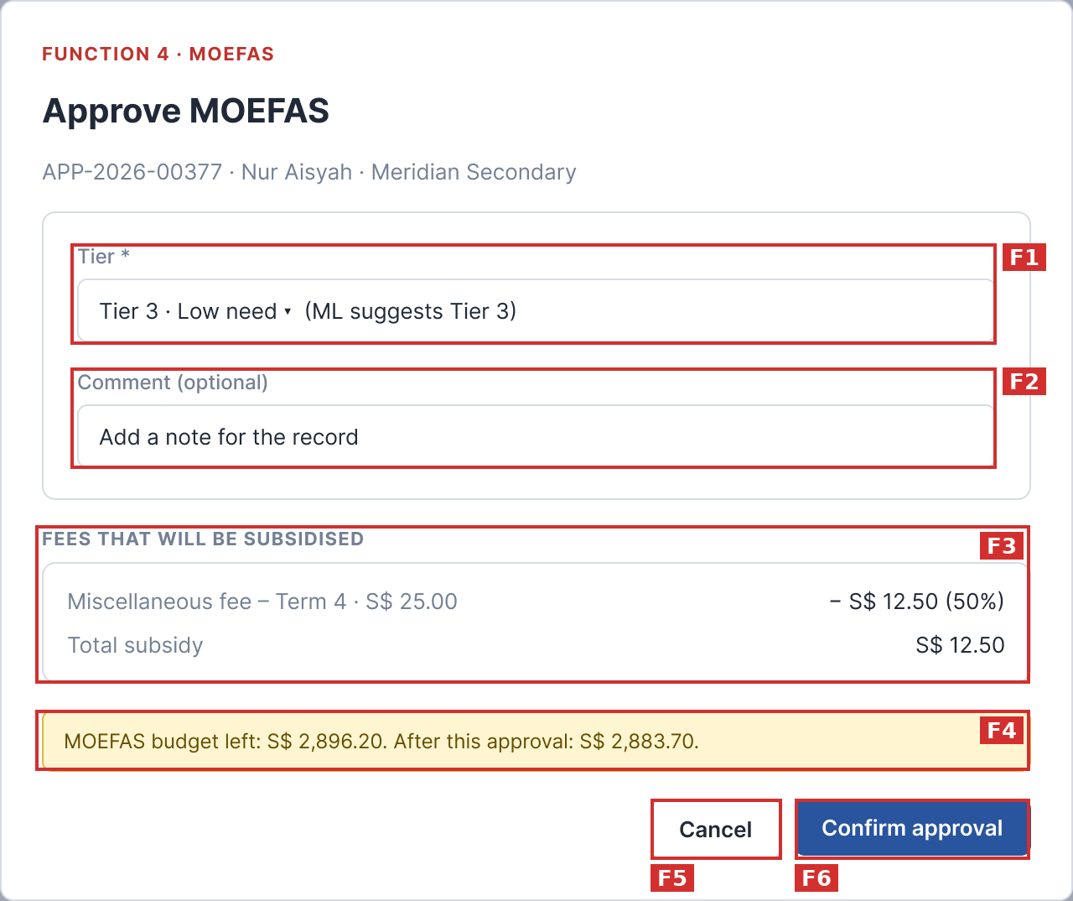
Figure F, Figma screen A3

8.1. Field summary
Code | Field | Type
F1 | Tier | Selection
F2 | Comment (optional) | Text input
F3 | Fees that will be subsidised | Display only
F4 | MOEFAS budget note | Display only
F5 | Cancel button | Button
F6 | Confirm approval button | Button

8.2. Field rules

F1. Tier
Item | Rule
Options | Tier 1 · High need  Tier 2 · Medium need  Tier 3 · Low need
Default | Tier ML suggests, with hint ML suggests Tier X  No selection when ML gives Borderline, Do not grant or no tier (QA proposal)
Required | Yes
Depends on | Active scheme
On change | Fee list recalculates  Total subsidy recalculates  Budget note recalculates
Message | Not chosen: Select a tier to approve. (QA proposal)  Confirm approval disabled  Scheme not Active: No active MOEFAS scheme.
Source in FS | FS 6.1 item 1, BR8

F2. Comment (optional)
Rule | Valid | Invalid | Message
Required | Empty or filled | None | None
Length | 0 to 500 characters | 501 or more characters | Counter turns red, for example 501/500  Error: Comment must be 500 characters or fewer.  Confirm approval disabled
Counter | Shows n/500  Line break counts 1  Emoji counts 1 | None | None
Paste over 500 | Text is kept, not cut | None | Counter shows for example 600/500 in red
Leading and trailing spaces and blank lines | Removed on save | None | None
Spaces only | Saved as empty | None | None
Allowed characters | Any printable Unicode character  Line break and tab | None | None
Control characters other than line break and tab | Removed | None | None
Null byte | Removed before save | None | None
Special characters ' " % \ ; | Saved exactly as typed | None | None
SQL string, for example ' OR 1=1 -- | Saved as text, parameterized query | None | No data changed
Script and HTML, for example <script>, <img onerror>, <b>text</b> | Saved as typed | None | Shown as plain text  Encoded in drawer, History, CSV and parent email
JSON, XML, template, for example {{7*7}}, ${7*7} | Saved as plain text, never parsed | None | API payload escapes quotes and backslash
CSV export | Value starting with =, +, - or @ gets an apostrophe prefix | None | None
Save fails | None | None | Something went wrong. Please try again.  Dialog stays open, text kept
Valid examples | A comment of exactly 500 characters  Two lines separated by a line break  <b>ok</b>  Approved after review | None | None
Invalid examples | 501 or more characters | None | None
Placeholder | Add a note for the record
Source in FS | FS 6.1 item 3, BR15

Code | Field | Shows | Rule | Source in FS
F3 | Fees that will be subsidised | Open fee name and amount, subsidy in S$ and percent, Total subsidy | Updates when Tier changes  Subsidy = amount x tier percent / 100, rounded half up to the cent  No open fee: No open fees right now. Fees issued later are subsidised automatically.  Paid fees unchanged, not refunded | FS 6.1 item 4
F4 | MOEFAS budget note | MOEFAS budget left: S$ X. After this approval: S$ Y. | Budget left = MOEFAS budget minus subsidies already granted  Total subsidy above budget left: red message, Confirm approval disabled  Total equal to budget left: allowed, After is S$ 0.00  Total 0.01 above budget left: blocked  No budget set: no limit  Message: Not enough MOEFAS budget. This approval needs S$ X but only S$ Y is left. | FS 6.1 item 5, BR17, section 8, T11

F5. Cancel button
Item | Rule
Function | Close the dialog without saving
Shown when | Dialog open
On click | Dialog closes  Tier and Comment discarded  Application stays Pending  Drawer stays open
Source in FS | FS 6.1 item 6

F6. Confirm approval button
Item | Rule
Function | Approve the application and apply the subsidy
Disabled when | No Tier chosen  Comment over 500 characters  Scheme has no Active version  MOEFAS budget not enough
On click | Status becomes Approved  Save tier, effective date (today), comment, decider, date and time  Apply subsidy to open and future EA fees  Write History  Send email with tier to parent  Refresh summary cards and tab counts  Subsidy added to the amount granted in the budget function
On double click | Saves once
Two users at once | First confirmation wins  Second user sees: This application was already decided by {user} on {DD/MM/YYYY}.
On error | Something went wrong. Please try again.  Nothing saved, dialog stays open
On success | Toast: Subsidy applied to the student's EA fees.
Source in FS | FS 6.1 item 7, sections 8 and 9, BR17, T11, T20, T21

8.3. Open points of screen F
Field | Open point
F1 Tier | FS does not say what is preselected when ML gives Borderline, Do not grant or no tier.
F4 MOEFAS budget note | Note when no budget is set, and whether After follows the Tier, are not in FS. QA proposal: After follows the Tier. Figure: left S$ 2,896.20, after S$ 2,883.70.
F2 Comment (optional) | Figma A3 shows no n/500 counter. FS 6.1 item 3 says the counter shows.

9. Screen G. Reject application dialog
Opens from Reject in a drawer. MOEFAS (MOE HQ) and SBFAS (School Admin). Source: FS 6.2, sections 8 and 9, BR9, BR12.
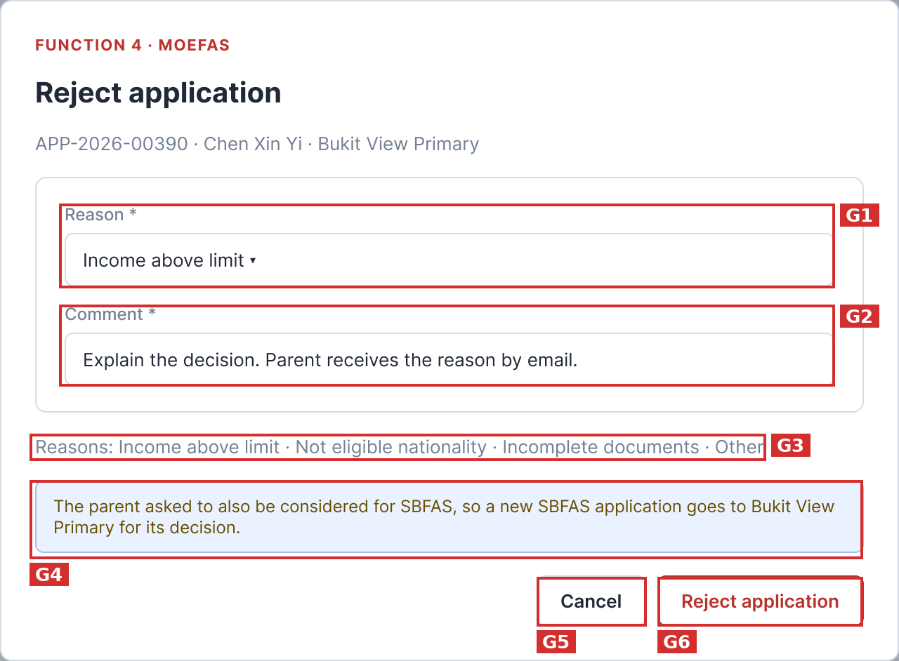
Figure G, Figma screen B2

9.1. Field summary
Code | Field | Type
G1 | Reason | Selection
G2 | Comment | Text input
G3 | Reasons hint line | Display only
G4 | SBFAS note | Display only
G5 | Cancel button | Button
G6 | Reject application button | Button

9.2. Field rules

G1. Reason
Item | Rule
Options | Income above limit  Not eligible nationality  Incomplete documents  Other
Default | No selection
Required | Yes
Depends on | None
On change | Reason is sent to the parent by email
Message | Not chosen: Select a reason to reject. (QA proposal)  Reject application disabled
Source in FS | FS 6.2 item 1, BR9

G2. Comment
Rule | Valid | Invalid | Message
Required | 1 to 500 characters after trim | Empty or spaces only | Comment is required.
Length | 1 to 500 characters | 501 or more characters | Counter turns red, for example 501/500  Error: Comment must be 500 characters or fewer.  Reject application disabled
Counter | Shows n/500  Line break counts 1  Emoji counts 1 | None | None
Paste over 500 | Text is kept, not cut | None | Counter shows for example 600/500 in red
Leading and trailing spaces and blank lines | Removed on save | None | None
Spaces only | Not valid | Spaces only | Comment is required.
Allowed characters | Any printable Unicode character  Line break and tab | None | None
Control characters other than line break and tab | Removed | None | None
Null byte | Removed before save | None | None
Special characters ' " % \ ; | Saved exactly as typed | None | None
SQL string, for example ' OR 1=1 -- | Saved as text, parameterized query | None | No data changed
Script and HTML, for example <script>, <img onerror>, <b>text</b> | Saved as typed | None | Shown as plain text  Encoded in drawer, History, CSV and parent email
JSON, XML, template, for example {{7*7}}, ${7*7} | Saved as plain text, never parsed | None | API payload escapes quotes and backslash
CSV export | Value starting with =, +, - or @ gets an apostrophe prefix | None | None
Save fails | None | None | Something went wrong. Please try again.  Dialog stays open, text kept
Valid examples | A comment of exactly 500 characters  Two lines separated by a line break  <b>ok</b>  Income above the limit based on NOA 2025. | None | None
Invalid examples | Empty  Spaces only  501 or more characters | None | None
Placeholder | Explain the decision. Parent receives the reason by email.
Source in FS | FS 6.2 item 2, BR9, BR15, T12, T14

Code | Field | Shows | Rule | Source in FS
G3 | Reasons hint line | Reasons and the four reasons separated by a middle dot | Lists exactly the four options of Reason | FS 6.2 item 1
G4 | SBFAS note | Yes: The parent asked to also be considered for SBFAS, so a new SBFAS application goes to {school} for its decision.  No: The parent did not ask for SBFAS. The application closes as Rejected. | MOEFAS only  Text follows the parent's Also consider for SBFAS choice | FS 6.2 item 3, BR12, T16, T17

G5. Cancel button
Item | Rule
Function | Close the dialog without saving
Shown when | Dialog open
On click | Dialog closes  Reason and Comment discarded  Application stays Pending  Drawer stays open
Source in FS | FS 6.2 item 4

G6. Reject application button
Item | Rule
Function | Reject the application and notify the parent
Disabled when | No Reason chosen  Comment empty or over 500 characters
On click | Status becomes Rejected  Save reason, comment, decider, date and time  Send reason to parent by email  Write History  MOEFAS with Also consider for SBFAS = Yes: create a new Pending SBFAS application for the school, old one records Moved to SBFAS  Also consider = No: process ends
On double click | Saves once
Two users at once | First decision wins  Second user sees: This application was already decided by {user} on {DD/MM/YYYY}.
On error | Something went wrong. Please try again.  Nothing saved, dialog stays open
On success | Toast: Application rejected. Parent notified by email.
Source in FS | FS 6.2 item 5, sections 8 and 9, BR3, BR9, BR12, T15, T16, T17, T20, T21, T30

9.3. Figma state D2: Reject dialog of an SBFAS application (School Admin, application 00398)
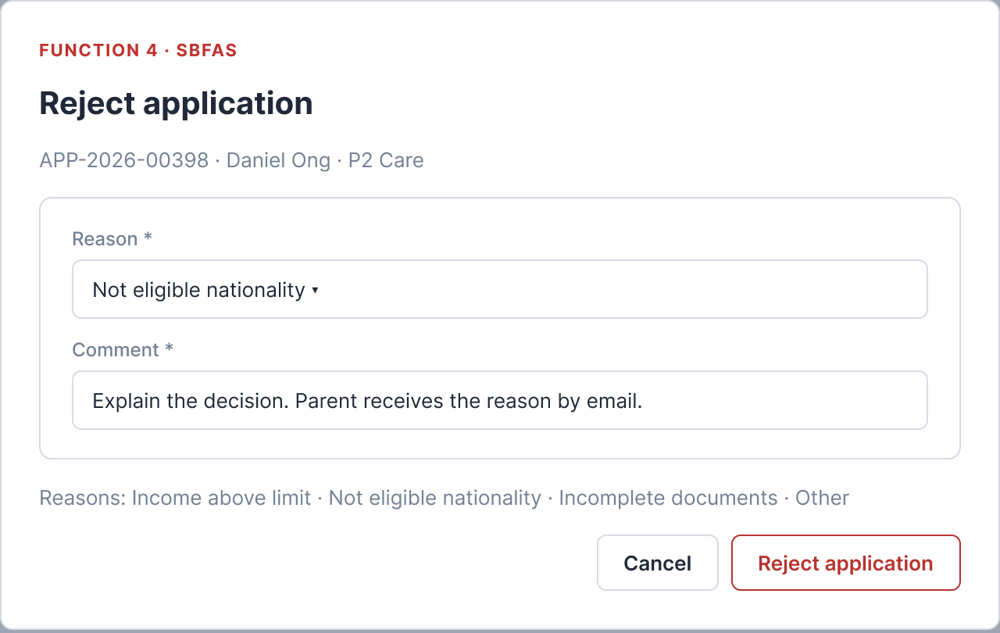
Figure G, Figma screen D2
Item | Rule
Title tag | FUNCTION 4 · SBFAS (the MOEFAS dialog shows FUNCTION 4 · MOEFAS)
Subtitle | APP-2026-00398 · Daniel Ong · P2 Care (class, the MOEFAS dialog shows the school)
Fields | Reason, Comment and the reasons hint line, same as the MOEFAS dialog
SBFAS note | Not shown  The note belongs to the MOEFAS dialog only  Settles the open point of G4
Reason in the figure | Not eligible nationality is already selected  FS 6.2: nothing selected by default  The figure shows a filled example
Buttons | Cancel and Reject application, same as the MOEFAS dialog
Source in Figma | Screen D2

9.4. Open points of screen G
Field | Open point
G1 Reason | Figma B2 and D2 show a reason already selected (Income above limit, Not eligible nationality), FS says nothing selected by default.
G4 SBFAS note | Figma D2 (SBFAS) shows no SBFAS note and Figma B2 (MOEFAS) shows it, so the note is MOEFAS only. Figma B2 shows the Yes case. The No case text is in FS 6.2 item 3.

10. Screen H. FAS schemes list (MOE HQ and School Admin view)
Menu Financial assistance, MOEFAS schemes (for MOE HQ) or SBFAS schemes (for School Admin). MOE HQ manages national MOEFAS schemes covering all schools. School Admin manages school-specific SBFAS tiers. Source: FS F4 v1.3 section 6.1 and 7.1; Test cases TC-168 to TC-180 (Suite F4.13).

10.1. Field summary

Code | Field | Type | Scope | Source in FS
H1 | New scheme button | Button / Link | MOE HQ / School Admin | FS 6.1 item 1
H2 | Summary cards (Active, Upcoming, Closed, Draft) | Display counters | Both roles | FS 6.1 item 2
H3 | Schemes data table | Data table | Both roles (Role isolated) | FS 6.1 item 3, 7.1
H4 | Status badge (Active, Upcoming, Closed, Draft) | Badge indicator | Both roles | FS 6.1 item 4
H5 | Actions menu (View, Add fee, Publish, Suspend) | Dropdown menu | Both roles | FS 6.1 item 5

10.2. Validation and Business Rules for Schemes List

Rule ID | Rule Name | Condition / Trigger | Expected System Behavior / Validation Message | Source
VR-SCH-01 | Role Data Isolation | MOE HQ accesses scheme list | MOE HQ sees MOEFAS schemes only. Cannot see SBFAS schemes of schools. | TC-168, FS 6.1
VR-SCH-02 | School Scheme Isolation | School Admin accesses scheme list | School Admin sees only the SBFAS schemes belonging to their own school. Cannot view MOEFAS management or other schools' SBFAS. | TC-169, FS 6.1
VR-SCH-03 | Summary Cards Calculation | Page load / Scheme status change | Cards count exact numbers of Active (effective today), Upcoming (published, effective later), Closed (past effective to), and Draft schemes. | TC-171, FS 6.1
VR-SCH-04 | Upcoming Scheme Definition | Scheme with Effective from > Today | Status must show 'Upcoming' with descriptive hint 'Published, not yet in effect'. | TC-171, FS 6.1
VR-SCH-05 | Table Column Structure | Display table | Mandatory columns: SCHEME, ELIGIBILITY, APPLICATION FORM, EFFECTIVE FROM, EFFECTIVE TO, STATUS, ACTIONS. | TC-172, FS 7.1
VR-SCH-06 | Action Restrictions by Status | Scheme status check | Draft: allows Edit, Publish, Delete. Active/Upcoming: allows View, Add fee, Suspend (No Edit). Closed: allows View only (Add fee and Edit strictly blocked). | TC-174, TC-229, TC-235

11. Screen I. New scheme wizard (4-step stepper)
Accessible via 'New scheme' button on Screen H. Stepper consists of Step 1 (General Information), Step 2 (Eligibility Criteria), Step 3 (Subsidy Components), and Step 4 (Review and Publish). Source: FS F4 v1.3 section 6.2; Test cases TC-181 to TC-218 (Suite F4.14).

11.1. Step 1: General Information Validation Rules

Rule ID | Field / Item | Validation Condition | Validation Message / System Reaction | Source
VR-WIZ-01 | Scheme Name - Blank | User leaves Scheme Name empty | Validation error: 'Scheme name is required'. Cannot proceed to Step 2. | TC-181, FS 6.2
VR-WIZ-02 | Scheme Name - Length | Name < 3 or > 100 characters | Validation error: 'Scheme name must be between 3 and 100 characters'. | TC-181, FS 6.2
VR-WIZ-03 | Scheme Name - Duplicate | Name already exists within the same scope | Validation error: 'A scheme with this name already exists'. Must be unique per school/MOE. | TC-182, FS 6.2
VR-WIZ-04 | Academic Year | Academic year not selected | Validation error: 'Academic year is required'. | TC-183, FS 6.2
VR-WIZ-05 | Form Opens vs Form Closes | Form opens date > Form closes date | Validation error: 'Form closing date cannot be earlier than opening date'. | TC-186, TC-187, FS 6.2
VR-WIZ-06 | Effective From vs Effective To | Effective from date > Effective to date | Validation error: 'Effective end date cannot be earlier than start date'. | TC-189, FS 6.2
VR-WIZ-07 | Form Period vs Effective Period | Form opens date > Effective from date | Validation error: 'Application form period must start before or on scheme effective date'. | TC-188, FS 6.2
VR-WIZ-08 | Effective From in Past | Effective from date < Today (New scheme) | Validation error: 'Effective start date cannot be in the past for new schemes'. | TC-190, FS 6.2

11.2. Step 2: Eligibility Criteria Validation Rules

Rule ID | Field / Item | Validation Condition | Validation Message / System Reaction | Source
VR-WIZ-09 | Nationalities Selection | No nationality option is checked | Validation error: 'At least one eligible nationality must be selected'. Cannot proceed. | TC-191, TC-192, FS 6.2
VR-WIZ-10 | GHI Max Limit - Format | Gross Household Income is negative or non-numeric | Validation error: 'GHI limit must be a positive number'. Currency format S$ #,##0.00. | TC-194, FS 6.2
VR-WIZ-11 | PCI Max Limit - Format | Per Capita Income is negative or non-numeric | Validation error: 'PCI limit must be a positive number'. Currency format S$ #,##0.00. | TC-195, FS 6.2
VR-WIZ-12 | Income Matching Operator | Operator selection | Must select either 'ANY' (Meet GHI OR PCI) or 'ALL' (Must meet both GHI AND PCI). Default is 'ANY'. | TC-196, FS 6.2
VR-WIZ-13 | At least One Income Metric | Both GHI and PCI are unchecked/disabled | Validation error: 'At least one income criterion (GHI or PCI) must be enabled'. | TC-197, FS 6.2

11.3. Step 3: Subsidy Components Validation Rules

Rule ID | Field / Item | Validation Condition | Validation Message / System Reaction | Source
VR-WIZ-14 | Subsidy Items Required | No fee subsidy components added | Validation error: 'At least one subsidy component must be configured'. Next button disabled. | TC-199, FS 6.2
VR-WIZ-15 | Subsidy Percentage Limit | Percentage value < 0% or > 100% | Validation error: 'Subsidy rate must be between 0% and 100%'. Field highlighted in red. | TC-205, FS 6.2
VR-WIZ-16 | Subsidy Fixed Amount | Fixed subsidy amount < 0 | Validation error: 'Subsidy amount cannot be negative'. | TC-206, FS 6.2
VR-WIZ-17 | Level / Grade Completeness | A level or grade row is left blank | Validation error: 'All applicable grades/levels must have an assigned subsidy value (0% if none)'. | TC-207, FS 6.2

12. Screen J. Review and publish scheme (Overlap Prevention rules)
Step 4 of the wizard or Review dialog. Summarizes the configured scheme and provides 'Save as Draft' and 'Publish'. Source: FS F4 v1.3 section 6.3; Test cases TC-219 to TC-230 (Suite F4.15).

Rule ID | Rule Name | Validation Condition | Validation Message / System Reaction | Source
VR-PUB-01 | MOEFAS Effective Overlap Prevention | MOEFAS Effective period overlaps another active/upcoming MOEFAS scheme | SYSTEM BLOCKS PUBLISH: 'Effective period overlaps with an existing MOEFAS scheme. Close the existing scheme or adjust dates'. | TC-219, FS 6.3
VR-PUB-02 | MOEFAS Form Overlap Prevention | MOEFAS Form period overlaps another active form period | SYSTEM BLOCKS PUBLISH: 'Application form period overlaps with an active form period'. | TC-220, FS 6.3
VR-PUB-03 | Adjacent Periods Allowed | New Effective from is exactly the day after earlier Effective to | Publish permitted. Touching periods without day overlap are valid. | TC-221, FS 6.3
VR-PUB-04 | SBFAS Same-Name Overlap | SBFAS with the same name in the same school overlaps period | SYSTEM BLOCKS PUBLISH: 'A scheme with this name already exists in this period for your school'. | TC-222, FS 6.3
VR-PUB-05 | SBFAS Different Name Allowed | Different SBFAS tiers (e.g. Tier 1 and Tier 2) in the same period | Publish permitted. Different SBFAS schemes can run concurrently in the same school. | TC-223, FS 6.3
VR-PUB-06 | Draft Flexibility Rule | Draft scheme with overlapping dates | Allowed to save draft: 'Draft saved successfully'. Overlap validation strictly enforced ONLY at Publish. | TC-225, FS 6.3
VR-PUB-07 | Automatic Preceding Scheme End Date | Publishing scheme when earlier scheme has no Effective To date | System automatically sets Effective To of the earlier scheme to (New Scheme Effective From - 1 day). | TC-226, TC-228, FS 6.3
VR-PUB-08 | Post-Publish Immutability | Attempt to edit published scheme via UI or API | Strictly prohibited. Published scheme cannot be modified. Only Add Fee or Suspend allowed. | TC-229, TC-230, FS 6.3

13. Screen K. Add fee to a published scheme dialog
Triggered from Screen H actions menu. Allows adding a newly created fee component to an already published scheme. Source: FS F4 v1.3 section 6.4; Test cases TC-231 to TC-241 (Suite F4.16).

Rule ID | Rule Name | Validation Condition | Validation Message / System Reaction | Source
VR-FEE-01 | Allowed Scheme Statuses | Add fee action invoked | Offered ONLY on Active and Upcoming schemes. Action hidden/disabled for Closed schemes. | TC-231, FS 6.4
VR-FEE-02 | Closed Scheme Rejection | Direct URL or API access to add fee on Closed scheme | HTTP 400 / 403: 'Cannot add fee components to a closed scheme'. | TC-235, FS 6.4
VR-FEE-03 | Component Filter | Component selection dropdown | Dropdown lists ONLY fee components not yet present in the scheme. Existing components displayed as read-only. | TC-232, FS 6.4
VR-FEE-04 | Cell Validation & Button State | Invalid rate entered (negative, > 100%, non-numeric, or blank) | Validation error on cell. 'Add to scheme' button remains DISABLED until all cells are valid. | TC-234, FS 6.4
VR-FEE-05 | Existing Components Locked | Dialog open | Existing fee components cannot be edited, removed, or modified during Add Fee operation. | TC-238, FS 6.4
VR-FEE-06 | Immediate Retroactive Application | New component successfully added to Active scheme | Toast notification shown. System automatically recalculates unpaid and future charges for enrolled students. | TC-236, TC-239, TC-240

14. Shared rules: AI/ML Need Score and Deny Rules engine
The ML Recommendation engine calculates a household Need Score and evaluates fraudulent/invalid data patterns. Source: FS F4 v1.3 section 7.2; Test cases TC-249 to TC-263 (Suite F4.19).

14.1. Hard Deny Rules Matrix

Rule Code | Deny Condition | System Reaction | Risk Level | Source
DENY-NO-CHILDREN | Application household contains 0 school-age children | Need Score = 0.00. Automatic flag for manual verification. | Low Risk (Score 0) | TC-258, FS 7.2
DENY-ONLY-CHILDREN | Household consists entirely of minors without an adult guardian | Need Score = 0.00. Flagged as invalid household structure. | Low Risk (Score 0) | TC-259, FS 7.2
DENY-INVALID-SIZE | Household member count <= 0 | Need Score = 0.00. Flagged as data inconsistency error. | Low Risk (Score 0) | TC-260, FS 7.2
DENY-WORKERS-EXCEED-SIZE | Reported employed workers > Total household members | Need Score = 0.00. Immediate audit flag for conflicting declaration. | Low Risk (Score 0) | TC-261, FS 7.2
DENY-NEGATIVE-MONTHS | Declared employment or residency months < 0 | Need Score = 0.00. Immediate validation error flag. | Low Risk (Score 0) | TC-262, FS 7.2

14.2. Need Score Weighting & Risk Thresholds

Parameter | Formula / Range | System Rule / Classification | Source
Score Weights | Score = 0.70*Income + 0.05*Size + 0.10*Housing + 0.10*JobStability + 0.05*SpecialNeeds | Linear weighted combination between 0.00 and 100.00. | TC-263, FS 7.2
High Risk Band | Need Score >= 75.00 | Classified as 'High'. Red risk indicator on Review Drawer. | TC-256, FS 7.2
Medium Risk Band | 50.00 <= Need Score <= 74.99 | Classified as 'Medium'. Amber risk indicator on Review Drawer. | TC-256, TC-257, FS 7.2
Low Risk Band | Need Score < 50.00 (or triggered Deny Rule) | Classified as 'Low'. Green risk indicator on Review Drawer. | TC-257, TC-258, FS 7.2

14.3. Standard Display and Input Format Rules

Data Type | Standard Format | Example | Validation Constraint | Source
Currency | S$ #,##0.00 | S$ 4,200.00 | Always prefixed with 'S$', thousands separator comma, exactly 2 decimal places. | TC-264, FS 8.1
Date | DD/MM/YYYY | 31/12/2026 | Zero-padded 2-digit day and month, 4-digit year. Slash separator. | TC-265, FS 8.1
Time | HH:mm (SGT UTC+8) | 09:30, 23:59 | 24-hour clock format. Converted to Singapore timezone regardless of browser locale. | TC-266, TC-267, FS 8.1

15. Shared messages
Situation | Message or display | Behavior | Fields | Source
Confirm or Reject is not allowed yet | Select a tier to approve.  Select a reason to reject.  Comment is required.  Comment must be 500 characters or fewer. | Field error, action button disabled | E1 Tier  F1 Tier  G1 Reason  E2 Comment (optional)  F2 Comment (optional)  G2 Comment | QA proposal. FS defines only the counter n/500 and the disabled button
Not enough MOEFAS budget | Not enough MOEFAS budget. This approval needs S$ X but only S$ Y is left. | Confirm approval disabled, nothing saved | F4 MOEFAS budget note  F6 Confirm approval button | FS section 8
Scheme has no Active version | No active {MOEFAS or SBFAS} scheme. | Confirm approval disabled | E5 Confirm approval button  F6 Confirm approval button | FS section 8
Someone else decided first | This application was already decided by {user} on {DD/MM/YYYY}. | Dialog closes, drawer read only, list refreshes | A13 Review or View button  B16 Review or View button  E5 Confirm approval button  F6 Confirm approval button  G6 Reject application button | FS section 8
School Admin opens another school's application | You do not have access to this application. | No data shown | A12 Applications table  A13 Review or View button  C1 Header | FS section 8
System error on save or export | Something went wrong. Please try again. | Nothing saved, dialog stays open | A1 Export button  B1 Export button  E5 Confirm approval button  F6 Confirm approval button  G6 Reject application button | FS section 8
Approval succeeded | Subsidy applied to the student's EA fees. | Toast | E5 Confirm approval button  F6 Confirm approval button | FS section 9
Rejection succeeded | Application rejected. Parent notified by email. | Toast | G6 Reject application button | FS section 9
Empty list or empty search result | No applications found. | Empty table | A3 Status tabs  A4 Search box  A14 Footer and paging  B3 Status tabs  B4 Search box  B17 Footer and paging | FS 3.5
Student has no open fee | No open fees right now. Fees issued later are subsidised automatically. | Shown in the fee list | E3 Fees that will be subsidised  F3 Fees that will be subsidised | FS 6.1 item 4
Pasted search text over 100 characters | Search is limited to 100 characters. | Helper text, text cut to 100 | A4 Search box  B4 Search box | QA proposal

16. Open points for BA
Code | Topic | Detail | Fields
O1 | Tabs, Status filter and tab counts | The FS does not say whether tab counts follow filters and search, or what the Pending tab shows when Status is Approved. Figure: All 46 while Submitted defaults to 30 days. | A3 Status tabs  A9 Status filter  B3 Status tabs
O2 | Search box rules | The FS gives no maximum length, whitespace rule, special character handling, trigger, or page reset on a new term. The rules in this document are QA proposals. | A4 Search box  B4 Search box
O3 | Export scope | Not stated whether the export covers all pages or the visible page, and whether tab and search apply. File name is also open. | A1 Export button  B1 Export button
O4 | Definition of this year | Cards SBFAS approved and rejected say This year. Calendar year or school year is not stated. | A2 Summary cards
O5 | Pass rule of System check | FS 3.4 says Pass when all criteria pass. FS 4.2 says Pass when nationality passes and at least one of GHI or PCI passes. The two give different results when only one of GHI or PCI passes. | B14 System check column  D2 Eligibility check
O6 | Tier 4 and Ineligible | FS 5.3 has Base Tier and Adjusted Tier 4 and Ineligible. FS 1.3 and the dropdown in 6.1 have Tier 1 to 3 only, and so does the Tier filter. The engine can suggest Tier 4 that the approver cannot choose. | B9 Tier filter  C5 ML suggestion  E1 Tier  F1 Tier
O7 | Preselected Tier when ML gives no tier | Not stated what the dropdown preselects when ML is Reject, Borderline, Do not grant or has no suggestion. | E1 Tier  F1 Tier
O8 | Confidence range | FS 5.4 states 55 to 95 percent but the score starts at 92 and only subtracts, so the maximum is 92. Subtracting everything gives 46, below 55, so a lower bound rule is needed. | C5 ML suggestion  D4 ML recommendation
O9 | Fee amount and subsidy rounding | Not clear whether the fee amounts include GST. The Dev data design says the subsidy applies to the amount before tax and rounds half up to the cent. | E3 Fees that will be subsidised  F3 Fees that will be subsidised
O10 | Display of PCI | The figure shows PCI rounded to the dollar (4,350 divided by 4 shows 1,088). The Dev data design rounds to two decimals. The display rule is not stated. | C4 Household and income  D3 Household and income
O11 | Figures differ from the FS text | The SBFAS approve dialog lacks the hint ML suggests Tier X. No dialog shows the n/500 counter. The Reject dialog preselects Income above limit while the FS says no default. The drawer lacks Score breakdown, the no scheme warning, and value, limit and percent above in Eligibility check. The ML recommendation header wraps. The search placeholder is cut. The Application ID wraps. | A4 Search box  A12 Applications table  B4 Search box  B13 Applications table  B15 ML recommendation column  C5 ML suggestion  D2 Eligibility check  E1 Tier  E2 Comment (optional)  G1 Reason
O12 | Sample numbers between two figures | The HQ card says Approved 2 for all schools while the School Admin card says 34 for one school. Tab All is 46 and 9. | A2 Summary cards  B2 Summary cards
O13 | Role name | FS F4 says School Admin. The menu in the figure says School user. FS 03 and the tender say School User. | All fields A1 to A14 of the School Admin list
O14 | FS F4 v1.1 differs from Database Design Func4 v0.1 | The Dev design (14/10) has seven application statuses, an automatic decision type MoefasAuto, ML for SBFAS only and PCI with two decimals. FS F4 v1.1 (18/10) has three statuses, no auto approval and ML shown for MOEFAS as well. Align before the seed data is loaded. | All fields  Seed data sheet SD-08 Applications
O15 | Tier income bands and subsidy percentages | BR5 and BR7 take them from scheme setup and the FS has no numbers. Backlog PB-17 says Needs client decision. The seed uses the Tier 3 values from the figure and QA proposals for the others, clearly marked. | E3 Fees that will be subsidised  F3 Fees that will be subsidised  Seed data sheets SD-05a Schemes and SD-05b Tiers
O16 | SBFAS eligibility numbers | The FS says SBFAS is for Citizens and PRs with PCI in the scheme band but gives no numbers. | C5 ML suggestion  Seed data sheets SD-05a Schemes and SD-05b Tiers
O17 | Time and date format | BR16 requires DD/MM/YYYY and Singapore time (UTC+8). The Function 9 payment screen shows Oct 15, 2026, 6:37 PM. See BUG-R9-002. | A12 Applications table  B13 Applications table
O18 | List of T scenarios | The list T1 to T35 has no T13 and T32 sits after T19. | Appendix B
O19 | Borderline can never occur | FS 5.4 gives Grant lowest tier when income is up to 5 percent over the limit and Need Score is 50 or more, otherwise Borderline. By the formula in 5.2, GHI up to 4,200 gives x_inc of at least 0.65, so the smallest Need Score is 0.70 times 0.65 plus 0.10 times 0.20 plus 0.10 times 0.30, which is 50.50. No application inside the 5 percent margin falls below 50, so Borderline never appears. BA to confirm the threshold or the formula. | B15 ML recommendation column  D4 ML recommendation  Seed data sheet SD-09 Engine
O20 | Order of deny rules | The FS lists five deny rules but does not say which one is recorded when two apply, nor the Confidence of a denied case. SD-09 uses cases that match one rule only. | C5 ML suggestion  Seed data sheet SD-09 Engine
O21 | Messages and field rules not in the FS | Select a tier to approve.  Select a reason to reject.  Comment is required.  Comment must be 500 characters or fewer.  Search is limited to 100 characters. All field level messages, the 100 character search limit, the 300 ms search trigger and the security handling (escaping, CSV formula prefix) are QA proposals. | A4 Search box  B4 Search box  E1 Tier  E2 Comment (optional)  F1 Tier  F2 Comment (optional)  G1 Reason  G2 Comment
O22 | Cards after a decision, School Admin list | Figma C4 keeps Pending 3 and SBFAS approved 34 after application 00412 is approved, while the tabs change to Pending 2 and Approved 35. FS 9 says summary cards and tab counts update. Expected: Pending 2 and SBFAS approved 35. | A2 Summary cards  A3 Status tabs
O23 | Tab counts and footer | Figma A4 shows Approved (3) with 2 rows and Figma C4 shows Approved (35) with 2 rows. Tab counts seem not to follow the filters while the footer does. Same question as O1: do tab counts follow the Submitted filter? | A3 Status tabs  A14 Footer and paging  B3 Status tabs  B17 Footer and paging
O24 | Drawer of a student who is not a Citizen or PR | Figma D1 (application 00398) shows Student with Full name and Citizenship only, no Parent and no Documents section, the value International Student, and an ML box with Confidence and Factors only. FS 4.1 lists NRIC/FIN, Class, Parent, Documents, Risk, Need Score, Base Tier and Adjusted Tier. BA to say which rows show for this case and the list of Citizenship values. | C2 Student  C3 Parent  C5 ML suggestion  C6 Documents
O25 | Eligibility check rows | Figma A2 (Fail) shows Pass or Fail only. Figma B1 (Pass) shows value and limit with no badge. FS 4.1 item 3 says value, limit, percent above and Pass or Fail for every row. BA to confirm the FS text. | D2 Eligibility check
O26 | Role names | Figma shows the School Admin as School user (footer of the menu, wireframe overview) and MOE HQ as MOE HQ Administrator. FS and Dev design use School Admin and MOE HQ (HQ Admin). | All fields
O27 | FAS schemes screens | The Figma canvas F4 FAS schemes (create SBFAS in 4 steps, scheme list, view SBFAS) is not part of FS F4 FAS Applications (FS 1.1 lists it as out of scope). It needs its own FS and validation rules. | None

Item | Rule
Tender row 4 and function tree 4.5 | MOEFAS is auto-granted
FS F4 v1.1 (BR1, T7) | No auto grant, every MOEFAS application waits for MOE HQ
This document | Follows FS F4 v1.1. Project convention says the tender wins, so BA and customer must settle it

Appendix A. Engine calculation (FS section 5)
Item | Rule
Deny rules (checked first) | DENY-NO-CHILDREN: no member under 21.  DENY-ONLY-CHILDREN: every member is under 21.  DENY-INVALID-SIZE: household size is 0 or less.  DENY-WORKERS-EXCEED-SIZE: workers are more than household size.  DENY-NEGATIVE-MONTHS: months since last aid is below 0.  When one applies, Need Score is 0 and both tiers are Ineligible.
Need Score | 100 times the sum of weight times feature.  Each feature is between 0 and 1 and the weights add up to 1.0.
Income, weight 0.70 | The larger of x_ghi equal to 1 minus GHI divided by 12,000, and x_pci equal to 1 minus PCI divided by 3,000, each clamped between 0 and 1.
Dependency, weight 0.05 | (household size minus workers) divided by household size.
Stability, weight 0.10 | Stable 0.20 (3 month average against 12 month average from 0.70 to 1.30).  Interrupted 0.50 (ratio below 0.70).  Unemployed short 0.80 (1 to 5 months without income).  Unemployed long 1.00 (6 months or more).
Recency, weight 0.10 | Last aid within 3 months: 0.90 with Fast-track. 4 to 12 months: 0.50. 13 to 24 months: 0.30.  Never or over 24 months: 0.30.
Vulnerability, weight 0.05 | Added up: single parent 0.15, a member aged 65 or over 0.10, a member with disability 0.20, a child under 6 years 0.10.  Maximum 1.0.
Base Tier (legal thresholds, GHI or PCI) | Tier 1: GHI up to 4,000 or PCI up to 1,000.  Tier 2: GHI up to 5,500 or PCI up to 1,375.  Tier 3: GHI up to 9,000 or PCI up to 2,250.  Tier 4: GHI up to 12,000 or PCI up to 3,000.  Ineligible: GHI above 12,000 and PCI above 3,000.
Adjusted Tier and ML risk (from Need Score) | Tier 1: 75.00 to 100, risk High.  Tier 2: 50.00 to 74.99, Medium.  Tier 3: 25.00 to 49.99, Low.  Tier 4: 1.00 to 24.99, Low.  Ineligible: 0, Low.
Suggested tier and recommendation | The suggested tier is the scheme tier whose band and nationality match.  Income up to 5 percent over the limit suggests the lowest tier.  MOEFAS: Grant · Tier X when a tier matches.  Up to 5 percent over: Grant · lowest tier when Need Score is 50 or more, otherwise Borderline.  Anything else: Do not grant.  SBFAS: Tier X · High, Medium or Low need, or Reject when no tier matches.
Confidence | Starts at 92.  Minus 18 when income is up to 5 percent over the limit.  Minus 8 when income is not from the API.  Minus 10 when the name differs from government data.  Minus 6 when the household profile is assumed.  Minus 4 when no tier is suggested.  The result is stated to stay between 55 and 95 percent.

Appendix B. FS scenarios mapped to fields
Scenario | Description | Related fields
T1 | MOE HQ opens the list | B3 Status tabs  B13 Applications table  B16 Review or View button
T2 | School Admin opens the list | A2 Summary cards  A12 Applications table
T3 | School Admin opens another school's link | A12 Applications table  A13 Review or View button  C1 Header
T4 | School Admin does not see MOEFAS | A12 Applications table
T5 | MOE HQ opens a Pending MOEFAS application | D2 Eligibility check  D4 ML recommendation  D5 Reject button  D6 Approve MOEFAS button
T6 | System check Fail can still be approved | D2 Eligibility check  D6 Approve MOEFAS button
T7 | MOEFAS Pass or Fail both stay Pending | B14 System check column
T8 | Open Approve, Tier preselected | F1 Tier  F3 Fees that will be subsidised
T9 | Choose Tier 2, no comment, confirm | E1 Tier  E2 Comment (optional)  E5 Confirm approval button
T10 | Change Tier, fee list changes | E1 Tier  E3 Fees that will be subsidised
T11 | Approve over the budget | F4 MOEFAS budget note  F6 Confirm approval button
T12 | Reject without Reason or Comment | G1 Reason  G2 Comment  G6 Reject application button
T14 | Comment of 501 characters | E2 Comment (optional)  G2 Comment
T15 | Reject with Reason and Comment | G6 Reject application button
T16 | Reject MOEFAS, consider SBFAS is Yes | G4 SBFAS note  G6 Reject application button
T17 | Reject MOEFAS, consider SBFAS is No | G4 SBFAS note  G6 Reject application button
T18 | SBFAS decided by School Admin, HQ read only | B13 Applications table  B16 Review or View button
T19 | MOE HQ opens a Pending SBFAS application | B16 Review or View button
T20 | Two users confirm | E5 Confirm approval button  F6 Confirm approval button  G6 Reject application button
T21 | Double click on Confirm | E5 Confirm approval button  F6 Confirm approval button  G6 Reject application button
T22 | Open a decided application | D5 Reject button  D6 Approve MOEFAS button  C1 Header
T23 | Approval lowers EA fees and sends email | E5 Confirm approval button  F6 Confirm approval button
T24 | Cards and tab counts refresh | A2 Summary cards  A3 Status tabs  B2 Summary cards  B3 Status tabs
T25 | Combined filters | A5 to A11  B5 to B12
T26 | Search by NRIC, name, Application ID | A4 Search box  B4 Search box
T27 | Filter with no match | A4 Search box  A14 Footer and paging  B17 Footer and paging
T28 | More than 10 results | A14 Footer and paging  B17 Footer and paging
T29 | Export while filtered | A1 Export button  B1 Export button
T30 | Save error | E5 Confirm approval button  F6 Confirm approval button  G6 Reject application button
T31 | Date, time and money format | A12 Applications table  B13 Applications table  E3 Fees that will be subsidised
T32 | PR student | B13 Applications table  C2 Student
T33 | Sample Need Score calculation | C5 ML suggestion  D4 ML recommendation
T34 | Deny rule | C5 ML suggestion
T35 | Fast-track | C5 ML suggestion

Appendix C. Figma screens mapped to this document
Figma id | Canvas | Content | Screen here | Use
A1 | F4 canvas, flow A | FAS applications, Pending tab, MOE HQ | Screen B | Annotated figure
A2 | F4 canvas, flow A | MOEFAS review drawer, application 00377 (Fail) | Screen D | Annotated figure
A3 | F4 canvas, flow A | Approve MOEFAS dialog | Screen F | Annotated figure
A4 | F4 canvas, flow A | Result, Approved tab, MOE HQ | Screen B | Figma state
B1 | F4 canvas, flow B | MOEFAS review drawer, application 00390 (Pass) | Screen D | Figma state
B2 | F4 canvas, flow B | Reject application dialog, MOEFAS | Screen G | Annotated figure
C1 | F4 canvas, flow C | FAS applications, Pending tab, School Admin | Screen A | Annotated figure
C2 | F4 canvas, flow C | SBFAS review drawer, application 00412 | Screen C | Annotated figure
C3 | F4 canvas, flow C | Approve SBFAS dialog | Screen E | Annotated figure
C4 | F4 canvas, flow C | Result, Approved tab, School Admin | Screen A | Figma state
D1 | F4 canvas, flow D | SBFAS review drawer, application 00398 (not a Citizen or PR) | Screen C | Figma state
D2 | F4 canvas, flow D | Reject application dialog, SBFAS | Screen G | Figma state

Figma screens of other canvases that are not covered:
Canvas | Reason
F4 canvas, FAS schemes (A1 to A7, B1, B2) | Scheme setup, not FS F4 FAS Applications (FS 1.1, scope). Not covered, open point O27
F1 Education account, F2 Top-up, F3 School setup and fees | Other functions
F5 Paper applications | Other function, creates the applications that F4 lists
F6 Budget and statistics | Other function, source of the MOEFAS budget left in Figure F
F7 Simulation, F8 Parent portal, F9 Payments, F10 Parent FAS application | Other functions

Appendix D. Figma versus FS
Code | Figma | Figma shows | FS says | Handling
FG1 | A2, B1 | Eligibility check rows differ between the two states: badge only (A2) or value and limit (B1) | FS 4.1 item 3: value, limit, percent above, Pass or Fail | Follow the FS text, open point O25
FG2 | D1 | Student who is not a Citizen or PR: two Student rows, no Parent, no Documents, ML box without Risk and Need score | FS 4.1 items 4, 5, 7, 8 | Open point O24
FG3 | C4 | Cards stay at Pending 3 and SBFAS approved 34 after an approval | FS 9: cards and tab counts update | Follow the FS, open point O22
FG4 | A4, C4 | Tab count (3 and 35) is higher than the rows shown (2) | FS 3.1: tab shows its count, filters combine by AND | Open point O23 and O1
FG5 | B2, D2 | Reason already selected | FS 6.2 item 1: nothing selected by default | Follow the FS
FG6 | A3, C3 | Hint ML suggests Tier 3 shown in the MOEFAS dialog and missing in the SBFAS dialog | FS 6.1 item 1: hint shows for both | Follow the FS
FG7 | A3, C3, B2 | No n/500 counter under Comment | FS 6.1 item 3, 6.2 item 2: counter n/500 | Follow the FS
FG8 | D2 | SBFAS reject dialog has no SBFAS note | FS 6.2 item 3: note for MOEFAS only | Matches the FS
FG9 | A1, C1 | Search placeholder is cut off | FS 3.1 item 4: matches student name, NRIC/FIN or Application ID | Open points in Screen A and B
FG10 | A1, C1 | Application ID wraps inside the number | Not in FS | Open points in Screen A and B
FG11 | C1 to C4, A1 to A4 | Role shown as School user and MOE HQ Administrator | FS 1.2: School Admin and MOE HQ | Open point O26
FG12 | B1 | Recommendation Grant · Tier 2 while Adjusted Tier is Tier 1 | FS 5.3 and 5.4: two different values | Matches the FS
FG13 | A1, B1, C1, C2, D1 | Routing rules, ML suggestion rule and ML Reject note in the sticky notes | FS 2.1, 5.4, BR1, BR6, BR19 | Matches the FS
FG14 | A3 | Budget note: left S$ 2,896.20, after S$ 2,883.70. Total subsidy S$ 12.50 (50 percent of S$ 25.00) | FS 6.1 item 5, BR17. Figma F6 shows budget S$ 3,000.00, used S$ 103.80, remaining S$ 2,896.20 | Matches the FS and F6
FG15 | C3 | Subsidy: Miscellaneous S$ 9.75 (50 percent of S$ 19.50), School Meal S$ 12.96 (20 percent of S$ 64.80), total S$ 22.71 | FS 6.1 item 4 | Matches the FS
FG16 | C2, D1, A2 | No History section and no Decision section in any drawer | FS 4.1 item 9, 4.3 | Not drawn in Figma, rules stay in section 5.3 and 6.3

