FS F4 – FAS Applications
Oct 19, 2026 · Version 1.3 · @Huy
Function 4 shows FAS applications (MOEFAS and SBFAS) in the Admin Portal and lets each school decide its SBFAS applications. Every FAS scheme has an application form period and an effective period. MOEFAS applications wait until the MOEFAS form closes; the system then ranks them by need and approves or rejects them automatically. MOE HQ views applications and manages MOEFAS schemes; each school manages its own SBFAS schemes (one scheme per tier).
Item | Detail
Function | F4 – FAS applications and FAS schemes
Project | Education Account (EA) and FAS website
Portal | Admin Portal
Users | School Admin, MOE HQ
Version | 1.3
Related functions | F5 Paper applications, F10 Parent FAS application (both create applications), F6 Budget & statistics, F3 Fee components and charges, FAS Scoring & Decision Engine
UI reference | Figma "Edusave" · pages F4 · FAS applications, F4 · FAS schemes · Prototype: edusave.vercel.app

Changes from v1.2
# | Change
1 | Every scheme has an application form period (Form opens, Form closes) and an effective period (Effective from, Effective to). Applications can be submitted only while a form is open. The form must close before the scheme takes effect.
2 | MOEFAS is no longer decided at submit. Applications stay Pending (System check "Waiting") until the MOEFAS form closes. The system then ranks them by need (lowest per capita income first) and assesses them in that order.
3 | Schemes have no tiers inside. A school creates one SBFAS scheme per tier (for example Tier 1, Tier 2, Tier 3), each with its own eligibility (nationality, GHI, PCI). The school's "Tier" decision = the SBFAS scheme it grants.
4 | Scheme wizard: 3 steps (General → Eligibility → Subsidy). General has no Scheme type and no Level fields.
5 | Subsidy: MOEFAS is one scheme for all levels with one row per level (Primary, Secondary, Pre-University). SBFAS has one row per grade the school offers (P1–P6, S1–S5 …). Choosing a fee component adds it at once (no "+ Add" button).
6 | Add fee: fee components can be added to an Active or Upcoming scheme (never removed or changed), for fees that appear later in the year.
7 | Application list: column Grade replaces Class; Tier (the final decision) comes before ML recommendation and ML risk. MOE HQ list also shows Grade.

1. Introduction

1.1 Scope
In scope | Out of scope
MOEFAS ranking and automatic decision after the form closes (section 2) | Creating applications (F5 paper, F10 online)
FAS applications list, filters, tabs, cards, export | Budget setup and statistics (F6)
Review drawer (view and decide SBFAS) | Parent screens (F8, F10)
Approve / Reject SBFAS | Training a machine-learning model (the engine is rule-based)
FAS schemes: MOEFAS (MOE HQ) and SBFAS (school), form and effective periods, Add fee

1.2 Users and access
Role | FAS applications | FAS schemes
School Admin | Sees SBFAS applications of students enrolled in their school. Approves (picks a tier) or rejects them. Never sees MOEFAS applications or MOEFAS income details. | "SBFAS schemes": creates, drafts and publishes the school's own SBFAS schemes (one per tier); adds fee components to published ones.
MOE HQ | Sees all applications of all schools (MOEFAS and SBFAS). View only: no Approve or Reject anywhere. | "MOEFAS schemes": creates, drafts and publishes MOEFAS schemes; adds fee components to published ones. Does not see SBFAS schemes.
System | Routes applications at submit; ranks and decides MOEFAS when the MOEFAS form closes.

1.3 Terms
Term | Meaning
MOEFAS | Nationwide FAS. One scheme per year covers all levels. Decided automatically by the system after its form closes. No tier.
SBFAS | School-based FAS. Each school creates its own schemes; each scheme is one tier (Tier 1, Tier 2 …). Decided by the school.
Application form period | Form opens – Form closes of a scheme. Parents (F10) and schools (F5) can submit only inside an open period. Example: form 01/08/2026 – 31/12/2026, scheme effective from 01/01/2027.
Effective period | Effective from – Effective to (or no end date). Subsidy is applied to fees due inside this period.
GHI / PCI | Gross household income per month / per capita income = GHI ÷ household size. Income comes from Government records (API).
Priority rank | Order in which MOEFAS applications are assessed after the form closes: lowest PCI first, then lowest GHI, then earliest submitted.
Grade / Level | Grade = P1–P6, S1–S5, PU1–PU3 (from the student's class). Level = Primary, Secondary, Pre-University (from the school).
Tier | The SBFAS scheme the school grants (final decision). Shown in the list before ML recommendation.
ML recommendation | Suggested tier = the first of the school's SBFAS schemes whose eligibility the household meets. "—" when none fits, and for MOEFAS.
ML risk | Low / Medium / High: likelihood of difficulty paying the remaining fees (from the Need Score).
Context | Optional free text (up to 2000 characters) about the family's circumstances or wishes, entered in F10 (parent) or F5 (school).
Nationality category | SC = Singapore Citizen, PR = Singapore PR, IS_ASEAN / IS_NON_ASEAN = International student from an ASEAN / non-ASEAN country.

2. Process flow and statuses

2.1 At submit (system)
Step | Condition | Result
1 | F5 or F10 submit. Allowed only when the MOEFAS form or the child's school SBFAS form is open today; otherwise the screen blocks submit ("the FAS application form is closed (next opens DD/MM/YYYY)"). | History "Submitted".
2 | Student's nationality category is not allowed by the open MOEFAS scheme (e.g. PR, International) | Application becomes SBFAS, status Pending, for the student's school. History "SBFAS application (not eligible for MOEFAS by nationality)".
3 | Otherwise | Application is MOEFAS, linked to the open MOEFAS scheme, status Pending, System check "Waiting". History "Waiting for the MOEFAS form to close on DD/MM/YYYY".

2.2 When the MOEFAS form closes (system)
Runs automatically at the end of Form closes for the MOEFAS scheme (the prototype has a button "Close form now (demo)" in MOEFAS schemes to run it early).
Step | Rule
1 | Take every Pending MOEFAS application of the scheme.
2 | Rank by need: lowest per capita income first, then lowest gross household income, then earliest submitted. Save rank "n of N" and History "Form closed · priority n of N (lowest per capita income first)".
3 | Assess in that order against the scheme's eligibility (nationality, GHI, PCI, match rule):  Pass → Approved, decided by "System (auto-approved)", Effective from = scheme Effective from (or today if later), subsidy for the student's level applied (section 8), email to parent.  Fail and "Also consider for SBFAS" = Yes → becomes SBFAS Pending for the student's school.  Fail and "Also consider for SBFAS" = No → Rejected, reason "Not eligible for MOEFAS", email to parent.
4 | The scheme shows "Assessed DD/MM/YYYY". No more MOEFAS applications are accepted for it.
The MOEFAS budget (F6) is display only; the ranking decides the order if a budget limit is introduced later.

2.3 SBFAS (school)
School Admin of the student's school approves (picks a tier = one of the school's SBFAS schemes for the application period) or rejects (reason and comment). Subsidy applies from the scheme's Effective from, or from today if the scheme is already in effect. The first decision is final.

2.4 Statuses
Status | Meaning | Next
Pending | MOEFAS waiting for the form to close (System check "Waiting"), or SBFAS waiting for the school | Approved, Rejected (or MOEFAS → SBFAS Pending)
Approved | Subsidy granted (MOEFAS: no tier · SBFAS: with a tier) | None (final)
Rejected | Not granted, with a reason | None (final)
Draft applications exist only in F5 and F10 until they are submitted; they are not shown in F4.

3. Screen: FAS applications list
Menu path: Financial assistance > FAS applications.

3.1 MOE HQ view
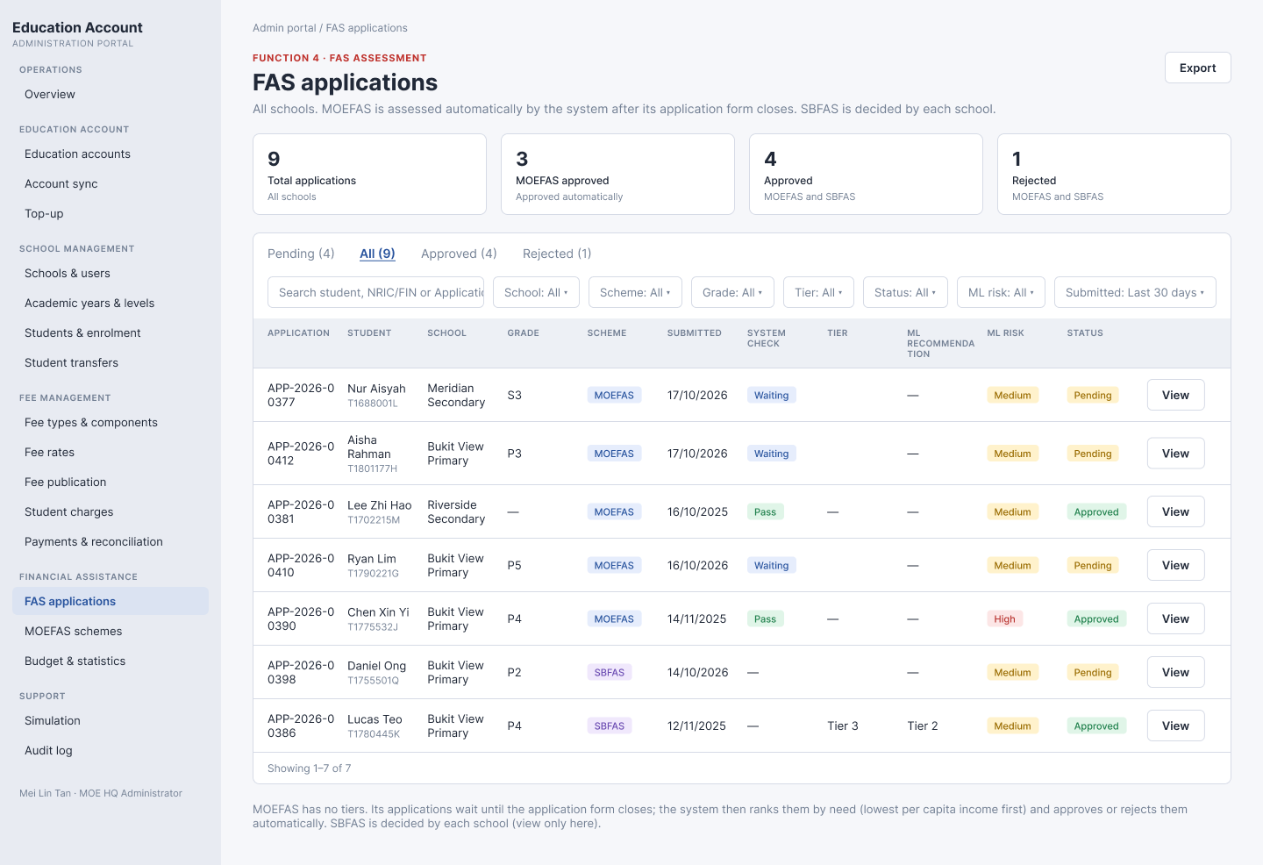
Figure: MOE HQ – FAS applications (All tab). MOEFAS rows submitted in the open form period show System check "Waiting".
# | Element | Behaviour
1 | Subtitle | "All schools. MOEFAS is assessed automatically by the system after its application form closes. SBFAS is decided by each school."
2 | Export | CSV of the filtered list (section 3.4).
3 | Cards | Total applications · MOEFAS approved · Approved (MOEFAS and SBFAS) · Rejected (MOEFAS and SBFAS). Not affected by filters.
4 | Tabs | Pending, All (default), Approved, Rejected, with counts.
5 | Filters | Search, School, Scheme, Grade, Tier, Status, ML risk, Submitted (section 3.3).
6 | Table | Application, Student, School, Grade, Scheme, Submitted, System check, Tier, ML recommendation, ML risk, Status, View.
7 | View button | Opens the drawer (section 4) read-only. MOE HQ has no Approve/Reject.
8 | Note | "MOEFAS has no tiers. Its applications wait until the application form closes; the system then ranks them by need (lowest per capita income first) and approves or rejects them automatically. SBFAS is decided by each school (view only here)."

3.2 School Admin view
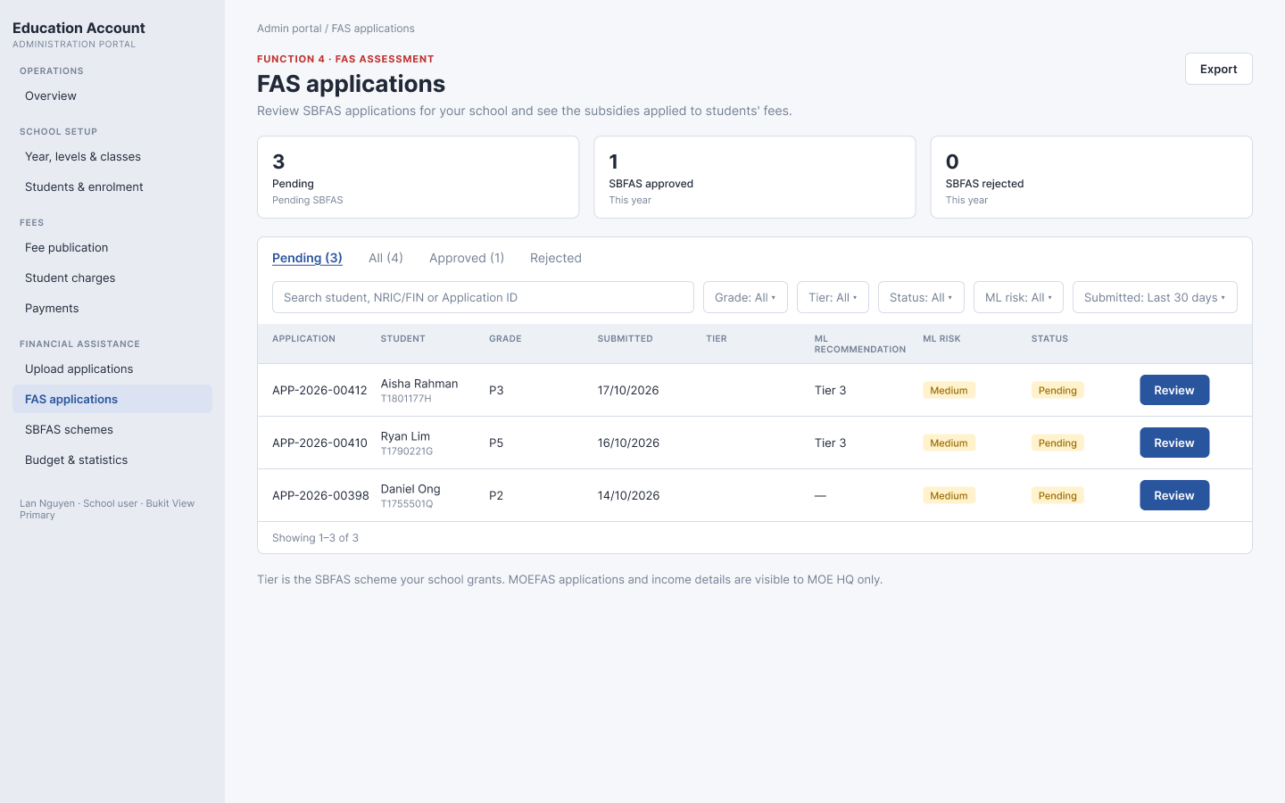
Figure: School Admin – FAS applications (Pending tab): Grade, then Tier before ML recommendation and ML risk
# | Element | Behaviour
1 | Rows shown | SBFAS applications of students currently enrolled in the user's school only.
2 | Cards | Pending (pending SBFAS) · SBFAS approved (this year) · SBFAS rejected (this year).
3 | Tabs | Pending (default), All, Approved, Rejected.
4 | Filters | Search, Grade, Tier, Status, ML risk, Submitted.
5 | Table | Application, Student, Grade, Submitted, Tier, ML recommendation, ML risk, Status, Review/View.
6 | Review / View | Review (primary) for Pending SBFAS of the school; View for decided ones.
7 | Note | "Tier is the SBFAS scheme your school grants. MOEFAS applications and income details are visible to MOE HQ only."

3.3 Filters
Filters combine with AND; changing a filter returns to page 1. Search matches Application ID, student name or NRIC/FIN (contains, not case sensitive).
Filter | Values | MOE HQ | School
School | All schools | Yes | No
Scheme | MOEFAS, SBFAS | Yes | No
Grade | Grades offered by the schools in scope (P1–P6, S1–S4 …) | Yes | Yes
Tier | MOE HQ: MOEFAS, SBFAS – {scheme name} · School: names of its SBFAS schemes. Pending rows match on the ML recommended tier. | Yes | Yes
Status | Pending, Approved, Rejected | Yes | Yes
ML risk | Low, Medium, High | Yes | Yes
Submitted | Last 7 days, Last 30 days, Any time (default) | Yes | Yes

3.4 Columns and export
Column | Rule
Application | APP-YYYY-NNNNN
Student | Name with NRIC/FIN under it
School | MOE HQ only
Grade | Grade of the student's current class (P3, S1 …); "—" when the student has no class
Scheme | MOE HQ only. MOEFAS or SBFAS
Submitted | DD/MM/YYYY
System check | MOE HQ only. MOEFAS: Waiting (Pending) / Pass (Approved) / Fail (Rejected) · SBFAS: "—"
Tier | SBFAS: name of the granted SBFAS scheme when Approved, otherwise empty · MOEFAS: "—"
ML recommendation | Suggested tier only ("Tier 3"); "—" for MOEFAS or when no tier fits
ML risk | Low / Medium / High
Status | Pending / Approved / Rejected
CSV columns: Application, Student, NRIC, School (MOE HQ only), Grade, Scheme, Submitted, System check, Tier, ML recommendation, ML risk, Status. Sort: Submitted, newest first. 10 rows per page. Empty result: "No applications found."

4. Screen: Review drawer
Opens from Review/View. Read-only except the decision buttons. Close with X or by clicking outside.
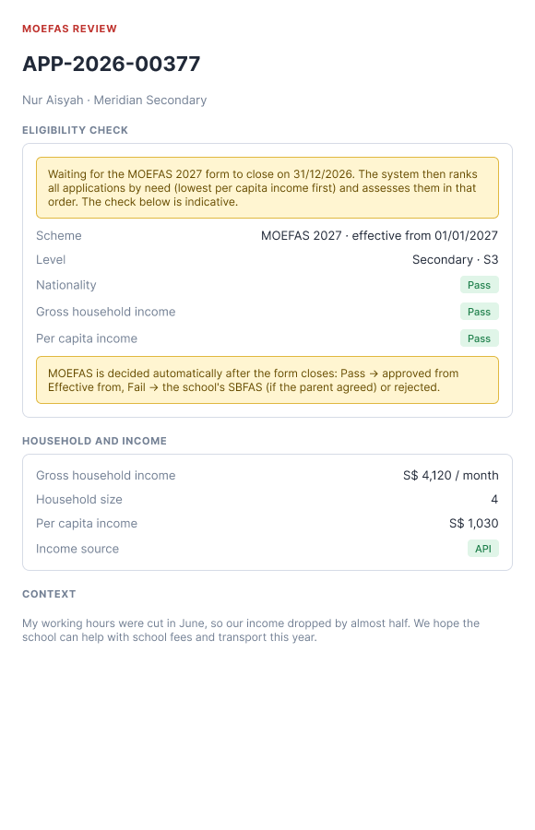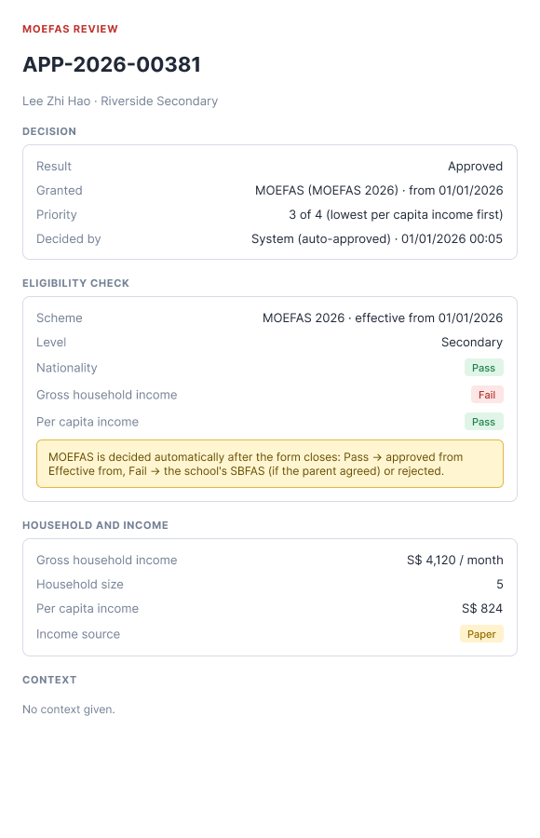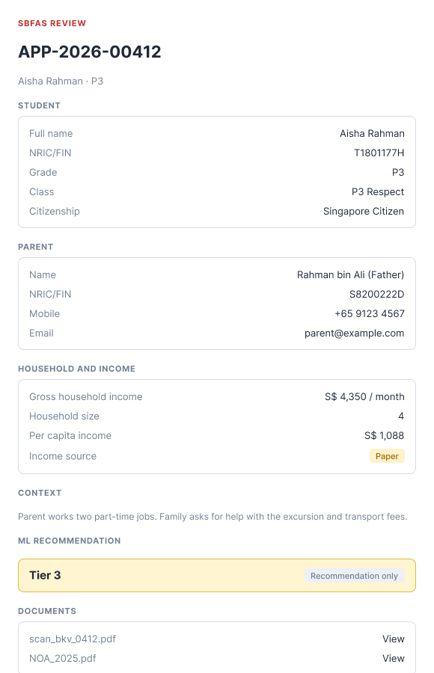
Figure: MOEFAS waiting for the form to close · MOEFAS approved after the form closed (with priority) · SBFAS review drawer (School Admin)
Section | MOEFAS | SBFAS | Content
Header | Yes | Yes | "MOEFAS REVIEW" / "SBFAS REVIEW", Application ID, student · school (MOE HQ) or grade (School Admin).
Decision | When decided | When decided | Result; MOEFAS: "Granted · MOEFAS ({scheme name}) · from DD/MM/YYYY" and "Priority · n of N (lowest per capita income first)" · SBFAS: Tier · from; Reason; Comment; Decided by · date time.
Eligibility check | Yes | No | When Pending: blue note "Waiting for the {scheme} form to close on DD/MM/YYYY. The system then ranks all applications by need (lowest per capita income first) and assesses them in that order. The check below is indicative." Rows: Scheme (name · effective from), Level (level · grade), Nationality, GHI, PCI with Pass/Fail. Note: "MOEFAS is decided automatically after the form closes: Pass → approved from Effective from, Fail → the school's SBFAS (if the parent agreed) or rejected."
Student / Parent | No | Yes | Name, NRIC/FIN, Grade, Class, school (MOE HQ), citizenship · parent name and relationship, NRIC/FIN, mobile, email.
Household and income | Yes | Yes | GHI, household size, PCI, income source.
Context | Yes | Yes | Text from F5/F10, or "No context given."
ML recommendation | No | Yes | The tier only, tag "Recommendation only". Red note when the school has no SBFAS scheme for the application period.
Documents / History | Yes | Yes | Files with View link · history oldest first.
Buttons | None | School Admin of the school, Pending only | Reject, Approve.

5. ML assessment
The FAS Scoring & Decision Engine (rule-based) runs for every application. Screens show only the recommended SBFAS tier and ML risk. The engine never decides.
- Candidate tiers = the school's published SBFAS schemes whose form period contains the submit date (if none, those in effect today), sorted by name.
- Recommended tier = the first candidate whose eligibility (nationality, GHI, PCI, match rule) the household meets; if none, the last one that is within 5% of its limit; otherwise "—".
- ML risk from the Need Score (Adjusted Tier): score ≥ 75 → High, 50–74.99 → Medium, otherwise Low.
- Need Score = 100 × Σ(weight × feature): income 0.70, dependency 0.05, stability 0.10, recency of support 0.10, vulnerability 0.05. Deny rules give score 0.

6. Dialogs (School Admin, SBFAS only)

6.1 Approve SBFAS
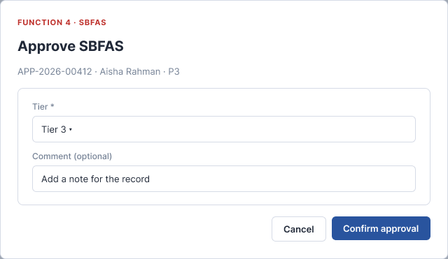
Element | Rule
Subtitle | "FUNCTION 4 · SBFAS · {application} · {student} · {grade}"
Tier * | The candidate SBFAS schemes (section 5) by name. Pre-selected with the ML recommended tier (hint "ML suggests Tier n"), otherwise the last one.
Comment | Optional, up to 500 characters, counter n/500.
Confirm approval | Disabled when there is no candidate scheme or the comment is over 500. Effective from = the scheme's Effective from, or today if the scheme is already in effect. History "Approved · {tier} · from DD/MM/YYYY". Toast "Subsidy applied to the student's EA fees."

6.2 Reject
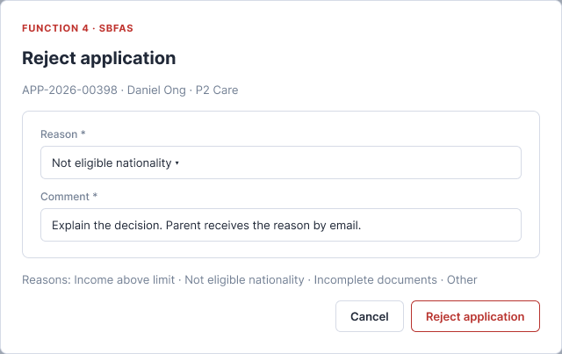
Reason * (Income above limit, Not eligible nationality, Incomplete documents, Other) and Comment * (up to 500, placeholder "Explain the decision. Parent receives the reason by email."). Reject application is disabled until both are filled. Toast "Application rejected. Parent notified by email."

7. FAS schemes

7.1 Scheme list
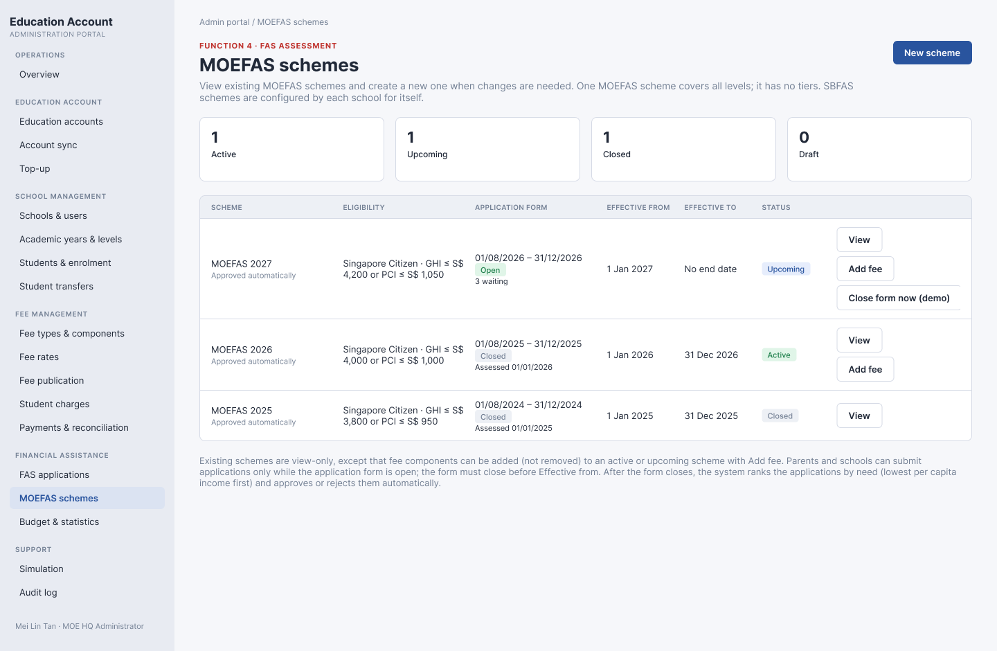
Figure: MOE HQ – MOEFAS schemes
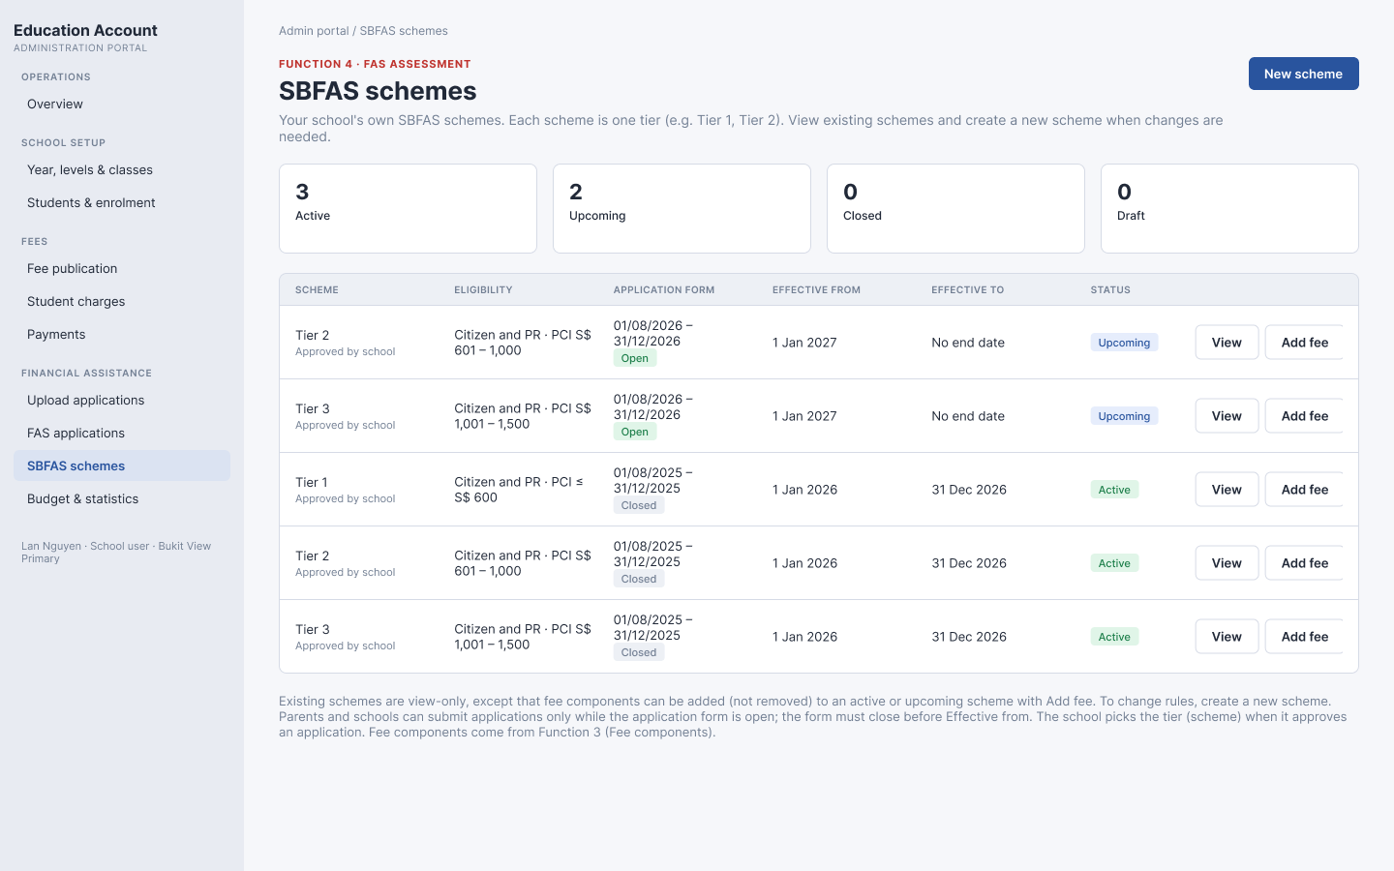
Figure: School Admin – SBFAS schemes (one scheme per tier)
# | Element | Behaviour
1 | Who sees what | MOE HQ: MOEFAS schemes only. School Admin: its own SBFAS schemes only.
2 | Cards | Active (in effect today) · Upcoming (published, not yet in effect) · Closed (Effective to has passed) · Draft.
3 | Table | Scheme (name; "Approved automatically" for MOEFAS, "Approved by school" for SBFAS) · Eligibility (nationality · GHI/PCI limits) · Application form (DD/MM/YYYY – DD/MM/YYYY with badge Open / Not open yet / Closed; MOEFAS also "n waiting" or "Assessed DD/MM/YYYY") · Effective from · Effective to ("No end date") · Status · actions.
4 | Actions | Draft: Edit. Published: View. Active or Upcoming: Add fee (section 7.4). MOE HQ, MOEFAS with form Open: "Close form now (demo)" (prototype only; the real system runs section 2.2 when the form closes).
5 | Sort | Effective from, newest first, then name.

7.2 New scheme wizard
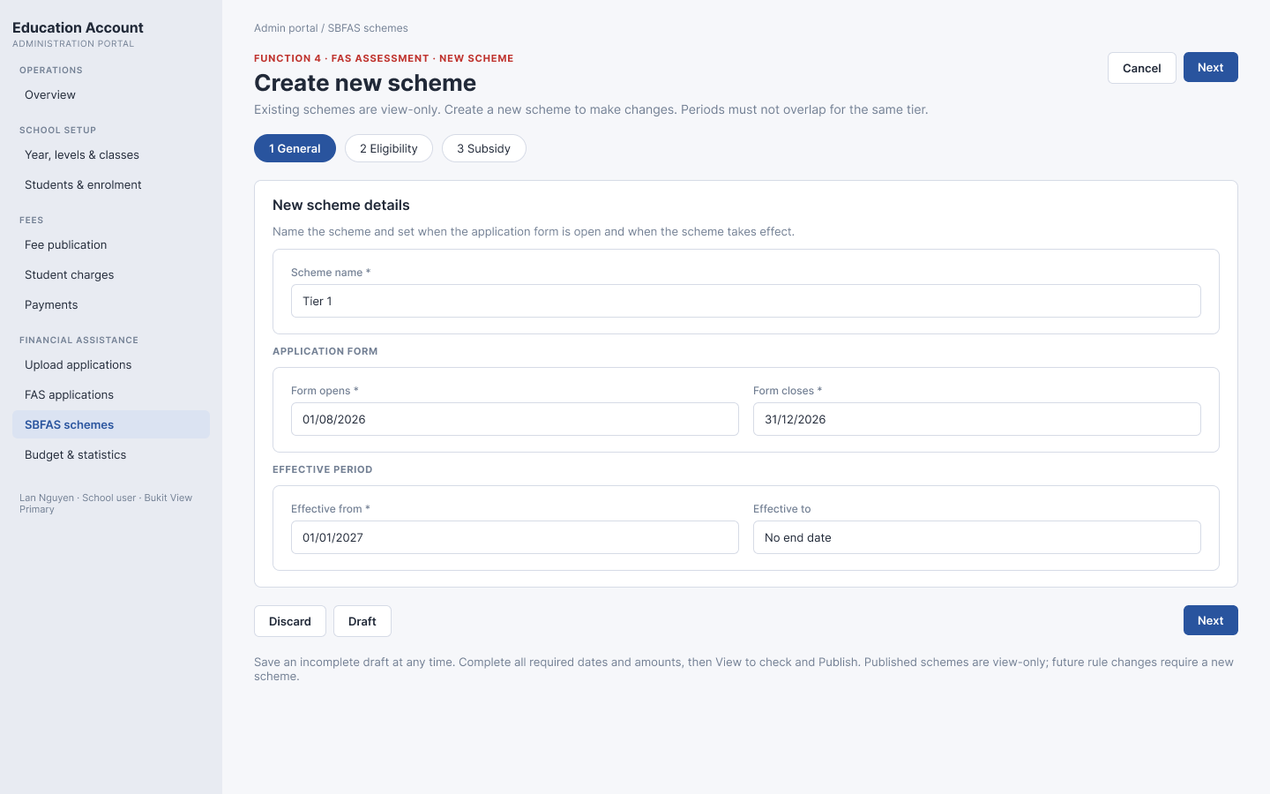
Figure: Step 1 General (no Scheme type, no Level)
Step | Fields and rules
1 General | Scheme name * (MOEFAS e.g. "MOEFAS 2028"; SBFAS e.g. "Tier 1"). APPLICATION FORM: Form opens *, Form closes *. EFFECTIVE PERIOD: Effective from *, Effective to (empty = no end date). The scheme type comes from the user's role (MOE HQ → MOEFAS, school → SBFAS of that school) and is not shown. A blue note summarises: form open → assessment → subsidy applies from.
2 Eligibility | Nationality (Singapore Citizen, Singapore PR, International – ASEAN, International – non-ASEAN); GHI band (from–to, optional); PCI band (from–to, optional); match rule: any / all selected bands.
3 Subsidy | Value type (Percentage of fee / Fixed amount S$).Feecomponent(selecttoadd):choosingacomponentaddsacolumnimmediatelywith0foreveryrow;✕removesit(onlywhiledrafting).Rows:MOEFAS=levelsPrimary,Secondary,Pre-University;SBFAS=thegradestheschooloffers.Eachcell0–100\%(orS$ ≥ 0).
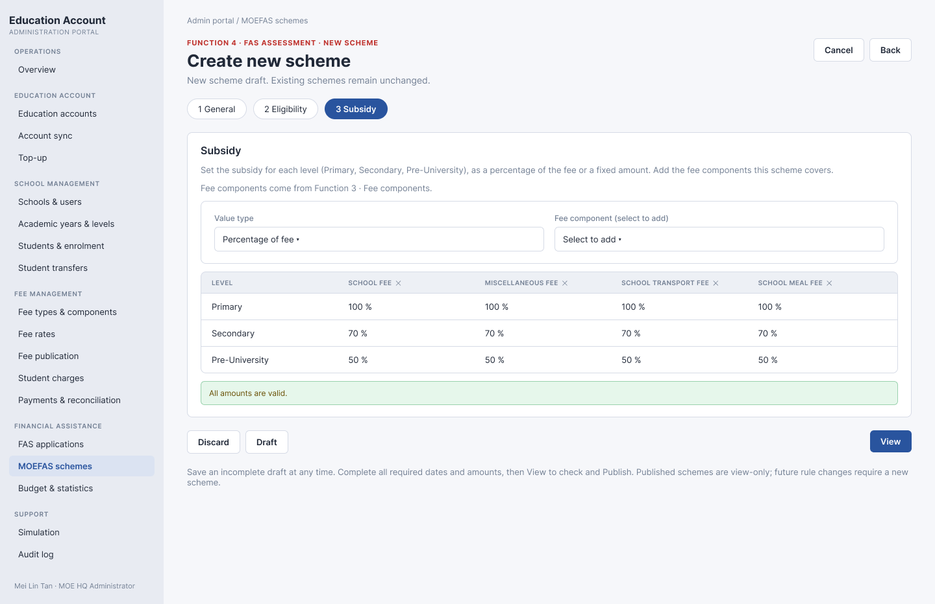
Figure: MOEFAS – Step 3 Subsidy by level (e.g. Primary 100 %, Secondary 70 %, Pre-University 50 %)
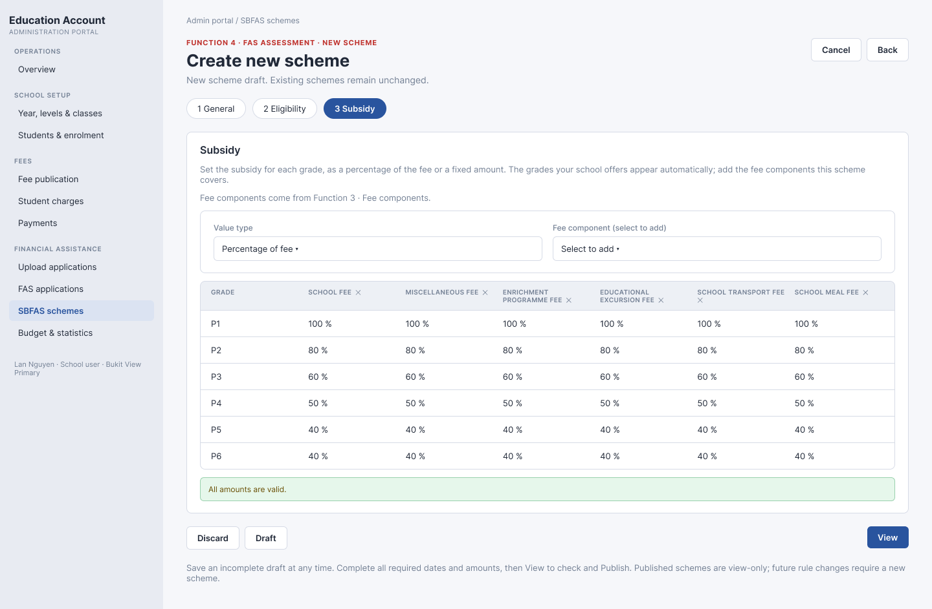
Figure: SBFAS – Step 3 Subsidy by grade (e.g. Tier 1: P1 100 %, P2 80 %, P3 60 %, P4 50 %, P5 40 %)

7.3 Validation, review and publish
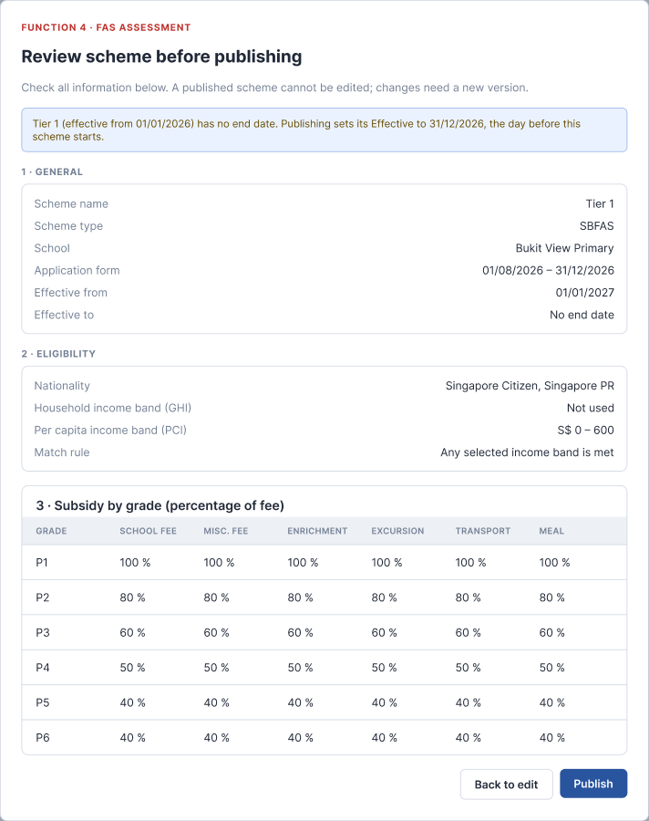
Rule | Message
Name required | "Enter a scheme name."
Form dates required; Form closes ≥ Form opens | "Enter Form opens and Form closes." / "Form closes must be on or after Form opens."
Effective from required and after Form closes | "Effective from must be after Form closes (applications are assessed after the form closes)."
Effective to after Effective from | "Effective to must be after Effective from."
At least one nationality and one income band | "Select at least one nationality." / "Use at least one income band (GHI or PCI)."
At least one fee component; every cell valid | "Add at least one fee component." / "{row} · {fee}: enter 0–100 %."
Publish: same slot must not overlap (MOEFAS: any MOEFAS; SBFAS: same school and same name) | "The period overlaps with {scheme} (…). Change Effective from / Effective to." / "The application form period overlaps with {scheme} (…). Change Form opens / Form closes."
Publish: an earlier scheme of the same slot with no end date | Its Effective to is set to the day before the new Effective from (blue note in the review).
Draft can be saved at any time (name required). View opens "Review scheme before publishing" with General, Eligibility and Subsidy; Publish makes it view-only.

7.4 Add fee to a published scheme
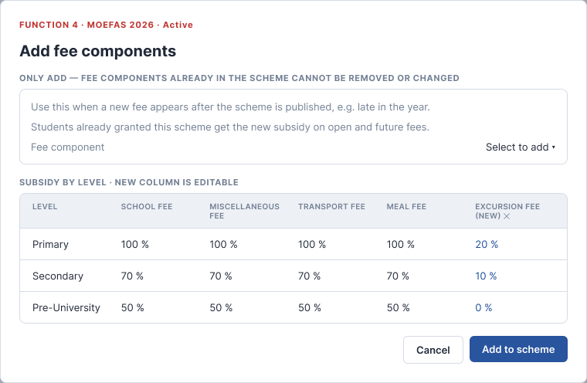
Element | Rule
When | Scheme is Active or Upcoming. Not for Closed or Draft schemes.
Fee component | Active fee components not yet in the scheme. Choosing one adds an editable column (0 for every level/grade). A newly added column can be removed with ✕ before saving.
Existing components | Shown read-only; cannot be removed or changed.
Add to scheme | Disabled until at least one component is added and every new cell is valid. Saves the components and values, records "added at / by", and applies the subsidy to open fees of those components for students already granted this scheme; future fees follow automatically. Toast "Fee components added to the scheme."

7.5 Close form now (demo only)
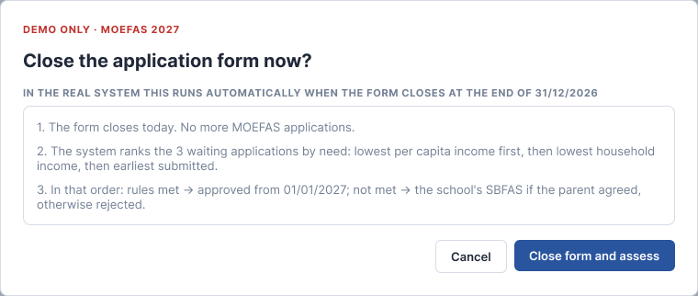
Prototype-only button for MOE HQ on a MOEFAS scheme whose form is Open. It sets Form closes to today and runs section 2.2. In production the same processing runs automatically when the form closes.

8. After a decision
Event | System updates
MOEFAS approved (after the form closed) | Subsidy for the student's level applied to outstanding fees due inside the effective period, and to fees published later. History "Form closed · priority n of N", "MOEFAS rules met · approved automatically", "Email with result sent to parent".
MOEFAS not eligible | SBFAS Pending for the school (parent agreed) or Rejected with email (parent did not agree).
SBFAS approved | Tier (scheme), Effective from, Comment, decided by saved; subsidy for the student's grade applied to outstanding and future fees inside the scheme's effective period; email to parent.
SBFAS rejected | Reason, Comment saved; email with the reason to the parent.
Any decision | Cards and tab counts update; the application becomes read-only.

9. Business rules
ID | Rule
BR1 | Applications can be submitted only while a FAS application form (MOEFAS or the child's school SBFAS) is open.
BR2 | MOEFAS is decided only by the system, after the MOEFAS form closes, in priority order (lowest PCI, then lowest GHI, then earliest submitted). No user can approve or reject MOEFAS.
BR3 | A scheme's form must close before it takes effect (Effective from > Form closes).
BR4 | Schemes have no tiers inside. MOEFAS: one scheme for all levels, subsidy per level. SBFAS: one scheme per tier, subsidy per grade the school offers.
BR5 | Only School Admin of the student's current school decides SBFAS, by choosing one of its SBFAS schemes. MOE HQ is view only.
BR6 | One decision per application; decided applications are read-only. If two users decide the same application, the second gets "This application was already decided by {user} on {date}."
BR7 | Eligibility limits and subsidy values come from the scheme, never from the screen.
BR8 | Published schemes are view-only, except that fee components can be added to Active/Upcoming schemes; existing components can never be removed or changed.
BR9 | MOE HQ manages MOEFAS schemes only and cannot see SBFAS schemes; each school manages its own SBFAS schemes.
BR10 | ML (tier, risk) is information only.
BR11 | Reject needs a reason and a comment (≤ 500 characters). The parent gets an email after every decision.
BR12 | School Admin never sees MOEFAS applications.
BR13 | Currency S$; date DD/MM/YYYY; time HH:mm Singapore time.

10. Test scenarios
ID | Scenario | Expected
T1 | Citizen submits while the MOEFAS form is open | MOEFAS Pending, System check "Waiting", History "Waiting for the MOEFAS form to close on …".
T2 | Submit when no form is open | F5/F10 block: "the FAS application form is closed (next opens …)".
T3 | Form closes with 3 waiting applications | Ranked 1–3 by PCI; each assessed in order; History shows "priority n of 3".
T4 | Waiting application within MOEFAS limits | Approved from the scheme's Effective from; subsidy by the student's level.
T5 | Above limits, "Also consider for SBFAS" = Yes / No | SBFAS Pending at the school / Rejected with email.
T6 | PR or International student submits | SBFAS Pending directly.
T7 | School list columns | Grade instead of Class; Tier before ML recommendation and ML risk.
T8 | Approve SBFAS | Tier list = school's SBFAS schemes; pre-selected ML tier; Effective from = scheme start or today.
T9 | New scheme with Effective from on or before Form closes | Error "Effective from must be after Form closes …".
T10 | MOEFAS Step 3 | Rows Primary, Secondary, Pre-University; choosing a fee adds a column at once.
T11 | SBFAS Step 3 | Rows = grades the school offers (P1–P6).
T12 | Publish SBFAS "Tier 1" overlapping another "Tier 1" | Overlap error; a different name (Tier 2) is allowed.
T13 | Add fee to an Active scheme | New column editable, existing columns read-only; after save the new fee is reduced for granted students.
T14 | Add fee on a Closed scheme | Button not shown.
T15 | Export with filters | CSV has only filtered rows and the columns in 3.4.

