**Cyber Forensics Practical 8**

**Aim: Acquisition of Cell phones and Mobile devices Steps:**

**Step 1: Download required files**

**(a) MOBILedit! Forensic 10.1.0.25985 Software (Desktop/Laptop)  
(b) Forensic Tool apk (Android)**

**Can be found here: (** [**https://t.me/+d2bggno1df9mMDJl**](https://t.me/+d2bggno1df9mMDJl) **)  
Step 2: Open MOBILEdit Forensic (Should be Activated/Cracked)**

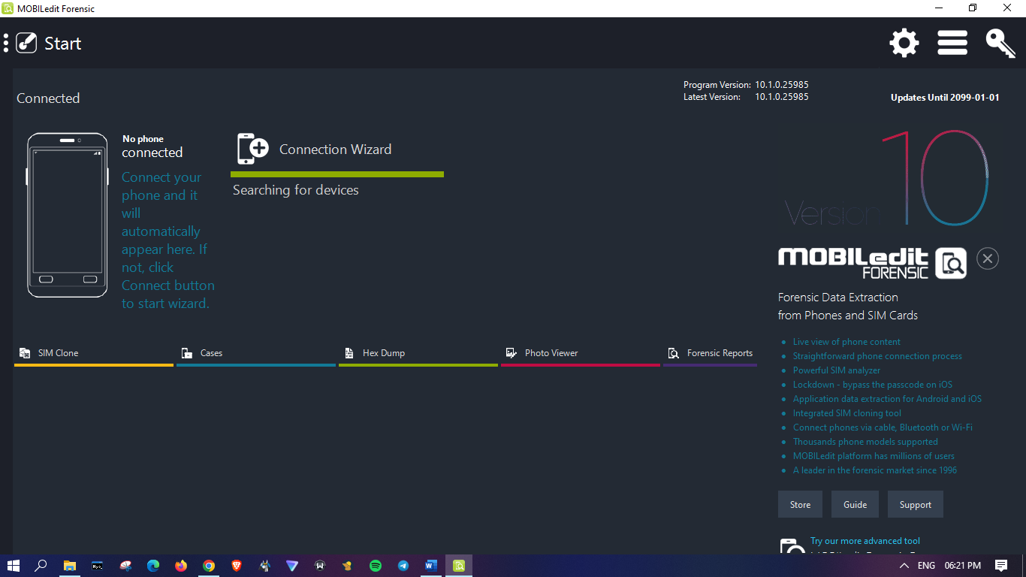**Step 3: Connect your Device by clicking on “Connection Wizard”  
 You may connect via: Wireless, Wired, etc   
(Used wired in this document, for wireless: Your laptop and android should be connected on same Wi-Fi network)**

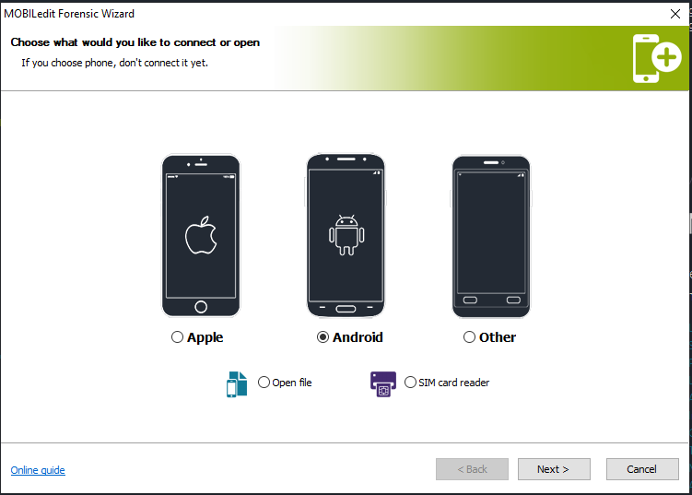

**CLICK ON “Android” and Click on Next [Ignore Open File | SIM Card Reader]**

**Step 4: Click on “Cable” and Next**

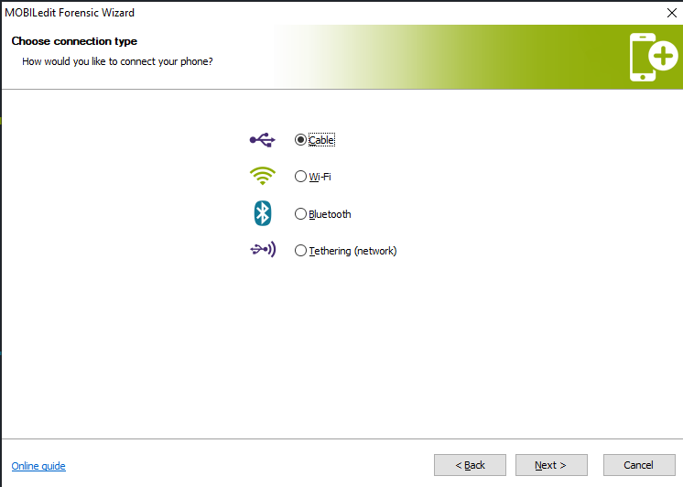

**Step 5: Follow Instructions and Enable Developer Mode in your Phone (Connect your Android Phone with USB | Install Driver as specified)**

**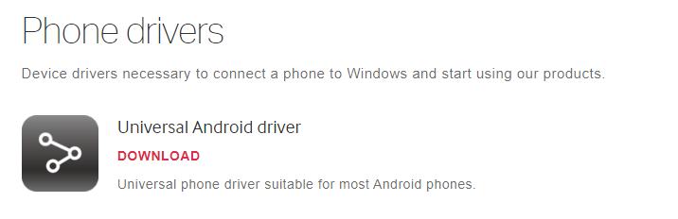  
After Developer Mode Enabled 🡺 Enable USB Debugging (developer options)  
**

**Step 6: Make sure USB Debugging is enabled and you choose to connect with your desktop when confirmation prompts at your phone screen (Tick if required)**  
- Click on USB Tethering (when connected with PC/Laptop)

(No need to wait if your device name pop-up click on name and Finish)  
**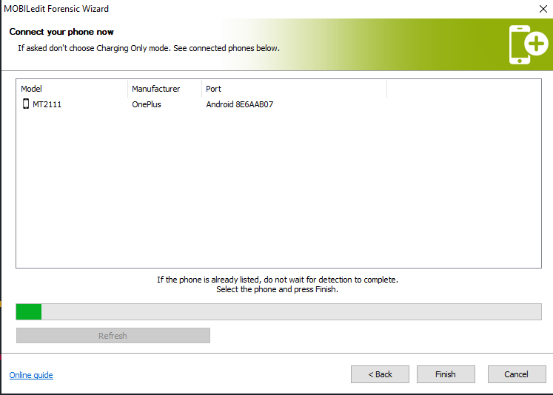  
  
It means you’re connected now!**

**Step 7: Click on Three Lines -> View -> Tree View**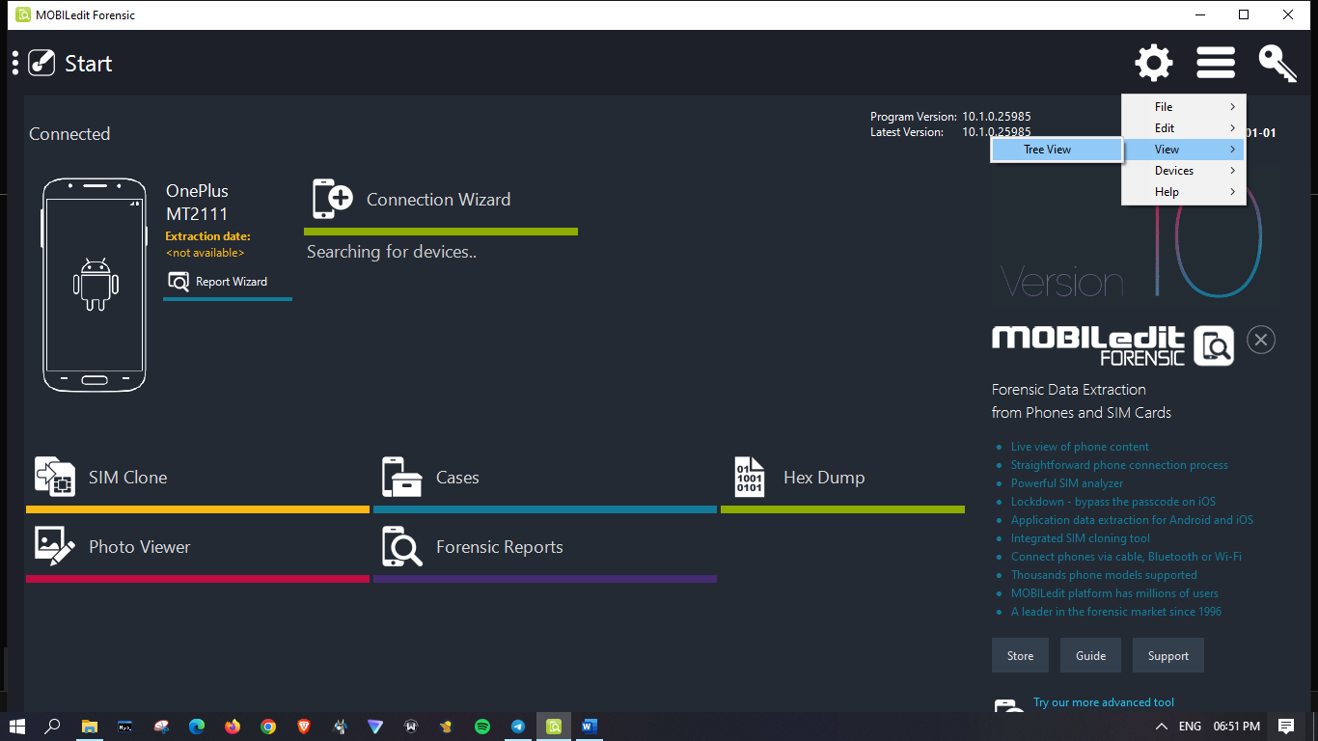

**Step 8: Click on Device to know more info 🡺 Report Wizard and follow instructions**

**(Check your information, select Device Capabilities and select path for logfile - > BROWSE)**

**Select Whole file system or Specified File types only**

(YOU WILL REQUIRE BACKUP REQUEST APPROVAL WITH YOUR PHONE PASSWORD)  
**Type password to proceed and click Backup my data**

**Acquiring of selected data may take a while.**

**You can check log file later wherever the path was selected after wizard process finished.  
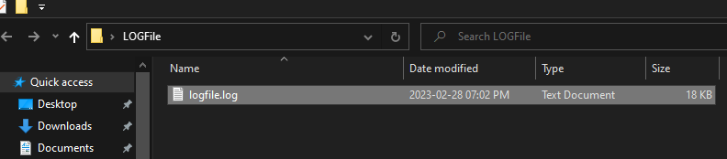**

**Step 9: Click on Cases and click on your device to download/backup available data  
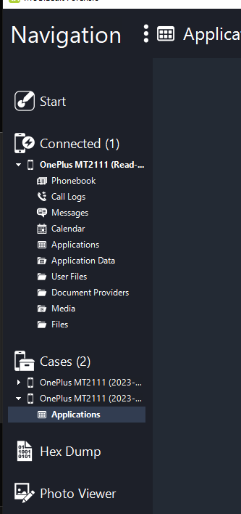**

**Step 10: Click on “Cases” (Left panel) and select your device to Check your reports or Open Data Folder | Done!***(It’s encrypted Backup Data)*

