Name: _Katelyn Truong_

Student Number: ___A00952509____

|  |  |  |
| --- | --- | --- |
| **Question** | **Total Marks** | **Your Score** |
| 1 from lesson 1 | 6 |  |
| 2 from lesson 2 | 6 |  |
| 3 from lesson 3 | 6 |  |
| 4 from lesson 4 | 6 |  |
| 5 from lesson 5 | 6 |  |
| 6 from lesson 6 | 6 |  |
| **Total** | **36** |  |

Show all the HTML and JavaScript code to do the following (do not use jQuery):

Use DOM 0, in an external JavaScript file, to resize the width of the first image on the document to 100.

Include a JavaScript comment to include:

* Your name

**<!- -Katelyn Truong**

Use a second type of JavaScript comment to include:

* A description of what the document, navigator, window, and style objects are

**/\***

**1. document: the HTML web page**

**2. window: the current window or tab**

**3. navigator: the browsers itself**

**4. style the CSS properties of an element**

**\*/**

Use a third type of JavaScript comment to include:

* Your student number

**// student number: A00952509**

# Question 2: From Lesson 2

Show all the HTML and JavaScript code to do the following (do not use jQuery):

At the end of the <body> section, using DOM 1, put a red solid 1px wide CSS border around all images.

**<body>**

**<script>**

**document.getElementsByTagName('img').style.border = 'red solid 1px';**

**</script>**

**</body>**

Also: in the head section, after the window is finished loading, alert how many days are left until Christmas later this year.

**<head>**

**<script>**

**onload = function () {**

**now = new Date();**

**christmas = new Date(2017, 11, 25, 12, 0, 0);**

**msec = christmas - now;**

**sec = msec / 1000;**

**min = sec / 60;**

**hour = min / 60;**

**day = hour / 24;**

**alert(Math.round(day) + " days till Christmas this year of 2017.");**

**}**

**</script>**

**</head>**

# Question 3: From Lesson 3

Show all the HTML and JavaScript code to do the following (do not use jQuery):

Write a function that loops through all of a page’s hyperlinks and disables any link that has the word “bcit” in its href attribute.

**<script>**

**onload=function(){**

**var str = 'bcit';**

**links = document.getElementsByTagName('a');**

**for (let i = 0; i < links.length; i++) {**

**if ((links[i].href.includes(str))) {**

**links[i].onclick = function (e) {**

**e.preventDefault();**

**}**

**}**

**}**

**}**

**</script>**

Also, write code that prevents the following form from being submitted if its textbox is empty. Do not use jQuery:

<form action=”f.php”>

<input type=”text” id=”t”>

<input type=”submit”>

</form>

**<script>**

**document.forms.onsubmit = function () {**

**if(document.getElementById('t').value == ' '){**

**alert('need to fill text field!');**

**return false;**

**}**

**}**

**</script>**

# Question 4: From Lesson 4

Show all the HTML and JavaScript code to do the following (**use jQuery**):

When the document is ready, put a red solid 2px red border around every image.

**$(function () {**

**$('img').css('border', 'red solid 2px');**

**});**

Show all the HTML and JavaScript code to do the following (**use jQuery**):

When an image is clicked, change its width attribute to 50.

**$('img').click(function () {**

**$('img').attr('width', '50px');**

**})**

Show all the HTML and JavaScript code to do the following (do not use jQuery):

When an image is clicked, change its width attribute to 50.

**myimg = document.getElementsByTagName('img');**

**for( let i = 0; i < myimg.length; i++){**

**myimg[i].onclick = function () {**

**myimg[i].style.width = '50px';**

**}**

**}**

# Question 5: From Lesson 5

Show all the HTML and JavaScript code to do the following (do not use jQuery):

What is the JavaScript code to create the following page using only JavaScript (e.g. **document.createElement**, etc…):

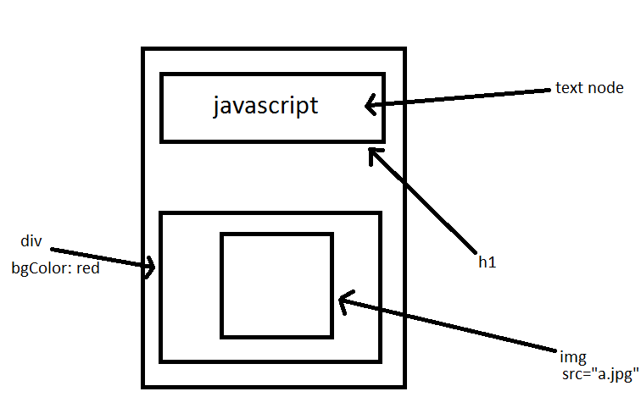

**function init() {**

**var h1 = document.createElement('h1');**

**var text = document.createTextNode('javascript');**

**h1.appendChild(text);**

**document.body.appendChild(h1);**

**var div = document.createElement('div');**

**div.style.backgroundColor = 'red';**

**var img = document.createElement('img');**

**img.src = 'a.jpg';**

**div.appendChild(img);**

**document.body.appendChild(div);**

**}**

Also, show all of the code that would move an image with ID “x” one pixel to the right every 100 milliseconds.

**function move() {**

**images = document.getElementById('x');**

**images.style.left = parent(images.style.left) + 1 + 'px';**

**}**

**images.onload = function () {**

**setInterval(move, 100);**

**};**

# Question 6: From Lesson 6

Show all the HTML and JavaScript code to do the following (do not use jQuery):

Create a Book object with fields for title (e.g. “harry potter”), author (“jk rowling”), yearPublished (2000), and a function/method called readBook, which logs to the console “You’re a wizard, Harry”.

Use all four techniques we learned:

* Literal
* Constructor
* Constructor pattern
* Prototype pattern

Then use the for/in loop to display all enumerable data.

**1. Literal: var book = {**

**title : 'Harry Potter',**

**author : 'Jk Rowling',**

**yearPublished : 2000,**

**readBook : function () {**

**console.log('You are a wizard, Harry');**

**}**

**}**

**alert(book.title);**

**book.readBook();**

**2. Constructor**

**var book = new Object();**

**book.title = 'Harry Potter';**

**book.author = 'Jk Rowling';**

**book.readBook = function () {**

**console.log('You are a wizard, Harry'); }**

**3. Constructor Pattern**

**function Book(bookTitle, bookAuthor, bookYear) {**

**this.title = bookTitle;**

**this.author = bookAuthor;**

**this.year = bookYear;**

**this.readBook = function () {**

**alert(book.title + "is the book I read");**

**}**

**}**

**var book1 = new Book('Ready Player One', 'Ernest Cline', 2011);**

**alert(book1.title);**

**book1.readBook();**

**book1.numberOfPages = 385;**

**4. Prototype Pattern**

**function Book(bookTitle, bookAuthor, bookYear) {**

**this.title = bookTitle;**

**this.author = bookAuthor;**

**this.year = bookYear;**

**}**

**book.prototype.material = 'hard paper';**

**var book2 = new Book('Ready Player One', 'Ernest Cline', 2011);**

**alert(book2.title + " is " + book2.material);**

**for(var value in book2){**

**console.log(book2[value]);**

**}**

**for(var value in theBook1){**

**console.log(name);**

**}**