# Homework 2

Worth 10%.

Due to be announced.

This assignment must be coded using the Angular framework.

**Submission Instructions:**

1. Submit all folders and files in your project but **do not include the node_modules directory**.

## Home Page

In your application define a class named *FoodItem*. Then, later declare the following array of *FoodItem* objects in your application.

var FOODITEMS: FoodItem[] = [

{ id: 1, name: "Cucumbers", mfg: "Hot House", pkg: "10 KG", qty: 6 },

{ id: 2, name: "Carrots", mfg: "Hot House", pkg: "8 KG", qty: 14 },

{ id: 3, name: "Cheese", mfg: "Hot House", pkg: "5 KG", qty: 20 },

{ id: 4, name: "French Fries", mfg: "McCain", pkg: "15 KG", qty: 8 }

];

When home page first loads, if no session data exists, save this array with your session data. If the session data exists load it from there.

On the home page dynamically display the summary if products. The product list is to be read from the session data.

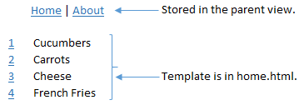

The user can select the id beside an item to display detail.

## Details

Detail data must be populated dynamically based on the user’s selection. Read it from the session data. Please note you are only allowed to pass the id to the detail view when the user selects the link.

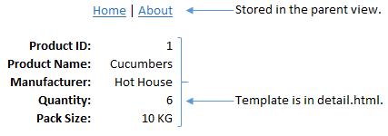

## About

If the user selects the ‘About’ link the about.html partial view is displayed within the application.

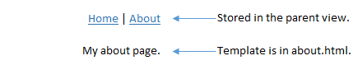

**Hint:** Since routing with parameters is required I recommend you begin your project with one of the examples from the day 2 homework which has routing.

## Footer

Create a separate directive component which contains the footer. The footer must display the current day dynamically. Use a date pipe to do this. The footer component must be visible from every view.

