EEEE3116 Coursework 1: Is Lighting Low-Dimensional? — Results Page
Student ID: 20617556 | Code Word: JDNW | Energy Target T = 99.0% | k_T = 5 (Cumulative Energy = 99.65% ≥ 99.0%)
Table 1: Singular Values, Cumulative Energy, and Rank-k Relative Errors (Row k_T = 5 Highlighted)
k | σ_k | Cumulative Energy | Relative Error (Measured) | Relative Error (from σ)
1 | 121.846 | 0.918799 (91.88%) | 0.284958 | 0.284958
2 | 24.3895 | 0.955612 (95.56%) | 0.210684 | 0.210684
3 | 18.8741 | 0.977658 (97.77%) | 0.149472 | 0.149472
4 | 13.3354 | 0.988664 (98.87%) | 0.106471 | 0.106471
5 [k_T = 5, ≥ 99.0%] | 11.2873 | 0.996548 (99.65%) | 0.0587501 | 0.0587501
6 | 7.46808 | 1.000000 (100.0%) | 1.40514e-15 | 0
Table 2: Relative Projection Residuals ||x − p|| / ||x|| of Held-Out Photos H1 (New Lighting) and E1 (Smile)
k | Residual of H1 (New Lighting) | Residual of E1 (Smile)
1 | 0.36046 | 0.19214
2 | 0.355658 | 0.177788
3 | 0.3422 | 0.177693
4 | 0.327411 | 0.144526
5 | 0.322855 | 0.13118
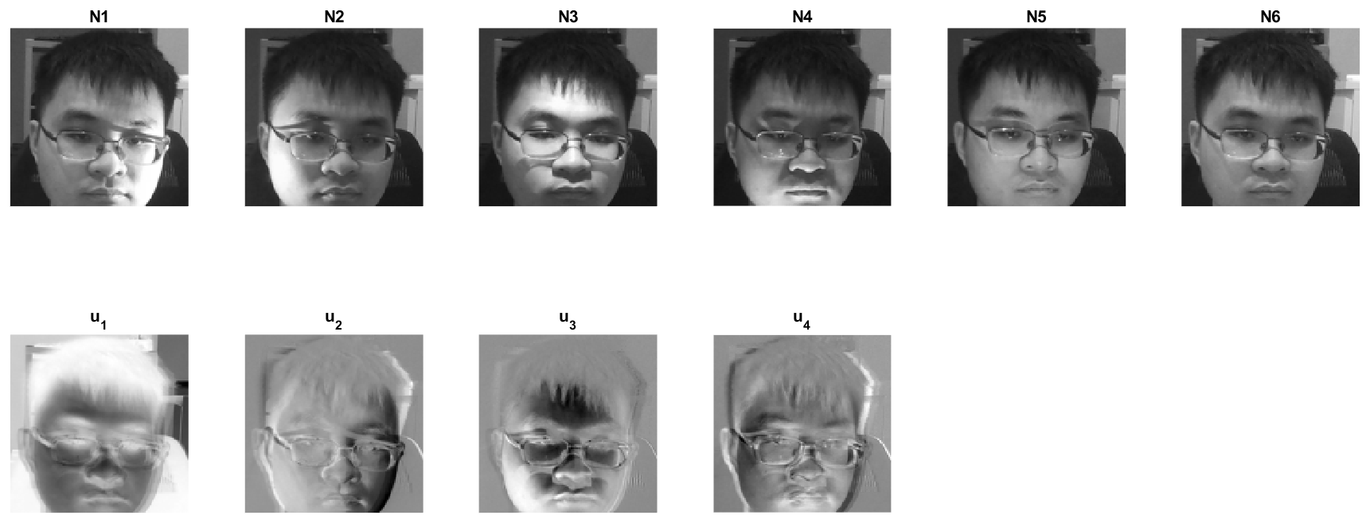
Figure 1: Six neutral lighting photos N1–N6 (top row) and first four left singular vectors u₁–u₄ displayed as images (bottom row).
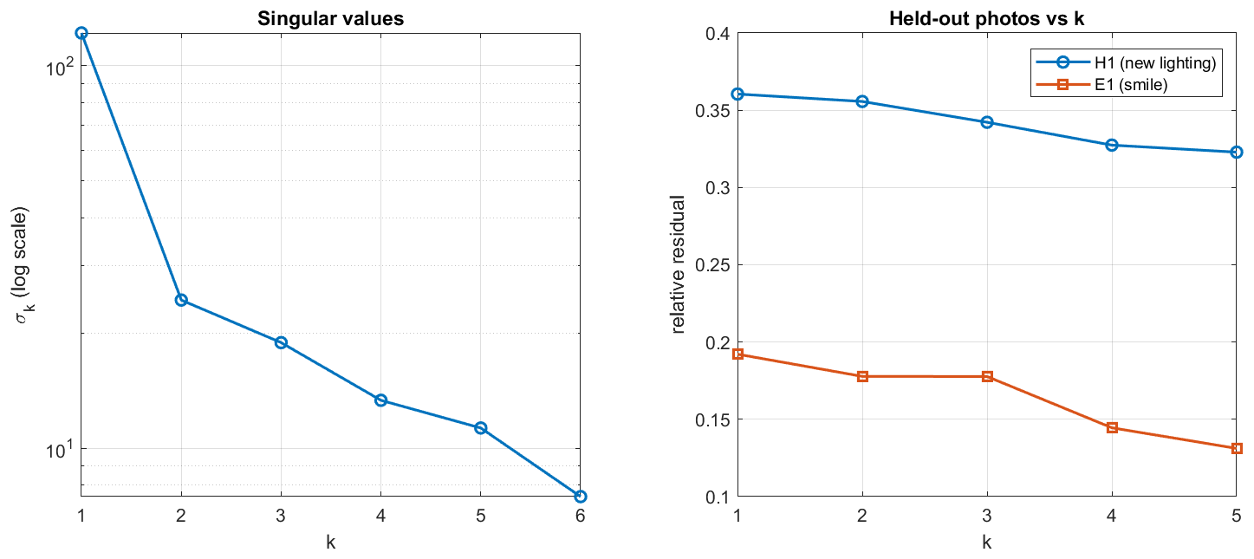
Figure 2: Singular values σ_k on a log scale (left) and relative projection residuals ||x − p|| / ||x|| vs k for H1 and E1 (right).
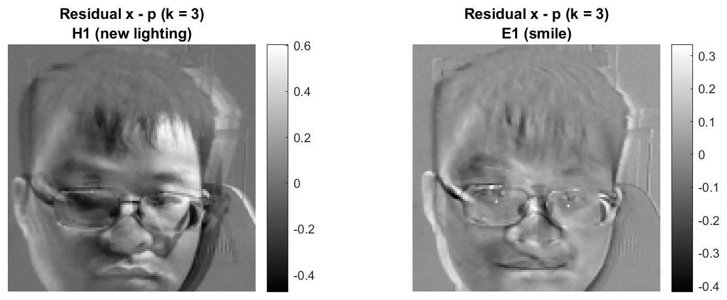
Figure 3: Residual images x − p at k = 3 for held-out photos H1 (new lighting, left) and E1 (smile, right).
AI Declaration: AI tools (Google Gemini) were used to help understand the MATLAB code, review the SVD mathematical derivations, and format the Task 2 results page.

