T&F Knowledge Hub
  - Technical PRD — Mobile-First Academic Reading Platform (MVP)
Version 1.0 · 11 July 2026 · LDP Innovation Capstone
Field | Detail
Product | T&F Knowledge Hub — B2B mobile academic reading platform for Taylor & Francis content
Document | Technical Product Requirements Document (MVP scope)
Backend | Java Spring Boot + Spring Cloud microservices · MongoDB (database-per-service)
Client | React Native (iOS + Android) · Readium reading toolkit · react-native-pdf
Cloud | AWS — S3 (content), AWS KMS (key management), containerised services
Delivery | Agile Scrum · 4 teams · 7 one-week sprints · weekly demoable milestone
Status | Approved for build

How to read this document. Sections 1–13 define the product, architecture, data model, security and observability. Sections 14–15 are the engineering focus: the SDLC approach and the 7-week, 4-team delivery plan. Companion specifications (APPROACH, CONTEXT, ENCRYPTION, IMPLEMENTATION, OBSERVABILITY) are listed in the final section.

1. Executive Summary
Taylor & Francis publishes books and journals across hundreds of disciplines, but that content reaches institutional readers through fragmented, desktop-era channels. The T&F Knowledge Hub is a mobile-first platform that unifies T&F books, e-books and journals (with their articles) into a single reading and research experience for universities and libraries.
The platform is B2B only: it is sold to organisations (universities and libraries) on subscription. There is no consumer purchase path. Every logged-in user can browse the entire catalogue; open-access content is readable by anyone, while licensed content is unlocked only when two time-bounded checks pass at read/download time — License (does one of the user's organisations license this title?) and Entitlement (is the user an active member of that organisation?).
This PRD scopes the MVP: the access-control spine plus the reading surface. It proves the loop log in → browse everything → attempt to read/download → gate → read & track end to end, with reading state (progress, highlights, bookmarks, downloads) synced across devices and available offline. Non-open-access files are AES-256-GCM encrypted at rest in AWS S3, with keys managed through AWS KMS envelope encryption — a free, standards-based stand-in for the paid Readium LCP DRM.
Content types supported in the MVP: e-books (EPUB) and journals with articles (EPUB/PDF). Audiobooks and other multimedia are modelled for the future but not built. The remainder of this document details the architecture, microservices, authentication, data model, diagrams, observability, and a dependency-aware 7-week delivery plan across four teams.

2. Problem & Opportunity

2.1 The problem, in our words
- Fragmented access. A student or researcher juggles separate portals, PDFs and proxy logins to reach T&F books and journals; there is no single, mobile, reading-first home for the content their institution already pays for.
- Discovery is gated too early. Traditional platforms hide anything the user cannot open, so readers never discover the breadth of the catalogue — and the publisher never sees the demand for titles an institution has not yet licensed.
- Offline and mobile reading are weak. Academic reading happens on commutes and in the field; existing tools assume a desktop browser and a live connection.
- Licensing is opaque. Whether a given title is readable depends on the institution's licenses and the user's membership — logic that is rarely surfaced clearly to the reader.

2.2 Our solution & approach
We separate discovery from access. Everyone browses the full catalogue for better discovery; enforcement happens only when a user tries to consume licensed content. That single decision — browse-all, gate at read/download, open-access bypasses — drives the whole architecture and makes every denied attempt a visible unmet-demand signal for the sales team.
The backend is a set of Spring Boot microservices coordinated by Spring Cloud, each owning its own MongoDB database, with content files in AWS S3 and keys in AWS KMS. The client is a React Native app that renders EPUB through the free Readium toolkit and PDF through react-native-pdf, works offline, and syncs reading state on reconnect. Because real T&F systems are out of scope for the capstone, all catalogue, organisation and membership data is mocked and seeded behind the same APIs the real integrations will later use.

2.3 Why this slice first
Licensing plus entitlement is the hard, differentiating core; reading plus sync is the engagement surface. Everything else — analytics pipelines, concurrent-seat DRM, federated SSO, recommendations — layers cleanly on top of a correct access model, so we build that model first and prove it end to end.

3. Goals & Success Metrics

3.1 Primary goal
Deliver a working, demoable MVP that proves the full access loop and reading surface on iOS and Android, backed by independently deployable microservices, in seven weeks.

3.2 Objectives
- Any logged-in user can browse the entire catalogue with a correct per-item access badge.
- Open-access content opens for anyone; licensed content is correctly allowed or denied at read/download time, with a specific denial reason.
- Non-open-access files are encrypted at rest and only decryptable after the gate passes; offline copies expire and are wiped on revocation.
- Reading state (progress, highlights, bookmarks, downloads) is synced with last-write-wins and available offline.
- Every service is observable from day one — health, traffic and business KPIs visible in Grafana.

3.3 Success metrics (MVP)
Metric | Target / definition
Access-decision correctness | 100% of seeded allow/deny scenarios resolve correctly (verified by integration tests)
Gate latency (p95) | ≤ 400 ms for POST /access including the cross-service chain
Catalogue browse latency (p95) | ≤ 300 ms for a paged catalogue request with badges
Offline read | A downloaded title opens with no network; expires at license end and wipes on revocation
Sync convergence | Two-device edits converge under last-write-wins with no lost newer write
Denials-by-reason | tf_access_denied_total{reason} visible on the Business dashboard (demand signal)
Observability coverage | Every service exposes /actuator/prometheus and emits its business metrics

4. Scope & Feature Set
Features are prioritised P0 (MVP, must-build) and stretch (roadmap). Both online and offline paths are covered in the MVP.

4.1 MVP feature set (P0)
Capability | MVP behaviour | Online | Offline
Authentication & sessions | Email/password login; access + refresh tokens; device-limited multi-device sessions (cap default 3, block-on-exceed); silent refresh; manage devices | Yes | Token cached; silent refresh on reconnect
Browse & search | Full catalogue via OPDS 2.0 feeds; text search; pagination; access badges | Yes | Last-fetched feed cached for browsing
Access gate | License + Entitlement checks at read/download; open-access bypass; deny with reason | Yes | Cached license.exp checked locally
Read (EPUB) | Readium reader — pagination, TTS, in-book search, highlights, fonts, accessibility | Yes | Yes (decrypted in memory)
Read (PDF) | react-native-pdf viewer | Yes | Yes
Download & protect | AES-256-GCM encrypted blob + license JWS + key (Keychain/Keystore) | Download | Read; wipe on expiry/revocation
Reading state | Progress, highlights, bookmarks, downloads in user_content; last-write-wins sync | Yes | Queued locally; synced on reconnect
Access badges / filter | Per-item Open / Full-via-org / Locked; filterable | Yes | From cached feed
Content protection | AWS KMS envelope encryption; key over TLS; never in the signed token | Yes | Wrapped key in secure enclave
Observability | Ops + Business dashboards (Prometheus + Grafana); denials-by-reason | Yes | n/a

4.2 Stretch / roadmap
- Audiobooks & multimedia (audio/video/datasets + media player) — Readium supports audiobooks natively.
- Real Readium LCP (paid EDRLab licence) replacing our License-token stand-in; per-resource on-the-fly decryption.
- Content-protection hardening — device attestation (App Attest / Play Integrity), JWE key delivery, watermarking.
- Concurrent-seat DRM — per-title seat counts + checkout/hold/waitlist (distinct from the per-account device cap).
- Federated auth — SAML / SCIM / OIDC institutional SSO and roster sync.
- Deep BI pipeline — Redshift + Power BI/QuickSight for per-entity analytics (top-N titles, cohorts, journeys).
- Session hardening — refresh-token rotation + reuse detection, step-up auth, idempotency-key store.
- Chapters / chapter-split · reading lists · recommendations · full-text search across the corpus.

4.3 Dropped entirely
- B2C / individual purchases — no paywall, no in-app purchase, no purchaseType: bought. The platform is B2B only.

5. Users, Personas & Roles
Persona | Needs | Key interactions
Student / Reader | Read set texts and journal articles on mobile, online and offline | Log in, browse, read, download, highlight, sync
Researcher | Deep reading, annotation, in-book search across licensed journals | Search, read, annotate, bookmark, sync
No-org user | Explore the catalogue and read open-access content | Browse, read open-access
Librarian / Org Admin | Manage what the institution licenses and who is enrolled | Manage licenses/subscription, manage roster (mocked/seeded)
System Scheduler | Keep OPDS feeds fresh | OPDS refresh cronjob
T&F Content Ingest | Load & encrypt content into the platform | Ingest + AES-encrypt content; wrap keys via KMS
The actor/use-case relationships — including the «include» gate and unlock steps that every read/download shares — are shown below.
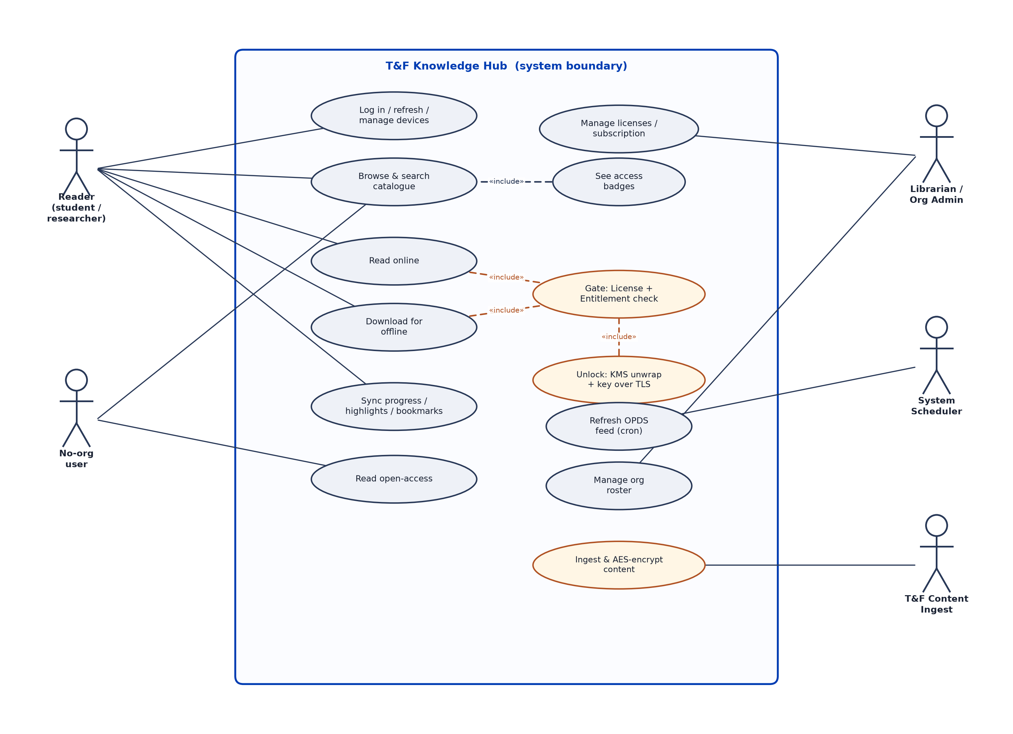
Figure 1 — UML use case diagram: actors and their interactions with the system.
Roles & permissions are detailed in §8.2.

6. System Architecture
A single backend of independently deployable Spring Boot services, coordinated by Spring Cloud. The React Native app talks only to the API Gateway, which validates the access token and routes to domain services. Services discover each other through Eureka and read configuration from the Config Server. Each service owns its own MongoDB database — no shared schema, no cross-service joins.

6.1 Client, backend, data
- Client — React Native (iOS + Android). Renders EPUB via the free Readium toolkit (a native Fabric UI component) and PDF via react-native-pdf; stores tokens and content keys in the Keychain/Keystore; works offline and syncs on reconnect.
- Backend — Spring Boot + Spring Cloud. Six domain services behind the Gateway, plus the platform trio (Eureka, Config Server, Gateway). Services call each other with OpenFeign over Eureka-resolved names.
- Data — MongoDB, database-per-service. Eight collections spread across service-owned databases (§10). Content binaries live in AWS S3, never in the database.
- Cloud — AWS. S3 for encrypted content; AWS KMS for the master key and envelope-encrypted per-file keys; services run as containers (ECS/EKS or EC2 for the capstone), fronted by the Gateway.

6.2 How online, offline and sync work
- Online. Every request carries a Bearer access token. Read/download calls hit the License gate, which chains checks and — on success — returns a short-TTL signed S3 URL, a license JWS, and the content key over TLS. The app fetches the encrypted blob, decrypts it in memory, and renders it.
- Offline. On download, the app persists the encrypted blob, the license JWS (exp = license.end) and the content key wrapped in the OS secure enclave. Opening offline checks exp locally and decrypts in memory; plaintext is never written to disk. On expiry or revocation (detected at the next heartbeat) the blob and key are wiped.
- Sync. Reading state is written to user_content with last-write-wins on updatedAtTime, so edits made on two devices — or while offline — converge deterministically on reconnect; a stale write is a no-op.

6.3 How the backend mocks T&F
Real T&F catalogue, organisation and membership systems are out of scope. Each service ships a CommandLineRunner seed loader that populates its MongoDB with realistic mock data behind the same REST contracts the production integrations will use: seeded users, organisations (with userList[] and subscription), a denormalised catalogue with articles, licenses/entitlements, and a handful of pre-encrypted objects in S3/MinIO. Swapping the mock for a real feed later is an adapter change behind an unchanged API — the seam is the OPDS ingest and the internal check endpoints.
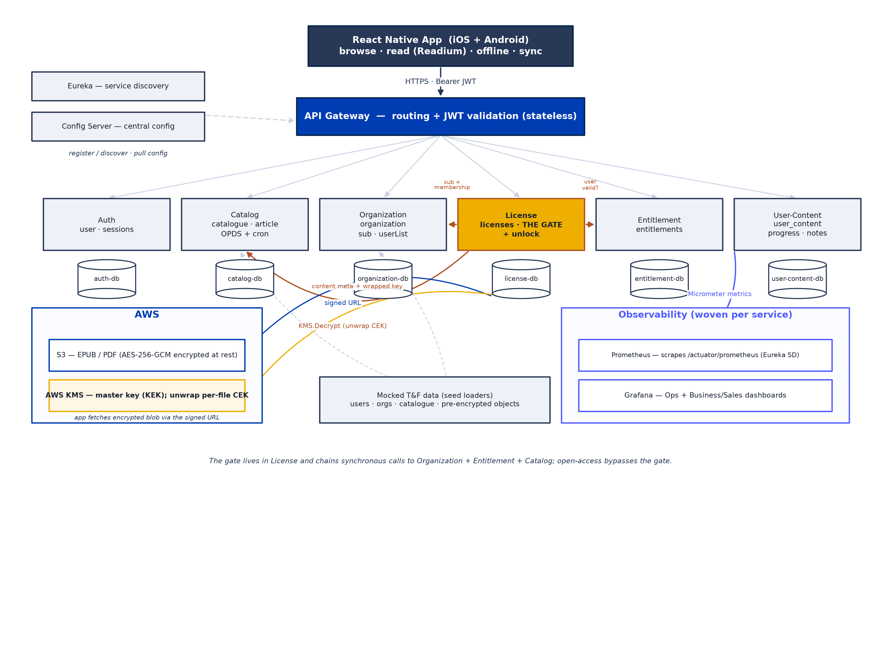
Figure 2 — System / microservices architecture: client, gateway, services, database-per-service, AWS (S3 + KMS), observability, and the mocked T&F seed.

7. Microservices Design

7.1 Platform services
Service | Responsibility
Eureka Server | Service registry / discovery — every service registers and resolves peers by name
API Gateway | Single public entry point (Spring Cloud Gateway, WebFlux); validates the access JWT once at the edge and routes to services; injects X-User-Id downstream
Config Server | Centralised configuration — DB URIs, JWT secret/keys, S3 bucket, KMS key id, TTLs, feed schedule

7.2 Domain services (database-per-service)
Service | Responsibility | Owns (MongoDB)
Auth | Accounts + email/password login; issues access + refresh tokens; device-limited multi-device sessions (cap, block-on-exceed); manage devices | auth-db: user, sessions
Catalog | Denormalised catalogue + articles; OPDS 2.0 feeds + refresh cronjob; computes per-user access badges | catalog-db: catalogue, article
Organization | The tenant (University/Library): licenses held (licenseId[]), subscription window, authoritative userList[]; answers membership + subscription checks | organization-db: organization
License | Owns licenses; runs the read/download GATE and mints the unlock token + releases the content key; calls Organization + Entitlement + Catalog | license-db: licenses
Entitlement | Owns entitlements; validates a user holds a valid, unexpired entitlement | entitlement-db: entitlements
User-Content | Per-user reading state — progress, highlights, bookmarks, downloads; last-write-wins sync | usercontent-db: user_content

7.3 How they communicate
- Edge → services. The React Native app only ever calls the API Gateway; the Gateway validates the JWT and routes by path prefix (/auth/**, /catalog/**, /access/**, /orgs/**, /entitlements/**, /me/**).
- Service ↔ service. Synchronous OpenFeign clients resolved through Eureka. The gate is the one cross-service chain: License → Catalog (content metadata + wrapped key), License → Organization (subscription + membership + licenseId[]), License → Entitlement (user validity). Catalog also calls License once per request for the licensed-ISBN set behind access badges.
- Discovery & config. All services register with Eureka and pull configuration from the Config Server on boot; the Gateway load-balances to service instances by name (lb://…).
- Isolation. No service reads another's database. Cross-context facts (subscription validity, entitlement validity, content metadata) are always fetched over the API, keeping bounded contexts clean.
Why the gate lives in License and chains outward. Organization, License and Entitlement are three bounded contexts — *who the tenant is · what is licensed · who is entitled*. The synchronous chain is the accepted cost of clean separation; the gate caches the per-request org check and sets Feign timeouts + fallbacks so a slow sibling cannot hang every read.

8. Authentication & Authorization

8.1 Authentication mechanism
- Tokens. Login (email/password + deviceId) returns a short-lived access token (signed JWS, ~15 min) and a long-lived refresh token. Access-token claims: sub (userId), orgs[] (organizationId), ents[] (entitlementId), sid (sessionId), did (deviceId). Passwords are stored BCrypt-hashed; refresh tokens are stored SHA-256 hashed in the sessions collection — never in plaintext.
- Device-limited multi-device sessions. One sessions row per (user, device), TTL-indexed. An account may hold at most N active devices (configurable, default 3); a login on a new device beyond the cap is refused (device_limit_reached) until a device is signed out — no auto-eviction.
- Silent refresh. A client interceptor catches a 401, calls /auth/refresh once, and retries — the user is never logged out mid-read. Manage devices via GET /auth/sessions, logout, logout-all.
- Stateless validation. The Gateway validates the access token's signature and expiry with no database hit; only login/refresh/logout/list touch the sessions store.

8.2 Roles & permissions
Role | Can do | Cannot do
Reader (member) | Browse all; read/download licensed titles their org holds; read open-access; sync reading state | Read titles not licensed by their org; manage licenses
No-org user | Browse all; read open-access | Read/download licensed titles
Org Admin / Librarian | Everything a reader can, plus manage the org's licenses, subscription and roster (mocked) | Access another org's admin functions
Ingest / System | Ingest & encrypt content; refresh OPDS feeds (internal, not public) | n/a (service-to-service only)
Authorization for content is not role-based alone — it is the License + Entitlement gate evaluated per title at consumption time, so *authentication ≠ content access*: a valid session still yields a denial if the user has left the org or the subscription has expired.

8.3 Securing endpoints
- Single public door. Only the Gateway is publicly reachable; it rejects any protected request without a valid Bearer token (401). Downstream services trust the injected X-User-Id because they are not directly reachable.
- Public vs protected. /auth/login and /auth/refresh are public; everything else requires a valid access token.
- Internal endpoints. The gate's /internal/** check endpoints are not exposed through the Gateway — they are service-to-service only (Feign), on the internal network.
- Transport. HTTPS/TLS everywhere; the content key is only ever returned in a TLS response body, never in a signed token (a JWS payload is readable).

8.4 Securing offline content
- Downloaded files are AES-256-GCM encrypted at rest — a leaked blob or signed URL is useless without the key.
- The content key is wrapped in the OS secure enclave (iOS Keychain/Secure Enclave, Android Keystore), bound to the device; plaintext is never written to disk (decryption happens in memory).
- The license JWS carries exp = license.end and the deviceId; the app enforces exp locally and wipes the blob + key on expiry or on revocation detected at the next heartbeat.
- GCM AAD is bound to `{contentId, userId, deviceId}` so a blob cannot be replayed under another context.

9. Content Protection & Encryption (AWS KMS)
Non-open-access content is protected by our own License layer — a free, standards-based scheme that mirrors the *shape* of Readium LCP (encrypted content, key released only after access control, signed license with a validity window) without the paid EDRLab licence. Open-access content is served plainly.

9.1 Key hierarchy & AWS KMS envelope encryption
Key | Role | Where it lives | Sent to client?
Content key (CEK) | AES-256-GCM encrypts one file (per-file random) | Stored wrapped on the content record — never in plaintext | Only the plaintext form, transiently over TLS
Master key (KEK) | Wraps / unwraps every CEK | AWS KMS (HSM-backed, rotatable); Config Server secret for local dev | Never
The blob | Ciphertext of the file | AWS S3 (ciphertext + IV + tag) | Fetched via short-TTL presigned URL
AWS KMS envelope encryption is the production key path and is wired in during the delivery plan (Week 4). At ingest, a per-file CEK encrypts the file; KMS returns the CEK in plaintext + ciphertext form; we store the ciphertext (wrapped) CEK on the content record and discard the plaintext. At `/access`, after the gate passes, the License service calls `KMS.Decrypt` to unwrap the CEK server-side and releases the plaintext CEK to the authorised client over TLS. The master key material never leaves the KMS HSM, and KMS provides managed rotation + audit. All keys exist before any /access call — /access unwraps and releases, it never creates keys.
Why not S3 server-side encryption (SSE)? SSE would make S3 decrypt on the fly, so a presigned URL would return plaintext — defeating the gate. We encrypt at the application layer so S3 only ever stores an opaque blob and the key is released solely by the License gate.

9.2 Online vs. offline
- Online — the CEK is fetched per read and discarded; no key at rest on the device. Strongest mode.
- Offline — blob + license JWS + CEK are stored on the device, the CEK wrapped in the Keychain/Keystore; license.exp is checked locally; content is decrypted in memory and wiped on expiry/revocation.

9.3 Honest ceiling
Any client-side decryption can ultimately be defeated (plaintext exists in memory at read time). The MVP measures make this a strong deterrent-grade protection; the certified, tamper-resistant endpoint of this path is real Readium LCP, kept as a production upgrade. Full detail and standards citations are in the companion ENCRYPTION specification.

10. Database Schema
MongoDB, database-per-service, 8 collections. The catalogue is denormalised (content-type fields embedded) so list/search hits one collection with no join; articles are the exception. Access is expressed by reference arrays: organization.licenseId[] → licenses, and user.entitlementId[] → entitlements (the license/entitlement docs are thin and carry no userId/orgId).

catalogue (Catalog)
Field | Type | Notes
_id | ObjectId | Primary key
title, subtitle?, description | string | Display metadata
authors[] | string[] | Embedded for MVP
language, image, price | string / string / number | price retained but unused (B2B)
openAccess | bool | True → skip the gate, serve plainly
region[]?, category[] | string[] | Faceting
contentType | enum[ebook|journal] | Not 'article'
ebook{isbn, format[], link} | object | link = S3 object key
journal{issn, format[]?, subject[], frequency, articleIds[]} | object | Journal block
timestamp | date | Created/updated

article (Catalog)
Field | Type | Notes
_id | ObjectId | Primary key
journalId | ObjectId → catalogue | Parent journal
link, format[] | string / string[] | S3 key + formats
rangeOfPage, subject[] | string / string[] | Article metadata
openAccess | bool | Per-article; else inherits journal license
timestamp | date

organization (Organization)
Field | Type | Notes
_id | ObjectId | Tenant id
type | enum[University|Library] | Tenant type
licenseId[] | ObjectId[] → licenses | Licenses the org holds ($addToSet)
subscription{status, startsAt, endsAt} | object | Validity window
userList[{userId, status}] | object[] | AUTHORITATIVE roster; status enum[active|left]

user (Auth)
Field | Type | Notes
_id | ObjectId | User id
name, email, passwordHash | string | email unique; BCrypt hash
organizationId[] | ObjectId[] | Multi-org (convenience index)
entitlementId[] | ObjectId[] → entitlements | Entitlements held ($addToSet)
userContentIds[] | ObjectId[] | Reading-state references

sessions (Auth)
Field | Type | Notes
_id (sessionId) | ObjectId | Also an access-token claim (sid)
userId, deviceId | ObjectId / string | One row per (user, device)
deviceInfo? | string | Platform/model label
refreshTokenHash | string | SHA-256 — never the raw token
createdAt, lastUsedAt | date
expiresAt | date | TTL index auto-deletes on expiry

licenses (License)
Field | Type | Notes
_id (licenseId) | ObjectId | Referenced by organization.licenseId[]
isbn | string | Content identifier (ebook ISBN / journal ISSN)
start, end | date | Validity; end ≤ subscription.endsAt
openAccess | bool | Whether the licensed item is open access

entitlements (Entitlement)
Field | Type | Notes
_id (entitlementId) | ObjectId | Referenced by user.entitlementId[]
start, end | date | Validity; end ≤ subscription.endsAt

user_content (User-Content)
Field | Type | Notes
_id | ObjectId
userId, catalogueId | ObjectId | Owner + content
inLibrary, purchaseType | bool / enum[free|subscription] | no 'bought' (B2B)
syncProgress{pageLocation, updatedAtTime} | object | Last-write-wins key
highlights[]{id,pageLocation,textHighlighted,color,updatedAtTime} | object[] | Annotations
bookmarks[]{id,pageLocation,label,updatedAtTime} | object[] | Bookmarks
download[]{deviceId,downloadedAt} | object[] | Offline copies
timestampOfUpdation | date

10.1 Relationships
- user 1—N sessions (device login, max N). organization N—M user (membership via userList[] / organizationId[]).
- organization 1—N licenses (holds via licenseId[]). licenses N—1 catalogue (matched by isbn).
- user 1—N entitlements (holds via entitlementId[]). catalogue 1—N article (journal contains).
- user 1—N user_content N—1 catalogue (reading state per title).

10.2 Indexes
Collection | Index | Purpose
user | email (unique) | Login lookup
sessions | {userId, deviceId} (unique); expiresAt (TTL) | One row per device; auto-expiry; device-cap count
catalogue | ebook.isbn, journal.issn; text index on title/authors/subject | License match; search
article | journalId | Journal → articles
licenses | isbn | Gate lookup by content id
organization | userList.userId | Membership check
user_content | {userId, catalogueId} (unique) | One reading-state doc per title; LWW upsert
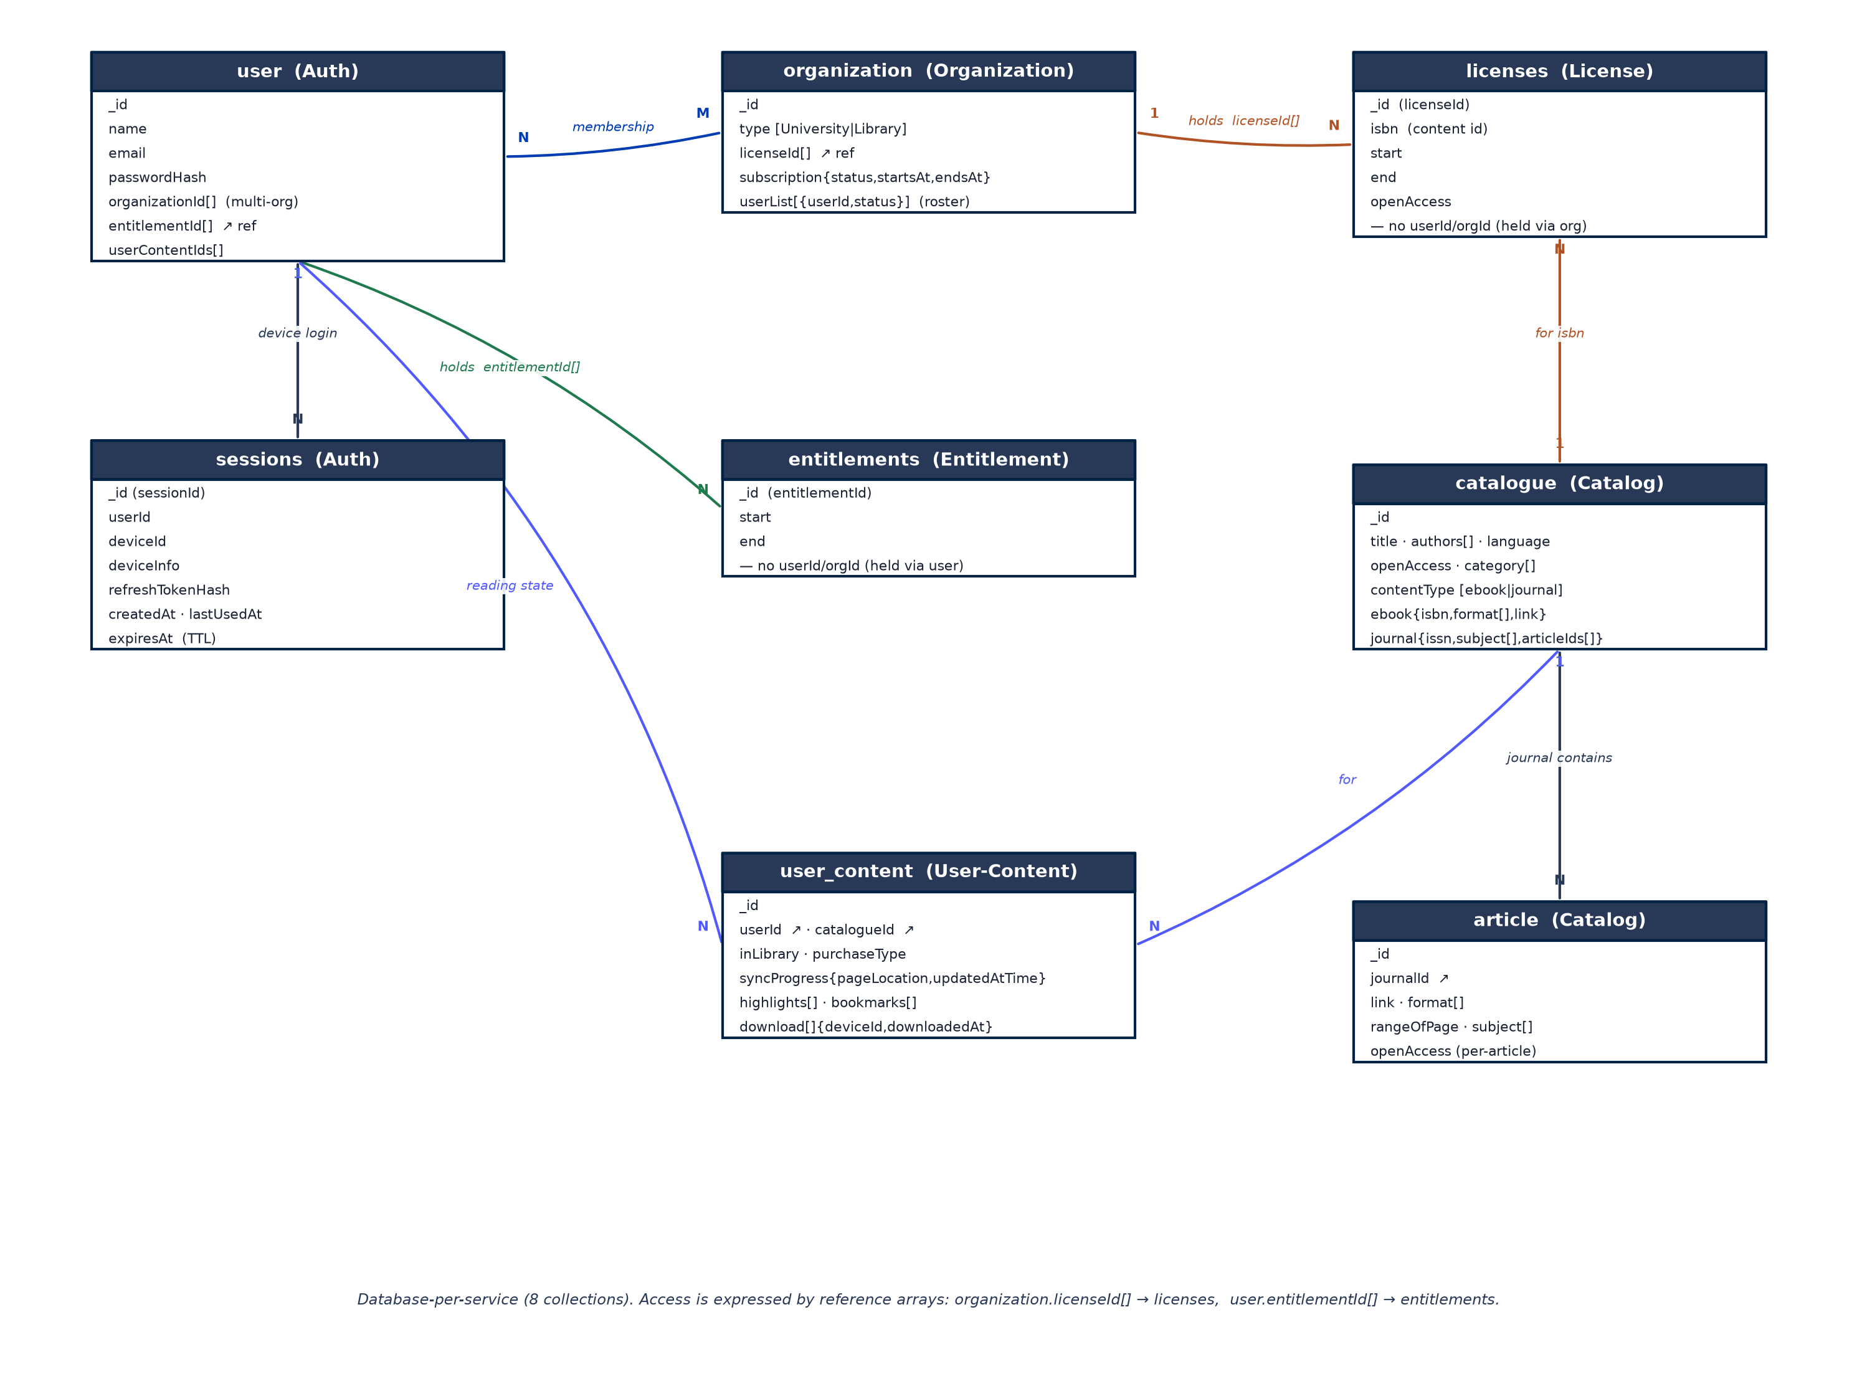
Figure 3 — ER diagram: entities, key attributes, and relationships across the 8 database-per-service collections.

11. End-to-End Access Flow
The gate fires at read/download time, not at browse time.
- Authenticate. Login (email/password + deviceId) → access token + refresh token; a new device beyond the cap is refused (device_limit_reached).
- Browse everything. Catalog returns the full catalogue (OPDS feed), each item tagged Open / Full-via-org / Locked.
- Open or download a book or a journal article.
- Open-access shortcut. If openAccess → serve plainly via a signed S3 URL; record in user_content.
- License check. License → Organization for the user's orgs with a valid subscription + user active, then the first matching licenses record whose isbn matches and is within start ≤ now ≤ end.
- Entitlement check. License → Entitlement: the token's ents[] must resolve to a valid entitlement.
- Unlock or deny. Both pass → License unwraps the CEK (KMS), mints the license JWS, presigns the S3 URL, and returns the key over TLS; the app decrypts in memory and renders. Otherwise deny with a reason.
- Read & track. Progress/highlights/bookmarks/downloads stored locally and synced (last-write-wins).
- Access window. Each access re-runs the gate against current validity windows — allow or deny; no reconciliation cron.
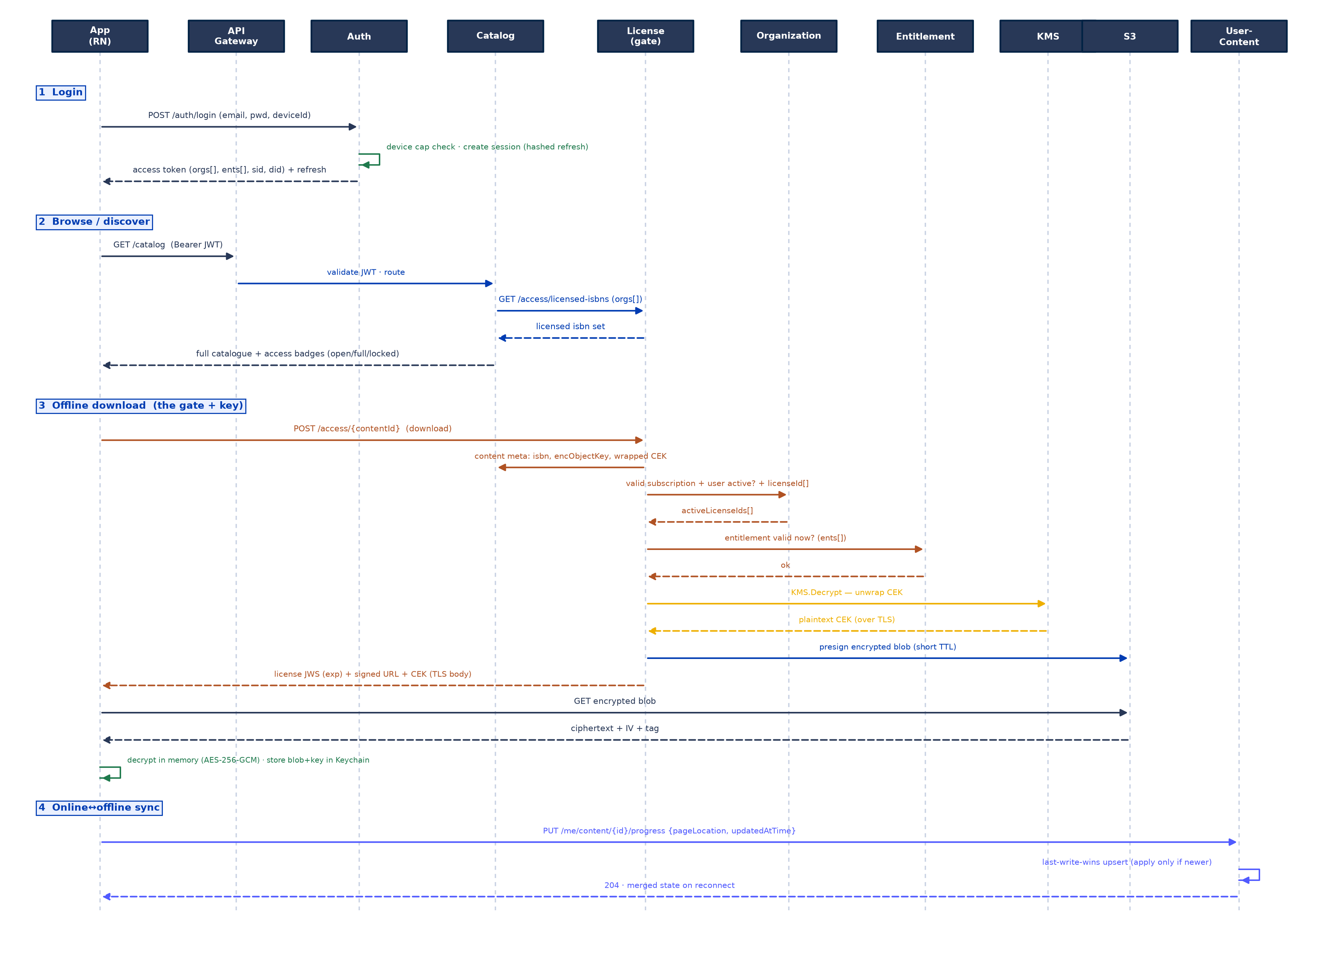
Figure 4 — UML sequence: login, browse/discover, offline download (gate + KMS unlock), and online↔offline sync.
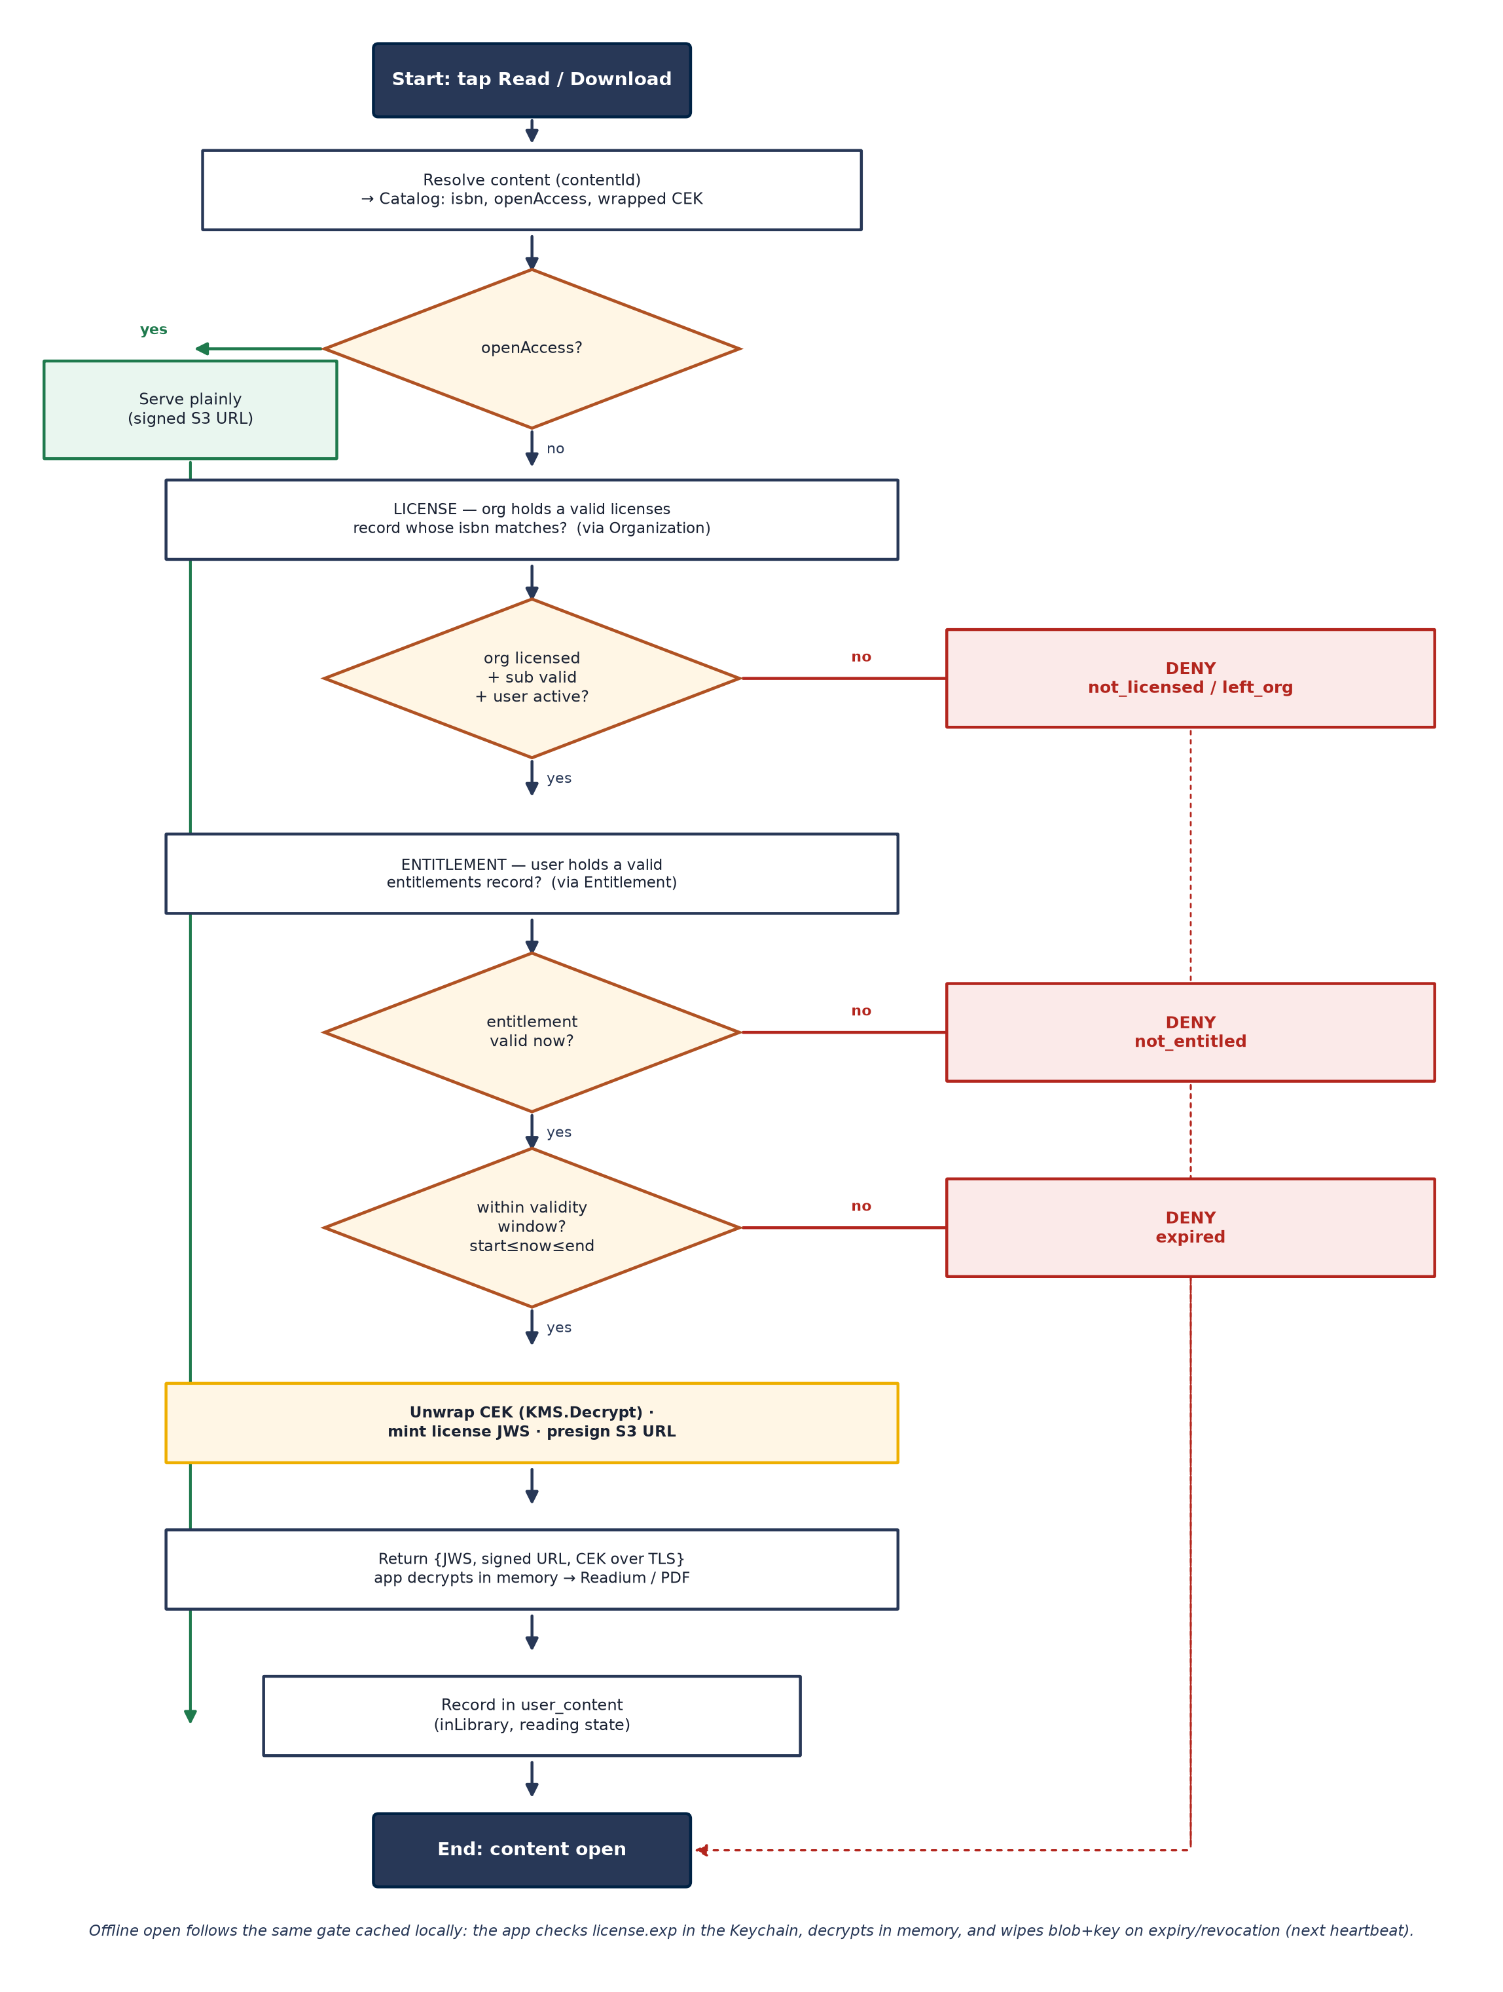
Figure 5 — UML activity: the read/download gate with its decision points and denial reasons.

12. Observability & Tracking
Tracking serves two audiences — ops (health + traffic) and the sales/business team (engagement) — using Prometheus + Grafana, woven into every service as it is built, like logging. Each service exposes `/actuator/prometheus` (Micrometer + Actuator) on an internal port; Prometheus scrapes via Eureka SD; Grafana serves an Ops dashboard and a Business/Sales dashboard.

12.1 Metrics catalog (bounded labels only)
Metric | Labels | Emitted at
http_server_requests_seconds (auto) | route, method, status, outcome | Every service (Actuator)
tf_logins_total | result (success|fail) | Auth login
tf_device_limit_hits_total | — | Auth login refused
tf_content_opened_total | contentType, openAccess | License /access (read)
tf_downloads_total | contentType | License /access (download)
tf_access_denied_total | reason (not_licensed|not_entitled|expired|left_org) | License gate — the headline demand signal
tf_reading_seconds (histogram) | — | User-Content on session end
tf_grant_provisioned_total | kind (license|entitlement) | License/Entitlement provisioning

12.2 Guardrails & boundary
- Bounded labels only — never userId / contentId / title / raw path as a label (cardinality blow-up). /actuator/prometheus is internal-only; Grafana sits behind auth.
- Metrics vs events. Prometheus holds aggregates; raw per-event detail goes to structured event logs now, ready for the roadmap Redshift + Power BI deep-BI pipeline with no app-code change.
Observability is not a phase. A service is not "done" until its metrics are emitted in the same PR as its logs. The Prometheus/Grafana platform is stood up at Week 1; each service ships its own instrumentation with the feature — so dashboards light up as services come online (see the delivery plan, §15).

13. Tech Stack
Layer | Choice
Language / framework | Java 17 · Spring Boot 3.2.x · Spring Cloud 2023.0.x
Discovery / edge / config | Spring Cloud Netflix Eureka · Spring Cloud Gateway (WebFlux) · Config Server
Service calls | Spring Cloud OpenFeign (Eureka-resolved)
Data store | MongoDB 6+ — one database per service
Auth | Access + refresh tokens (jjwt); BCrypt passwords; device-limited sessions; mocked membership
Discovery feed | OPDS 2.0 + scheduled cronjob
Content files | AWS S3 (signed-URL delivery); MinIO locally
Content protection | AES-256-GCM at rest; AWS KMS envelope encryption; key over TLS; Keychain/Keystore offline
Reading client | React Native (iOS+Android); Readium toolkit (native Fabric UI) for EPUB; react-native-pdf for PDF
Observability | Micrometer + Actuator → Prometheus (Eureka SD) → Grafana (Ops + Business)
Build / run | Maven multi-module; Docker Compose (local); CI on every PR

14. SDLC Approach

14.1 Lifecycle model
We follow Agile Scrum with one-week sprints (seven sprints = seven weeks). Weekly sprints suit a capstone: they force a demoable milestone every Friday, expose integration risk early, and let four teams re-plan quickly. Work is decomposed into vertical, demoable increments rather than horizontal layers, so every week ends with something that runs end to end.

14.2 Team structure & ownership
Four teams own durable areas so knowledge compounds and hand-offs are minimised. Ownership is chosen to balance load: backend-heavy teams start on the critical path; the smaller Auth backend is paired with app work; the reader (largest client task) is paired with DevOps so its team is productive from Week 1.
Team | Durable ownership | Primary skills
Team 1 — Platform & Access Core | Eureka, Config, Gateway, common lib; Organization, License (the gate), Entitlement | Spring Cloud, security, distributed systems
Team 2 — Content & Protection | Catalog (OPDS, cron, badges), User-Content (LWW); content-encryption ingest + KMS key delivery | Spring Boot, MongoDB, crypto, AWS
Team 3 — Auth & App Experience | Auth service (tokens, sessions, device cap); React Native app shell (nav, auth, browse, badges, sync client, manage-devices) | Spring Security, React Native, UX
Team 4 — Reader Client & Platform Eng. | Native Readium Fabric reader + react-native-pdf + offline decrypt; DevOps: Docker/CI, AWS (S3, KMS, IAM), Prometheus/Grafana | iOS/Android native, RN, DevOps, AWS

14.3 Ceremonies & cadence
- Sprint planning — Monday AM: each team pulls its week's stories from the backlog against the delivery plan.
- Daily standup — 15 min per team; a short cross-team sync (one lead each) to surface interface changes.
- Integration checkpoint — Thursday: cross-service flows are wired and smoke-tested against the shared Docker Compose stack.
- Sprint review / demo — Friday PM: each team demos its milestone increment on the running stack.
- Retro — Friday: quick what-went-well / adjust; re-balance load for the next sprint if a team finished early.

14.4 Tracking
- A shared board (Jira / GitHub Projects) with one epic per service/area and story-pointed tickets; a burndown per sprint; a visible dependency lane so a blocked story is obvious.
- Interface-first tickets. Any cross-team dependency starts with an agreed API contract (endpoint + DTO) so producer and consumer can work in parallel against a stub.

14.5 Branching, CI/CD & environments
- Trunk-based with short-lived PR branches; main is always deployable to the shared dev environment.
- CI on every PR — build + unit + slice tests + linting; a merged PR auto-deploys to dev via Docker Compose (capstone) with a path to ECS/EKS.
- Environments — local (Docker Compose + MinIO), shared dev (AWS), demo. Config differs only via the Config Server.

14.6 Testing strategy
Level | What | Tools
Unit | Grant resolution (first-qualifying-org, deny reasons), LWW comparator, JWT issue/parse, device-cap rule | JUnit 5, Mockito
Slice | Repositories + index behaviour (unique {userId,deviceId}, TTL, $addToSet no-dupes) | @DataMongoTest
Contract | License → Organization / Entitlement / Catalog Feign calls | WireMock / Spring Cloud Contract
Integration | login→refresh→logout; device-limit; open-access vs licensed vs denied gate; idempotent provisioning | Testcontainers (Mongo)
Gateway / security | No/valid/expired Bearer → 200/200/401; internal endpoints not public | Spring MVC test
Client | Auth interceptor, offline decrypt, reader progress events | Jest + Detox (E2E)
End-to-end smoke | Full loop on Docker Compose; a denied access increments the demand metric | curl / Postman + Grafana check

14.7 Definition of Done
A story is Done only when all of the following hold — this is how quality, security, AWS and observability are enforced continuously rather than deferred:
- Code merged via a reviewed PR; unit + slice tests pass in CI; the feature works on the shared dev stack.
- Metrics emitted (Micrometer counters/timers, bounded labels) and structured logs added — in the same PR.
- API documented (endpoint + DTO); relevant contract/integration test added.
- For content/crypto stories: keys via AWS KMS (or the Config-Server master key locally), never in a JWS.
- Demoable in the Friday review.

15. 7-Week Delivery Plan
Timeline note. The capstone brief frames an 8-week plan. Per the team's decision this plan delivers the same MVP in 7 one-week sprints by running platform bring-up and DevOps/AWS provisioning in parallel in Week 1 and keeping all four teams on the critical path throughout. If an 8th week is preferred, Week 7 (hardening + demo) simply splits into two.

Sequencing is dependency-aware and load-balanced: the platform trio and DevOps/AWS (quick to stand up) run in parallel in Week 1 so no team is idle; Auth finishes early and Team 3 pivots fully to the app; the reader (the largest single task) fills Team 4's Weeks 2–7. Observability ships with each feature (Definition of Done), and AWS/KMS is provisioned early (Week 1) and wired into the crypto path in Week 4.

15.1 Plan at a glance
Week | Team 1 · Platform & Access | Team 2 · Content & Protection | Team 3 · Auth & App | Team 4 · Reader & DevOps/AWS
1 | Eureka, Config, Gateway (JWT filter), common lib | Catalog scaffold + seed mock T&F + list | Auth: user + login (access token) | Docker Compose, CI, AWS (S3+KMS+IAM), Prometheus+Grafana
2 | Organization + Entitlement + internal checks | OPDS 2.0 feeds + cron; catalog detail + search | Refresh + sessions + device cap; app shell + secure storage | RN app bootstrap w/ Team 3; Readium native module spike
3 | License /access gate: open-access + License→Org | User-Content: progress/highlights/bookmarks + LWW | Browse UI + access badges + login/refresh interceptor | Readium Fabric reader (EPUB) — pagination + locator
4 | Gate: + Entitlement + deny reasons; $addToSet provisioning | Ingest-encrypt (AES-GCM) + KMS wrap; key delivery in gate | Manage-devices UI; reading-state sync client | Reader: highlights/bookmarks + progress events → sync
5 | Multi-org resolution; gate hardening + Feign timeouts | Signed-URL delivery; badge licensed-ISBN set; article access | Offline UX; download queue; deny messaging + deep-links | Offline: encrypted download + Keychain key + in-memory decrypt
6 | End-to-end gate perf + security review | PDF path (react-native-pdf temp-file handling); sync edge cases | Search UI; polish; client tests (Jest/Detox) | Offline expiry/revocation wipe + heartbeat; PDF reader
7 | Access core hardening; final integration | Data/seed polish; encryption verification | App polish; accessibility; store-build checks | Grafana Ops+Business dashboards finalised; E2E demo build

15.2 Week-by-week detail

Week 1 — Foundations & walking skeleton
Goal. Stand up the platform and the CI/AWS/observability backbone so metrics and deploys work from day one; prove a login-to-catalogue path.
- Team 1 — Platform & Access: Build Eureka, Config Server, API Gateway (stub route + JWT-validation filter) and the shared common module (JWT util, error model with denial-reason slugs).
- Team 2 — Content & Protection: Scaffold Catalog; define catalogue/article models; write the mock T&F seed loader; expose GET /catalog (badges stubbed open/locked).
- Team 3 — Auth & App: Scaffold Auth; user model + seed; POST /auth/login issuing a signed access token; protected-ping through the Gateway.
- Team 4 — Reader & DevOps/AWS: Docker Compose (Mongos, Eureka, Config, Gateway, MinIO); CI pipeline; provision AWS S3 bucket, KMS CMK, IAM roles; stand up Prometheus (Eureka SD) + Grafana (empty dashboards).
- Observability increment: Prometheus scrapes every registered service; Actuator HTTP/JVM metrics visible; tf_logins_total emitted by Auth.
- AWS increment: S3 dev bucket, KMS customer master key created, IAM roles for services — provisioned now even though local dev uses a Config-Server master key.
Demoable milestone (Fri): docker-compose up brings the whole stack up; a user logs in through the Gateway and lists the seeded catalogue; Prometheus Targets show all services UP.

Week 2 — Access foundations, auth hardening, discovery
Goal. Build the two sibling checks the gate will call, harden auth into full sessions, and turn the catalogue into real OPDS discovery.
- Team 1 — Platform & Access: Build Organization (organization, subscription, userList[]) and Entitlement (entitlements) with their internal check endpoints and $addToSet provisioning.
- Team 2 — Content & Protection: Add OPDS 2.0 feeds + refresh cronjob; GET /catalog/{id}, journal→articles, text search (Mongo text index).
- Team 3 — Auth & App: Add refresh tokens + `sessions` (hashed refresh, TTL, unique {userId,deviceId}) + device cap + manage-devices; begin the RN app shell (navigation, Keychain token storage, auth/refresh interceptor).
- Team 4 — Reader & DevOps/AWS: Build the RN bootstrap with Team 3; Readium native-module spike (compile Readium Kotlin/Swift into a bare Fabric view).
- Observability increment: tf_device_limit_hits_total, tf_active_sessions; Catalog feed-refresh counter; Business dashboard skeleton added.
- AWS increment: Confirm services read S3/KMS config from the Config Server; MinIO mirrors S3 for local runs.
Demoable milestone (Fri): Multi-device login works and a 4th device is refused (device_limit_reached); OPDS feed renders in a client; org/entitlement check endpoints return correct results on seeded data.

Week 3 — The gate (v1), reading state, and the reader
Goal. Get the access gate returning allow/deny for the license path, build reading-state persistence, and get EPUB rendering on device.
- Team 1 — Platform & Access: Build the License `/access` gate: open-access bypass first, then License → Organization (subscription + membership + licenseId[]); return allow for licensed titles.
- Team 2 — Content & Protection: Build User-Content: progress, highlights, bookmarks, downloads with the last-write-wins upsert.
- Team 3 — Auth & App: Browse UI with real access badges (Catalog → License licensed-ISBN set); wire the login/refresh interceptor end to end.
- Team 4 — Reader & DevOps/AWS: Build the Readium Fabric reader (EPUB): pagination, initial locator, theme/font props — the largest client task begins in earnest.
- Observability increment: tf_content_opened_total on the gate; tf_reading_seconds scaffold in User-Content; Ops dashboard shows gate latency.
- AWS increment: Reader loads a plain seeded EPUB from S3/MinIO (encryption arrives next week).
Demoable milestone (Fri): A member opens an open-access title and a licensed title (license check only); reading progress persists and reloads; EPUB renders in the app.

Week 4 — Full gate + AWS KMS content protection
Goal. Complete the two-check gate with denial reasons and wire real encryption + AWS KMS into the unlock path — the security core.
- Team 1 — Platform & Access: Build the ingest-encrypt job (AES-256-GCM, unique IV, AAD {contentId,userId,deviceId}); KMS-wrap the per-file CEK; store the wrapped key on the content record; return key over TLS in the gate.
- Team 2 — Content & Protection: Add License → Entitlement to the gate; finalise deny reasons (not_licensed|not_entitled|expired|left_org); $addToSet provisioning endpoints.
- Team 3 — Auth & App: Manage-devices UI; the reading-state sync client (queue + flush on reconnect).
- Team 4 — Reader & DevOps/AWS: Reader consumes the decrypted-in-memory file; wire highlights/bookmarks + debounced progress events to the sync API.
- Observability increment: tf_access_denied_total{reason} live on the Business dashboard (the demand signal); tf_downloads_total.
- AWS increment: KMS envelope encryption in the live path: ingest wraps the CEK with the KMS CMK; /access calls KMS.Decrypt to unwrap server-side and releases the CEK over TLS.
Demoable milestone (Fri): A licensed title is served encrypted and opens after the full gate; a non-member/expired user is denied with the correct reason, visible on Grafana.

Week 5 — Offline, multi-org, and delivery hardening
Goal. Make reading work fully offline and resolve access across multiple orgs; harden the gate.
- Team 1 — Platform & Access: Add signed-URL delivery + the licensed-ISBN set for badges; article access = parent journal's license.
- Team 2 — Content & Protection: Multi-org resolution (first-qualifying-org wins); gate Feign timeouts + fallbacks + per-request caching.
- Team 3 — Auth & App: Offline UX + download queue; clear `device_limit_reached` messaging deep-linking to manage-devices.
- Team 4 — Reader & DevOps/AWS: Offline download: store encrypted blob + license JWS + CEK wrapped in Keychain/Keystore; decrypt in memory on open.
- Observability increment: tf_grant_provisioned_total; alert-worthy panels (error rate, gate p95) added to Ops.
- AWS increment: Presigned-URL TTLs tuned; role/temporary credentials preferred so URLs cannot outlive the session.
Demoable milestone (Fri): A user downloads a licensed title, goes offline, and reads it; a second-org user reaches content via a different org's license.

Week 6 — PDF, sync edge cases, revocation & tests
Goal. Close the offline security loop (expiry/revocation), add the PDF path, and raise test coverage.
- Team 1 — Platform & Access: End-to-end gate performance + security review (token handling, internal-endpoint exposure, IV discipline).
- Team 2 — Content & Protection: PDF path (react-native-pdf) incl. safe temp-decrypted-file handling; sync edge cases (out-of-order, conflicting device writes).
- Team 3 — Auth & App: Search UI, polish, and client tests (Jest unit + Detox E2E for login/read/offline).
- Team 4 — Reader & DevOps/AWS: Offline expiry/revocation wipe + heartbeat (re-check grant on reconnect, wipe blob+key); PDF reader integration.
- Observability increment: Verify /api/v1/status/tsdb shows no high-cardinality blow-up; dashboards reviewed under load.
- AWS increment: S3 lifecycle + bucket policy check; KMS key-rotation/audit settings confirmed.
Demoable milestone (Fri): An expired/ revoked offline title refuses to open and wipes itself; a PDF article reads online and offline; test suites green in CI.

Week 7 — Integration, dashboards & demo
Goal. Freeze features, finish dashboards, harden, and rehearse the end-to-end demo.
- Team 1 — Platform & Access: Access-core hardening + final cross-service integration; fix any gate correctness gaps.
- Team 2 — Content & Protection: Data/seed polish; encryption verification pass (round-trip decrypt, AAD binding, tag validation).
- Team 3 — Auth & App: App polish + accessibility; iOS/Android store-build checks; final UX pass.
- Team 4 — Reader & DevOps/AWS: Finalise Grafana Ops + Business dashboards from the metrics flowing since Week 1; assemble the E2E demo build.
- Observability increment: Both dashboards complete: traffic/latency/errors + logins/opens/downloads/denials/reading-time by contentType/org.
- AWS increment: Final AWS review — least-privilege IAM, encrypted buckets, KMS key policy.
Demoable milestone (Fri): Full walkthrough: login → browse (badges) → open-access read → licensed download (KMS unlock) → offline read → denial (demand signal on Grafana) → sync across two devices.

15.3 Load balancing — no team sits idle
- Team 1's platform trio is quick, so Week 1 also delivers the common module and Gateway security filter; from Week 2 they are fully loaded on the access core (Org, Entitlement, the gate) through Week 7.
- Team 3's Auth backend completes by Week 2; the same team then owns the entire non-reader client (browse, badges, manage-devices, sync, search, polish) for Weeks 3–7 — no gap.
- Team 4 uses Week 1 for DevOps + AWS provisioning (before the reader is unblocked), then the native reader — the largest single task — fills Weeks 2–7.
- Team 2 is loaded throughout: Catalog → OPDS → User-Content → encryption/KMS → delivery/PDF → verification.
- Slack absorption. If a team finishes early, the Friday retro re-assigns from the shared backlog: reader accessibility, extra tests, dashboard panels, or seed-data realism.

16. Assumptions & Risks

16.1 Key assumptions
- Mocked T&F data. Catalogue, organisations and membership are seeded behind the real API contracts; membership is pre-seeded (organization.userList[] authoritative, user.organizationId[] convenience). No SAML/SCIM.
- Ownership by reference. organization.licenseId[] → thin licenses; user.entitlementId[] → thin entitlements; the gate window-validates. Arrays get long by design (accepted).
- Protection = AES-256-GCM + KMS-managed keys; real Readium LCP deferred. Content key over TLS, never in a JWS.
- Reading client = free Readium (native bridge is the main effort/risk); PDFs via react-native-pdf.
- First-qualifying-org wins for multi-org access; no reconciliation cron — each access re-runs the gate.

16.2 Risk register
Risk | L / I | Mitigation
Native Readium reader (Fabric) overruns — the largest client task | H / H | Owned by Team 4 from Week 2; spike in Week 2; buffer in Weeks 6–7; PDF path as fallback content
Cross-service gate latency / a slow sibling hangs reads | M / H | Per-request caching of the org check; Feign timeouts + fallbacks; gate p95 on the Ops dashboard
Whole-file decryption leaks a temp file (PDF) | M / M | Prefer in-memory; app-private OS-encrypted temp; delete on close; per-resource decryption on the roadmap
Content key mishandling (leak in a token/log) | L / H | Key only over TLS, never in a JWS or log; KMS envelope encryption; security review Week 6
Mock data diverges from real T&F shapes | M / M | Seed behind the real API contracts; OPDS ingest + internal checks are the only swap points
Device-cap race (two simultaneous new-device logins) | L / M | Unique {userId,deviceId} index + tight count+insert; block-on-exceed, no auto-eviction
High-cardinality metrics blow up Prometheus | L / M | Bounded labels only; metric_relabel_configs drop rule; tsdb series check Week 6
7-week compression leaves no slack | M / M | Parallel Week 1; weekly demoable milestones; retro re-balancing; Week 7 splits to 8 if needed

17. MVP ↔ PRD Mapping
MVP piece | PRD concept
License (licenses{isbn,…} held via organization.licenseId[]) | Concurrent-seat license + AES/JWT content key — 'what is licensed'
Entitlement (entitlements held via user.entitlementId[]; active in userList[]) | Institutional + subscription entitlement — 'who you are'
Gate at read/download; open-access bypass | Access badges (Full / Preview / Open) + access-status behaviour
Access + refresh tokens; device-limited sessions | Auth/session layer (PRD adds SAML/OIDC); device cap = account-sharing control
Organization (University | Library) | institutionId multitenancy / tenant isolation
OPDS cronjob | Weekly OPDS feed refresh
AES-GCM + AWS KMS unlock (open-access plain); Readium LCP later | AES-encrypted content + JWT license tokens (PRD DRM); LCP as production option
Readium toolkit (free) for reading | Readium SDK reading experience (EPUB, TTS, search, accessibility)
user_content (progress/notes/downloads) | Offline-first reading, annotation, sync
Prometheus + Grafana (aggregate KPIs) | Analytics / demand signals; Redshift + Power BI deep BI (roadmap)

18. Glossary
License — A thin content-license record ({isbn,start,end,openAccess}, no userId/orgId) referenced by organization.licenseId[], plus the unlock token the License service mints.
Entitlement — A thin validity record ({start,end}) referenced by user.entitlementId[]; the user must also be active in the org's userList[].
Open access — Content readable by any logged-in user, served plainly, no gate.
Organization — A University or Library — the licensee/tenant; userList[] is the authoritative roster.
OPDS — Open Publication Distribution System — the open catalogue-feed standard the Catalog service exposes (2.0).
CEK / KEK — Content Encryption Key (per file) / Key Encryption Key (master key in AWS KMS that wraps every CEK).
Readium toolkit — The free, open-source (BSD-3) reading toolkit for EPUB — brings TTS, search, highlights, fonts, accessibility.
Readium LCP — Readium's paid DRM (EDRLab agreement + liblcp); not used in the MVP — our License layer stands in.
Device limit — At most N active sessions per account (default 3); a login beyond the cap is refused until a device signs out.
Last-write-wins — Sync rule: a reading-state write applies only if newer than the stored updatedAtTime.

Sources & companion specifications
APPROACH.md — engineering approach: architecture, services, data model, access flow, PRD mapping.
CONTEXT.md — decision rationale and the full clarification history.
ENCRYPTION.md — fact-backed content-encryption & key-delivery design (AES-256-GCM, KMS, JWS/JWE, LCP comparison).
IMPLEMENTATION.md — REST APIs per service + Spring Cloud build patterns (JWT/gateway, sessions, $addToSet, OPDS, tests).
OBSERVABILITY.md — Prometheus + Grafana metrics plan (ops + aggregate business KPIs).
TF_KnowledgeHub_PRD_v1.pdf — the full product vision (superset of the MVP).
README.md — The Palace Project / OPDS architectural inspiration.

