Coursework Four Results by mlo08

Mean vector for HepatitisC.txt:

[ 1.1638756 3.91626794 0.44796651 5.67882775 4.86543062 3.77811005

4.12739234 3.60406699 0.21650718]

Covaraince matrix for HepatitisC.txt:

[[ 5.87977145e+00 2.44729254e-01 -4.03520225e-03 -2.84260206e-01

-3.45977253e-01 -4.17236477e-01 -4.81092461e-01 -2.67213856e-01

-6.72190105e-02]

[ 2.44729254e-01 7.57168014e+00 7.34382472e-02 -3.57848064e-01

-3.45804735e-01 2.57292284e-01 2.27279170e+00 9.45882333e-01

-3.15314154e-02]

[ -4.03520225e-03 7.34382472e-02 2.47440506e-01 -1.15764204e-01

-3.90230616e-02 -3.47362408e-03 9.96906846e-02 6.61602799e-02

-5.48406679e-03]

[ -2.84260206e-01 -3.57848064e-01 -1.15764204e-01 1.69602217e+01

7.96872307e+00 4.44275589e+00 -1.03625991e+00 -3.06173566e-01

4.68368367e-02]

[ -3.45977253e-01 -3.45804735e-01 -3.90230616e-02 7.96872307e+00

8.36069533e+00 4.92105013e+00 -7.62619224e-01 -7.52294990e-01

-7.69530322e-04]

[ -4.17236477e-01 2.57292284e-01 -3.47362408e-03 4.44275589e+00

4.92105013e+00 6.68263245e+00 -8.72157033e-02 -3.75757719e-01

-1.41038802e-01]

[ -4.81092461e-01 2.27279170e+00 9.96906846e-02 -1.03625991e+00

-7.62619224e-01 -8.72157033e-02 2.05828040e+01 1.12168386e+00

1.36947764e-02]

[ -2.67213856e-01 9.45882333e-01 6.61602799e-02 -3.06173566e-01

-7.52294990e-01 -3.75757719e-01 1.12168386e+00 4.31711092e+00

1.19286506e-01]

[ -6.72190105e-02 -3.15314154e-02 -5.48406679e-03 4.68368367e-02

-7.69530322e-04 -1.41038802e-01 1.36947764e-02 1.19286506e-01

1.69733334e-01]]

Components magnitudes for c.pgm:

1206.254 -1590.133 -248.136 -821.249 246.009 -771.900 963.633 376.967 161.599 -533.276

Eigenface images from 4.3:

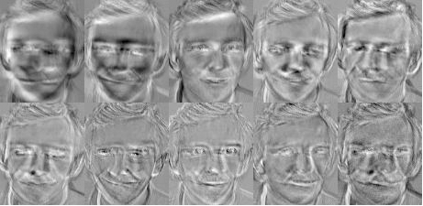

Reconstructions of c.pgm from 4.5:

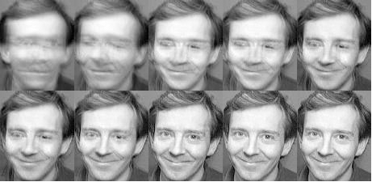

Eigendace images from 4.6:

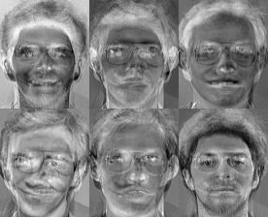

Reconstructions of c.pgm from 4.6:

