CPE 487 Midterm Exam (100 Points)

Due: October 18, 12:30pm

Signed **Alex Gaskins**  Date **10/17/2022**

**Part1:** By hands only

1. 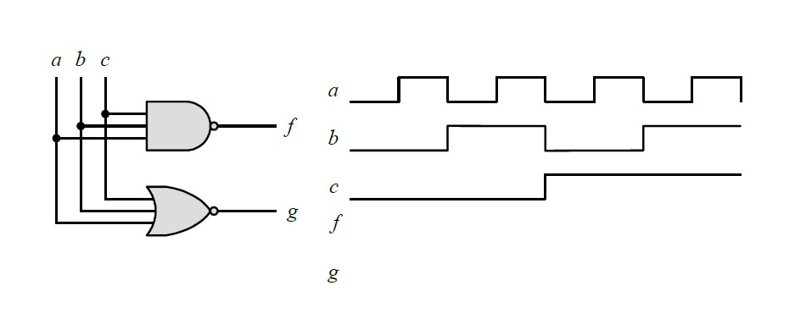Complete the timing diagram of the following circuit by adding the timing trace for **f** and **g**:

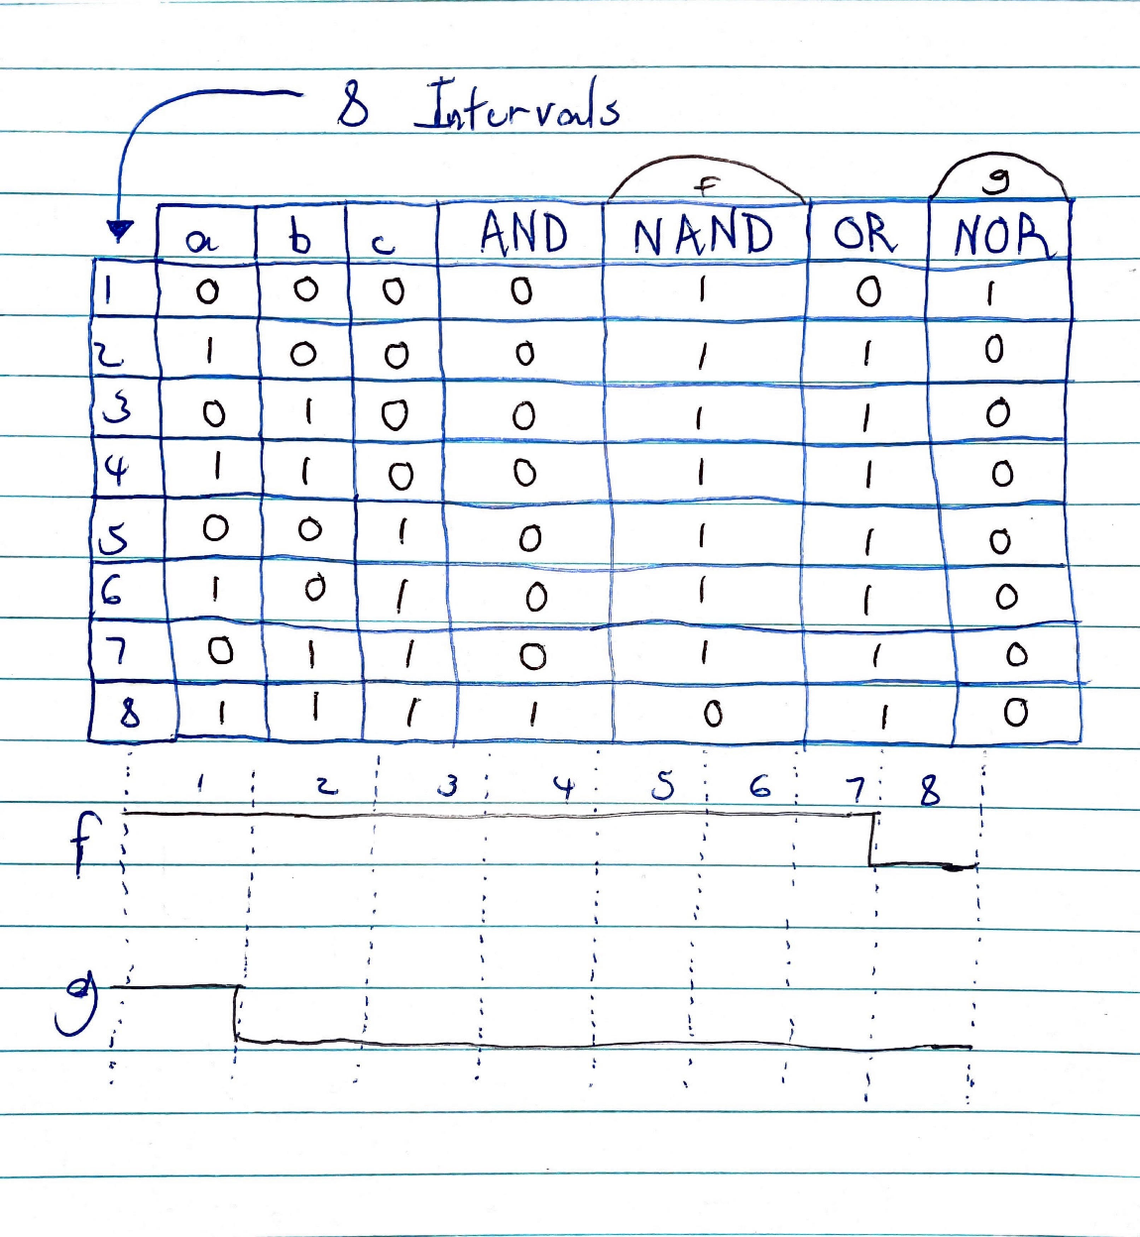

1. Write Boolean expression for the following circuits:

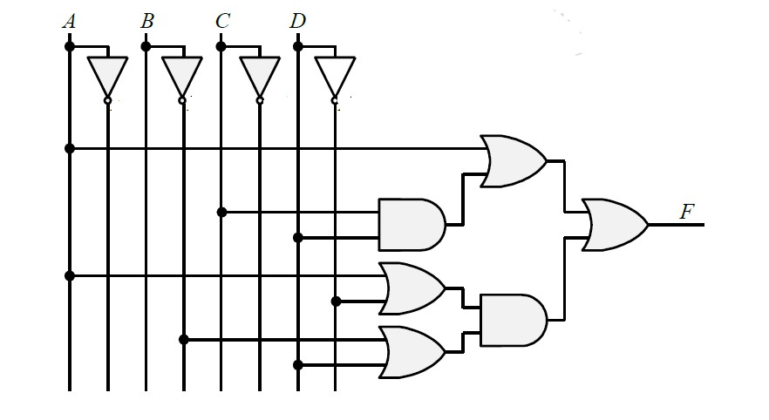

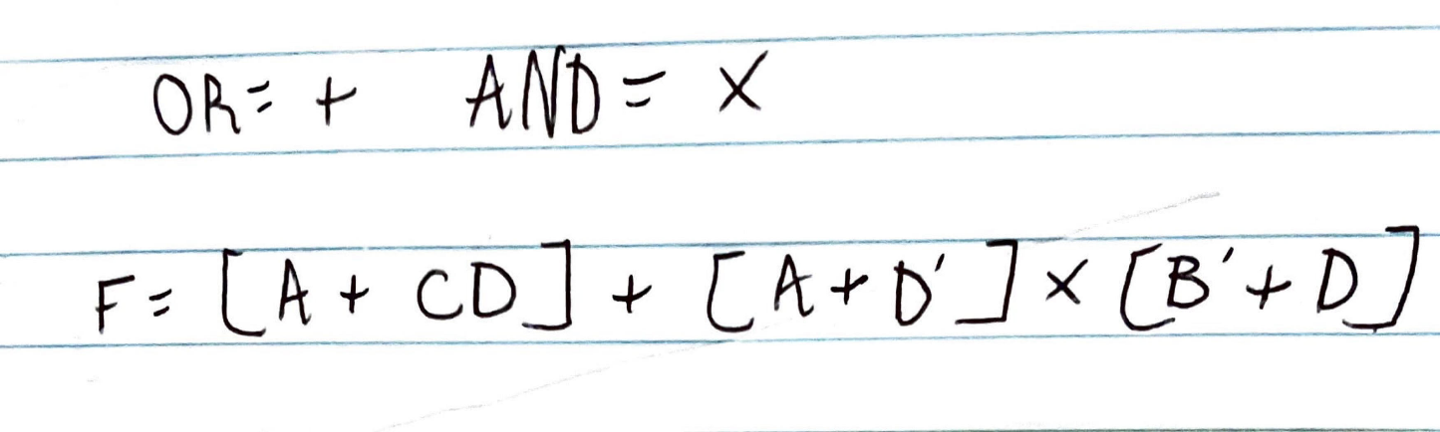

1. Draw the logic diagram corresponding to the following Boolean expression:

(AB + A’B’)(CD’ + C’D)

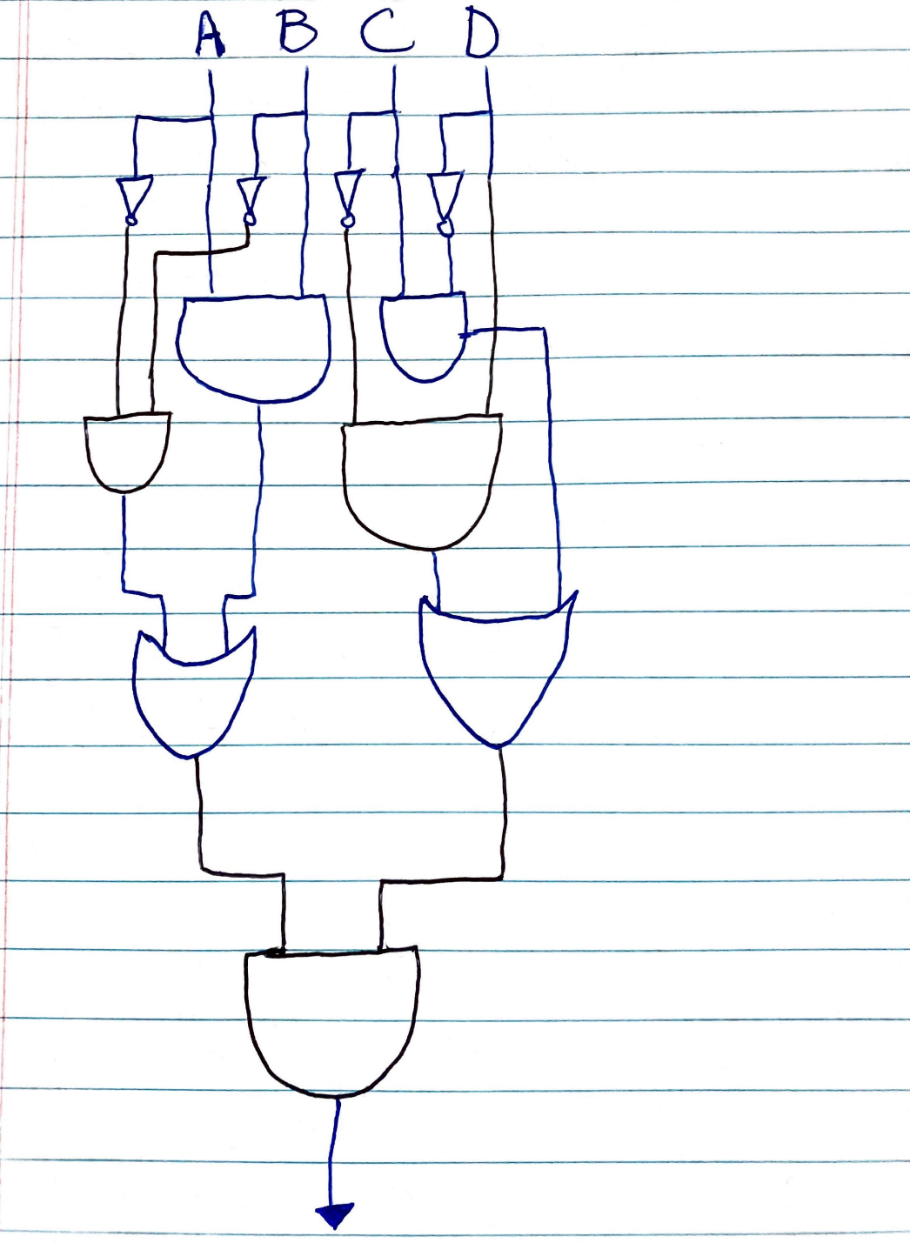

**Part 2:** Using Vivado

1. Use Vivado to write VHDL gate-level description encoder circuit shown below

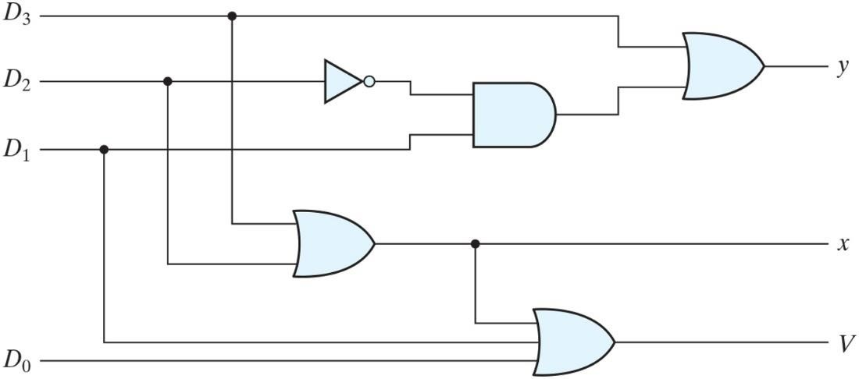

**Code:**

Library ieee;

use ieee.std_logic_1164.all;

entity encoder is

port(D3,D2,D1,D0:in bit; y,x,v:out bit);

end encoder;

architecture logic of encoder is

begin

y<= D3 or((not(D2) and D1);  
x<= D3 or D2;

v<= D3 or D2 or D1 or D0;

end logic;

**

1. Write behavioral (testbench) description of a four-input encoder circuit shown in #4, above.

**Code:**

LIBRARY ieee;

USE ieee.std_logic_1164.ALL;

ENTITY Testbench_encoder IS

END Testbench_encoder;

ARCHITECTURE behavior OF Testbench_encoder IS

COMPONENT MidTerm

PORT(

D3 : IN std_logic;

D2 : IN std_logic;

D1 : IN std_logic;

D0 : IN std_logic;

y : OUT std_logic;

x : OUT std_logic;

v : OUT std_logic );

END COMPONENT;

signal D3 : std_logic := '0';

signal D2 : std_logic := '0';

signal D1 : std_logic := '0';

signal D0 : std_logic := '0';

signal y : std_logic;

signal x : std_logic;

signal v : std_logic;

BEGIN

uut: MidTerm

PORT MAP ( D3 => D3, D2 => D2, D1 => D1, D0 => D0, y => y, x => x, v => v );

process stim_proc: process begin

wait for 100 ns;

D3 <= '1'; D2 <= '0'; D1 <= '0'; D0 <= '1'; wait for 10 ns;

D3 <= '1'; D2 <= '1'; D1 <= '1'; D0 <= '1'; wait for 10 ns;

D3 <= '0'; D2 <= '1'; D1 <= '1'; D0 <= '0'; wait for 10 ns;

D3 <= '1'; D2 <= '1'; D1 <= '0'; D0 <= '1'; wait for 10 ns;

D3 <= '1'; D2 <= '0'; D1 <= '1'; D0 <= '1'; wait for 10 ns;

D3 <= '0'; D2 <= '0'; D1 <= '0'; D0 <= '1'; wait for 10 ns;

D3 <= '0'; D2 <= '0'; D1 <= '0'; D0 <= '0'; wait for 10 ns;

end process;

END; Top of Form

**Output in Vivado:**

