Stevens Institute of Technology

**Department of Electrical and Computer Engineering**

**Spring Semester 2022**

**CPE 462 Introduction to Image Processing**

Homework 1: Due Feb. 10.

* 1. Determine if **y[n]=3x[n]+7** is linear? time-invariant?

**Linearity:**

**y1[n]=3x1[n]+7**

**y2[n]=3x2[n]+7**

**T{ax1[n]+bx2[n]} = 3(ax1[n]+bx2[n])+7**

**aT{x1[n]}+bT{x2[n]} = (3ax1[n]+7a)+(3bx2[n]+7b)**

**T{ax1[n]+bx2[n]} ≠ aT{x1[n]}+bT{x2[n]}**

**∴Non-Linear**

**Time-Invariance:**

**x1[n] = x[n-n0], then y1[n] = T{x[n-n0]} = y[n-n0]**

**3x[n]+7 = 3x[n-n0]+7**

**∴Time-Invariant**

* 1. Prove that convolution is commutative, i.e. **x[n]*h[n]=h[n]*x[n].**

**y[n] = ∑-∞∞(x[k]h[n-k])**

**x[n]*h[n] = ­­-∞∞∫(x[k]h[n-k])dk**

**Let l=n-k**

**x[n]*h[n] = -[­­-∞∞∫(x[n-l]h[l])dl] = -∞∞∫(h[l]h[n-l])dl = h[n]*x[n]**

1.3.1 Calculate the 1-D convolution **x[n]*h[n]** using graphic approach, provide necessary intermediate steps.



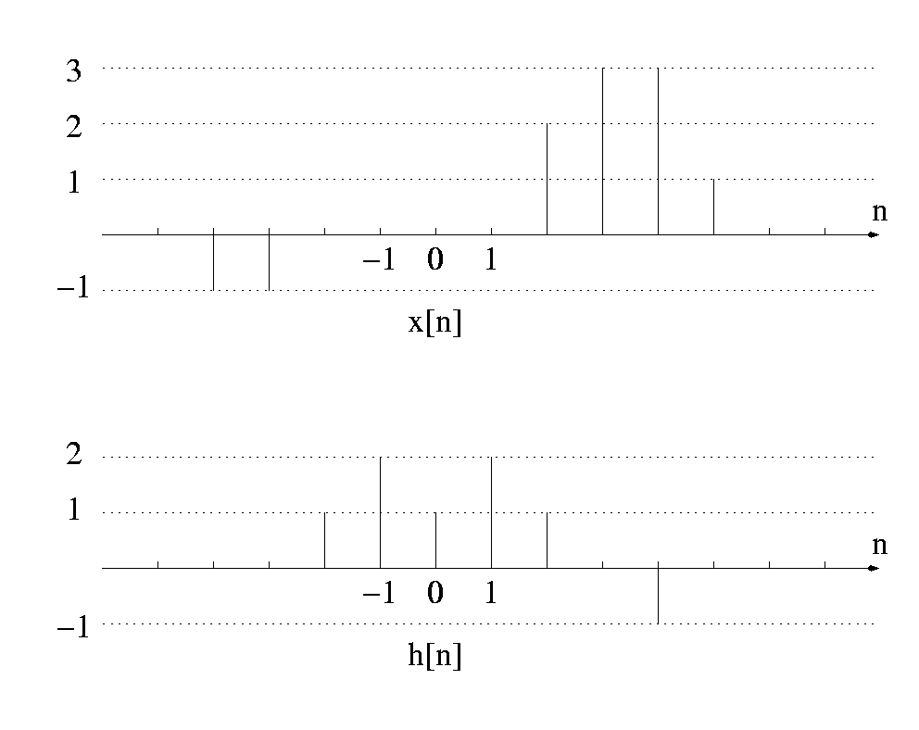



**1(-1) = -1 , 2(-1)+1(-1) = -3 , 1(-1)+2(-1)+1(0) = -3 , 2(-1)+1(-1)+2(0)+1(0) = -3 , 1(-1)+2(-1)+1(0)+2(0)+1(0) = -3 ,**

**0(-1)+1(-1)+2(0)+1(0)+2(0)+1(0) = -1 , -1(-1)+0(-1)+1(0)+2(0)+1(0)+2(0)+1(2) = 3 , -1(-1)+0(0)+1(0)+2(0)+1(0)+2(2)+1(3) = 8 ,**

**-1(0)+0(0)+1(0)+2(0)+1(2)+2(3)+1(3) = 11 , -1(0)+0(0)+1(0)+2(2)+1(3)+2(3)+1(1) = 14 , -1(0)+0(0)+1(2)+2(3)+1(3)+2(1) = 13 ,**

**-1(0)+0(2)+1(3)+2(3)+1(1) = 10 , -1(2)+0(3)+1(3)+2(1) = 3 , -1(3)+0(3)+1(1) = -2 , -1(3)+0(1) = -3 , -1(1) = -1**

**y[n] = {-1, -3, -3, -3, -3, -1, 3, 8, 11, 14, 13, 10, 3, -2, -3, -1}**

1.3.2 Confirm your results using MATLAB conv function. Show your steps by saving your script using diary command or some screen shots. (Use help to find more about conv and diary in MATLAB.)

