Introduction:

The goal of this assignment was to observe the sun’s movement through the sky in real-time and compare its properties to a [simulation](https://ccnmtl.github.io/astro-simulations/sun-motion-simulator/) that provides a theoretical trajectory of the sun’s motion with respect to my latitude. To do this, I used my iPhone XR to record a set of images with the sun in the sky, where each image was taken 10 minutes apart from one another. The landscape in each image remained the same, with the purpose of analyzing how the sun moved over the time that the photos were taken. The images were combined into a gif that shows how the position of the sun changed quite significantly in just one hour. Using the online simulation, the sun’s theoretical path was observed at my respective latitude and date, with the goal being to validate the sun’s movement that was found from the images that were taken.

Simulation Results:

6 a.m. 12 p.m. 6 p.m.

These results were recorded for my latitude in Hoboken, NJ, which is at approximately 40.8ºN. The season was winter, with the date being February 14. From the simulation, it was shown that the sun was situated in the East at 6 a.m., directly overhead at 12 p.m., and in the West at 6 p.m. This data shows that the sun is moving in the sky from East to West, as the Earth is spinning counterclockwise, with the East being the first area to gain exposure to incoming sunlight as a result.

Actual Observation:

For the experimental phase of this analysis, 6 different photos of the sun in the same surrounding landscape were taken. Each photo was taken about 10 minutes apart, while the camera remained situated in the same position for the entirety of the capturing time.

The camera used was an iPhone XR 12MP Wide Camera resting upon a windowsill against my loft bed. Similar to the simulation, my respective latitude was approximately 40.8ºN. The date was February 14, 2022. The season was winter, so the sun was not as strong in my local sky. The camera was facing Southwest, which meant East was to the left and West was to the right.

As seen from the images captured below, the sun moved from left to right as time commenced, which shows that the sun was moving from East to West in the sky. Thus, validating what was shown in the simulation.

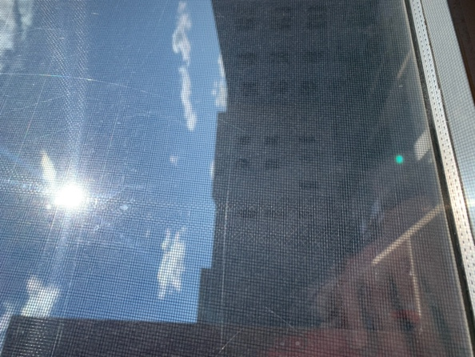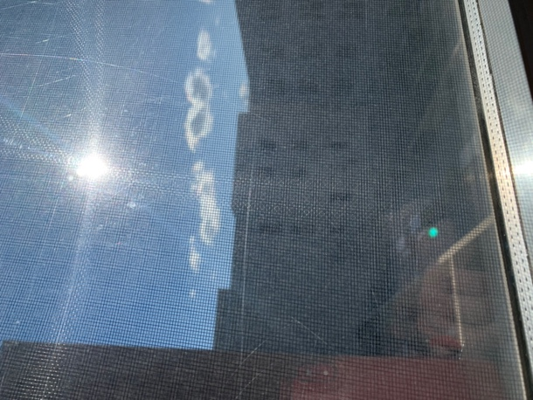

02/14/2022 @ 14:09:40 02/14/2022 @ 14:25:26 02/14/2022 @ 14:33:43

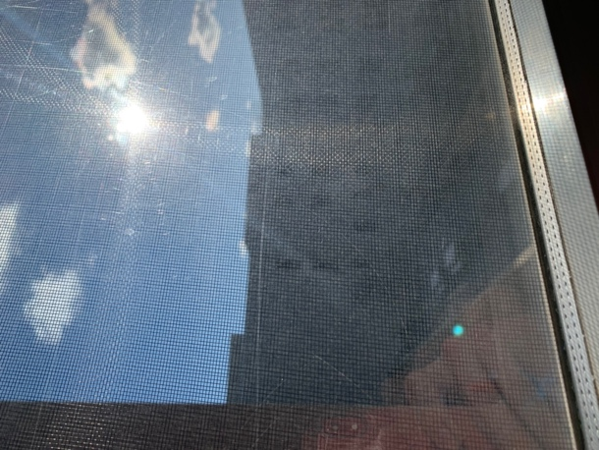

02/14/2022 @ 14:42:06 02/14/2022 @ 14:56:51 02/14/2022 @ 15:15:29

**Gif of sun moving Real Position shown in Simulation**

 