Introduction:

The goal of this assignment was to observe the moon’s movement through the sky in real-time and compare its properties to a [simulation](https://ccnmtl.github.io/astro-simulations/lunar-phase-simulator/) that provides a theoretical estimation of the moon’s phase with respect to the position of the sun. To do this, I used my iPhone XR to record a set of images with the moon in the sky, where each image was taken 10 minutes apart from one another. The landscape in each image remained the same, with the purpose of analyzing how the moon moved over the time that the photos were taken. The images were combined into a gif that shows how the position of the moon changed quite significantly in just one hour. Using the online simulation, the moon’s phase was observed at my respective position and date, with the goal being to validate the moon’s phase and movement that was found from the images that were taken.

**Part 1: The Moon**

Actual Observation:

For the experimental phase of this analysis, 6 different photos of the moon in the same surrounding landscape were taken. Each photo was taken about 10 minutes apart, while the camera remained situated in the same position for the entirety of the capturing time.

The camera used was an iPhone XR 12MP Wide Camera resting upon a music stand I had set up in my father’s backyard. The date was March 16, 2022. The camera was facing somewhat Southeast, which meant East was to the left, and Northwest was behind me slightly to the right.

As seen from the images captured below, the moon moved in an angled trajectory overhead, traveling somewhat Southeast toward the Northwest.

**GIF of the Moon Moving**

All Images Taken on March 16, 2022

20:08:34 20:17:48

20:27:09 20:37:14

20:47:35 20:57:40

Simulation Results:

These results were recorded for my time in Lancaster, PA (Lat: 40.049880 Long: -76.292790), at around 20:30. The season was winter, with the date being March 16. I observed a full moon from my father’s backyard, which meant that the entirety of the moon’s visible face (from Earth’s perspective) was being illuminated by the sun’s rays. To further analyze this, the simulation showed that the sun’s rays were positioned directly perpendicular to the moon’s face. It also confirmed the direction that I had observed the moon traveling in, from Southeast to Northwest.

Extra Credit:

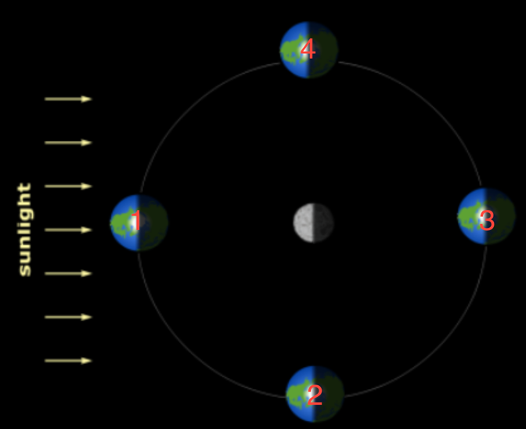

Now let’s consider a scenario in which the roles of the moon and the Earth are switch. As seen from the above image, the Earth is orbiting the moon, with the moon remaining in the center of the contraption.

When viewing the moon from Earth, the following lunar phases would be observed:

**1: 2: 3: 4:**

 

Full Moon First Quarter New Moon Third Quarter

From this, we see that despite the change in roles of the two celestial bodies, the phases that can be viewed because of the sun’s rays remain the same since the position of the sun does not change.

**Part 2: Stars**

Double Click the Thumbnail Below to Watch the Video

As seen in the video, I estimated the angle of the North Celestial Pole with respect to my location to be approximately 45º. As we know, the altitude of the celestial pole in my local sky is equal to the latitude of my location. In Long Island, NY, my approximate latitude was 40.789º. This resulted in a percent error of 10.32%, which is not bad considering all I used was my fist.