**PEP 151 Homework 1**

Problem 1 (2 points).

Explain If there’d still be seasons on Earth,

1. if Earth’s axis has no tilt and is perfectly perpendicular to the ecliptic plane.

**If the axis of Earth was not tilted, and instead perpendicular to the ecliptic plane, there would not be seasons on Earth. Were there no tilt along the Earth’s axis, its hemispheres would always be the same distance from the sun. As a result, there would not be a change in sun exposure in different locations throughout the year, instead having uniform climates all over the Earth.**

1. if Earth’s axis is in the ecliptic plane.

**If the Earth were tilted 90º, placing its axis in the ecliptic plane, it would be almost inhabitable due to the harsh seasons. However, instead of having four seasons like we do with a 23.5º angle, there would only be two seasons with respect to the Earth’s orbit around the sun. Each half of the Earth would either experience a harsh summer or winter cold depending on where the sunlight is directed. Also, a day would last an entire year at one end of the Earth, while the other end would never see daylight. Due to the consistent exposure or lack of exposure to sunlight depending on which end of the Earth you are on, temperatures would be too extreme for most life, besides maybe bacteria and some microorganisms.**

Problem 2 (2 points).

The Sun is about 27,000 light-years away from the center of our own galaxy.

1. use the definition of light-year, i.e. distance light travels in a year, to convert the Sun’s distance from the galactic center from light-years to km.

**Using the fact that light travels at approximately 300000000 meters/second, it can be converted to kilometers/second by simply dividing by 1000, yielding 300000 kilometers/second. Since there are [60min•60sec/min] = 3600 seconds in an hour, this value can be multiplied by 300000 to give us 1080000000 kilometers/hour. We know that there are approximately 24 hours in a day, and 365 days a year, allowing us to find the speed of light per year by multiplying (24)(365)(1080000000), giving us 9460800000000 kilometers per year. Using the distance in kilometers that light travels in a year, the distance of 27000 light years can be obtained by multiplying 9460800000000 by 27000, resulting in a distance of 255441600000000000 kilometers.**

1. use your answer in a) and the fact that 1AU = 1.5e8 km to figure out how far the Sun is from the galactic center in AU. (i.e. can think of it roughly as how many Sun-Earth system can be packed in between)

**After finding the distance between the Sun and the galactic center to be 255441600000000000 kilometers, this can be converted to AU by dividing by 150000000, resulting in a distance of 1702944000 AU.**

Problem 3 (2 points).

For a neutron star whose density is 5e17 kg/m3,

1. what would the mass of 1 teaspoon’s worth of the material from that neutron star be? You can assume the volume of a standard teaspoon to be 5e-6 m3.

**The mass is proportional to the product of the density and given volume: (5e17)•(5e-6) = 25e11 kg.**

1. how many empire state buildings (3.3e8 kg) would that be?

**Given that the mass in a teaspoon is 25e11 kg: (25e11)/(3.3e8) = 7575.75 empire state buildings.**

Problem 4 (4 points).

In class we learned the difference between keeping track of time relative to distant stars and relative to the Sun, e.g. sidereal day vs. solar day. A tropical year has 365.2422 solar days and 366.2422 sidereal days.

1. What is the length of one sidereal day in terms of solar days?

**Given that there are 365.2422 solar days and 366.2422 sidereal days in a year, one sidereal day equates to 365.2422/366.2422 = 0.9973 solar days.**

1. If we know the average solar day is 24 hours, use your answer in a) to figure out the length of one sidereal day in terms of hours, minutes and seconds (in the format hh:mm:ss).

**Knowing that the average solar day is 24 hours: 24 = x/0.9973, x=23.9352hr. 60•0.9352=56.112min. 60•0.112=6.72sec. Thus, yielding 23:56:07 for a sidereal day.**

1. Hypothetically, as part of a project to show Jupiter’s apparent motion relative to distant stars, you took a first photo of Jupiter one night at 9:00:00 pm. You want to take a second photo **the very next night** and have all the ***distant stars*** show up at the same positions in your photo as the night before (with exactly the same camera position and orientation), at what time (in the format hh:mm:ss) should you take the second photo?

**Knowing 23:56:07 for a sidereal day, if a photo were taken at 21:00 of Jupiter with the desire of keeping the location of the distant stars the same, 23:56:07 would have to pass, making the time 08:56:07 p.m.**

Problem 5 (5 points).

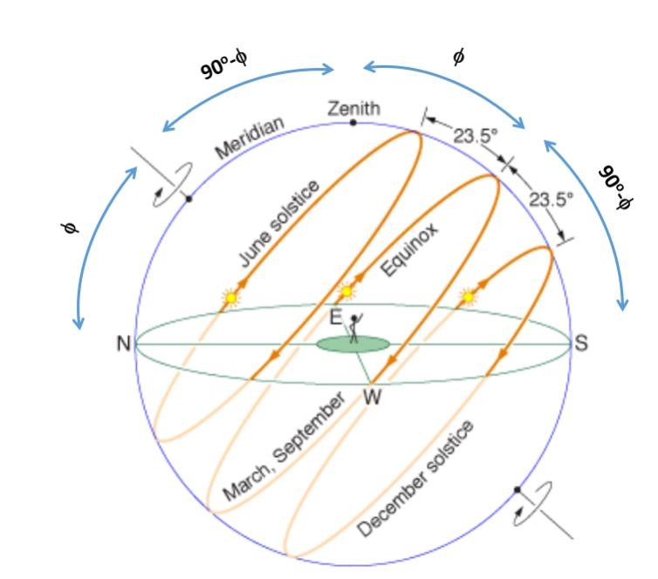

With the help of the diagram above, answer the following for the location of Hoboken (latitude φ = 41 deg):

1. What is the angle between the zenith and the north celestial pole?

**An individual’s latitude is the altitude of their respective celestial pole, so in Hoboken (Northern Hemisphere), the North Celestial Pole is at an angle of 41º, and zenith is always at an angle of 90º. Thus, the angle between zenith and the NCP is 49º in Hoboken.**

1. On the day of June solstice, when the sun is the highest in your local sky, what is the angle between the sun and the zenith?

**On the day of the June solstice, the sun is located 23.5º above the equator at its highest point (noon). At solar noon, the zenith angle is at a minimum and is equal to latitude minus solar declination angle, which is at its max on the summer solstice, at 23.5º. Thus, at a latitude of 41ºN, the zenith angle is 41 - 23.5 = 17.5º.**

1. On the day of March equinox, when the sun is the highest in your local sky, what is the angle between the sun and the zenith?

**The sun runs along the celestial equator during the March equinox, resulting in the zenith angle being equal to the latitude at solar noon, which means the angle in Hoboken would be 41º.**

Problem 6 (2 points).

1. What is so special about Polaris? Is it because it’s the brightest star in the sky? If your answer is no, then explain why else Polaris is special.

**Polaris as we know it today in the 21st century is special, but not because it is the brightest star in the sky. It is situated at the North Celestial Pole (NCP), with Earth’s axis pointing directly at it. While it will not be situated there forever, it allows for us to easily keep track of where North is, simply by following Polaris.**

1. Was our north pole pointed at Polaris 13000 years ago? If not, sketch out the orientation of the north pole relative to Polaris today and 13000 years ago.

**No, the axis of rotation wobbles over time, causing it to point in different directions on different time intervals. Roughly 13,000 years ago, Vega was the north star, and in about 13,000 years, it will once again be the north star.**

Problem 7 (1 point).

Do lunar eclipses happen every single month? Explain your answer.

**No, a lunar eclipse occurs when the Moon enters the Earth's shadow. They do not happen every month because the Earth's orbit around the sun is not in the same plane as the Moon's orbit around the Earth.**