



***Software Engineering Lab File***

**HOSPITAL MANAGEMENT SYSTEM**

**Name : Abhishek Tyagi**

**E. No. : EN18CS301009**

**Class : CS-A**

**Batch : A1**

**Guided By : Ms. Sakshi Yadav**

**INDEX**

|  |  |  |
| --- | --- | --- |
| S No. | Name Of Experiment | Page No. |
| 1. | Study of UML Tools { Free and Licensed } | 2-8 |
| 2. | Types of UML Diagram | 9-10 |
| 3. | Case Study  - Problem Statement  - Objective | 11-12 |
| 4. | UML Diagrams  - Use Case Diagram  - Activity Diagram  - ER Diagram  - Sequence Diagram  - Class + Object Diagram  - State Diagram | 12-25 |

**m**

**Study of UML Tools (Free and Licensed)**

**UML :**

The Unified Modeling Language (UML) is a general-purpose, developmental, modeling language in the field of software engineering that is intended to provide a standard way to visualize the design of a system

It clearly represents the working of any hardware/ software system. There are numerous tools, both commercial and open-source, which are available for designing UML diagrams, are enlisted below:

**1. StarUML**



StarUML is an open-source software modeling tool, which is provided by MKLab. It has come up with eleven different types of modeling diagrams. It also supports UML2.0 specified diagrams.

**Features:**

* It let you create Object, Use case, Deployment, Sequence, Collaboration, Activity, and Profile diagrams.
* It is a UML 2.x standard compliant.
* It offers multiplatform support (MacOS, Windows, and Linux).

**2. Umbrello**



Umbrello is a Unified Modeling language tool, which is based on KDE technology. It supports both reverse engineering and code generation for C++ and Java.

**Features:**

* It implements both structural and behavioral diagrams.
* It imports C++ and can export up to a wider range of languages.

**3. Altova**



Altova has provided UModel, which is another UML software modeling tool. It supports all types of 14 UML2 diagrams as well as SysML for the embedded systems. It also holds up for business process modeling for enterprise analysts. It generates visually designed software models by incorporating Java, C++, and C #or Visual Basic .NET.

**Features:**

* It provides a dedicated toolbar for an individual diagram.
* It offers unlimited undo/redo, which inspires to discover new ideas.
* In UML diagrams, you can easily add a hyperlink to any element.
* It also provides an intuitive color-coding, icons, customized alignment grid, and cascading styles for colors, fonts line size.

**4. Visual Paradigm**

A visual Paradigm is a tool that supports SysML, UML2, and Business Process Modeling Notation from Object Management Group. It involves report generation as well as code generation.



**Features:**

* It supports all of the 14 UML2 diagrams.
* It supports BPMN 2.0, ERD, ORMD, SysML.

**5. Draw.IO**



Draw.io is an open-source modeling tool to create flowcharts, process diagrams, UML, ER, and network diagrams.

**Features:**

* Since it is very easy to use, it provides an intuitive interface, drag& drop functionality, a huge amount of templates, and also, it does not need to install.
* It offers security and reliability.
* It can be used anywhere, both online and offline.
* It is compatible with every browser.

**6. GenMyModel**



GenMyModel began as a UML tool but, today It is expanded to cover also business modeling with Archimate and BPMN support. It offers a centralized model repository which allows easy and simultaneously models collaboration.

**Features:**

* Share your knowledge with versioning and access right management.
* Useful for presentations to management and project stakeholders.
* Helps you to combines the power of desktop modeling tools with a modern web solution.
* Allows you to directly import or export as PDF documents.

**Types of UML Diagrams**

**1. Use Case Diagrams**

As the most known diagram type of the behavioral UML types, Use case diagrams give a graphic overview of the actors involved in a system, different functions needed by those actors and how these different functions interact. It’s a great starting point for any project discussion because you can easily identify the main actors involved and the main processes of the system. You can create use case diagrams using our tool and/or get started instantly using our use case templates.

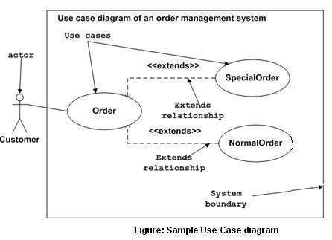

**2. Activity Diagram**

Activity diagrams represent workflows in a graphical way. They can be used to describe the business workflow or the operational workflow of any component in a system. Sometimes activity diagrams are used as an alternative to State machine diagrams.

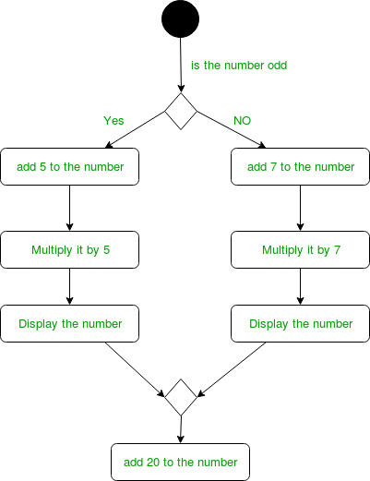

**3. E-R Diagrams**

An Entity–relationship model (ER model) describes the structure of a database with the help of a diagram, which is known as Entity Relationship Diagram (ER Diagram). An ER model is a design or

blueprint of a database that can later be implemented as a database. The main components of E-R model are: entity set and relationship set.

An ER diagram shows the relationship among entity sets. An entity set is a group of similar entities and these entities can have attributes. In terms of DBMS, an entity is a table or attribute of a table in database, so by showing relationship among tables and their attributes, ER diagram shows the complete logical structure of a database. Lets have a look at a simple ER diagram to understand this concept.

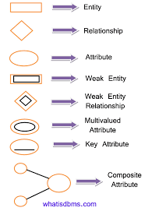

**4. Sequence Diagram**

Sequence diagrams in UML show how objects interact with each other and the order those interactions occur. It’s important to note that they show the interactions for a particular scenario. The processes are represented vertically and interactions are shown as arrows.

Template for sequence diagrams can be seen below :

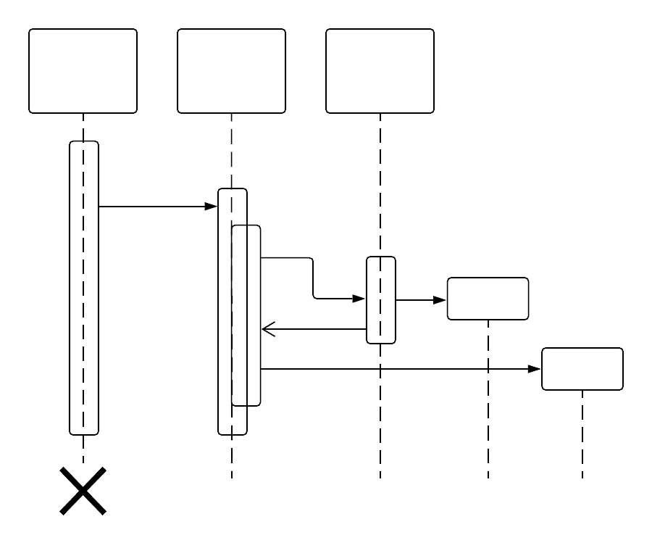

**5. Object Diagram**

Object Diagrams, sometimes referred to as Instance diagrams are very similar to class diagrams. Like class diagrams, they also show the relationship between objects but they use real-world examples. They show how a system will look like at a given time. Because there is data available in the objects, they are used to explain complex relationships between objects.

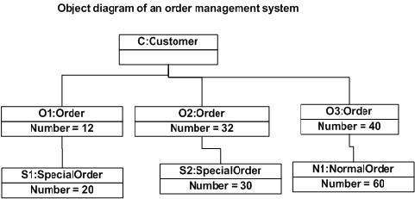

**6. Class Diagram**

Class diagrams are the main building block of any object-oriented

solution. It shows the classes in a system, attributes, and operations of each class and the relationship between each class.

In most modeling tools, a class has three parts. Name at the top,

attributes in the middle and operations or methods at the bottom. In a large system with many related classes, classes are grouped together to create class diagrams. Different relationships between classes are shown by different types of arrows.

Below is an image of a class diagram. Follow the link below for more class diagram examples or get started instantly with our class diagram templates.

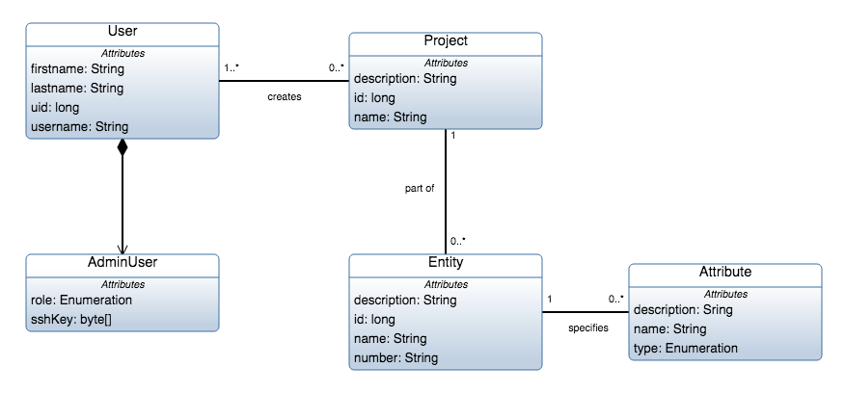**7. State Machine Diagram**

State machine diagrams are similar to activity diagrams, although

notations and usage change a bit. They are sometimes known as state diagrams or state chart diagrams as well. These are very useful to describe the behavior of objects that act differently according to the state they are in at the moment. The State machine diagram below shows the basic states and actions.

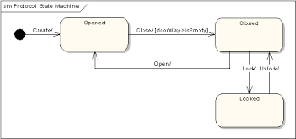

**CASE STUDY**

**HOSPITAL MANAGEMENT SYSTEM**



Medicaps hospital is a multi speciality hospital that includes a number of departments, rooms, doctors, nurses, compounders, and other staff working in the hospital along with Receptionist. Patients having different kinds of ailments come to the hospital and get checkup done from the concerned doctors. If required they are admitted in the hospital and discharged after treatment.

The aim of this case study is to design and develop a System Design for the hospital to maintain the records of various departments, rooms, and doctors in the hospital. It also maintains records of the regular patients, patients admitted in the hospital, the check up of patients done by the doctors, the patients that have been operated, and patients discharge.

**PROBLEM STATEMENT :**

To simplify the above use case into vairous UML Diagrams, aiding the developmental and creative aspects of coding the application into real life as an application of the matters studied earlier.

**OBJECTIVES :**

To develop UML diagrams specifically :

* Use Case Diagrams
* Activity Diagrams
* E-R Diagrams
* Sequence Diagrams
* Class Diagrams and Object Diagrams
* State Diagrams

**Use Case Diagram**

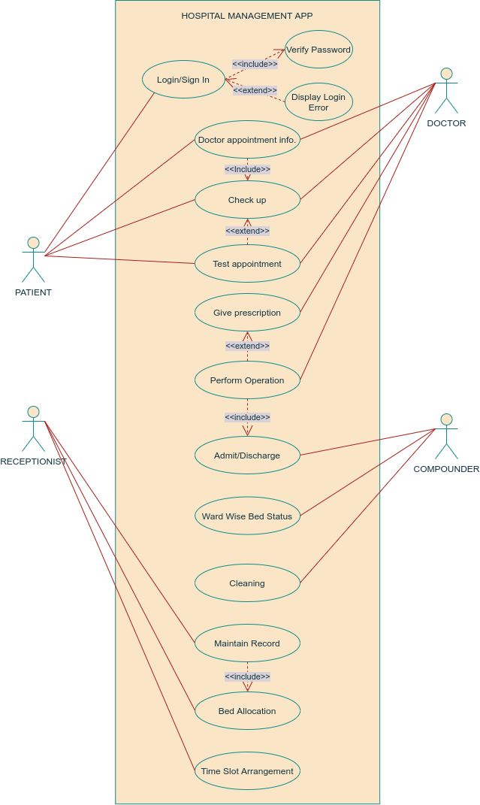

**Activity Diagram**

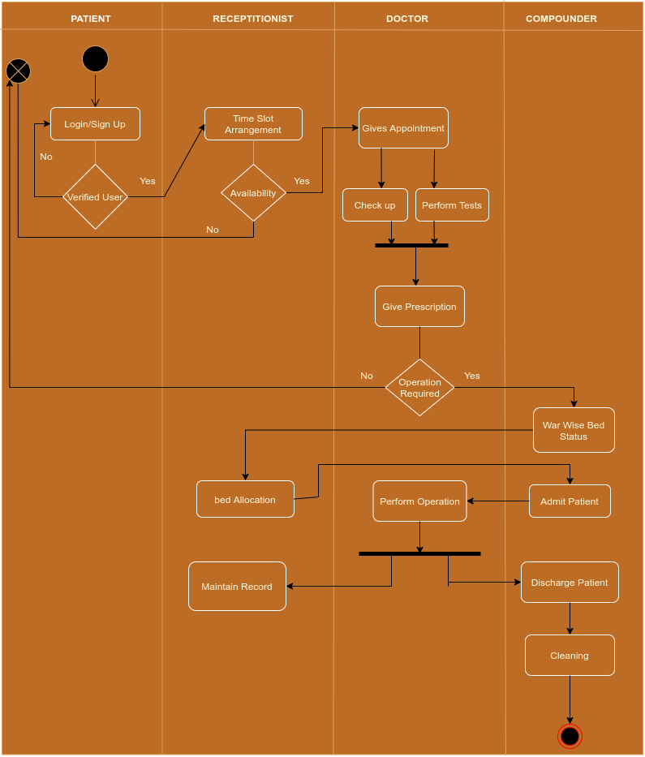

**E-R Diagram**

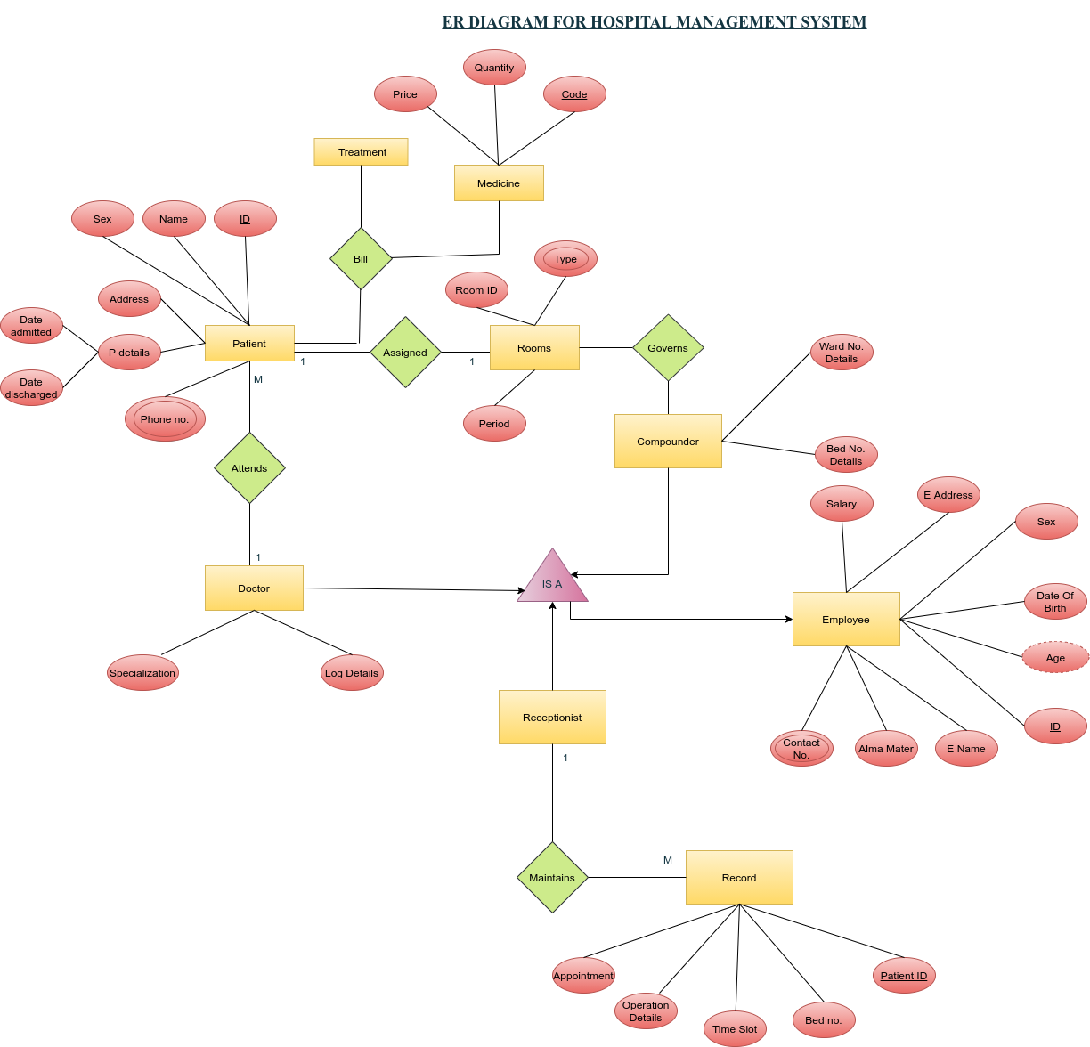

**Sequence Diagrams >>**

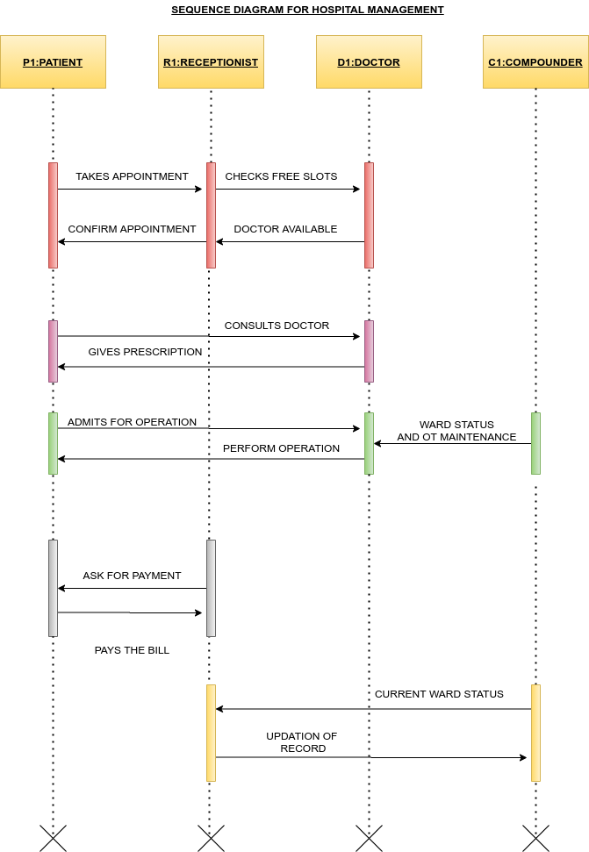

**Class Diagram**

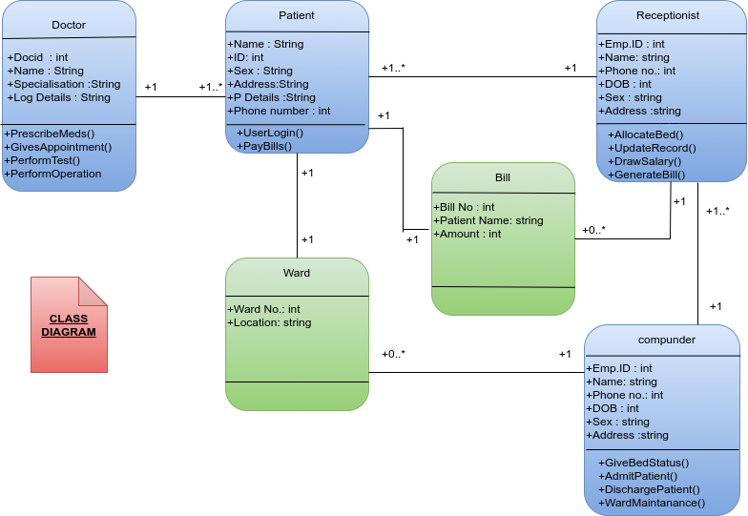

**Object Diagram**

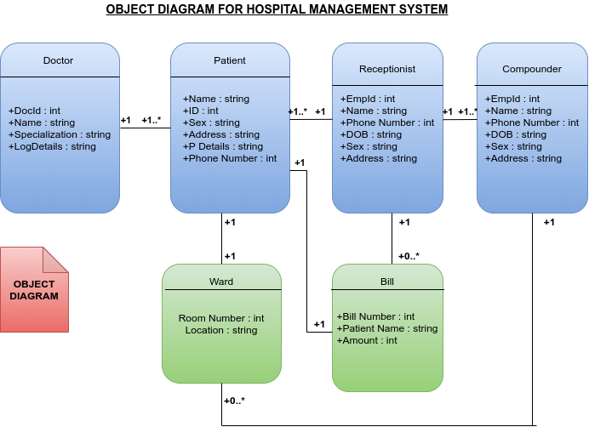

**State Diagram For Patient and Doctor**

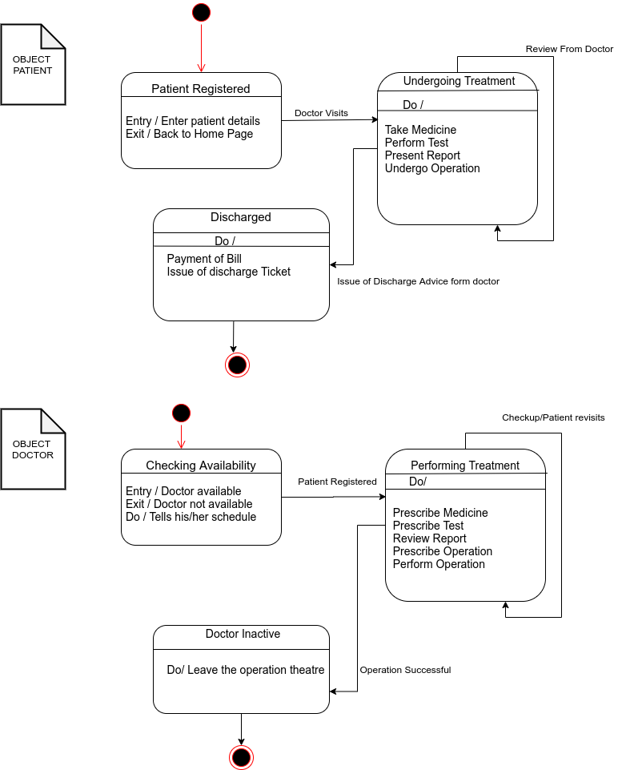**State Diagram for Receptionist**

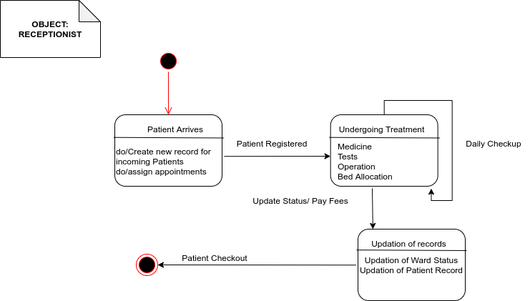

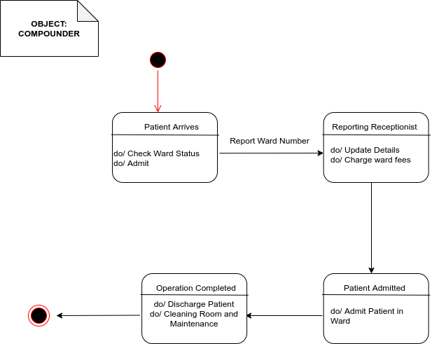**State Diagram for Compounder**