**SDLC(Software Development Life Cycle)**

Software Development Life Cycle (SDLC) is a process used by the software industry to design, develop and test high quality softwares. The SDLC aims to produce a high-quality software that meets or exceeds customer expectations, reaches completion within times and cost estimates.

* SDLC is the acronym of Software Development Life Cycle.
* It is also called as Software Development Process.
* SDLC is a framework defining tasks performed at each step in the software development process.
* ISO/IEC 12207 is an international standard for software life-cycle processes. It aims to be the standard that defines all the tasks required for developing and maintaining software.

**What is SDLC?**

SDLC is a process followed for a software project, within a software organization. It consists of a detailed plan describing how to develop, maintain, replace and alter or enhance specific software. The life cycle defines a methodology for improving the quality of software and the overall development process.

The following figure is a graphical representation of the various stages of a typical SDLC.

**Planning and Requirement Analysis**

**Defining Requirements**

**Maintenance**

**Designing the Product Architecture**

**Deployment in the Market**

**Testing the Product**

**Building or Developing the Product**

A typical Software Development Life Cycle consists of the following stages −

**Stage 1: Planning and Requirement Analysis**

Requirement analysis is the most important and fundamental stage in SDLC. It is performed by the senior members of the team with inputs from the customer, the sales department, market surveys and domain experts in the industry. This information is then used to plan the basic project approach and to conduct product feasibility study in the economical, operational and technical areas.

Planning for the quality assurance requirements and identification of the risks associated with the project is also done in the planning stage. The outcome of the technical feasibility study is to define the various technical approaches that can be followed to implement the project successfully with minimum risks.

**Stage 2: Defining Requirements**

Once the requirement analysis is done the next step is to clearly define and document the product requirements and get them approved from the customer or the market analysts. This is done through an **SRS (Software Requirement Specification)** document which consists of all the product requirements to be designed and developed during the project life cycle.

**Stage 3: Designing the Product Architecture**

SRS is the reference for product architects to come out with the best architecture for the product to be developed. Based on the requirements specified in SRS, usually more than one design approach for the product architecture is proposed and documented in a DDS - Design Document Specification.

This DDS is reviewed by all the important stakeholders and based on various parameters as risk assessment, product robustness, design modularity, budget and time constraints, the best design approach is selected for the product.

A design approach clearly defines all the architectural modules of the product along with its communication and data flow representation with the external and third party modules (if any). The internal design of all the modules of the proposed architecture should be clearly defined with the minutest of the details in DDS.

**Stage 4: Building or Developing the Product**

In this stage of SDLC the actual development starts and the product is built. The programming code is generated as per DDS during this stage. If the design is performed in a detailed and organized manner, code generation can be accomplished without much hassle.

Developers must follow the coding guidelines defined by their organization and programming tools like compilers, interpreters, debuggers, etc. are used to generate the code. Different high level programming languages such as C, C++, Pascal, Java and PHP are used for coding. The programming language is chosen with respect to the type of software being developed.

**Stage 5: Testing the Product**

This stage is usually a subset of all the stages as in the modern SDLC models, the testing activities are mostly involved in all the stages of SDLC. However, this stage refers to the testing only stage of the product where product defects are reported, tracked, fixed and retested, until the product reaches the quality standards defined in the SRS.

**Stage 6: Deployment in the Market**

Once the product is tested and ready to be deployed it is released formally in the appropriate market. Sometimes product deployment happens in stages as per the business strategy of that organization. The product may first be released in a limited segment and tested in the real business environment (UAT- User acceptance testing).

**Stage7: Maintenance**

Then based on the feedback, the product may be released as it is or with suggested enhancements in the targeting market segment. After the product is released in the market, its maintenance is done for the existing customer base.

**SDLC Models**

There are various software development life cycle models defined and designed which are followed during the software development process. These models are also referred as Software Development Process Models". Each process model follows a Series of steps unique to its type to ensure success in the process of software development.

Following are the most important and popular SDLC models followed in the industry −

* Waterfall Model
* Iterative Model
* Spiral Model
* V-Model
* Big Bang Model

Other related methodologies are Agile Model, RAD Model, Rapid Application Development and Prototyping Models.

The Waterfall Model was the first Process Model to be introduced. It is also referred to as a **linear-sequential life cycle model**. It is very simple to understand and use. In a waterfall model, each phase must be completed before the next phase can begin and there is no overlapping in the phases.

The Waterfall model is the earliest SDLC approach that was used for software development.

The waterfall Model illustrates the software development process in a linear sequential flow. This means that any phase in the development process begins only if the previous phase is complete. In this waterfall model, the phases do not overlap.

**Waterfall Model – Design:-**

Waterfall approach was first SDLC Model to be used widely in Software Engineering to ensure success of the project. In "The Waterfall" approach, the whole process of software development is divided into separate phases. In this Waterfall model, typically, the outcome of one phase acts as the input for the next phase sequentially.

The following illustration is a representation of the different phases of the Waterfall Model.

* **Requirement Gathering and analysis** − All possible requirements of the system to be developed are captured in this phase and documented in a requirement specification document.
* **System Design** − The requirement specifications from first phase are studied in this phase and the system design is prepared. This system design helps in specifying hardware and system requirements and helps in defining the overall system architecture.
* **Implementation** − With inputs from the system design, the system is first developed in small programs called units, which are integrated in the next phase. Each unit is developed and tested for its functionality, which is referred to as Unit Testing.
* **Integration and Testing** − All the units developed in the implementation phase are integrated into a system after testing of each unit. Post integration the entire system is tested for any faults and failures.
* **Deployment of system** − Once the functional and non-functional testing is done; the product is deployed in the customer environment or released into the market.
* **Maintenance** − There are some issues which come up in the client environment. To fix those issues, patches are released. Also to enhance the product some better versions are released. Maintenance is done to deliver these changes in the customer environment.

**Iterative Model – Design:-**

Iterative process starts with a simple implementation of a subset of the software requirements and iteratively enhances the evolving versions until the full system is implemented. At each iteration, design modifications are made and new functional capabilities are added. The basic idea behind this method is to develop a system through repeated cycles (iterative) and in smaller portions at a time (incremental).

The following illustration is a representation of the Iterative and Incremental model

Build-1

Build-2

Requirements

Build-3

Iterative and Incremental development is a combination of both iterative design or iterative method and incremental build model for development. "During software development, more than one iteration of the software development cycle may be in progress at the same time." This process may be described as an "evolutionary acquisition" or "incremental build" approach."

In this incremental model, the whole requirement is divided into various builds. During each iteration, the development module goes through the requirements, design, implementation and testing phases. Each subsequent release of the module adds function to the previous release. The process continues till the complete system is ready as per the requirement.The key to a successful use of an iterative software development lifecycle is rigorous validation of requirements, and verification & testing of each version of the software against those requirements within each cycle of the model. As the software evolves through successive cycles, tests must be repeated and extended to verify each version of the software.

**Spiral Model – Design:-**

The spiral model has four phases. A software project repeatedly passes through these phases in iterations called Spirals. The Design phase starts with the conceptual design in the baseline spiral and involves architectural design, logical design of modules, physical product design and the final design in the subsequent spirals

**Evaluation**

**Cost**

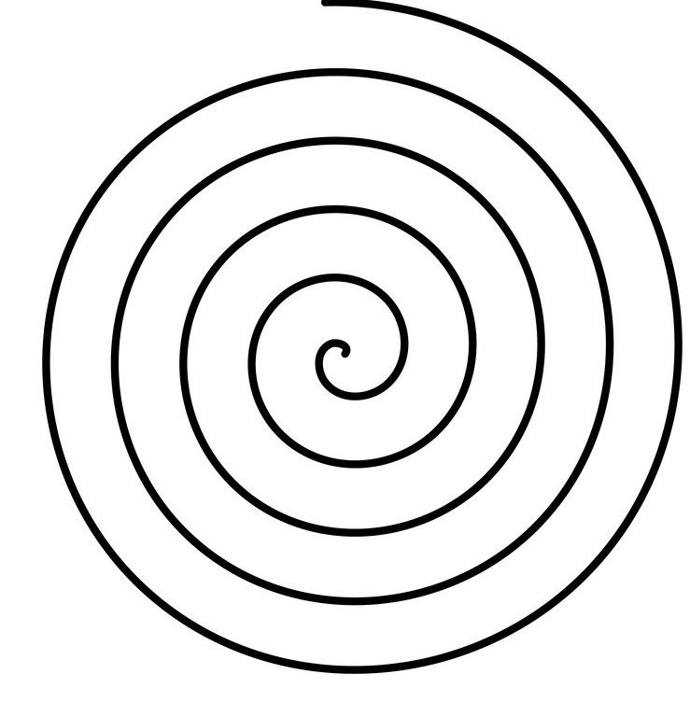

**Release**

**Implementation**

**Test**

**Integration**

**Code**

**Design**

**Prototypes**

**Risk Management**

**Product Development**

**Next Phase Planning**

**Object Identfication**

**Review**

**Each cycle in the spiral is divided into four parts:**

**Objective setting:** Each cycle in the spiral starts with the identification of purpose for that cycle, the various alternatives that are possible for achieving the targets, and the constraints that exists.

**Risk Assessment and reduction:** The next phase in the cycle is to calculate these various alternatives based on the goals and constraints. The focus of evaluation in this stage is located on the risk perception for the project.

**Development and validation:** The next phase is to develop strategies that resolve uncertainties and risks. This process may include activities such as benchmarking, simulation, and prototyping.

**Planning:** Finally, the next step is planned. The project is reviewed, and a choice made whether to continue with a further period of the spiral. If it is determined to keep, plans are drawn up for the next step of the project.

The development phase depends on the remaining risks. For example, if performance or user-interface risks are treated more essential than the program development risks, the next phase may be an evolutionary development that includes developing a more detailed prototype for solving the risks. The **risk-driven** feature of the spiral model allows it to accommodate any mixture of a specification-oriented, prototype-oriented, simulation-oriented, or another type of approach. An essential element of the model is that each period of the spiral is completed by a review that includes all the products developed during that cycle, including plans for the next cycle. The spiral model works for development as well as enhancement projects.

**Big Bang Model:-**

In this model, developers do not follow any specific process. Development begins with the necessary funds and efforts in the form of inputs. And the result may or may not be as per the customer's requirement, because in this model, even the customer requirements are not defined.

This model is ideal for small projects like academic projects or practical projects. One or two developers can work together on this model.

**……………...Release**

**BIG BANG**

**Time**

**Resources**

**Effort**