Week 6 - ECS Fargate Deployment

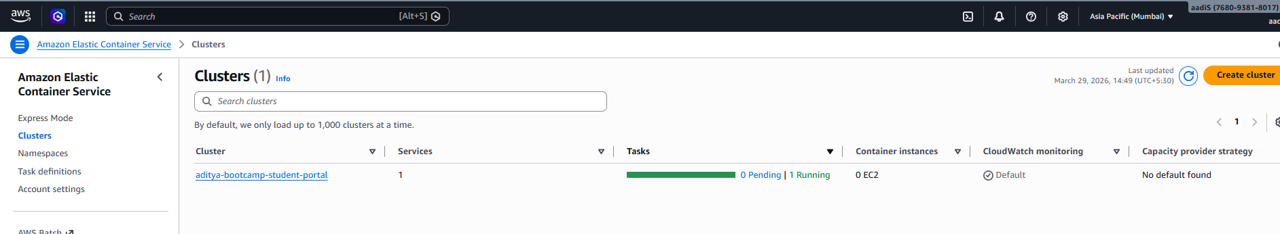
ECS Cluster - aditya-bootcamp-student-portal running

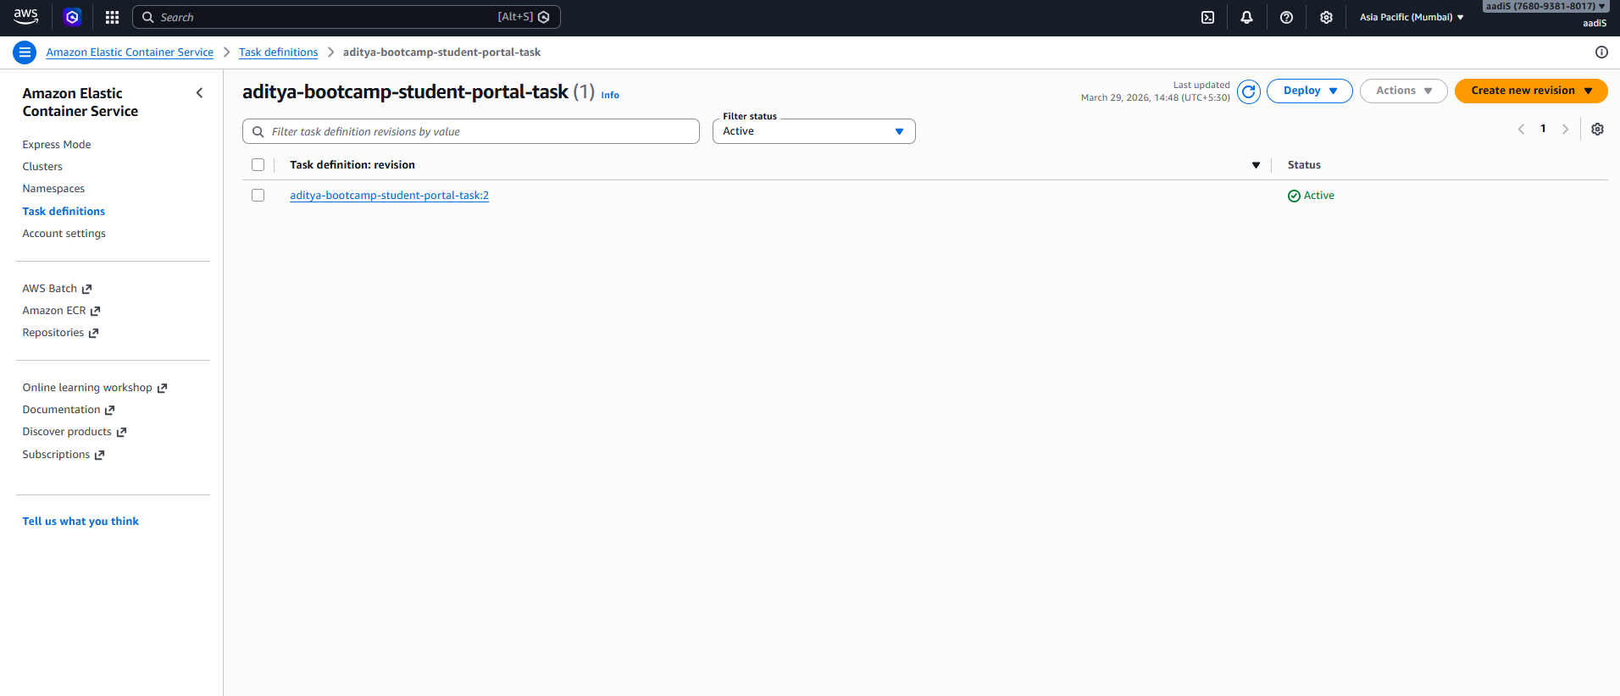
ECS Task Definitions

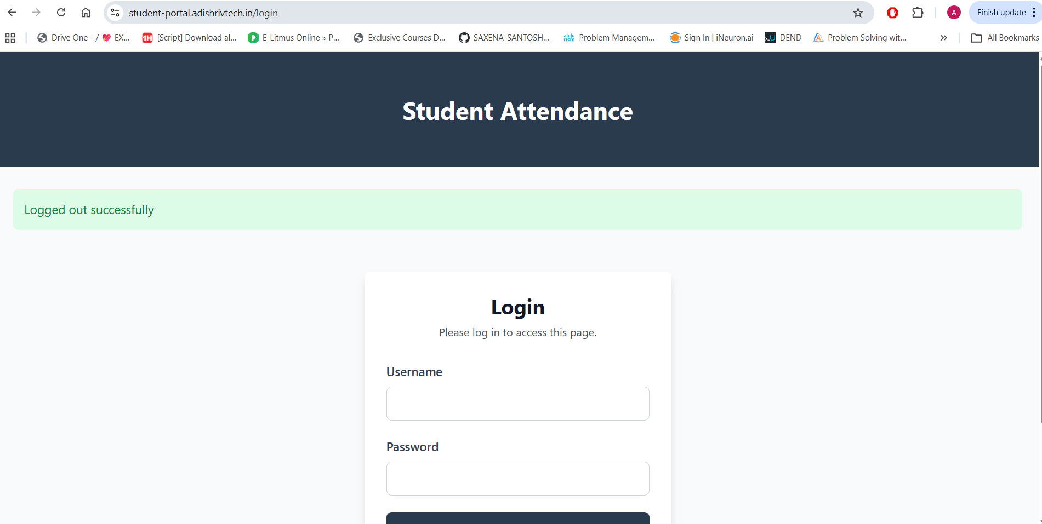
Student Attendance App - Login Page

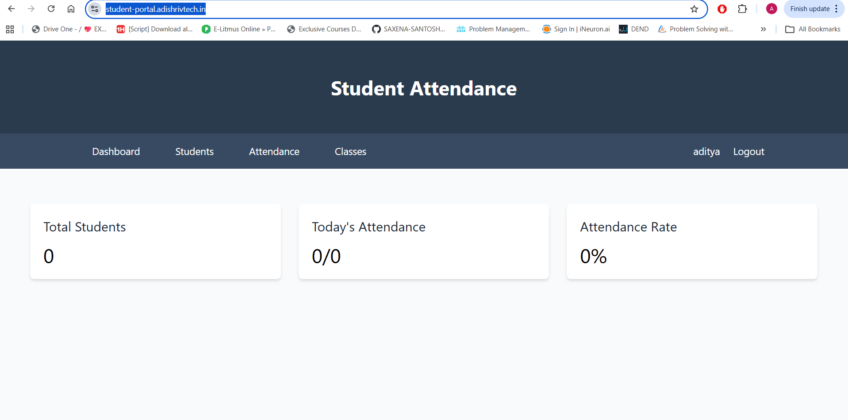
Student Attendance App - Dashboard

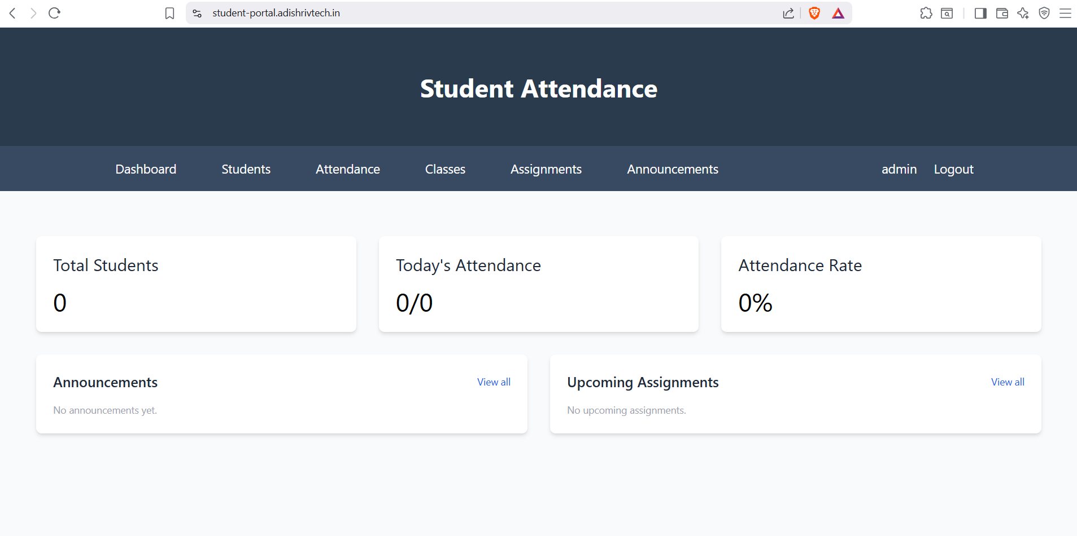
DevOps Learning Platform - Topics Dashboard

Week 8 - 2 Tier App using GitHub CI/CD

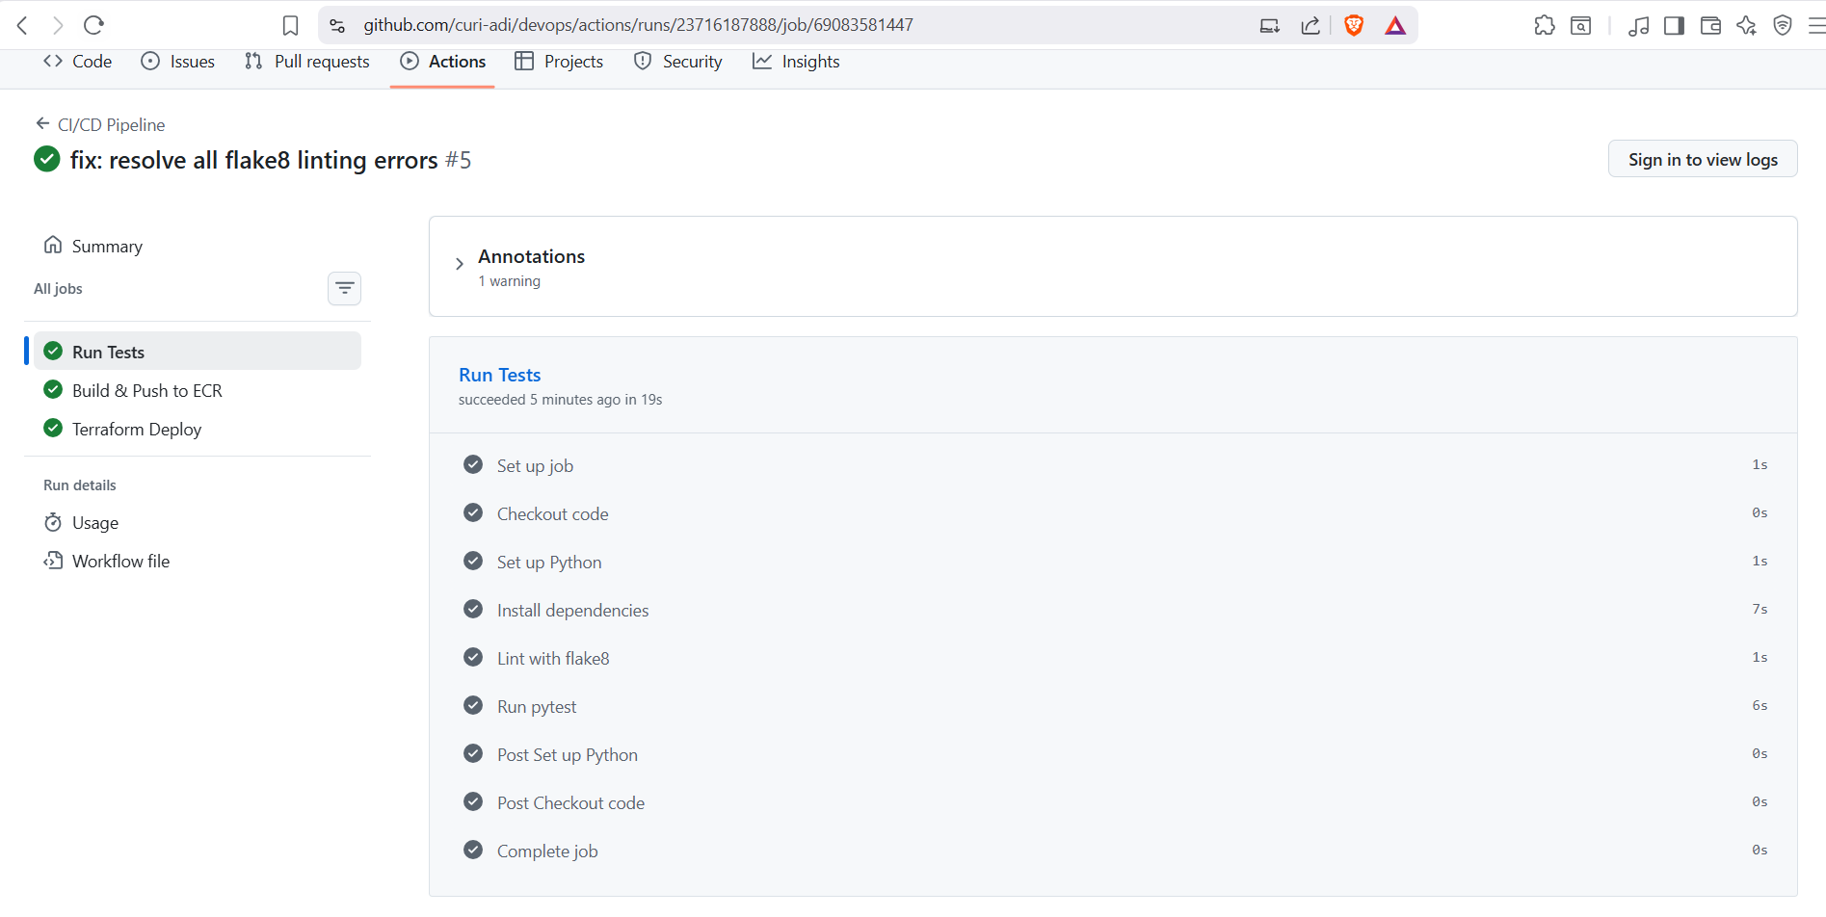
GitHub Actions - Run Tests (CI) passing with linting using flake

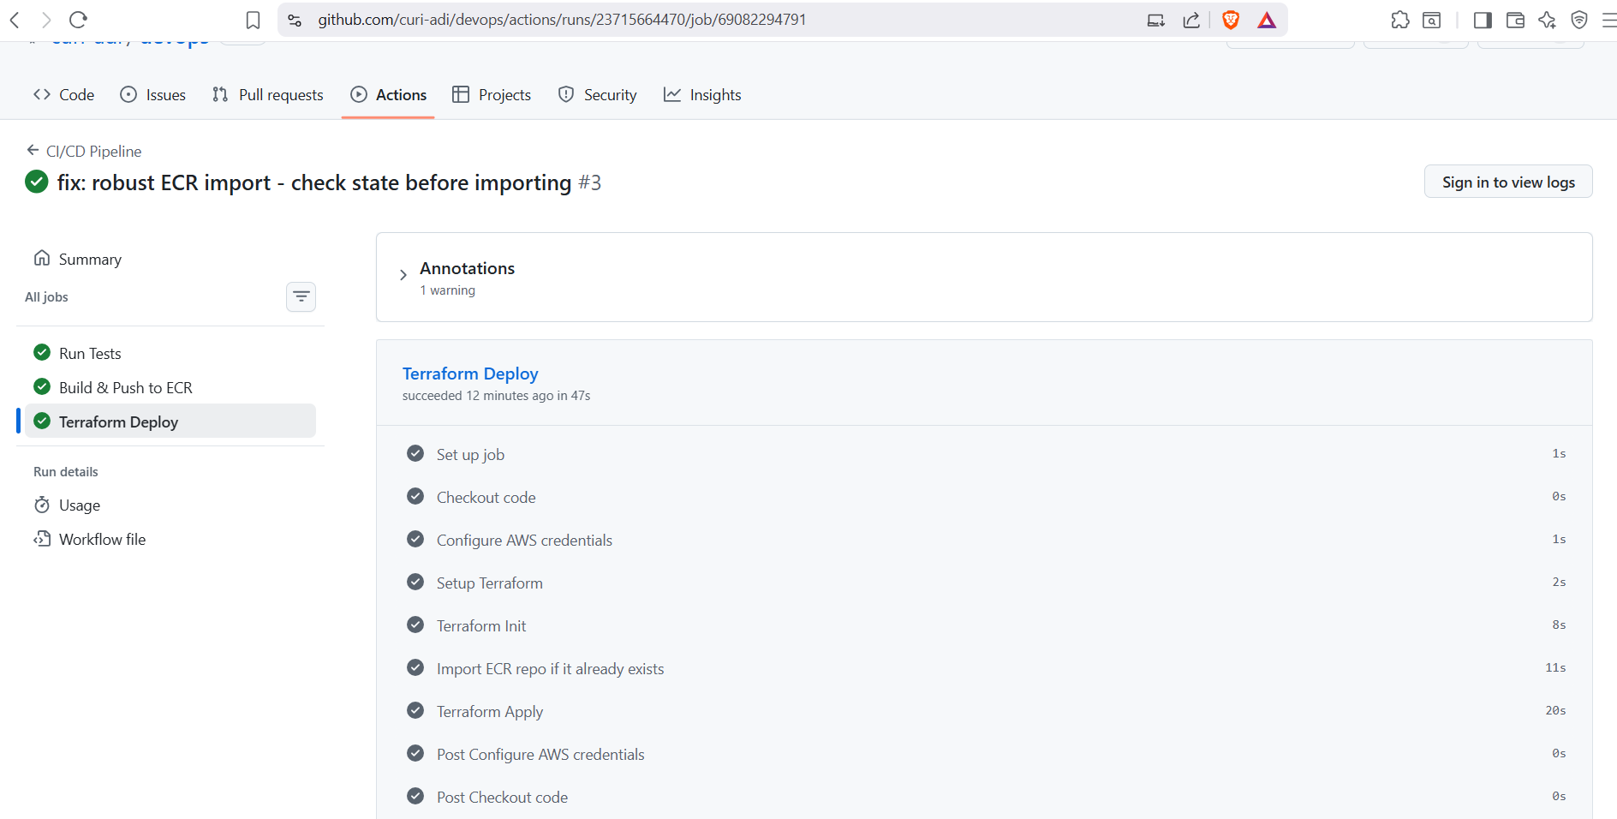
GitHub Actions - Terraform Deploy (CD) passing

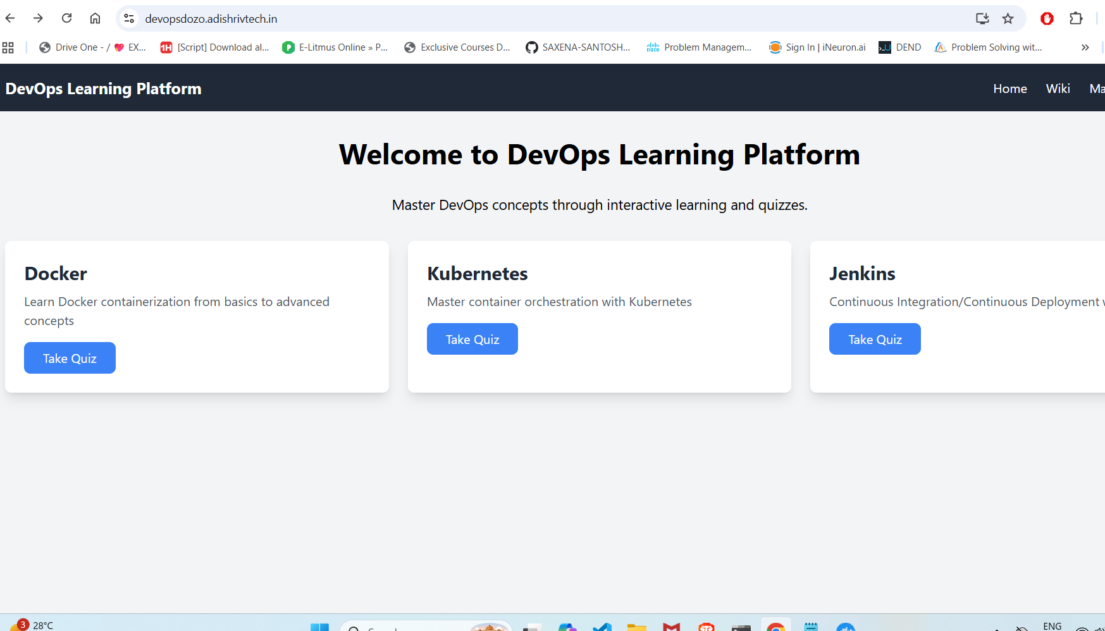
DevOps Learning Platform - Home Page live(for week 8)

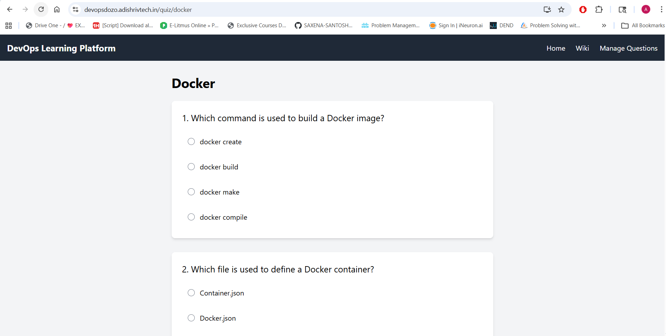
DevOps Learning Platform - Docker Quiz

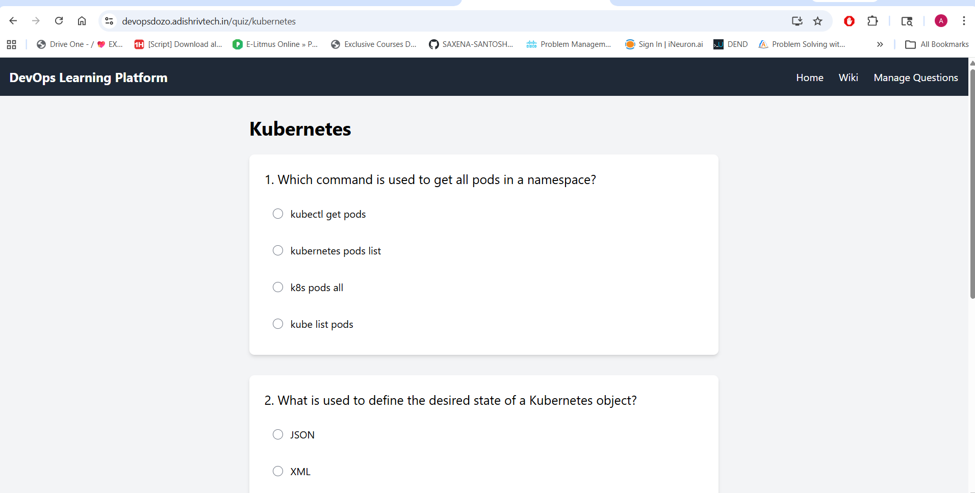
DevOps Learning Platform - Kubernetes Quiz

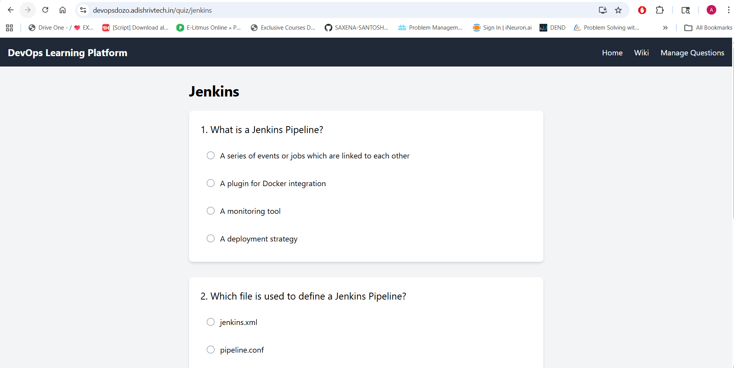
DevOps Learning Platform - Jenkins Quiz

