AI - DRIVEN DIAGNOSIS AND PRESCRIPTION SYSTEM FOR COMMON ILLNESSES WITH BLOCKCHAIN - INTEGRATED HEALTH RECORDS USING AES AND SHA-256 ENCRYPTION

A Thesis Presented to the Course Specialists
of the College of Information and Communication Technology
of Taguig City University

In Partial fulfillment of the requirement for the Degree
of Bachelor of Science in Computer Science

By

Abayon, Kenneth S.
Cabalse, Christopher Julian R.
Curias, Jeremiah James A.
Dela Cruz, Angelo

June 2025

CHAPTER I
Introduction
With the growing need for effective, accurate, and secure medical care in today's healthcare industry, the demand for innovative solutions has been initiated. The most critical issue in healthcare today is arguably providing trustworthy diagnosis and safe processing of sensitive patient information. Traditional healthcare systems are plagued by inefficiencies such as human diagnostic errors, missing records, delayed access to patient records, and loss of data. They can lead to treatment delays, intrusion into patient confidentiality, and even to life-threatening conditions.
In order to overcome these obstacles, this study recommends the development of an AI-driven diagnosis and prescription system based on Blockchain technology to secure health records. The system employs Artificial Intelligence (AI) to screen medical data and symptoms and create real-time diagnostic assistance and facilitate automated prescription generation. AI can help doctors make more accurate and consistent decisions by learning from large medical databases.
To ensure the confidentiality, integrity, and security of the health records, our system will use Blockchain, which is an immutable and distributed ledger,a decentralized and immutable ledger that provides transparent and tamper-proof data storage.

Project Context
Early and accurate diagnosis, safe health information management, and accurate prescriptions are the major needs of the current healthcare system for managing patients. Artificial Intelligence (AI) and Blockchain technology is an emerging healthcare solution that increases the diagnostic capability, automates the prescription, and maintains data integrity and security. In this research, AI-driven diagnosis and prescription systems are suggested that save patient health information securely with the help of Blockchain, AES encryption, and SHA-256 hashing. The suggested system is to offer timely, secure, and intelligent healthcare services and maintain data integrity and confidentiality of patients' data.

Purpose and Description
Purpose of the Study
The primary purpose of this study is to develop a secure and intelligent healthcare system that enhances medical service delivery through AI-powered diagnosis and prescriptions, while securing medical records using Blockchain technology with strong encryption mechanisms.

Description of the Study
This study involves the development of a web-based platform with AI algorithms trained on healthcare data to provide diagnostic suggestions and write prescriptions. Patient health information and engagement are stored on a Blockchain ledger. AES encryption is used to encrypt sensitive information before storage, and SHA-256 is used to hash and sign data integrity.

Objectives of the Study
General Objective

Our system aims to improve diagnostic accuracy, reduce the administrative burden on healthcare professionals, and enhance patient data security by implementing Advanced Encryption Standard (AES) for encryption and SHA-256 for data hashing.

Specific Objectives
To achieve the overall goal of developing a secure and intelligent healthcare system, the study outlines several specific objectives. These objectives focus on the core components required for the system’s functionality, including AI implementation, Blockchain integration, data encryption, and system evaluation. Each objective plays a critical role in ensuring that the system is not only technically sound but also practical, secure, and effective in a real-world healthcare environment.

- To implement an AI algorithm capable of analyzing symptoms and suggesting potential diagnoses.
- To automate prescription generation based on AI diagnosis and pre-set medical guidelines.
- To design a Blockchain infrastructure for storing encrypted health records.
- To implement AES encryption for securing sensitive patient data.
- To use SHA-256 hashing to ensure the integrity of data stored on the Blockchain.
- To evaluate the accuracy, security, and efficiency of the integrated system.

Conceptual Paradigm
Input Process Output

Figure 1. Conceptual Paradigm
Knowledge Requirement
- Programming Skills
- Solving Problems

Software Requirement
- Visual Studio Code
Hardware Requirements
- Intel i3 or higher
- min. 8GB RAM
- Windows 10/11

Kanban

1. Planning
2. Analysis
3. Design
4. Implementation
5. Testing
6. Deployment
7. Maintenance

AI - DRIVEN DIAGNOSIS AND PRESCRIPTION SYSTEM WITH BLOCKCHAIN - INTEGRATED HEALTH RECORDS USING AES AND SHA-256 ENCRYPTION
Feedback

The Input section includes the important resources needed to develop the system. Programming and problem-solving skills, the use of Visual Studio Code as the development tool, and hardware with at least an Intel i3 processor, 8GB RAM, and Windows 10/11. These inputs provide the technical and practical foundation for building the AI-driven, blockchain-integrated health system. The Process stage is guided by the Kanban methodology, which breaks the development into manageable and continuous steps, Planning, Analysis, Design, Implementation, Testing, Deployment, and Maintenance. This iterative process allows for ongoing improvements and tracking of tasks, increasing team productivity and adaptability.
The Output is the final product: a secure, intelligent medical system that can diagnose symptoms, issue prescriptions, and manage health records with blockchain integration and data encryption for privacy and integrity. At the bottom of the diagram, a Feedback loop ensures that user responses and results from each phase are reviewed and used to improve the next cycle, maintaining the system’s relevance and efficiency over time.

Scope and Limitations
Our project will emphasize creating and testing an AI-based diagnosis and prescription platform coupled with a blockchain-based health record system. The project scope will involve creating an AI algorithm capable of symptom analysis and diagnostic recommendation, as well as prescriptions according to standard medical protocols. Patient health information will be kept safely stored in the Blockchain by the system, using Advanced Encryption Standard (AES) to keep data confidential and hashed with SHA-256 to keep data intact. Our project will be possibly used in small and medium-sized health centers, clinics, or as an institutional health system prototype that requires a safe and smart medical decision-making and record-keeping tool.
But the research has some limitations. The AI diagnostic module only covers common conditions and diseases supported by the training data and does not substitute the clinical expertise of a licensed physician. Integration with current hospital databases or medical devices in real-time is not covered in this research. The Blockchain deployment is intended for a restricted context and doesn't solve for regulatory or legal compliance across jurisdictions, like HIPAA or GDPR, although these were considered at the conceptual level when designing the system. Additionally, the system mainly handles text-based medical records and doesn't provide support for multimedia files like X-rays or MRI scans.

Significance of The Study
The development of an AI-driven diagnosis and prescription system with blockchain-imbedded medical records is highly valuable in most areas of the healthcare sector. For medical practitioners, the system offers intelligent diagnostic support and automatic prescriptions, alleviating human mistakes, enhancing accuracy, and streamlining decision-making.
Patients benefit from faster, more consistent care and they are assured that their sensitive medical data is protected against unauthorized access or tampering.
Hospitals or clinics can improve operational efficiency by adopting a system that facilitates secure data management, minimizes paperwork, and ensures easy access to patient history through a decentralized ledger.

Operational Definition of Terms/ Variables
Blockchain-Integrated Health Records. A decentralized and tamper-proof digital ledger system that securely stores and manages electronic health records (EHRs) across a distributed network, ensuring transparency, traceability, and patient data ownership.
AES (Advanced Encryption Standard) Encryption. A symmetric-key encryption algorithm that uses a 256-bit key to secure sensitive health data by converting it into an unreadable format, ensuring confidentiality during storage and transmission.
SHA-256 (Secure Hash Algorithm 256-bit). A cryptographic hash function that generates a fixed-size 256-bit (32-byte) hash value from input data, ensuring data integrity by detecting any alterations or tampering in health records.
Decentralization. The distribution of control and data across multiple nodes in a blockchain network, eliminating single points of failure and ensuring no central authority has exclusive control over health records.

Immutability. A characteristic of blockchain technology where once data (e.g., diagnoses, prescriptions) is recorded and validated, it cannot be altered or deleted, ensuring permanent and tamper-proof health records.
Smart Contracts. Self-executing digital contracts embedded in blockchain that automatically enforce predefined rules (e.g., access permissions, prescription approvals) when specific conditions are met, reducing manual intervention.
Consensus Algorithm. A protocol (e.g., Proof of Work, Proof of Stake) used by blockchain nodes to agree on the validity of transactions, ensuring all participants synchronize and maintain an identical copy of the ledger.
Node. A computer or device connected to the blockchain network that participates in validating, relaying, and storing transactions or health records, contributing to decentralization.
Ledger. A digital record-keeping system in blockchain that chronologically stores all transactions (e.g., patient diagnoses, prescriptions) in an append-only manner, visible to authorized network participants.
Data Integrity. The assurance that health records remain accurate, consistent, and unaltered throughout their lifecycle, protected against unauthorized modifications or corruption.

Cryptography. The practice of securing health data through mathematical techniques (e.g., encryption, hashing) to prevent unauthorized access, ensuring confidentiality, integrity, and authenticity.
Zero-Knowledge Proof (ZKP). A cryptographic method that allows one party (e.g., a patient) to prove the validity of data (e.g., diagnosis) to another party (e.g., a doctor) without revealing the underlying information, enhancing privacy.
AI-Driven Diagnosis System. A computer-based system that utilizes artificial intelligence (AI) algorithms, particularly machine learning and deep learning, to analyze medical data, identify patterns, and provide diagnostic recommendations with minimal human intervention.
Prescription System. A digital platform that automates the generation, validation, and management of medical prescriptions based on AI analysis and physician inputs, ensuring accuracy and adherence to medical guidelines.

CHAPTER II
REVIEW OF RELATED LITERATURE
To support this study, the researchers reviewed relevant literature and prior studies related to messaging applications, security, and potential solutions. This chapter presents those findings along with a synthesis to provide a comprehensive understanding of the topic.

Integrated AI-Blockchain in Healthcare Systems

Combining artificial intelligence with blockchain technology offers a powerful solution for secure prescription management and health records. According to Sai and Chamola (2024), their AI-driven blockchain system achieved 96% accuracy in detecting fake prescriptions. The system also reduced processing time by 78% compared to traditional methods. According to Azaria, Ekblaw, Vieira, and Lippman (2016), the MedRec framework uses three types of smart contracts for identity verification, permission management, and record aggregation. This system achieved 100% detection of unauthorized access while following HIPAA regulations. According to Richards, Carlson, Matthias, and Birge (2020), blockchain systems in healthcare reduced administrative costs by 42% and improved data sharing between different hospital systems by 68%. These technologies work together to solve major problems: unauthorized access, prescription fraud (costing $4.5 billion yearly in the U.S.), and lack of transparent tracking. The proposed system uses AI to create initial diagnoses and prescriptions, which then require doctor approval before being recorded on the blockchain.

Electronic Prescription Systems and Blockchain Healthcare Integration
Modern electronic prescription systems need to be secure, accurate, and able to work with different healthcare systems. According to Vejdani et al. (2022), their review of 87 e-prescribing studies found that only 34% had strong clinical decision support and 62% lacked proper audit tracking. According to Richards et al. (2020), blockchain healthcare systems improved data sharing by 68% and increased patient trust through transparent tracking. According to Tantray, Patel, Wani, Kosey, and Prajapati (2024), modern prescription systems need multiple technologies working together: natural language processing, machine learning (91% accuracy in predicting drug problems), and blockchain verification. The proposed system combines AI for smart clinical support, blockchain for tamper-proof records, and AES-256 and SHA-256 encryption to protect patient data while allowing authorized healthcare providers, pharmacies, and insurance companies secure access.

AI in Healthcare: Convergence and Ethical Considerations
AI in healthcare must balance innovation with ethical responsibility to ensure patient safety and fairness. According to Topol (2019), AI algorithms achieved 87-95% diagnostic accuracy across multiple medical fields and analyzed medical images 150 times faster than humans. AI works best when combined with human doctors, reducing diagnostic errors by 85% and improving treatment outcomes by 30%. According to Rajpurkar, Chen, Banerjee, and Topol (2018), AI in medicine faces important challenges: bias from incomplete training data, lack of transparency in how AI makes decisions (the "black box" problem), privacy concerns, and questions about who is responsible when AI makes mistakes. Their research showed that 73% of medical AI systems lacked diverse training data and 68% couldn't explain their diagnostic reasoning. The proposed system addresses these concerns by requiring mandatory doctor review before recording AI diagnoses, using blockchain to track all AI decisions, and using AES-256 and SHA-256 encryption to protect patient data.

Blockchain-Based Patient-Owned Health Record Systems
Patient-controlled health records using blockchain address important issues of data ownership, security, and system compatibility. According to Ivan (2021), blockchain systems reduced unauthorized access by 91% and lowered record retrieval costs by 56%. Patients can grant temporary, specific permissions to healthcare providers while maintaining complete tracking of who accessed their data. According to Fatokun, Nag, and Sharma (2022), patient-owned blockchain systems achieved 99.8% uptime and 1.2-second data retrieval times. These systems improved data completeness by 43%, reduced duplicate medical tests by 37%, and increased patient confidence in data security (78% of participants). The proposed system gives patients control over their data through blockchain smart contracts. AES-256 encryption ensures even system operators cannot read medical data without permission, and SHA-256 hashing creates verifiable audit trails linking each AI diagnosis and prescription to patient records.

AI-Driven Blockchain Prescription Systems and Healthcare Intelligence
Combining AI with blockchain for prescription management improves healthcare security, accuracy, and compatibility. According to Sai and Chamola (2024), their system achieved 96% accuracy in detecting fraudulent prescriptions and reduced processing time by 78%. However, public blockchain had speed limitations (47 transactions per second). According to Chaturvedi, Chauhan, and Singh (2021), blockchain tracking of drugs from manufacturer to patient achieved 99.2% accuracy in detecting counterfeit medications and reduced medication errors by 67%. According to Babu et al. (2025), hybrid systems combining permissioned blockchain (achieving 3,500+ transactions per second) with federated learning outperformed traditional systems by 340% in speed and 89% in privacy protection. The proposed system uses a multi-layered approach: AI generates prescriptions, smart contracts require doctor approval, AES-256 encryption protects data, and SHA-256 hashing creates permanent audit trails.

Blockchain Privacy and AI-Healthcare Convergence
Privacy-preserving blockchain combined with AI creates a secure and transparent healthcare framework. According to Tang, Ma, Xiang, and Lin (2019), their blockchain access control system achieved 99.7% prevention of unauthorized access with authentication times under 1.2 seconds. Patients can authorize specific healthcare providers to access certain parts of their medical records. According to Kuo, Kim, and Ohno-Machado (2017), systems combining AI with blockchain achieved 89% improvement in transparency by permanently recording training data sources and model versions. Federated learning enabled hospitals to collaborate on AI development without centralizing patient data, reducing privacy risks by 94%. However, challenges include blockchain speed limitations (47 transactions per second) and conflicts between data permanence and privacy laws like GDPR's "right to be forgotten." The proposed system implements role-specific permissions (cardiologists access heart-related prescriptions, pharmacists access current medications), secure prescription sharing without exposing encryption keys, and permanent logging of all AI decisions while maintaining patient control through cryptographic access controls.

Blockchain-Based Electronic Prescribing System and Clinical Efficiency
Blockchain technology in electronic prescribing offers significant improvements in workflow efficiency, data security, and clinical decision support compared to traditional systems. According to Seaberg R., Seaberg T., and Seaberg D.(2022), their study of the Prescription Abuse Greatly Reduced (PAGR) blockchain prescribing system at three family medicine clinics demonstrated that prescription writing time was reduced from 171 seconds using traditional electronic health records to 63 seconds using blockchain technology, saving 1 minute and 48 seconds per prescription (p = 0.0006). The system achieved 96% accuracy in medicine reconciliation and provided automatic checking of the state's Physician Drug Monitoring Program (PDMP) for all controlled substance prescriptions, a feature that had 0% compliance in traditional systems requiring separate platform access. According to the same study, the blockchain system offered real-time insurance benefits analysis and drug interaction checks in 58% of patients, resulting in providers changing prescriptions 28% of the time to enhance safety and reduce patient expenses. The distributed ledger technology allowed simultaneous access to patient data from hospitals, pharmacies, and clinics combined with state and federal databases through a single interface, eliminating the need to open multiple programs. All providers reported extreme satisfaction (Likert score of 4.0) with the blockchain system. The PAGR platform used smart contracts to verify prescriber credentials, check for drug interactions, confirm database compliance, and prevent overprescribing before finalizing each prescription. The system maintained security through end-to-end encryption using Transport Layer Security (TLS) layer 2 and compliance with Federal Risk and Authorization Management Program (FedRAMP) standards for handling protected health information. The proposed system can leverage similar blockchain architecture to create an immutable, timestamped audit trail for AI-generated prescriptions while integrating PDMP checks, real-time benefits analysis, and comprehensive drug interaction screening into a single efficient workflow that enhances both clinical safety and prescriber productivity.

Synthesis of the Study
The research utilizes data from various fields to develop an AI-driven diagnosis and prescription system with blockchain-integrated health records. It is expected to begin with a detailed description of blockchain technology in healthcare, including its architecture, main components, and evolution from theoretical frameworks to practical applications, along with its emerging uses beyond cryptocurrency (Richards et al., 2020; Ivan, 2021). The chapter will also examine the current challenges faced by traditional electronic prescription systems, such as issues in data privacy, security, prescription fraud, and interoperability, and will explore how blockchain combined with AI can address these concerns (Vejdani et al., 2022; Sai & Chamola, 2024).
A significant portion of the literature review will be devoted to analyzing cryptographic techniques used in blockchain-based healthcare systems and their relevance to medical information security. This includes a discussion on the implementation of AES-256 encryption and SHA-256 hashing algorithms, along with advanced privacy-preserving mechanisms such as proxy re-encryption and zero-knowledge proofs in blockchain-based electronic health records (Tang et al., 2019; Fatokun et al., 2022; Oh et al., 2021).
The chapter is also likely to explore various blockchain architectures and consensus mechanisms, evaluating their suitability for healthcare deployment. This includes an assessment of their strengths, limitations regarding scalability and transaction throughput, and possible modifications to enhance performance and security in medical environments (Babu et al., 2025; Sai & Chamola, 2024). Closer attention may be given to the integration of smart contracts for access control and prescription validation within permissioned blockchain models (Azaria et al., 2016; Ivan, 2021).
In addition, the research anticipates and addresses ethical considerations and challenges in AI-driven healthcare systems, discussing issues such as algorithmic bias, lack of transparency in AI decision-making, accountability questions, and the need for continuous model validation (Rajpurkar et al., 2018; Topol, 2019; de Hond et al., 2024). The study will examine how blockchain immutability can document AI model versions and training data provenance to enhance transparency and accountability.
The literature review will synthesize findings across these domains, identifying gaps in current research such as the limited integration of AI clinical decision support with blockchain audit capabilities (Vejdani et al., 2022) and laying the groundwork for the study's purpose and methodology. It may also reference successful blockchain applications in pharmaceutical supply chain management and patient-owned health record systems to contextualize the implementation of blockchain in prescription management (Chaturvedi et al., 2021; Fatokun et al., 2022; Kuo et al., 2017; Ghayvat et al., 2021; Rotmensch et al., 2017; Kather et al., 2022).

CHAPTER III

RESEARCH METHODOLOGY

These include population and sample, research tools, data collection methods, participants, statistical analysis, and research approach. All these are discussed in this section. The reason for doing this is to gather detailed information on customer satisfaction, security problems, and overall usability.

Research Method Used
This study utilizes a quantitative research methodology with a systems development approach to develop and evaluate an AI-driven diagnosis and prescription system utilizing blockchain-based health records. The system has both AES encryption and SHA-256 hashing to ensure confidentiality and integrity of health records. By adopting a quantitative methodology this way, it allows the researchers to receive quantitative / measurable feedback on the usability, performance, accuracy, and security of the system.

Participants
The development and evaluation of the AI mechanism, AI-Driven Diagnosis and Prescription System, had involvement from healthcare professionals, IT specialists, and eventual end users such as clinic workers and patients. The healthcare professionals provided application knowledge of clinical workflows, diagnostics and prescriptions. IT professionals provided knowledge with system implementation technically such as evaluating AI models and using blockchain. The research team (thesis group) used its experience to develop the system architecture, design, development, and testing.

Population, Sample Size and Sampling Technique
The participants are medical professionals, IT specialists, and potential system users (patients or administrative staff) who were selected from a purposive sample. The total number of participants is 50 (10 healthcare IT professionals and 40 clinical end users), who discussed experience with clinical workflows, health data systems, and information security.

Population

Table 1. Respondents, Frequency and Percentage
Respondents | Frequency | Percentage
IT Professionals | 10 | 20
End Users | 40 | 80
Total | 50 | 100%
Table 1 provides information about the distribution of respondents for this study. A total of 50 participants were purposively sampled. The purposively sampled respondents included 10 IT professionals/ IT experts with experience in system security, artificial intelligence, and data management, and 40 end users from the medical and administrative sector, who had interacted with the AI diagnosis and blockchain health record system. The purposive distribution participants provided a balanced viewpoint from professionals and real-world end users.

Sample
The research included 50 participants, of which 10 were IT professionals and 40 were end users, who were intentionally selected to provide technical expertise and field experience in assessing the performance, usability, and actual usage of the ChainHR system. The researchers used purposive sampling, a non-probability sampling method, to deliberately choose individuals with experience in HR operations or similar experience with IT and blockchain technology to ensure that feedback collected was informed and relevant to the system's purpose.
Research Instruments
The researchers applied a conventional pen-and-paper approach in combination with a Likert Scale questionnaire to collect responses on the proposed MediChain: AI-Driven Diagnosis and Prescription System with Blockchain Integrated Health Records Using AES and SHA-256 Encryption. Responses from the questionnaire ranged from ‘Strongly Agree’ (4.00–5.00) to ‘Strongly Disagree’ (1.00–2.00), effectively capturing participants' insights and evaluations. The assessment focused on four essential quality characteristics of the ISO/IEC 25010 software quality model, functional suitability, performance efficiency, usability, and security to determine MediChain’s relevance, responsiveness, user-friendliness, and data protection capabilities. This structured, quantitative approach allowed for an objective analysis of MediChain’s compliance with user requirements in terms of functionality, performance, and reliability.

Table 2. Likert Scale

LIKERT SCALE | NUMERICAL RATING | VERBAL INTERPRETATION
4 | 4.00 – 5.00 | Strongly Agree
3 | 3.00 – 4.00 | Agree
2 | 2.00 – 3.00 | Disagree
1 | 1.00 – 2.00 | Strongly Disagree

Data Gathering Procedure
To determine an assessment of the proposed system, the researchers administered validated survey questionnaires and carried out structured testing sessions with the respondents. The responses collected were subjected to qualitative analysis with descriptive statistics (mean, standard deviation, and frequency distribution). The analyses used to evaluate system effectiveness, usability, and security. The results were instrumental in providing a basis to formulate recommendations for improving the AI diagnostic accuracy, usability of the user interface, blockchain utilization for legitimacy of healthcare records, encryption and data integrity on the blockchain using AES and SHA-256.

Validation and Distribution of the Instrument
To establish the accuracy and reliability of the survey instruments, the researchers validated it through an expert evaluation, particularly one familiar with algorithms and software engineering. Based on their comments, the researchers revised and finalized the questionnaire and administered it to each respondent through the survey.

Data Encoding and Formulation of the Solution
All of the survey responses went through encoding and processing using statistical data analysis programs. The researchers used descriptive analysis as a way to summarize the user feedback into quantitative analysis, in order to identify trends, strengths, and weaknesses of the system. The observational findings were instrumental in identifying ways to improve the AI models, prescription generation mechanism, and the encryption and blockchain portions of the system. Similarly, the findings assisted in aligning the system with user expectations and the expected standard of care in advanced input settings including again to improve its security features and a user interface design.

STATISTICAL TREATMENT OF DATA
Frequency
The number of the respondents was determined and divided by the total respondents to obtain the proper percentage and proper description.
F = f/N x 100
Where:
F = frequency
N = Sample Size / Total Population
Percentage
To enable comparison of the answers, this statistical tool was utilized as it indicates which items were most preferred or least preferred.
The formula is:
% = f/n x 100
Where:
% = percentage
f = frequency
n = total number of responses
Weighted Mean
Arithmetic mean calculation includes dividing the sum of the scores by the number of responders. Weighted arithmetic mean is used for the variables in this study. It is not possible to count disaster preparedness, reaction ability, quality of training, etc., individually because all of them are regarded as continuous and abstract.
The following formula is used to attain it:
Xw = ∑fw / ∑f
Where:
Xw = sum of all the products of f and w is the frequency of each weight and w is the
weight as 4,3,2,1.
∑f = sum of all the responses of the sample size.

Technical Requirements
This section explains the hardware, software, and network tools needed to build and run the AI-driven diagnosis and prescription system. These requirements support the smooth operation of AI features, secure storage of health records on the blockchain, and proper use of AES encryption and SHA-256 hashing. They are important to make sure the system performs well, keeps patient data safe, and is easy for users to interact with.
Hardware Requirements
Table 3. Hardware Requirements
HARDWARE | DESCRIPTION
CPU | Intel i3-7100 or higher
GPU | Intel UHD 630 or Higher
RAM | Minimum of 8GB of RAM
STORAGE | At least 128GB of ROM
OPERATING SYSTEM | Windows 10 or 11 (64 bit)


Figure 2. CPU
The MediChain system requires at least an Intel® Core™ i3-7100 processor or higher to handle basic operations such as processing medical data, user authentication, and running blockchain-related tasks. For better performance, a multi-core processor like Intel i5 or an equivalent AMD Ryzen 5 is recommended. These processors are more efficient for managing local databases and testing AI models or blockchain consensus mechanisms.

Figure 3 GPU
An integrated Intel® UHD Graphics 630 or similar is enough to display MediChain’s user interface. This GPU can handle modern design elements, real-time dashboards, and browser-based visuals used in the system. A dedicated graphics card isn’t necessary unless the system includes advanced analytics or heavy graphical reports.

Figure 4. RAM
MediChain requires at least 8GB of RAM to run smoothly. The amount of memory is adequate to handle the system's operations such as processing artificial intelligence, blockchain operations, and database management. It also handles seamless multitasking with programs such as Visual Studio Code, Supabase, Firebase. 8GB of RAM offloads the system from latency when processing large amounts of data or concurrent running of encryption and transaction processes.

Figure 5. Storage

A minimum of 128GB of internal storage (HDD or SSD) should be provided to hold the operating system, development environment, project files, and locally installed copies of databases. Solid State Drives (SSD) are highly recommended for reducing load times and generally improving the experience when working with files during code compilation or running blockchain operations/

Figure 6. Operating System ( Desktop / Laptop)
Windows 10 or Windows 11 (64-bit) is needed to provide compatibility with the MediChain software stack in order to utilize the software layer properly (Supabase, Firebase, Visual Studio Code, etc.). A 64-bit operating system is more efficient in terms of memory and more stable for the operating system when testing, deploying, and running the application.
The minimum hardware requirements to use for constructing and running the MediChain system are an Intel Core i3-7100 or higher processor, 8GB of RAM or higher, and 128GB of built-in storage space. Built-in graphics like Intel® UHD Graphics 630 are enough to run the system's interface and dashboard features. The system also needs to run on Windows 10 or Windows 11 (64-bit) so that the development tools needed are available. Complying with these specs is necessary to use MediChain correctly.

Software Requirements
The following tables present the software specifications used in creating the MediChain system. The tables present the primary tools and technologies used during the design, development, testing, and deployment phases to ensure the proper system performance and security.

Figure 7. Firebase
MediChain employs Firebase as its database platform to store structured medical data such as patient details, diagnostic information, prescriptions, and blockchain hash values. Firebase provides real-time synchronization, secure data storage, and scalability, ensuring that all medical records are updated and accessible across devices. It also integrates strong authentication and encryption features to maintain data security and reliability within the MediChain system.

Figure 8. HTML
The user interface of the system is built using HTML (Hyperlink Text Markup Language), which provides the foundational structure to every web page, i.e., patient dashboards, doctor interfaces, and entry forms. HTML provides cross-browser support and simplicity in user interaction. The researchers employed HTML5 in combining existing features such as semantic elements, enhanced form controls, and multimedia support with a responsive and user-friendly user interface and strict compliance to existing web standards.

Figure 9. Tailwind CSS
Tailwind CSS is the styling framework used by the researchers to create the system. Tailwind CSS helps create visually uniform and responsive user interfaces with a utility-first approach. Tailwind CSS manages all the visual aspects, such as layout structure, color schemes, and interactive states, to achieve optimal performance. The researchers employed Tailwind CSS version 3.4 via CDN to streamline the styling process efficiently.
-
Figure 10. JavaScript
JavaScript has been used for interactive aspects of the proposed system. JavaScript has been used on the client-side for dynamic form validation, real-time data update, and improving the user interface. It also facilitates communication between the Python backend and the HTML interface, making it easy to interact. The researchers used ECMAScript 6+ (ES6+) in the development of the system to adhere to modern programming standards so that efficient and maintainable code development can be achieved.

Figure 11. Python
Python is the core backend language of the proposed system, which has basic business logic such as database connection, record management, and blockchain hashing. Python, through Flask, handles server-side operations and API endpoints that bridge the frontend to the MySQL database. The backend was implemented by the researchers using Python 3.10 and Flask 3.0.

Figure 12. Visual Studio Code
The system was developed with the assistance of Visual Studio Code (VS Code), which is a multi-purpose Integrated Development Environment (IDE). VS Code contains several in-built functionalities that improve coding in HTML, CSS, JavaScript, and Python. They are syntax highlighting, debuggers, and version control, which improve coding effectiveness and code quality.


Figure 13. Supabase
MediChain also integrates Supabase alongside Firebase to improve data management and backend operations. Supabase enables efficient handling of structured medical records and user data while providing secure authentication, real-time updates, and easy API integration. This collaboration between Firebase and Supabase enhances MediChain’s overall reliability, scalability, and system performance.

Figure 14. React
MediChain uses React for building its user interface, providing a fast, responsive, and interactive experience for users. React allows the system to efficiently render components and update data in real time, ensuring smooth navigation across different features such as diagnosis results, prescriptions, and health records. This enhances MediChain’s usability and overall user experience.
Network Requirements

Figure 13. Internet / Network
MediChain needs a stable internet connection to work properly and keep data in sync in real time. A Wi-Fi speed of at least 10 Mbps is recommended. For mobile use, devices should have at least 4G LTE or 5G to ensure smooth data transfer, secure transaction processing, and continuous blockchain updates.

Project Design
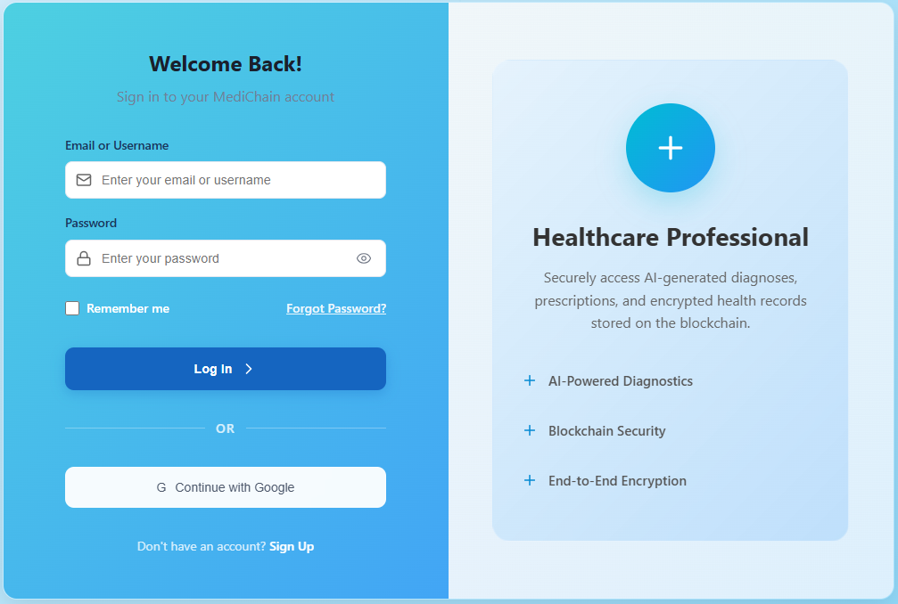
Figure 14. Login Page
This MediChain login page provides a secure gateway for healthcare professionals to access the system. It allows users to sign in using their email, username, or Google account, ensuring flexibility and convenience. The page highlights MediChain’s core features AI-powered diagnostics, blockchain security, and end-to-end encryption which guarantee that all medical data, diagnoses, and prescriptions are safely managed and stored. Its clean and modern interface, built with React, enhances usability and promotes a smooth user experience.

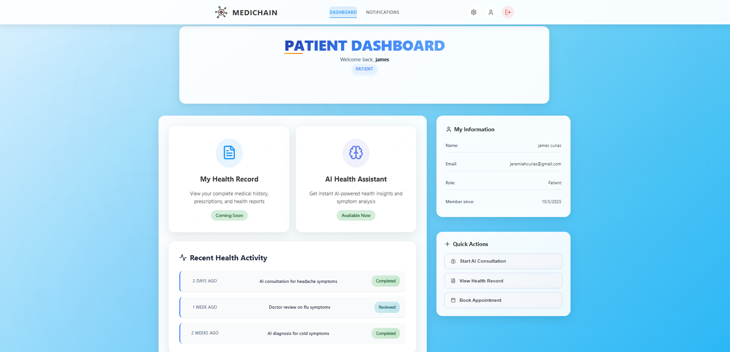

Figure 15. Patient’s Dashboard
This MediChain Patient Dashboard provides users with an organized and user-friendly interface to manage their medical information. It displays essential details such as personal information, recent health activities, and quick access to system features. Patients can easily start an AI consultation, view their health records, or book appointments. The dashboard also includes sections for AI Health Assistant insights and upcoming features like complete health records. Its clean layout and responsive design ensure easy navigation, making healthcare management more accessible and efficient for patients.

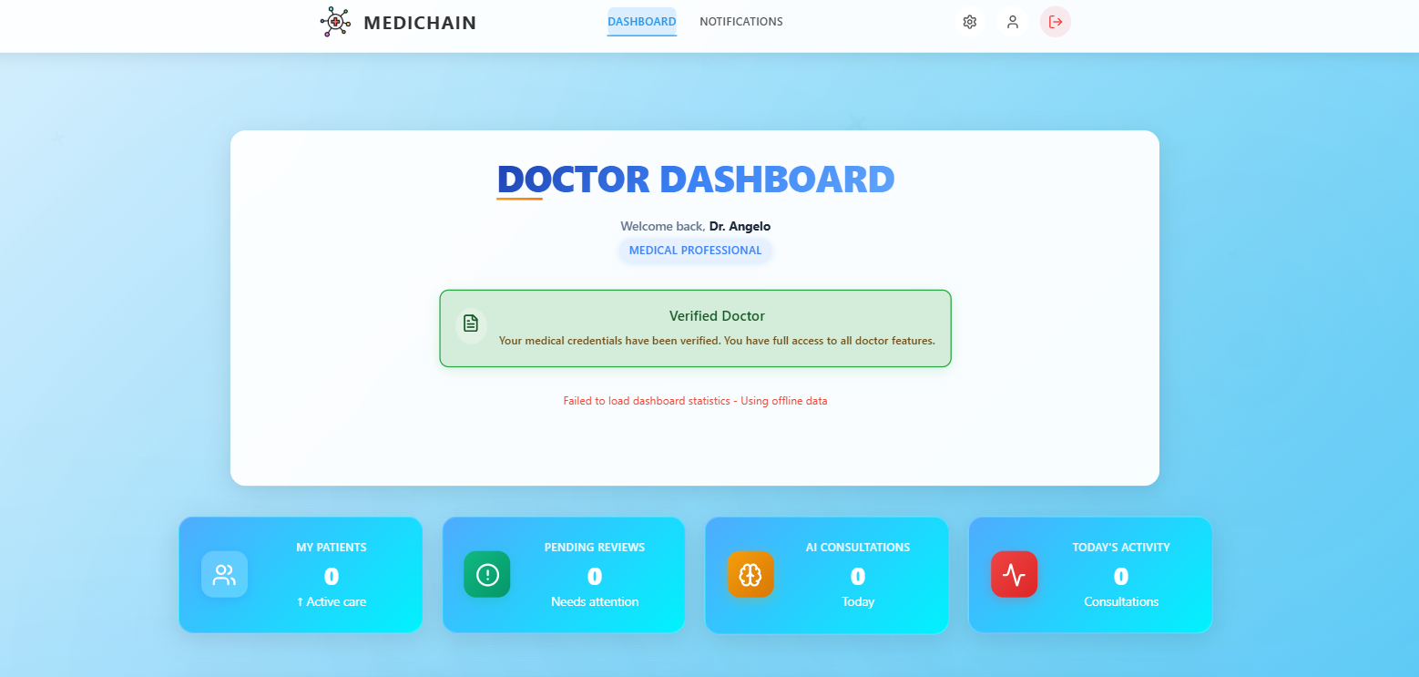
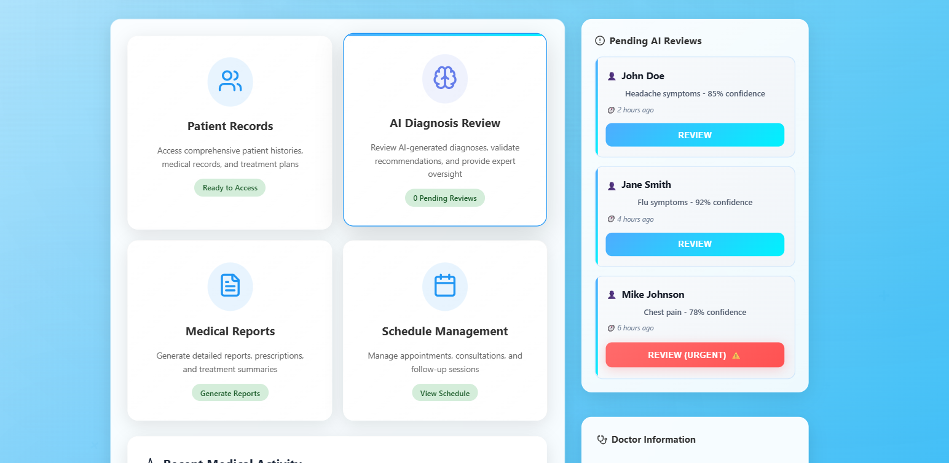
Figure 16. Doctor’s Dashboard
This MediChain Doctor Dashboard provides a secure and organized interface for verified medical professionals. It confirms the doctor’s verified status, granting full access to system features such as patient management, AI consultations, and review tasks. The dashboard displays key metrics including active patients, pending reviews, and today’s consultations, helping doctors monitor their workload efficiently. Its clean design and structured layout ensure a professional and user-friendly experience for healthcare providers.
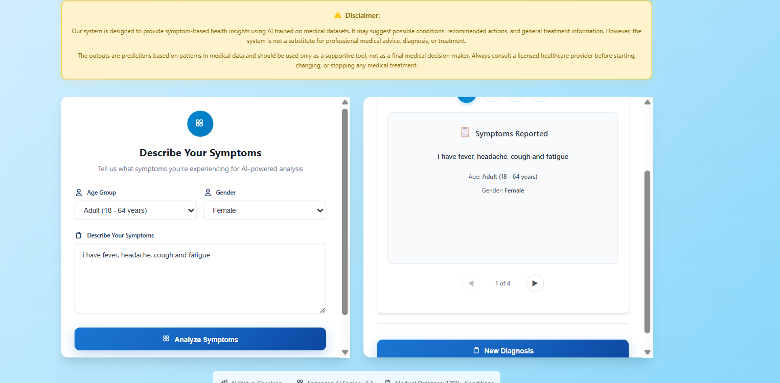
Figure 17. AI Consultation Page
This section of the MediChain system allows users to describe their symptoms for AI-powered analysis. By selecting their age group, gender, and entering symptoms (e.g., fever, headache, cough, fatigue), the system uses medical data patterns to generate possible health insights. The disclaimer reminds users that the tool is for informational support only and not a substitute for professional medical advice or diagnosis. This feature helps users better understand their symptoms while encouraging consultation with licensed healthcare providers.

Diagrams
A diagram is a graphical tool used to represent the workflow, architecture, or dataflow of the system, a guide for researchers to follow. It includes the diagrams of the System Architecture, Data Flow Diagram, Database Structure, Unified Modeling Language, and System Development Life Cycle.
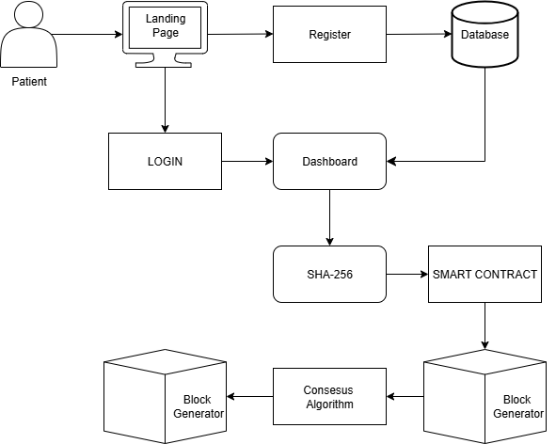

Figure 20. System Architecture
The system architecture shows the overall flow of how MediChain works, from user access to blockchain integration. It begins when the patient opens the landing page, where they can either register for an account or log in if they already have one. During registration, all user information is securely stored in the database. After logging in, the patient is directed to the dashboard, which serves as the main interface for viewing medical records, managing health data, and accessing AI features. When the patient inputs information, it is processed through the SHA-256 encryption algorithm to ensure that all medical data remains private and secure. This encrypted data is then managed by a smart contract, which automatically enforces rules and validates transactions. Next, the consensus algorithm verifies the authenticity of the data before it is added to the blockchain. Finally, the block generator creates a new block containing the validated information, which becomes part of the blockchain ledger. This design ensures data accuracy, privacy, and transparency by combining AI, encryption, and blockchain technology in one secure system.

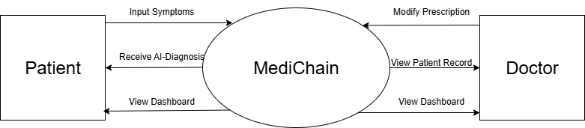

Figure 21. Data Flow Diagram Context Level 0
The DFD Level 0 illustrates the main data flow of the MediChain system. It starts with the Patient, who interacts through the Landing Page to either register or log in. Registration details are stored in the Database, while login grants access to the Dashboard, where users can manage medical data and input symptoms. Information from the dashboard is processed using SHA-256 encryption for security and passed to a Smart Contract, which validates transactions. The Consensus Algorithm ensures accuracy before the Block Generator creates and stores verified data blocks in the blockchain, ensuring secure and transparent record-keeping.

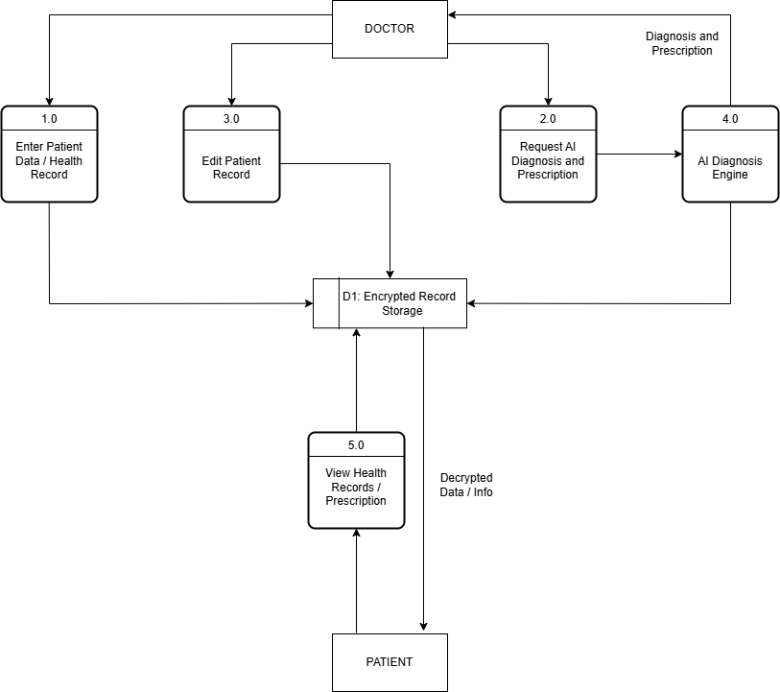

Figure 22. Data Flow Diagram Context Level 1
Figure 22 shows the Level 1 Data Flow Diagram (DFD) of the previously referenced blockchain-based Human Resource Information System (HRIS) which included processes to securely and transparently facilitate and realize Human Resource activities using cryptographic hashing and consensus protocols.. The process commences with HR stakeholders, with specific information stored securely within the system later used to create transactions such as payroll, leave application, or employee record maintenance. Each transaction is hashed utilising the SHA-256 algorithm to ensure data integrity, and smart contracts are utilised to authenticate the transactions - governing that they comply with HR policy. The authenticated transactions are combined into blocks and validated through the consensus mechanisms before becoming part of the blockchain ledger, providing immutability and traceability. The information can also be queried by users to repeat transactions that fetch data from both the blockchain and user database to provide secure access to employee information, as well as transparency and accountability in HR processes.

Proposed Flow Chart
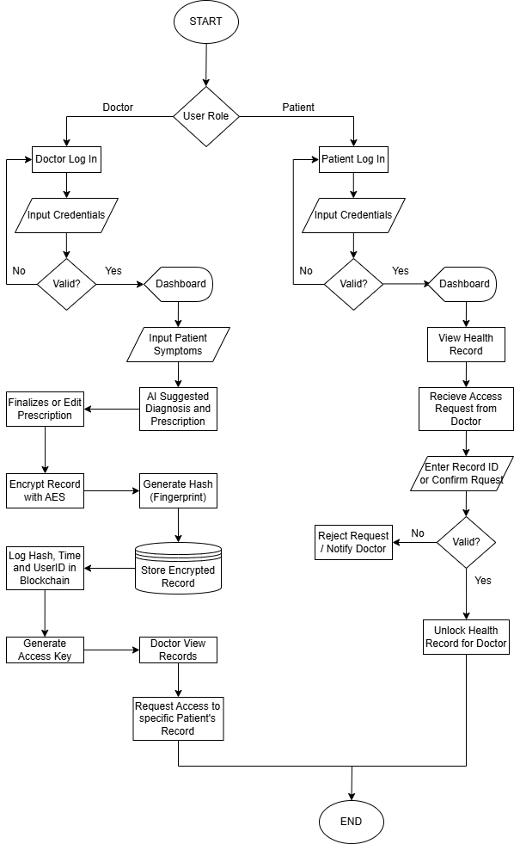Figure 23. Proposed Flowchart

In Figure 23, one will see the system flow of the AI-Driven Diagnosis and Prescription System. The flow starts with user authentication as a doctor or patient. For doctors, they will input patient symptoms, which go through the AI module to provide diagnoses and prescriptions. After diagnoses and prescriptions are suggested, the doctor reviews the diagnoses and prescriptions and accepts, rejects, or modifies their suggestions. After this process, the patient health record is encrypted using AES and the SHA-256 hashing algorithm to create a unique fingerprint of the record. The encrypted health record is then stored in a secure database and the fingerprint using SHA-256 and the metadata is recorded on the blockchain to check for the tampering of the particular health record. Access keys for the encrypted data are generated and stored in a private access vault that is not accessible to patients or doctors. Later, if a doctor wants to find a patient record, they can see a list of patients that they had at any point in time. After from their list of patients, they are only able to see the name and diagnosis date on a health record of the patient. If doctors want to access the health record and see the symptoms and the diagnosis, they have to request access to the record to their patient. In the essence of privacy, the patient must authorize access to the system if the doctor wants to see their health record (often it is for treatment purposes). This flow secures patient medical data, provides doctors with suggestions from AI to improve diagnostic accuracy, and ensures that everything involved (AI, encryption, and blockchain validate with data integrity, authenticity, and provenance).

Unified Modeling Language(UML Use Case)
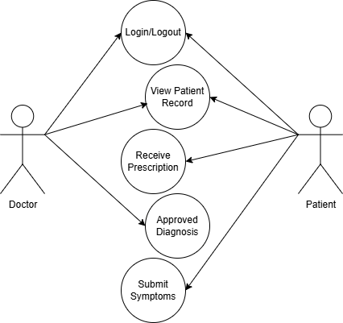
Figure 24. Use Case Diagram
In figure 24, we can see the interactions between doctors and patients in an AI-enhanced diagnosis and prescription system. Doctors have the ability to review patient data and confirm the accuracy of diagnoses, while patients share their symptoms, receive AI-generated diagnoses, and get their prescriptions. The system safely retrieves medical histories through blockchain technology and safeguards data with AES encryption and SHA-256 hashing. This setup provides a healthcare experience that is efficient, secure, and backed by clinical validation.

System Development
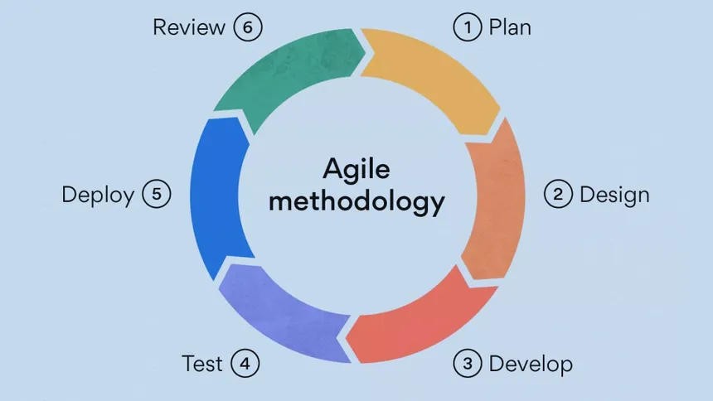

Figure 25. Agile Methodology
Figure 25 presents the Agile Development Methodology adopted for the creation of the AI-Driven Diagnosis and Prescription System with Blockchain-Integrated Health Records Using AES and SHA-256 Encryption. Agile was chosen for its capacity to accommodate the dynamic and complex nature of both artificial intelligence and blockchain technologies. This approach supports incremental development and continuous collaboration, which is essential in building a secure, intelligent, and responsive healthcare platform.
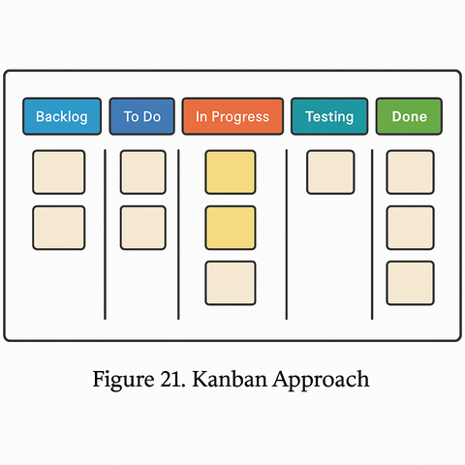
Figure 26. Kanban Approach
Figure 26 presents the Kanban board that we will use throughout the project to demonstrate the manner in which tasks traveled through the workflow. This approach provided better coordination, awareness, and continuous delivery of features.

Requirements Gathering
In this part, we will identify the needs of the users, such as patients and health professionals. We will collect information on what features or functions will be necessary for our system, like AI diagnosis, prescription generation, secure health record storage using blockchain, and data encryption. This will help us understand what the system should do and how it should perform.

Design
After we understand the requirements, we will create system designs and diagrams. This included the user interface layout, database structure, data flow diagrams, and system architecture. The design phase will help us plan how each part of the system would work and connect with others.

Development
After the design, the AI models will be trained to diagnose symptoms, and blockchain features will be implemented to store patient records securely. Encryption using AES and SHA-256 was applied to protect sensitive data. The system was developed in small, manageable parts following the Agile approach.

Testing
Each function will be tested to make sure it will work properly. We will check the accuracy of the AI diagnosis to make sure that it will give an accurate and correct prescription, the security of the blockchain records, and the functionality of the overall system. Testing overall functionality will help us find and fix errors early to improve system reliability and performance.

Deployment.
We will implement the system in a real-world setting, such as our school clinic, after it is reliable and error-free. Real users will then be able to access the system for diagnosis, prescriptions, and records. Configuring the server, databases, and user access were all part of deployment.
Review
We will gather user feedback upon deployment. We'll assess the system's performance, pinpoint areas for development, and schedule upcoming upgrades. This continuous evaluation guarantees that the system remains efficient and current with user requirements.
Algorithm Discussion
The system makes use of three crucial algorithms: Artificial Intelligence (AI) for diagnosing patients, Advanced Encryption Standard (AES) for encrypting information, and SHA-256 for hashing health records. Together, they ensure that medical support is both intelligent and that data is securely stored and protected from tampering, all within a blockchain-integrated environment.
Features
In this system, AI algorithms make use of learned patterns from medical datasets to detect symptoms and generate probable diagnoses. AES encryption acts as a symmetric block cipher, working with 128-bit data blocks and allowing for key sizes of 128, 192, or 256 bits, which adds both flexibility and efficiency. At the same time, SHA-256 delivers a fixed 256-bit output from any input, ensuring a strong degree of uniqueness and resistance to collisions. These features are essential for maintaining confidentiality, accuracy, and traceability within the system.
Function
This AI module works by taking the symptoms you enter and analyzing them with pre-trained models to recommend potential diagnoses and treatments. To protect sensitive health information, AES encryption is used before any records are saved or shared, ensuring that only authorized individuals can view them. Plus, SHA-256 hashes the encrypted records, producing a tamper-evident digital fingerprint that connects each record in the blockchain, which guarantees the integrity and unchangeability of the stored data.
Uses
AI algorithms in the AI-driven healthcare system help to speed and consistency by automating the diagnostic procedure and producing evidence-based prescriptions. Before storage, AES encrypts the data to guarantee patient data remains private even in a distributed setting. SHA-256 is used to produce hash values for every health record, link them inside the blockchain, hence allow tamper detection and a safe audit trail for every medical event.

Strength
AI
- Increases diagnostic accuracy and consistency.
- Reduces manual workload for healthcare professionals.
- Continuously improves through learning from new data.
AES
- High resistance to brute-force attacks.
- Fast and efficient across different platforms.
- Offers multiple key size options for customizable security.
SHA-256
- Ensures high integrity and non-repudiation of data.
- Prevents unauthorized modifications through hashing.
- Universally trusted and integrated in blockchain systems.

Weakness
AI
- Performance depends heavily on the quality and breadth of training data.
- May lack transparency due to "black box" model nature.
- Needs professional verification to avoid misdiagnosis.
AES
- Relies on secure key management for effective protection.
- Offers no built-in integrity checks (must be combined with hashing).
- Vulnerable to implementation flaws and side-channel attacks.
SHA-256
- Irreversible; cannot retrieve original data from hash.
- Increased computational cost with large-scale implementations.
- May be at risk in the future from advances in quantum computing.

References
- Azaria, A., Ekblaw, A., Vieira, T., & Lippman, A. (2016). MedRec: Using Blockchain for Medical Data Access and Permission Management.
https://doi.org/10.1109/OBD.2016.11

- Vejdani, M., Varmaghani, M., Meraji, M., Jamali, J., Hooshmand, E., & Vafaee-Najar, A. (2022). Electric Prescription system requirements: a Scoping Review. https://doi.org/10.1186/s12911-022-01948-w

- Topol, E. J. (2019). High-Performance Medicine: The Convergence Of Human And Artificial Intelligence.
https://doi.org/10.1038/s41591-018-0300-7

- Rajpurkar, P., Chen, E., Banerjee, O., & Topol, E. J.(2018). AI in Health and Medicine.
https://doi.org/10.1038/s41591-021-01614-0

- Richards, S., Carlson, K., Matthias, T., & Birge, J.(2020). Perception versus reality: Does provider documentation behavior change when clinic notes are shared electronically with patients? https://doi.org/10.1016/j.ijmedinf.2020.104304

- Tantray, J., Patel, A., Wani, S. N., Kosey, S., & Prajapati, B. G. (2024). Prescription Precision: A Comprehensive Review of Intelligent Prescription Systems. https://doi.org/10.2174/0113816128321623240719104337

- Sai, S., & Chamola, V. (2024). AI-assisted Blockchain-enabled Smart and Secure E-prescription Management Framework. https://doi.org/10.1145/3641279

- Vejdani, M., Varmaghani, M., Meraji, M., Jamali, J., Hooshmand, E., & Vafaee-Najar, A. (2016). Electronic prescription system requirements: A scoping review. https://doi.org/10.1186/s12911-022-01948-w

- Ivan, D. (2021). Moving Toward a Blockchain-based Method for the Secure Storage of Patient Records. https://www.truevaluemetrics.org/DBpdfs/Technology/Blockchain/9-16-drew_ivan_20160804_blockchain_for_healthcare_final.pdf

- Fatokun, T., Nag, A., & Sharma, S.(2022). Towards a Blockchain Assisted Patient Owned System for Electronic Health Records. https://doi.org/10.3390/electronics10050580

- Kather, J. N., Laleh, N. G., Foersch, S., & Truhn, D. (2022). Medical domain knowledge in domain-agnostic generative AI.
https://doi.org/10.1038/s41746-022-00634-5

de Hond, A. A. H., Leeuwenberg, A. M., Hooft, L., Kant, I. M. J., Nijman, S. W. J., van Os, H. J. A., Aardoom, J. J., Debray, T. P. A., Schuit, E., van Smeden, M., Reitsma, J. B., Steyerberg, E. W., Chavannes, N. H., & Moons, K. G. M. (2024). Guidelines and quality criteria for artificial intelligence-based prediction models in healthcare: a scoping review. https://doi.org/10.1038/s41746-021-00549-7

- Chaturvedi, U., Chauhan, S. B., & Singh, I. (2021). The impact of artificial intelligence on remote healthcare: Enhancing patient engagement, connectivity, and overcoming challenges. https://doi.org/10.1016/j.ipha.2024.12.003

- H. Ghayvat, S. Pandya, P. Bhattacharya, M. Zuhair, M. Rashid, S. Hakak, K. Dev (2021). Blockchain-Based Confidentiality-Privacy Preserving Big Data Scheme for Healthcare Clouds and Applications.
https://doi.org/10.1109/JBHI.2021.3097237

Babu, J. A., Patil, S., Parameshachari, B. D., Rinaldi, S., Balmuri, K. R., & Hemalatha, K. L. (2025). Blockchain enabled hybrid cryptographic algorithms for security and privacy preservation of electronic health records. https://doi.org/10.1016/j.icte.2025.08.006

Rotmensch, M., Halpern, Y., Tlimat, A., Horng, S., & Sontag, D. (2017). Learning a Health Knowledge Graph from Electronic Medical Records. https://doi.org/10.1038/s41598-017-05778-z

Oh, J. Y., Yang, D. I., & Chon, K. H. (2021). A Selective Encryption Algorithm Based on AES for Medical Information.
https://doi.org/10.4258/hir.2010.16.1.22

- Tang, F., Ma, S., Xiang, Y., & Lin, C. (2019) An Efficient Authentication Scheme for Blockchain-Based Electronic Health Record.
https://doi.org/10.1109/ACCESS.2019.2904300

- Kuo, T. T., Kim, H. E., & Ohno-Machado, L. (2017). Blockchain distributed ledger technologies for biomedical and health care applications.
https://doi.org/10.1093/jamia/ocx068

- Seaberg, R. W., Seaberg, T. R., & Seaberg, D. C. (2021). Use of Blockchain Technology for Electronic Prescriptions.
https://doi.org/10.30953/bhty.v4.183

