Comprehensive Machine Learning Analysis: Bike Sharing Demand Forecasting

Curinetha Hubbard
The School of Business, Belhaven University
MDS 620: Making Data Decisions
Dr. Brett Andrews
26 April 2025

Comprehensive Machine Learning Analysis: Bike Sharing Demand Forecasting

Problem Statement
The outcome of machine learning projects is to provide information that will direct enterprises' resources into avenues that produce the best profitability and goodwill in their respective consumer communities. This machine learning project focuses on bike sharing, which has increased in popularity, particularly in urban areas. The primary outcome variable, or target variable, is the bike rental count during a specific interval, in this case, hourly or daily. Since weather and environmental factors greatly affect the target variable, this project can provide information about the appropriate times to implement alternative income-generating tactics to sustain managed control profit. Also, by accurately predicting bike demand, bikes can be optimally distributed and readily available to consumers. This will improve customer satisfaction. Likewise, these forecasted results can provide data to improve public transportation needs in green communities where the pollution from city buses may be seen as an environmental and health concern.
Key Findings from EDA
The findings show that bike rentals increase significantly on warmer days. Weekends and holidays are also more likely to lead to higher demand.
Machine Learning Model
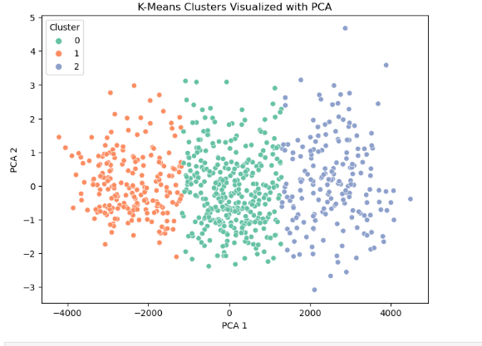
This project used K-Means clustering and linear regression. The purpose of k means is to cluster days into groups based on weather and rentals
- Clustering results:
  - Cluster 1: Low rentals (colder days)
  - Cluster 2: Moderate rentals
  - Cluster 3: High rentals (warmer days, weekends)
- Evaluation:
  - Silhouette score: 0.6 indicating good clustering
The following was found for linear regression.
- MAE: 583.02
- RMSE: 796.46
- R²: 0.84
The regression model reasonably predicts bike rentals with some error margin

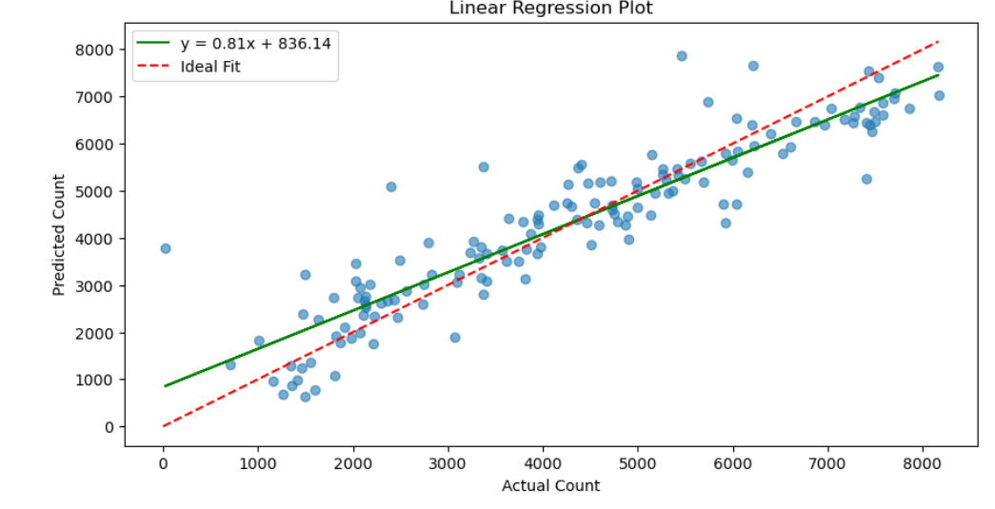

Summary of Models and Their Performance
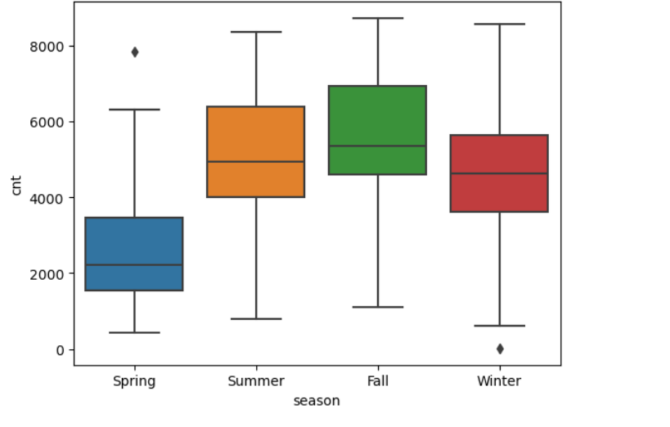

- Outliers in Spring and Winter, accounting for unusually warm days (Spring) or cold days (Winter)
- Spring: Moderate box, higher in the middle, indicating rentals are more common as weather improves
- Summer: wide box (more variation) higher median, rentals are more popular
- Fall: Largest number of rentals
- Winter: Narrow box with low rentals

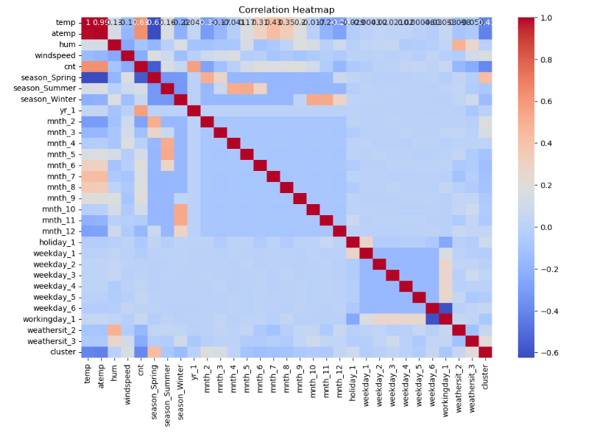
- Key relationships Identified:
  - Temperature
  - Rentals

Final Recommendations
The findings suggest that bike distribution should be optimized in warmer months. An increase in availability during weekends and holidays would be ideal. Cluster data may also be used to better allocate resources.

