RISK FACTOR DECOMPOSITION ANALYSIS

SUMMARY
This project takes a simulation of asset returns from a typical immature DB pension plan in 2011, over the period from June 2013 to December 2025 and decomposes the returns into various risk factors using ordinary least squares (OLS) and LASSO regression, with principal components analysis (PCA) also performed in Python for a more detailed analysis of explanatory variable variances.

The return series is generated using index proxies for various asset classes and the typical asset allocation taken from the PPF Purple Book 2011.

For the full DB pension plan funding simulator project that the series was drawn from, visit my GitHub page: https://github.com/curingd/db-pension-plan-funding-simulator

The key findings are that returns are mainly explained by exposures to credit and changes in inflation using the OLS model, or credit and a negative linear relationship with equity using the LASSO model. These results are not contradictory as OLS regressions of S&P 500 returns over high-yield bonds on credit factors and inflation changes on credit and S&P 500 factors show high significance, so whether the factors are framed as credit, equity, or inflation exposures over the 2013-25 period are a matter of preference.

DATA
Below are the primary set of factors used for regression:

Factor | Proxy | Data Source
Risk-free rate | Average SONIA | Bank of England
Swap spread | 3-year gilt yield minus 3-year OIS | Bank of England
Yield curve slope | 20-year minus 3-year gilt yield | Bank of England
Yield curve curvature (butterfly) | 2 x 10-year minus 3-year minus 20-year gilt yield | Bank of England
Investment-grade credit spread | SLXX minus interpolated 5.56Y gilt yield (duration matched) | FMP, Bank of England
High-yield credit spread over investment-grade | GHYS.L minus SLXX | FMP
Equity over high-yield credit | S&P 500 returns minus GHYS.L | FMP, Robert Shiller
Equity uncertainty | VIX | FMP
Equity risk premium | S&P 500 E/P minus average SONIA | Robert Shiller, Bank of England
Inflation | Implied real 3-year gilt minus 3-year gilt yield | Bank of England
GBP currency hedge | Average SONIA minus EFFR | Bank of England, FRED
Figure 1: Table of primary risk factors for OLS
After inspection of plots of the asset returns time series and the above factors, the following second-order factors were then derived for regression:

Factor | Proxy | Data Source
Yield curve slope change | Change in 20-year minus 3-year gilt yield | Bank of England
Yield curve butterfly change | Change in 2 x 10-year minus 3-year minus 20-year gilt yield | Bank of England
Equity uncertainty change | Percentage change in VIX | FMP
Inflation change | Change in implied real 3-year gilt minus 3-year gilt yield | Bank of England
Figure 2: Table of secondary risk factors from differencing primary risk factors
Apart from the equity uncertainty measure (VIX), each of these factors are ex post and represent realised return factors, rather than ex ante market expectations (for example, investment grade and high-yield CDS spreads could have replaced the credit fund indices). This is consistent with the use of realised asset returns, rather than forward-looking projections.

ORDINARY LEAST SQUARES REGRESSION
OLS regression was performed on various factor combinations, checking for model and factor significance, and examining normal QQ plots for the distributions of the regression residuals. These are documented in the various tabs of risk_factor_decomposition_ols.xlsx and Figure 3 presents comparable summary statistics:

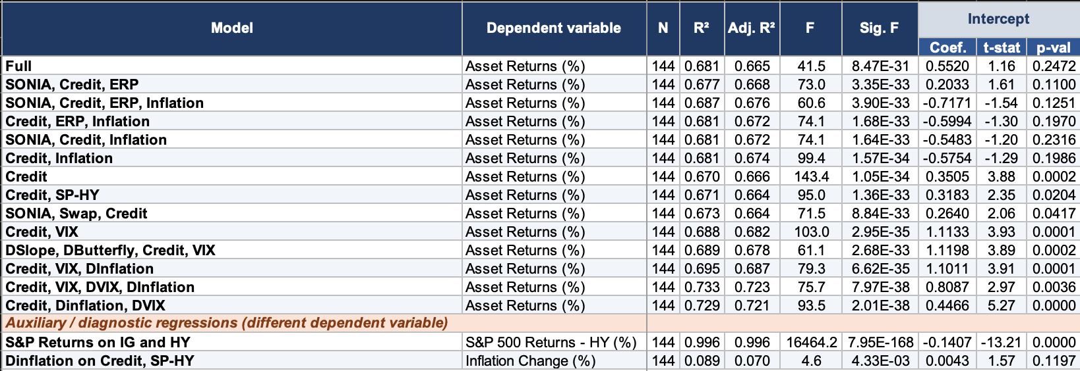
Figure 3: OLS Regression Summary Statistics
The most statistically significant model, both in overall terms (lowest significance F) and with the most significant intercept (lowest p-value) is the regression of the asset returns on credit factors, changes in inflation and changes in implied equity uncertainty. The full statistical output is given in Figure 4 and this implies a model for asset returns given by the formula (rounded to 4 significant figures):

$$R_{t}=0.4466+0.6604{IGS}_{t}+0.2989{HYS}_{t}+9.238{DINF}_{t}-0.01838{DVIX}_{t}+ε_{t}$$

Where:
$${IGS}_{t}=\text{investment grade bond spread over gilts}$$
$${HYS}_{t}=\text{high-yield bond spread over investment grade bonds}$$
$${DINF}_{t}=\text{change in inflation}$$
$${DVIX}_{t}=\text{change in implied equity uncertainty}$$

The regression could just as well have been specified in terms of equity (S&P 500 as a proxy) returns or the spread of equity returns over high-yield bonds: as the results of the bottom two regressions in Figure 1 show, there are significant linear relationships between equity returns, credit returns and changes in inflation over the 2013-25 period studied.

Note that the regression above is unusual in that there is no factor for a risk-free rate, apart from a negative contribution from the investment grade credit spread. When SONIA was included as a regression factor, it was repeatedly found to be insignificant and the problem is apparent from comparing the graph of SONIA returns to the asset returns (Figures 5 and 6): SONIA is clearly not covariance stationary, whereas asset returns do appear to be. The post-COVID rise in interest rates in 2022 is within the lookback period, ending a long period of historically low rates post GFC.

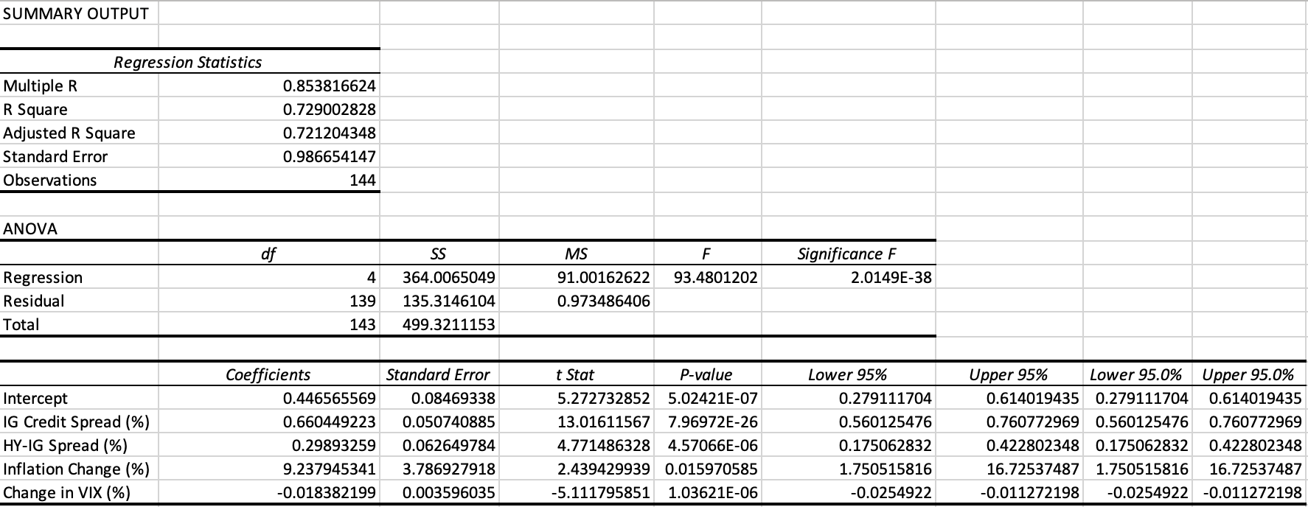
Figure 4: Summary statistics for OLS regression of asset returns on credit, inflation changes and VIX changes.

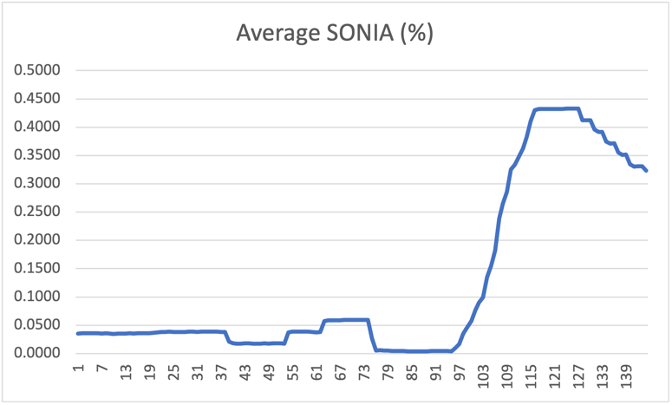
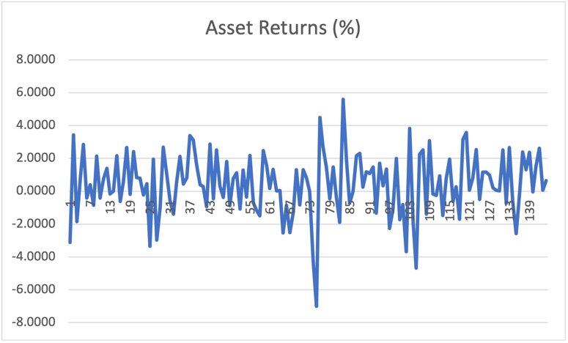
The asset returns series’s insensitivity to SONIA can be explained by both the predominant equity allocation of the returns (41.1% vs. 40.1% gilts), the higher volatility of equity relative to bonds and the global exposure inherent in the proxies used for private credit, equity, and hedge fund asset classes. From looking at the graph of the SONIA-EFFR spread (Figure 7), the lack of correlation between US and UK rates is also clear: positive correlation would appear as a near-flat graph.
Figure 5: Average SONIA, June 2013 to December 2025
Figure 6: Asset returns, June 2013 to December 2025
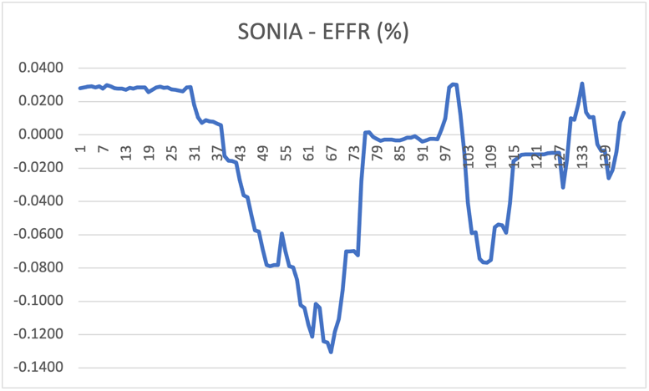
Figure 7: SONIA-EFFR base rate spread, June 2013 to December 2025

LASSO AND RIDGE REGRESSION
The process of identifying significant risk factors and reducing their number for parsimony was performed manually: an alternative is to use LASSO and/or ridge regression to penalise the sum of squares or the absolute sum of factor coefficients, respectively.

Of course, given the inconsistent measures used for the various risk factors, a prerequisite is to normalise each factor before regressing, so that large coefficients are not penalised purely because of the units of measurement of the corresponding factors.

Grid searching identified the optimal hyperparameters to use for ridge and LASSO regression and five-fold time splitting was used to separate training and test samples to identify the regression’s predictive power within the 2013-25 period. Both aggregate in-sample and out-of-sample R² values and the changes in R² from fold to fold are in Figures 8 and 9. Both ridge and LASSO were compared to a near-unconstrained OLS regression on six principal components from principal components analysis (more on that later).

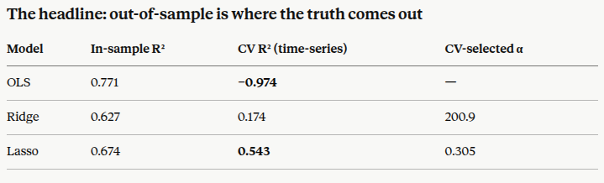
Figure 8: in-sample and out-of-sample OLS/ridge/LASSO regression R^2 values

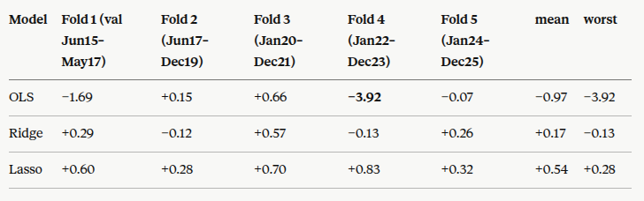
Figure 9: per-fold out-of-sample changes in R^2 values for OLS/Ridge/Lasso regression

This points to the LASSO model as the most stable out-of-sample. Following on from the discussion of the asset returns’ insensitivity to SONIA, the un-normalised Lasso regression avoided sensitivity to interest rate factors (see Figure 10 which documents the coefficients) and thus remained stable throughout the sample period.

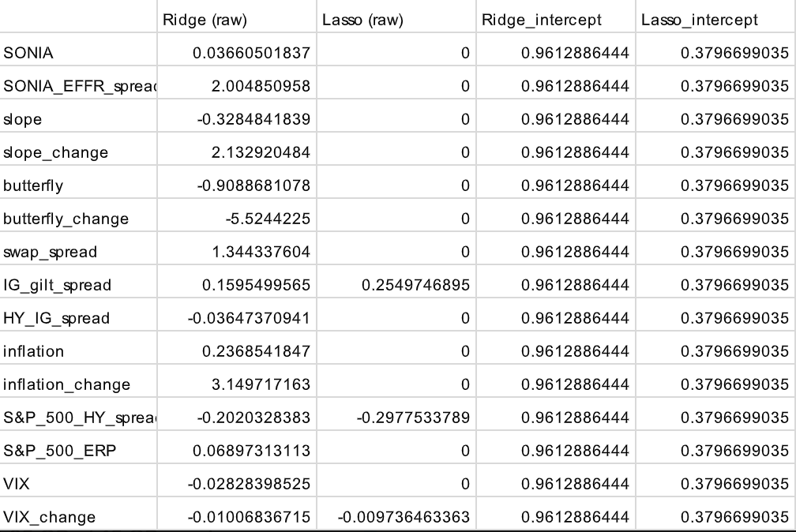
Figure 10: un-normalised Ridge and LASSO regression coefficients
The next question to ask is whether the LASSO regression is a better fit than the most statistically significant model found through manually experimenting with factors in OLS. Figure 11 compares the R², adjusted R², AIC and BIC values of the credit/change-in-inflation/change-in-VIX model in Figure 3 with the LASSO model, and the LASSO model’s chosen factors re-run through OLS to give revised coefficients. The statistics clearly point to the original OLS model being the best explainer (in statistical terms) of asset returns:

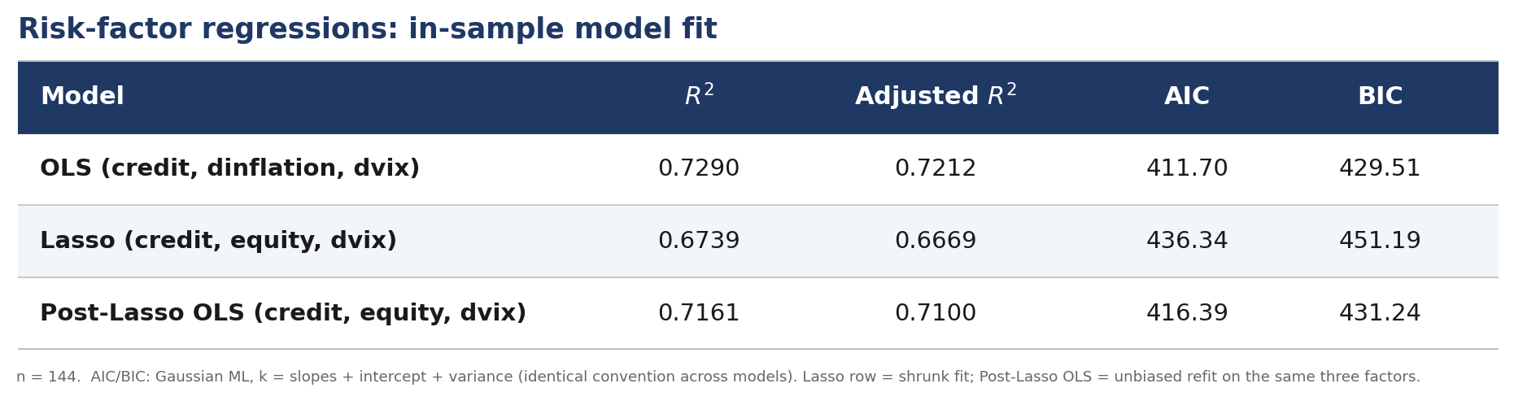
Figure 11: Comparison of summary statistics between manually chosen OLS, LASSO and post-LASSO OLS models.

CONCLUSIONS
To determine the primary drivers of asset returns, looking at raw coefficients from the 4-factor OLS model is insufficient: standardisation is required to factor out measurement assumptions and the distributions of the factors used for regression.

Writing each factor as $F_{t}=μ_{F}+σ_{F}Z_{t}$ where $μ_{F}$ and $σ_{F}$ are the factor mean and standard deviation, respectively, gives the new regression coefficients as $σ_{F}$ times the old ones for each factor, and the new intercept as $a+\sum_{F}{μ_{F}b_{F}}$ where $a$ is the old intercept and $b_{F}$ is the old slope coefficient for factor $F$. This computation for the new coefficients is given in Figure 12.

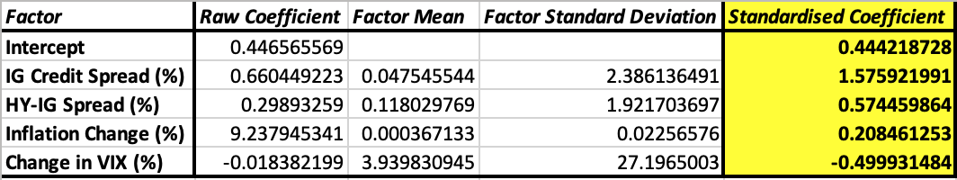
Figure 12: standardised factor coefficients for 4-factor OLS regression
This reveals the largest driver of returns as the investment grade credit spread, followed by high-yield spreads over investment grade returns, then a negative relationship with equity uncertainty and a weaker relationship with inflation changes, despite the raw coefficient for inflation changes being of greatest magnitude. This conclusion is supported by corporate bonds being the largest weighted asset subclass from the PPF 2011 asset allocation (Figure 13, from the DB fund simulator):

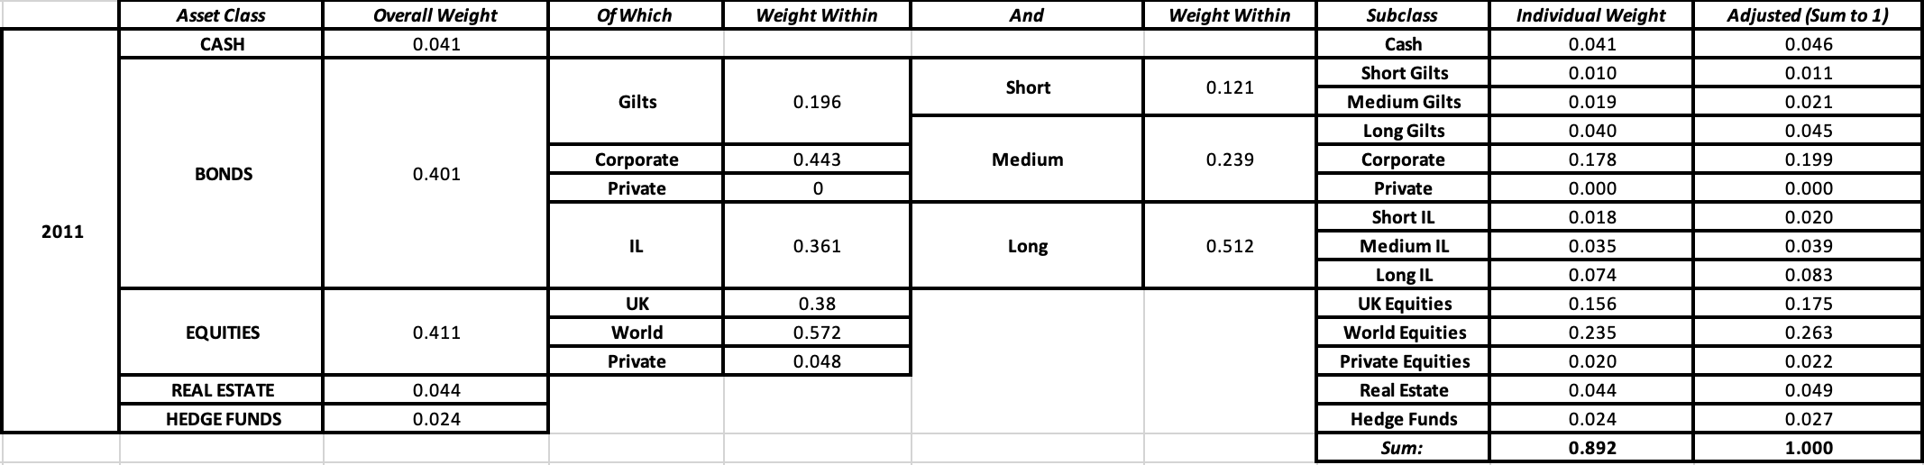
Figure 13: typical DB plan 2011 asset allocation, used to generate asset returns.

APPENDIX: PRINCIPAL COMPONENTS ANALYSIS (PCA)
Although it did not turn out as central to the analysis, PCA was performed on the standardised regression factors to offer insight into what factors may be selected for the regression and which may be discarded. The factor loadings for the first six principal components and component scree plots for total variation are given below alongside a correlation matrix for comparison.

The lack of “knee” to the scree plot, narrow range of factor loadings (-0.47 to 0.59) and predominance of weak pairwise correlations from the correlation matrix all point to a lack of conclusion regarding what factors to select based on factor covariances alone:

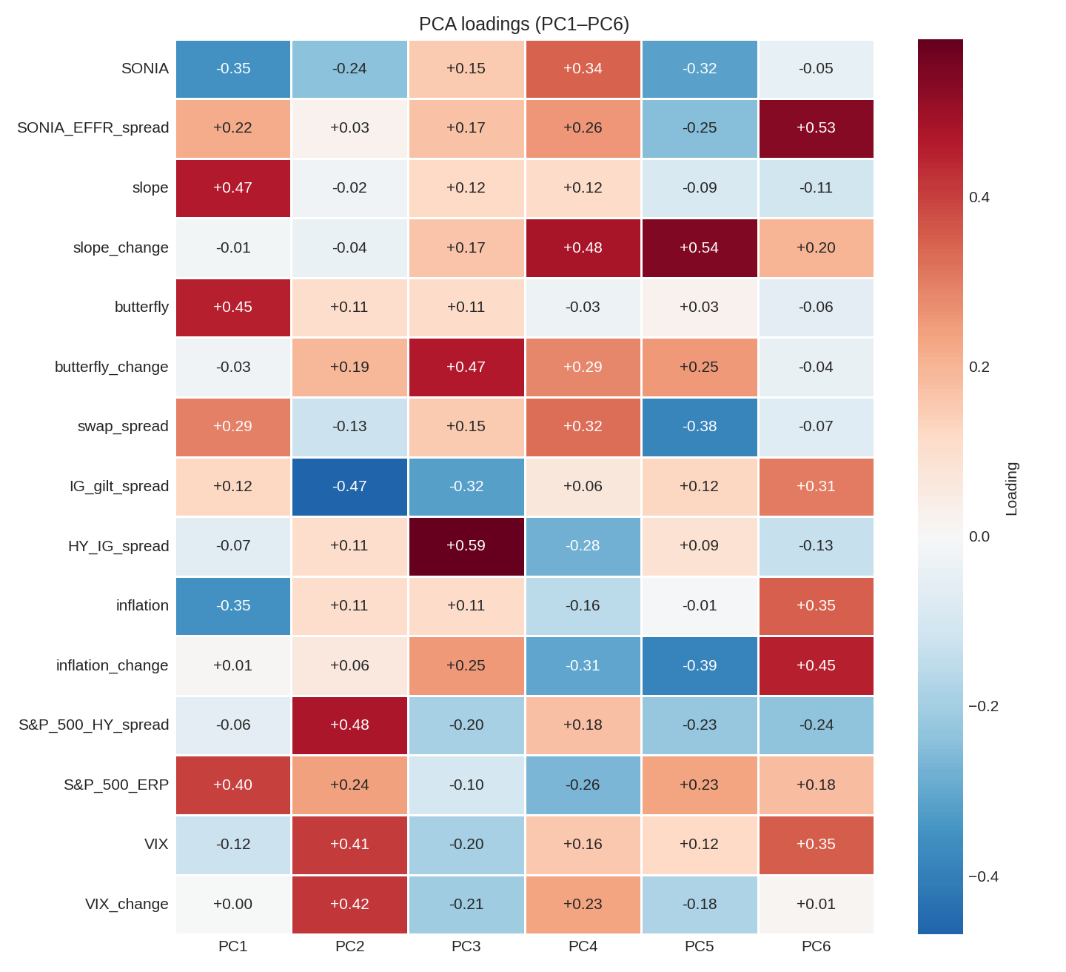
Figure 14: Factor loadings for PC1-6

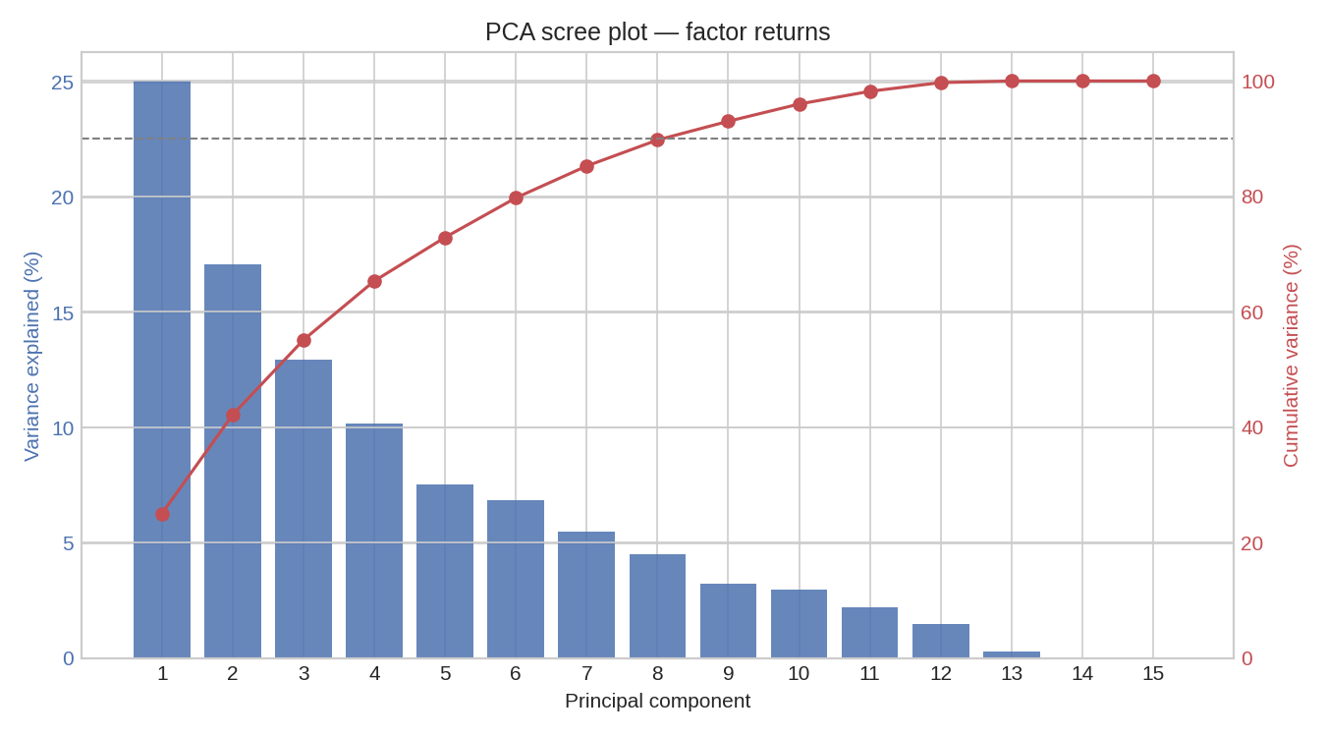
Figure 15: Scree plot for principal components with cumulative variation

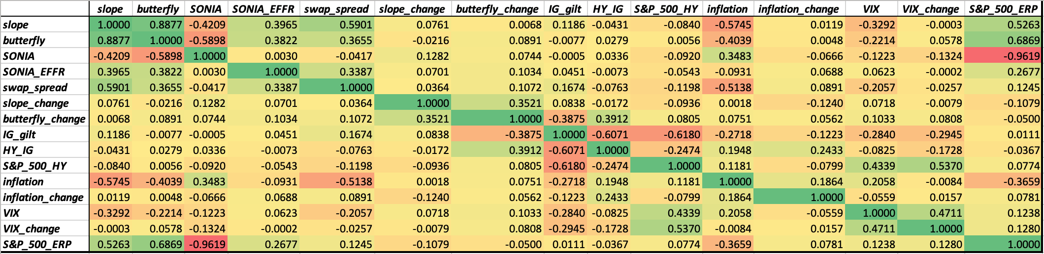
Figure 16: Correlation matrix of all factors
REFERENCES
Bank of England (2026) Yield curves. Available at: https://www.bankofengland.co.uk/statistics/yield-curves (Accessed: 6 June 2026).
Federal Reserve Bank of St. Louis (2026) Federal Reserve Economic Data (FRED). Available at: https://fred.stlouisfed.org/ (Accessed: 6 June 2026).
Financial Modeling Prep (no date) Chart API documentation. Available at: https://site.financialmodelingprep.com/developer/docs#chart (Accessed: 6 June 2026).
Pension Protection Fund and The Pensions Regulator (2011) The Purple Book 2011: DB pensions universe risk profile. Available at: https://www.ppf.co.uk/-/media/PPF-Website/Public/Files/file-2018-11/P/purple_book_2011.pdf (Accessed: 6 June 2026).
Shiller, R.J. (no date) Online data Robert Shiller. Available at: http://www.econ.yale.edu/~shiller/data.htm (Accessed: 6 June 2026).

