**Practical No. 5**

Name: Pratik Patil

Roll no: D469

Topic: Writing a Packet sniffer for monitoring network traffic

**TCP Packets:**

from scapy.all import *

def scapycallback(pkt):

if(pkt[TCP].sport==443):

#pkt.show()

print("source:%s:<----> dest: %s: \n payload:"%(pkt[IP].src,pkt[IP].dst))

print(str(bytes(pkt[TCP].payload)))

sniff(filter='tcp',prn= scapy_callback)

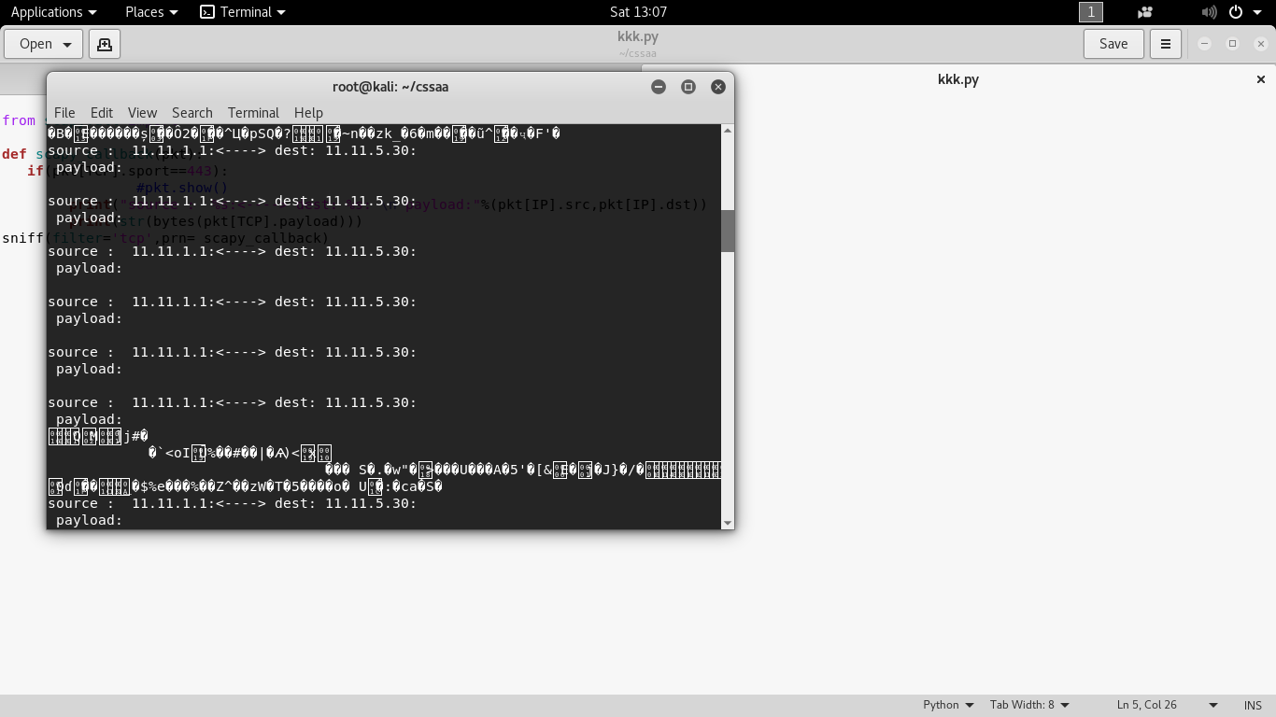

**UDP Packets:**

from scapy.all import *

def scapy_callback(pkt):

if(pkt[UDP].sport==161 ):

#print("Source IP: %s:%s <---> Dest IP: %s:%s \n Payload:" %(pkt[IP].src,pkt[TCP].sport,pkt[IP].dst,pkt[TCP].dport))

#print(pkt[TCP].payload)

#pkt.show()

print("source : %s:<--->dest : %s: payload:" %(pkt[UDP].src,pkt[UDP].dst))

print(str(bytes(pkt[UDP].payload)))

sniff(filter='udp port 161', prn=scapy_callback)

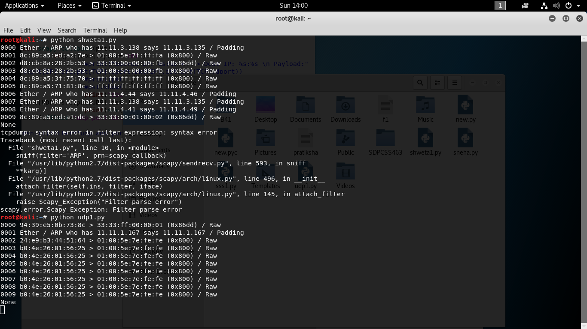

**ARP Packets:**

from scapy.all import *

def scapy_callback(pkt):

if(pkt[ARP].sport==219 ):

#print("Source IP: %s:%s <---> Dest IP: %s:%s \n Payload:" %(pkt[IP].src,pkt[TCP].sport,pkt[IP].dst,pkt[TCP].dport))

#print(pkt[TCP].payload)

#pkt.show()

print("source : %s:<--->dest : %s: payload:" %(pkt[ARP].src,pkt[ARP].dst))

print(str(bytes(pkt[ARP].payload)))

sniff(filter='ARP', prn=scapy_callback)