# CS4243 Lab 3

# ===================

# Name: Tay Yang Shun

# Matric: A0073063M

import cv2

import cv2.cv as cv

import numpy as numpy

im = cv2.imread('LabPhoto1.jpg', cv2.CV_LOAD_IMAGE_COLOR)

gr = cv2.imread('LabPhoto1.jpg', cv2.CV_LOAD_IMAGE_GRAYSCALE)

# Pops up a window for displaying the CV_LOAD_IMAGE_GRAYSCALE

winname = 'imageWin'

win = cv.NamedWindow(winname, cv.CV_WINDOW_AUTOSIZE)

cv2.putText(im, 'motion', (20, 20), cv2.FONT_HERSHEY_COMPLEX_SMALL, 1, (255, 255, 255))

cv2.imshow('motion image', im)

cv2.waitKey(1000)

cv.DestroyWindow(winname)

invid = cv2.VideoCapture('LabVideo.MOV')

width = int(invid.get(cv.CV_CAP_PROP_FRAME_WIDTH))

height = int(invid.get(cv.CV_CAP_PROP_FRAME_HEIGHT))

fps = int(invid.get(cv.CV_CAP_PROP_FPS))

length = int(invid.get(cv.CV_CAP_PROP_FRAME_COUNT))

for i in range(length):

_, im = invid.read()

if i % 3 == 0:

cv2.imshow('fastForward',im)

cv2.waitKey(100)

del invid

cv2.destroyAllWindows()

# Lab 3

IMAGE_1_FILENAME = 'LabPhoto1.jpg'

IMAGE_1_GRAY_FILENAME = 'grayImage1.jpg'

IMAGE_2_FILENAME = 'LabPhoto2.jpg'

IMAGE_2_GRAY_FILENAME = 'grayImage2.jpg'

IMAGE_1_TRACKING_FILENAME = 'LabPhotoTracking1.jpg'

IMAGE_2_TRACKING_FILENAME = 'LabPhotoTracking2.jpg'

TEXT_ORIGIN = (20, 20)

TEXT_FONT = cv2.FONT_HERSHEY_COMPLEX_SMALL

TEXT_FONT_SCALE = 1

TEXT_FONT_COLOR = (255, 255, 255)

TRACKING_CORNER_COUNT = 200

TRACKING_QUALITY_LEVEL = 0.001

TRACKING_MIN_DISTANCE = 9.0

im1 = cv2.imread(IMAGE_1_FILENAME, cv2.CV_LOAD_IMAGE_COLOR)

im2 = cv2.imread(IMAGE_2_FILENAME, cv2.CV_LOAD_IMAGE_COLOR)

im1_height, im1_width, im1_depth = im1.shape

im2_height, im2_width, im2_depth = im2.shape

print 'Dimensions of', IMAGE_1_FILENAME, ':', im1_height, 'x', im1_width

print 'Dimensions of', IMAGE_2_FILENAME, ':', im2_height, 'x', im2_width

grImg1 = cv2.cvtColor(im1, cv2.COLOR_BGR2GRAY)

cv2.putText(grImg1, IMAGE_1_FILENAME, TEXT_ORIGIN, TEXT_FONT, TEXT_FONT_SCALE, TEXT_FONT_COLOR)

cv2.imshow(IMAGE_1_GRAY_FILENAME, grImg1)

cv2.imwrite(IMAGE_1_GRAY_FILENAME, grImg1)

grImg2 = cv2.cvtColor(im2, cv2.COLOR_BGR2GRAY)

cv2.putText(grImg2, IMAGE_2_FILENAME, TEXT_ORIGIN, TEXT_FONT, TEXT_FONT_SCALE, TEXT_FONT_COLOR)

cv2.imshow(IMAGE_2_GRAY_FILENAME, grImg2)

cv2.imwrite(IMAGE_2_GRAY_FILENAME, grImg2)

feat1 = cv2.goodFeaturesToTrack(grImg1, TRACKING_CORNER_COUNT, TRACKING_QUALITY_LEVEL, \

TRACKING_MIN_DISTANCE).reshape((-1, 2))

criteria = (cv.CV_TERMCRIT_ITER | cv.CV_TERMCRIT_EPS, 80, 0.0001)

win = (3, 3) # actual size is 3*2+1 x 3*2+1

zero_zone = (-1, -1) # no dead zone

cv2.cornerSubPix(grImg1, feat1, win, zero_zone, criteria)

feat2 = np.copy(feat1)

feat2, status, err = cv2.calcOpticalFlowPyrLK(grImg1, grImg2, feat1, feat2)

print feat1

print feat2

im1 = cv2.imread(IMAGE_1_FILENAME, cv2.CV_LOAD_IMAGE_COLOR)

cv2.namedWindow('Picture1')

for (x, y) in feat1:

cv2.circle(im1, (int(x), int(y)), 3, (255, 255, 255), -1)

cv2.imshow("Picture1", im1)

cv2.imwrite(IMAGE_1_TRACKING_FILENAME, im1)

im2 = cv2.imread(IMAGE_2_FILENAME, cv2.CV_LOAD_IMAGE_COLOR)

cv2.namedWindow('Picture2')

for (x, y) in feat2:

cv2.circle(im2, (int(x), int(y)), 3, (255, 255, 255), -1)

cv2.imshow("Picture2", im2)

cv2.imwrite(IMAGE_2_TRACKING_FILENAME, im2)

if cv2.waitKey(0) == 27:

cv2.destroyAllWindows() # Save marked images.

**Question 7**

Picture 1

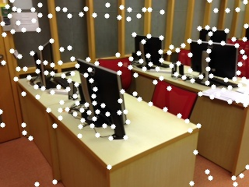

Picture 2

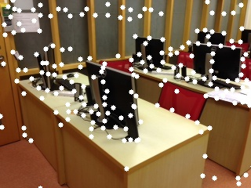

**Question 8**

Picture 1 Marked (Points in black circles)

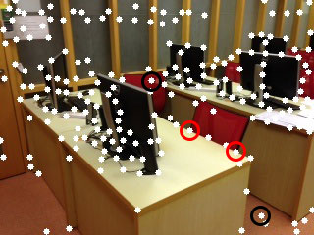

The tracking was wrong for the points circled in black because they were not very distinct corners.

The points circled in red are good corners but they aren’t real features. They are created from the superposition of two objects. Hence they should not be tracked.