Managing data reliability and integrity
in federated cloud storage
Krzysztof Styrc¹, Piotr Nowakowski¹, Marian Bubak¹
¹ ACK CYFRONET AGH , ul. Nawojki 11, 30-950 Kraków
emails: kstyrc@gmail.com, ymnowako@cyf-kr.edu.pl, bubak@agh.edu.pl
Keywords: data integrity, cloud computing, federated cloud storage
Introduction
Nowadays, we observe a rapid shift from privately owned and maintained computer systems toward cloud computing, especially cloud storage which provides virtually unlimited storage capacity, high availability and built-in replication, while reducing operational costs. However, recently numerous cloud provider downtimes question the reliability of cloud solutions [1]. Furthermore, when SLA contracts are not meet, provider only guarantees return of costs. While methods that ensure data integrity of local storage are well-established, vast volumes of externally stored data accessible via network pose an engineering challenge. Naive retrieving entire volume and validating its cryptographic integrity is practically infeasible, especially when providers charge fees for outbound data transfer. It is an ongoing effort to propose methods for ensuring data integrity in cloud storage.
VPH-Share project [2] aims to build a collaborative computing environment and infrastructure where researchers from the domain of physiopathology
of the human body will work together on developing new biomedical simulation software. The data in VPH platform is predominantly of static nature and stored on federation of public and private cloud storage resources. Ensuring data availability and integrity is a crucial requirement, but neither of the proposed solutions are applicable for VPH platform. As a result, we propose a new method to ensure data reliability in federated cloud storage environment which periodically monitors the availability and integrity of datasets (sets of files) and notifies the owner if any data corruption has been detected. Additionally, the solution will enable data replication across multiple cloud storage providers.
Description of a problem solution
In the context of VPH-Share project [2] we propose a data reliability and integrity (DRI) service that provides suitable API to ensure data integrity of data in the cloud. DRI is a stateless REST web service that was designed, implemented and deployed within service-based VPH environment. The conceptual architecture of the component is presented in Fig. 1. DRI depends on Atmosphere Internal Registry (AIR) for metadata persistence of validation checksums, datasets and configuration. It accesses multiple cloud storage providers to access VPH-Share users data and notifies data owners of data unavailability or corruption via Notification Service. Internally, DRI abstracts all its dependencies via separate package that is responsible for access. Typical use case is as follows: user tags selected dataset for data integrity monitoring. Then DRI periodically retrieves dataset metadata from AIR registry, validates the data on multiple cloud storages and notifies the user is case of any problems detected.
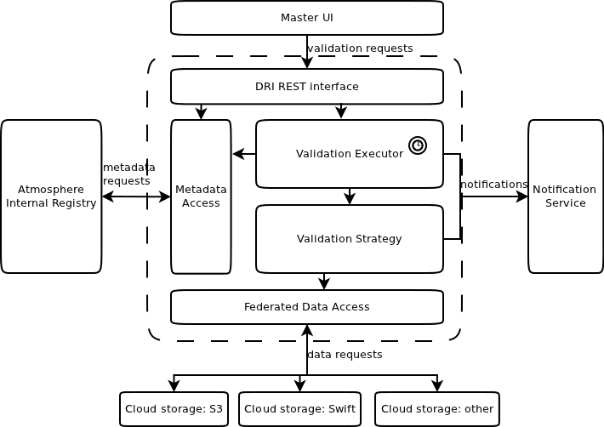
Fig. 1 DRI architecture within VPH-Share environment
Results
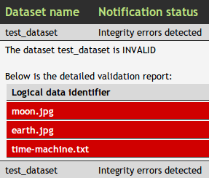
In setup phase, our validation algorithm divides a file F into n equally-sized chunks, computes their MAC hashes and store them in metadata registry. In validation phase, it randomly selects k out of n chunks (where k << n), computes its hashes again and compares them with the original ones. In comparison with classic whole file content approach, our algorithm significantly reduces network overhead – only k out of n chunks are downloaded, but provides only limited error detection rate.
DRI was successfully implemented and deployed within VPH-Share Cloud Platform environment, ensuring users with integrity of their data.
Conclusions and future work
In this work we proposed a method for ensuring data availability and integrity in federated cloud storage and provided a proof of concept DRI component design and its implementation within VPH-Share project.
The future work should focus on proposing better validation algorithm, as well as on extracting DRI design from VPH-Share context and enable to use it outside of the platform.
References
[1] C. Cerin et al: Downtime statistics of current cloud solutions, IWGCR, June 2013
[2] P. Nowakowski et al: VPH-Share WP2: Data and Compute Cloud Platform, Deliverable: D2.2
, VPH-Share, 2011

