Ph.D. Chen Hu 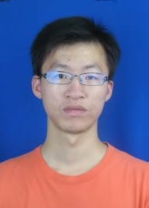

Tel：0755-2694-3167

E-mail: curiousbull@163.com

Address: Room 339, Administration Building, Shenzhen University, Nanshan District, Shenzhen, Guangdong, China, 518060

**EDUCATION**

2016 Nanjing Normal University, China, School of Physics and Technology, Ph.D

2010 Changchun University, China, School of Sciences, BSc

**WORKING EXPERIENCE**

2011-2015 Visiting Scholar, IHEP, China

**AWARDS**

**RESEARCH INTERESTS**

Quantitative Investment

High Energy Physics

**PUBLICATIONS**

International Journal Paper

1. Ablikim M, Achasov M N, Ai X C, et al. Measurement of the Matrix Elements for the Decays $η→π^{+}π^{-}π^{0}$ and $η/η^{'}→π^{0}π^{0}π^{0}$ [J]. Physical Review D, 2015, 92.
2. APAKang, X. L., Wu, L. H., Wu, Z., Luo, T., Hu, C., & Wang, H. X., et al. (2014). Study of the calibration of x-t relation for the besiii drift chamber. Eprint Arxiv.

**CONFERENCE AND PRESENTATIONS**