|  |  |
| --- | --- |
|  | DC Power MonitorInstructions |

|  |  |  |  |  |  |
| --- | --- | --- | --- | --- | --- |
| Date: | 01/06/21 | Version: | 1.0 | By: | Matt Little |

|  |  |
| --- | --- |
|  | *This is a reasonably simple kit which requires some soldering.*  *It should take under 1 hour to build.*  *Not suitable for under 12 years old.* |

# Parts included:

|  |  |  |  |  |  |  |  |  |
| --- | --- | --- | --- | --- | --- | --- | --- | --- |
|  |  |  | 2×1W Solar PV Panels | |  |  |  |  |
|  |  | | | | | | |
|  |
|  |
|  |
| Wire  (not shown)  Single core cable. |  |
| 18650  Battery holder |  |
| PCB |
|  |  |
| 2 x Screw terminals |  |
|  |
| 6 way header pins | Switch |
|  | 2 x LEDs |
|  |  | DC-DC Converter (version 1) | | 2×1uF Capacitors | 4 x Resistors |  |  |  |

# PCB Parts List:

|  |  |  |  |  |  |
| --- | --- | --- | --- | --- | --- |
| **Ref** | **Item** | **Quantity** | **Ref** | **Item** | **Quantity** |
| C1 | 100nf capacitor (SMD Soldered) | 1 | J8, J9 | Input and Output 20A terminals | 2 |
| C2 | 2.2uf capacitor (SMD Soldered) | 1 | R1, R2 | 4.7k (SMD Soldered) | 2 |
| C3 | 1uf capacitor (SMD Soldered) | 1 | R3, R4, R5 | 470R (SMD Soldered) | 3 |
| C4,C5 | 10nf capacitor (SMD Soldered) | 2 | R6 | Shunt Resistor.  ( 0.005 Ohm supplied). | 1 |
| J1, J2 | DATA - Grove connector 4 way | 2 | U1 | ISL28022 Power Monitor IC (SMD Soldered) | 1 |
|  | PCB | 1 |  |  |  |

# Tools required:

|  |  |  |
| --- | --- | --- |
|  |  |  |
|  | Long-nosed  Pliers |
| Soldering Iron | Posi-drive  Screwdriver |
| Solder |  |
| Side cutters |  |
|  |  |
| Scissors  (not shown) |  |
|  |  |

# Instructions:

|  |  |  |
| --- | --- | --- |
| **Step: 1** | Solder resistors | |
|  | |  |

|  |  |  |
| --- | --- | --- |
| **Step: 2** | Solder capacitors | |
|  | |  |

|  |  |  |
| --- | --- | --- |
| **Step: 3** | Solder switch and screw terminals | |
|  | | *.* |

|  |  |  |
| --- | --- | --- |
| **Step: 4** | Solder LEDs | |
| . | |  |

|  |  |  |
| --- | --- | --- |
| **Step: 5** | Solder DC-DC converter (version 1) | |
|  | |  |

|  |  |  |
| --- | --- | --- |
| **Step: 5** | Solder DC-DC converter (version 2) | |
|  | |  |

|  |  |  |
| --- | --- | --- |
| **Step: 6** | Solder Li Ion cell holder | |
|  | |  |

|  |  |  |
| --- | --- | --- |
| **Step: 7** | PCB is finished! | |
|  | | The IC is a surface mount device and almost impossible to solder by hand, hence we have already soldered this component for you. |

# Communication Instructions:

|  |  |  |
| --- | --- | --- |
| **Step: 8** | Connect up to your microcontroller of choice! | |
|  | |  |

# Testing & Fault Finding

# Contact details:

This kit has been designed and produced by:

The Curious Electric Company

[**hello@curiouselectric.co.uk**](mailto:hello@curiouselectric.co.uk)

[**www.curiouselectric.co.uk**](http://www.curiouselectric.co.uk/)

Unit 23, Block D, Hartley Business Centre, Haydn Road, Nottingham, NG5 1DG, UK

We would like you to be happy with this kit. If you are not happy for any reason, then please contact us and we will help to sort it out.

Please email [**hello@curiouselectric.co.uk**](mailto:hello@curiouselectric.co.uk) with any questions or comments.

Please tweet us at **@curiouselectric**

If any parts are missing from your kit then please email [**hello@curiouselectric.co.uk**](mailto:hello@curiouselectric.co.uk) with details, including where the kit was purchased.

More technical information can be found via [**www.curiouselectric.co.uk**](http://www.curiouselectric.co.uk/)

# Circuit Schematic:

# PCB:

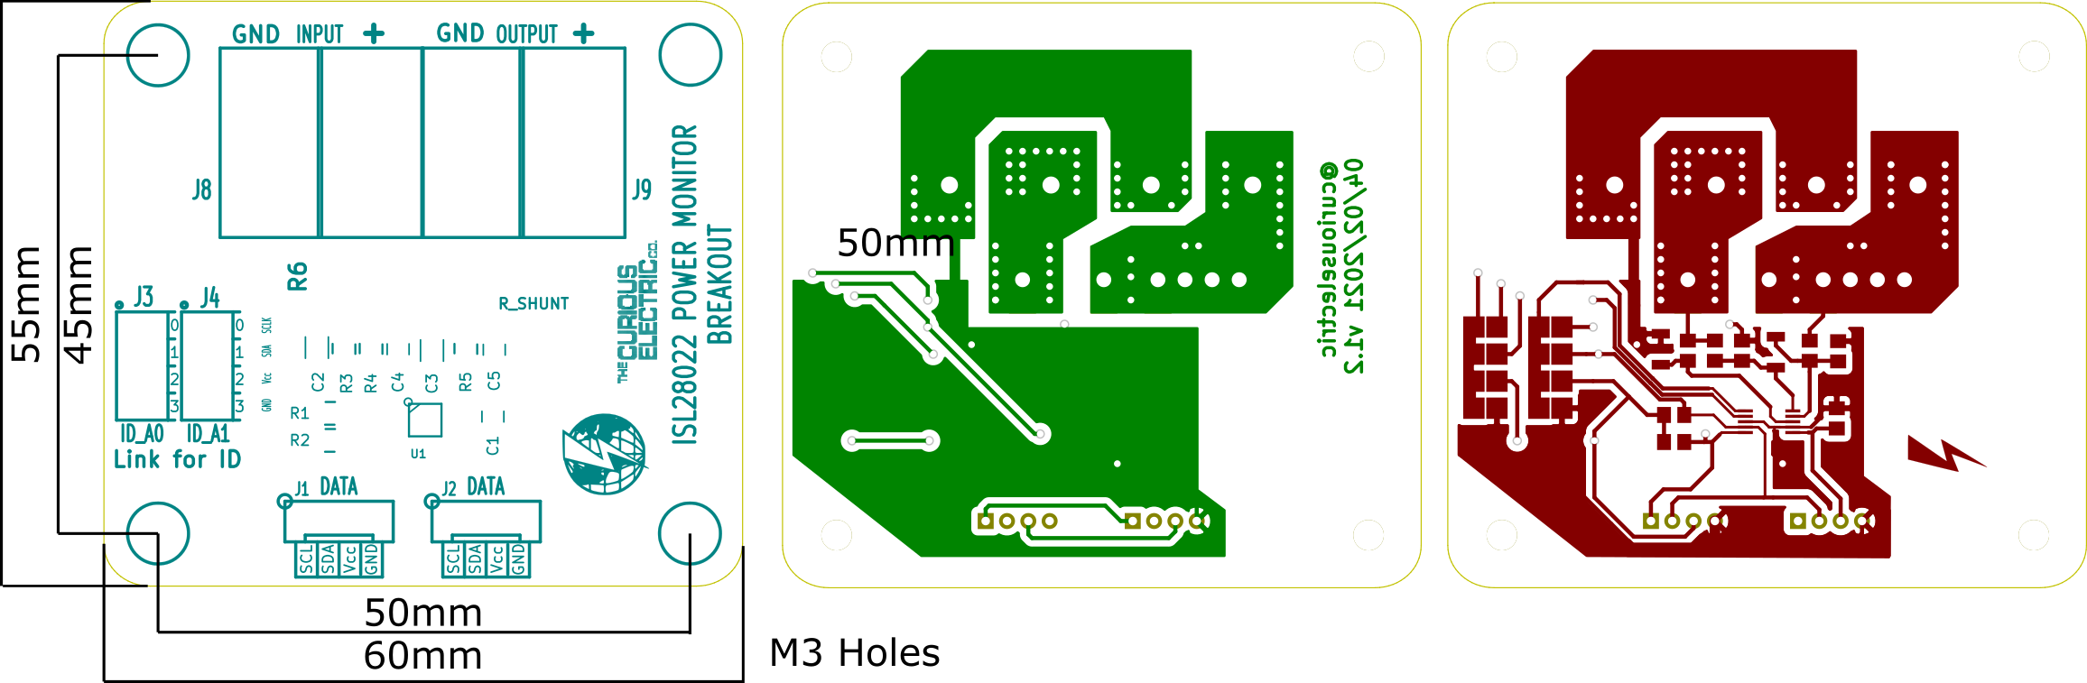

(Not to scale)