 | Solar 8-Ball Instructions

Date: | 09/05/2020 | Version: | 1.0 | By: | Matt Little

Parts included:
Parts list:
Item | Ref | Item | Ref
Tools required:
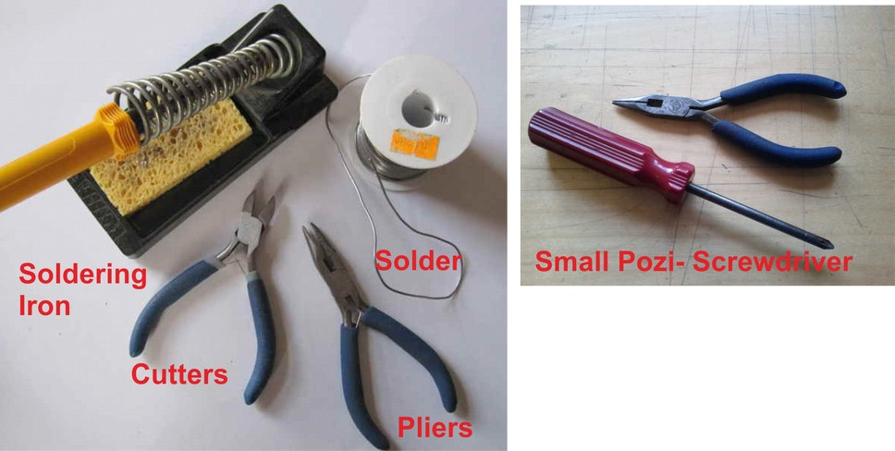

PCB Instructions:
Step: 1 | Solder resistors
Value | Ref | Colour

Insert and solder the resistors.
Polarity does not matter for resistors.
Ensure they are soldered flat close to the PCB.

Use a multimeter or colour code chart to ensure correct resistor values.

Step: 2 | Solder capacitors
First solder the non-polarised capacitors.
Orientation of these does not matter:

Value | Ref | Marking

Note: You may need a magnifying glass for reading the text on these capacitors.

Next solder the polarised capacitors. Ensure correct orientation of these components.
The negative lead is marked with a white strip. The positive lead is slightly longer than the negative. Align the positive lead with the + sign and the negative lead with the white PCB marking.

Value | Ref | Marking

Step: 3 | Solder diodes
There are 4 diodes to solder.
Ensure correct orientation for these components.

First solder the LED into D4.
The long lead is positive, so place that into the hole marked +. The negative side is slightly flat.

Then solder the 5.1 V zener diode into D1. This diode is on it’s own and has very tiny marking of “5V1”. Ensure the black band aligns with the white band marked on the PCB.

Then solder the remaining 2 diodes into D2 and D3. These have tiny markings saying “4148”. Ensure the black band aligns with the white band marked on the PCB.

Step: 4 | Solder transistor
There is just one transistor to solder, Q1, BC337.
Ensure the flat side of the transistor aligns with the PCB markings.

Step: 5 | Solder IC holders
There are two 14 pin IC holders and one 8 pin IC holder. These fit into the areas marked U1, U2 and U3.

Ensure correct orientation!

Ensure the notch on the holder aligns with the notch shown on the PCB.

Step: 6 | Solder Switch and Potentiometer
The switch fits into the holes marked SW1. The switch knob goes off the PCB.
Solder all metal tabs.

The potentiometer fits into the holes marked RV1. There are 5 pins to align and the pins might need slightly moving to ensure they align correctly.

Solder all metal tabs.

Step: 7 | Solder the ultrasonic receiver
The ultrasonic receiver has two pins, one is attached to the metal case of the unit, the other has a small ring around it.

The pin with the small ring around it is the +ve connection and this pin fits in the hole with the + symbol. The ground fits next to the indicator P1.

Carefully bend the legs to 90 degrees to the receiver is facing away from the PCB.

Step: 8 | Solder Speaker
The speaker has a slightly unusual mounting method.

The speaker base fits through the large hole in the PCB and the speaker tabs align with the PCB tabs.

Use an off-cut of resistor lead and solder two small leads from the PCB (as shown). Carefully bend the legs to 90 degrees before soldering in position facing away from the PCB.

Then put the speaker in place and solder the small wires to the speaker.

This method holds the speaker in place, as well as being the electrical connection.

Step: 9 | Solder PP3 battery connector
Nearly there!
The PP3 battery clip as two wires: one positive (red) and one negative (black).

I usually put a knot in the cable for strain relief.

The cables then go through the larger holes from the underside and are fed back into the solder pads.

The red cable goes through the hole to the pad marked “+”.

Step: 10 | Insert ICs
Now we need to insert the ICs into their holders.
Ensure the notches align with the notches on the IC holders and the PCB.

U1 is the LM386 (8 pin)
U2 is the TL074 (14 pin)
U3 is the 4024 (14 pin)

Step: 11 | Insert battery and test
Add a PP3 9V battery to the battery clip. Switch the unit on.
You may hear a squeal from the device. Adjust the potentiometer until you just do not hear any noise.

The red LED should also flash when the speaker clicks.

Use a reel of sticky tape to test. Slowly peel the tape off the reel and you should hear crackles from the speaker. This is picking up high frequency sound from the glue breaking. You can also test by pointing at a compact fluorescent light bulb. These switch at around 100 kHz and hence give off ultrasonic noise.

Step: 12 | PCB is finished! Lets test it!
Have a nice cup of tea.


Please note: This unit is NOT waterproof. Do NOT leave outside if it will get wet.

Step: 13 | Re-programming
Contact details:
We would like you to be happy with this kit. If you are not happy for any reason then please contact us and we will help to sort it out.

Please email hello@curiouselectric.co.uk with any questions or comments.
Please tweet us at @curiouselectric

If any parts are missing from your kit then please email hello@curiouselectric.co.uk with details and, if possible, where the kit was purchased.

More technical information can be found via www.curiouselectric.co.uk

This kit has been designed and produced by:
The Curious Electric Company
hello@curiouselectric.co.uk
www.curiouselectric.co.uk
Unit 23, Block D, Hartley Business Centre, Haydn Rd, Nottingham, NG5 1DG, UK

Circuit Schematic

Resistor Colour Codes
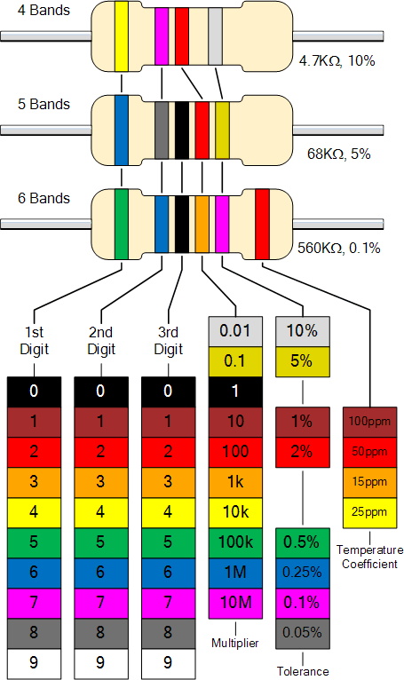
0

1

2

3

4

5

6

7

8

9

