 | Solar 8-Ball Instructions

Date: | 15/05/2020 | Version: | 1.0 | By: | Matt Little

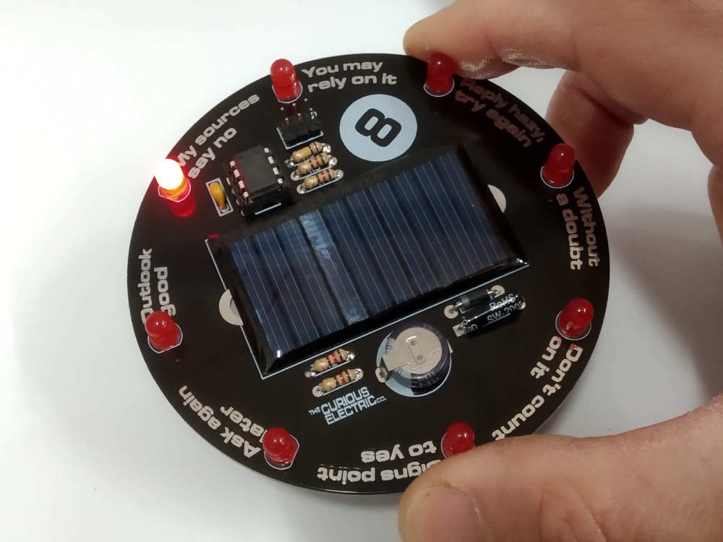  Shake the Solar 8 Ball to reveal the answers to your deepest questions! | When you shake and wake the unit, the eight LEDs around the edge of the PCB will glow in sequence and slowly stop on one of eight ‘answers’ to your questions.  It’s solar powered, so will never need batteries! It uses an ultra-capacitor to store the solar energy, so will work even if left uncharged for a long time. But it will need to be left in sun to recharge and then you get in the region of 10-20 ‘rolls’ of the 8 ball.  Once made, it should look great on a bright bit of desk or a windowsill and will be ready for you to ask your most existential questions…  It’s designed as a fun and interactive way introduce solar power and improve soldering skills.
Parts included:
 |  |  | Beautiful Circuit Board! |  |  |  |  | 8 x LEDs
 | 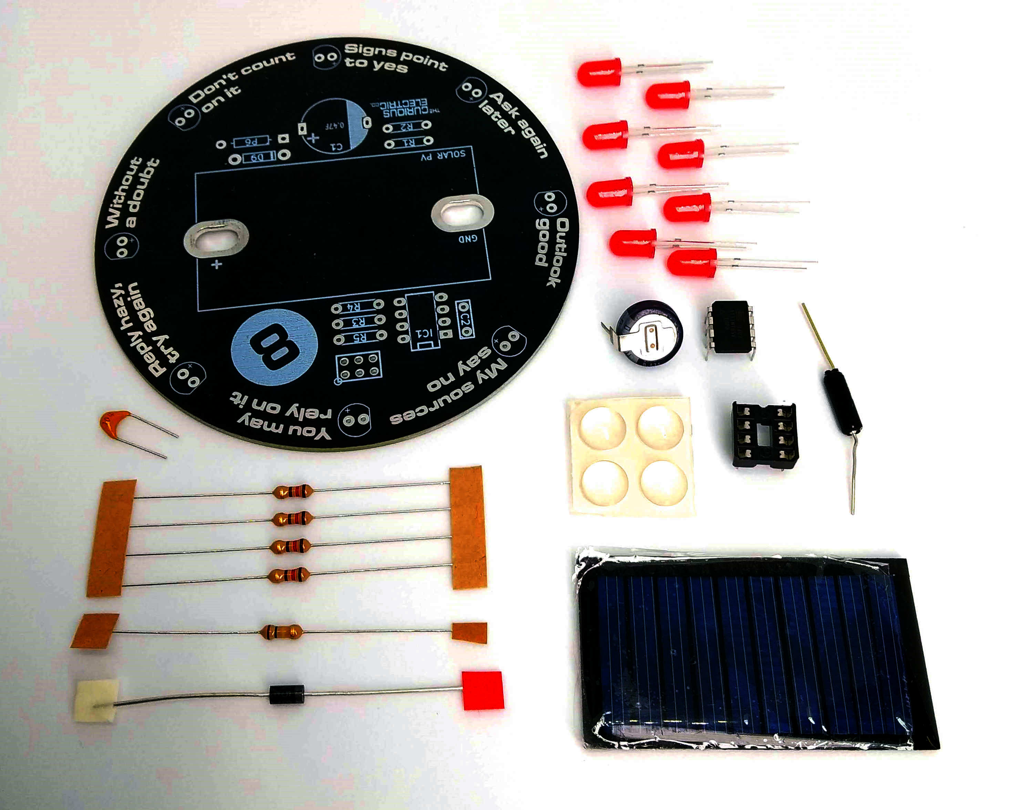 |  |  |  |  |  |  | 8 x LEDs
 |  |  |  |  |  |  |  | Ultra-Capacitor
ATTiny85
Programmed Microcontroller
(& holder)
100 nf  Capacitor |  |  |  |  |  |  |  | Vibration Sensor Switch
 |  |  |  |  |  |  |  | Rubber Feet
5 x resistors:  4 x 120 Ω  1 x 100 kΩ |  |  |  |  |  |  |  | Solar Photovoltaic Panel  (5V, 30mA)
 |  | Diode
Parts list:
Item | Ref | Item | Ref
0.47F Ultra Capacitor | C1 | 2x3 ISP Header | P2
100nF Decoupling Capacitor | C2 | Vibration Switch | P6
5mm Red LEDs | D1 – D8 | Printed Circuit Board | PCB
1N5819 Shottky Diode | D9 | 120 Ω Resistor | R1 – R4
ATTiny85 Microcontroller (programmed)  Plus IC Holder | IC1 | 100 kΩ Resistor | R5
Solar Photovoltaic Panel (5V, 30mA) | SC1 | Rubber Feet
Tools required:
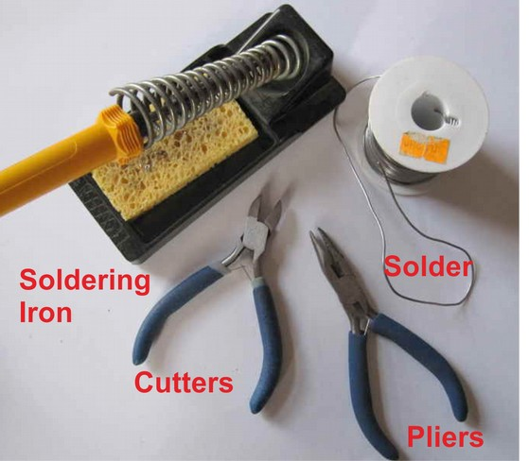

PCB Instructions:
Step: 1 | Solder resistors
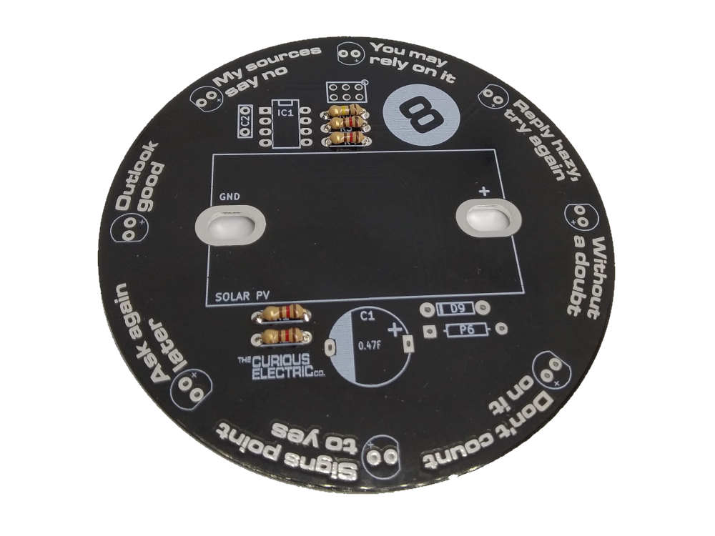 |  | Insert and solder the resistors to the locations marked on the PCB.  Polarity does not matter for resistors.  Ensure they are soldered flat & close to the PCB.  You can use a multi-meter or colour code chart to ensure correct resistor values.
  Value | Ref | Colour
  120 Ω | R1 – R4 | Brown – Red – Brown – Gold
  100 kΩ | R5 | Brown – Black – Yellow - Gold

Step: 2 | Solder diode (D9)
Ensure correct orientation for the 1N5819 diode component.  This has tiny markings saying “1N5819” and also a white band around one end to indicate polarity.  Ensure the white band on the diode aligns with the white band marked on the PCB. |  | 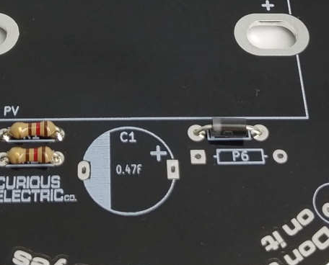

Step: 3 | Solder capacitors
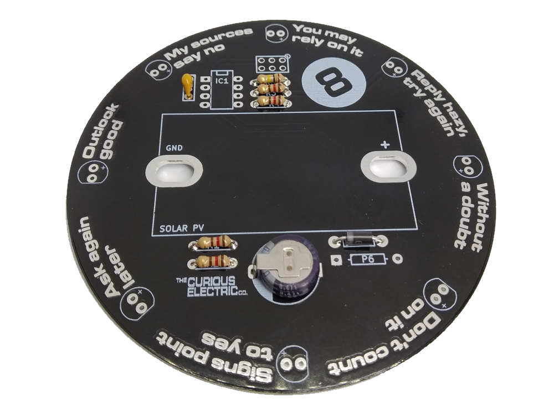 |  | First solder the non-polarised capacitor, C2.  Orientation of these does not matter:  Next solder the polarised ultra capacitor. Ensure correct orientation of this component.  The negative lead is marked with a white bars. The positive lead is on the bottom of the capacitor. Align the positive lead with the + sign and the negative lead with the white PCB marking.
  Value | Ref | Marking
  100nf | C2 | 104
  Value | Ref | Marking
  0.47F | C1 | 0.47F 5.5V

Step: 4 | Solder IC holders & ISP Port
Solder the 8 pin IC holder. These fit into the areas marked IC1  Ensure correct orientation!  Ensure the notch on the holder aligns with the notch shown on the PCB.  If you want to be able to reprogram the unit then solder in the 2x3 ISP header pins into the location marked ISP P2 on the back of the board. (This is not needed if you are not going to re-program it!) |  | 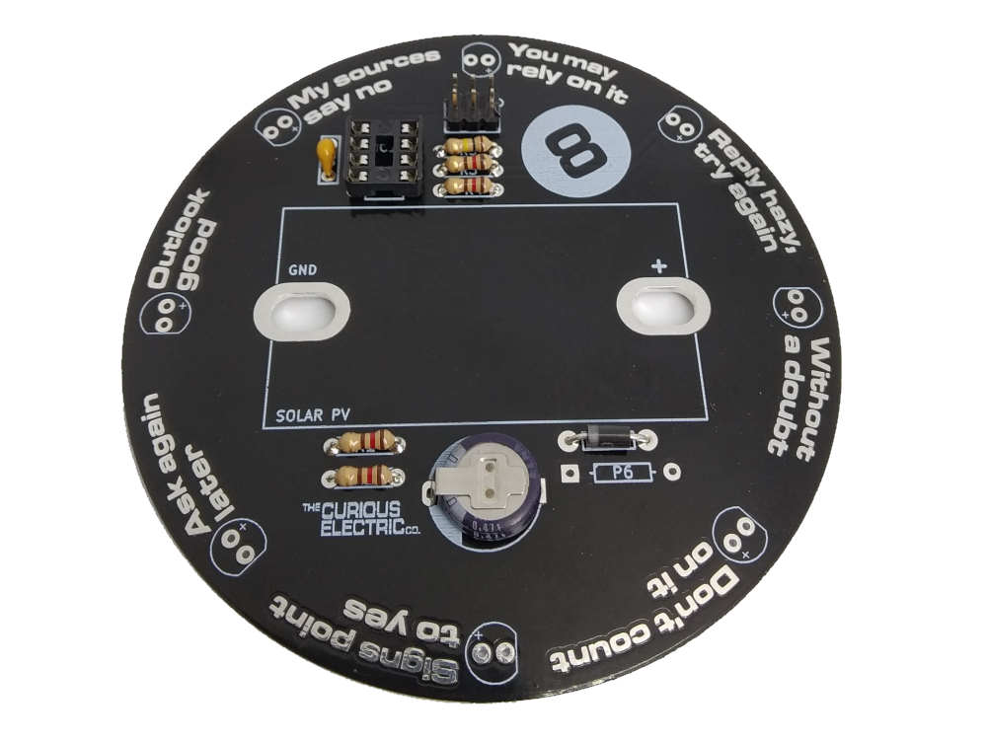

Step: 5 | Solder Vibration Switch
The vibration switch (P6) contains a small metal ball which connects some contacts to trigger the circuit.  One lead of the switch is gold coloured, the other is silver coloured.  To ensure correct operation of the switch, you need to solder the vibration switch so that it is at a slight angle (as shown) with the gold wire end slightly higher than the silver wire end. |  | 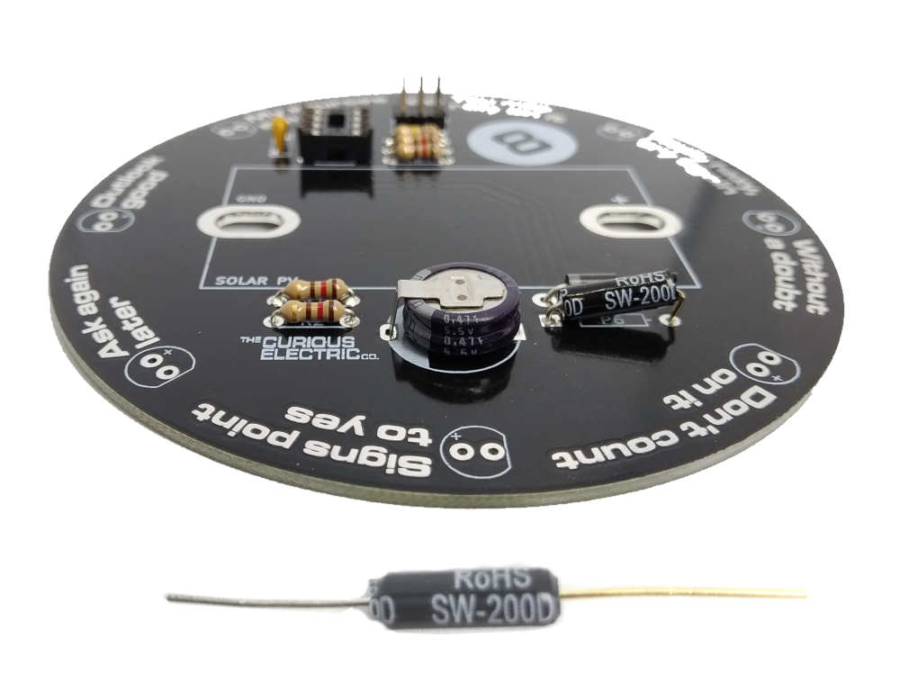

Step: 6 | Solder Solar Photovoltaic Panel
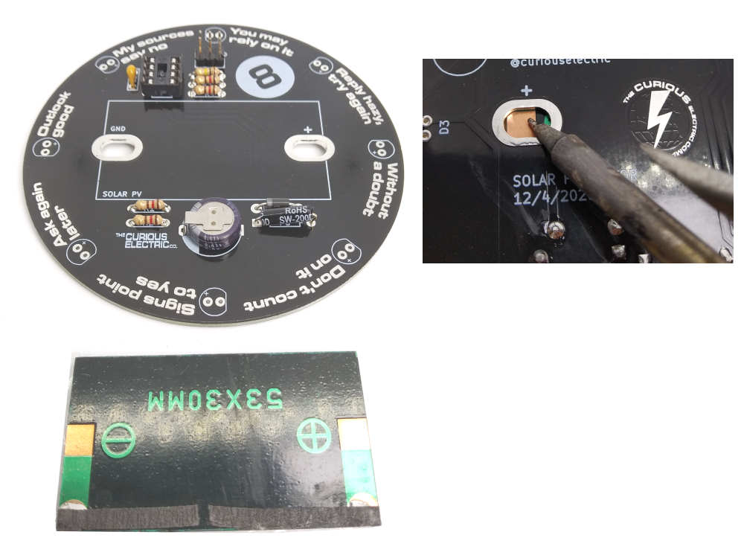 |  | The solar panel must be soldered with the correct orientation.  The solar panel has a + and a – marked side, which must align + to + and – to GND on the PCB.  The solar panel is placed flat onto the top of the PCB with the solder pads showing through the large holes.  It can help to use some tape or blue-tac to hold it in place here.  Solder the pads and onto the large holes of the PCB. You might need quite a bit of solder here.

Step: 7 | Solder LEDs
There are 8 LEDs to solder around the edge of the PCB, marked D1 – D8 on the underside of the PCB.  Ensure correct orientation!  The longer lead on the LED is positive, so place that into the hole marked +. The negative side has a slightly flat edge on the body of the LED.  Note: The LEDs are ‘charlieplexed’ which is an interesting way of running lots of LEDs from a small number of micro-controller pins. |  | 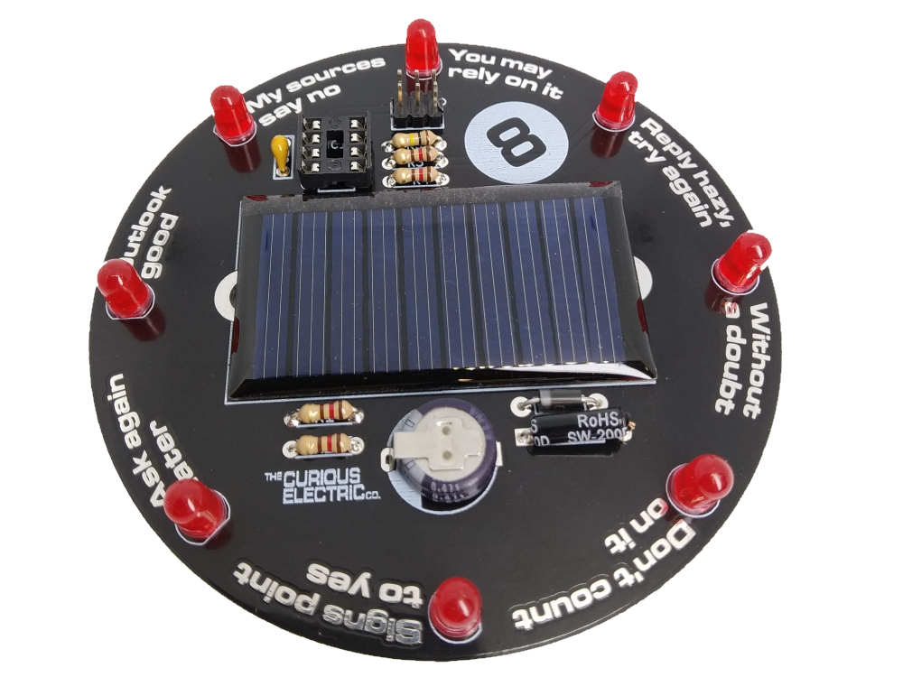

Step: 8 | Insert the IC & Test
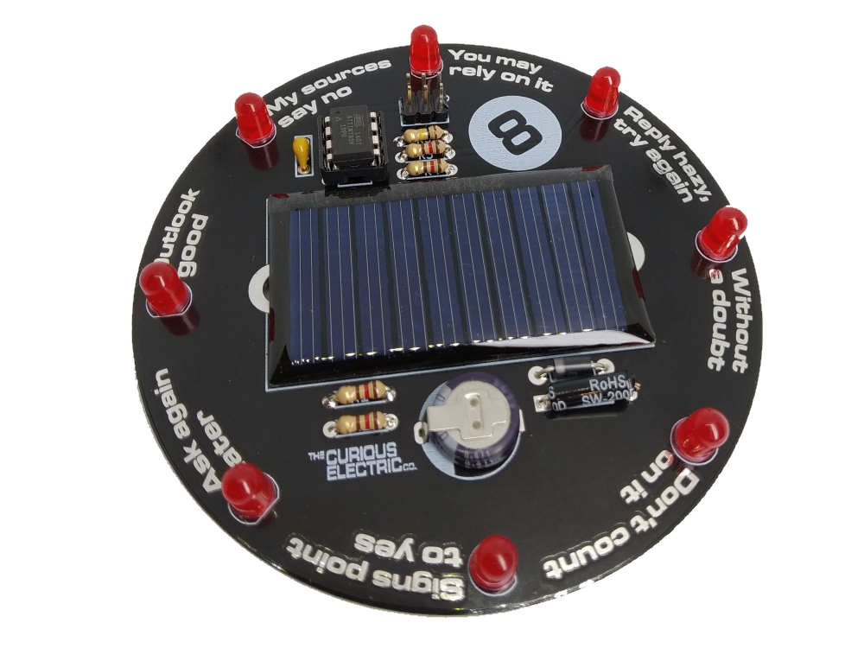 |  | Carefully push the microcontroller into the 8 pin IC holder.  Ensure that the dot on the microcontroller aligns with the notch on the IC holder.

Step: 9 | Add Rubber Feet
Stick the four rubber feet onto the base of the PCB in the locations marked with a white circle. |  | 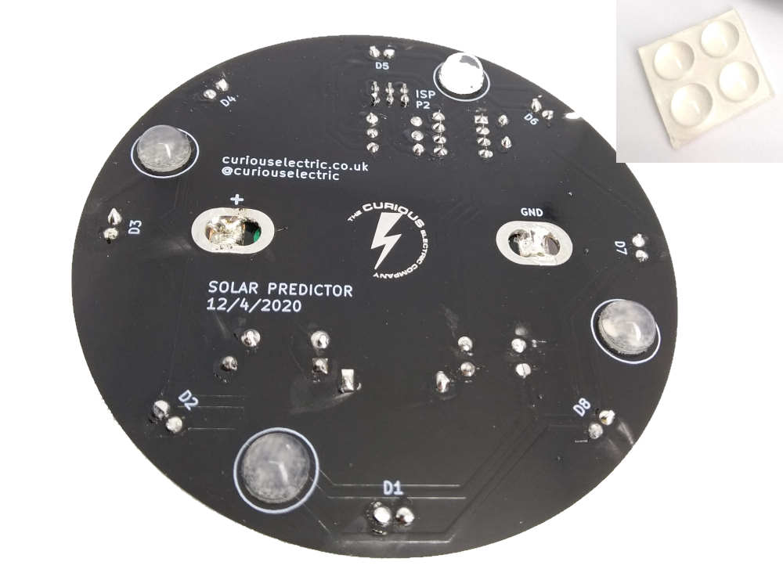

Step: 10 | PCB is finished! Lets test...
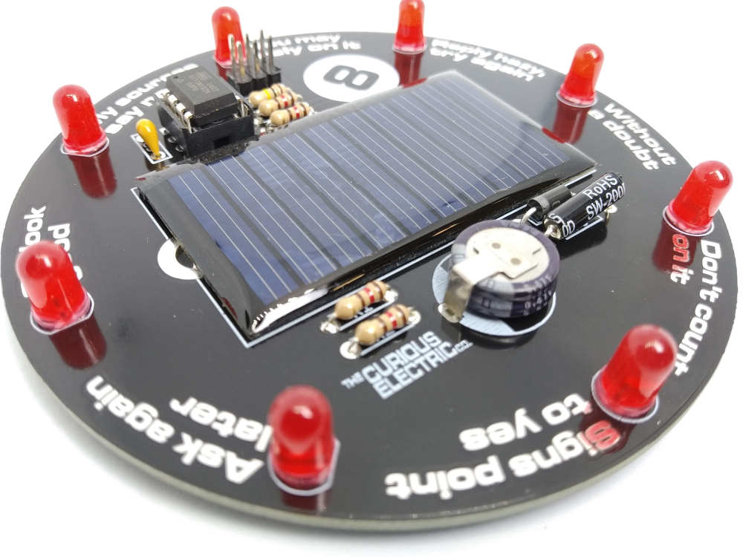  Please note: This unit is NOT waterproof.  Do NOT leave outside if it will get wet. |  | Place the finished unit in bright sunlight.  It should charge up enough to work quite quickly.  Give it a shake and you should see the LEDs light up and slowly settle on one answer.  Keep the unit level or it will be activated all the time!  To get a full charge it will need to be left in the sun for a while. It can be left on a windowsill and will work very well there.

Step: 11 | Re-programming Notes
Note: No programming is needed – the microcontrollers are already programmed!
Here are some notes for people wanting to take things a step further…
The circuit board has a standard ISP (In-System Programming) port for the ATTiny85 microcontroller and full access to the code which can be programmed via the Arduino IDE, if that’s your thing.

You will need an Arduino Uno with wiring set up for programming an ATTiny85 (please search internet).

You will need to include the ATTiny85 programming board manager into your version of the Arduino IDE (please search internet).

You upload code by using the “Arduino as an ISP” option.

Contact details:
We would like you to be happy with this kit. If you are not happy for any reason then please contact us and we will help to sort it out.

Please email hello@curiouselectric.co.uk with any questions or comments.
Please tweet us at @curiouselectric

If any parts are missing from your kit then please email hello@curiouselectric.co.uk with details and, if possible, where the kit was purchased.

More technical information can be found via www.curiouselectric.co.uk

This kit has been designed and produced by:
The Curious Electric Company
hello@curiouselectric.co.uk
www.curiouselectric.co.uk

Circuit Schematic

Resistor Colour Codes
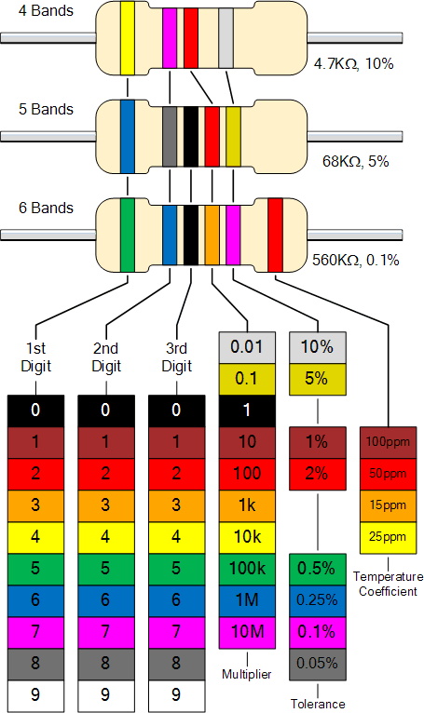
0

1

2

3

4

5

6

7

8

9

