 | Solar Charger Kit Instructions
Date: | 15/09/17 | Version: | 1.0 | By: | Matt Little

Build your own solar charger!

This unit has a USB output to recharge phones and other small devices.

There are two 1Wp solar panels which recharge a bank of three AA batteries.
A DC-DC converter ensures regulated 5V for the USB connector output.

This is a reasonably simple kit which requires some soldering and a few fiddly connections.
It should take 1-2 hours to build.
Not suitable for under 12 years old.

Parts included:
 |  |  | Laser-cut Enclosure |  |  | 3 x AA rechargeable batteries
1W Solar PV Modules
1W Solar PV Modules |  |  |  |  |  |  |  | Battery Holder
DC-DC
Converter

DC-DC  Converter |  |  |  |  |  |  |  | 7 x M3 Hex spacers
PCB |  |  |  |  |  |  |  | 7 x M3 6mm  7 x M3 8mm
 |  |  |  |  |  |  |  | Sticky Pads
Wire
 |  | Diode 1N4001 |  |  |  | Switch + 2 x M2.5 screws

Enclosure Parts:
Top 1 |  | Front
Top 2
Top 3 |  | Back
Bottom 1
Bottom 1
Bottom 1 |  | Switch  Holder

Parts list:
Item | Quantity
DC DC Converter | 1
Diode | 1
PCB | 1
Switch | 1
M2 Machine screws 10m long | 2
M3 Machine screws 6mm long | 7
M3 Machine screws 8mm long | 7
M3 Threaded Hex spacers 8mm long | 7
3 x AA Battery Holder | 1
AA NiMH Rechargable Batteries | 3
1Wp Solar PV Units. 5V max out. | 2
Wire – Red and Black | length
Laser-cut enclosure (9 pieces) 3mm Ply | 1
Double sided sticky pads | 3

Tools required:
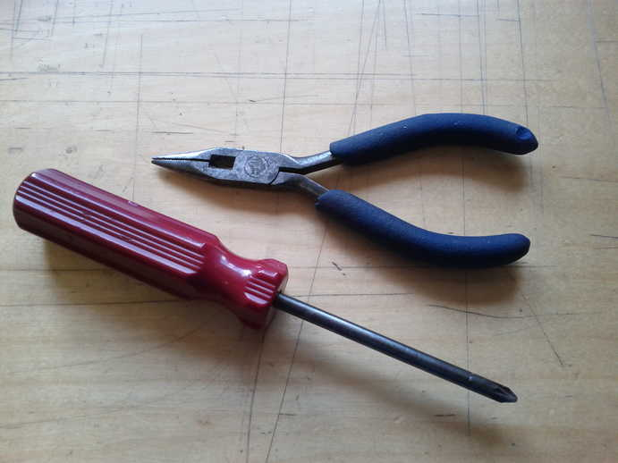
Posi-drive
Screwdriver
Long-nosed
Pliers
Soldering Iron
Solder
Side cutters
(not shown)

Instructions:
Step: 1 | Push out laser-cut parts
Sometimes not all the small laser-cut pieces have been removed. These can be pushed out using the point of a screwdriver. Only slight force should be required.

Step: 2 | Solder diode
Solder the diode onto the PCB. This is the only component on the PCB.

Ensure it is the correct orientation – the grey line on the diode body should go next to the thicker white line on the PCB.

Solder and cut off the wire ends.

Step: 3 | Add switch
Fix the switch to the wooden switch older with the two M2.5 screws.

Cut two pieces of wire 50mm long (one red/one black).

Solder them to two tabs on the switch – choose two on one row – the middle tab and the one near the ON side, marked with a small circle.

Step: 4 | Fit Solar PV Cells
Take the two solar PV units.
Lie them flat next to each other with the + to the same side and the – to the other side.

Cut 2 x 70mm long pieces of wire (one red, one black).

Solder these to the tabs on the edge of the PV units.
The red wire will connect the +'s of both modules.
The black wire will connect the -'s of both modules.

Cut 2 x 100mm long pieces of wire (one red, one black).

Put some solder onto the two middle pads of one of the PV units.
Solder the red wire to the + pad and the black wire to the – pad.
We want the wires to be soldered so the 'stand-up' so the come out of the back of the module.

These wires are fed through the wooded 'front' piece.
Ensure that the wires go through from the front of the unit (ensure the slot is on the left hand side). The front has the better quality side, with no laser cutter burn marks.

Use two of the sticky pads, each cut in half, to stick to the back of the PV units.
Then stick the two PV units to the front of the unit. Ensure they are well aligned, straight and next to each other.
We suggest doing a practice run, before removing the protective cover of the sticky pads.

You can also use silicone sealant to do this.

Step: 5 | Solder DC-DC
Cut 2 x 70mm pieces of wire (one red and one black).
Solder the red wire to the +ve connection and the back wire to the -ve.

Step: 6 | Solder to PCB
Solder each part to the connector PCB.
The red wire always goes to the + hole.

There are four things to connect to the PCB:
- Solar PV units
- DC-DC Converter
- Switch
- Battery pack

The battery holder already has wires attached.

Be careful with your soldering.
Make sure that there are no solder 'bridges' between the pads on the PCB.

Cut any excess wire from the soldered side of the PCB.

You can insert the batteries here and check that the light on the DC-DC converter turns on when the switch is towards the ON position.

If the switch action is reversed, then just unscrew the switch and rotate it.

Step: 7 | Fit plastic spacers
Now we will put it all together in the enclosure.

From the front wood piece (with the PV units stuck to it), use seven of the black M3 6mm, one through each hole and screw into the hex plastic spacer.

Do not tighten these fully, as they will need to be aligned.

Step: 8 | Add level 1
Take the base unit marked '1'.

Flip it around so the '1' is facing the front.

Fit it around the PV wires coming from the back of the front piece.

Rotate the hex spacers slightly to align with the hexagonal holes.

Fit the DC-DC converter into the slot on the left hand side. Ensure the USB socket faces the bottom of the unit.

Fit the switch (facing outwards) into the slot.

Step: 9 | Add level 2
Take the bottom piece marked '2'.
Flip it around so the '2' faces the front.

The wires from the DC DC converter and the solar PV feed through to the slot at the top of piece '2'.

Ensure no wires are trapped between layers.

The wire from the battery pack comes in from the middle slot.

Step: 10 | Add level 3
Take the bottom piece marked '3' and flip it around.

Ensure the wires are not trapped and fit through the holes.

The PCB and the excess wires need to be carefully fitted in to the space behind the switch.

If your wires are too long then this can be fiddly.

Step: 11 | Add back
Fit the back to the unit.

The logo shows to the back of the unit.

Fit the battery holder through the hole.

Ensure no wires are trapped between layers.

Use 5 x M3 8mm silver screws to fasten the back.

Step: 12 | Add top hanger
The hanging section can be built up then inserted into the top of the charger main unit.

Do this by placing 1 on top of 2 on top of 3. Piece number 2 should be in the middle, with 1 and 3 on either side.

Insert a plastic spacer into the hex hole.

Carefully push into the top of the unit. Do this one side at a time.

Use 2 x M3 6 mm long machine screws for the front of the unit.

Use 2 x M3 8mm long machine screws for the back of the unit.

Step: 13 | Add battery holder
With the remaining sticky pad, stick this to the BACK of the battery holder.

The front has a removable panel for access to the batteries.
The back does not and has a couple of small cut out holes (see photo).

Carefully align the battery holder so that the top (without wires) is pushed up against the top of the charger.

This leaves a small gap at the bottom so that the back can be removed and the batteries replaced.

Step: 14 | Fit batteries
Remove the back cover of the AA battery holder.

Do this by pushing down the removable black plastic panel.

There might be a small screw – this needs to be removed to gain access to the batteries.

Insert the 3 x AA batteries.

ENSURE CORRECT POLARITY!

Replace the back cover and insert the small screw, if you will not need access to the batteries often.

Step: 15 | Test working
The unit is nearly done.

You want to test that it is working by pushing the switch to the ON position.
There should be a small red glow from behind the USB connector. This means the DC/DC converter is working.

The solar panels will recharge the batteries whenever it is in the sun (does not matter the position of the switch).

Leave the unit switched OFF if nothing is plugged into the USB port.

Step: 16 | Build is finished!
Remove the protective plastic cover from the solar PV units.

Leave your new creation in the sun to recharge.

Have a nice cup of tea.

Use a piece of string or wire through the two holes at the top and it can be hung from a hook.

Note: This unit is NOT waterproof. Do NOT leave outside if it will get wet.

Note: The weather and available sunlight is variable, so there are no definite rules about recharging times.
If outside on an average UK summers day the batteries will be fully charged in one day.
If outside on an average UK winters day then the batteries will be fully charged in 2-3 days.
If used behind a window, the glass will affect the available sunlight and increase the recharge times by a factor or around 50%.

This kit has been designed and produced by:
The Curious Electric Company
hello@curiouselectric.co.uk
www.curiouselectric.co.uk
Hopkinson Gallery, 21 Station Street, Nottingham, NG2 3AJ

Contact details:
We would like you to be happy with this kit. If you are not happy for any reason then please contact us and we will help to sort it out.

Please email hello@curiouselectric.co.uk with any questions or comments.
Please tweet us at @curiouselectric

If any parts are missing from your kit then please email hello@curiouselectric.co.uk with details, including where the kit was purchased.

More technical information can be found via www.curiouselectric.co.uk

Circuit Schematic:

