 | Air Quality Unit Build Instructions

Date: | 17/09/2026 | Version: | 1.3 | By: | Matt Little

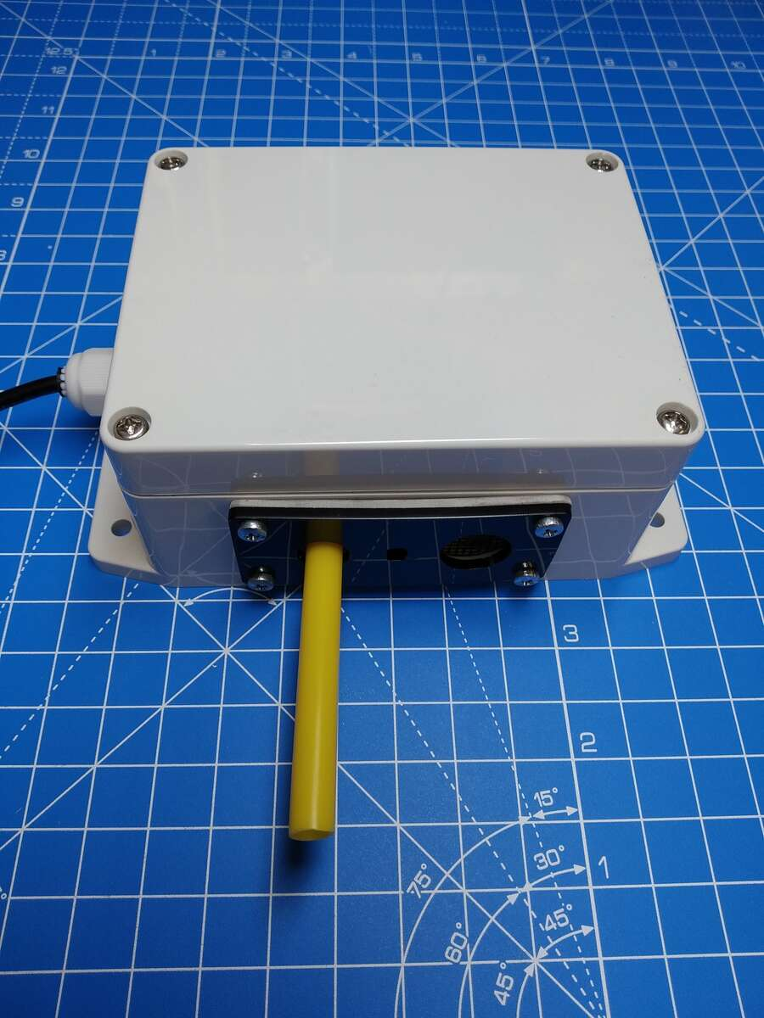  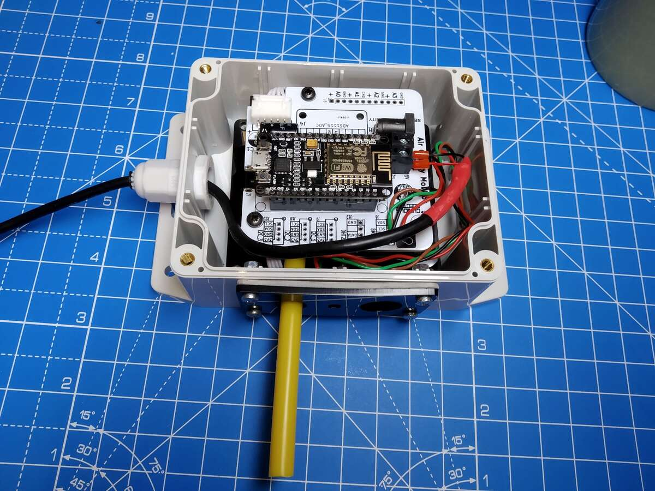 | Build your own air quality monitor and contribute to the https://maps.sensor.community worldwide air quality monitoring project. Civil Tech in action!  This kit contains all you need to set up your own online air quality monitoring unit. This records the PM2.5 and PM10 particulate data, along with temperature and humidity. This is sent (via your Wi-Fi connection) to the sensor.community platform.  In building and installing this equipment you are helping monitor local and global air quality and provide results to a growing network of civil technology sensor units!  The unit uses the SDS011 dust and particulate sensor, along with a BME280 temperature and humidity sensor. These are interfaced with an ESP8266 Wi-Fi enabled microcontroller.  Additional PCB connections can be made to add more sensors in the future.  Note: This kit contains all hardware required to set up your sensor unit. You will need a local wifi connection. You will need to install in a location which can connect to that network.  This kit requires soldering, some hardware construction and setting up an online sensor.community account and sensor node. This should take in the region of 2-4 hours to build.  This kit relies upon the sensor.community platform. Curious Electric use their firmware and do not have any input to the software side of the project.

Parts included:
 |  | Baseplate | 4 x self-tapping screws |  | PCB | SDS011 Dust Sensor
Enclosure  (pre-cut holes) | 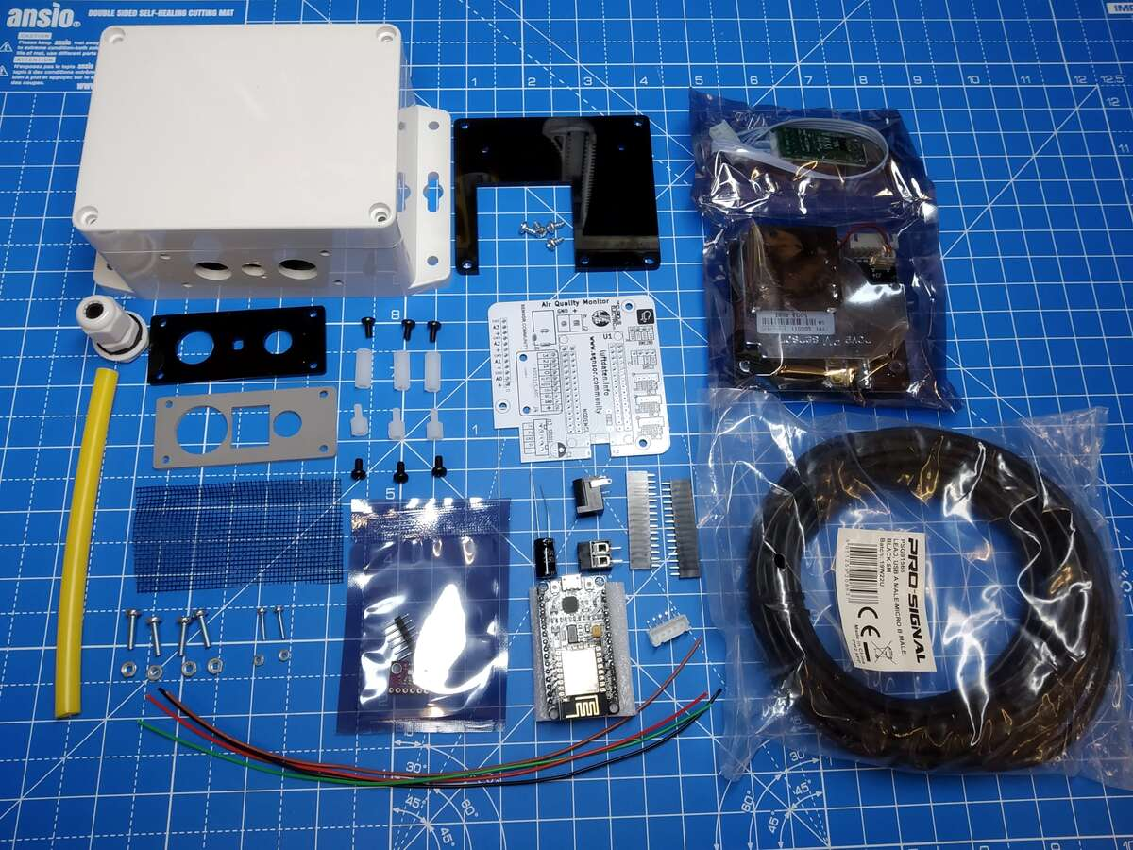
Enclosure  (pre-cut holes) |  |  |  |  |  |  |  | Power Jack
Enclosure  (pre-cut holes) |  |  |  |  |  |  |  | 2 x 15way Header Pins
Compression Gland
Sensor Plate |  |  |  |  |  |  |  | 220uf Capacitor
Sensor Plate |  |  |  |  |  |  |  | Screw Terminals
Rubber Gasket |  |  |  |  |  |  |  | USB lead (5m)
M3 Hex Spacers:
3 x 6mm & 3 x 15mm
6 x M3 6mm screws |  |  |  |  |  |  |  | 5 Way JST-XH Socket
8mm Pipe | M3 fixings  12mm x 4 | M2.5 fixings  12mm x 2 |  | Mesh | BME280  (in bag – pins not needed) | Node MCU (ESP2866)

Parts list:
Item | Ref |  | Item | Ref
Power supply buffer capacitor. 220uf | C1 |  | Dust and Particle sensor | SDS011
2.1mm barrel jack power connector | J1 |  | 5m USB cable. | USB Power Lead
2 way screw terminal | J2 |  | Waterproof small enclosure.  Pre-cut holes. | Enclosure
ADC input pins  NOT supplied/needed! | J3 |  | Laser Cut | Baseplate
ADS1115 ADC connector.  NOT supplied! | J4 |  | Laser Cut | Rubber Seal
BME280.  Temperature and Humidity Sensor | J8 |  | Laser Cut | Side Plate
4 way Connector - Grove Wiring.  NOT supplied! | J9, J10, J11 |  | Small piece | Insect Mesh
Temperature and Humidity Sensor. NOT supplied! | J12 |  | For USB power lead | Compression Gland
5 Way JST-XH 90 Connector  for SDS sensor. | J13 |  | Small piece of Pipe  6mm OD 8mm - yellow | Pipe
2 x 15 way Header for NodeMCU | J14, J15 |  | Hold SDS011 sesnsor to PCB.  M3 Hex Spacers. | 3 x Hex Spacers 6mm
SMD USB connector.  NOT supplied! | P1 |  | Hold SDS011 sesnsor to PCB.  M3 Hex Spacers. | 3 x Hex Spacers 15mm
4k7 ohm. For DHT22 sensor.  NOT supplied! | R1 |  | Hold PCB and Baseplate | 6 x M3 screws 6mm
NodeMCU ESP8266 Unit.  Programmed with airRohr software. | U1 |  | Hold baseplate to enclosure | Self Tapping screws
Printed Circuit Board. | PCB |  | Hold rubber seal and side plate | 4 x M3 screws 12mm
4 x colour cable for connecting  BME280 to PCB. 10cm long. | Cable |  | Hold rubber seal and side plate | 4 x M3 Nuts
240V AC UK Plug USB PSU 1.2A | PSU |  | Hold BME280 in place | 2 x M2.5 screws 12mm
 |  |  | Hold BME280 in place | 2 x M2.5 Nuts

Tools required:
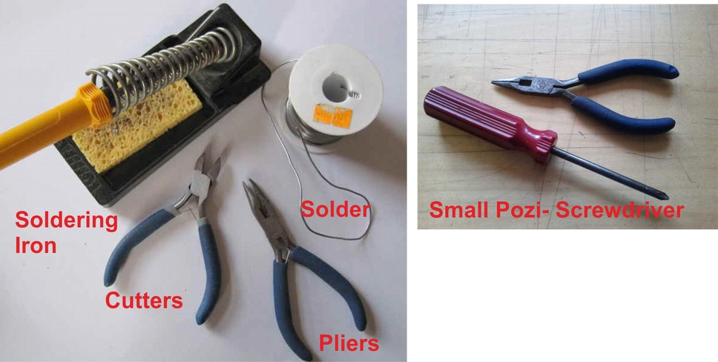
You may also need some scissors.
Hardware Instructions:
Step: 1 | Solder PCB
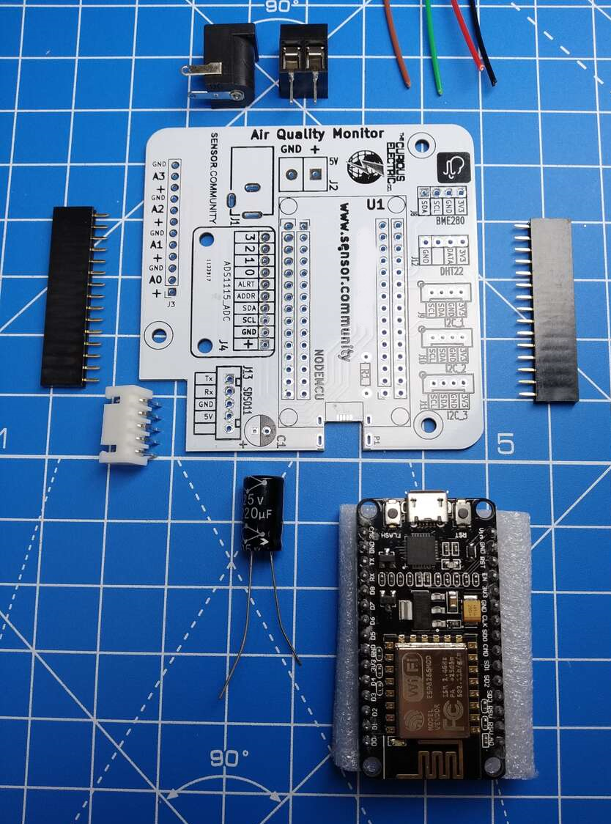 |  | First we need to solder the components to the printed circuit board (PCB).  There are 6 components and 4 wires to solder.  Note: J1, J2 and J13 need to be pointing away from the edge of the PCB when fitted.  Fit J1 (barrel jack socket) and solder.  Fit J2 (screw terminals) and solder.  Fit J13 (JST-XH 5 way right angle connector) and solder.  Fit the two rows of header pins onto the pins of the NodeMCU. This can then be put in the holes marked for U1.  Check the orientation of the NodeMCU – the USB port should be towards the edge of the PCB.  The header pins can then be soldered to the PCB. Using the NodeMCU during soldering keeps the pins in place.  Next solder the polarised capacitor. Ensure correct orientation of these components.  The negative lead on the capacitor is marked with a white strip. The positive lead is slightly longer than the negative. Align the positive lead with the + sign and the negative lead with the black PCB marking.  This component is put into position then bent to lie flat on the PCB. Then solder it. This is required to ensure the lid fits on the enclosure.  Ensure sockets are point away from the edge of the PCB, as the cables will enter from the edge.  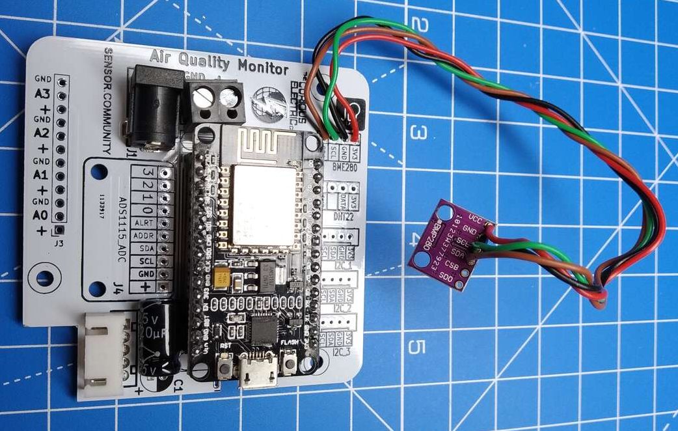  Using the four wires we need to solder the main PCB and connect to the BME280 sensor. Solder these wires so they come out on the labelled side of the sensor (as per photo).  Ensure USB pointing out, towards the PCB edge  There are four connections to make:  PCB BME280  +3.3V – Use Red wire. - VCC  GND – Use Black wire. - GND  SDA – Use either colour. - SDA  SCL – Use either colour. - SCL  The BME280 PCB is labelled with the same connections. Solder the matching names to the BME280.
  Value | Ref | Marking
  220uf Capacitor | C1 | 25V 220uf

Step: 2 | Add spacers to dust sensor
Take the SDS011 unit and cable from its package.  (Note: There is a USB to serial converter in the package, if you would like to directly connect to the sensor from a computer, but that is not needed for this project)  Use the 3 x 6mm M3 hex spacers (with thread sticking out) and the 3 x 15mm M3 hex spacers and connect through the three mouthing holes on the dust sensor.  The longer (15mm) hex spacers should go on the side with the sensor (shiny box and fan), while the shorter spacers go on the PCB side of the sensor. |  | 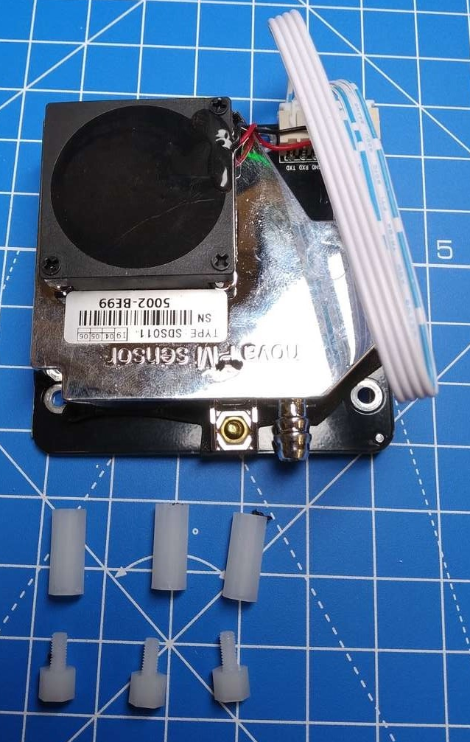  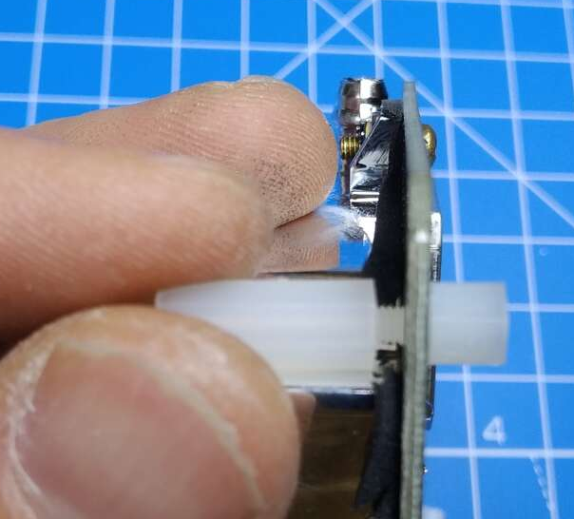

Step: 3 | Mount sensor to baseplate.
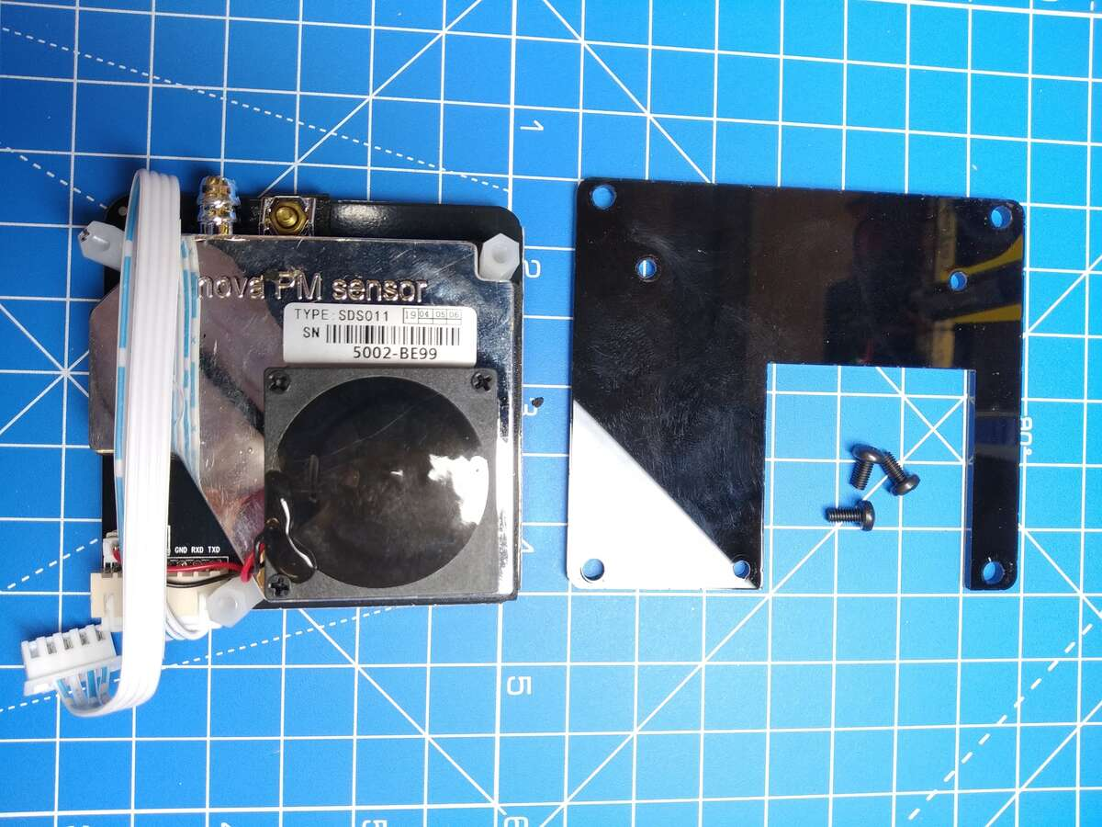  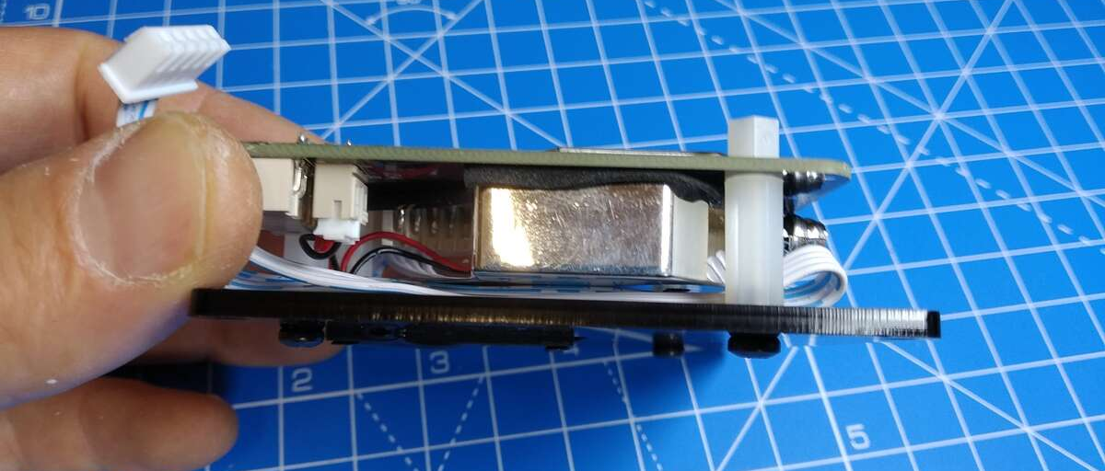 |  | The SDS011 is mounted on the baseplate with the 20mm spacers towards the baseplate. The fan fits into the cut-out of the baseplate.  Use 3 x M3 6mm machine screws to hold the sensor to the baseplate.

Step: 4 | Mount PCB to Sensor
Mount the PCB to the top of the sensor.  Use 3 of the M3 6mm machine screws to hold the PCB to the shorter hex spacers on the sensor.  Use the white cable that comes with the SDS011 dust sensor to the PCB.  The cable might need to be folded under to keep it out of the way. |  | 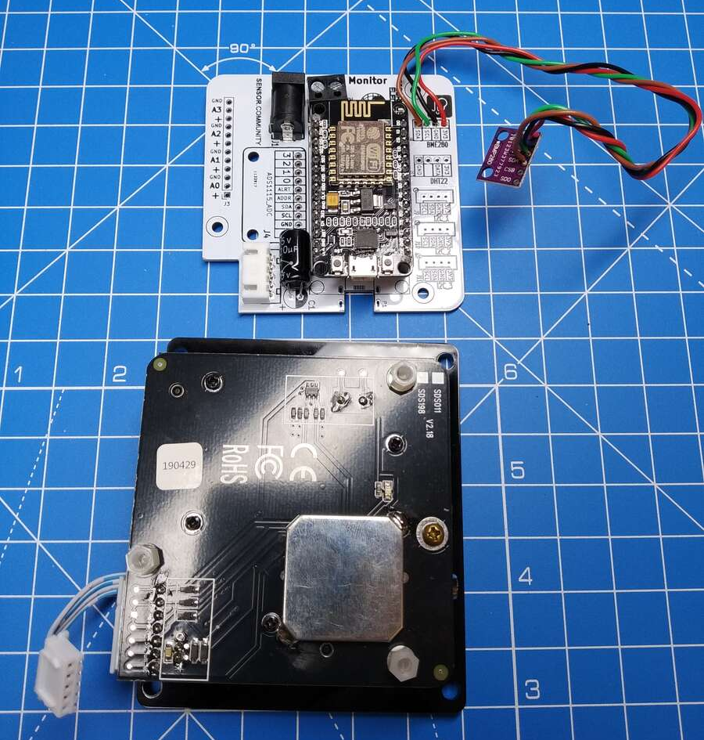  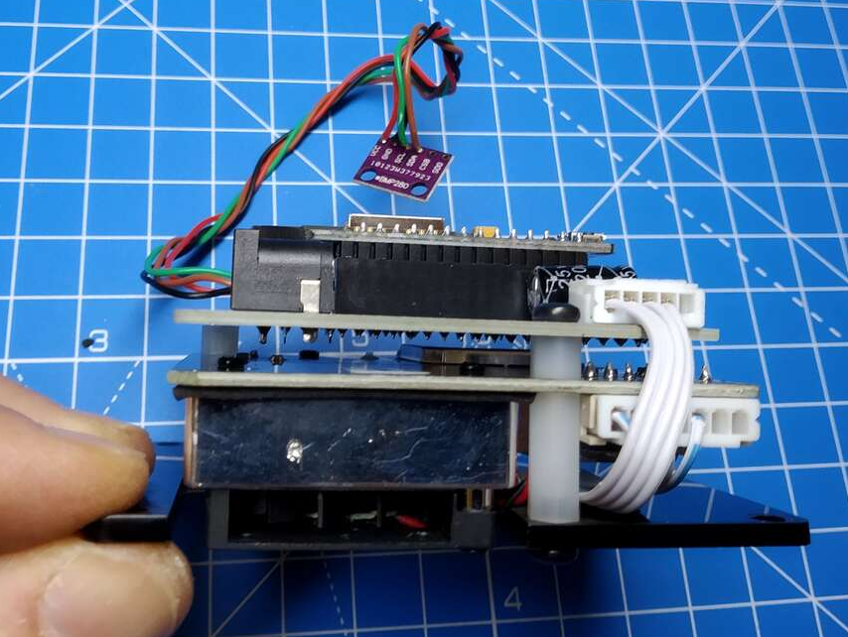

Step: 5 | Add compression gland
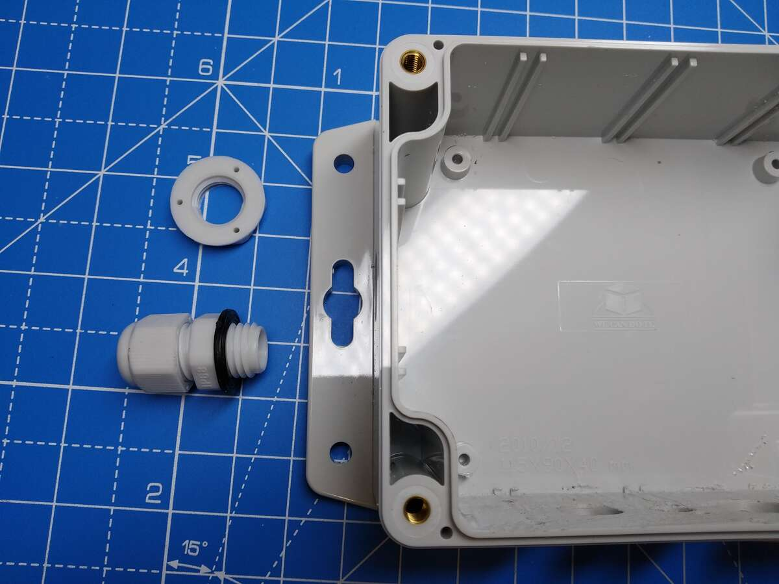 |  | Mount the compression gland through the hold on the side of the enclosure.  The enclosure is slightly thick for the gland, but if the nut is turned around, so the wide lip faces away from the gland, then it should grip the screw thread.  Or the black rubber ring can be removed, although it will have slightly less waterproofing.

Step: 6 | Mount BME280 temperature and humidity sensor
Use the 2 x M2.5 screws and nuts to mount the BME280 sensor PCB into the middle hole (hole with two smaller holes next to it) so that the small metal sensor unit shows through the larger hole in the middle. |  | 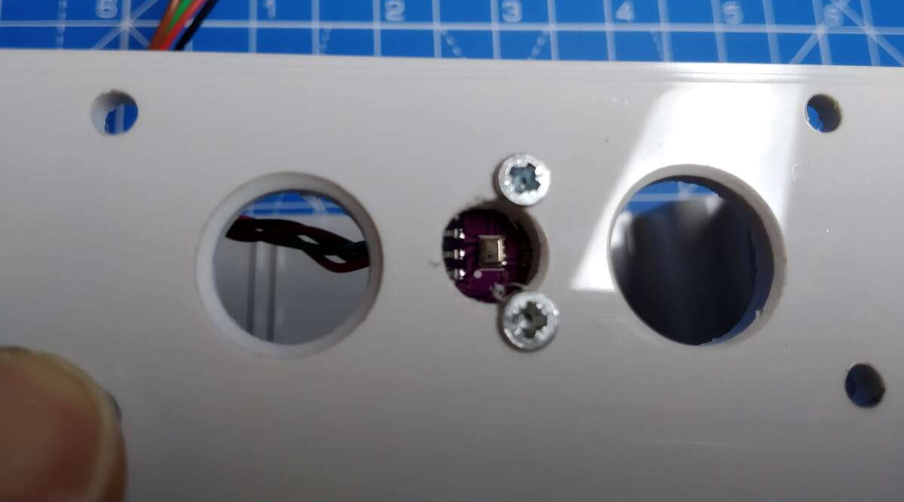  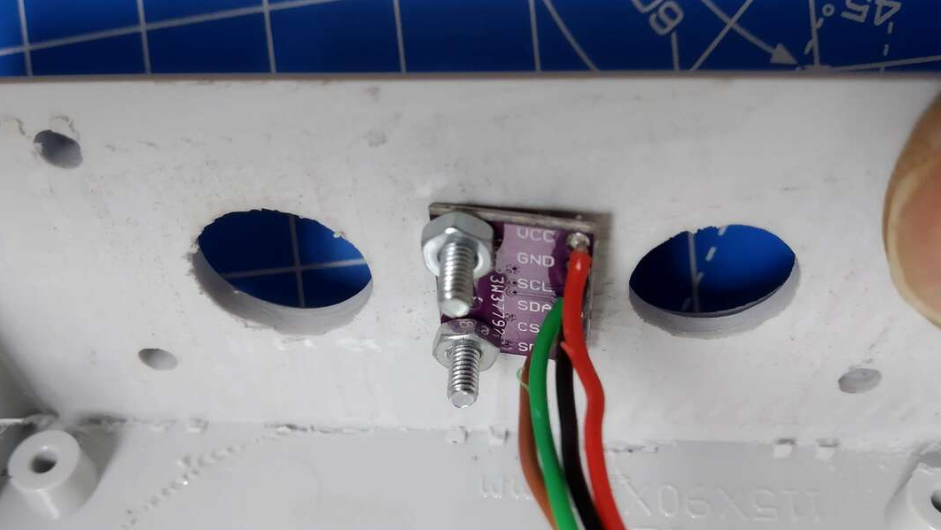

Step: 7 | Cut mesh
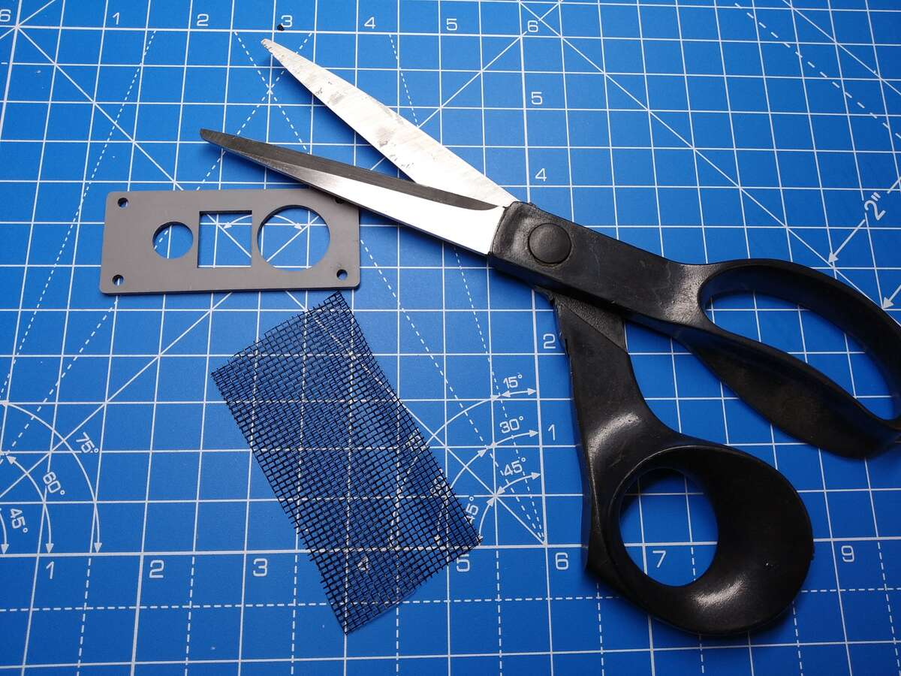  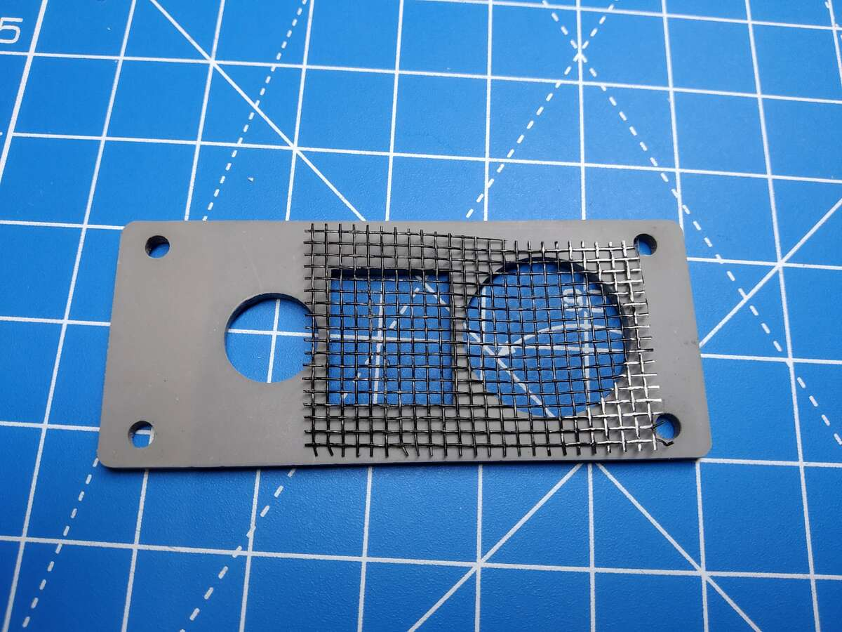 |  | Cut the piece of mesh to a size that covers the larger round and the middle rectangular hole on the rubber gasket.

Step: 8 | Add mesh, gasket and sensor plate
The mesh is held in place with the rubber gasket and the plastic outer plate.  Fit the mesh first, then the rubber gasket, then the 3mm acrylic output plate.  Use the 4 x M3 12mm screws and nuts to hold these in place onto the enclosure. |  | 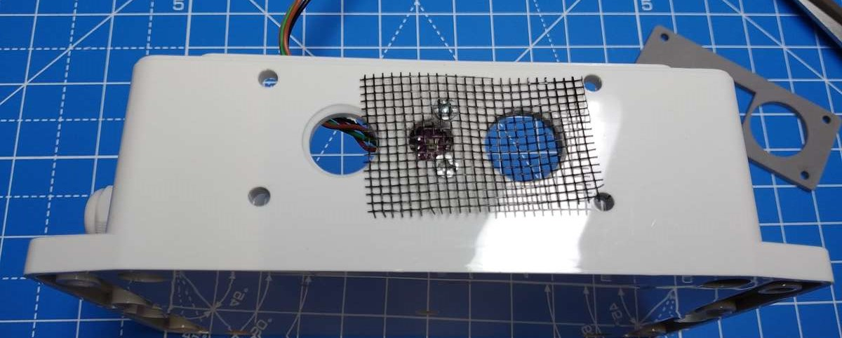  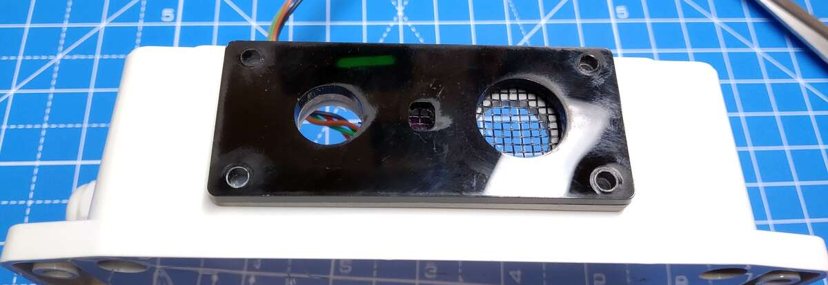  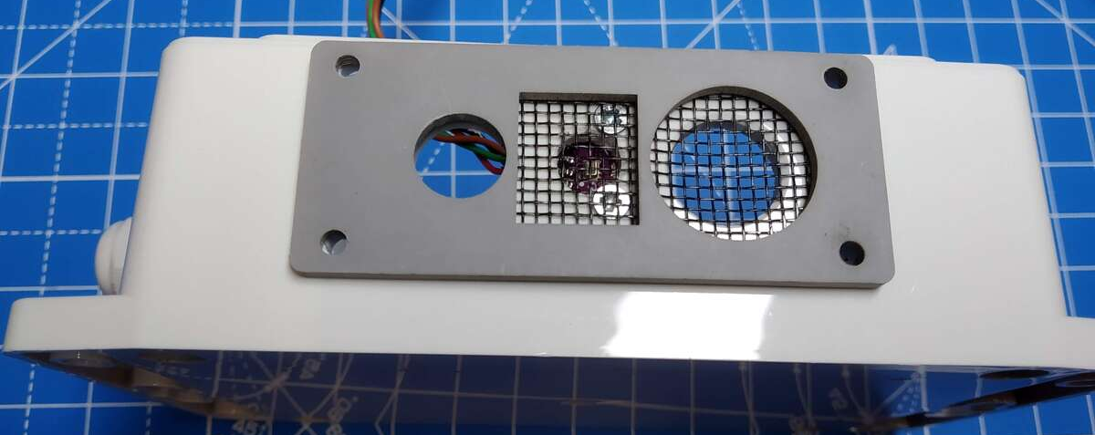  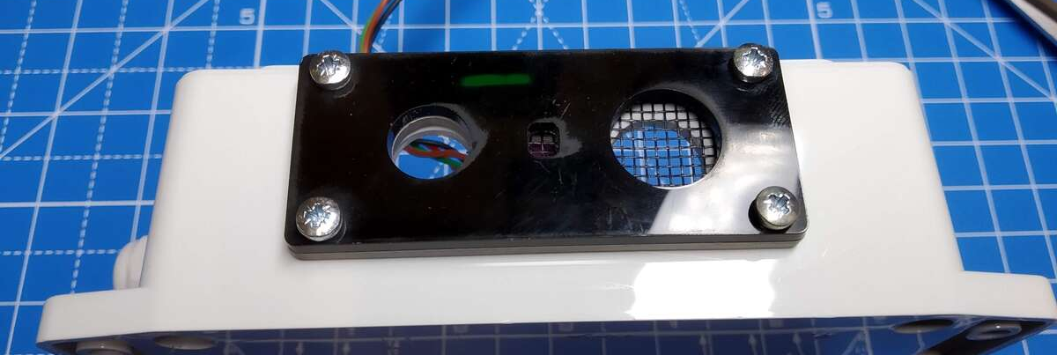

Step: 9 | Mount baseplate into enclosure.
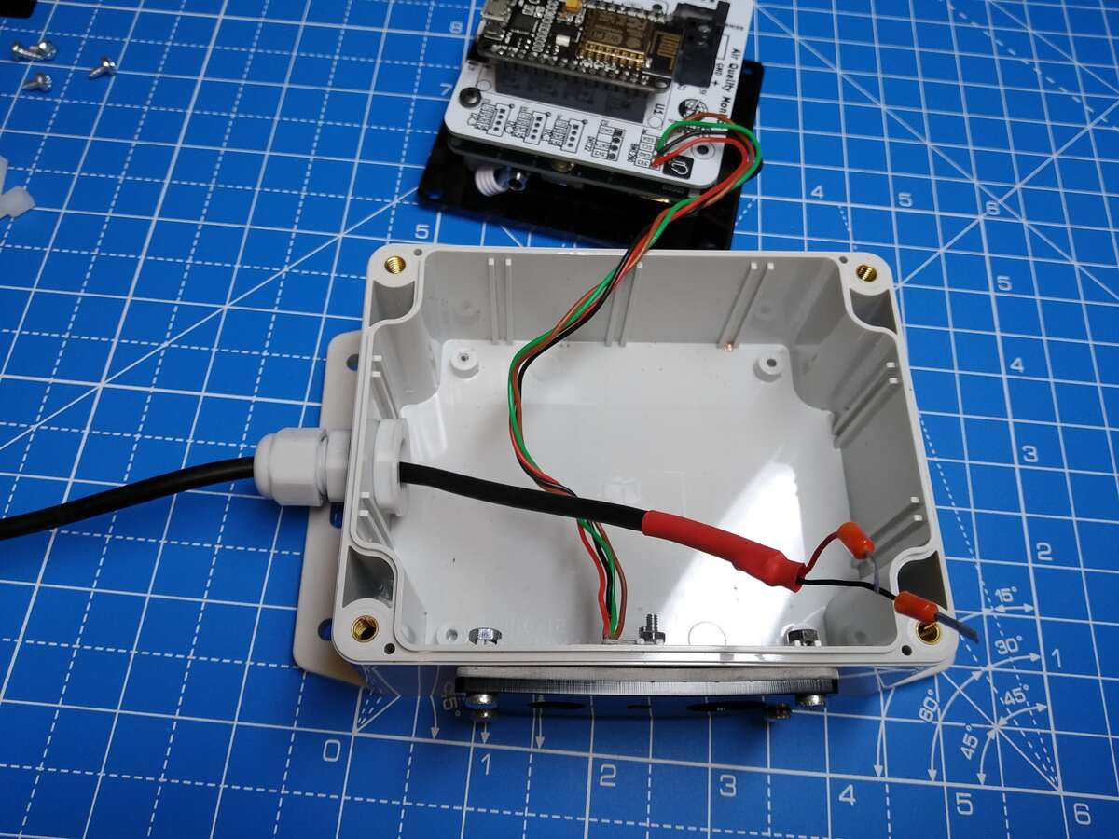  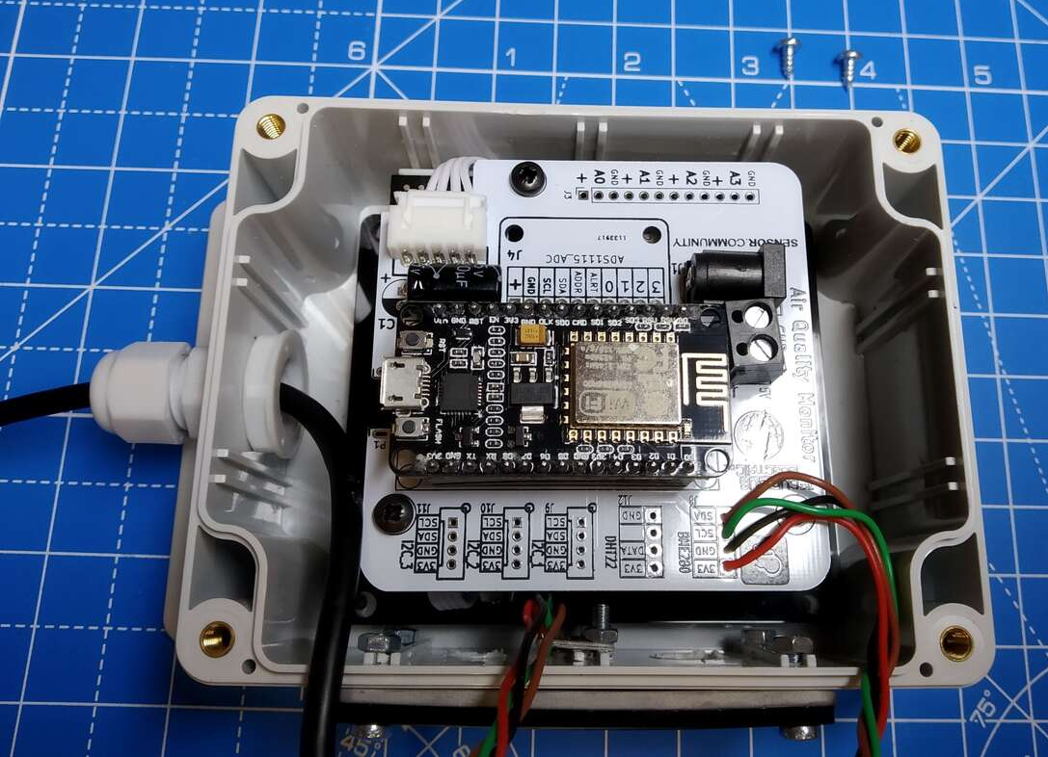 |  | Put the USB power cable through the compression gland, with the power terminals through into the enclosure. It’s easiest to add the USB lead now, or else it’s more difficult with the sensor/baseplate in place.  Fold the USB cable out of the way.  Fit the baseplate (with sensor and PCB) into the enclosure.  Use the 4 x self-tapping screws to hold the baseplate to the base of the enclosure.  I only use two of the self-tapping screws, as that is enough to hold the baseplate.  Ensure no cables are pinched or trapped.

Step: 10 | Add the sensor tube
The yellow plastic tube is used as the intake for the sensor. The tube is mounted through the smaller round hole on the outer sensor plate through and onto the round intake for the SDS011.  To make this a bit easier, warm the yellow tube in some boiling water for a few minutes.  Warning: Take care! This can be very hot!  Push the intake tube through the smaller hole and onto the intake for the SDS011 sensor. You may need to rotate slightly as you push. This will be quite a tight fit. |  | 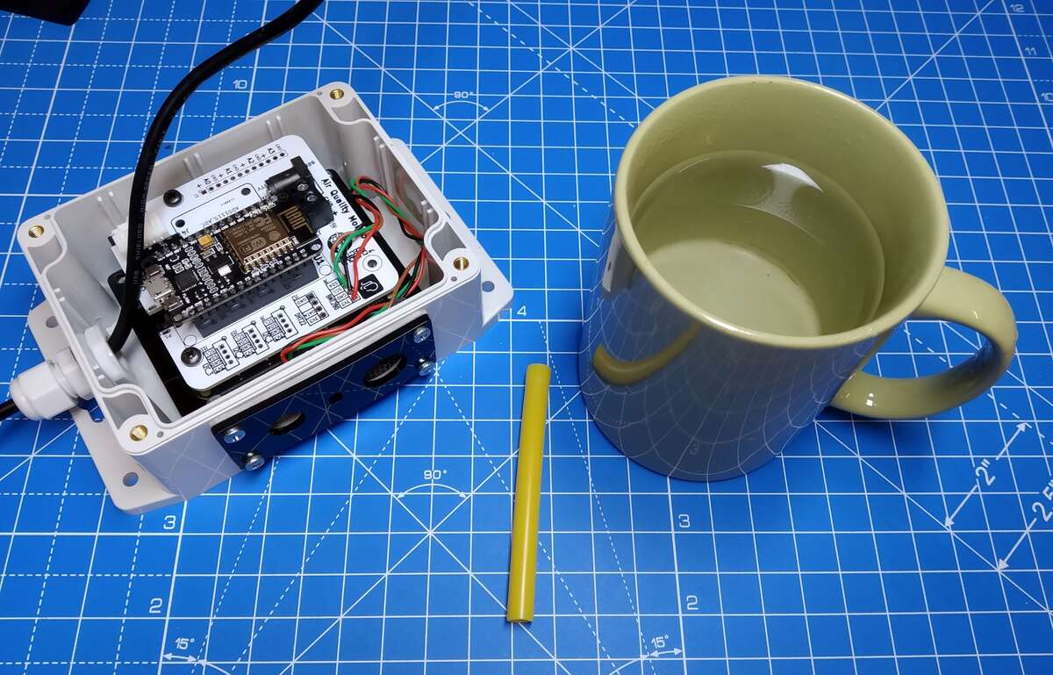  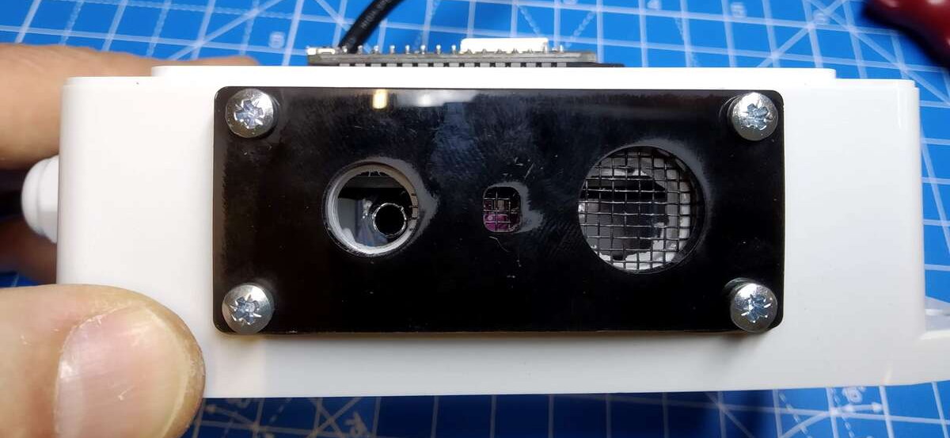  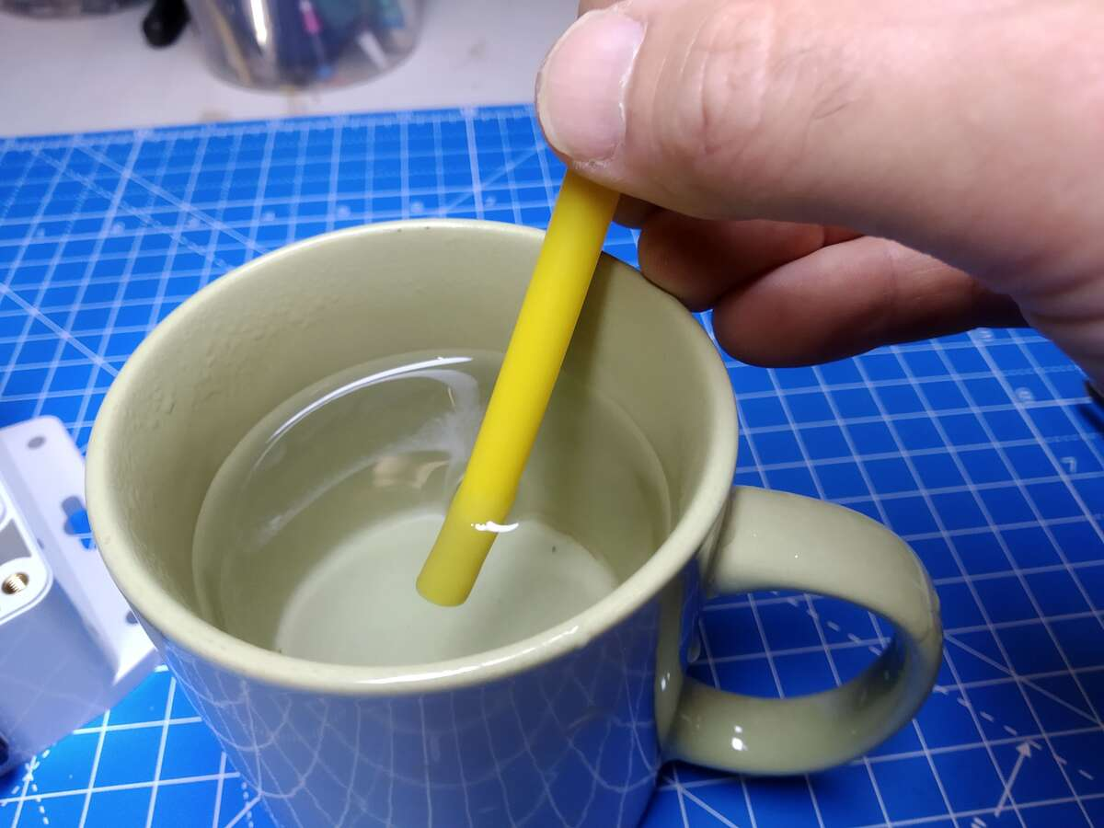  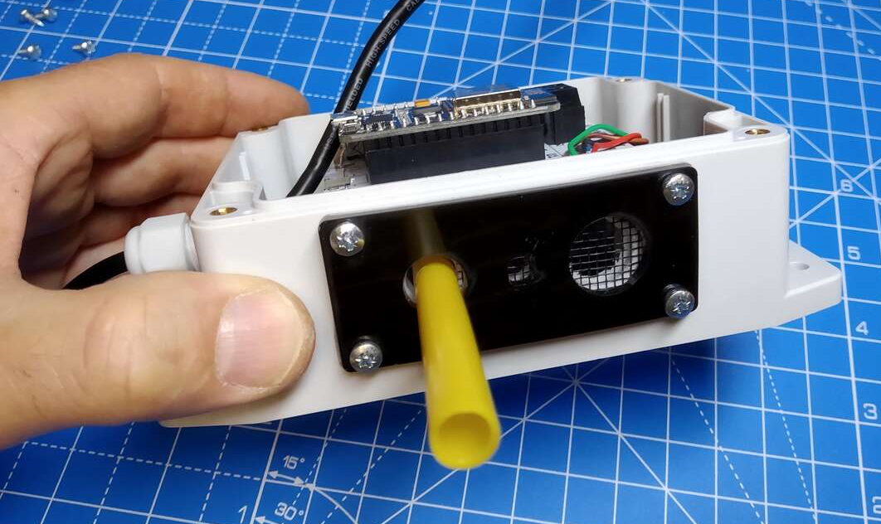

Step: 11 | Wire up power supply
Ensure the cables fit into the enclosure.

Wire up the USB power supply cable into the unit, with the red wire into the “+5V” screw terminal and the black wire into the “GND” terminal.

If you plug the other end into the USB power supply unit then the blue light on the NodeMCU should briefly flash.

Step: 12 | Fit lid to enclosure
The lid needs the sealing strip mounted around the lid.

Then fit the 4 x enclosure screws through the lid holes and close the unit up.

Step: 13 | Build is finished!
Have a nice cup of tea.


Set-Up Instructions:
Step: 1 | Register and set-up your sensor node
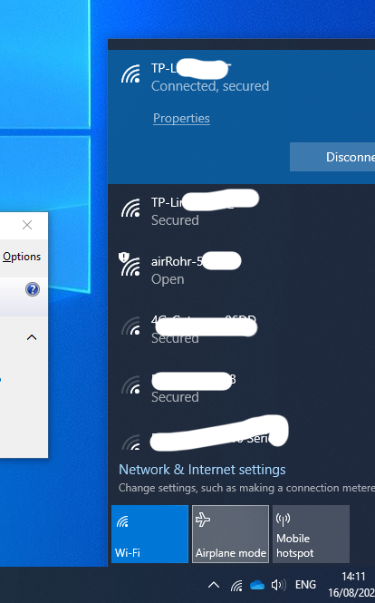  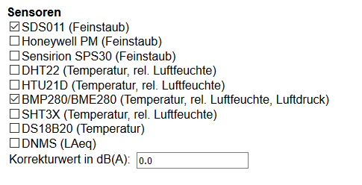  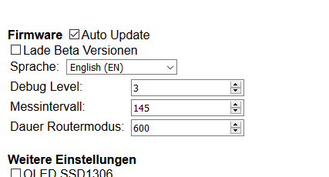  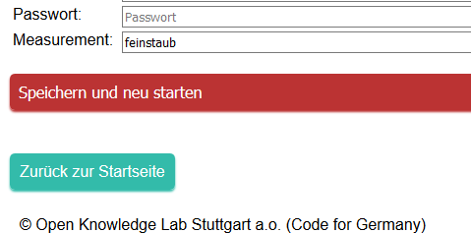 |  | Note: These instructions follow the information given by the air-rohr/sensor.coummunity information given here:  https://sensor.community/en/sensors/airrohr/  Power up the sensor node using the USB lead.  Wait a few moments and refresh your Wi-Fi channel list (Note: this might take a while and require a few refreshes of the list)  There should be a Wi-Fi connection called “airRohr-123456”, where 123456 is an ID number.  Write down the ID number for future reference.  Connect to the airRohr Wi-Fi connection.  It should open automatically, but if not: Using your browser, go to http://192.168.4.1/  There will be a lot of options on that page. Some is written in German (as this was originally a German project).  Click on your network and enter in the network password.  Click on the “English” language option (or others for different language options). (Update: This now starts in English automatically)  Un-click the DHT22 sensor.  Click on the BME280 sensor.  Click on the RED “Speichern und neu starten” or “Save and Re-start” button at the bottom of the page. This will save the data and restart the node.  Re-connect your computer to your normal Wi-Fi connection.

Step: 2 | Register the sensor with sensor.community
Go to: https://devices.sensor.community/

You will need to register an account with this site.

Then click on: “My Sensors”
The click on “Register a new Sensor”

Follow the sensor registration page – you will need the device ID you wrote down in the previous step.

Change the hardware configuration so that the first sensor is the SDS011 (on pin 1) and the BME280 (on pin 11). The pin number change automatically when you click on the correct sensor. To see the pin numbers you may need to click on the “Advanced” tab (as pin numbers are hidden to keep it simpler). The pin numbers are the default values, so should not need changing.

Enter the location and any other details required and then “Save settings”

You can then check under your “My Sensors” list to check it is there.
Wait at least 30mins (or more!) and then re-check the “My Sensors” list.

Click on ‘Data’ and you should be able to see the latest data that has been uploaded.

Step: 3
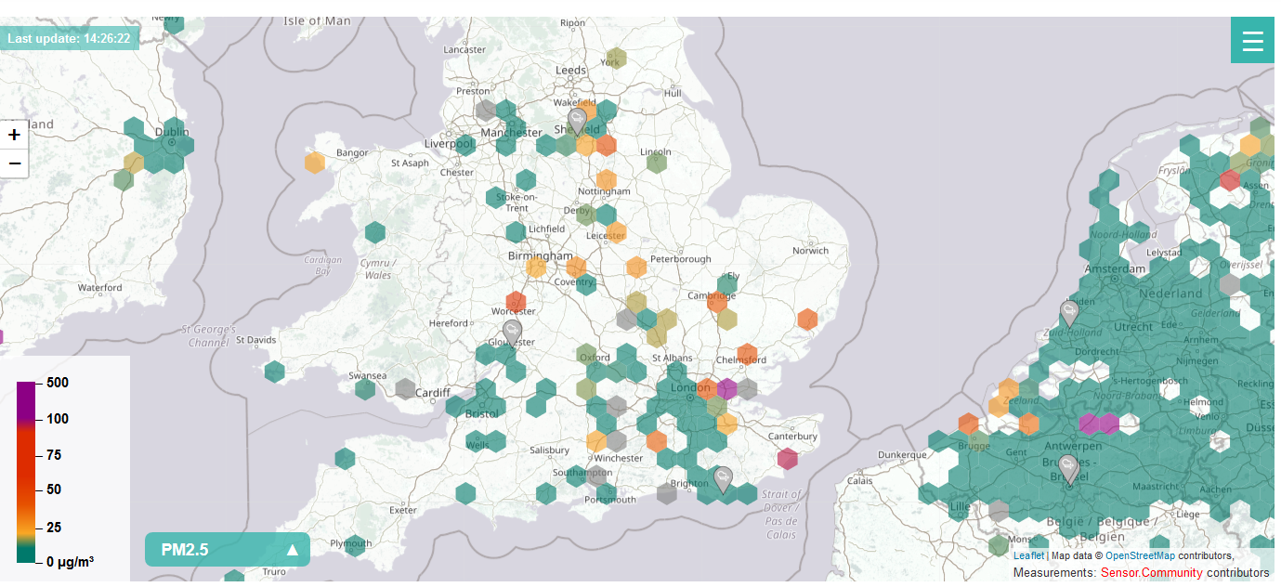 |  | Congratulations! You are now sending data to the sensor.community site and you should be able to see you sensor data on the world map!

This project full build, PCB and instructions can be found here:
https://github.com/curiouselectric/airQualitySensor
Contact details:
We would like you to be happy with this kit. If you are not happy for any reason then please contact us and we will help to sort it out.

Please email hello@curiouselectric.co.uk with any questions or comments.
Please tweet us at @curiouselectric

If any parts are missing from your kit then please email hello@curiouselectric.co.uk with details and, if possible, when and where the kit was purchased.

More technical information can be found via www.curiouselectric.co.uk

This kit has been designed and produced by:
The Curious Electric Company
hello@curiouselectric.co.uk
www.curiouselectric.co.uk

History
This kit is based upon lots of work by others especially:
- https://sensor.community/en/
- https://github.com/CivicLabsBelgium/influencair-pcb
- https://github.com/Naesstrom/Airrohr-kit
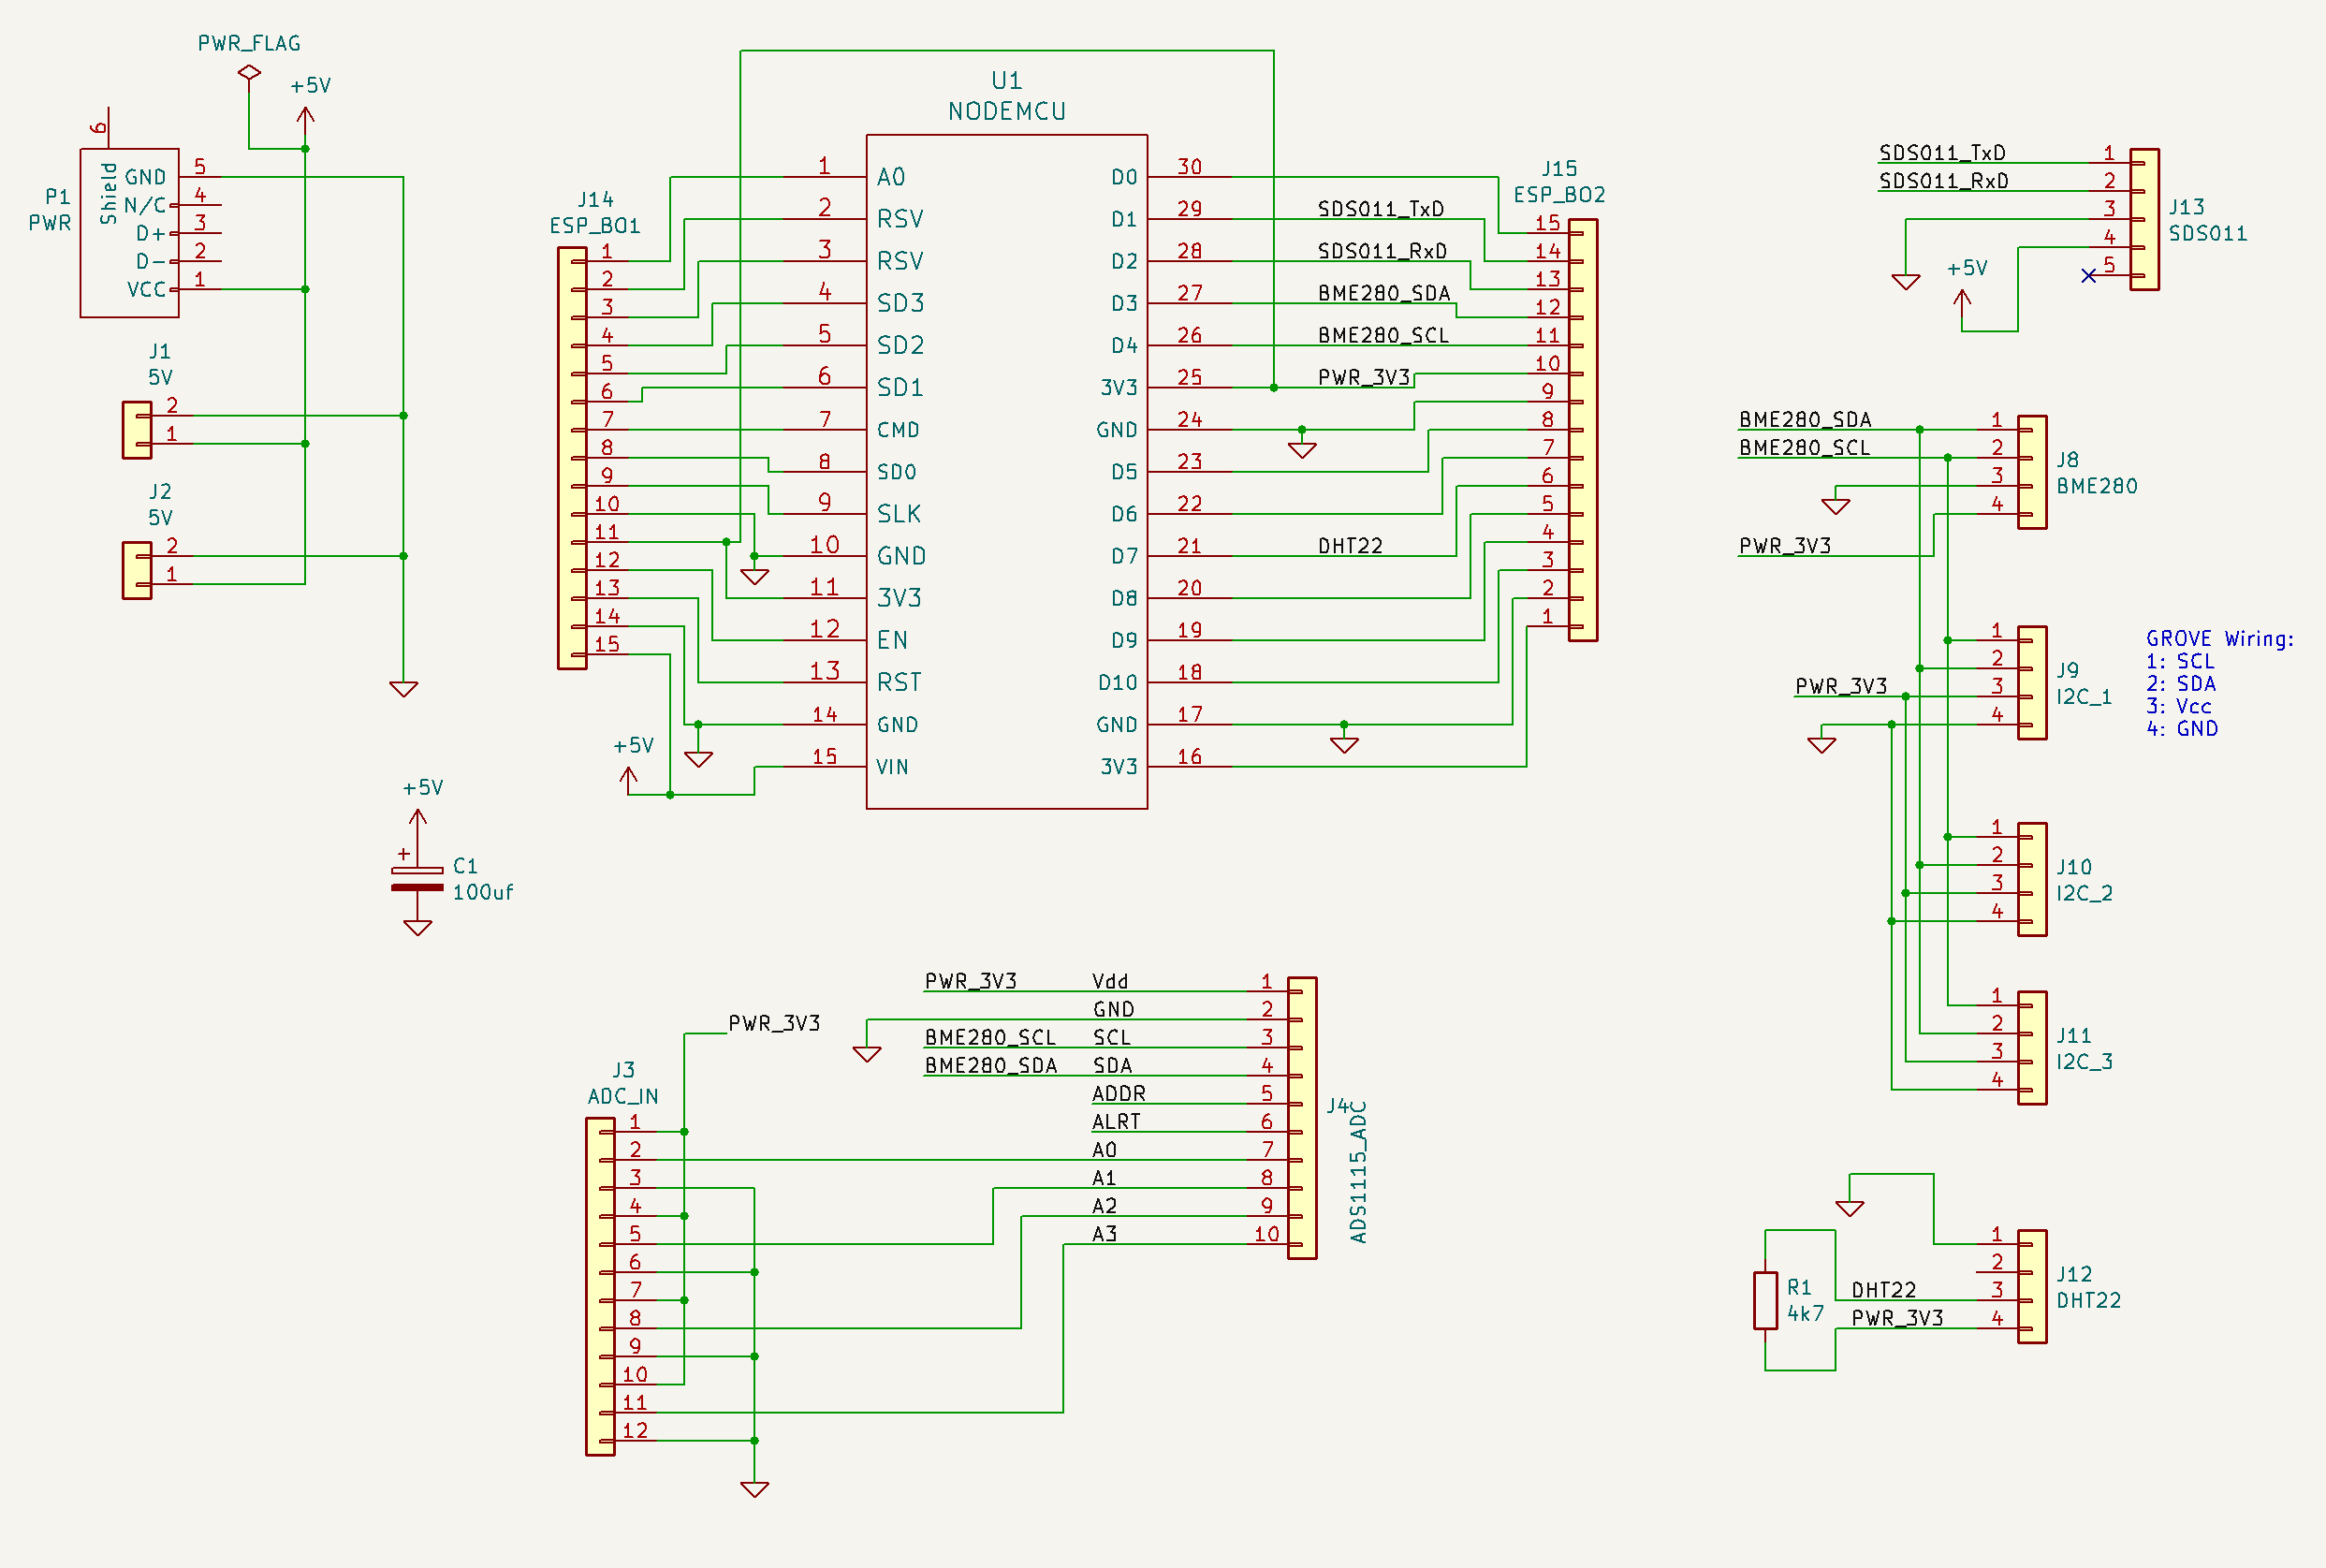
Circuit Schematic

