  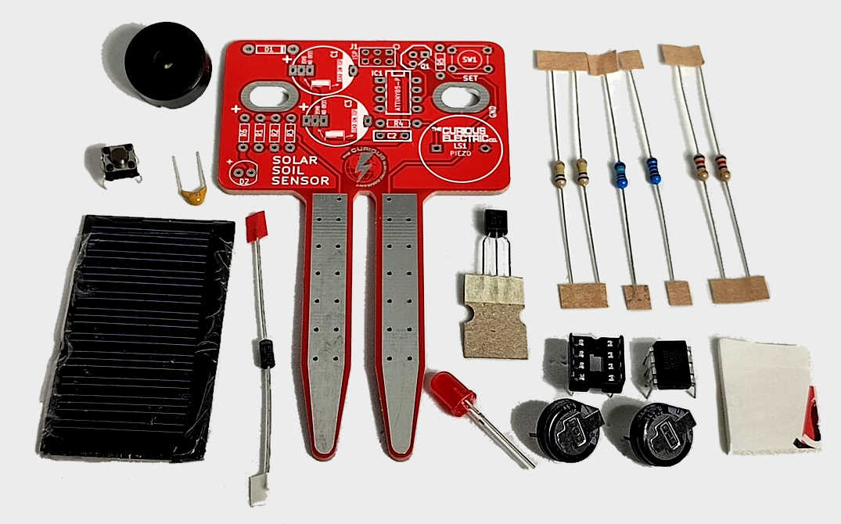  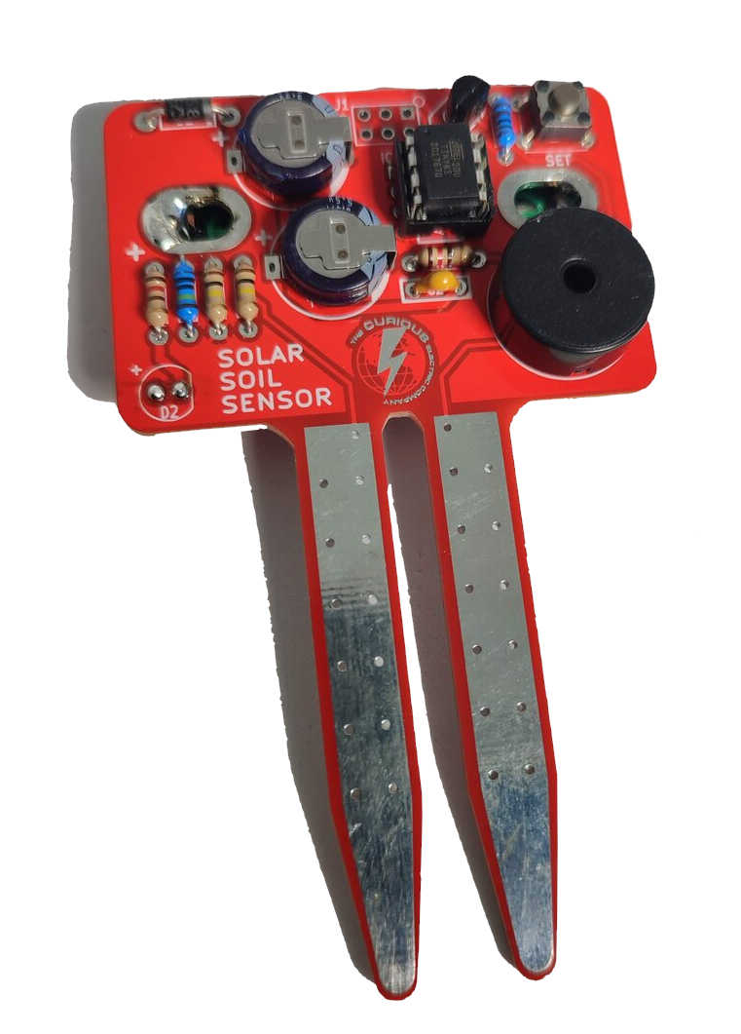  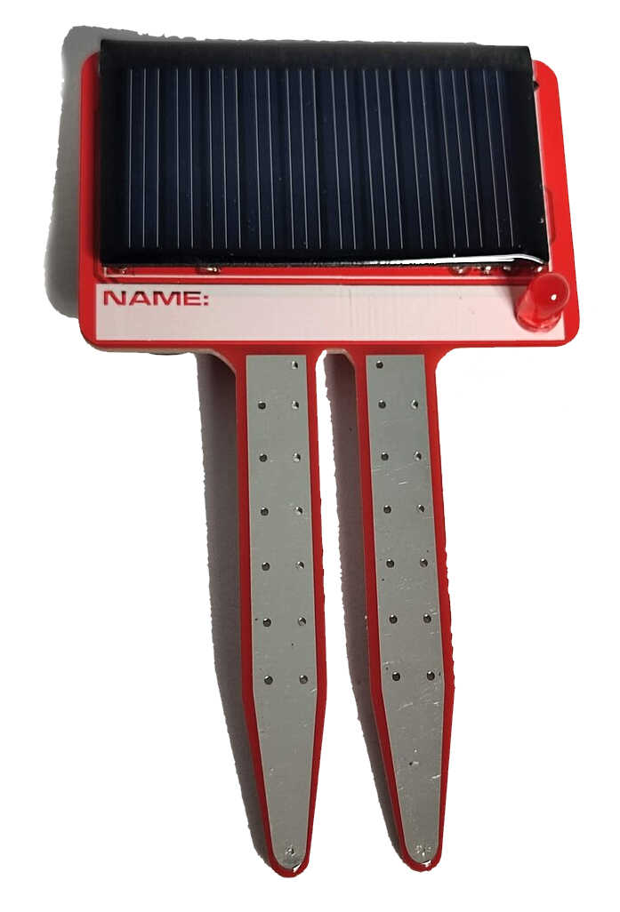 | Solar Soil Sensor Instructions

Date: | 10/06/2025 | Version: | 1.1 | By: | Matt Little

Add this soil moisture sensor to your pot plants to let you know when to water them.
This checks the moisture level and either blinks an LED or 'chirps' to remind you to water the plant.

It is solar powered, so will never need batteries! It uses an ultra-capacitor to store the solar energy, so will work even if left uncharged for a long time. But it will need to be left in sun to recharge – on a sunny windowsill will work perfectly!

This kit has been designed as a fun and interactive way to introduce solar power and to improve soldering skills.
It is designed for indoor use on houseplants.

Parts included:
Piezo |  |  | Printed Circuit Board |  |  |  |  | 6 x resistors:  2 x 120 Ω  1 x 1 kΩ  2 x 100 kΩ  1 x 1 MΩ
100 nF  Capacitor |  |  |  |  |  |  |  | 6 x resistors:  2 x 120 Ω  1 x 1 kΩ  2 x 100 kΩ  1 x 1 MΩ
Switch
Transistor
BC547
Solar Photovoltaic Panel  (5V, 30mA) |  |  |  |  |  |  |  | ATTiny85  Programmed Microcontroller  (& holder)
 |  | Diode - 1N5819 |  |  | LED | Ultra-Capacitor  x 2 (0.47F 5.5V) |  | Sticky Pad

Parts list:
Item | Ref | Item | Ref
2x 0.47F Ultra Capacitor | C1, C3 | 1 MΩ Resistor | R1
100nF Decoupling Capacitor | C2 | 100 kΩ Resistor | R2
5mm Red LED | D2 | 100 kΩ Resistor | R3
1N5819 Shottky Diode | D1 | 120 Ω Resistor | R4
ATTiny85 Microcontroller (programmed)  Plus 8 pin DIL IC Holder | IC1 | 1 kΩ Resistor | R5
Piezo buzzer | LS1 | 120 Ω Resistor | R6
Printed Circuit Board | PCB | Solar Photovoltaic Panel (5V, 30mA) | SC1
BC 547C Transistor | Q1 | Switch | SW1
 |  | Sticky Pad

Tools required:
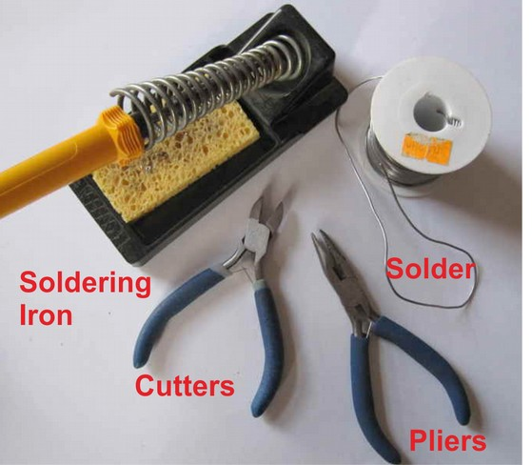

PCB Instructions:
Step: 1 | Solder resistors
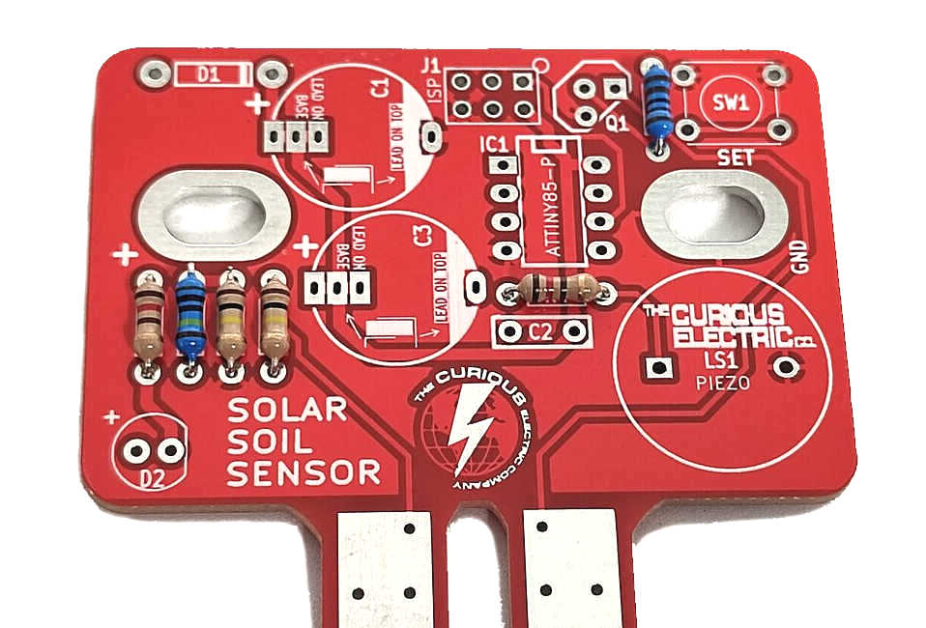 |  | Insert and solder the resistors to the locations marked on the PCB.  Polarity does not matter for resistors.  Ensure they are soldered flat & close to the PCB.  You can use a multi-meter or the colour code chart at the end of these instructions to ensure correct resistor values.
  Value | Ref | Colour
  1 MΩ | R1 | Brown – Black - Black– Yellow – Brown (5 band)
  100 kΩ | R2 | Brown – Black – Yellow - Gold
  100 kΩ | R3 | Brown – Black – Yellow - Gold
  120 Ω | R4 | Brown – Red – Brown – Gold
  1 kΩ | R5 | Brown – Black - Black– Brown – Brown (5 band)
  120 Ω | R6 | Brown – Red – Brown – Gold

Step: 2 | Solder diode D1 and Switch
Ensure correct orientation for D1, the 1N5819 diode.  This has tiny markings saying “1N5819” and also a white band around one end to indicate polarity.  Ensure the white band on the diode aligns with the white band marked on the PCB.  Solder the switch into the four pads marked 'SET'. Due to it’s dimensions the switch will only fit in one orientation. |  | 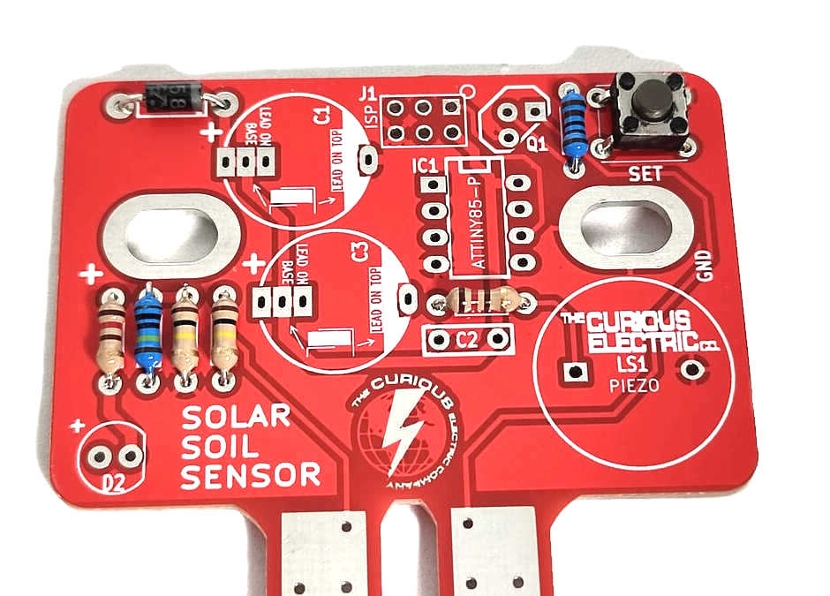

Step: 3  Note: There are additional holes on the PCB as these capacitors sometimes come in different sizes. Use the holes that fit the capacitors supplied. | Solder capacitors
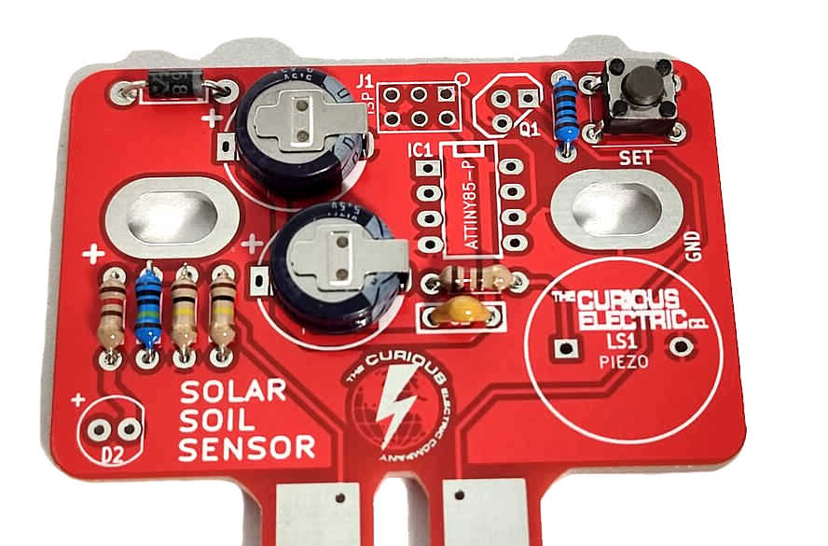 |  | First solder the non-polarised capacitor, C2.  Orientation of this does not matter:  Next, solder the two polarised ultra-capacitors. Ensure correct orientation of this component.  The negative lead is marked with a white bars. Align the positive lead with the + sign and the negative lead with the white PCB marking.
  Value | Ref | Marking
  100nf | C2 | 104
  Value | Ref | Marking
  0.47F | C1, C3 | 0.47F 5.5V

Step: 4 | Solder Transistor
Solder the transistor into the part marked Q1. This is a BC547 NPN transistor.  Ensure the flat side of the transistor aligns with the long flat side of the silk screen markings. |  | 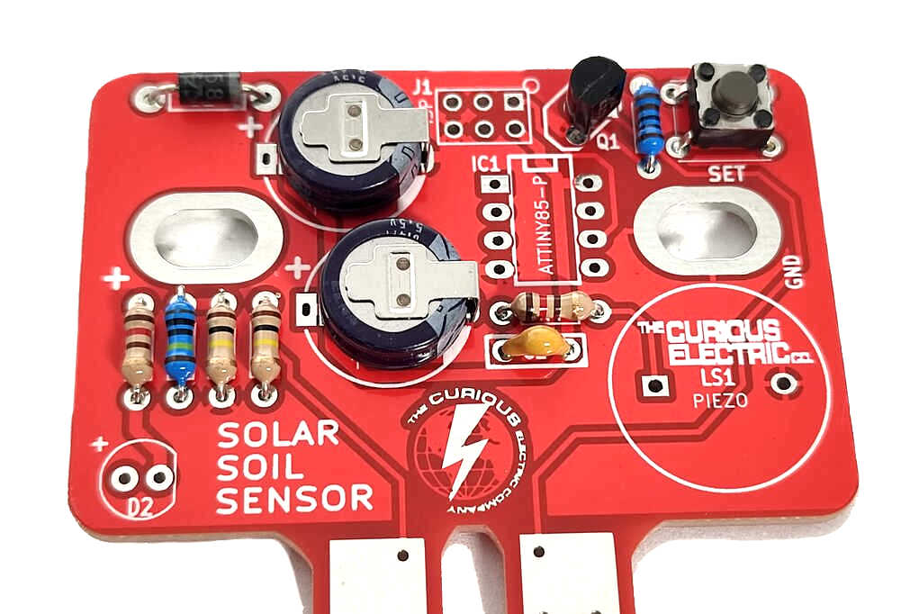  Flat  side

Step: 5 | Solder Piezo
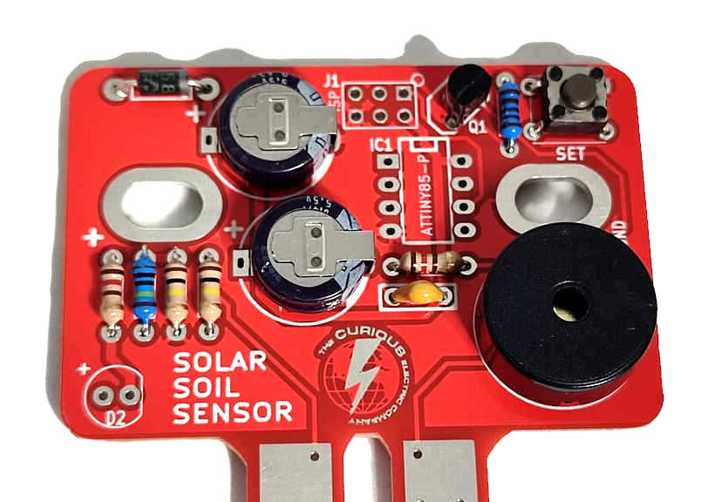 |  | Solder the piezo into the section marked LS1.  This creates the beep sounds.  The orientation of this component does not matter.
Check notch!
Step: 6 | Solder IC holders
Solder the 8 pin IC holder. These fit into the area marked IC1.  Ensure correct orientation!  Ensure the notch on the holder aligns with the notch shown on the PCB. |  | 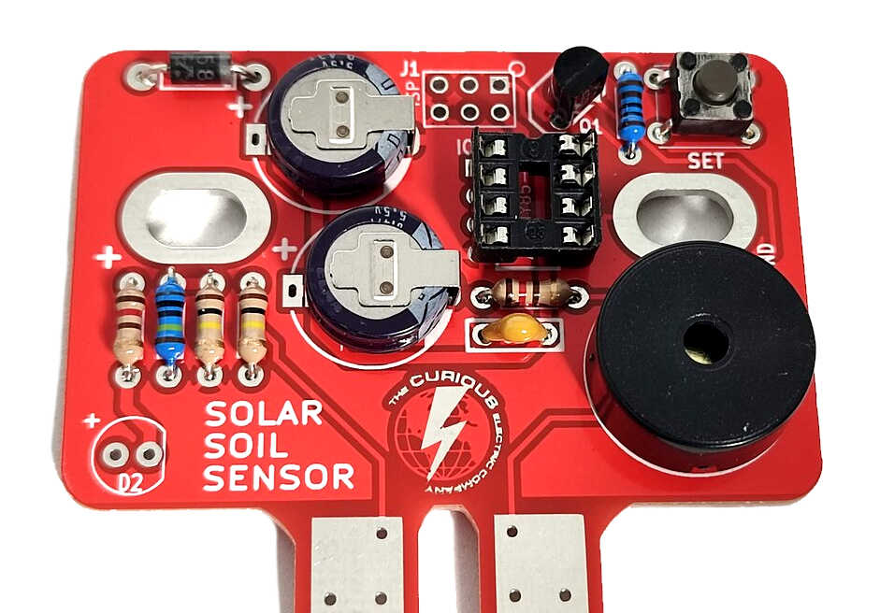

Step: 7 | Insert the IC
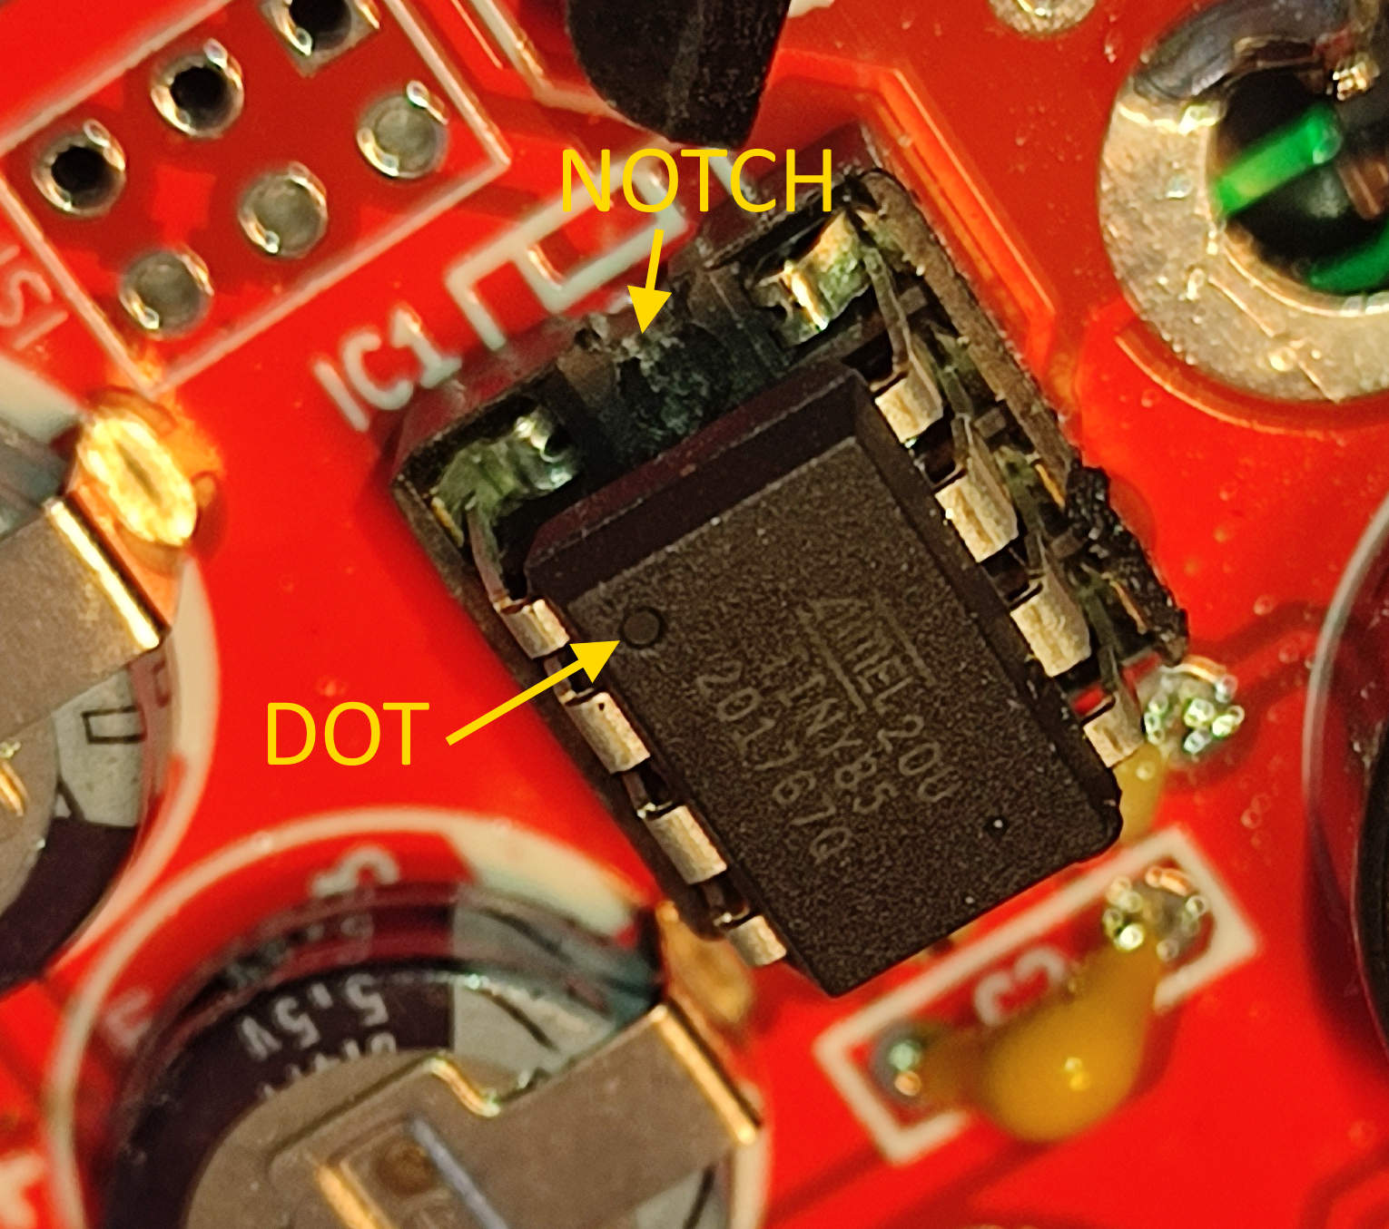  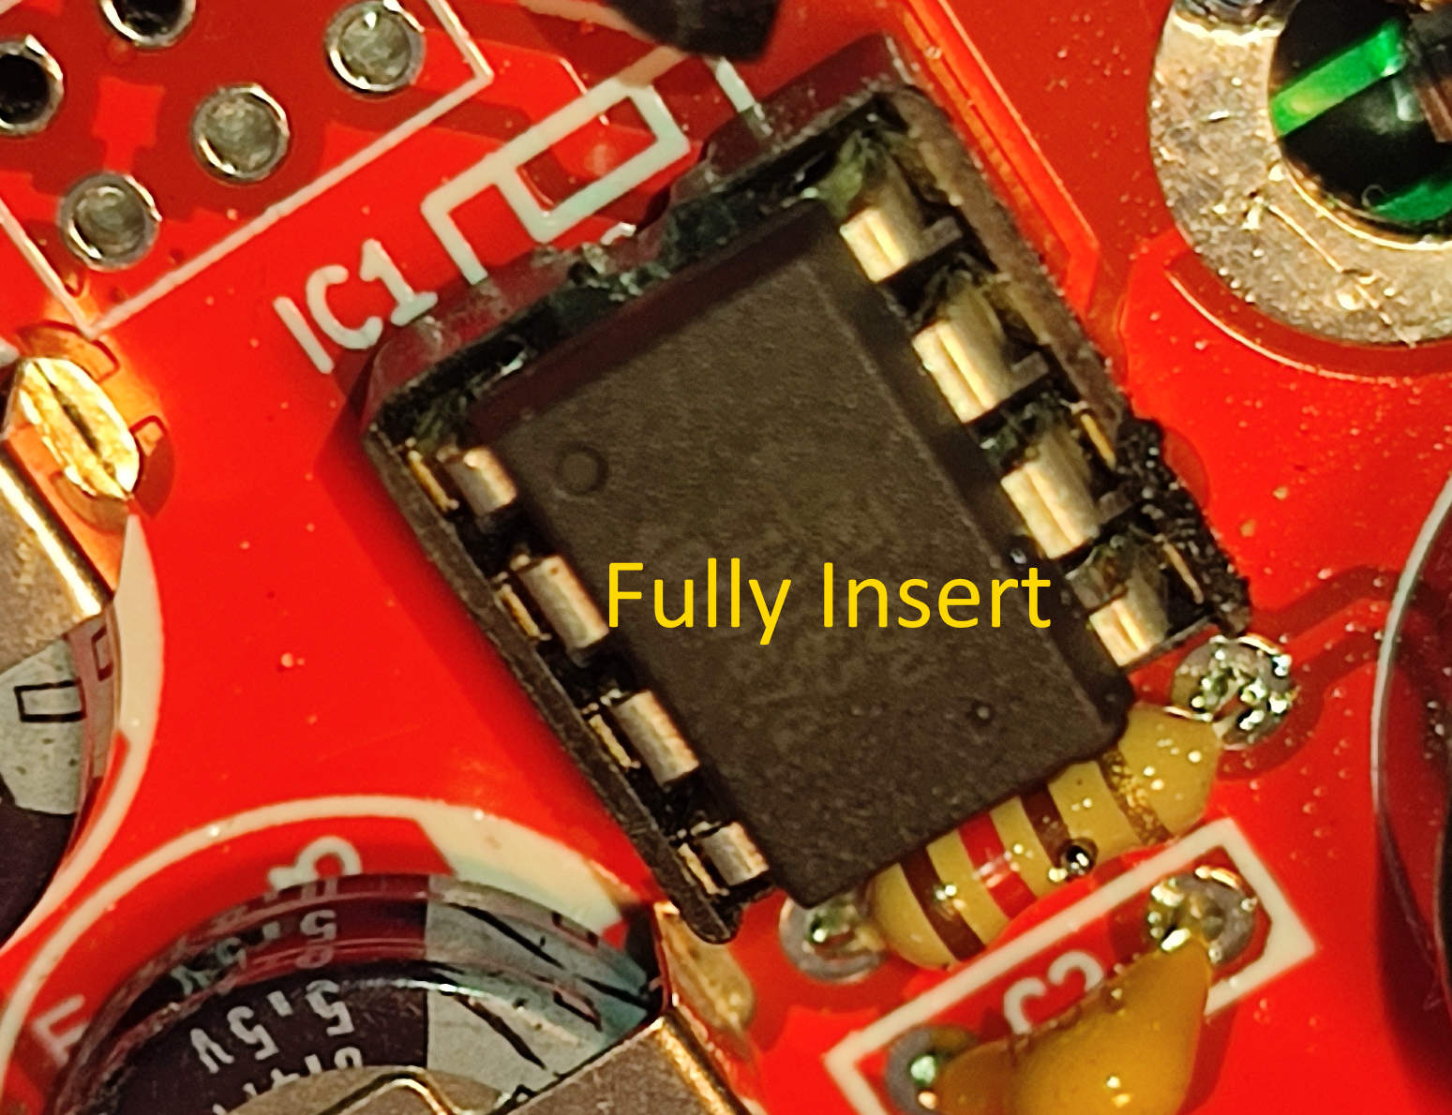 |  | Carefully push the microcontroller into the 8 pin IC holder.  Ensure that the dot on the microcontroller aligns with the notch on the IC holder and the PCB.
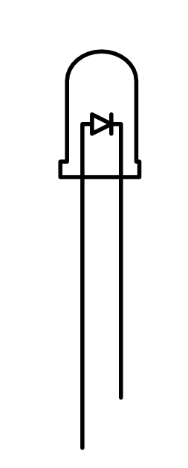
Step: 8 | Solder the LED
The LED is soldered to the other side of the PCB in area D2. Please see photos.  Ensure correct orientation!  FOR THIS BATCH OF PCBs THE SILKSCREEN IS PRINTED IN REVERSE!  The longer lead on the LED is positive,  so place that into hole next to the FLAT side on the PCB  The negative side has a slightly flat edge on the body of the LED. This goes to the ‘+’ marked hole on the PCB. |  | 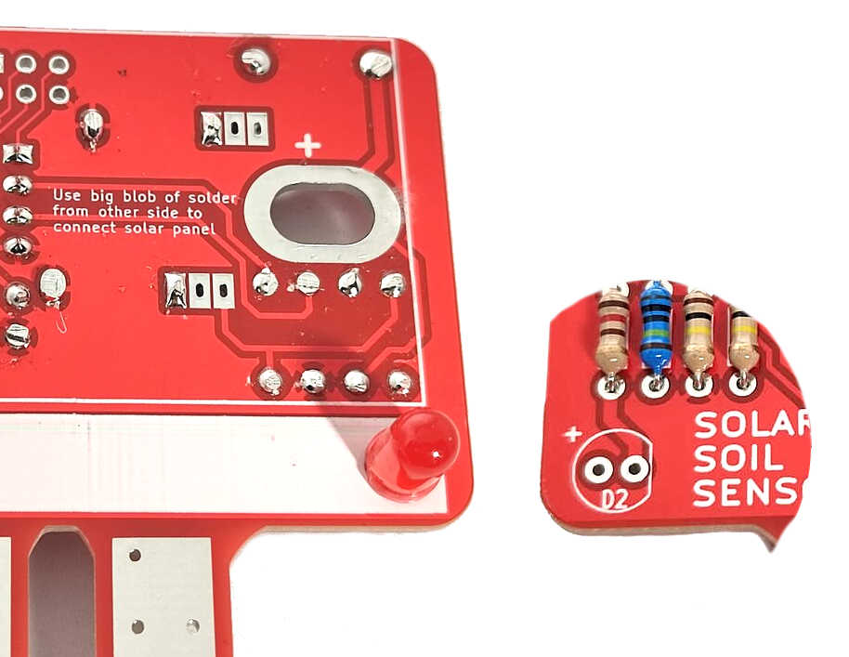  NOTE: SILK SCREEN INCORRECT!  The LED long lead goes to the FLAT side on PCB and the LED flat side goes to the + on the PCB

Step: 9 | Fit and solder the Solar PV Panel
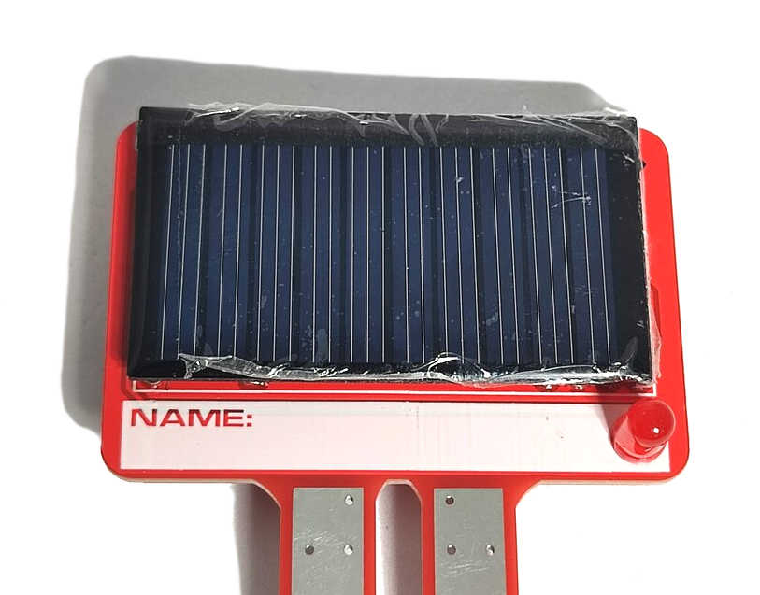  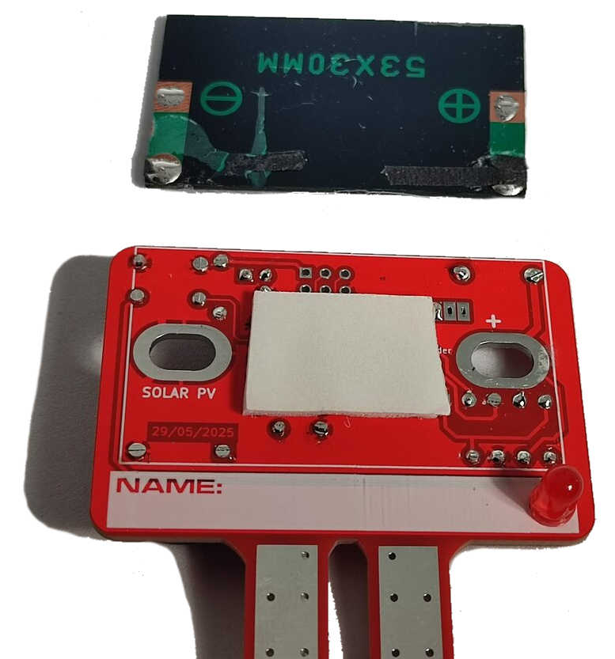 |  | Stop and double check that all the components are soldered correctly and in the correct locations. Once the solar PV panel has been soldered in place it will be difficult to fix any soldering issues!  - Use two cut-off resistor leads (1).  - Bend the resistor leads to make two little ‘legs’ for the solar panel (2).  - Add some solder to the pads of the PV panel, next to the + and – markings. Solder the short bent section of leads to the pads on the PV panel with the longer section pointing upwards (3).  - Add the sticky pad to the centre of the PCB on the solder side. Take off the backing of the sticky pad.  - Align the solar PV panel, ensuring that the + of the solar panel is aligned with the + solder pad. Also ensure the PV panel is aligned with the white outline.  - Stick the solar panel down and then solder the leads on the other side through the large holes (4). Ensure you don’t touch any of the other components with the soldering iron (especially anything that may melt, like the piezo).  - Then cut off the excess lead ends (5).  Check the image below for more details.
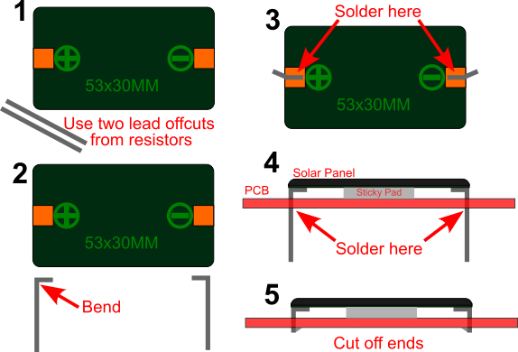

Step: 9 | PCB is finished! Let’s test...
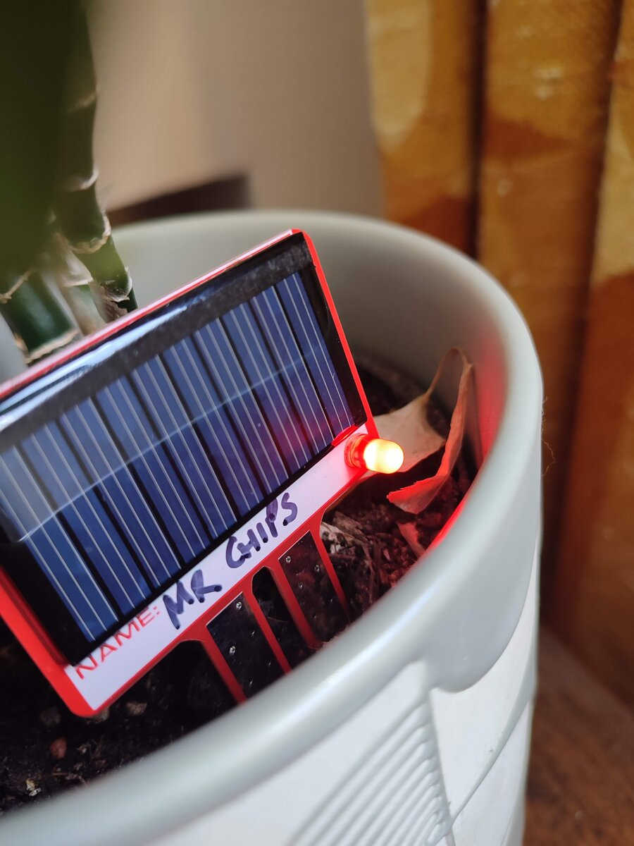  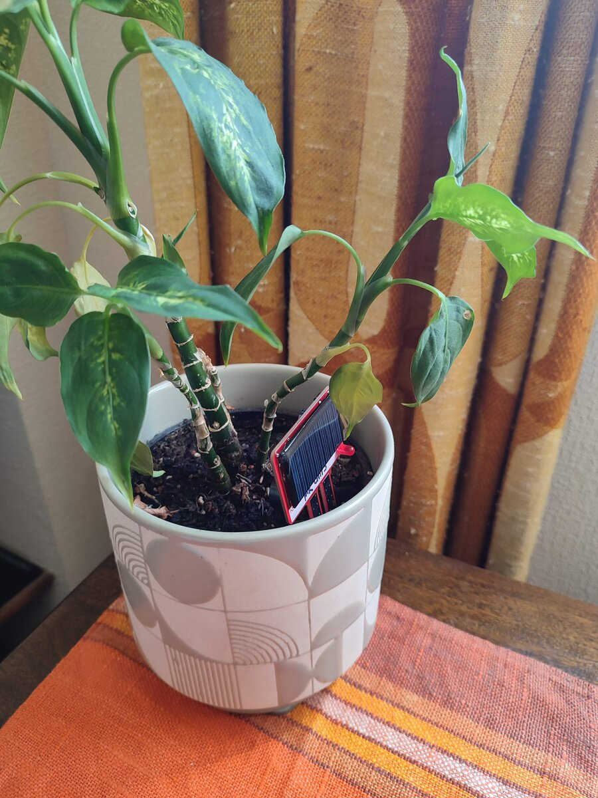 |  | Place the finished unit in bright sunlight.  It should charge up enough to work quite quickly (1-5 mins).  To get a full charge it will need to be left in the sun for a while. It can be left on a windowsill and will work very well there.  Please note: This unit is NOT waterproof.  Do NOT leave outside if it will get wet. It is designed for indoor houseplants.

Step: 10: Operation
This unit has a few different functions, all controlled through the 'SET' button on the PCB.
The unit will only work when it is charged, so this is best performed outside on a sunny day.
You can check to see if the unit is charged by pressing and holding the ‘SET’ button – if the LED is on and bright then the unit is fully charged. (This check will also change the mode the unit, so make sure you put the unit back into the right mode).

Set the 'I'm OK' moisture level:
We need to calibrate the unit for the moisture level that is “OK”. Do this by watering your plant to the perfect amount. Pressing the 'SET' button for a short press (less than 1 second) will read the moisture value of the probes. It will use this value to make decisions on what is under-watered.
This value is stored in memory, even if the unit it fully discharged. The LED will flash quickly 5 times to show it has saved the moisture setting.
When the moisture level drops below this level minus a fixed amount (set in code) then it will trigger a flash and ‘Chirp’.

Changing Modes:
Pressing and holding the 'SET' button (for more than 1 second) will cause the unit to cycle through the three modes. Each time the next mode is entered then there will be a beep(s). The number of beeps indicates the mode the unit is in. Release the 'SET' button when you are in the correct mode.

Mode 1: Flash and 'Chirp' on under-water
The unit will wake up every 8 seconds and check the moisture level.
If the moisture level is a bit below the set level (set as explained above), then the unit will 'Chirp' with a rising tone. This means 'water me!'. The LED will also flash.
The 'Chirp' will only happen when there is sunlight available (to stop it beeping through the night!). The ‘Chirp’ only happens every 30 seconds or so (although the LED will flash as a warning every 8 seconds).

Mode 2: Flash ONLY
This is the quiet mode. It will never 'chirp' but just flash if under-watered.

Mode 3: Flash and 'Chirp' on under-watered AND over-watered
This mode is similar to Mode 1 and does the same operation as Mode 1. It also checks for over-watering. If the plant is over-watered then the unit will do a falling 'Chirp' tone.

Note: Even in normal operation this unit may discharge overnight or with a few cloudy days (as the capacitor does not hold a huge amount of energy). This is normal and the unit will start again when there is solar power available.

Step: 11 | Re-programming Notes
Note: No programming is needed – the microcontrollers are already programmed!
Here are some notes for people wanting to take things a step further…
The circuit board has a standard ISP (In-System Programming) port for the ATTiny85 microcontroller and full access to the code which can be programmed via the Arduino IDE, if that’s your thing.

You will need a programmer for the ATTiny85 - an Arduino Uno with wiring set up for programming an ATTiny85 will work (please search internet for this information).

You will need to include the ATTiny85 programming board manager into your version of the Arduino IDE (please search internet for this information).
I installed “ATTinyCore” via the Arduino boards manager and these devices were programmed with the “ATTiny25/45/85 (no bootloader)”, “1MHz (internal)” and B.O.D at “1.8V”.

You upload code by using the “Arduino as an ISP” option.

The Arduino code for this unit (and all other design files) is available at the repository:
https://github.com/curiouselectric/solarSoilSensor

Contact details:
We would like you to be happy with this kit. If you are not happy for any reason, then please contact us and we will help to sort it out.

If any parts are missing from your kit then please email hello@curiouselectric.co.uk with details and, if possible, where the kit was purchased.
More technical information can be found via www.curiouselectric.co.uk

Please email hello@curiouselectric.co.uk with any questions or comments.
You can find us on social media at:
Mastodon: https://mas.to/@curiouselectric
Blue Sky: https://bsky.app/profile/curiouselectric.bsky.social
Facebook: https://www.facebook.com/curiouselectriccompany/

This kit has been designed and produced by:
The Curious Electric Company
hello@curiouselectric.co.uk
www.curiouselectric.co.uk

Circuit Schematic
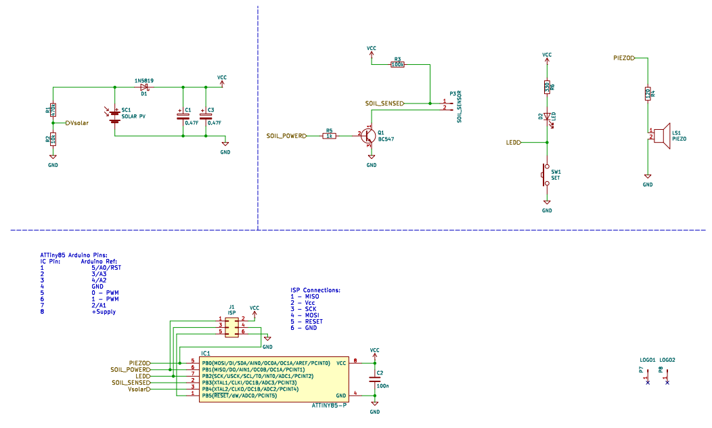

Resistor Colour Codes
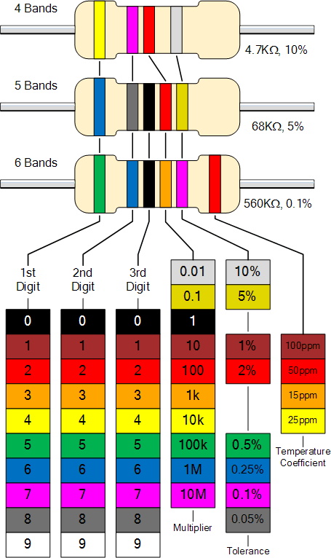
0

1

2

3

4

5

6

7

8

9

