Class and Database Diagrams for SC2 Build Order Generator

Venelin Valkov
University of Plovdiv
Faculty of Mathematics and Informatics

source code: https://github.com/naughtyspirit/sc2bog

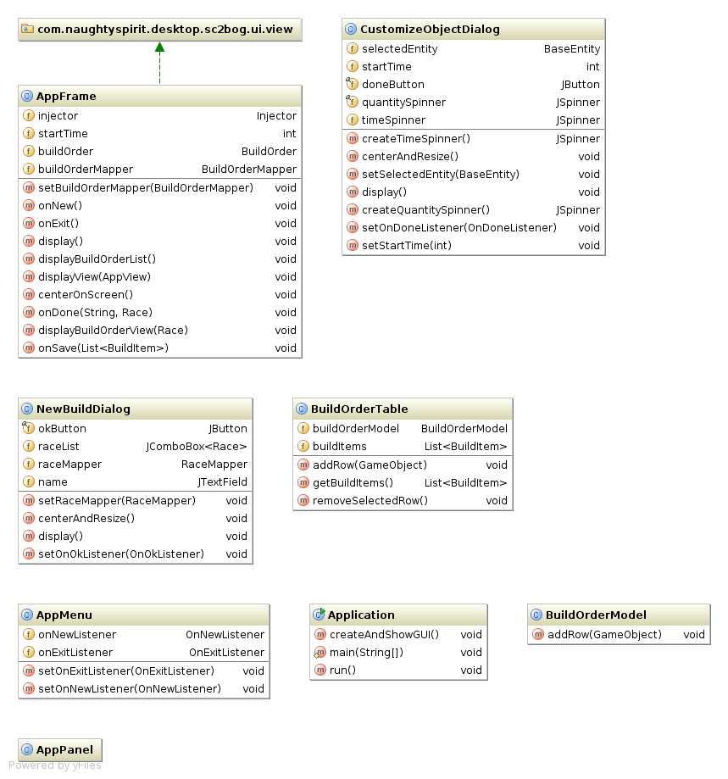

UI classes explained
- AppFrame – Main Application Frame responsible for managing Build Orders
- NewBuildDialog – Popup Dialog responsible for initializing a new Build Order
- CustomizeObjectDialog – Popup Dialog responsible for editing/creating new Build Order object
- BuildOrderTable – Table for presenting and editing Build Order objects ( along with custom TableModel – BuildOrderModel )

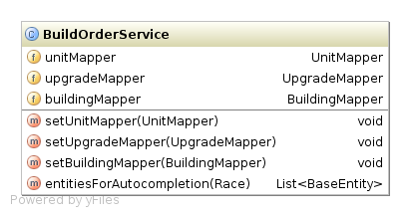

Service class explained
BuildOrderService – Acts as a mediator between the UI and Persistence layer. Must hide all dependencies between the Mappers and the Views. Guarantees return of non-null values

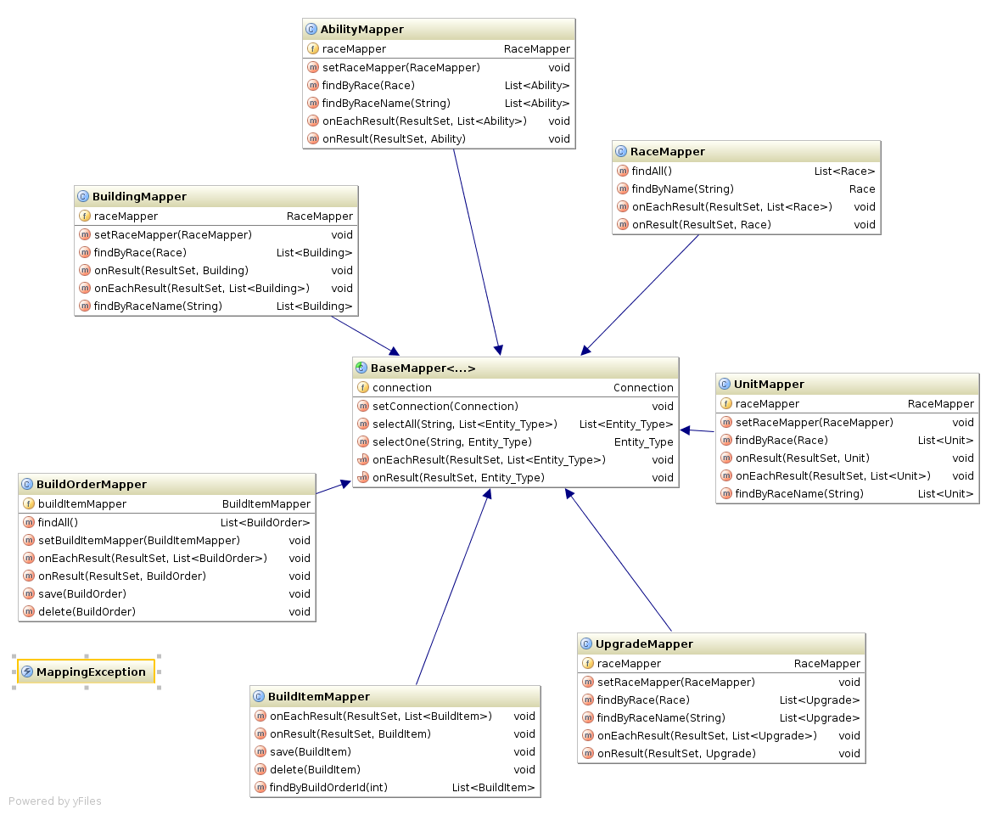

Mapper classes explained
- BaseMapper – Acts as common method repository for Persistence CRUD operations. All other mappers should extend him
- MappingException – Represents an event of exceptional condition such as unavailable Persistence storage

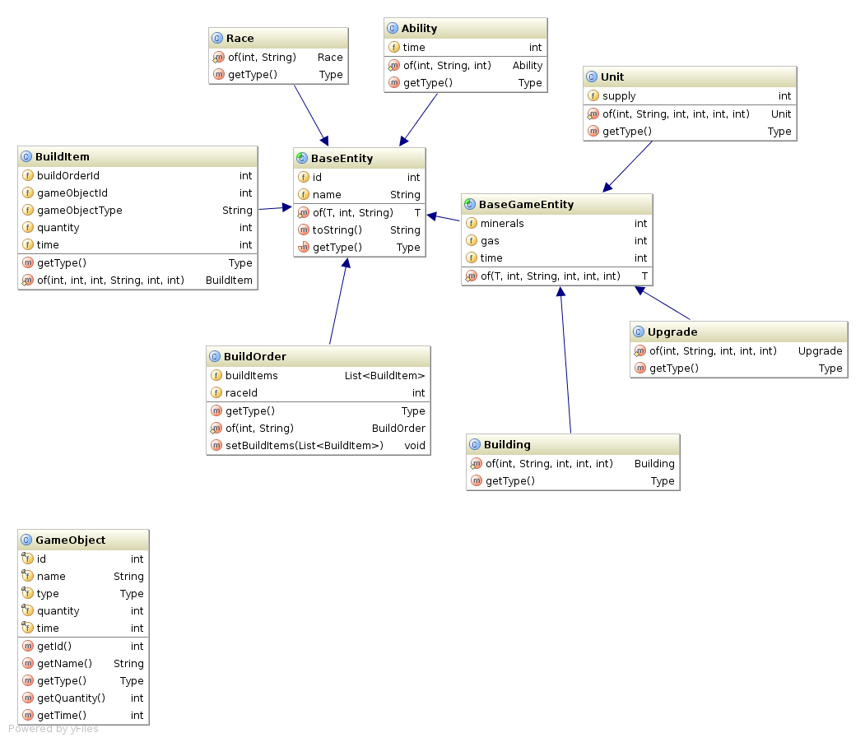

Entity classes explained
- BaseEntity – Acts as common data repository for persisting data. All other entities should extend him
- GameObject – Represents an item in Build Order. Acts as mediator between the entities and the application view layer

